Huawei pronounces 12.12 Super Sale with up to 50% discount!

Huawei introduced that up to 50% off pick gadgets is up for grabs in the course of its 12.12 Super Sale this Christmas season. Read on for extra info!

Until December 15, you can get up to 50% off pick gadgets consisting of the 64GB variant of the MatePad 10.4, MatePad T10 WiFi, Band 4e, and MateBook D 15 2021 with a tenth Gen Intel Core i5.

huawei 12.12

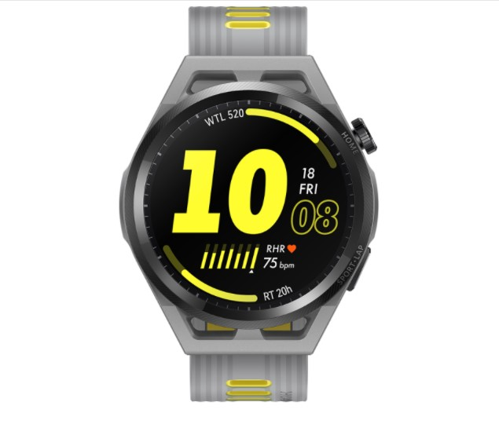

The Huawei GT Runner Will Present You Serious Smartwatch Envy
Huawei's GT Runner places pro-grade health tech in a smartwatch that appears like a sports activities car. However, it may not be as low-priced as its predecessors.

Huawei's GT Runner is a smartwatch that combines pro-grade fitness-monitoring technological know-how with the glossy styling of a sports activities car. It provides several improvements over its predecessor, however additionally comes with a greater rate tag, at the identical time. Despite being specifically recognized for its smartphones. Huawei's enhancing vary of smartwatches has genuinely been stirring up the opposition lately.

The Huawei Watch GT 2, in particular, got here with adequate pizzazz to take on the likes of Apple and Samsung's flagship wearables, even coming with a variant designed in collaboration with Porsche Design, the agency at the back of the iconic Porsche 911 sports activities car. It supplied masses of top-class facets such as a blood oxygen (SpO2) tracker, sleep monitoring, luxurious titanium exterior, and two-week battery life, to title a few. However, it used to be finally succeeded by way of the Huawei Watch GT three returned in October, which improves on most of its predecessor's super features, consisting of a bigger, higher-resolution display screen and higher health-monitoring software program accuracy.

huawei 1212 sales

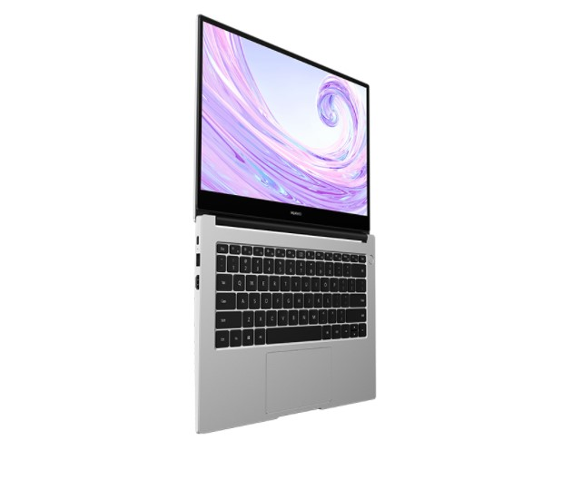

Huawei MateBook D 14
The MateBook D 14 provides top-notch fee for money, beating most mid-range opposition each in phrases of overall performance and design.

Huawei’s MateBook D 14 shares many plan similarities with the high-end MateBook X Pro barring compromising on the less costly nature of the laptop. Couple that with effective mid-range internals and all-day battery life, and you’ve bought an astounding mid-range laptop.

Verdict
The Huawei MateBook D 14 is the superstar of the company’s mid-range offering, boasting effective mid-range internals that can compete with extra high priced laptops and provide fundamental gaming capabilities, amazing 10-hour battery life, and speedy 65W charging that offers around forty-three percentage of cost in solely half of an hour. The show is brilliant and crisp, with thinner bezels enhancing the normal top-class appearance that Huawei has crafted for the D Series.

huawei 1212

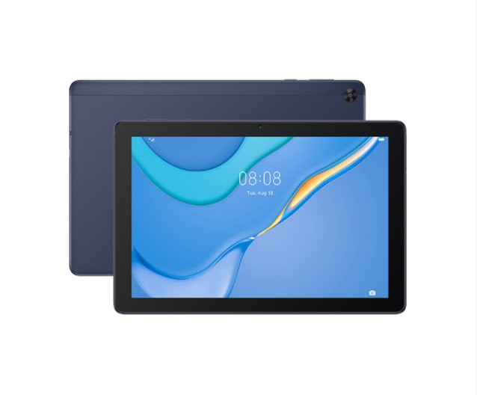

HUAWEI MATEPAD T10 - A excellent tablet, however a higher Learning associate for toddlers

The MatePad T10 LTE has been developed following the well-loved DNA of the MatePad line-up. The effective performance, immersive viewing and audio experience, and clever interactions. It has the identical massive HD+ display, stereo loudspeakers, and successful chipset, however, is complemented with the aid of 4G LTE cell facts connectivity in addition to Wi-Fi.

KIDS COMPANION
As I said, the MatePad T10 is a machine you ought to use for work and online learning, however, it is certainly an even higher mastering accomplice for babies and younger children due to the fact of the built-in KIDS CORNER.

It is now not simply an app or sport but a committed location for your kids. It includes 4 preinstalled Apps–a Recorder, Camera, Multimedia, and Kids Painting. It additionally points to Parental manipulation that lets approve app management, content material administration, and even time management.

Once you open Kids Corner, it is the sole vicinity they can play around with and they can’t get entry to any exterior apps.

At 7,999 the Huawei MatePad T10 is one of these inexpensive and dependable capsules you can get to praise your work from domestic or research from domestic setup. Just as lengthy as you don’t want something with high-end specs.
It is something that the complete household can use for staring at films or studying books and notwithstanding the lack of Google Apps, you can discover a lot of selections with the aid of truly the use of the Petal Search widget.

But for me one of the great motives to get it is Kids Corner which creates a separate area for your infants that will hold them entertained so you should end your duties barring interruption.

huawei 1212 sales Malaysia

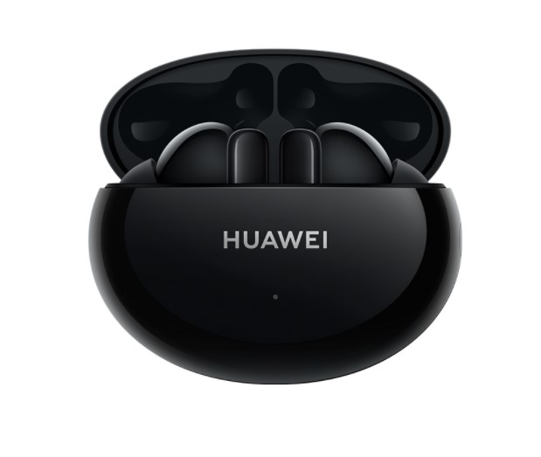

Huawei Freebuds 4i
Huawei may have bothered in the smartphone field, however, it is doing an extraordinary job with audio wearables. We’ve had the hazard to evaluate the company’s flagship TWS, the Huawei Freebuds Pro, and now we received the Freebuds 4i - an extra low-cost alternative that retains the Active Noise Cancellation and brings a wonderful battery life.

Design and comfort
The Huawei Freebuds 4i we acquired have been in Carbon Black, however, you can additionally have them in Red or Ceramic White (no proper ceramic included). We determined the one we acquired is the excellent preference of all due to the fact it can be matched with any outfit except being an accent (like the purple version) or have the AirPods lookalike vibe, like the white option.

The buds are an enhancement over the Freebuds 3i with barely thicker stems, and there are rubber pointers for a higher fit. One fascinating factor that Huawei is doing is transporting the special measurement rubber guidelines in separate labeled packages, making it a bit quicker to discover the dimension you want.

Verdict
The Huawei Freebuds 4i is without difficulty amongst the greater stunning wi-fi ANC earphones in their fee category. The enterprise did a splendid job fixing the whole lot that used to be incorrect with the Freebuds 3i whilst retaining the aggressive fee - higher plan for each the bud and the case, proper lively noise cancellation, and handy navigation.

The 10-hour non-stop playtime is a godsend when we have to work barring being distracted at home. The rapid charging and the stable sonic trip make for an average wonderful package.

