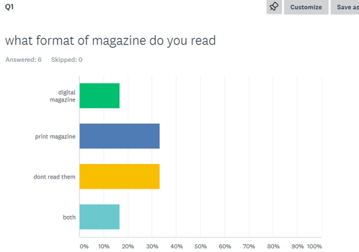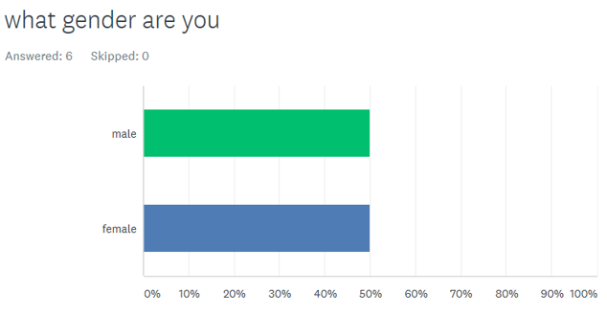
Exactly half of magazine readers are male or female, so I will have to make sure the magazine is suitable to interest both genders.
Here we have mixed results as most people do not read magazines or they mainly read print magazines. We can see print magazine is more likely to be read than digital magazine so it will be important the magazine is available digitally.

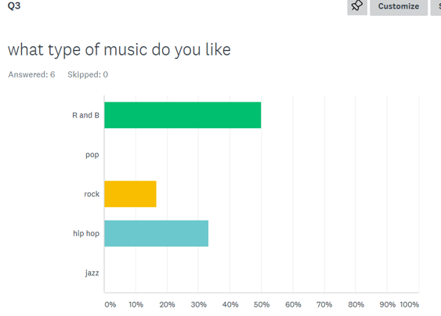
Here we can see that RnB is the most popular genre and the second most popular genre is hip hop which is followed by rock music. When making my magazine I will include the RnB genre as it is the most popular, meaning more people should read it.
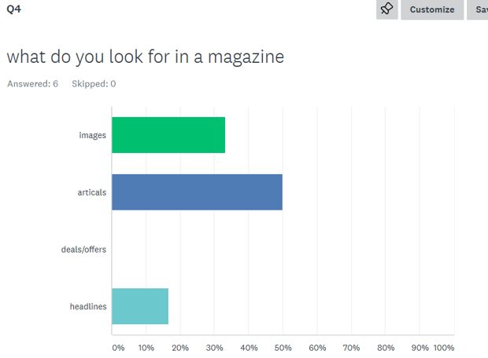
It is evident that the two most popular categories that attract people to a magazine is the images and articles. When making my magazine I will need to try and include these two features on the cover, and I won’t include and deals/offers on the cover as we can see it is not appealing to readers.
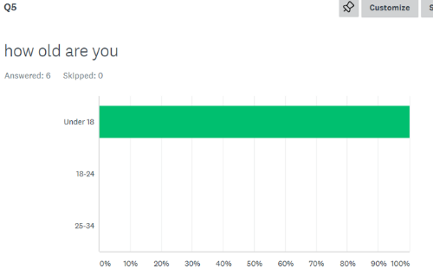
From these results we can see that everyone that took the survey were 18 and below, meaning I can target my magazine to that specific age group.
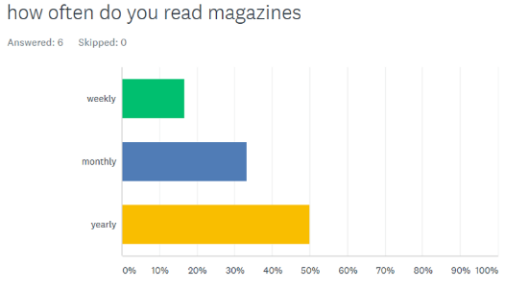
This question tells me that 50% of people only read magazines yearly and the other 50% reads magazines monthly or weekly. From this I can conduct that it will be better to release the magazine monthly to suit the different people who read magazines.
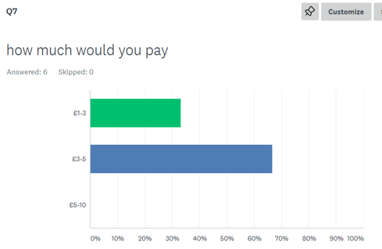
From the survey we an see that 70% of people would be willing to spend £5 maximum for a magazine and the other 30% is only willing to spend less than £3. This will a factor that will influence how much my magazine will be worth.

