Best Approach To Pick Your Ideal Cannabis Seed
In relation to gathering, standouts among probably the most energizing stuff you can gather are cannabis seeds. These questionable little beans really are a standout among probably the most hereditarily built natural products accessible cbd, presumably just marginally behind roses. The astounding characteristics plus the amount of numerous strains of seed accessible make sure they are a standout among probably the most intriguing, notable and most overwhelming accumulations to begin.
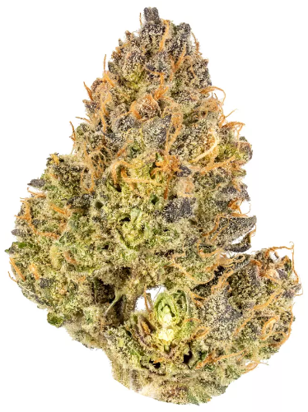
Among the journeys a couple of government bodies attempt would be to attempt and look for their ideal big bud seeds. Each diverse strain holds another arrangement of credits that will join to provide you with the perfect seed that suits your boutique cbd taste. Here's a thing that is required to be used proper care of:

This is actually the primary psychoactive part found fully grown cannabis plant. Using these full-grown plants you are able to calculate the speed of acheter du cbd obtainable in exactly the same. While THC isn't obtainable in these seeds, each strain continues to be meant to dependably generate a plant which will have this degree of THC. When you aren't, you will have to manage together with your ideal seed getting the ability to deliver certain amounts of magasin cbd.

When cannabis is grown there are lots of things you need to take proper care of. The very first factor which you should know about cannabis is it is measured in grams. If you fill it up on consistent basis it becomes simpler that you should calculate the quantity grown. When you receive a kick from the opportunity to know your seed could produce a high return this really is ascribe you might jump at the opportunity to have a gander at.

Picking Cannabis seeds for purchase isn't just concerning the essential measurements however. You discover genuinely comparable THC and yield levels on various cannabis seeds. A good approach to get this done would be to have a gander at ones which have won authentic recompenses for quality. Probably the most esteemed being the High Occasions cbd shop france Cup. Feminized seeds are presumably probably the most de rigueur at this time. Using the development of limitless cannabis seeds each year, it's been checked what one is recognized as the very best for individuals. Probably the most helpful factor you need to look for inside a pot seed may be the manner through which effectively you will get it communicated. You need to anticipate that the ideal seeds is going to be communicated for free and tactfully.

