Can laser hair removal work on darker, brown or olive skin tones?
The short answer - Yes, laser hair removal works on dark, brown and olive skin tones. It is a myth that you cannot use laser hair removal if you have darker skin tones.
A few decades ago, this may have been true. Laser hair removal was used for people with fair skin and dark hair. Back then the lasers were not able to properly distinguish hair follicles and skin pigment. This meant that for those who had dark skin, they could run the risk of burns, scarring, and discoloration.
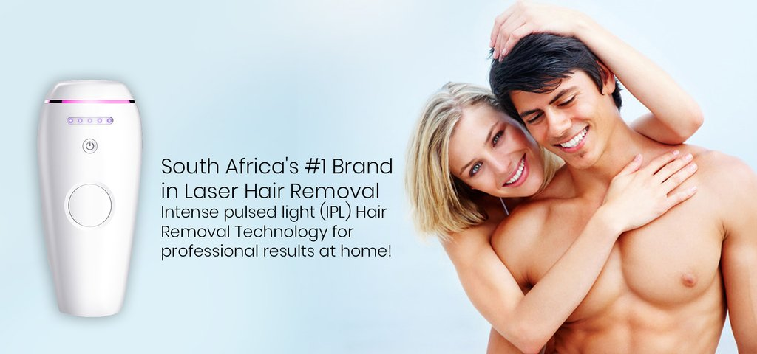
With advances in technology, this is no longer true, research and development have been done to tackle these issues and now laser hair removal can be used on everyone, if you have a dark complexion then, it may take longer, but it will work nonetheless.
Laser hair removal is a process and it will take a few sessions, it is also not the cheapest option, so it is best to ask a few questions before investing in permanent hair removal.

How does laser hair removal work?
Lasers target the hair follicle with an intense light, which causes permanent damage so the hair will no longer grow. It works by targeting the pigment in the hair, contrast between the darkness of the hair and the skin will help the laser focus on the hair follicle. This explains the misconception of why people don’t think laser hair removal works on olive or darker skin tones.
Smarter lasers have been designed and now there is a range of inclusive lasers that can be used for people of color. Two laser technologies are worth mentioning, the ND:YAG and Diode lasers. They are the preferred lasers for people with higher levels of melanin.
- The ND:YAG laser is sensitive to subtle differences in pigmentation between the skin and hair. It is suitable for any skin tone and produces one of the more powerful beams. This results in shorter sessions as few pulses are needed to complete the job. The wavelength goes deeper into the skin and offers a safe and effective option. This laser has been increasingly popular for clients with dark skin tones.
- Diode lasers are gentler, it effectively removes hair whilst ensuring maximum protection to the surrounding tissue. It works on all skin tones, but best on fair to olive skin tones. Because it is a gentler laser, it has been commented that it is a less painful procedure when compared with others.

Things to be aware of:
Choose the right laser. As mentioned already, having darker skin tones increases the risk of laser hair removal related side-effects. Both the ND:YAG and Diode lasers are highly sensitive to color and melanin so they will precisely penetrate the hair follicles without damaging your skin. Using a laser that delivers longer wavelengths would decrease these risks.

However, if you are treated with a laser that is not right for you or the wrong setting, it will not get the results you want, or even worse, you can end up with burns and damage to your skin. Dark skin tones are more sensitive than lighter skin tones, there are different lasers that are specifically designed for a range of skin tones. Don’t be shy, ask you laser practitioner if they have treated dark skin tones before, what are their experience? If you are committed to spending this much time and money to permanently remove your hair, then take some extra time to make sure you have asked all the right questions and consult a qualified practitioner.
Always ask for a test patch. As the saying goes “better safe than sorry”, there are risks of laser-related side effects, especially for dark skin. These include; hyperpigmentation, dark spots, and hypopigmentation. If this is your first time, then it would be highly suggested that you have a test patch done to see if you might be prone to these side effects.
Be patient. It takes an average of six sessions to completely remove hair growth. Laser hair removal takes time and how long it takes will depend on your skin tone and your hair type. After each session, you should be able to observe reduced hair growth. Thicker hair and darker skin tones will most likely take more sessions, this will also equate to more money spent. Remember, this is an investment and once it is over you won’t have to bother with tedious chores of shaving, waxing, or plucking. Consult your beauty technician, they will be able to break down the different lasers they have and which ones will work best and most effective on you.


Follow the pre and post-treatment advice
These guidelines are offered to help protect your skin and to make sure you gain the maximum benefits from the laser treatment.
We all know by now that the sun emits harmful UVA and UVB rays, so it is recommended that direct sun exposure is avoided for at least one month before and after treatment. It is impossible to completely avoid the sun, so please use adequate sun protection (SPF 30+)
- Bleaching, plucking, and wax is best avoided for a minimum of four to six weeks
- After each session, exercise should be avoided for 24 hours. Redness and swelling may occur and there are a few treatments to alleviate these symptoms; cool compress, aloe vera gel, soothing creams
- Skip the skin products containing harsh ingredients, especially if you are using laser to remove facial hair. Ingredients like glycolic acid, retinoids, and benzoyl peroxide can make your skin more sensitive to the lasers used and cause a negative reaction.
Laser hair removal is a great way to rid your body parts from the hair that you don’t want growing. Yes, it takes time, but it is safe and it is effective. Just make sure you ask the right questions and have a consultation with your laser practitioner. If you have a dark or olive skin tone, there no stopping you. There are lasers designed for all skin tones and hair textures.

Original article can be found at - https://www.bareskin.co.za/blogs/news/can-laser-hair-removal-work-on-darker-brown-or-olive-skin-tones

