27 Old Gloucester street. London WC1N 3AX

Inventory Report
Apartment xxx, Port East, Hertsmere Rd, London E14
Inventory Inspection date: 01/04/16 Report print date: 02/04/2016

Inventory of the contents and conditions for

Apartment E101 Port East, 18 Hertsmere Rd. E14 4AF

Inventory Inspection Date: | 01/04/16
Inventory Report Reference: | VCA- 01AL
Inventory Preparation By: | VCA property inspection
Inventory Report Compiled On Behalf Of: Landlord Ltd

Basis of reporting:
This report has been prepared on the basis that unless specifically mentioned all items inspected have been found in a good ‘Normal Use’ condition and free from defects and damage over and above normal expected defects and imperfections commensurate with our perceived age of any item. Accompanying images or video form part of the detail of this inventory and this inventories subsequent comparison at the end of the applicable tenancy
Moved Items
At the end of the tenancy relating to this inventory all items for the property listed below and or detailed in this inventories photographic or video evidence as applicable must be returned to the locations as at the date of this inventory. This includes all furniture, fittings and other movable items, especially but not limited to items stored to kitchen cupboards and worktops etc.

At the end of the tenancy relating to this inventory a charge may be payable by the tenant/s to cover any landlord costs for any time expended in searching for items that are not in the locations set out below and or detailed in this inventories photographic and or video evidence

Report Contents
Bedroom 1 .......................................................................... 3
Bathroom 1 ......................................................................... 3
Bathroom 1 Fittings .............................................................. 4
Preliminary Items ................................................................. 4
Entrance & Hallway Parts...................................................... 5
Inner Lobby ......................................................................... 5
Cloakroom ........................................................................... 6
Living Room 1 ...................................................................... 7
Kitchen ................................................................................ 8
Kitchen / Dining Room .......................................................... 9
Kitchen Units ....................................................................... 9
Utility Room ...................................................................... 10
Bedroom 1 ........................................................................ 11
Check In Comments .
Check In Declaration 13
Disclaimer 15
Basis Of Reporting 15
Report Copyright 15
Contact Details 15

Tenant’ / s Initials
Tenant / ’s Initials

Page

AREA | PART | DESCRIPTION | CONDITION
BEDROOM 1 | Built in Furniture | Built in wardrobe. | Good 'In Use' condition. Also noted a small metal safe inside
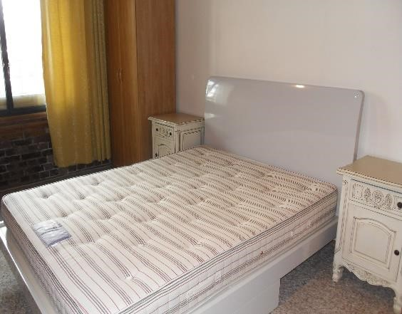  Master bed 1  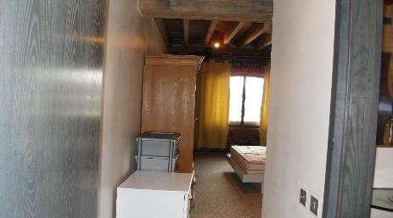  En suite passage 1 |  | 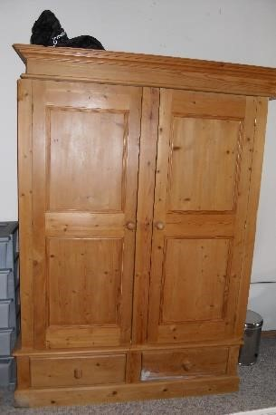  Free standing wardrobe | 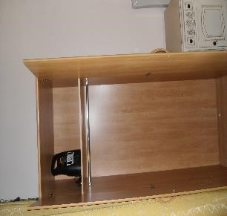  Single wardrobe  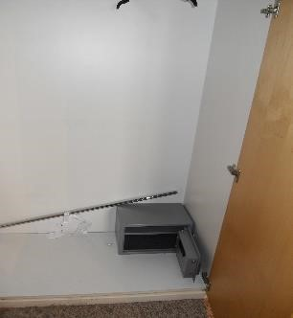  Built in wardrobe with metal safe 1
 | Free Standing  Furniture and  Accessories | Chair  Wooden framed bed  Double mattress  Chest of drawers  Bedside cabinet Free standing single wardrobe  Free standing double  wardrobe  -. | Reasonable 'Far In Use' condition.
BATHROOM 1 | Ceiling | Same description as in the hallway | Previous dried water ingress probably caused by leak from flat above noted on a section of ceiling
 | Ceiling Fittings | One spot light not working

AREA | PART | DESCRIPTION | CONDITION
BATHROOM 1 | Walls | Painted in magnolia  emulsion  Tiled. | Reasonable 'Far In Use' condition.
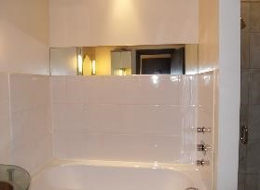  En suite bath area | 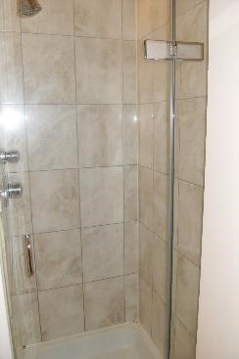  Shower enclosure | 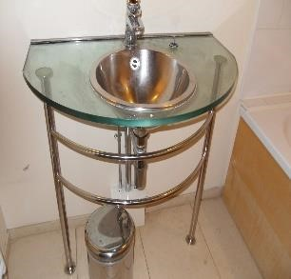  Hand basin | 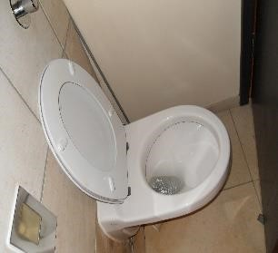  WC
BATHROOM 1  FITTINGS | WC | White porcelain close coupled suite with chrome flush handle, white plastic seat and lid. | Good 'In Use' condition.
 | Shower  installation | White porcelain, with  chrome taps and waste  fittings  -. | Good 'In Use' condition.
 | Wash Basin | Contemporary steel with glass surrounds, mixer tap, mirror and each side of mirror has light fittings | No damage noted
 | Bath | Mixer tap block with hose and shower head. | All controls working
PRELIMINARY  ITEMS | Gas Meter Reading | Could not be located | NA
 | Electricity Meter Reading | Could not be located | NA
 | Water Meter Reading | Could not be located | NA

AREA | PART | DESCRIPTION | CONDITION
 | P.A.T Test Label | Could not be determined
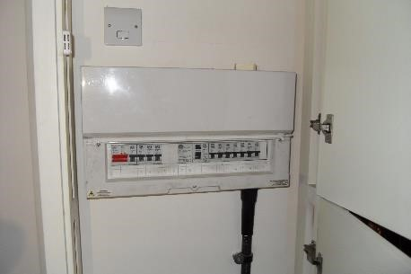  Fuse board |  | Fuse board 2 | 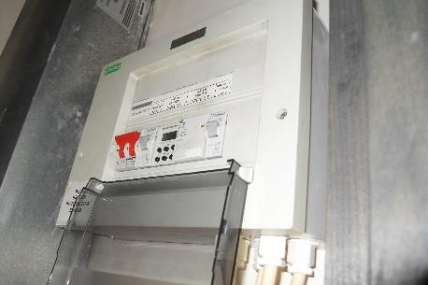
 | Gas Safety  Certification Seen | Could not be determined | We assume no gas appliances in the apartment
ENTRANCE &  HALLWAY PARTS | External Door and  Frame | Dark oak veneer solid door  Metal lever handle  Letter box plate  House number numerals  ‘Yale’ style with cylinder lock and internal rim  housing letter box flap. | No damage or defects noted.  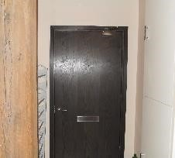  Hallway entrance internal
INNER LOBBY | Ceiling | Natural wooded timber beams supporting panelled timbers | Dried water Ingress noted on the wooden ceiling adjacent to the smoke alarm
 | Ceiling Lighting | Three spot lights | Two spots not working
 | Walls | Painted in magnolia emulsion. | Good 'In Use' condition.

AREA | PART | DESCRIPTION | CONDITION
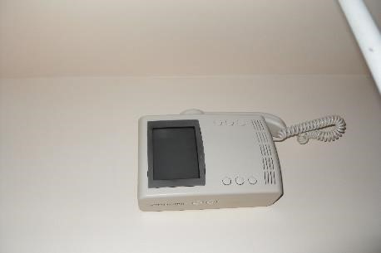  Intercom | 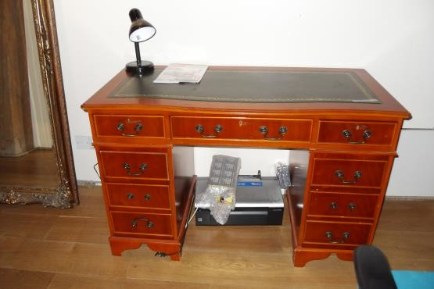  Desk |  | 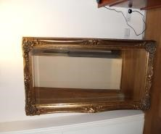  Framed Mirror  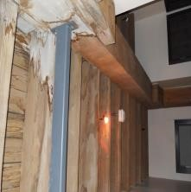  Ceiling 1
 | Wall Furnishings and Fixings | Intercom phone near the entry door | Appear to be working but not tested
 | Free Standing  Furniture and  Accessories | Armchair. | Clean without stains
 |  | Colonial pedestal desk with green patterned fitted mat which I presumed to be leather and a black table lamp | Good 'In Use' condition
 |  | Extra large French vintage traditional framed mirror | Colour - gold and no scratches noted
 | Other | unidentified item that look like a somewhat free standing rack | situated by the entry door leaning against wall by intercom entry phone
CLOAKROOM | Door Internal Side | Dark oak veneer solid door | Stainless steel door handle and latch
 | Ceiling | smooth finished painted white with wooden beams forming as moulding around | Good 'In Use' condition

AREA | PART | DESCRIPTION | CONDITION
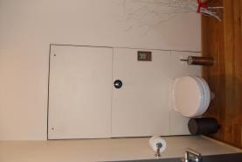  WC 1 | Stained wall 1 | 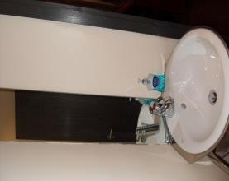  Hand basin 1 | 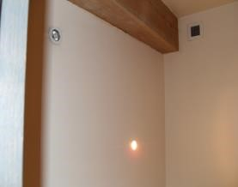  Ceiling 1
 | Ceiling Lighting | 2 x spotlights | One spot light is out
 | Walls | Painted in magnolia emulsion. | section of wall adjacent to towel rail has scuffs that seem to be caused by cleaning
 | Flooring | Wood strip and matching wooden skirting | No marks, damage or defects noted on the floor. Some section of skirting require sealing at the top edge
 | Other | Extractor | Good 'In Use' Condition
 |  | Free standing WC | Good 'In Use' condition
 |  | Hand basin with mixer tap and mirror back splash | Good 'In Use' condition
LIVING ROOM 1 | Ceiling | Natural wooden timber beams supporting timber  panels | Good 'In use' Condition
 | Ceiling Lighting | Four spots but one not working | Good 'In use' Condition

AREA | PART | DESCRIPTION | CONDITION
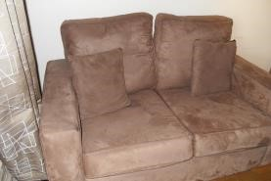  Settee 1  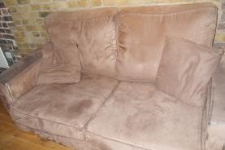  Settee 2 | 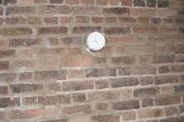  Wall clock  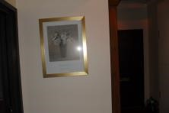  Picture frame 1 | 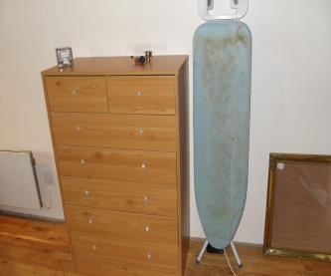  Free standing Items | 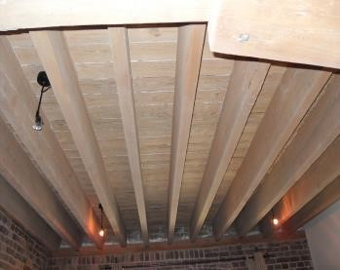  Ceiling
 | Walls | Left hand side of wall facing the window has original brick finish but the opposite wall is smooth finish painted in magnolia emulsion. The middle wall where the window is located has brick finish | Good 'In use Condition
 | Windows | Clear glazed with metal frame and handle  Double window installation. | No damage or defects noted - Openings operate with ease.
 | Window Dressings | CURTAINS  Wooden curtain pole with matching finials  Unlined fabric curtains. | Good 'In Use' condition.
 | Flooring | Wood strip. | Reasonable 'Far In Use' condition.
 | Heating | Electric radiator, wall mounted x 2 | Not tested
 | Free Standing  Furniture and  Accessories | Sofa  Settee  Nest of occasional tables  Coffee table  Dining table  Chest of drawers Faux suede. | Reasonable 'Far In Use' condition.
KITCHEN | Walls | Painted in magnolia emulsion. | Good 'In Use' condition.

AREA | PART | DESCRIPTION | CONDITION
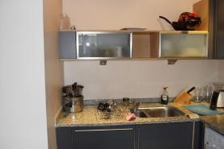  LH side of kitchen 1 | 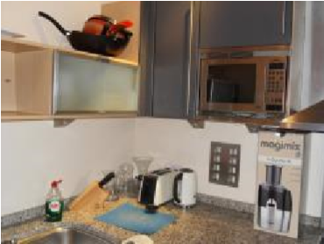  Middle section 1 | 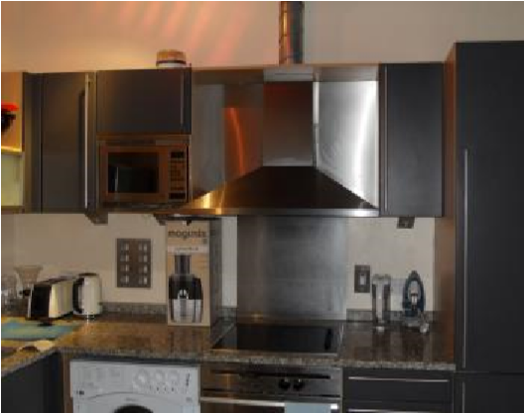  RH side of kitchen 1 | 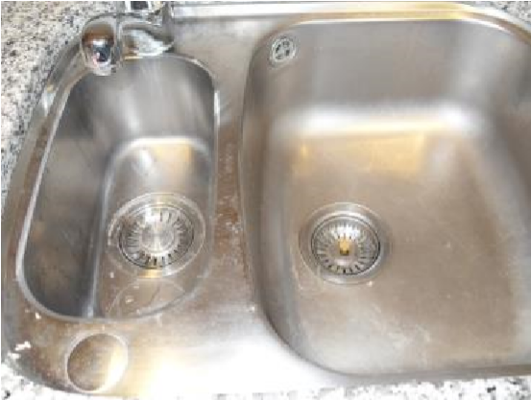  Sink 1
KITCHEN | Flooring | Wood strip. | Reasonable 'In Use' condition - No marks, damage or defects noted.
 | Other | Please we did not take record of utensils, pans and sauce pan | NA
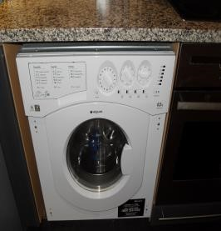  Washer dryer 1 | 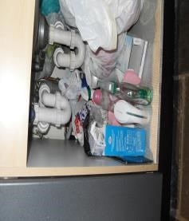  Base unit 1 | 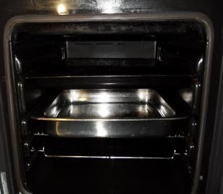  Oven 1 | 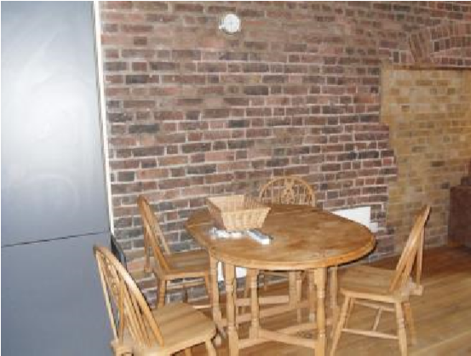  Dining area 1
KITCHEN /  DINING ROOM | Ceiling | Natural wooden timber beams supporting timber  panels | Good 'In use' Condition
 | Ceiling Lighting | Three spot light but only two works | Good 'In use' Condition
 | Free Standing  Furniture and  Accessories | Chair  Dining table. | presumed pine
KITCHEN UNITS | Kitchen  Installation  Description | Contemporary style Modern. | Good 'In Use' condition.
 | Worktop | Presume Granite. | No damage or defects noted  - Clean.

AREA | PART | DESCRIPTION | CONDITION
 | Sink | Mixer tap set  One and a half bowl sink  and drainer Steel. | Good 'In Use' condition - No damage or defects noted - Clean.
 | Fridge/Freezer | Tall and integrated to match unit doors | Not tested
 | Washer/Dryer | Integrated | NT (not tested
 | Dishwasher | Integrated | NT
 | Microwave | Integrated | NT
 | Cooker-Oven | Integrated. | Not tested
 |  | Integrated - electric | NT
 | Cooker-Hob | Integrated - electric | NT
 | Cooker Extractor Hood | Integrated - Steel back splash | NT
UTILITY ROOM | Door Internal Side | Matching outside including fittings  Metal lever handle. | Matching other doors - Good 'In use' Condition
 | Ceiling Lighting | lighting not working
AREA | PART | DESCRIPTION | CONDITION
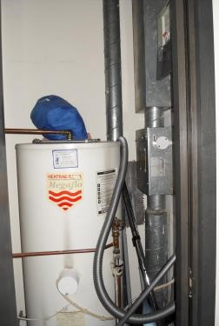  Megaflow cylinder 1 | Heating | Mega flow water cylinder with unidentified blue bag sitting on top | Presumed working
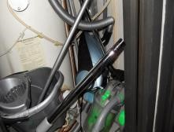  Vacuum cleaners x 2 1 | Other | 1x Dyson vacuum + 1 unidentified vacuum | Not tested
BEDROOM 1 | Ceiling | Same description as in the bathroom
 | Ceiling Lighting | All spots working
 | Walls | Wall were window is located has brick finish | Good 'In use' condition
 |  | Painted in magnolia emulsion. | Good 'In Use' condition.
 | Window Dressings | -  Wooden curtain pole with matching finials  Unlined fabric curtains. | Good 'In Use' condition.
 | Flooring | Herring bone pattern. | No marks, damage or defects noted.
 | Heating | Electric radiator Wall mounted. | Not tested
VCA Property Inspection Services

CHECK IN DECLARATION
I the tenant hereby acknowledge receipt of this inventory and accept the contents and condition of the property to be as set out in this inventory.
I the tenant further hereby acknowledge accept and understand that I have seven days in which to make a closer and more thorough inspection of the property and confirm in writing any comments or amendments to this inventory on the check In comments section of this document and return this inventory to the landlord or their agent.
I further acknowledge accept and agree that unless I make any such written amendments or comments and return this document to the landlord or their agent within seven days of the date of my receipt of this document this inventory document will be the definitive basis of comparison of the contents and condition of the property at the time of the end of tenancy howsoever occasioned.
I further accept acknowledge and agree that this check in declaration applies to tenant in the singular or tenants in the plural as applicable to the tenancy agreement this inventory relates to.
Sign & Print all Names *
Tenant / s

Landlord / Landlords’ Agent.

Check In Date:

Keys List at Check In:

DISCLAIMER
This inventory has been prepared to provide a written recording of the contents of the property as well as the condition of the contents and the decorative condition of the areas and spaces to the extent of the instructing principals’ instructions. The accuracy of this report is subject to the agreement of the tenant and landlord or their respective agents. This report has been compiled by a person who is not a qualified buildings surveyor or health and safety expert or qualified to offer legal advice of a landlord or tenants obligations. Neither is the person compiling this report an expert on any materials that may be found and described in the property including but not limited to woods, fabrics and antiques. This inventory is not to be used as a definitive and accurate description of each and every piece of equipment and furniture in the property or as any type of report such as a property survey or structural survey. Any property in lofts garages and cellars that are not included in this inventory are the sole responsibility of the landlord. This inventory is not a statement that any item or materials described complies with any regulations. All statements as to safety labels must be checked for validity by the recipient / s of this inventory. Our services are subject to the terms and conditions published on our website at www.activeinventories.co.uk.

BASIS OF REPORTING
This report has been prepared on the basis as set out earlier in this report.

REPORT COPYRIGHT
© VCA Property Inspection Services

Contact Details
VCA Property Inspection Services
27 Old Gloucester Street, London WC1N 3AX www.vcapropertyinspection.co.uk
07399 954464
victor@vcapropertyinspection.co.uk

Tenant’ / s Initials
Tenant / ’s Initials

Page

