A Synopsis Of Regina Web Design

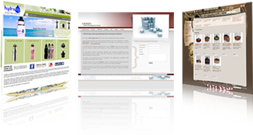
The majority of people create some major mistakes as a way to make their web design innovative. This-not only damages their future prospects but, also their past clients. Therefore, what're these mistakes and how to prevent them? Here is the great place for all the people that wish to make their web site design creative but, fail to do this. Given forward are several easy tips that can help you creating your website excellent. For obtaining the information and facts about Regina web design, it is best to More Information. We've included not only the aspects of layout but additionally the issues linked to workflow. Simply follow them to obtain a professional web layout. Take the initial and the foremost move that's copying down the items you have in your head regarding the layout.
You can begin by illustrating preliminary diagrams of illustrations. This is really a very essential and basic step yet, the majority of the designers avoid carrying it out and get straight-ahead to work through the ideas. The purpose of Regina web design will be to resolve problems. And you can't resolve these difficulties with the aid of gradients or shadows. Quite simply, a superb format should have a clear structure. So, we'll counsel you to take it slow and think. Before starting, assure the data is proper and the format is perfect. Then you can move onto to putting innovative effects. Next, begin with illustrating a platform of top level. What is a platform? A framework is UI that envelops the data. It assists in taking measures and steering through them. The points involved in framework will be the navigation, sidebars and bottom bars.
This way of making Regina web design will allow you to in understanding the design requirements. It will also enable you in developing more pages simply. In the end just put in a grid inside your website design. This is a quite simple and straightforward move equally as the name suggests. Before starting to make anything in Photoshop, you wish a suitable grid to get going on with. You will find no legitimate explanations for beginning with out a grid. We assure you that should you skip this, it'll really affect the look of the web design. A grid will help you to construct the format of the many pieces. Creating a grid can help you will get an ideal measurement of display, produce receptive templates, steady spacing in material, and cope with other related issues.

