CHAPTER-7
ANTIQUE FURNITURE IDENTIFICATION

Styles, Periods & Design History
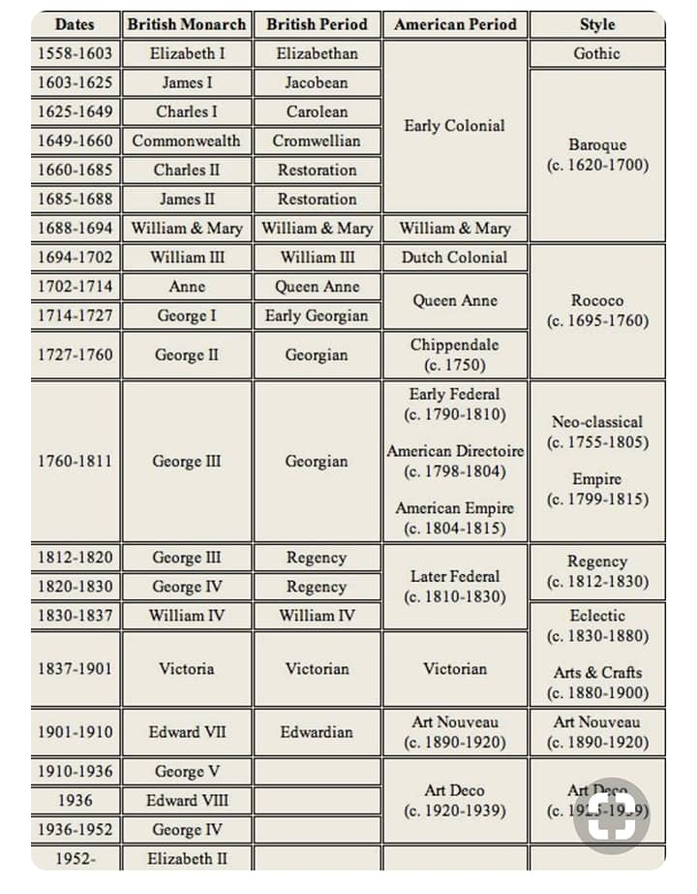
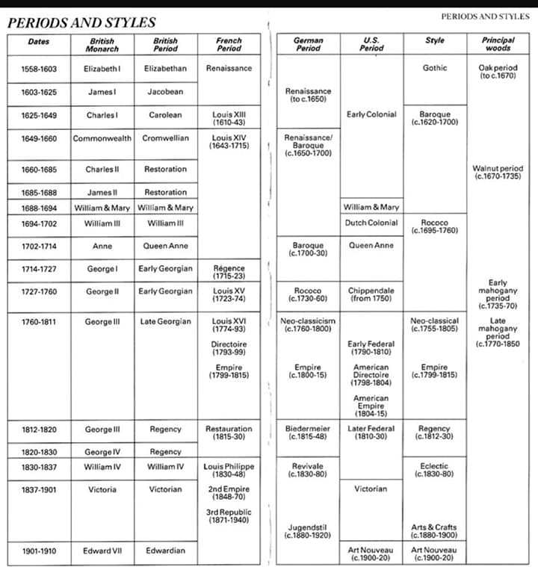
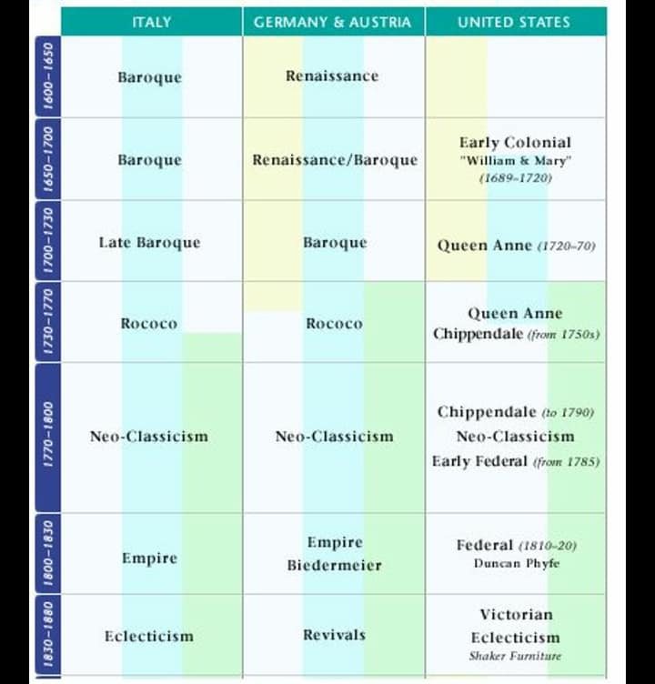

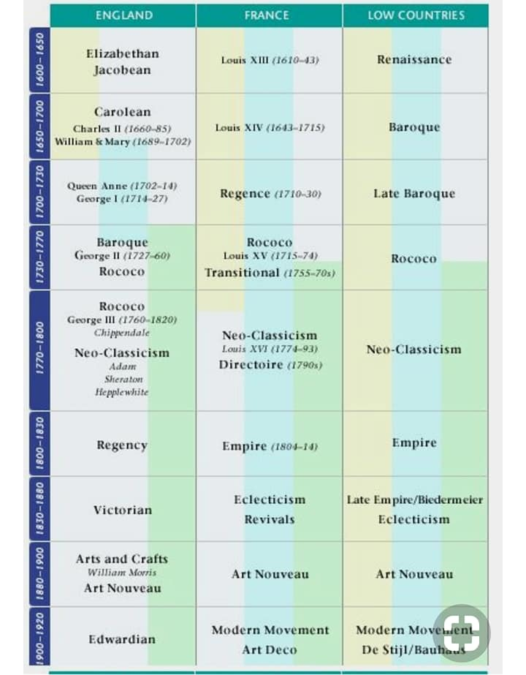

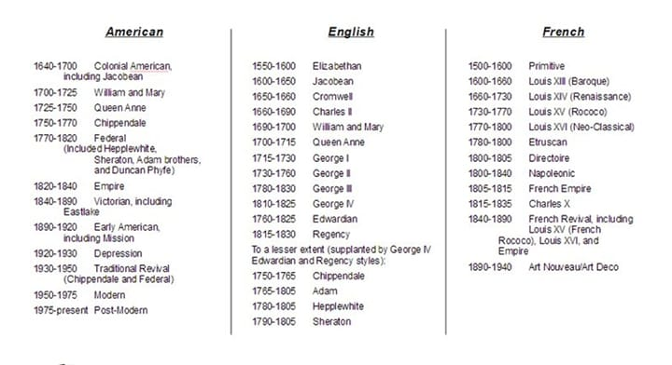
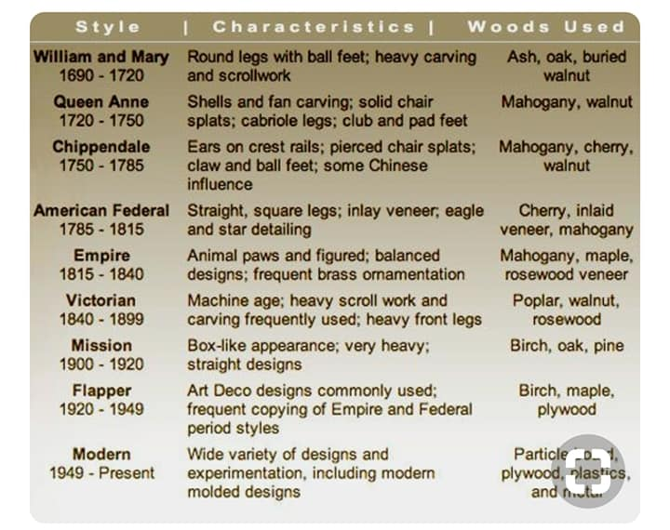

I. Ancient Furniture History
A. Ancient Egyptian Furniture
Ancient Egypt
The ancient Egyptians formed the first of the great classical civilizations. While most of Europe was still in the Stone Age, the Egyptians were building palaces, studying mathematics and writing on papyrus. They were great builders and great artists, drawing the inspiration for their art from nature. A complex social and religious structure was in place. The Egyptians kept books of accounts and recorded history; their children played with carved wooden toys with moving parts.
Egypt was eventually conquered by Alexander the Great, and later by the Romans. Both the Greek and Roman conquerors were significantly influenced by Egyptian culture, art and philosophy, so that to some extent it was a case of the conquerors being civilized by the conquered.
Ancient Egypt Antique Furniture
Egyptian antique furniture provides almost the only surviving examples of actual ancient furniture. Egyptians believed that possessions could still be used in the afterlife, and items of furniture were buried with the dead in sealed tombs. In the hot, dry climate of Egypt, many items were preserved through the centuries to become fascinating and valuable museum pieces today. In some cases, the wooden furniture itself had rotted away, but it was possible to recreate it from the gold sheaths that decorated the original pieces.
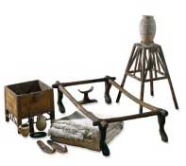
Old Kingdom
Very little Old Kingdom furniture has survived and hence we must resort to wall paintings to gain pictures of it. What can be seen is that furniture from this period was divided into two groups: platform pieces such as benches, chairs, tables, beds, couches, and stools;, and boxes such as chests and cupboards.
While there was some surface ornamentation in the form of gilding and carving most Old Kingdom furniture relied on shape, line, proportion, and texture for its decorative effect. Thrones and chairs featured carved lion-paw feet, beds were decorated with animal skins and colorful mats, giving us a clue to the importance that the ancient Egyptians placed on decoration, as well as comfort.
The presence of stools, chests, footrests, small cabinets, small tables, and even vase stands, points to a fairly high level of organisation in living arrangements, even at this early stage in the development of Egyptian culture. Four legged stools with animal shaped legs amd sturdy square seats made from concave wood or woven or braided rushes were important items of the time.
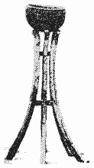
Vase on a Stand
Later, in the second half of the Old Kingdom, chairs with arms and backs began appearing. Large size tables were rare. Egyptian furniture designs of this age often incorporated metal work. Also inlay was increasingly used, as well as relief carving, and gilding.
Middle Kingdom
The Middle Kingdom saw further development of earlier trends, with a marked sophistication evident. Decorative effects such as inlay, paint, gilt, and veneer became more prominent. Popular design motifs included figures of sacred animals such as cow heads, lion heads, and hippopotamuses.
New Kingdom
The Empire, or New Kingdom period, 1570 B.C to 1085 B.C, witnessed the growth of magnificent cities such as Thebes, with their grand temples, palaces, and tombs. Naturally the furniture produced during this period is on a similarly luxurious scale, and is also evidence of greater woodworkingskill.
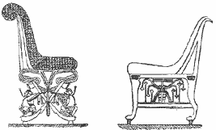
The New Kingdom saw the Egyptians extend their empire to new lands from Nubia to the Euphrates River and this contact with foreign cultures seems to have had its effect on furnishings. In wealthy Egyptian homes chairs appear in greater abundance. Folding stools were richly painted in bright colors. Small, low tables were often woven from rush.
Tutankhamun
The discovery of the tomb of King Tutankhamun in 1922 opened the world's eyes to some of the richness and elaborateness of ancient Egypt furniture. Reflecting the great wealth of King "Tut" the furniture to be found among his possessions was of an unprecedented grandeur. The dry Egyptian climate preserved for centuries wooden frame chairs and couches decorated with open relief carvings, and inlays and overlays of precious metals. Three dimensional carving adorned ivory headrests, small chests, used for storing clothes and household items, were also extravagantly finished.
Chairs
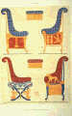
Egyptian Chairs
Egyptian style furniture of the noble and upper classes spared neither cost nor craftsman's effort. Gold sheathing, ivory inlays, intricate marquetry, inset jewels and fine stones were used to decorate ancient furniture that was often carved to represent animal forms. Chairs sometimes had feet in the shape of lion's paws or crocodile feet; legs and feet were sometimes carved to simulate the legs of a gazelle. Egyptian furniture design commonly incorporated carvings of flowers, animals or birds.
Stools
Stools were the most common items of furniture in Egyptian homes, and it was the Egyptians who invented the folding stool. Since these were much used by army commanders in the field, they became a status symbol, and were often heavily carved and decorated. High backed chairs are seen in many paintings. These were supplemented with cushions for comfort. Both stools and chairs commonly had woven rush seats, which have long since disintegrated.
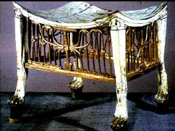
Egyptian Stool, Ebony Inlaid with Ivory.
Beds, Headrests
Beds almost always had carved animal-like legs with hooves or paws. They were gently inclined so that the sleeper's head was elevated, and had a footrest. The wooden Egyptian headrests were probably covered with a cushion or other soft material. Chests, boxes and cabinets formed an important part of Egyptian bedroom furnishings. These were highly decorated and were designed for many different purposes: large chests for storing household items and linen, small compartmentalized ones for storing cosmetics, and miniature chests with sliding lids and drawers made to hold jewelry.
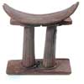
Egyptian Headrest
Tables
Tables were also an important item of Egyptian furniture. They were used for eating, writing and playing games. They were usually low and easily moveable. In many cases, the tops were decorated with marquetry or with inlaid ivory. Carved legs, gold sheathing and ivory inlays were used to decorate table legs.
Home Decor
Egyptian home decor was very elaborate. Colored ceilings, wall paintings, carvings, hangings, inscriptions and tiled floors were the background to ornate furniture and ornaments. Gold, blue, black, red and orange were popular colors in Egyptian room decor. Egyptian temple decor was even more elaborate, with rich furnishings and hangings, jeweled ornaments and heavy inscriptions.
Egyptian Revival Furniture
In the early 19th century, Napoleon carried out several military campaigns in Egypt. He was fascinated by ancient Egyptian designs and Egyptian decor. Egyptian Revival furniture and Egyptian Revival home decor became extremely popular in France, called Empire furniture, and this fashion quickly spread to the rest of Europe as well as to England, Regency furniture, and America, American Empire. This began the Neoclassical era in furniture design.
The current interest in Egyptology and pyramid theories has again popularized Egyptian fashion and decor. Egyptian themed furniture is attractive and fun, and the atmosphere of mystery and antiquity can be accentuated with Egyptian ornaments, carvings, hieroglyphics and pyramids. Egyptian revival furniture antiques from the Neoclassical era are both valuable and beautiful, and are the ideal starting points for room decor Egyptian theme. We have put together some shopping ideas for Egyptian decor and buying Egyptian style furniture to help out in this area.

B.Ancient Greek Furniture
Ancient Greece
Greek culture can be said to have begun with the Bronze Age civilization of the Minoans in Crete. The Minoans built vast palaces, and were skilled in metalwork, pottery, artwork and the crafting of jewelry. Civilization on the Greek mainland followed closely behind that of Crete, and Greece soon became the cultural center of the ancient world. Ancient Greek civilization was at its zenith during the Classical era, from 499 BC to 79 BC.
The early Greeks were encouraged to be great thinkers and philosophers. Their scientists and mathematicians laid the groundwork that made today's scientific discoveries possible. They loved to gather together to discuss concepts, ideas, religion and politics, spending much time in the agora (marketplace) in conversation and argument. Ancient Greeks were great lovers of beauty, art,
History
The Greek history of furniture can be traced back to the heritage of Egyptian furniture. The earliest Greek civilizations borrowed styles and ideas from Egypt, but by the Classical era, designs had subtly changed to a style that was uniquely Greek. Lines became softer, much use was made of subtle and elegant curves, and more attention was given to comfort. Although almost no furniture has survived the centuries, Greek artwork such as pottery decorations and friezes depict daily Greek life in Greek homes, and this has given us an accurate idea of early Greek furniture designs.
Styles
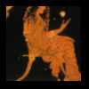
Chair Scene.
Greek furniture styles were simple, elegant and tasteful. Although carving and inlays were used, furniture was not over-decorated. Houses were not cluttered with much furniture, and household items were made for use and comfort rather than decoration. However, the Greek love of beauty and art extended to furniture design, and the few simple items of furniture in an early Greek household were often works of art in their own right.
Couches – Klines
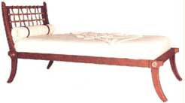
The andron was furnished with reclining couches;
Greek Klinethe Greeks followed the Eastern tradition of lying down to eat. These couches, known as klines, had a headboard that could be used as a backrest while sitting, and were elegantly upholstered. They could be made entirely of wood, but often had bronze legs cast in animal styles. The klines would be placed around the walls, and small tables would be placed next to them to hold the food and drink.
Stools & Chairs
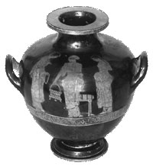
Stool with a woven cushion.
Both fixed and folding stools were popular from early times. Later these evolved into chairs for everyday use; previously chairs were only used for ceremonial occasions. Greek classical chairs had curved backs and legs, and were often elegantly upholstered.
literature and drama, and enjoyed listening to stories, fables and legends.
Chests
Cupboards and shelves were unknown. Various types and sizes of chests were used for storage.
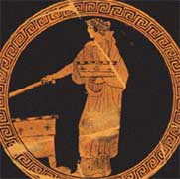
These were usually decorated, perhaps painted with a
Greek Chest Picturefrieze of leaves and flowers. Chests were prized pieces of furniture, and would often be passed down from one generation to another.
Greek Revival
Greek classical furniture was the inspiration for the designers of the late 18th and early 19th centuries. Archaeological finds fired the imagination of the world, and the simple, elegant lines of ancient Greek's furniture inspired the cabinet makers of the day to move away from earlier, heavier and more ornate styles to imitate ancient Greek and Roman designs. This gave rise to the Neoclassical style of furniture, which is much sought after by antique collectors of today. Early Greek furniture design has influenced the world of interior decorating, just as surely as early Greek thinking has left its mark on the world of science and technology. Our section on Greek decor & furniture will give you some ideas on shopping for greek inspired furniture.
Ancient Greece Furniture

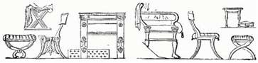
Greek Furniture Pictures
C. Ancient Roman Furniture
Ancient Rome
The Republic of Rome, later known as the Roman Empire, can truly be said to be the birthplace of our modern civilization. Most legal systems today are based on Roman law; Roman art, sculpture and literature are still enjoyed to this day, and most European languages are based on Latin. The Roman genius for building and holding together an empire brought an orderly system of government to lands far and wide, creating a world where artists, craftsmen, designers and scientists could exercise their talents in peace and prosperity.
Empire
The focal point of a vast empire, Rome quickly became a city of great wealth and prosperity. With trade routes opening up, and Roman legions on hand to protect them, anyone with a good head for business could become fabulously rich. An upper class of rich merchants and important legislators soon sprung up, so that elaborate tastes in architecture and decor could be indulged to the full. Roman empire houses and furniture designs have greatly influenced our own lifestyles.
Wealthy Romans were interested in politics and political intrigues; they were also great patrons of the arts. The Romans had a taste for drunken debauchery alongside which the modern permissive society pales into insignificance. This lifestyle eventually eroded the empire from within, so that when Rome was eventually attacked by hordes of barbarians, the invaders met with little resistance, and the great Imperial Empire effectively died.
Ancient Rome Furniture
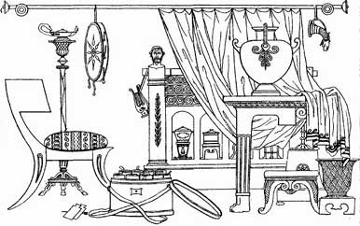
Roman Furniture
Furniture in Roman houses tended to be sparse, since the occupants liked space and simplicity in their decor. Beauty was created by mosaics, frescos and water features and other features of Roman interiors rather than by use of elaborate furnishings. However, the few items of Roman Empire furniture were elegant and costly, using excellent materials and craftsmanship. Pictures of ancient Roman furniture painted on frescos and other artworks, together with the few pieces still in existence today, have made it possible to reconstruct with accuracy the furniture in Roman times.
Much furniture that we take for granted was entirely unknown to the Romans. No mirrors hung on their walls. They had no desks or writing tables, no dressers or chiffoniers, no glass door curio cabinets for the display of bric a brac, tableware, or books, no mantles, no hat racks. The main items of Roman furniture found in the best houses were couches or beds ( lectus ), chairs and stools, tables and lamps. Adding chests or wooden cabinets with doors, an occasional brazier, and still seldomer, a water clock, we have assembled everything that can be called furniture, except perhaps for tableware and kitchen utensils.
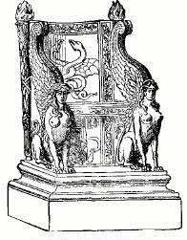
Roman State Chair.
However this does not mean that Roman furnshings were dull and dreary. If we take into account the decorations, the showy display of the atrium, and the singular beauty of the peristylium, it is clear that the Romans put importance on a very few exquisite and expensive pieces rather than attempting to fill up rooms with just this and that.
Roman Revival
Roman and Greek ancient furniture was the inspiration for the classical revival of the 18th and 19th centuries, giving rise to the attractive neoclassical designs of that time. Roman furniture history is the history of the empire itself - initially copying the ideas of the Greeks and from Egyptian furniturestyle, the Romans began to improve on and adapt what they had learnt, creating a style of architecture and furniture distinctive to this, the greatest of empires. Look here for some Roman decor & furniture ideas.
Ancient Roman Chairs & Stools
Houses in Ancient Rome made use of various types of chairs. Stools, folding stools and benches were commonly used, but later these began to evolve into proper chairs.
Stools
The early form of chair among the Roman and other ancient civilisations, the sedile, was the backless stool or bench with four perpendicular legs. The stool, or sella, was the regular seat for a person, used by men and women resting or working, and by children and slaves at their meals as well.
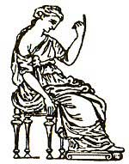
Roman Stool Picture
The bench, or subsellium, differed from the stool only in that it could seat more than one person. It was used by senators in the curia, by jurors in the courts, and by boys in school, as well as in private houses. A special form of the sella was the famous curule chair (sella curulis), which had curved ivory legs. The curule chair folded up like a camp stool to make it portable and had straps across the top to support the cushion which formed the seat.
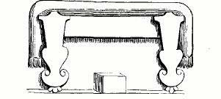
Roman Bench.
Solium
The solium - an upright, high-backed chair with solid arms was used by the master of the house when receiving business visitors in the atrium, was the first improvement upon the primitive sella. The solium looked like it had been cut from a single block of wood and was so high that a footstool was needed to reach it as with the lectus.
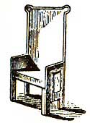
Roman Solium
Cathedra
Later, the cathedra became popular. This was a more comfortable chair, without arms, and with a curved back, and it was often used by lecturers in the Schools of Rhetoric. This gave rise to the term 'ex-cathedra' for an authoritative statement - in other words, 'from the lecturer's chair.' The cathedra supina was a similar chair with the back set at an angle more suitable for relaxing comfortably.
Neither the solium nor the cathedra was upholstered, but cushions and coverings were used with them both as with the lectus, and they allowed similar opportunities for skillful workmanhp and lavish decoration.
Ancient Roman Interiors & Decoration
Roman houses were small and quite simple without much in the way of interior decoration until the final century of the Roman Republic. The outside of the house was usually severely plain; the walls were merely covered with stucco. The interior was decorated to suit the tastes and means of the owner; not even the poorer houses lacked charming effects.
Interior Wall Decoration
At first the stucco finished walls were simply marked off into panels of rectangle shape, painted in deep and rich colors with red and yellow predominating. Then in the middle of these panels simple centerpieces were painted, and the whole was surrounded with brilliant arabesques. Then came elaborate pictures, figures, interiors, landscapes, etc., of large size and skillfully done, painted directly upon the wall. A little later the walls began to be covered with panels of thin slabs of marble with a baseboard and cornice. Beautiful effects were produced by the combination of marbles of different tints, since the Romans ransacked the world for striking colors. Later still came raised figures of stucco work, enriched with gold and colors, and mosaic work, chiefly of minute pieces of colored glass, having a jewel like effect.
Doors

Mosaic Door Threshold.
Roman doors and doorways gave opportunities for equally artistic treatment. Doors were elaborately paneled and carved, or were plated with bronze, or made of solid bronze. The threshold was often of mosaic as in the picture above. The postes were sheathed with marble ordinarily carved in elaborate designs, as in the picture below.
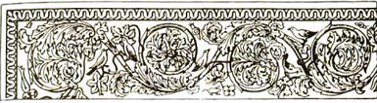
Carved Roman Doorway.
Floors
The floors were covered with marble tiles arranged in geometrical figures with contrasting colors, similar to now in public buildings, or with mosaic pictures only less beautiful than those upon the walls. The most famous of these, "Darius at the Battle of Issus," measures sixteen feet by eight, but despite its size has no less than one hundred and fifty separate pieces to each square inch. Roman ceilings were often barrel vaulted and painted in bright colors, or divided into deeply sunk panels, by heavy intersecting beams of wood or marble, and then decorated in the most elaborate manner with raised stucco work, or gold or ivory, or with bronze plates heavily gilded.

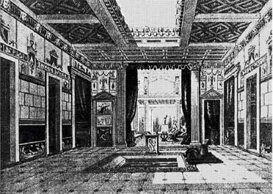
Roman Interior.
Ancient Roman Lamps & Lighting
Roman lamps, or lucerna, were relatively simple items, simply a vessel that held olive oil or melted grease with threads twisted loosely together for a wick or wicks, drawn out through one or more holes in the cover or top as in the picture below. Usually there was a special hole through which the lamp was filled. The light given by such Roman lamps and lanterns would likely have been fairly unclear and dim. There was no glass to keep the flame steady and there was never a chimney or central draft.
As works of interior and decorative art such lamps were often quite beautiful though. Even lamps made of cheap materials were often of graceful form and proportions, while lighting of expensive material was given the full treatment by artists and such lamps as these would likely have had far greater value compared to the rare stones or precious metals out of which they were made.
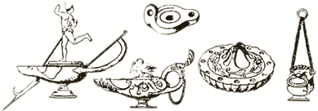
Roman Lamps.
Some of these lamps, as in the picture above, were meant to be carried in the hand like lanterns, as shown by the handles, while others were to be suspended from the ceiling by hanging chains. Other lamps were kept on tables expressly made for them, as the monopodia commonly used in Roman bedrooms, or the tripod shown in the picture below.
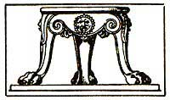
Lamp Base.
For the lighting of public rooms there were also, tall stands, like those of modern floor lamps, as seen in the picture. On some of these, several lamps were placed or hung at once and some of the stands were adjustable in height. The name of these lamp stands (candelabra) shows that they were originally intended to hold wax or tallow candles (candelae) and the fact that these candles were supplanted in the houses of the rich by the smoking and fould smelling lamp is good proof that the Romans were not skilled in the art of candle making.
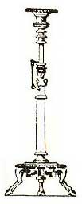
Candelabra
Finally, torches (faces) of dry, inflammable wood, often soaked in oil or smeared with pitch, were kept near to the outer door for use on the unlit night streets.
Ancient Roman Lectus, Couch, Bed
The lectus, or couch, or bed, was perhaps the most important item of Roman style furniture. Used for sleeping, sitting, relaxing or eating, the lectus was a wooden frame supporting criss crossed leather straps that held a matress stuffed, originally with straw, and later with wool or feathers.
At one end there was an arm, as in modern sofas; sometimes there was an arm at each end, and a back as well. The back was likely a Roman addition to the ordinary form of the ancient couch.
It had a headboard, and was furnished with pillows, cushions and a coverlet. The legs were often highly decorated and inlaid or plated with tortoise-shell, ivory, or the precious metals. Mention is made even of frames of solid silver. The coverings were often made of the finest fabrics, dyed in the most brilliant colors, and worked with figures of gold. Primarily used for relaxing and socializing in the living areas, the lectus also formed the basis of Roman style bedroom furniture.
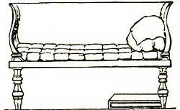
Roman Lectus
In some of the bedrooms of Pompeii the frame seems to be missing ; when like this the mattress was laid on a support built up from the floor. The couches used as sleeping beds seem to have been larger than those used as sofas, and they were so high that stools or even steps were necessary to reach them.
As a sofa the Roman lectus was used in Roman libraries for reading and writing; the student supported himself on his left arm and held the book or writing with the right hand. In Roman dining rooms the lectus had a permanent place.
Roman Tables or Mensa
Roman home decor made much more use of tables (mensa) than Greek decor; in fact, there were tables to suit every purpose. Tables were specially designed to hold lamps or ornaments, and many tricliniumscontained a large inbuilt center dining table made possibly of concrete, with a polished stone or mosaic top. Tables were often elaborately carved and decorated, and could be round or square depending on their purpose. Some also had adjustable legs, so that the height could be altered. The table gave a better opportunity than even couches or chairs for artistic workmanship, especially in the matter of carving and inlaying the legs and top.
All manner of materials were used for table supports and tops: stone wood, solid or veneered, precious metals, probably in thin plates only. The most expensive were the round tables made from cross sections of the citrus tree. The wood was beautifully marked and single pieces could be ordered from three to four feet in diameter.
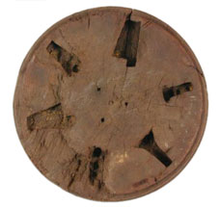
Roman Table Top,
underside
Special names were given to tables of certain types. The monopodium was a table or stand with only one leg support, used especially to hold lamps or toilet articles. The abacus was a table with a rectangular top having a raised rim; it was used for plates and dishes, in the place of the modern sideboard. The delphica had three legs

II. Furniture Design Periods History
Furniture design has been a part of the human experience since the beginning of history. Evidence of furniture survives from as far back as the Neolithic Period in the form of paintings, wall Murals discovered at Pompeii, in sculpture and examples have also been excavated in Egyptian Pyramids and found in tombs in Ghiordes (modern day Turkey). These notes will track the main advancements, developments, styles and materials in furniture design highlighting the identifying features of each period, the materials used and show images of some of the most significant pieces of furniture ever designed. The furniture design timeline below outlines just some of the different periods of furniture design and gives you a basic overview of the timeline of furniture design history. Choose from the menu below to look at one furniture design period in more depth

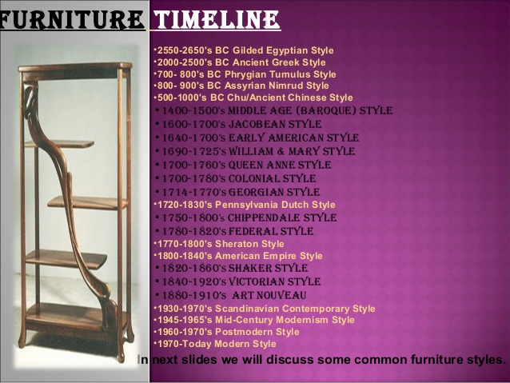
. 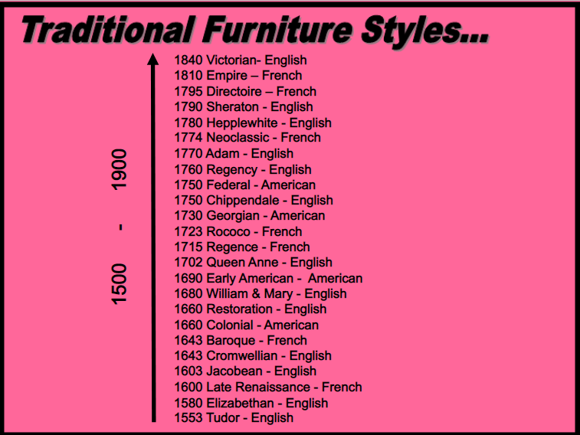
Furniture Design History Timeline
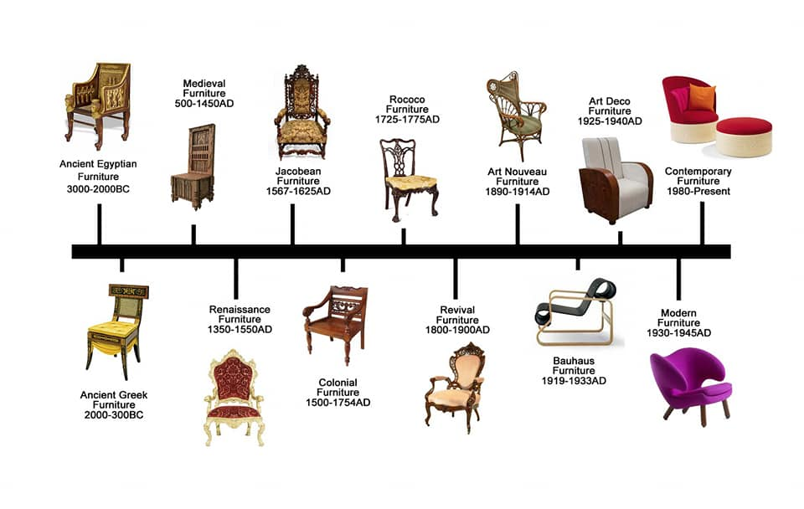
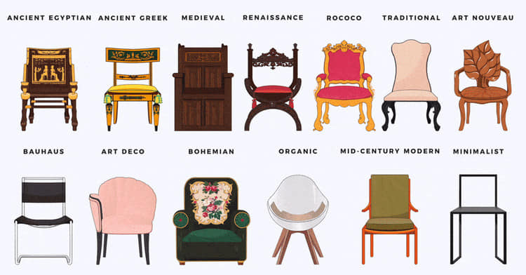
A.


1. Neolithic Period Furniture:
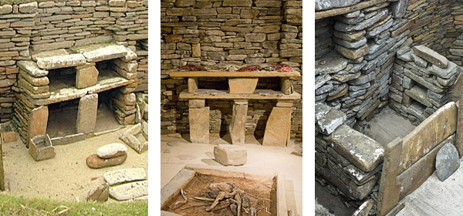
Neolithic Period Furniture
A excavated site dating from 3100-2500 BC in Skara Brae, Orkney uncovered a range of stone furniture. Due to a shortage of wood in Orkney, the people of Skara Brae were forced to build with stone, a readily available material that could be turned into items for use within the household. Each house was equipped with an extensive assortment of stone furniture, ranging from cupboards, dressers and beds to shelves and stone seats. The stone dresser was regarded as the most important as it symbolically faced the entrance in each house and is therefore the first item that was seen when entering a house.
2. Ancient Egyptian Furniture:
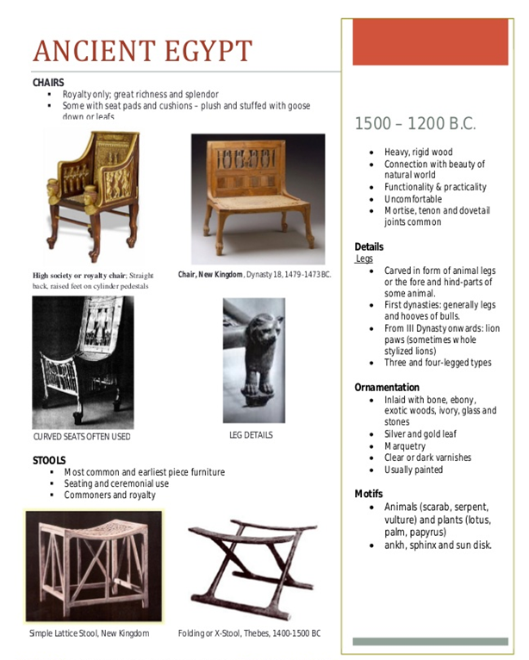
The hyperarid climatic conditions of Egypt since the third millennium BC are perfect for the preservation of organic material. Thanks to these conditions Ancient Egyptian furniture has been excavated and various sites and includes 3rd millennium BC beds, discovered at Tarkhan, a 2550 BC gilded bed and chairs from the tomb of Queen Hetepheres, and boxes, beds and chairs from Thebes. There were two severe sides to the furniture excavated, the intricate gold gilded ornate furniture found in the tombs of the Pharaohs and the simple chairs, tables and baskets of the ordinary Egyptians.

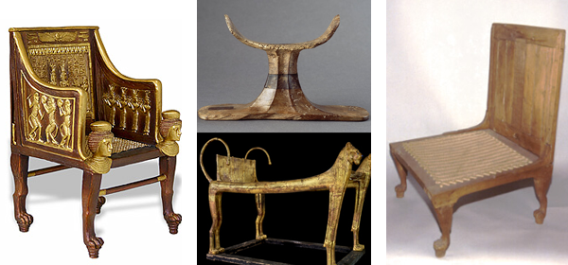
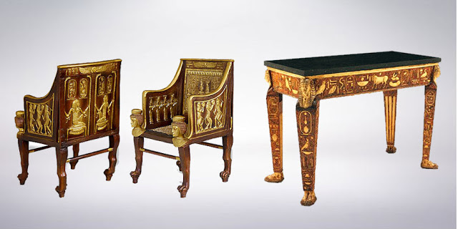
Egyptian Style Furniture
When we think of Egyptian furniture we imagine the intricate gold gilded ornate furniture found in the tombs of the Pharaohs as opposed to the simple chairs, tables and baskets of the ordinary Egyptians.

The identifying features of ancient Egyptian furniture are...
- beech wood and mahogany
- ornate designs using different colors
- depicting animals, gods and goddesses
- gold gilding and inlays
- mosaic designs
- mother-of-pearl inlays
3. Ancient Greek Furniture:
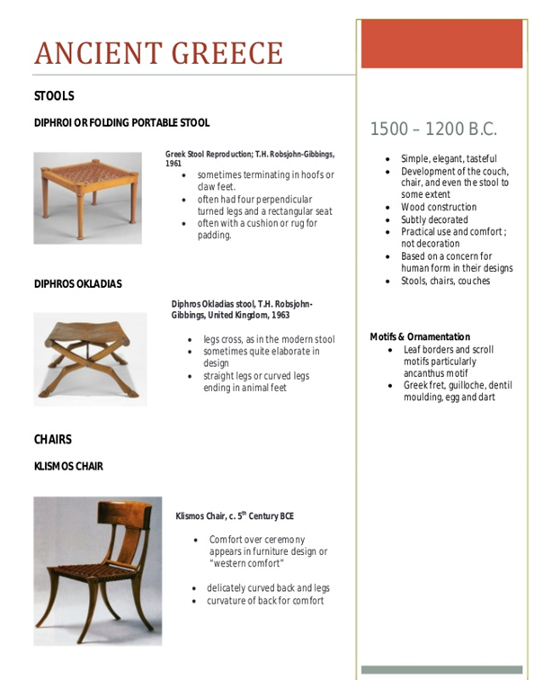
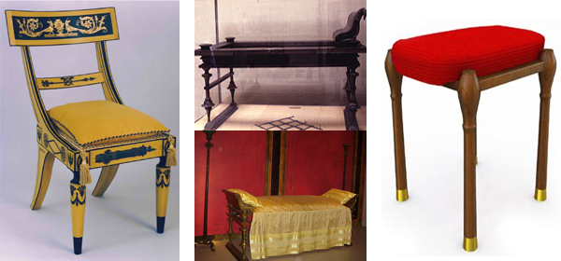
Ancient Greek Furniture
Ancient Greek furniture design can be dated back to the 2nd millennium BC, including the famous klismos chair. The furniture designs are preserved not only by the examples still in existance, but by images of them depicted in Greek vases. In 1738 and 1748 excavations of Herculaneum and Pompeii revealed perfectly preserved Roman furniture. The ashes from the eruption at Mount Vesuvius preserved the furniture from 79 A.D. right up its excavation in the eighteenth century. Characteristic of this early furniture were highly influenced by the furniture of the ancient Egyptians with a stiff, rectangular, and unflattering shape. In the 4th and 5th centuries, once the Greeks developed their own style, furniture became less square and rigid and more curved and flowing.
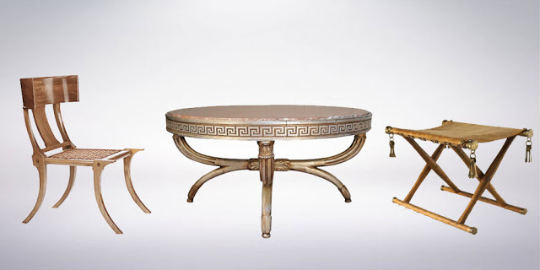
Greek Style Furniture
Ancient Greek furniture is possibly still most remembered for the famous klismos chair, shown above.
- The identifying features of ancient Greek furniture are...
- elegant and tasteful
- detailed carving and inlays
- select detailing, not cluttered
- comfortable rather than decorative
- Renaissance Furniture
4. Ancient Rome Furniture:
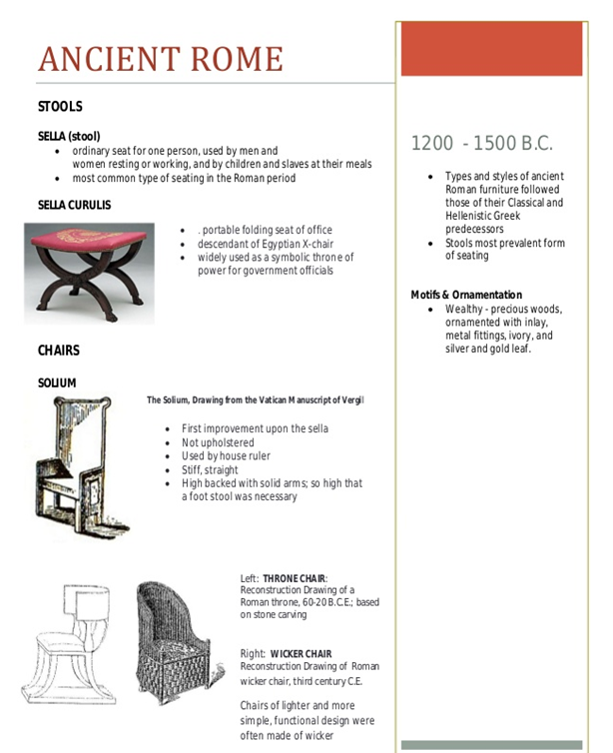

B. Early Medieval Furniture


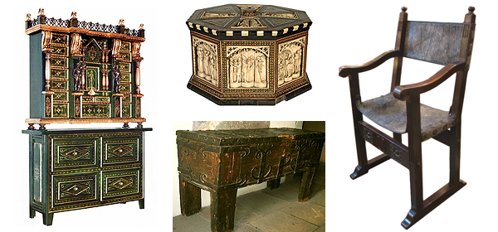
Medieval Furniture
The medieval period was a stark and somewhat crude time, and that is reflected in the furniture styles of the era. The furniture of the medieval period is very distinctive in style. Its most notable characteristics are ornate wood carvings on the border of chairs and canopy beds, garish structural layouts and colours that are basically grey, beige or black. Forms were mainly square or rectangular with very little in the way of curved lines or circular forms.
The medieval time period (from the fall of the last Roman Emperor, in 476 AD, to the fall of Constantinople, in 1453) was the era in which furniture began to develop its modern characteristics. Early medieval Europe was a place of unrest; the medieval era was a time when not only nations but also lords of the manor fought for supremacy and battled to establish boundaries and kingdoms. Medieval history abounds with struggles between countries, between rival barons, and between neighbors. Large aspects of the medieval age are still in darkness to us today - confusion even reigns as to spelling with many variations of the term in use, such as midieval, medevil, midevil, mideval, medival, mediaeval, and midievil!
Medieval life was uncertain, and families were often on the move: fleeing from conflict, or traveling to lend support to the warlord of their choice. Journeying from one dark, draughty castle or medieval manor to another, their possessions needed to be portable, and needed to provide maximum protection from the bleak northern European winters.
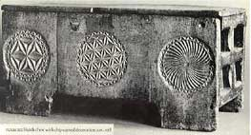
13th Century Hutch Chest

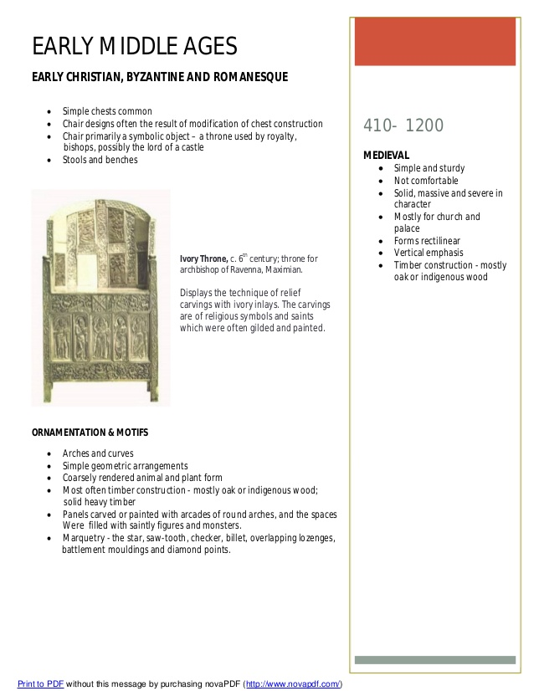

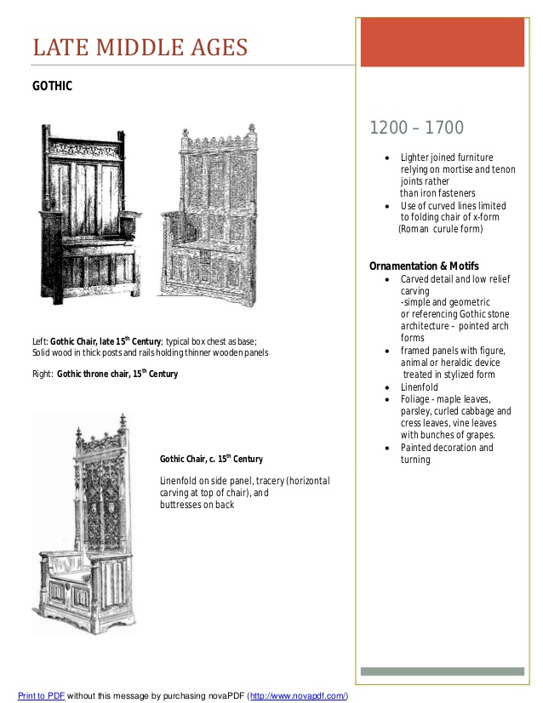

Medieval Gothic Furniture
The Gothic styles of architecture, art and furniture date from the 12th century through to the 16th century. With the Byzantine influence introduced to Europe by the crusaders, as well as Islamic and arabesque elements, furniture and architecture became more ornate, and the typical Gothic motif of the pointed arch became prevalent in furniture design as well as in buildings.
Styles & Wood
Gothic wood furniture was mostly made from oak, although local softwoods were also used towards the end of the period. Medieval Gothic style furniture was heavily carved and decorated. Religious themes were popular in carvings, as were heraldic symbols such as griffins, lions or hawks. Floral themes were also widely used, and the royal fleur-de-lis furniture motif dates from this era. Paintings and inlays were also used for furniture decoration so that the whole effect was much more ornate than the furniture of earlier eras. Furniture pieces were large and solid, following the lines of Gothic church furniture.
Typical Gothic Furniture
Gothic furniture craft paved the way for the Renaissance period to follow, and many new items of furniture appeared at this time. The armoire for clothes storage, the buffet for eating utensils, and tables with drawers were first seen in this period. Gothic cabinet furniture progressed a long way from the simple storage chests and coffers of earlier times.
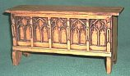
Gothic Coffer
Bedroom
Gothic bedroom furniture featured massive four poster beds, with linenfold-carved valences, and heavily carved and decorated posts and bedsteads. Gargoyles and other horrific mythical creatures were popular motifs since it was believed that they would frighten away evil spirits. Bed coverings and hangings in rich colors completed the elaborate Gothic bedroom style.
Gothic Home Decor Revival
In the 18th century, Gothic revival furniture and architecture became popular in England. This theme spread to the United States in the 19th century, and reproduction Gothic furniture of this period is quite common. Many Victorian pieces feature the ornate carving and the soaring, pointed arches of Gothic origin. This style was known as "Gothick". The Gothick style was perhaps most popular in Victorian church furnishings, since it fitted in well with the ancient church buildings still surviving from medieval times.
Gothic home decor has again become popular in recent times. The mystical, magical aura of the Gothic era, with its strange ceremonies and magic rites, has caught the imagination of artists, writers and designers. Tolkien's "Lord of the Rings" inspired an era of fantasy literature wherein dark castles, evil warlords and heroic warriors performed daring deeds and overcame evil with bravery, skill, cunning and the help of strange mythical beings.
Featuring outlandish symbols such as the Gothic bat, home decor Gothic style gives scope for imagination, creativeness and fun. Gothic decor makes use of rich tapestries and hangings, along with heavy and ornately carved furniture. Stone walls or paneling are ideal for the Gothic look. Decor ideas for Gothic rooms include plenty of candles, stained glass, brass and pewter. Curtains are likely to be heavy and feature rich colors such as wine, ruby, purple, black and gold. Murals and heraldic carvings are typically Gothic. Victorian reproduction Gothic furniture is perfect for this type of decor, and there are many good modern reproductions available as well. The Gothic look is 'in', not only for ancient manor houses and castles, but also for modern homes.
C. Early Renaissance Furniture

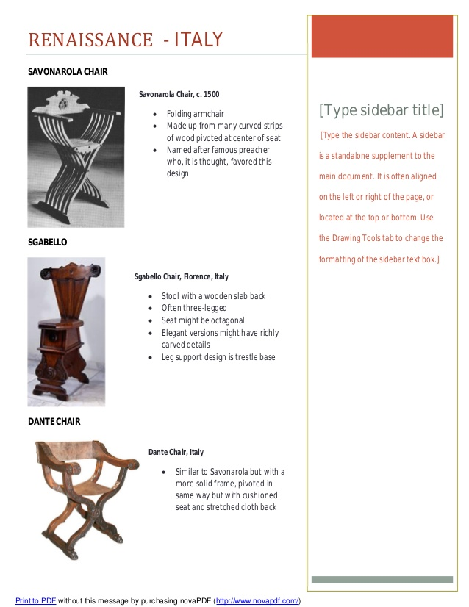
Along with the other arts, the Italian Renaissance of the fourteenth and fifteenth century marked a rebirth in furniture design, often inspired by the Greco-Roman tradition. Starting in the fifteenth century, a similar renaissance of culture, occurred in Northern Europe, particularly in the Netherlands, Belgium and Northern France. These designs were distinctly different from that of Medieval times and were characterized by opulent, often gilded designs that frequently incorporated a profusion of floral, vegetal and scrolling ornamentation. The aim of these pieces were often to showcase the skills of the craftsmen who made them.

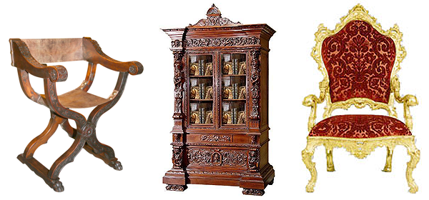
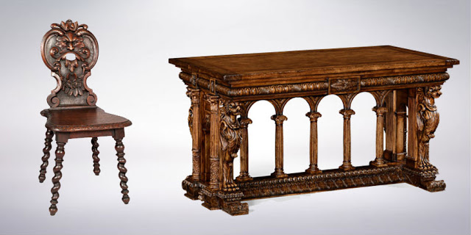
Renaissance Style Furniture
Along with the other arts, the Italian Renaissance of the fourteenth and fifteenth century marked a rebirth in furniture design, often inspired by the Greco-Roman traditions.
The identifying features of renaissance furniture are...
- ornate and opulent
- form above function
- gilded designs
- floral, vegetable and scrolling ornamentation

D. European Furnitures
1. English
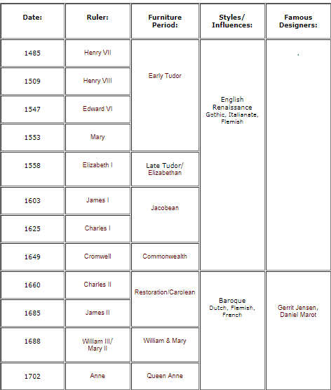
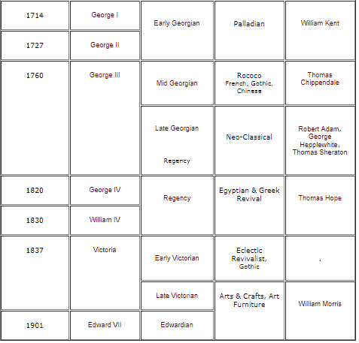

i. English Tudor ( Rulers: Henry VII, Henry VIII, Edward VI, Mary)
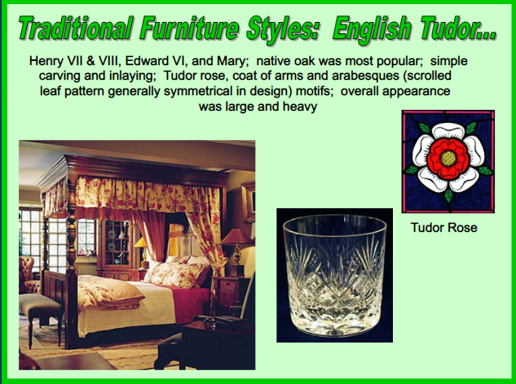
ii. Late Tudor/Elizabethan (1520–1620)( Ruler: Elizabeth I)

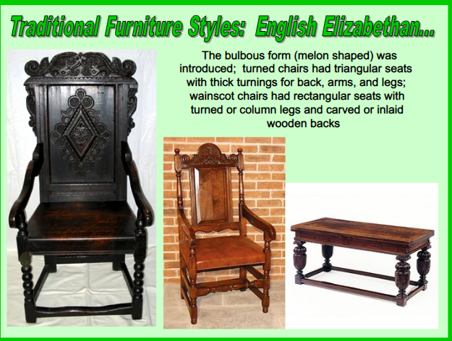

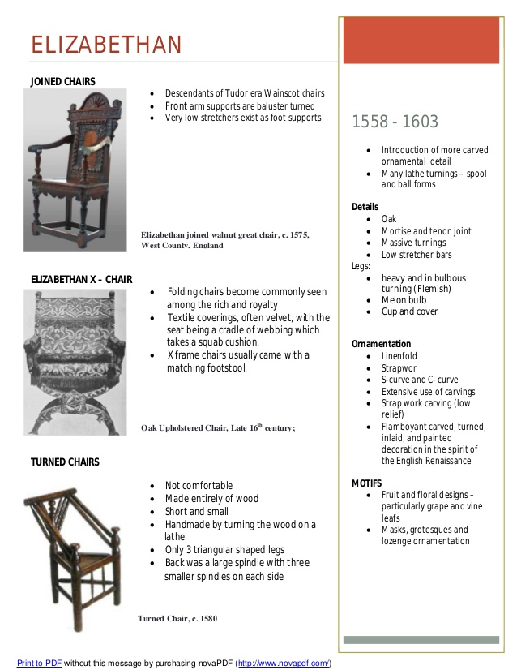

Geographic origin: England
Materials: oak, walnut, porcelain
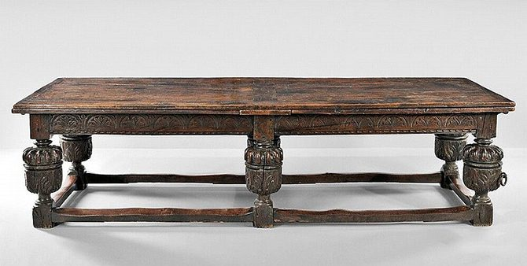
Elizabethan Oak Withdrawing Table, late 16th/early 17th century

While Queen Elizabeth didn’t begin her reign until 1533, this style of furniture is broadly defined as being created during the Renaissance. Around this time, furniture emerged from the Gothic era and slowly transformed to include classical influences. One key characteristic of the furniture is heavy ornamentation, especially on tables and four poster beds.
iii. Jacobean (1603–1625)(Rulers: James I, Charles I)
After the Renaissance there was a gradual change to a less ornamented, quieter style of furniture. In Britain table legs, for example became straighter and narrower than were typical of earlier pieces and instead spiral turned legs became typical of this period. In general furniture profiles became lower and more rectangular. Later Jacobean furniture, during the era of Oliver Cromwell the Protector, was very stern, square, and frugal, a suitable style for a time of relative poverty. But with the return of the monarchy under Charles II, Carolean furniture once again became more ornate, characterized by intricate carved stretchers and colourful upholstery with tasselled trim.
By the end of the period, the influence of the British William and Mary style was beginning to show. Compared to the Jacobean and Carolean pieces this style of furniture was lighter and more elegant. Inverted, cup-turned legs, bun feet, and serpentine stretchers made this a very identifiable style.
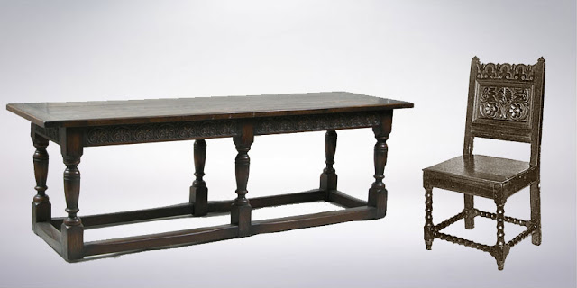
Jacobean Style Furniture
After the Renaissance there was a gradual change to a less ornamented, quieter style of furniture. In general furniture profiles became lower and more rectangular.
The identifying features of Jacobean furniture are...
- stern, square, and frugal
- colourful upholstery with tasselled trim
- straight lines & rigid designs
- sturdy construction
- dark finish

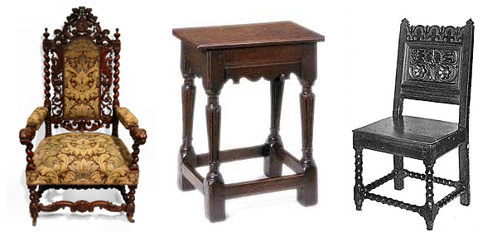
Jacobean Furniture

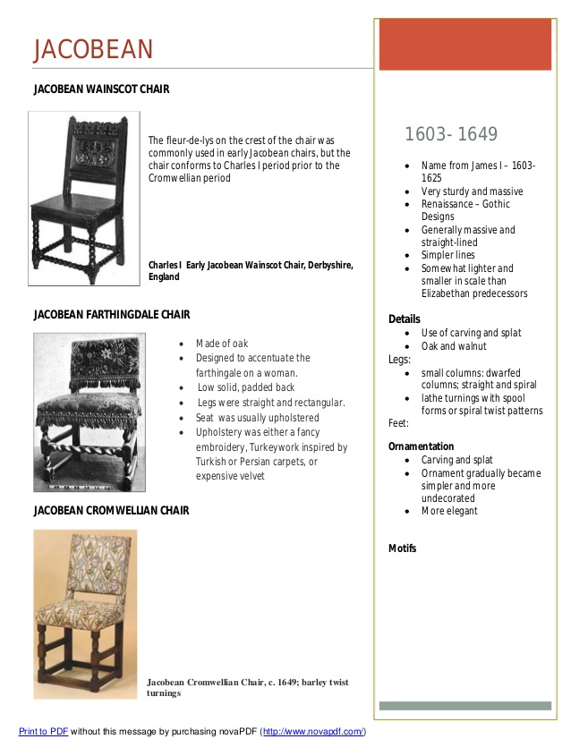

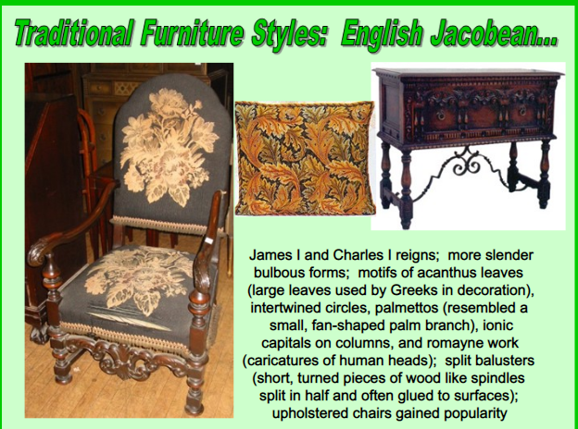

Geographic origin: England
Materials: oak, pine, porcelain, mother-of-pearl
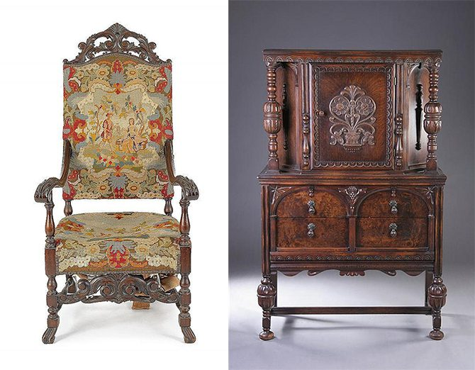
Left: Jacobean style needlepoint armchair,

This era of design began when King James I inherited the crown of England from Queen Elizabeth and resulted in large, boxy furniture meant to last several generations. The furniture is known to be more practical than comfortable, using mainly oak and pine.

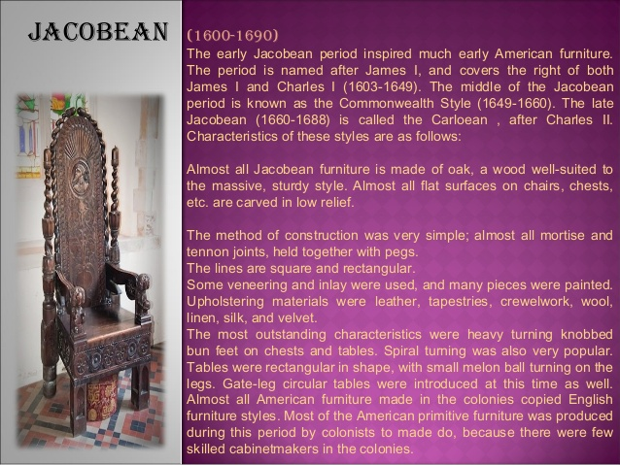
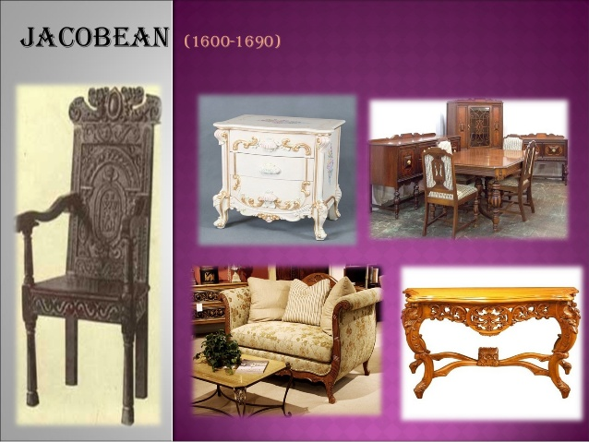
iv. English commonwealth ( Ruler: Cromwell)

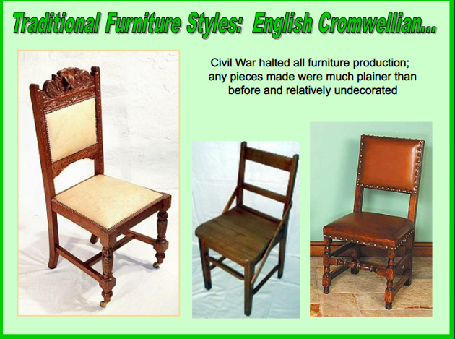

v. Carolean/Restoration (1660–1685)( Rulers: Charles II, James II)

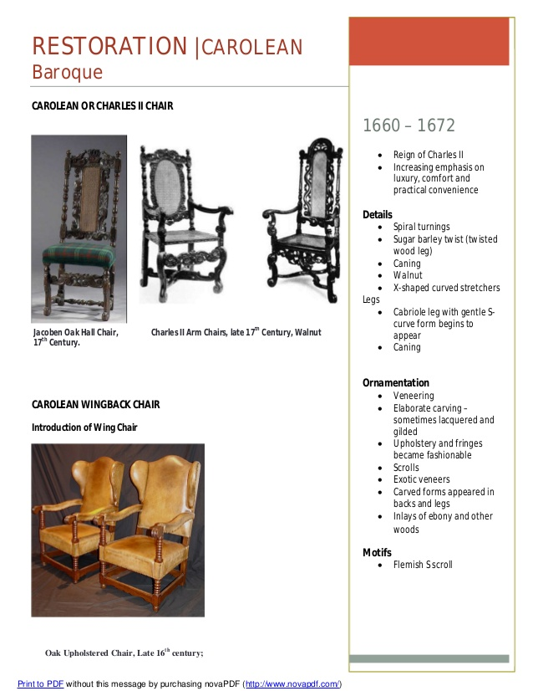

Geographic origin: England
Materials: gold and silver embellishments, leather, walnut, velvet

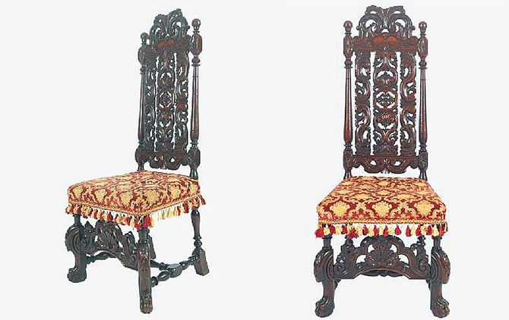
17th century Carolean Carved Walnut Ceremonial Chair
King Charles II ascended to the throne after a period of monarchical upheaval in England, bringing with him French and Dutch Baroque inspiration from his time in exile. Furniture of the period was decorated with floral marquetry, walnut, and velvet upholstery and included carvings and gilding.
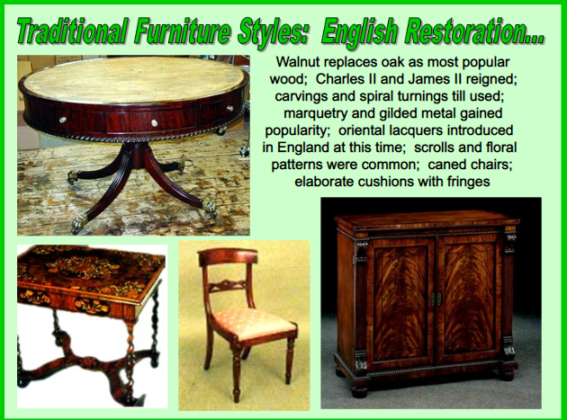
vi. William and Mary (1690–1730)(Rulers: William III, Mary II)
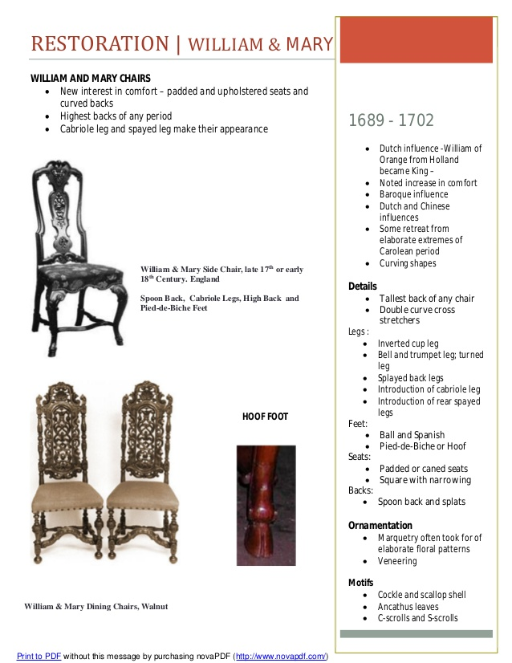

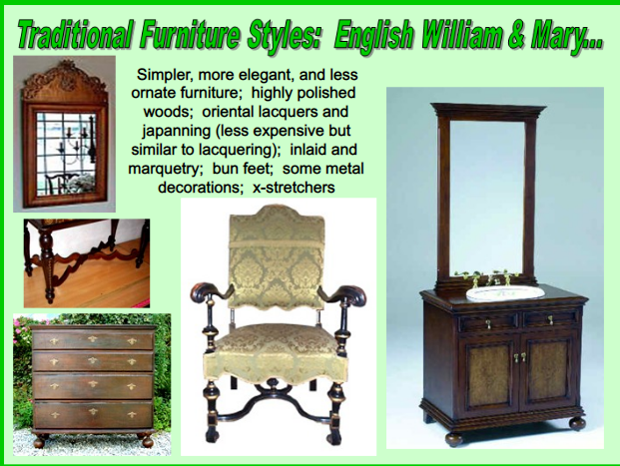
Geographic origin: England
Materials: walnut, maple
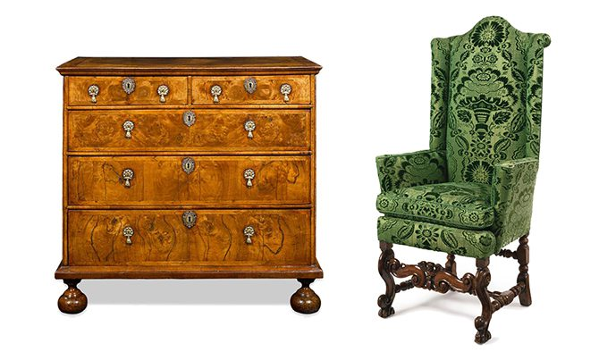
Left: William and Mary Burl Walnut Chest, 17th century Right: William and Mary walnut armchair,
Also known as “Early Baroque” furniture, this was the era in which the daybed and writing desk were both invented. William of Orange appreciated French design, and its influence is felt in the decoration of the furniture. Walnut and maple were heavily used, and designs were thinner and more embellished than in previous reigns.
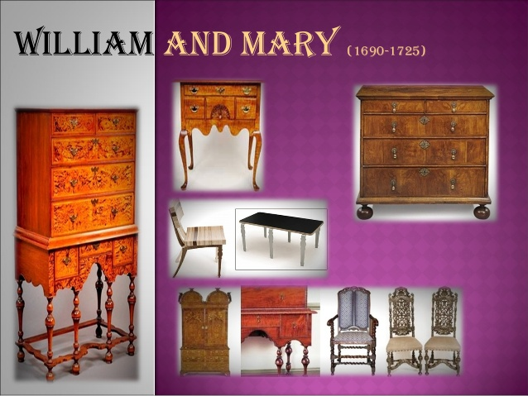
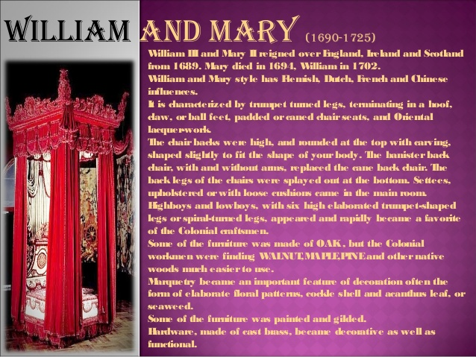
vii. Queen Anne (1702–1760)( Ruler: Anne)
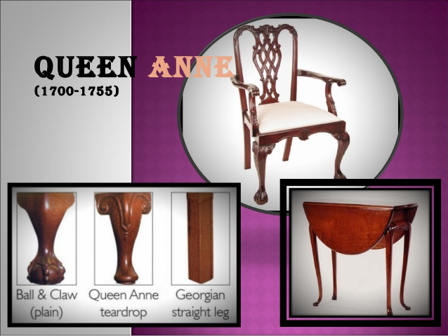
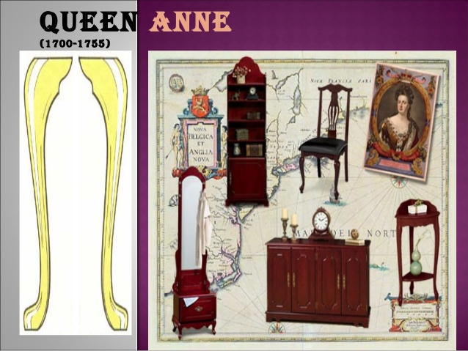
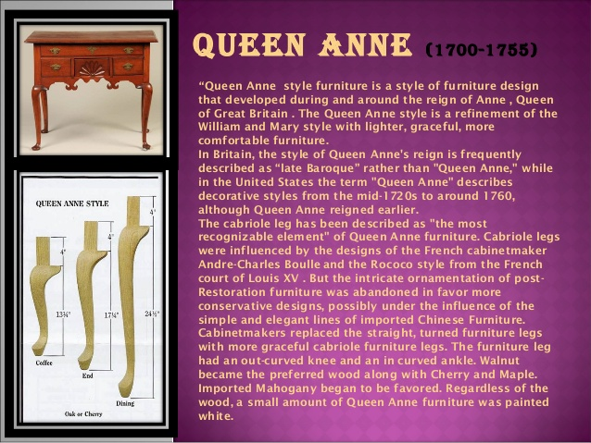
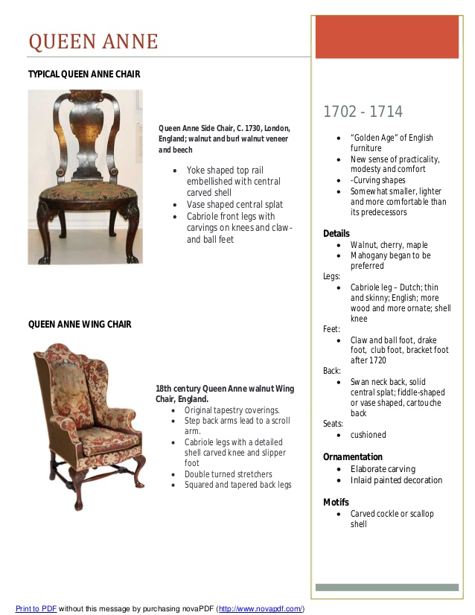
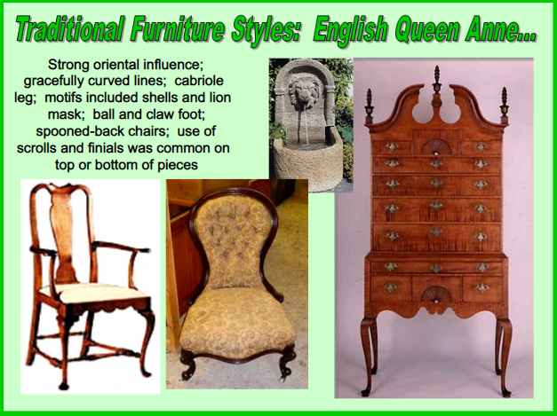
Geographic origin: England
Materials: walnut, poplar, cherry, maple
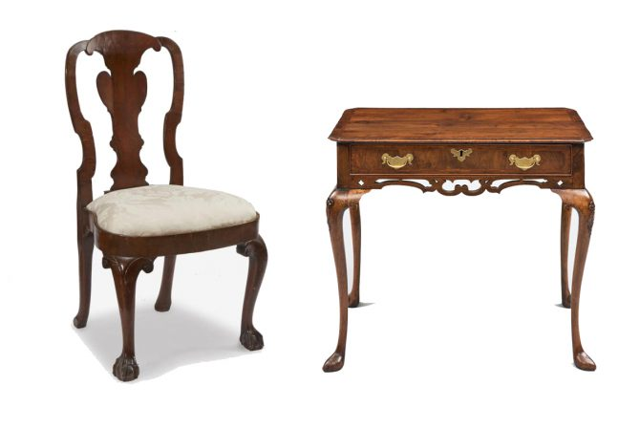
Left: Queen Anne walnut side chair, English, early 18th century, Right: Queen Anne lowboy, 18h century
Curved lines and minimal ornamentation are known characteristics of the Queen Anne style, sometimes known as “Late Baroque.” The furniture designs began to evolve during the reign of William III, but the term generally applies to pieces popular during and after Queen Anne’s reign (1702-1714). It continued to be lighter and more designed than previous eras, featuring curved shapes, cabriole legs, cushioned seats, and padded feet, but ornamentation is minimal.
The Queen Anne style is a style with a moderate proportion and graceful appearance. It is named after Queen Anne of England who reigned from 1702-1714.
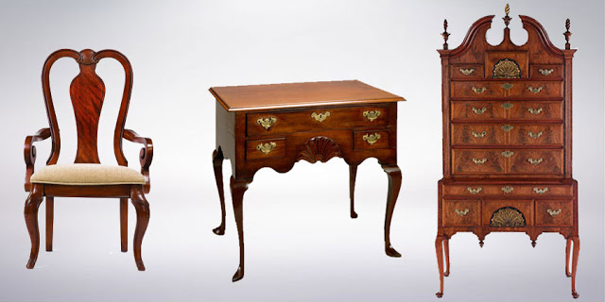
Queen Anne Style Furniture
The identifying features of Queen Anne furniture are...
- graceful and refined
- cabriole legs terminating in a pad or drake foot
- fiddle-back chair backs
- bat wing shaped drawer pulls
- cushioned and covered with fabric
Georgian periods (1714–1830)
Geographic origin: England
Materials: mahogany
Key designers: Thomas Chippendale, George Hepplewhite, Robert Adam
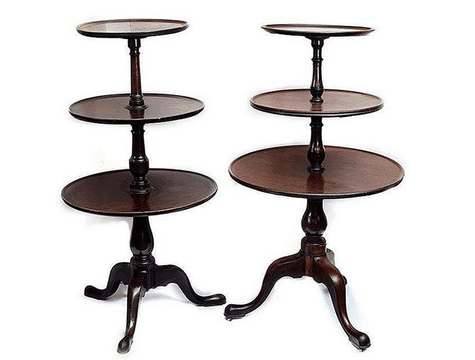
A matched pair of Georgian mahogany 3 tier dumb waiters, circa 1790

The importation of mahogany from Central and South America led to its replacing walnut as the primary wood in furniture-making during the Georgian era. This term extends to design under Kings George I, George II, and George III. Designer Thomas Chippendale rose to prominence during the period, which was identified by straight forms with intricate low-relief ornamentation.
viii. Early Georgian ( Rulers: George I, George II)(Designer: William Kent)
Pelladian Style:
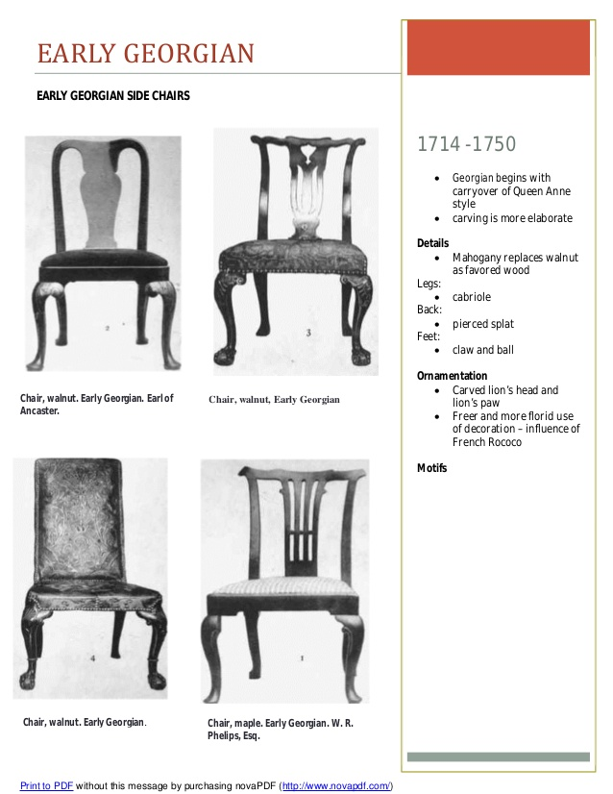
ix. Middle Georgian (Ruler: George III)
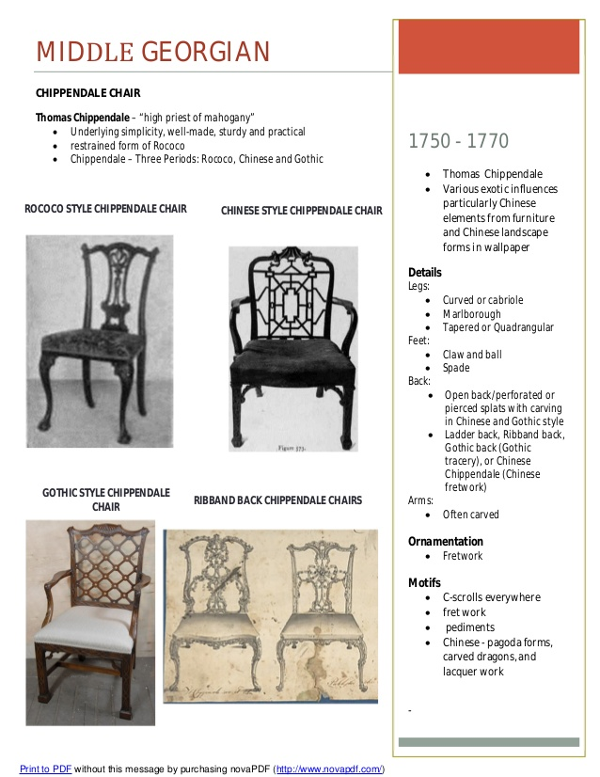

a. Rococo Furniture Style:
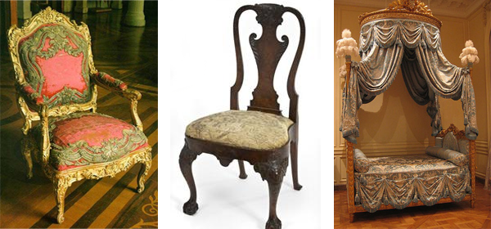
Rococo Furniture
Geographic origin: France, Germany, Austria, Britain
Materials: mahogany, walnut, oak, ash, elm, beech, and marble inlay
Key designers: Hubert Gravelot, Thomas Johnson, and Paul de Lamerie
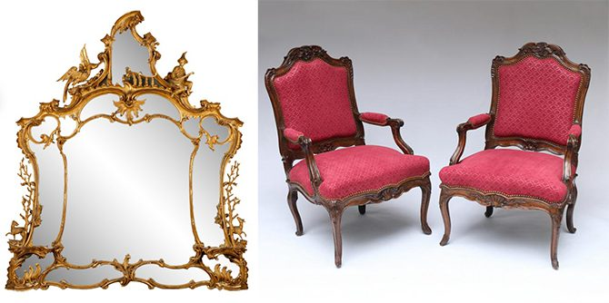
Left: George III Rococo pierced giltwood girandole mirror Right: Pair of Rococo carved walnut fauteuils, late 18th/early 18th century
The name for this style is derived from the French word “rocaille,” meaning “shell” or “rock;” indeed, rock and broken shell motifs are defining features of the style. The Rococo aesthetic first became popular in France in the early- to mid-18thcentury, during which time there was a push toward asymmetrical, free-flowing designs.
Like its art, Rococo furniture was influenced by nature and characterized by playful designs including acanthus leaves, S- and C-scrolls, and decorative borders. Its elaborate decoration encourages viewers to gaze upon Rococo furniture with wandering eyes, reveling in the seemingly unbridled patterns adorning the objects. British pieces are typically more “natural-looking” than French pieces, although British furniture designers, most notably Thomas Johnson, found ways to balance the public’s taste for utility-minded construction with twisting, organic forms.
In the eighteenth century, furniture design began to develop rapidly, although there were some styles that belonged primarily to one nation, such as Palladianism in Great Britain or Louis Quinze in French furniture, others, such as the Rococo and Neoclassicism were commonplace throughout Western Europe. In reality the term '18th-century furniture' therefore refers to a wide variety of styles including William and Mary, Queen Anne, Georgian, Chippendale, Hepplewhite, Sheraton, Adam, Regency, Federal, and the French periods of the several Louis, Directoire, and Empire.
While seperate, all 18th-century furniture, whether American, British, or French shared a similar style of construction that is distinct from the subsequent mass-produced furniture of the 19th century. Eighteenth-century furniture is commonly thought of as representing the golden age of the highly trained master cabinetmaker, trained in the craft of furniture design which manifests in highly finished, sophisticated designs.
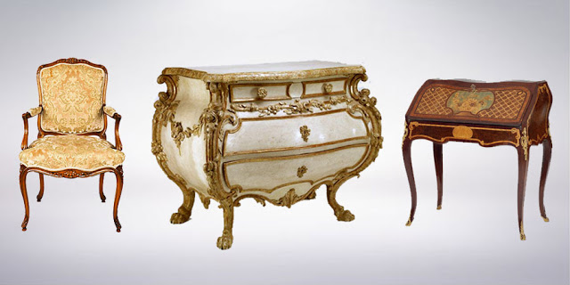
Rococo Style Furniture
In the eighteenth century, furniture design began to develop rapidly and styles such as Rococo and Neoclassicism were commonplace throughout Western Europe.
The identifying features of Rococo furniture are...
- Natural motifs
- Elaborate carved forms
- Asymmetry
- Curved forms are common in Rococo
- Rocaille carving
- Acanthus leaf
b. Gothic Revival Style(1740–1900)
Geographic origin: Britain, United States
Materials: dark woods, velvet and leather upholstery
Key designers: A.W.N. Pugin, John Ruskin, and William Burges
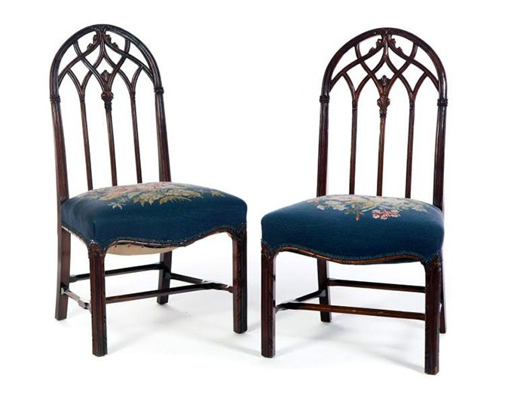
Pair of English Gothic Revival side chairs, 19th century
The rebirth of the Gothic style coincided with the resurgence of traditional Anglo-Catholic beliefs between the mid-1700s and late 19th century. Concerns about the need to return to social and religious conservatism necessitated stylistic changes that not only affected the art and architecture of the period but also drastically altered the appearance of furniture. Tables, chairs, dressers, and other pieces were carved with shapes resembling pointed arches and rose windows. Decorative elements, such as floral details, finials, heraldic motifs, and linenfold designs, frequently adorned the objects’ surfaces.
In addition to hearkening back to the religiosity and traditionalism of the Middle Ages, furniture made in the Gothic Revival style also fed into nostalgic ideas about the romance and chivalry of medieval Britain. The evolution of the style is visible in the details of Gothic Revival objects – earlier pieces are more whimsical and delicate, whereas later examples are more boldly carved and colorful.

- Designer: Thomas Chippandale
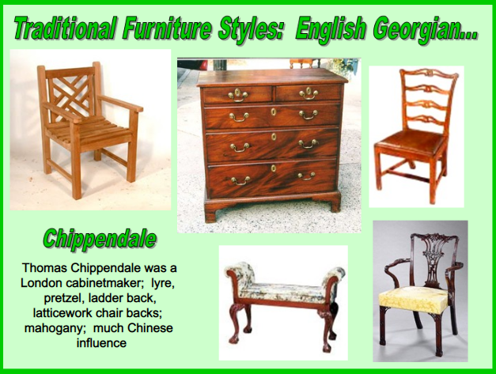
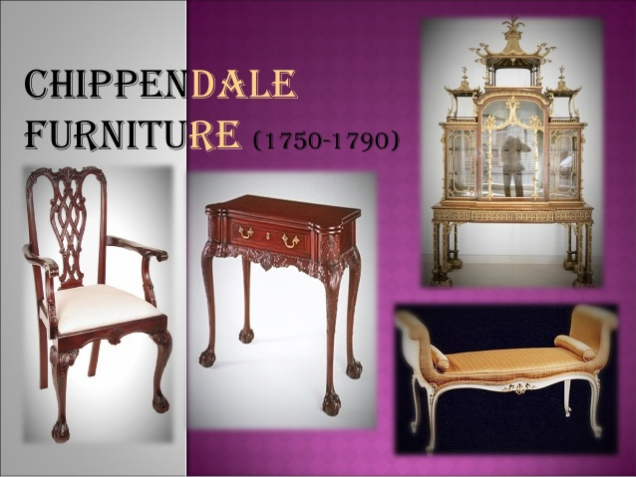
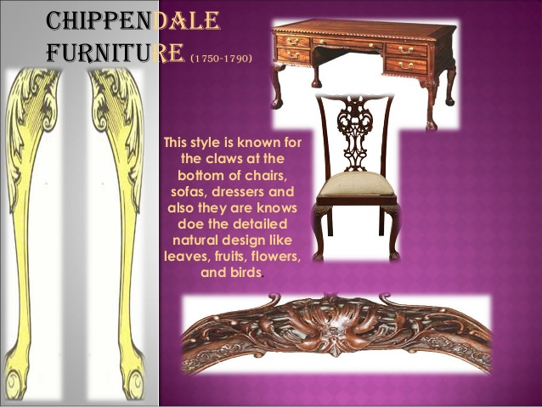
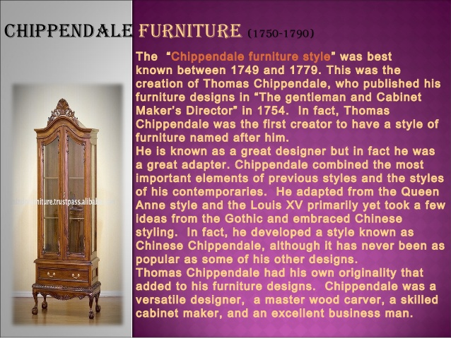
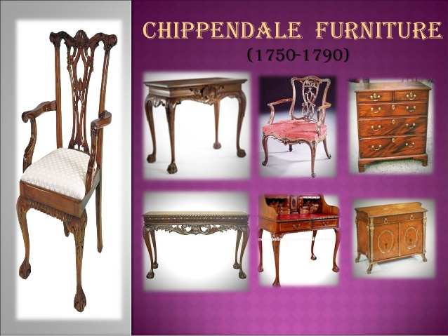
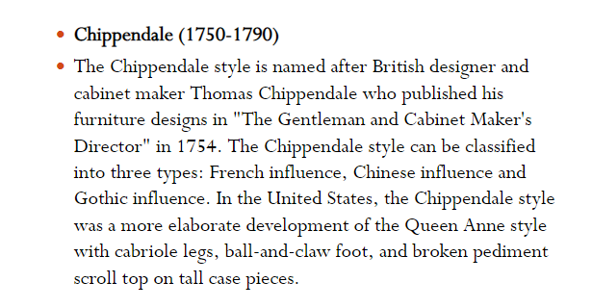

x. Late Georgian (Ruler: George III)
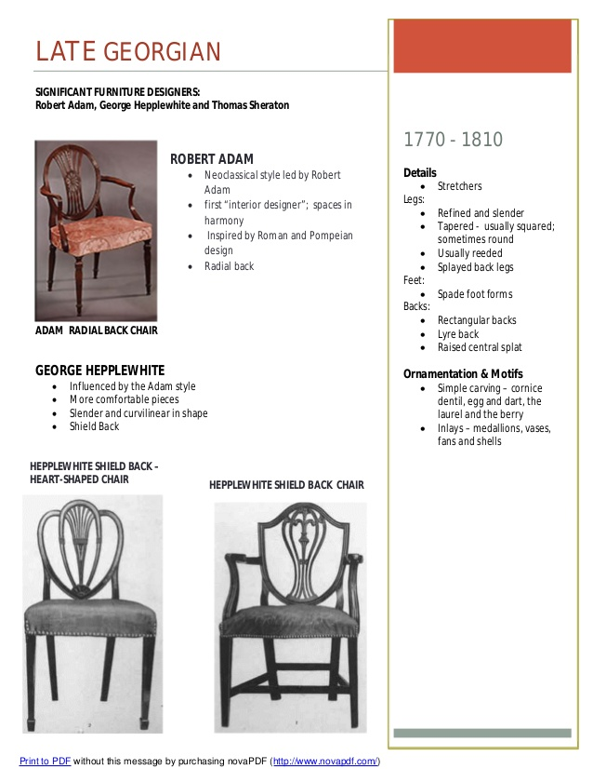
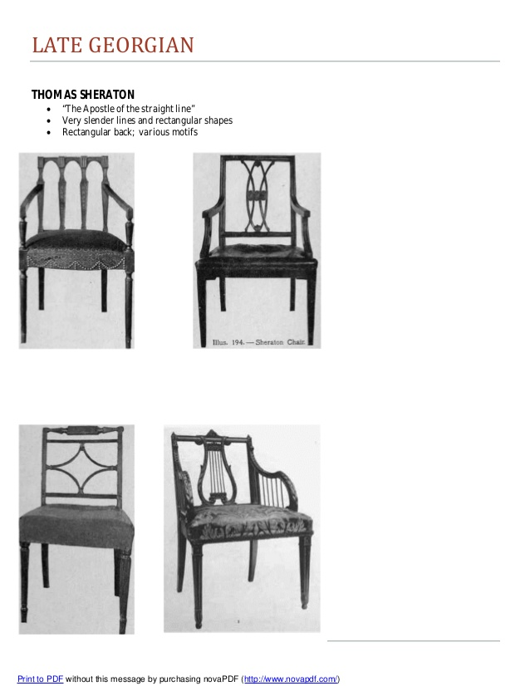
Neo-Classical Style (1750–1830)
Geographic origin: France, Britain, Italy, United States
Materials: painted and gilded wood, marble inlay
Key designers: Sir William Chambers, James Stuart, Robert Adam, George Hepplewhite, and Thomas Sheraton
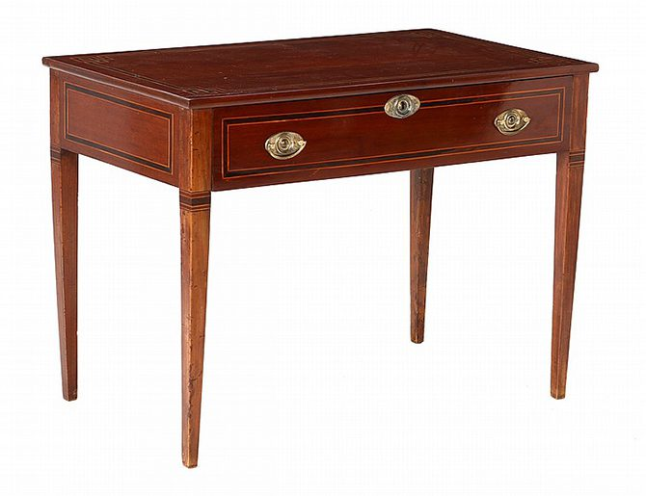
Neo-Classical console in hazelnut and mahogany
British Neo-Classical furniture is similar to Regency furniture, as both styles rely heavily upon influences from ancient Greece and Rome. The primary distinguishing factor is that Neo-Classical furniture is less strict in its interpretation of ancient models. British designers (Robert Adam, for example) often looked to contemporary developments in Paris and Rome when creating furniture pieces for British consumers. The objects are typically more extravagant than Regency pieces, but they still favor straight lines, twisted fluting, and classicizing motifs. They were often made to complement a Neo-Classical interior space, resulting in an overarching aesthetic marked by clean lines, elegant forms, and sophisticated details reminiscent of ancient splendor.
- Designer: Adam (1965-1805)
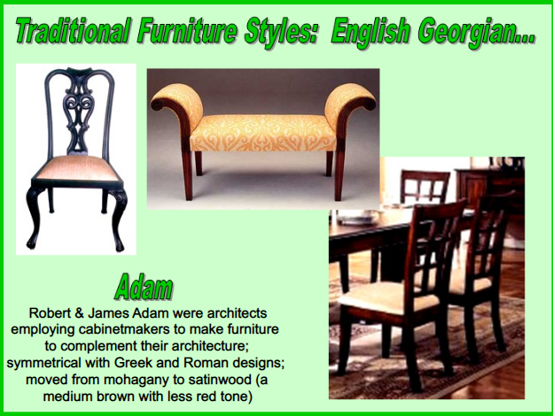

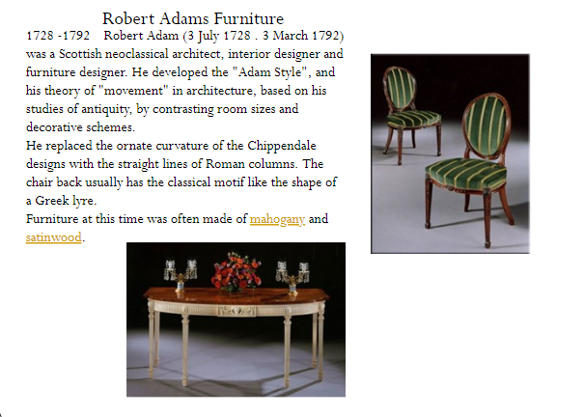
- Designer: Hepplewhite (1780-1805)
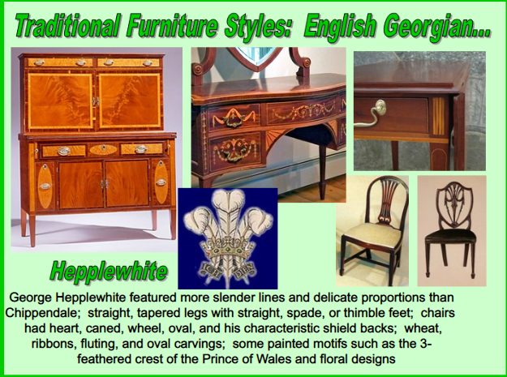

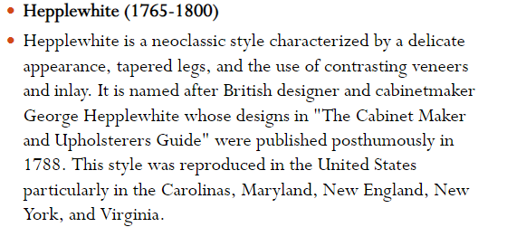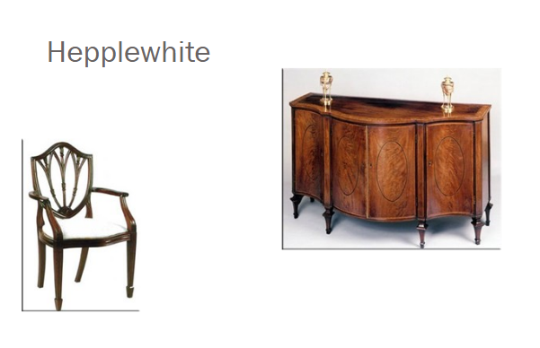
- Designer: Sheraton
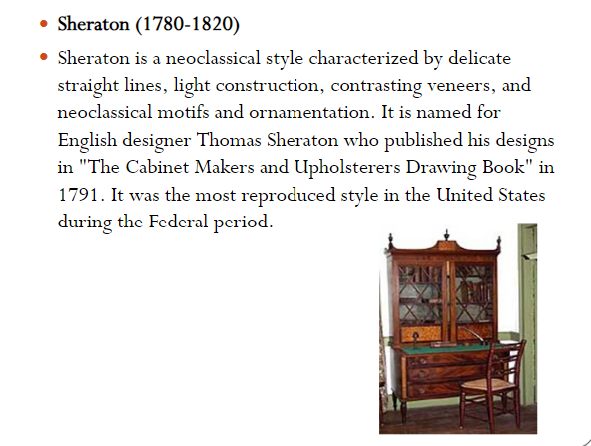
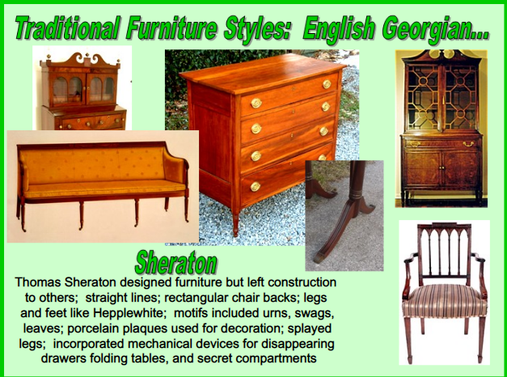
xi. Regency (1762–1830)( Rulers: George IV, William IV)
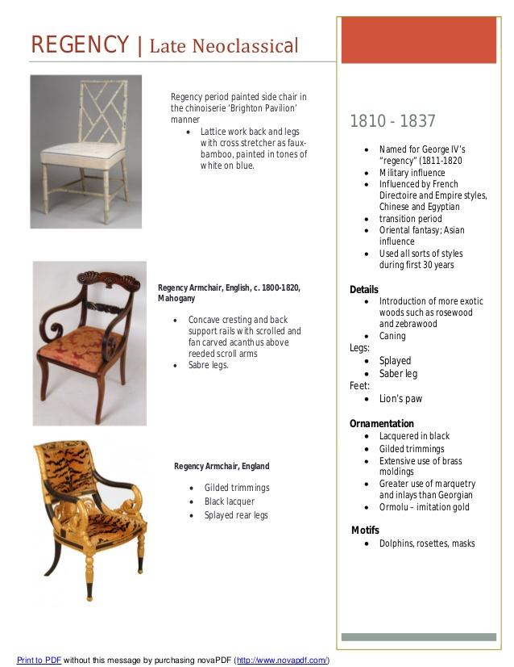
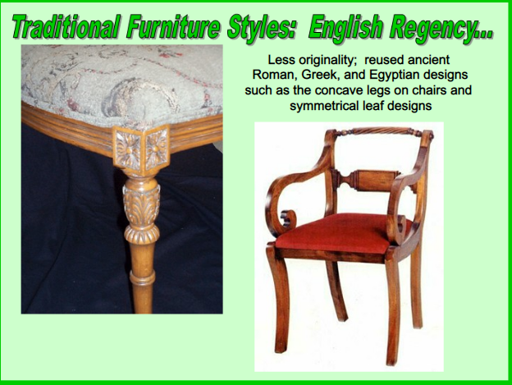
Geographic origin: France, Britain
Materials: mahogany, carved wood, wood veneers, paint, and metal inlay
Key designers: Thomas Hope, Thomas Sheraton, and George Smith
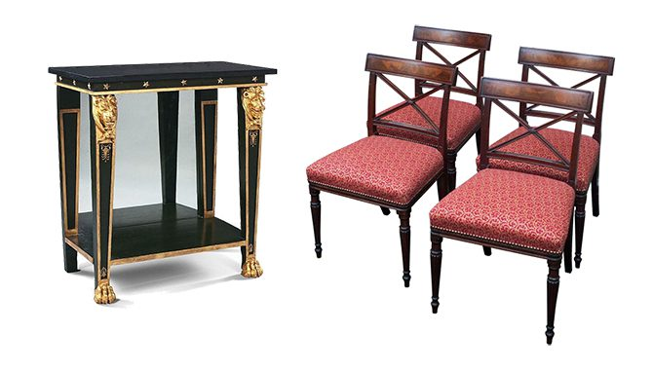
Left: A Regency parcel gilt side table, circa 18252015. Right: Set of four Regency chairs, circa 1815.
Known in France as the French Empire style, the Regency style coincided with the reign of King George IV of Great Britain. Inspired by recent discoveries of ancient Greek, Roman, and Egyptian artifacts, Regency furniture is characterized by a strict interpretation of archaeological finds, or “pure forms.” Defining features of Regency furniture include flat surfaces, delicately painted and/or veneered wood, metal inlay, and classicizing motifs like rosettes, lion masks, and metal paw feet. Each piece exemplifies the harmony of utility with the pure classical forms popular in Britain at the time. Furthermore, each piece was made so it would fit seamlessly within any interior space devoted to the Regency style.
- Revival Furniture style:
The 19th century was marked by the Industrial Revolution, which caused profound changes in society. With increasing working populations in cities, the rise of a new class of wealthy of furniture buyers, together with the arrival of mass-production and the demise of the individual craftsman-designer, the gradual progression of furniture styles that had developed through the previous centuries was replaced by a raft of imitation or revival styles. These concurrent revival styles, including Gothic revival, Neoclassicism and Rococo revival became easy and inexpensive to manufacture as technology developed during the industrial revolution.
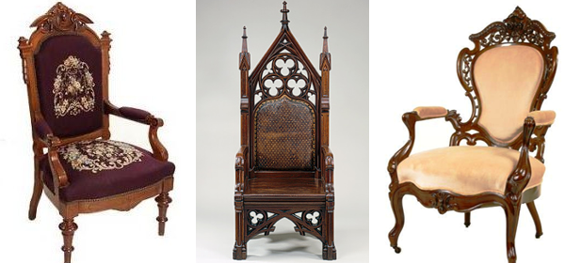
Revival Furniture
With mass-production technology in place it was a simple matter to graft historically correct ornaments onto all sorts of furniture, thereby making possible for the creation of a continual stream of revival styles to meet the demands of the public. The result was a century of furniture whose common denominator was excessive ornamentation in the form of applied metal or wood carvings, inlays or stencils.
xii. Victorian (1830–1900)( Ruler: Victoria)
(styles:Electric,Revivalist,Gothic)
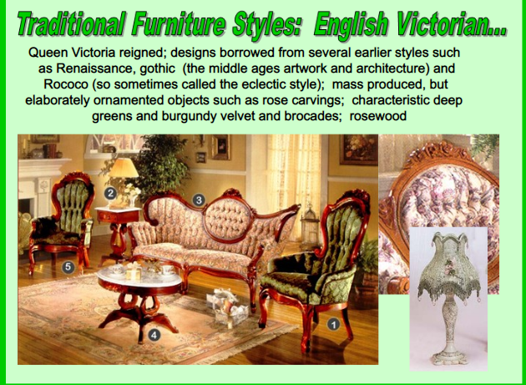
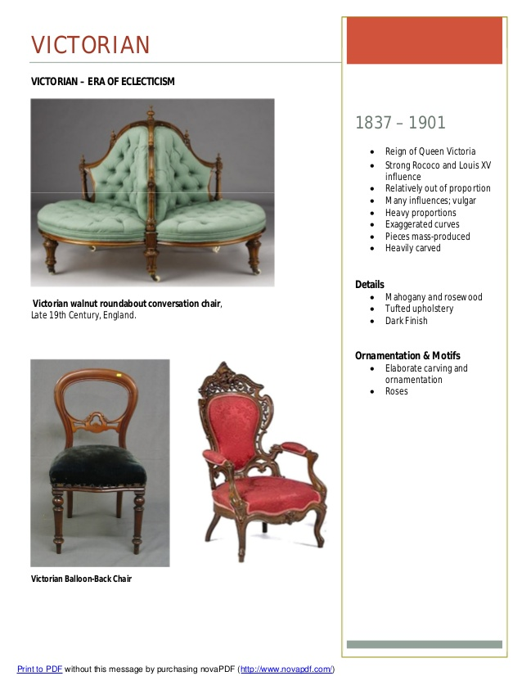

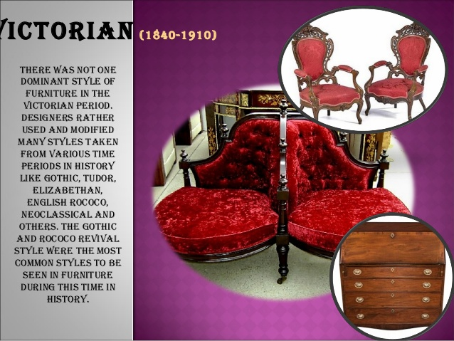
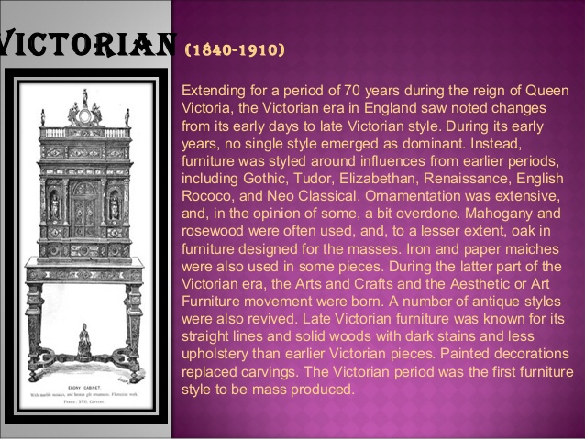
Geographic origin: England
Materials: walnut, rosewood, mahogany, velvet
Key designers: William Morris, Augustus Pugin, Christopher Dresser
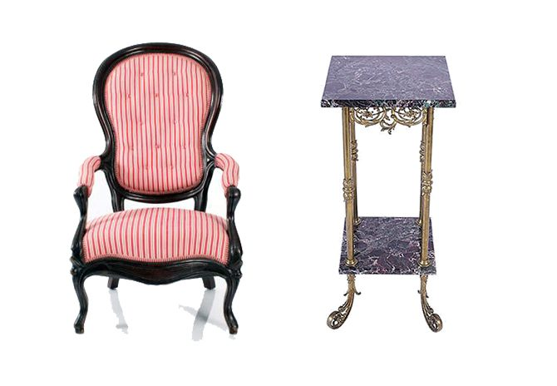
Left: Victorian armchair, Right: Victorian brass and marble pedestal
Queen Victoria reigned for 63 years, during which time the Industrial Revolution enabled furniture-makers to produce furniture for the growing middle class championed by the Queen. While it encompassed many styles and designers (including the Arts & Crafts movement), Victorian furniture was often heavy and big. Styles that inspired Victorian designers include Elizabethan, Rococo, Neoclassical, and more.
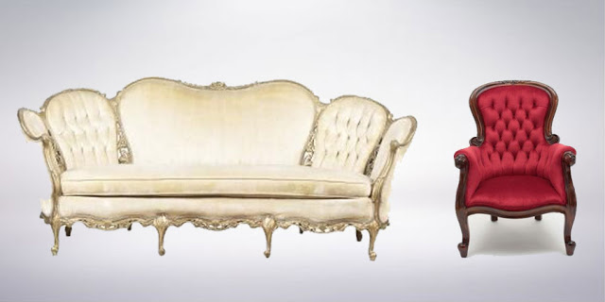
Victorian Style Furniture
The Victorian style draws its influence from previous Gothic forms. It is named for Queen Victoria of England who reigned from 1837-1901 and was the first furniture style of mass production.
The identifying features of Victorian furniture are...
- heavy proportions
- dark finish
- elaborate carving and ornamentation.
- somber appearance
- balloon-shaped chair backs

2. French styles and Periods

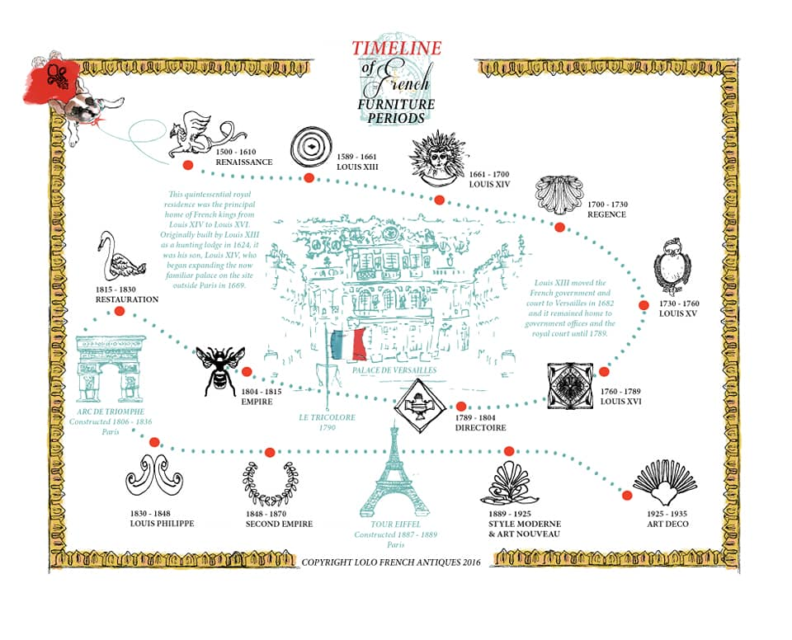
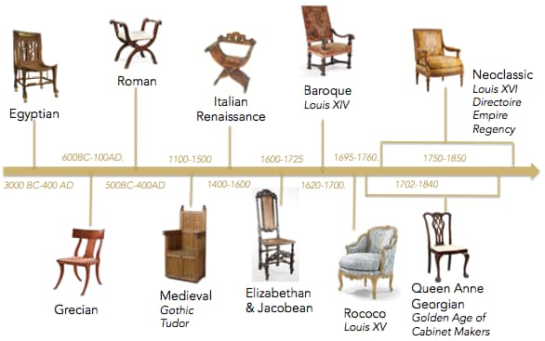
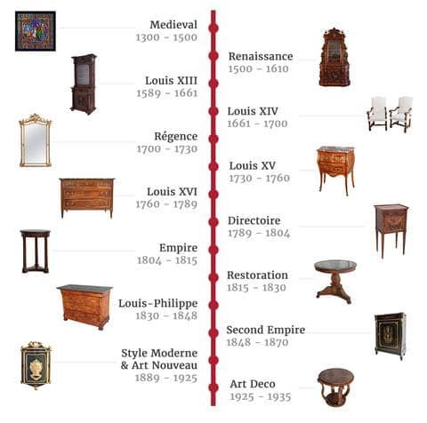
More than any other country, France’s complex political history is reflected in the fine and decorative arts of each era. From the absolute monarchs that emerged in the 16th century to the French Revolution and beyond, the socio-political zeitgeist of the country has long influenced the types of furniture and ornamentation preferred by the elite and bourgeoisie.
i. Late French Renaissance style
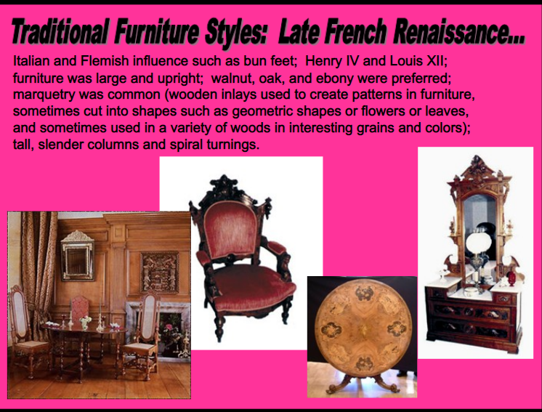

- Louis XIII Period (1590–1660)

Louis XIII Style Chairs
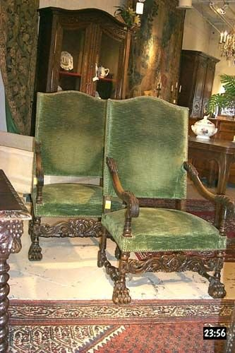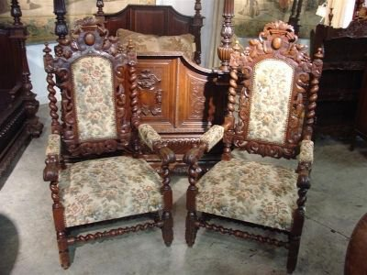
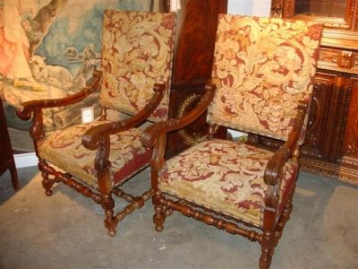
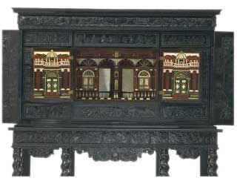
Ebony Cabinet, 1640-1650.
Ebony, on an oak and pine carcase, with carved decoration; interior with marquetry including ivory and several woods, mirror glass and gilded balusters.
Cabinets like this one were the height of fashion in France from about 1640 to 1660. They were used to house collections of precious objects and natural rarities, such as unusual shells, but they were also admired as luxury objects in their own right. Ebony was at that time the most fashionable wood for veneering cabinets. It was imported into France at great expense from Africa, Madagascar and India. In France the skilled woodworkers who made cabinets of this kind came to be called "ébénistes", after the wood they used most. The outside of this cabinet is carved with scenes taken from the engraved illustrations to a novel first published in Paris in 1624. It is the story of the goddess Diana and her love for the youthful shepherd Endymion.
An increasing variety of forms in furniture appeared with many more types of furniture being made for everyday use. Many forms of chairs and sofas became common, and the divan and console were products of the Louis the Thirteenth time. Louis XIII chairs, as a rule, were more comfortable, and were more commonly used for ordinary domestic purposes. Sometimes they were made in sets, and were usually upholstered in velvet, brocade, tapestry, and needlework. Bedroom furniture became more luxurious and the walls were commonly decorated with ornamental friezes above paneled wainscots and bed draperies were used and canopies were in vogue.
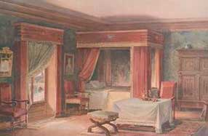
Louis XIII Bedroom Interior.
Cane was imported as seat coverings. Chairs were covered with leather or fabrics and upholstered very heavily. Reception beds were introduced. The Louis XIII period saw the introduction of the use of table covers and scarfs. Many of these trends remained in effect through to the great period of French baroque furniture.
Materials: oak, walnut, pearwood, pine, marble, metal
This style began during the reign of “Good King Henry,” Henry IV of France, and continued under his son King Louis XIII. Austere and architectural, the furniture possessed a distinctly geometric appearance with thick, heavy decoration. “Turning,” a technique in which wooden spindles are shaped with chisels and gouges while being spun through a lathe, was often used for ornamentation.
ii. Baroque Style
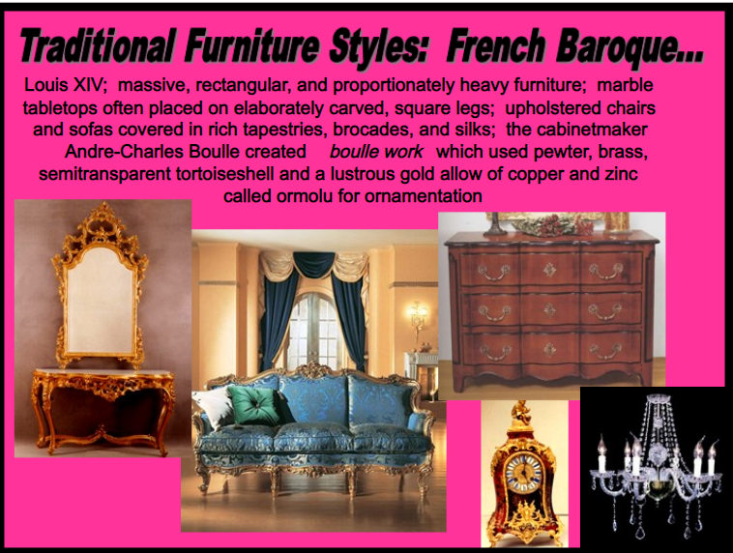
- Louis XIV period (1660–1715)
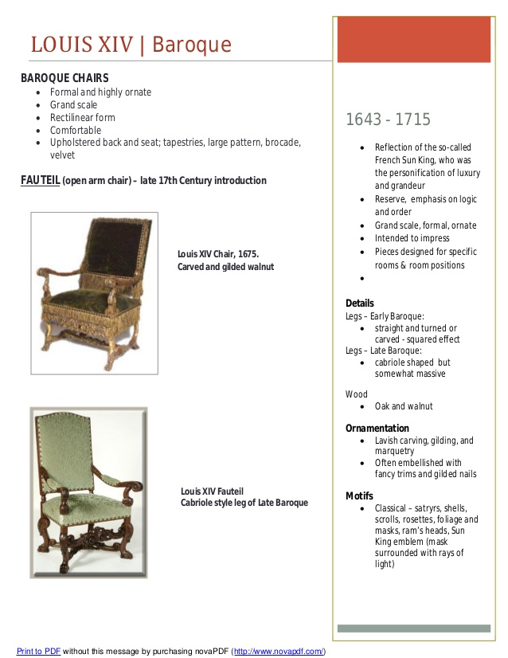
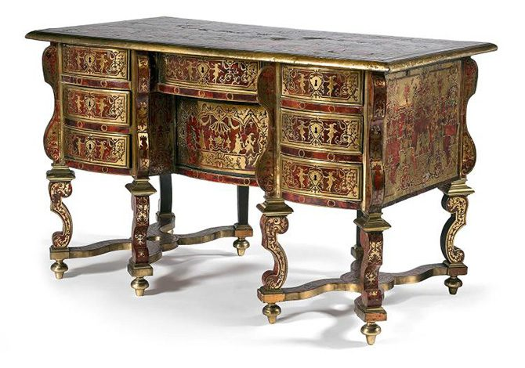
A Louis XIV Mazarin desk with a scale and engraved brass marquetry, attributed to Nicolas Sageot

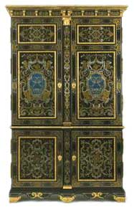
French Baroque Cupboard, 1700.
Ebony veneer, with marquetry of engraved pewter and brass and panels of clear horn over blue pigment, on an oak carcase.
Large cupboards in which to keep clothes and other objects had been in use in France for some time before this type of furniture was adapted in the later 17th century to serve in rooms of state. An impressive appearance could be heightened by means of the materials used, as in this example, which is finely decorated with boulle marquetry - veneers (wafer-thin sheets that are glued and then cut out to a design) in ebony, tortoiseshell, brass, pewter and horn. The Paris workshop of André-Charles Boulle (1642-1732) made the most important pieces of furniture of this kind, but this example, although of high quality, is probably the work of another cabinet-maker.
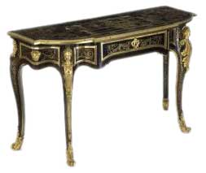
Boulle Console Table, 1701
Veneers of tortoiseshell and engraved brass, on an oak carcase, with gilt-bronze mounts.
This table is an elaborate example of boulle marquetry - thin sheets of brass and tortoiseshell veneer on an oak frame.
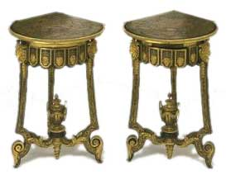
Boulle Tables, 1701
Oak and walnut, veneered with brass and Boulle contrepartie marquetry of tortoiseshell, pewter, copper and horn, back-painted in blue pigments, with gilt bronze mounts.
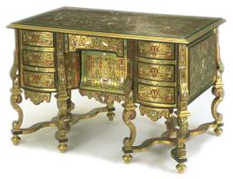
Mazarin Writing Desk, 1685-1700.
Marquetry of brass, ebony, ivory, mother-of-pearl and clear toroiseshell or horn with painted paper backing, on a pine carcase.
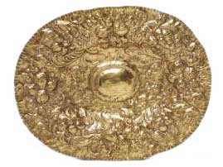
Baroque Dish, 1680.
This Baroque style dish was intended for display on a buffet or sideboard. The Baroque style is characterised by exuberant decoration, expansive curvaceous forms and an air of solemn, sometimes pompous grandeur.
Materials: chestnut, walnut, oak, ebony, brass, pewter, silver, tortoise-shell, mother-of-pearl
The 72-year reign of Louis the Sun King is the longest recorded of any European monarch, marked by military triumph and overwhelming opulence. During this era, the commode, console tables, and desks became popular, as did mirrors, chandeliers, and candelabras. Decoration in the form of marquetry, carving, and painting was inspired by mythology, nature, and war. Notable motifs were the royal emblem (the sun) and the fleur-de-lis.
iii. Between Baroque and Rococo Styles
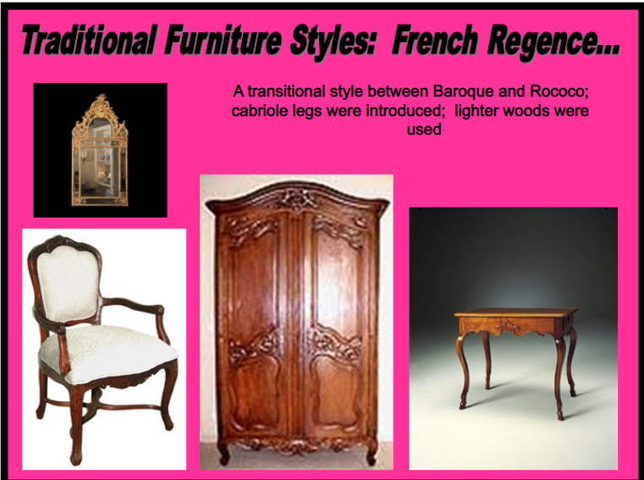
- Régence Period (1715–1730)(between XIV and XV)
Materials: oak, pine, poplar, beech, walnut, bronze
Between 1715 and 1723 France was ruled by a Regent, Philippe d’Orléans, while King Louis XV was too young to rule. During this period, furniture began to exhibit characteristics of the Rococo style. Seating became more intimate and comfortable, and plentiful decoration in the form of veneers, gilt bronze, and wood marquetry was popular. Common pieces included bookcases, cane chairs, chaise longues, and drop-front secretaries.
The Regence, or French Regency, period refers to the time after the demise of Louis XIV when France was ruled by Philippe, the Duke of Orleans, during Louis XV's minority.
Regence furniture represents another phase of the wider and preceding Baroque furniture of Louis XIV. Its main distinguishing characteristic is seen in the work of Juste Aurele Meissonnier, in whose published designs we see a very asymmetrical, organic style using natural motifs, these forms becoming popularised and used and by other furniture makers as well as metalsmiths, and other craftsmen.
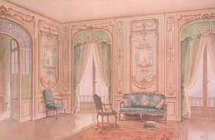
Regence Furniture & Interior.
It was in fact in the work of metalworkers such as goldsmiths and bronzesmiths where we see the best expression of Regence furniture design. Gilt mounts composed of assymetrical scrolls, shell designs, and floral motifs predominate. By asymetrical, to spell it out, is meant that the ornamentation on either side of a piece of furniture did not match exactly, and this rather sinous, curvy, style is the forerunner to the later Rococo of Louis XV furniture.
Regence furniture is a particular favourite of antique dealers and collectors.
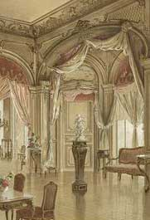
Regence Salon.

iv. Rococo Style
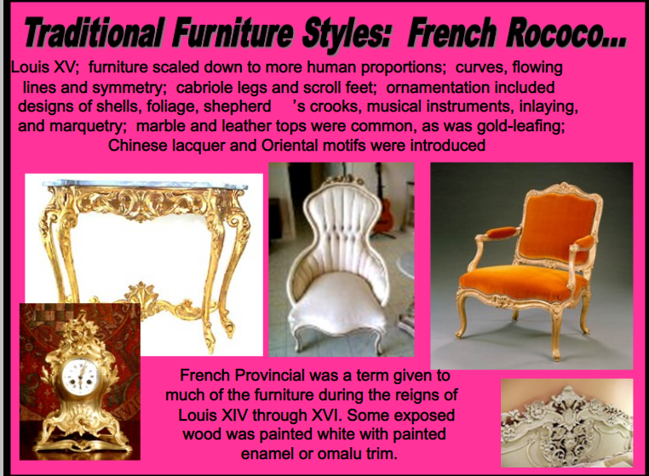
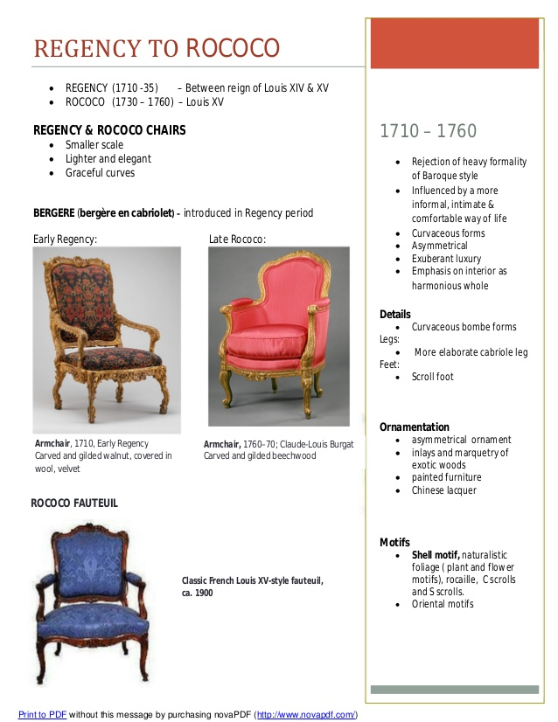

- Louis XV Period (1730–1770)
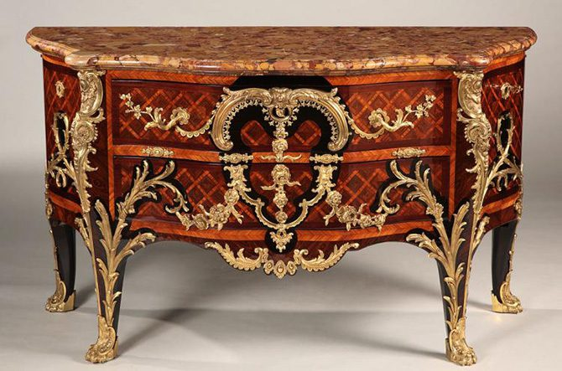
Marble-topped Marquetry and Gilded Bronze Louis XV Style Commode
Materials: oak, walnut, marble, porcelain
Louis XV reigned without his Regent for 50 years, during which time French culture and influence were at their height in furniture-making and beyond, even as the political influence of the monarchy waned. Curved lines and asymmetry overtook geometry as the style of choice, and while furniture became more practical and easily transported, it was nonetheless elegant. New items were introduced, like chiffoniers, card tables, dressing tables, and roll-top desks. Ornamentation included exotic themes, female faces, flowers, shells, doves, and dolphins. Oriental themes were pervasive as global trade became more accessible.
Louis XV Armchair, 1715-1774, Rococo
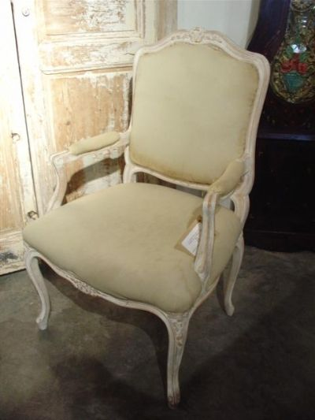
Louis XV Upholstered Chair, 1715-1774, Rococo
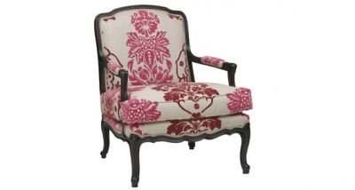
Louis Cane Chairs
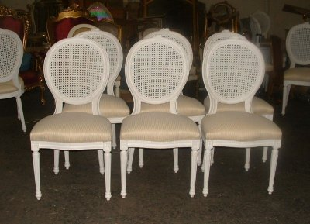
Louis XV Style Bergeres, 1715-1774, Rococo
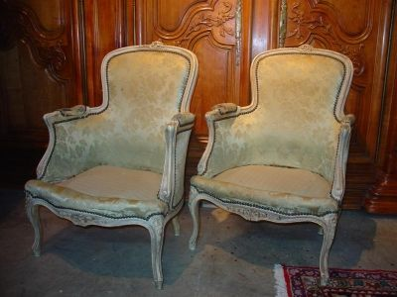
Louis XV Style, 1715-1774, Rococo
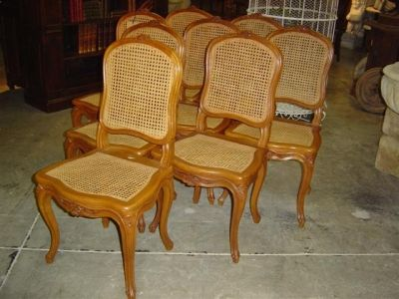
Louis XV Style
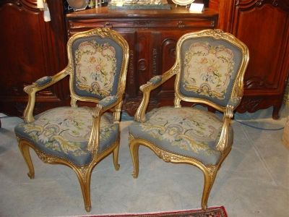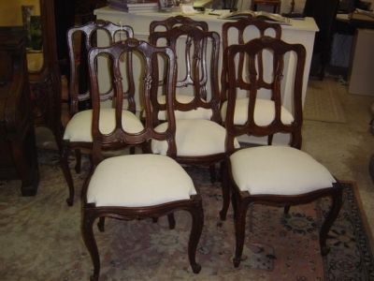
Louis XV Fauteuils Chairs French Painted
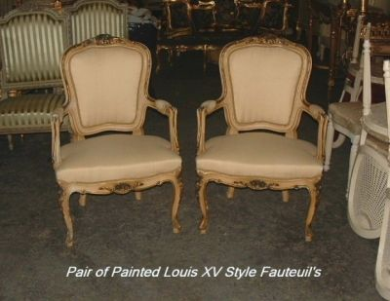
Louis XV Style, 1715-1774, Rococo
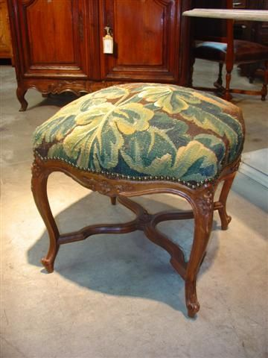
Chic French Painted Louis XV Bergere Chairs

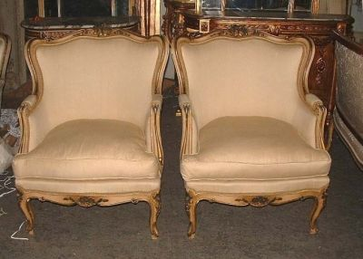
Louis XV Console Table.
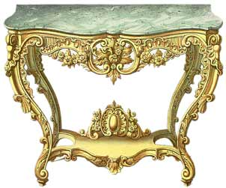
Louis XV Salon.
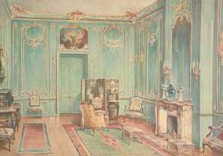
French Rococo Style Armchair, 1750.
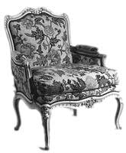
Commode, 1774.
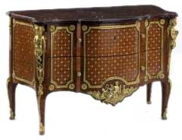

Classical Revival
In the late 18th century and throughout much of the nineteenth century furniture designers and artists return again and again to the heritage of the classical world of Greece and Rome, and now Egypt, and this is seen Louis XVI furniture, Directoire furniture, Empire furniture, Restoration, and Louis Philippe furniture, and to some extent in the reproduction furniture of Napoleon III.
v. Neoclassic Style
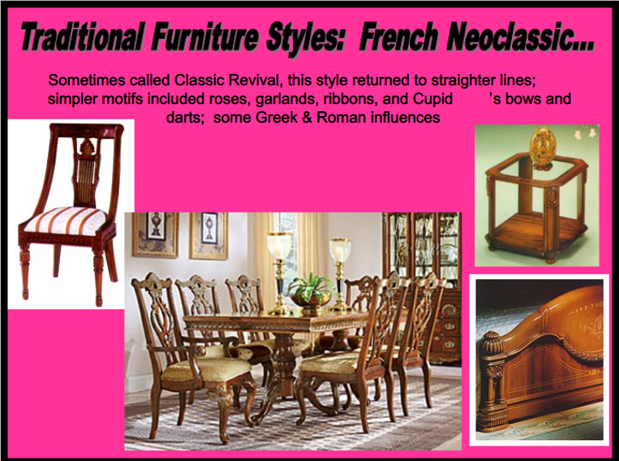

- Louis XVI Period (1770–1789)
Louis XVI - 1774 - 1792
Several years before the accession to the French throne of Louis XVI, or Louis Seize, we meet what is almost the exact opposite of the Rococo furniture of the preceding Louis XV age. Inspired by the discoveries at Pompeii and Herculaneum, which revealed something of the character of the interiors and furniture of the ancient classical civilizations of Rome and Greece, a new form of furniture design, the neo classical, comes to dominate the world of French furniture.
Characteristics
In Louis XVI furniture there is an emphasis on straight lines and right angles, seriousness, logical design, a sharp move away from the curves of the Rococo. Furniture becomes restrained in its form and decoration, with much use of fluted columns, carved friezes, oak and laurel leaf, wreaths, the Greek band, and other various neo classical attempts to imitate the furniture and architecture of the Romans and Greeks.
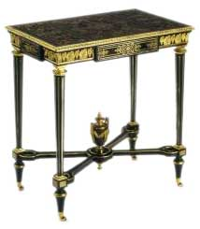
Side Table, circa 1800.Carcase of oak, pine and walnut, veneered with African ebony, tortoiseshell and stained wood; gilt-bronze mounts.
The Louis XVI neo classical style is also often associated with the "Etruscan" style, which was characterised by a fairly complex mixing in of sculpture like ornamentation and metal and ceramic mounts. After about 1770 we note the popularity of more simple furniture based on the classical architectural orders from ancient architecture.
Influences
The taste of Queen Marie Antoinette, queen to Louis 16th, is given a great deal of credit for the existence of the neo classical style in furniture design. She was much responsible for the making of many small pieces of furniture that suited the furnishings of her apartment at Versailles.
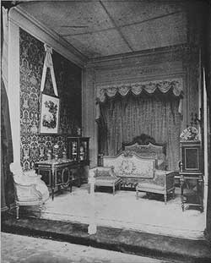
Marie Antoinette's Bedroom.
A reproduction of Queen Marie Antoinette's bedroom at the Little Trianon, in Versailles.

Makers
Late 18th century furniture makers in France included Jean Henri Riesener, Jean Guillaume Beneman, Jean Henri Martin Carlin, and Adam Weisweiler.
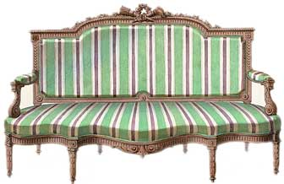
Louis XVI Sofa.
Revolution
The downfall of the Louis XVI style was of course the downfall of Louis himself in the French Revolution of 1789 and from this time French furniture lost its position of dominance. However the tradition of neo-classical furniture did linger on into a second phase, called Directoire furniture.
Materials: oak, walnut, ash, mahogany, ebony, porcelain, copper, steel, bronze, marble
Furniture created during the reign of King Louis XVI favored a more rustic feeling than previous eras. Increasingly, dining room tables came into use. Mahogany was popularized, and turning came back into fashion as a means for decoration. Straighter lines and right angles returned, and classical motifs became typical once more while human faces, flora and fauna remained popular decorative motifs.
Louis XVI-Style Bergere Baroque Style, Cir 1600

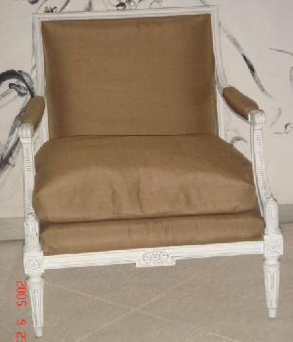

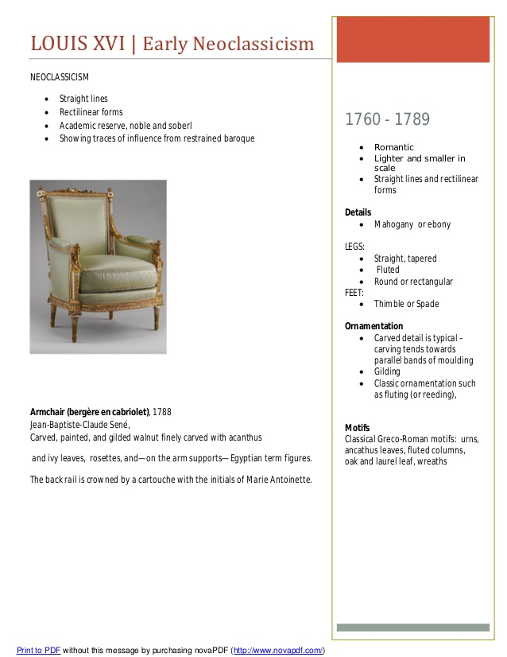
Chic French Country Tapestry Louis XVI Settee Sofa
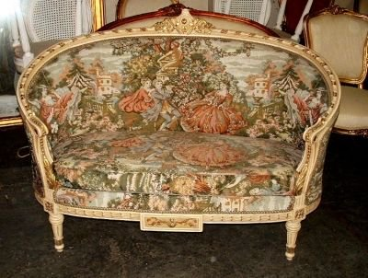
Louis XVI-Style Large Scale Marquis, 1600 Baroque Style Neo-Classic Design
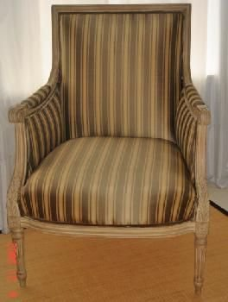
Louis XVI
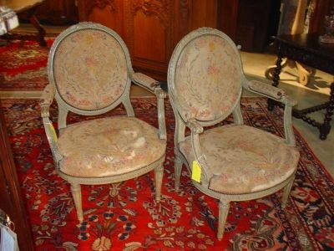
Louis XVI Style Giltwood Caned Chairs
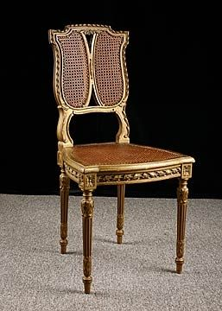
Louis XVI Chairs, Pair of Chic French Country Painted
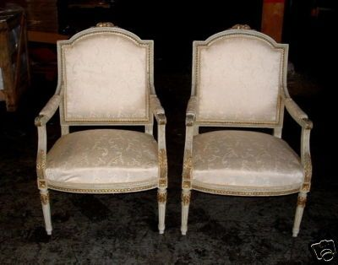

vi. Mid Neo-classic style
Directoire (Transition period) (1789–1805)
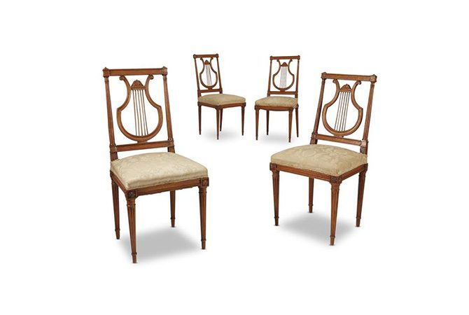
Four Directoire carved fruitwood lyre-back side chairs, late 18th century
Materials: elm, walnut, beech, ebony, copper, brass
After the collapse of the monarchy, France entered a tumultuous period of revolution marked by Neoclassical forms, which reflected the importance of Roman Republic principles to France’s new leaders. The demand for decorative arts was high but clients did not possess the same exacting eye as before, so furniture was mainly economical with some design flourishes.
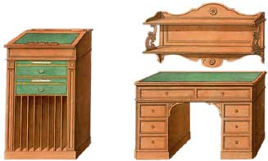
Directoire Furniture.
Geometric patterns remained in use but were less extravagant than before, often integrating a Grecian urn into the designs. The caryatid form was also used. And we note the entrance of Egyptian motifs into furniture design. Furniture of the Directoire time sometimes included carvings of sphinxes in the bronze hardware detailing.
The directoire period is often considered to be a transition between Louis XVI and French Empire furniture, and therefore has characteristics of both, with a psychology of its own, and is sometimes called Transitional furniture. The Directoire marks the early beginnings of the Empire style and came about due to various historical circumstances: the luxury of the ruling classes under the Louis; the rebellion of an oppressed people and the Revolution; condemnation and destruction of luxuries and consequent reaction to simple living.
Directoire Interiors
Architecture and interior decoration were in especially good accord during the Directorate and later First Empire. Directoire rooms and interiors are often what people unconsciously think of when something is called French.
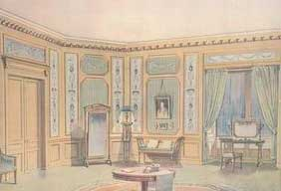
Directoire French Interior.
Directoire French interiors are characterised by painted wallpaper instead of the tapestries of earlier French periods, furniture coverings and curtains of cretonne with classic designs in place of brocades and damasks, or magnificent textiles; simple curtain poles, often arrow shaped, not heavy cornices; painted furniture with straight lines or simple mahogany and chestnut; chair backs showing the graceful backward curve from seat to rolled-over chair top ; slender and curved legs like the silver line of a very new moon, the classic type (with outward curve) seen in ancient Egyptian and Greek frescoes.
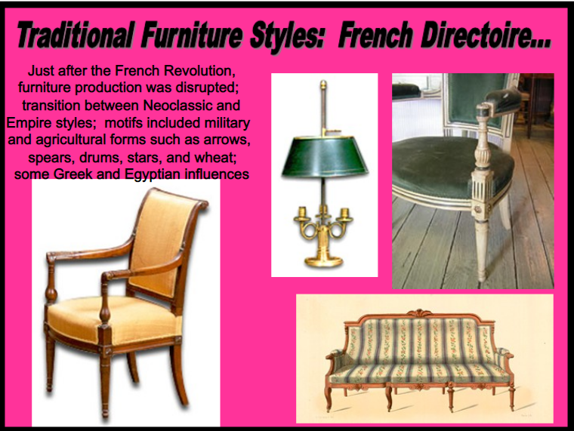
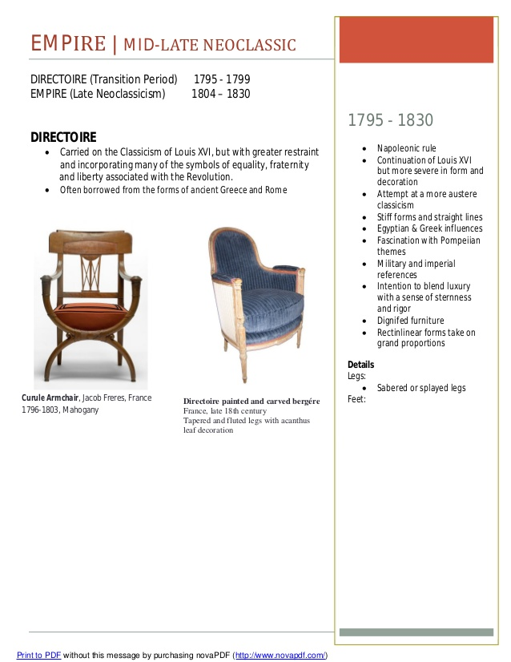
Directoire to Empire
The Directoire furniture period is often classed together with the next part of our story, French Empire furniture.
vii. Late Neo-classic style/Empire style
Empire Period (1805–1815)
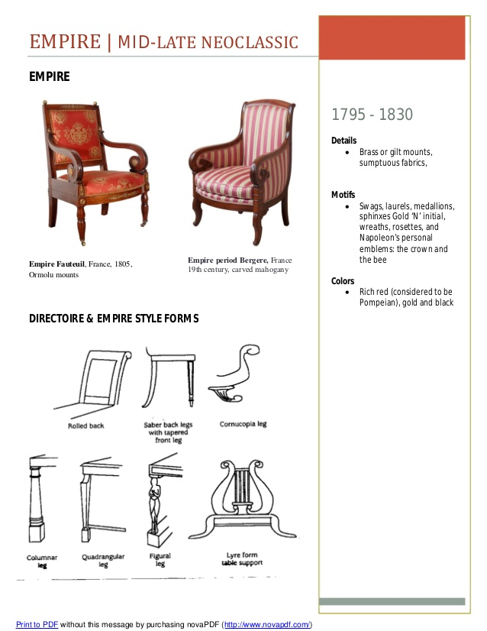

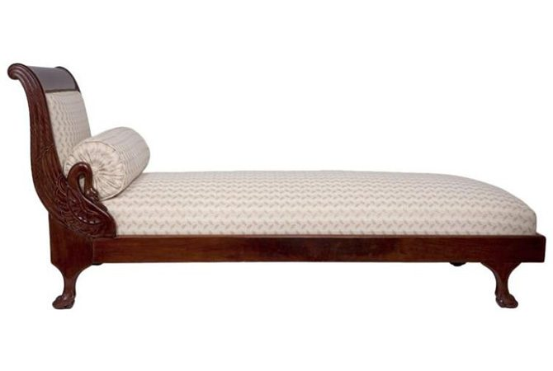
Empire Mahogany Daybed, early 19th century
Materials: mahogany, walnut, burled elm, bronze, marble
The Empire style was popularized during the reign of Napoleon I and is marked by a continuation of Neoclassical motifs from the era preceding it, albeit in a more elegant and opulent way. Napoleon centralized artistic production so that furniture design was consistent, its grandeur marked by symmetrical ornamentation and large, solid forms. While other styles developed after Napoleon lost power, the Empire style was in favor for many decades.
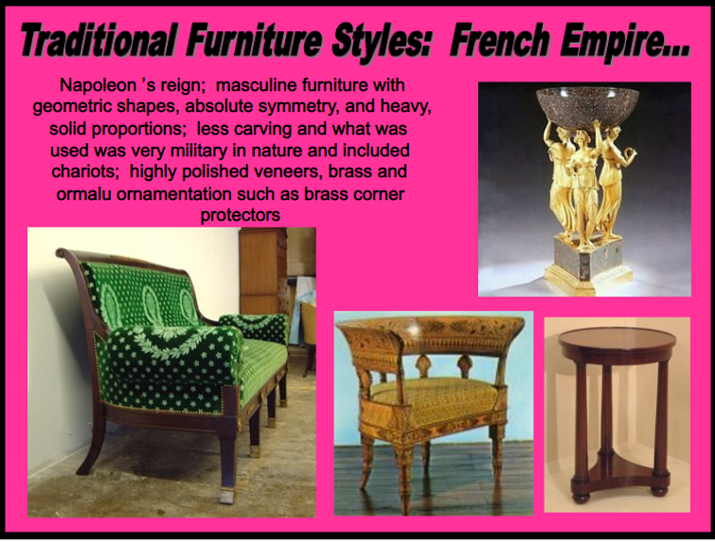

1804 - 1814
The French Empire style, or First Empire, was developed during the reign of Napoleon, and the letter "N" was found everywhere in the decoration and interiors of the period. The style was a revival of Greek, Roman and Egyptian motifs which had begun in the neo classical period and extending through the time of Directoire furniture. Empire style was paralled in England in the time of Regency furniture and in American Empire furniture.
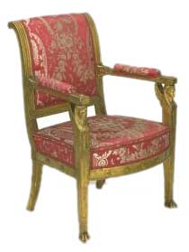
Empire Chair, 1810.
Carved and gilded beechwood, upholstered in red silk damask.
Characteristic Features
The wreath, torch, Sphinx, Greek band, honeysuckle, Roman eagle, columns and scroll supports predominated in 1st Empire furniture. Classic shapes or lines and classic decorations in chiseled bronze, called ormolu, were notable attempts in the neoclassic style. The subjects for ormolu decorations were taken from Greek mythology and were often combined with emblems of liberty, lyres, rosettes, and so forth.
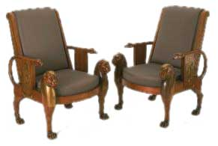
Empire Egyptian Style Chairs, around 1803-1813.
Mahogany, with ormolu (gilt-bronze) mounts.
The original designer of this kind of chair, Denon, copied a number of designs for chairs from the walls of ancient Egyptian tombs, including several which relate to this chair.
There was also much fine brass inlaying figures on Empire furniture. Marquetry and carving were discarded and plain surfaces were decorated with brass and ormolu mounts of antique emblems. Mahogany was the principal wood employed and considerable veneering was used.
On some French empire furniture we also see fine "turning", not spiral, but in a round style which can be seen in the legs of sofa on which Madame Recamier reclines in the well known portrait of her by Jacques Louis David, as in the picture below. David, who was court painter under Louis XVI, became during the Empire era the prime influence and eventually a kind of artistic dictator of this movement to revive the classical.
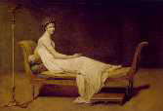
Madame Recamier
Influence of Napoleon
Napoleon wanted to be surrounded by all the dignity and pomp associated with the great Roman generals, and those who served him catered to this wish. On his return from Borne and Egypt furniture made for his palaces reflected styles he had seen in both places. As such it is because much so called Late Empire furniture was really just slavish imitation of what had been made for another time and different conditions that it is sometimes judged the least attractive of the period.
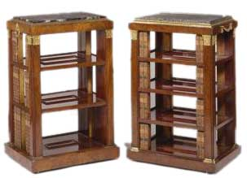
Empire Etagere, 1812.
Mahogany, on a carcase of oak and poplar; the capital mounts chased and gilt, the handles probably lacquered brass. Top with Rosso antico marble slab.
This form of small open bookcase was an innovation in the early 1800s.

viii. Regency style
Restoration Period (1815–1830) (Louis XVIII: 1815-1824 & Charles X: 1824 – 1830)
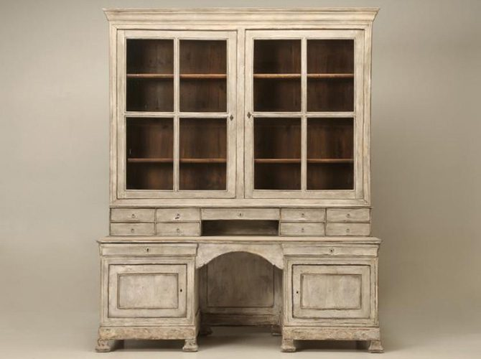
Antique French Restoration Bookcase and Desk, circa 1815-1830Materials: ash, elm, maple, marble
When Napoleon was defeated at Waterloo, the Bourbons once again ruled France. The reintroduction of the monarchy influenced furniture design of the time, which was comfortable and portable. Molding was delicate, as light as other ornamentation, and popular motifs included cornucopias, floral bouquets, and ribbons.
The styles associated with the reigns of Louis XVIII and Charles X are largely in line with the earlier Empire furniture although they are seen by many as a decline into decadence.
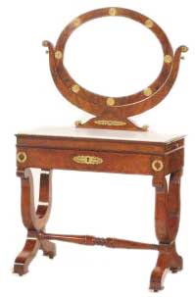
Dressing Table, circa 1825.
Solid mahogany, veneered on beech, oak and poplar, with lacquered brass mounts and a white marble top.
This type of dressing-table, with looking-glass attached, was a form developed in the early years of the 19th century, and some exceptionally grand examples were made by Parisian cabinet-makers, for example Jacob-Desmalter & Cie and Francois Remond.
At the beginning of the Restauration period, under Louis XVIII, furniture was designed still mostly in the Empire style with the difference that the symbols used during the reign of Napoleon I were no longer used for obvious reasons.
A softer version of the Empire style came into vogue at this time in the early 19th century in France. While cabinetmakers continued to employ the strong geometrical patterns of the Empire period they also added a some amount of whimsy and fantasy in their designs. Musical instruments were carved into the legs of small tables and desks. Woods were lighter in both color and density and the art of marquetry returned with decorative flowers, garlands and rosettes, and detailing that highlighted the architecture and geometry of furniture.
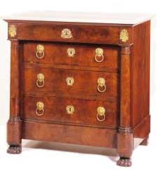
Restauration Commode, circa 1825.
Mahogany veneered on oak and poplar, with lacquered brass mounts and a white marble top.
This commode, with its naturalistic floral mounts, is likely to have been made in the years of the Restauration of the Bourbon monarchy.
Furniture making slowed down due to economic uncertainty and furniture was not a focus of the French kings of this period. Rooms and interiors were being designed with more emphasis on comfort than display and the old way of keeping seat furniture against the walls was abandoned.
Smaller sized pieces of furniture were made with "Bateau" (boat shaped) beds, gondola chairs, and three-legged tables being important items of early nineteenth century French furniture.
Gondola Chairs
Chair design reflected the change to make rooms more intimate and personal with conversational seating arrangements. The predominant shape in chairs was the "gondole", or gondola. The gondole design was comfortable and the smaller size made it easily portable. During the reign of Charles X the use of "bois clair", or blond woods, became popular and dark wood marquetry with palmette motifs was used for decorative effect rather than bronze.
Wood
For contrasting effects in marquetry light French and exotic woods were used : burr ash or elm, flecked maple, satin wood, sycamore, walnut were used together with types of rosewood, mahogany, and ebony. There was also some use of gilt bronze.
What is termed the Restoration period in French history sometimes includes the time of Louis Philippe furniture looked at in the next section.
ix. Electric Style
a. Louis Philippe Period (1830–1850)
Materials: mahogany, rosewood, walnut
Louis Philippe came to power when his cousin, Charles X, was forced to abdicate after the July Revolution (an event that inspired the allegorical painting “Liberty Leading the People” by Eugene Delacroix). The rise of the bourgeoisie led to a deviation from the formality of earlier furniture to softer, sparser designs. Most pieces were curvilinear, and coil spring upholstery was popularized.
1830 - 1848
The Louis Philippe style in France followed the same general pattern as the furniture of the French Restoration but perhaps with more emphasis on comfort and a darkening of tone.
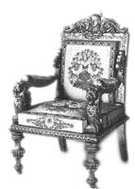
Louis Philippe Chair, circa 1830.
Louis Philippe Chairs
Chairs shapes changed, becoming more rounded with softer, smoother lines. Chair arms were decorated with scroll work and front legs put in an s-shape, ending in a scroll up to the corner blocks.
Cathedral Style
Another notable fashion in the Louis Philippe furniture period was the "style a la cathedrale" which came to prominence around 1825. Louis Philippe chairs kept the same shape consistent with the period but were decorated with gothic architectural designs in sculpted form. Such chairs sported crenelated top rails and foliate spandrels. Decorative details now usually were carved by machines with a flatter appearance.

Wood
During the reign of Louis Philippe, the color, grain, and quality of the wood became more a focus of design. Wood was painted in black, decorated with gilt with painted decoration, and sometimes veneered.
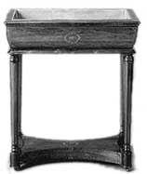
Jardiniere, 1835.
Clear, light wood lost out to darker woods. Mahogany and palissandre were still employed while ebony and other darkened wood such as beech and pear tree came into use. Flood, sycamore, wild cherry, magnifying glass of elm, maple, root of if reddish, thuya were also common woods of the age.
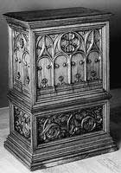
Gothic Cabinet, 1836.
The Gothic cathedral style was an example of the popularity of reproduction furniture which occupies our interest in the following era of Napoleon III.
b. Napoleon III (Second Empire Period) (1848–1870)
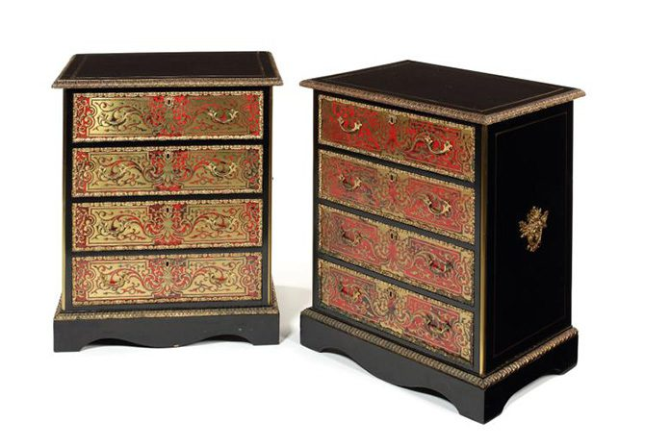
A pair of Napoleon III side cabinets with tortoise-shell and brass marquetry.
Materials: ebony, walnut, cast iron, mother-of-pearl, porcelain
Like the scattered history of the 19th century in France, the furniture of Napoleon III’s rule is an eclectic mix of previous periods and outside influences. Seating options, such as ottomans, were extremely popular and extensively produced. Decorative imagery was pulled from Asia, Africa, and native cultures in America.
The era of Louis Napoleon, Emperor of the French, is known as the Second Empire and constitutes the peak of the popularity of reproduction furniture much as occurred in late Victorian England.
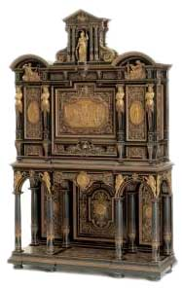
French Cabinet, 1865.
Ebony, partly veneered on oak, with inlay and carved decoration in box, lime, holly, pear, walnut, mahogany and hardstones.
Displayed at the Exposition Universelle in Paris in 1867.
Battle of the Styles
A great number of revival styles competed with one another including Renaissance revival and Henri II furniture, reproduction Boulle furniture of the baroque period, and revivals in rococo and neoclassic Louis XVI furniture.
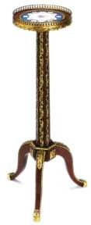
Gueridon, 1870.
Solid mahogany and mahogany veneered on oak, with inset plaque of porcelain or bone china and gilt-bronze mounts.
This stand was made to support a reading light or as an occasional table. Such pieces are sometimes known by the French name gueridon, a term originally used in the 17th century for a circular tray on a pillar, made of carved and gilded wood, used to support a candelabrum.
The top is inset with a soft-paste porcelain plaque, perhaps made originally as a plate at the French national porcelain factory at Sevres, near Paris. It was probably later ground down to form this table top. The decoration was almost certainly applied in the 19th century, probably by expert flower painters in Britain who sought to imitate the fine work of the painters at Sèvres.
Rococo Revival
From around 1840 the era of Rococo furniture in France was revived from its 100 year old slumber. The main features of this reproduction style included use of cabriole legs, fanciful carvings such as the shell, curved surfaces, and great use of C and S scrolls.
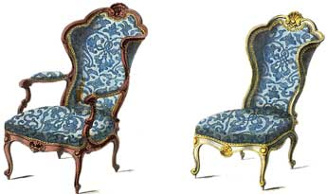
Rococo Revival Chairs.
Renaissance Revival
The Renaissance revival came about largely due to the influence of Napoleon III, the Emperor wishing to have his name associated with the classical grandeur of Rome and cement his place in French history.
The main attributes of the revival in the Renaissance style were carved and ornamented decoration particularly used in the bedroom and dining room furniture of the period.
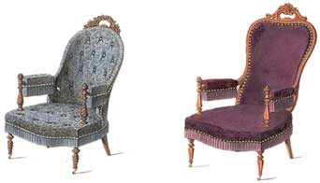
Renaissance Revival Easy Chairs.
The craze for reproduction furniture at this time is evidence of a lack of innovation which continued through the 19th century in France until the rise of the art nouveau furniture movement.

3. German Furniture
The Germans are not a fashionable people and their furniture, and art generally, does not always receive the attention it deserves.
German Renaissance
Prior to the emergence of the European renaissance in the 15th century German furniture had been steeped in the Gothic tradition and Gothic elements continued to exert some influence after the Renaissance had fully penetrated Germany in the 16th century, or specifically around 1550, under the leadership of Albrecht Durer. The other main difference between German Renaissance furniture and its counterparts in Italy and France was the freer style of carving, German carved furniture being of a more robust, less delicate nature, than the painfully careful work seen in Italian Renaissance furniture.
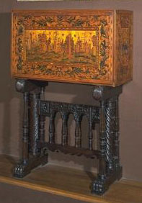
German Cabinet, 1560, by Hieronymus Wolf.
Marquetry of walnut, plum, maple, birch and other woods, carved boxwood drawer fronts and pine carcase.
Augsburg
As early as the 1550s the grandest cabinets and cupboards in Europe were being made in Augsburg, and by the 1590s they were regarded as highly important diplomatic gifts, fit for kings. The furniture of Augsburg, which had been a cabinet making centre since around 1322, was extraordinarily dazzling and showy, employing the most advanced and never-before matched techniques, but was meant largely for display than use.
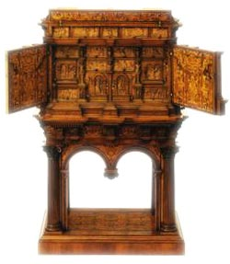
Augsburg Cabinet, 1560.
Oak carcase, with ash-lined drawers, boxwood carving and inlay of various woods.
On the exterior of two outer doors there are battle scenes based on engravings by the Swiss artist Jost Amman (1539-1591). The fronts of the internal drawers consist of reliefs in carved boxwood. These reliefs depict moral themes based on engravings by the German printmaker Virgil Solis (1514-1562).

17th Century
German furniture of the period normally termed "Baroque" in 17th century Europe became distinguished by its use of marquetry treatment of furniture, especially on cabinets. German cabinetmakers made innumerable tables, chests, cupboards, and cabinets, with very elaborate and finely wrought marquetry decoration. On chests as well is to be seen some use of architectural type forms.
German cabinet making at this time was renowned throughout Europe, particularly the centre of Augsburg, and it the fashion among European royalty to order custom pieces from Germany continued unabated.
18th Century
During the time of the dominance of Rococo styled designs the city of Dresden distinguished itself by the production of many very specialised and unique items such as writing cabinets and bureaus, usually done in exquisitely beautiful and complex form. The workshops of Martin Schnell, early eighteenth century, are noteworthy in this regard, especially for painted furniture.
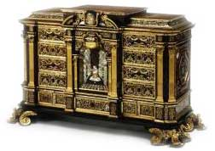
Marquetry Cabinet, 1715.
Marquetry of tortoiseshell, mother-of-pearl, brass, copper and silver, on an oak carcase, with gilt-copper mounts and drawers lined with printed paper.
German rococo furniture was characterised by the popularity of lacquer work with chairs and tables decorated with scarlet, embellished with gold, and crowned with ormolu mounts being important works of the era.
The furniture makers Abraham Roentgen and his son David, in their Neuwied workshop, were influential designers having some impact on the course of French furniture. David Roentgen in particular was noted for his combining of Rococo styles with native German traditions, and his chests, bureaus, and cabinets were much sought after in fashionable European circles.
19th Century
The neoclassic period of furniture in Europe that arose in the early nineteenth century, was, in Germany, known as Biedermeier furniture and it remains today popular among antique collectors.
- Biedermeier Period Furniture

From the 1820s to the 1840s in Germany, as well as Austria, the Biedermeier type of furniture design was wildly popular, especially among the middle class.

Biedermeier Style

The Biedermeier style is a take on French Empire furniture, but modified to incorporate local German traditions, particularly old peasant furniture. Biedermeier style is simple and elegant, consisting of clean, smooth lines, and utilising light color wood, sometimes with painted black highlights. Veneered cherry, walnut, ash and birch are the predominant woods used, most of them coming from German farm and orchard lands.

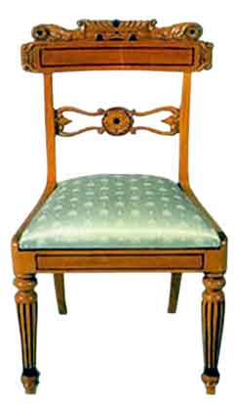
Biedermeier Chair.

Biedermeier furniture craftsman eschewed most forms of ornament, preferring simplicity. When there is ornament such as carving there is little detail in the work, although by around 1830 more detailed carving became prevalent. The main decorative motifs employed by Biedermeier era craftsmen included simple forms of swans, sphinx, dolphins, lion paws, acanthus, lyres, and garlands.

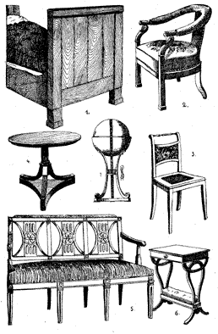
Biedermeier Furniture

1. Bed of Hungarian oak. 2, & 3. Biedermeier chairs from Vienna, 1820-30. 4. Table from the castle of Obernzenn in Unterfranken. 5. Biedermeier sofa. 6. & 7. Sewing tables from Vienna, 1820.

In wider terms, or cultural terms, it has been suggested by many scholars that the Biedermeier style was an insular and conservative one, that it emphasised domestic comfort and security, and attempted to block out the world outside, a world engulfed in conflict in the age of Napoleon.

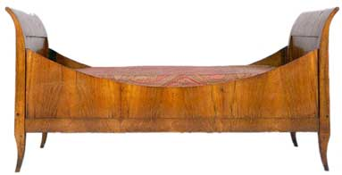
Biedermeier Sleigh Bed.

Biedermeier Interiors

The Biedermeier style of interiors and home decorating revolves around the use of light colours and a certain simplicity, and perhaps sparseness, in decorations. There is order and balance but it is informal, unstuffy.

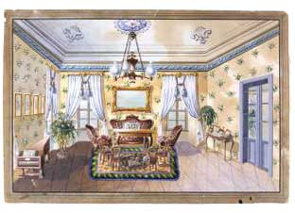
Painted Biedermeier Interior, 1840.

There is little emphasis on draperies and textiles as backdrops with wallpaper schemes often being of intense, deep colors.

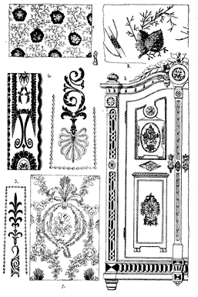
Biedermeier Design.
1 & 2. Samples of cotton fabric. After the originals in the Industrial Art Museum in Berlin. 3. Cupboard front Unterammergau, 1820. 4. Sample of material for Biedermeier furniture covering. After the original in the Industrial Art Museum, Berlin.
Modern German Furniture
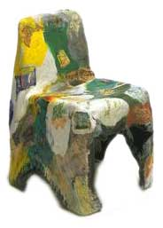
Recycled Plastic Chair, 1996.
Germany today is the third largest manufacturer of furniture in the world and German contemporary designs, particularly in upholstered furniture, dominate some markets. Much of the impetus for the modern German furniture industry can be traced back to the early 20th century Bauhaus furniture movement.

- Bauhaus Furniture
The Bauhaus school in Dessau, Germany, was probably the most important school of art, design, and perhaps architecture of the 20th century. Its avant garde designs made a radical break with the antique past and pushed German furniture design firmly into the Modernist camp.
The school, the "Staatliches Bauhaus", existed from 1919 to 1933. The term is based on the verb "to build" and the best translation is probably "Architecture House". The Bauhaus movement artisans emphasised function over form, decoration was discarded in favour of fairly strict use of clean lines, a characteristic of much modernist furniture.
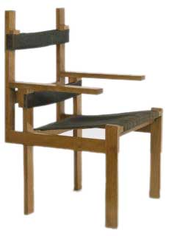
Bauhaus Chair, 1922, by Marcel Breuer.
Cherrywood, with horsehair and cotton upholstery.
The design of this wooden chair is strongly influenced by the Dutch "de Stijl" group, in particular by the furniture of Gerrit Rietveld. It is a particularly notable example of Modernist furniture, more concerned with artistic expression than comfort.
Chair Designs
The most famous items of Bauhaus furniture are Cantilever chairs and the model B3 chair, also called Wassily chairs.
Cantilever
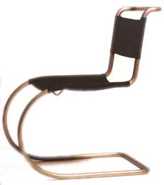
Cantilever Chair.
Cantilever chairs have no rear legs, relying for support on the tensile properties of steel tubing, the original material from which they were made. Several people can be credited with the development of this type of Bauhaus chair including the Dutch designer Mart Stam in 1926 and also the Hungarian furniture designer, Marcel Breuer (1902-1981) who is one of the most influential furniture designers of the 20th century. Breuer was the first to incorporate tubular steel into furniture design.
Wassily Chairs
Breuer was also responsible for the innovative design of the Model B3 chair, the Wassily. These chairs were radical in their use of bent steel tubes and leather, and methods of making. It is generally believed that Breuer's push-bike was the inspiration for him to use steel tubing to make these chairs.
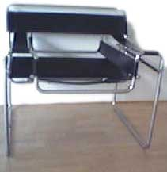
Wassily Chair.
Steel proved to be a useful material for furniture construction with Wassily chairs, like many other designs of the modernist furniture movement, being mass produced in the 1950s and 1960s.

4. Scandinavian (Northern Europe) Design Furniture & Decorating
Scandinavian here is a geographical term covering Sweden, Norway and Denmark, and also Finland for our purposes.
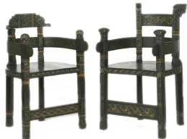
Viking Revival Chairs, 1900, by Lars Kinsarvik.
Carved and painted pine.
Shown at the International Exhibition in Paris in 1900. This is in the Norwegian Viking or Dragon style. On this chair, designer Lars Kinsarvik combined motifs that he would have seen in ancient Nordic art and architecture, with the colourful decoration that was typical of more modern Norwegian peasant furnishings.

Design
Furniture design and decorating styles in the countries of Scandinavia are renowned internationally for their innovative, contemporary, and streamlined qualities. Scandinavian design is characterised by a focus on function or utility, by a continued committment to modernist ideals and the use of modern technology and materials, the use of teak wood, naturalistic forms of pottery and glassware, and clear, simple patterns for fabrics.
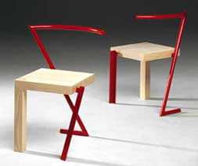
Scandinavian Chairs.
Furniture - Neoclassicism For The Masses
The overwhelmingly dominant theme in Scandinavian furniture design is the strength of neoclassicism, a neoclassicism in its most modern, advanced, and rigorous stage.
The Stockholm Exhibition in 1930 and the 1939 World's Fair in New York, did most to introduce the world to the characteristics of Scandinavian style furniture and its simple, clean, and light-weight designs as can be best seen in Danish furniture and also in Swedish furniture. Quality craftsmanship joined with mass production where possible and suitable are the major points of the style. Bent plywood is a frequently used material as is metal.
i. Danish Furniture (Denmark country)
The most striking aspect of the history of Danish furniture design is the constant recurrence of Classical forms, even in modern times.
Early History
Before the impact of the European renaissance was felt on the world of Danish crafts and arts Danish furniture was in the Viking tradition.
Post Renaissance
Danish furniture design as a distinct entity is not really recognised until the 18th century. Prior to the 18th century the only works of note are those from the hands of Hans Gudewerth and his son of the same name who produced highly detailed carved chests incorporating biblical motifs with three dimensional decoration of an architectural nature with plant motifs and grotesque ornamentation.
Later, influences from the main cultural and artistic centers of Europe become pronounced. In the area of Danish interior design and soft furnishings the French Rococo style is made some use of, although it is a softer, less dramatic form, and is made to blend in with a more Classical style, better suited to the Danish temperament. In furniture design proper German furniture of the 18th century has the most impact, in both its baroque and rococo stages.
In 1754 the Danish Royal Academy of Fine Arts was established and gave some structure and direction in the training of furniture artisans, mainly in the area of drawing, however in general it is architecture that proves to have the most profound effect on the course of the Danish design arts.
The first major architect to influence furniture was C.F. Harsdorff. Harsdorff designed mahogany furniture in strict, Doric classicism, with simple, clear construction and form containing features that were later to prove typical of much Danish furniture.

19th Century
As early as the late 1700s English neoclassical influences, which in Denmark produced delicate, painted furniture decorated with classical motifs, made by J.C. Lillie among others, were beginning to have their impact. In the 1800s this was furthered with most Danish furniture being made in an English inspired simple Classicism from mahogany wood with inlaid citrus wood decorations of classical figures and borders. Typical pieces of this time were light horsehair upholstered arm-chairs and benches with lattice-work.
Inspiration was taken from Greek and Roman wall paintings, vases and reliefs, and attempts were made to make faithful copies of antique furniture much as occured in Regency furniture in England. This period in Denmark is known as the first "Golden Age" and was dominated by the works of Nicolai Abildgaard, Gottlieb Bindesbøll, and H.E. Freund who were designers of furniture and interiors in the Pompeiian style.
Later in the nineteenth century, and into the 20th, the Arts and Crafts movement, Art Nouveau naturalistic forms, as well as Japanese styles of design become important. Classical Roman motifs come to be replaced by native Nordic ones, particularly in flora and fauna ornamentation.
Modern
While, as we have seen, the history of furniture in Denmark is not simply restricted to Danish modern furniture much of our interest does centre on the contemporary designs which Danish style furniture is most famous for.
Form and Function
In contemporary Danish furniture the major driving force is an attempt to harmonise the aesthetic qualities of furniture with the obvious practical functions of sitting, eating at, etc.
The Royal Academy of Fine Arts established a school for furniture design in 1924, and in 1927 this was followed by the Guild of Cabinet Makers starting yearly exhibitions of Danish furniture designed by architects. Kaare Klint, an important designer, tutored in the Academy of Fine Arts and had a considerable influence over Danish furniture design well into the 1950s. Klint and his students paid much attention to detail, worked with traditional types of furniture, and held firm to the use of wood, such as teak, and the specific skills needed to work with it, all in contrast, and reply to, Bauhaus furniture designers in other parts of Europe who made mass produced steel furniture.
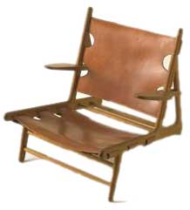
Hunting Chair, 1950, by Borge Mogenson.
Oak and leather.
This chair was designed by Borge Mogenson and made by Erhard Rasmussen in Denmark in 1950. The frame is made from oak and the seat and back support from leather. A series of buckles are used to fasten the leather but are only visible from the back and underside of the chair. This model was designed as part of the furnishings of a hunting lodge shown at the Copenhagen Cabinet Makers' Guild exhibition of 1950.
This period of functionalism from the nineteen thirties to fifties is the second so-called "Golden Age" and its famous designers were Mogens Lassen and Poul Henningsen, and later Børge Mogensen, Hans J. Wegner, Finn Juhl and Mogens Koch, and it is notable by being again largely grounded in Classical ideas of proportion, line, and form.
Danish Design
Following the end of the Second World War the Danish modern furniture tradition made varied attempts to come to terms with, and take adavantage of, the effects of industrialisation. The story here is a fairly complex one with different strains competing for attention. Some designers, like Arne Jacobsen, embraced modern materials and methods of production, and produced the ever-popular tubular steel chairs.
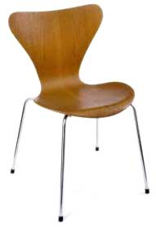
Danish Chair, 1957, by Arne Jacobsen.
Moulded teak veneered plywood, with satin chromium-plated tubular steel legs.
This is one of the most successful chair designs of the 1900s. Its simple and elegant form and suitability for mass production contributed to its success. It is still being made and comes in a range of finishes, including natural oak and bright colours. In 1957 Arne Jacobsen (1902-1971) won the Grand Prix for the chair at the Triennale Exhibition in Milan. Many companies have copied and produced their own versions of this design.
The Bauhaus style of design was taken up with enthusiasm and verve by Poul Kjærholm as seen in his minimalist furniture works. Finn Juhl reacted against the Bauhaus with his expressive, organic furniture.
From the 1960's the Danish style of furniture design became increasingly influential around the world. Often called industrial design, the main factors in its uniqueness are an emphasis on what might be called natural functionalism. Strictly geometrical shapes are avoided, there is much importance placed on simplicity, and on the interaction between the user of the furniture, his or her surroundings, and the tools and materials necessary for making.
Modern Manufacturers & Stores
Manufacturers and stores outlets with a strong design tradition today include Bang & Olufsen, the LEGO Group, Danfoss, Grundfos, VELUX, Kompan, Novo Nordisk, Coloplast, Fritz Hansen, Louis Poulsen among others.
ii. Swedish Furniture & Design (Sweden Country)
Overview
What constitutes Swedish design in brief and in general is simple shapes, symmetry, pale colours, emphasis on adapting form to function, that is making useful things, furniture in light or "blonde" wood, and textiles with checks and stripes. Swedish design is rarely obviously decorative or pretty, tending rather to the serious, even austere, or cold side. In some ways it represents the triumph of neoclassicism in the modern world.
In the minds of many Swedish furniture, specifically, is most associated with suburban IKEA stores in innumerable locations through the America, Canada, the U.K. and elsewhere, selling a cheap version of Swedish style decor and home decorating, particularly bedroom furniture. However the design history of Swedish antique furniture holds some interest in the overall story of Scandinavian furniture.
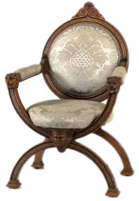
Swedish Armchair, circa 1880, by Carl Svensson.
Veneered in rosewood, with engraved pewter inlay, the cross-banded fillets veneered in tulipwood, the carving in solid rosewood and walnut; removeable pad seat and back panel with modern upholstery in cotton damask.
X-shaped chairs like this one were often formal, even throne-like, and this example is certainly made more for show than use. The way that the back panel attaches to the seat is weak and would not stand up to regular wear, though markings under the seat make it clear that this was one of a set of at least eight chairs. Carl Svensson, who put his mark under the seat, described himself as "Upholsterer to the Royal court". The chair may have been designed and made in his workshops or he may have bought it in for supply to a client. Such a practice was well established by the 19th century. The engraved pewter inlay is an unusual and elegant decorative detail.
Like other Nordic countries, perhaps excepting Finland, Swedish style furniture followed the main currents of furniture styles elsewhere in Europe, with much French, German, and English influence, although tempered and modified according to the strong local crafts traditions, and by the heritage of the Vikings.
Swedish Country
One of the distinguishing characteristics of Swedish furniture is the country and painted furniture styles to be found. Originating in folk arts with their typical rose painting and floral motifs, and influenced by English Arts & Crafts furniture, Swedish country style uses wooden furniture painted in faded primary colours. Stencil designs in contrasting colours of hearts and roses are also common in furniture decoration.
In general the Swedish country look is best suited to simple rustic homes with light and bright whitewashed rooms with plaster walls, bare, bleached wood floors with wide planks, and unbusy window treatments using plain muslin instead of curtains.
Modern & Contemporary
1930 Stockholm Exhibition
In 1930 the Stockholm exhibition marked an important step in the development of Swedish design. The Exhibition saw radical changes in architecture and some areas of interior decoration, with large windows, clean surfaces, open spaces and spartan decor. The architects like Sigurd Lewerentz, Uno Åhrén, Gunnar Asplund and Sven Markelius were given free rein to create something completely new.
In the area of furniture, Bruno Mathsson, to become one of Sweden's most internationally acclaimed furniture designers, found much inspiration in the Stockholm exhibition and it helped him continue his experimental chairs designs, with curved wood, cane and tubular steel. Bruno Mathsson was a pioneer in the functionalist furniture school and was active in later years in the computer workspace furniture making. Karl Malmsten is another of note, specialising in a more arts and crafts approach, but combined with the functional aspect, Malmsten has done much to give modern homes of Sweden a pleasant, graceful style, rich in interest and decorative qualities.
The styles and models of furniture exhibited at the 1930 Exhibition were heavily influenced, above all, by events in Germany, especially the Bauhaus furniture movement, and also had a strong social-political element, almost feverish, based in a desire to create new art for a new world. Much of the innovative and ground-breaking furniture designs and modes of interior decoration which were later to have such a large impact on the world also had their debut at this time.
Forties & Fifties
In the 19 40s and 50s Swedish design becomes more industrially focused. The work of Josef Frank, an Austrian immigrant, has had the most impact on Swedish home furnishings from this period, and is a charming combination of craftmanship and industrial production.
Nils Strinning, in the nineteen fifties designed the String shelf system – an almost universal feature in fifties era home. Strinning's shelves were made of teak wood and had nylon-coated steel wire.
Sixties & Seventies
Furniture design in this era became less decorative, was simple and fairly lean. The company Ikea, founded in 1965, making down to earth chipboard furniture, came into its own in the seventies, and fairly rapidly became the world's largest chain of furniture stores. Aside from Ikea, the designers Lindvall & Lindekrantz, and Huldt & Dranger, fashioned modern, aggressive looking tubular steel chairs and tables.
The Contemporary Era
Swedish furniture and interiors design has remained quite dynamic up to modern times. The focus on function and usefulness continues, and many talented designers remain employed by large manufacturers as well as smaller boutique producers. Designs are almost always simple, practical solutions to the needs of modern living styles. Alder, pine and birch are commonly used woods.
iii. Norway country’s
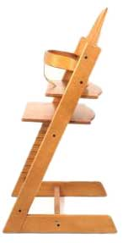
High Chair and Accessories, 1972, Norway.
Stained beech, with steel fittings.
This high chair is so adjustable that a child could use it from the cradle to the grave. The manufacturer's slogan is "The chair that grows with your child". It is designed to encourage natural movement even while the child is at rest, for greater comfort. The manufacturer believes, in accordance with Scandinavian design tradition, that the form or structure an item takes should develop from its usage by people. The two vertical side pieces, each in the shape of an inverted 7, have grooved inner surfaces to accommodate various horizontal elements, such as a baby rail, back rails (the upper one with a high centre to support a baby’s head), a seat, a footrest and stretcher rods. As the child grows, the high back rail and baby rail can be removed and the depth and height of the seat and footrest changed. For a full-sized person, the lower stretcher rod and original seat are also removed, and the footrest becomes the seat.
The types of Scandinavian furniture that remain popular items in stores include Scandinavian beds, often platform beds, and other bedroom furniture, office furniture and especially office chairs, recliners made of leather, contemporary coffee tables, and Scandinavian teak furniture.
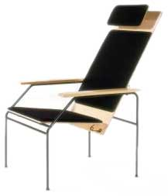
Finnish Modern Chair, 1979.
Tubular steel, metal fittings, laminated birch seat, and cotton upholstery.
This is one of the Visio range of office chairs that were shown at the Milan Furniture Fair in 1980. It has four visible springs that allow the seat and back to tilt, responding to the weight and posture of the sitter. Another version was produced with a lower back rest. Castors were optional for the feet. The functional pared-down form is typical of Scandinavian design, which at this time combined modern aesthetics with a concern for human needs.
- Scandinavian Furniture
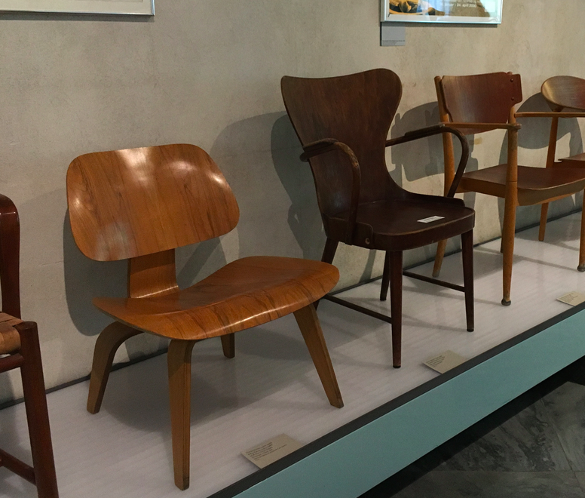

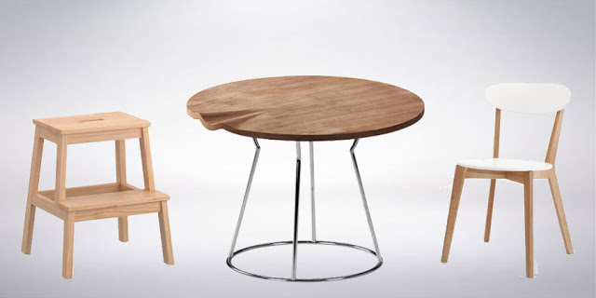
Scandinavian Style Furniture
Simplicity and function are the guiding principles that have shaped the design sensibilities of Nordic Europe.
The identifying features of Scandinavian furniture are...
- natural materials, mainly wood
- favour neutral colour palettes
- clean, simple lines
- optimal function out of every part of the piece
- robust and fuss-free

E.

Unique American furniture can add eye-popping touches to modern rooms, serve as prized investments, and be passed down as historically important heirlooms. American furniture, especially by mid-century modern and modernist designers, is one of the most widely collected types in today’s market.
Furniture periods in America were strongly influenced by regions abroad, namely in Europe and Asia, and were distinctly variant from the 17th through the 20th century. Today, the Early American furniture style is considered one of the most important furniture movements in America, as this style set the precedent for the American furniture movements that followed.
American Antique Furniture
The course of antique furniture history in America largely mirrors that of the English furniture tradition, and to some extent, events in Holland and France, and in order to fully appreciate the American contribution to furniture design in colonial and later historical times it will likely be found necessary to return now and again to the source, England, and follow developments there.
This is due to the fact that while colonial decoration and furnishing is distinct and recognisable, the United States did not develop a characteristic national style. The influence of England and France on the taste of the old colony moulded the work of American craftsmen, who were as skilled and thorough as their English contemporaries, but, apart from Nicholas Disbrowe and Duncan Phyfe, there are few names that stand out.
The development of American taste in the eighteenth century was directed by Europe, and even after achieving independence, English and French tastes in furniture still predominated. However, if we can find a main difference, it is that American antique furniture was made with practical concerns at the fore, decorative details and finery trailing behind in importance.
Major American Antique Periods
The periods of American furniture can be divided into two halves, the Colonial and the Federal.
1. Colonial Styles
In our broad guide through early American furniture we note the major trends in early antique American furniture history as well as deal with the major types of furniture, with pictures, in colonial times, often called the Jacobean period.
This early period spans from the beginnings of settlement until around 1720 when we meet the William & Mary style, the Queen Anne or early Georgian, and finally the Chippendale.
2. Federal Styles
Following independence we enter the Federal period which can be divided into three broad periods, the early Federal period, when the designs of Hepplewhite, Shearer, and Sheraton predominate, and the American Empire time when French inspired furniture comes to the fore.
After these classic antique periods we meet with American Victorian furniture.
1. Colonial Styles
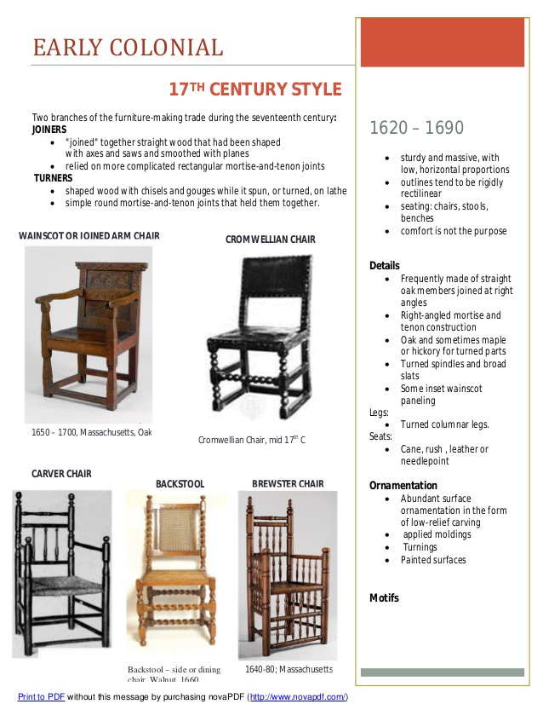
i. Early American Furniture: Colonial period

Across the water in the United States, during the early Colonial period, most furniture arrived along with the first immigrants. They brought furniture pieces typical of the Jacobean and Carolean periods in Britain with them, and then later made their own furniture in a similar style. These pieces were generally sturdy and heavily carved, many with turned legs and bun feet. In the harsher environment of some of the Colonies these pieces were simpler representatives of their parent styles, befitting the more straightforward and utilitarian life of the settlers.
Other settlers also brought their influences with them to the colonies, most notably the Dutch and French in the North east, and the Spanish in the South west. Although recognisably different from the British inspired designs, the Dutch pieces are essentially in the same tradition. However the different climate and different wood available to Spanish colonists led to a distinctly different style known as Mission or South western.
The earliest American-made piece of furniture is a chest made by Nicholas Disbrowe around 1660. Uncompromisingly rectangular, its distinctively carved frame-and-panel construction, although very reminiscent of earlier British Age of Oak pieces, is already recognizable as a distinct American style. Many other early Colonial era pieces, such as wainscot chairs and heavy joint-tables, are similarly in the Age of Oak tradition.
These pieces were generally sturdy and heavily carved, many with turned legs and bun feet. In the harsher environment of some of the Colonies these pieces were simpler representatives of their parent styles, befitting the more straightforward and utilitarian life of the settlers.
The identifying features of colonial furniture are...
- less ornate than European furniture of the same style period
- combing features of previous styles
- variety of wood types used
- chair arms have slight outward curve

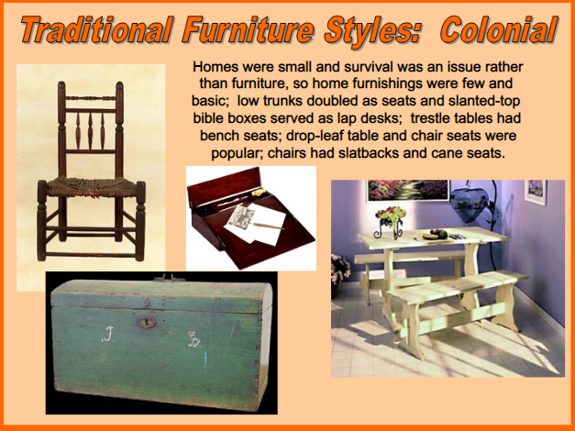
Early American Furniture History
Early American Style (1640–1700)
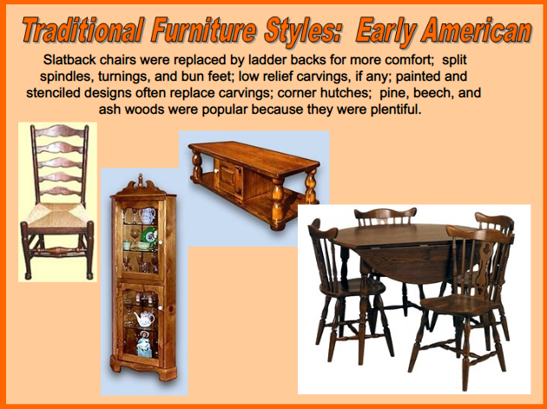
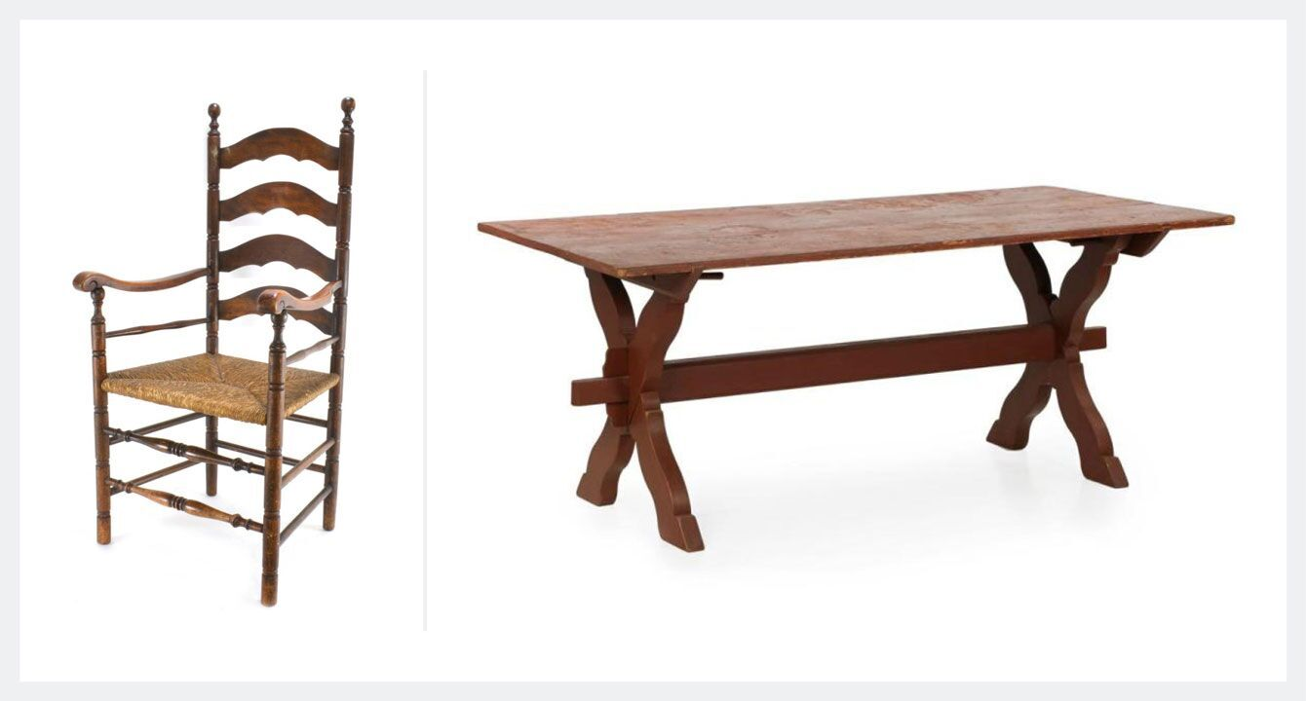
Left: Early American Style Arm Chair. Right: American Scrubbed Pine Antique Trestle Farm Table.
Geographic origin: United States
Materials: Pine, birch, cherry, maple, oak
The Early American style of furniture emerged during the second half of the 17th century by American colonists as life in the colonies became more settled. The Early American style is unique; it was the first point where a distinct style emerged and furniture began to be about more than just practicality.
Early pieces were large and were based upon styles that were popular in England; however, there were some key differences in physical features. Common motifs on furniture from this time included floral carvings, crescent shapes, and chip-carved scrolls and leaves. These carvings are generally more primitive and less finished than similar English versions.
Furniture from this period is known for features like ornamental carvings, raised panels, finials, and woodturnings. Common materials included wood like pine, birch, maple, cherry, and oak. Because many of the colonists were still somewhat unsettled, chests were in high demand due to their portability. Other quintessential pieces from this period include the court and press cupboards, trestle tables, and beds with with low, simple headboards and low turned posts.
The Early American movement is an especially important furniture style, as the furniture styles that came after were directly impacted by the styles and techniques established during this time. The unique style and craftsmanship of these pieces make them particularly sought-after today.
Early American Furniture History
Heading for the New World with high hopes and dreams of a better life, the early American settlers found themselves in wild, unclaimed country that they made their home. They brought little in the way of furniture or possessions, and built rough, rudimentary shacks. Early American furniture for the most part consisted of a few benches, perhaps a trestle table, and mattresses on the floor.
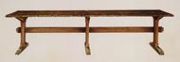
Trestle Table
Bit by bit, they began to make their homes more comfortable, and the tradition of early American furniture was born. Finding virgin forests of maple, cherry, oak and other native trees, the early American pioneers were able to use the finest quality wood for their furniture, unlike their European counterparts who were already beginning to feel the effects of deforestation.
Hand Made Early Style
Much of the early American furniture, such as colonial beds, was handmade by the settlers themselves, although skilled cabinetmakers also found their way to the New World. Early American furniture from this period tended to copy the Jacobean and Carolean styles in England: heavy and solid, with straight simple lines and little fuss or ornamentation.
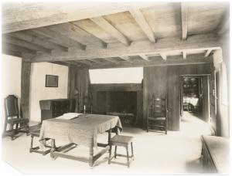
Parlor or living room in the John Ward house, formerly on land occupied by the Salem Jail and removed to the garden of the Essex Institute. Built in 1684.
These homemade pieces of furniture were made from sheer necessity, but many of them were also made with love. Many early American settlers tried their hands at low-relief carving. Furniture was carved with simple patterns. One of the most popular of these was the maple leaf motif.
Hearth
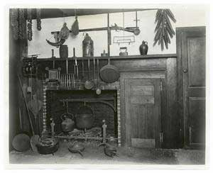
Colonial Fireplace, 1750.
Typically, life in the days of the early American settlers revolved around the fireplace - the only source of warmth in those bitter winters without any kind of heating system. Any type of furniture that provided a shield from the draught was popular, such as wing-backed chairs and hooded cradles.
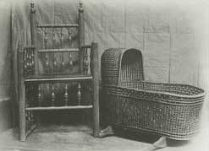
Late 17th Century Cradle & Turned Chair at Plymouth.
A Heritage of Fine Wood
Early American furniture is extremely popular with collectors of antiques. One of the reasons for this is the excellent quality of the wood used during this era of unlimited, untamed forests. Woods commonly in use included maple, cherry, walnut and oak.
Maple wood is strong and durable, and is not harmed by such working techniques as steam bending. And being a hard wood, maple can be brought to a highly polished finish. All of this made maple furniture an excellent choice for the early American pioneers, as they began to add comfort to their rudimentary shack homes.
Cherry is a medium density wood with a fine grain and smooth texture. It is easy to work with, and can be bent easily. It is not as durable as maple, but produces an attractive finish. It was also a popular choice for early American furniture makers.
Oak, like maple, is a heavy and durable wood. The early American pioneers used both white oak and red oak. White oak is particularly suitable for casks as it is impermeable to liquids.
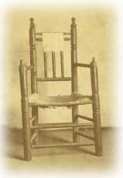
Gov. Carver's chair, Plymouth.
Walnut is a darker, medium density wood; usually straight-grained but can also have a wavy or curly grain that is attractive. With polish, it has a rich patina, and this improves with age. It can be easily worked with hand tools.
Antiques and Reproductions
Genuine early American antique furniture is much sought after. The quality of the wood and the quality of the craftsmanship make it superior in many ways to European antiques of the same era. However, demand exceeds supply, and early American antique furniture is expensive and often hard to find. Many home makers content themselves with finding one or two valuable pieces, and supplementing them with good reproductions of early American furniture. Reproduction furniture is made, often by hand, in the same style and uses the same woods as the genuine antiques, thereby blending in well and creating an attractive decor effect in which history and comfort both have their part.

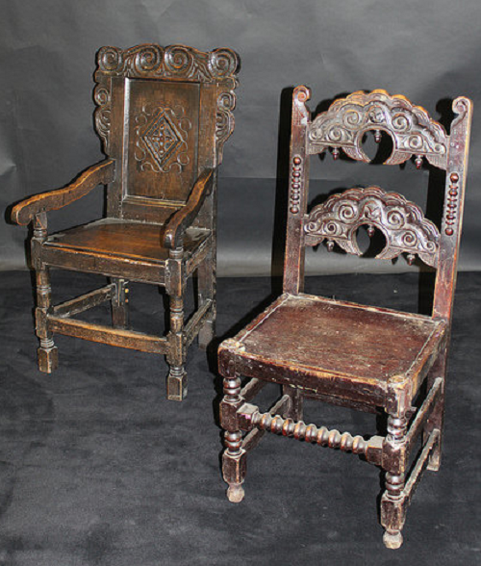
Wainscot chairs with elaborately carved wooden back. These 17th century American furniture comes with or without arm supports
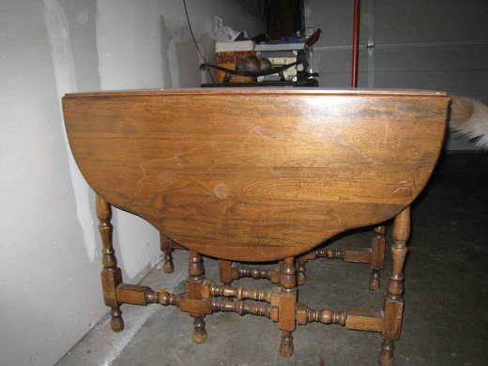
Gate-leg table made from walnut wood - Early designs of the 17th to 18th century American style table.
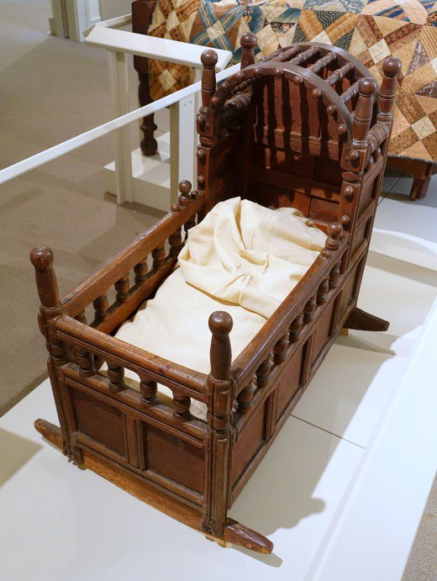
Baby's cradle, a common piece of furniture found in most Colonial era homes.
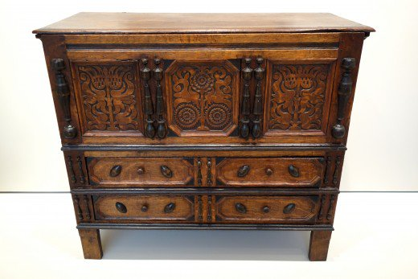
17th century American chest.
a. New England Furniture, Colonial Pilgrim Furniture
The early Jacobean furniture period, which inspired much of the early American furniture of the pilgrims (in America Jacobean style furniture is often called Pilgrim furniture), was similar to Elizabethan furniture in that it was still largely made of oak, and of a solid, sturdy construction.
The pilgrims arrived at Plymouth, Massachusetts in 1620 with little or no furniture to speak of, the hold of the Mayflower carried only a handful of wood cutting tools. While hewing their homes, and a new life, out of the raw wilderness of New England any furniture used could have consisted only of tree stumps, logs, or stones used to sit by fires or otherwise.
After the initial extreme hardships and trials were overcome and permanent settlements fully established the hands and tools of budding craftsmen and artisans among the pilgrims turned to work in the forest to build more comfortable homes and early New England furniture began to be built.
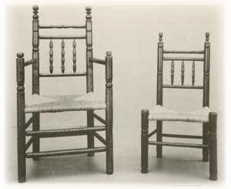
Early Pilgrim Chairs.
While very early pilgrim furniture was crude and extremely utilitarian, lacking much meaning in the great story of furniture styles, later use of more advanced tools such as broad axes, and adzes, in addition to labour intensive pitsawing, enabled squared lumber to be harvested from the virgin New England forests and thence more character-full furniture was built in the style that later would become known as "New England Colonial".
Wood types used in making pilgrim furniture were maple, birch, and honey coloured pine. Some walnut and cherry were also made use of. These softer woods were the natural choice of the early colonists, being easily felled and sawn.
The pilgrims were of course Englishmen and the furniture they made bore a heavy debt to the heritage of the English furniture tradition, in particular the country furniture of England in the seventeenth and eighteenth centuries. Over time however, perhaps due to the independent mind of the early settlers, the old world designs for carved chests, chairs, tables, benches, and beds, with their somewhat "heavy", overbearing, Gothic lineage, were revised in tune with the spirit of a new nation and gained more delicate proportions and were decorated with more humanly appealing carving and scrolling.
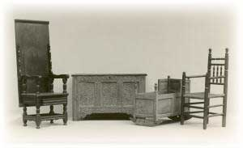
Pilgrim Furniture, 17th century.
Scrollwork especially, in the form of curved scrolls, like the cyma scroll, and turned shapes, was a special skill of the colonial woodworkers of New England.
Making Pilgrim Furniture
In the very early period of pilgrim settlement in New England metal, nails, and glue were unavailable thus requiring pilgrim furniture craftsmen to use wooden pegs and wedged keys in the joints of stools and chairs and other early colonial furniture.
Table tops of antique American furniture evince that the pine trees encountered by pilgrim settlers were of considerable width enabling wood planks to be utilised up to 30 inches wide. This allowed for tables to be constructed without the need for joining boards together.
In the surviving examples, (and perhaps in some reproductions) of antique chests, stools, candlestands, hutches, sconces, wallboxes, racks, shelves, benches, and a myriad of other furniture types from the early years of the pilgrim settlement in America it can be seen that the minds and hands of the founders and pioneers of the American nation soon turned to works of art, beauty, and simplicity of design attuned to the everyday needs of those living in a frontier land.

b. Dutch Colonial Furniture, Architecture & Homes
The Dutch Colonial Period
From the early seventeenth century the Netherlands intermittenly held control of American lands southwards from Canada to Virginia and inland as far as the Delaware river. By 1674 English efforts to eliminate direct Dutch influence in North America were finally successful but many Dutch settlers remained and Dutch culture and living styles continued to exert some influence on various areas including those of furniture, home decor, and home design.
Dutch Colonial Homes & Architecture
Traditional Dutch homes were of the baroque style made of stone or brick and stood three or four storeys high. Roofs were thatched and often shingles, rather than clapboards, were put to use for covering rooves and sides of houses.
In the Dutch New York of the 17th century, or New Amsterdam as it was then called, a typical street saw rows of brick houses with bright red and blue tiled roofs. These Dutch colonial homes had, as per the exterior Dutch architecture tradition, raised stone door steps at front entrances.
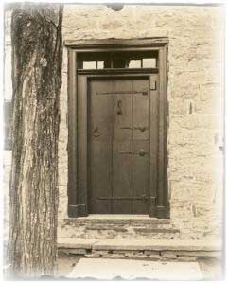
Dutch door, Senate House, Kingston, N.Y.
Interiors of Dutch houses usually had a cellar and also sometimes a cellar kitchen. Main floors had front and back rooms and second floors contained bedrooms and also garrets with clock lofts overhead.
Colonial Dutch Furniture Heritage
Dutch furniture in colonial times was made in the baroque style with a heavy and ornate form.

Bedroom Furniture
Bedrooms of Dutch homes in the colonial era were dominated by very large wardrobes known as "kas" replete with ornately carved decorative accents and massive panels which were often painted with flower or fruit motifs.
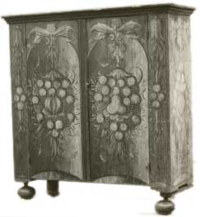
Dutch Painted Chest.
Dutch beds were sometimes built in to an alcoved corner of the bedroom complete with panelled sides and end and door like barriers to protect the occupants from the night air.
Dutch Colonial Chairs
Chairs made or imported by Dutch settlers came in two broad types: elaboratly turned, carved, and scrolled baroque (fiddleback chairs), as well as simpler ladderback chairs. Either model of chair would normally have seats woven of rush or splint. What distinguished Dutch colonial style chairs from their Pilgrim counterparts was the type and extent of the turning.
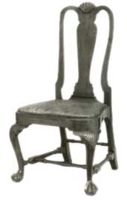
Dutch Chair.

Dutch Colonial Tables
Tables whether dining or otherwisse were usually made of heftier and stronger stuff than in New England. Wide, - up to four inches -, turned legs distinguished Dutch gate-leg tables and very slanted legs graced the frames of side and occasional tables.
A Dutch colonial specialty in the dining room was a trestle type dining table that held a large storage case built in just below the top.
Dutch Decor
Dutch homes in the colonial age often contained interior decoration such as figured storied glasses in windows and portraits hanging on walls. Additionally small decorative mirrors and Friesland clocks as wall decor items reminded Dutch colonial settlers in America of the homes they had left behind.
c. Pennsylvania Dutch Furniture

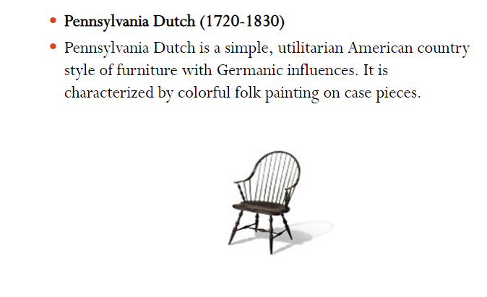
German settlers and pioneers arrived in Pennsylvania in large numbers from 1683, mostly deeply religious people called Pietists and later ordinary Lutheran and Reformed colonists. (Sometimes they are called Pennsylvania Dutch, Dutch here being a mistranslation of "Deutsch", which is German for "German".)
The Germans, or Dutch, who settled in Pennsylvania tended to maintain their own culture and language for an unusually long period and this included the German style of home decor and furnishings particularly that of the Rhine Valley in Germany.
Pennsylvania Dutch Furniture
The furniture handmade in Pennsylvania followed prevailing German furnituretraditions and heritage in the home country but developed its own traits and peculiarities.
Painted Furniture
Pennsylvanian Dutch furniture's most characteristic feature was the use of decorative hand painted motifs.
Painted Hope Chests
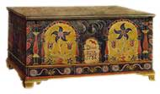
Painted Dowry Chest
Pennsylvania German furniture makers made a trademark out of their handpainted hope or dowry chests. Built to store the linen made by young german American women dowry or hope chests were customarily painted a light blue colour over which was painted a variety of decorative accents such as vases of flowers, tulips, stars, birds, angels, and unicorns among others.
Cupboards
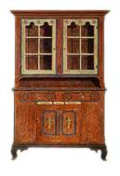
Painted Cabinet
German cupboards, or "shrank" were distinctive pieces usually massive in size, occupying much of the available floor space. Either painted, or finished naturally of walnut or cherry, the painted models were normally decorated with floral or fruit motifs.

Tables
Colonial german tables were made of similar size and in a similar style to other wood tables of the same period. A distinguishing type of German Pennsylvanian furniture was the walnut sawbuck dining table. The ends of sawbucks were subtly shaped and curved to soften the imposing look of these huge tables. The central rails were pierced by keyed end tenons making these German inspired tables very structurally sound and some antique examples remain in use today.
Chairs
Dining chairs made by German settlers came in a number of derivative styles from, at first, wainscot chairs of New England origin, and later, ladderback and Windsor style chairs. Also of note were arrow back chairs which had backs made of arrow shaped spindles.
German influenced chairs were usually painted in decorative patterns. The Germans were skilled at stenciling designs of fruit, flowers, and birds against backgrounds of yellow, green, or brown paint.
Moravian chairs were also commonplace. Made with a splay legged design the moravian chair was built with a carved out heart through the backrest. Peglegs without rungs had the effect of simplifying the making process.
Decor
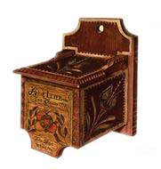
Hanging Salt Box
German decorating style in the country Pennsylvania mirrored the desire of furniture makers to apply some unique details and decorations to otherwise fairly plain and simple designs. Decor items included hanging cabinets and wall racks often adorned with fancy scrolling and painted accents.
German Country Style
The furniture described above was made in a true country style without the sophistication of design seen in urban centers like Philadelphia. Suited to the needs of ordinary folk in the farmhouses and barns of German Pennsylvania this German, or "Dutch", furniture, as evidenced in the use of painted decoration and elaborate turning and scrolling of wood, also had a unique country style of its own.

ii. William and mary period
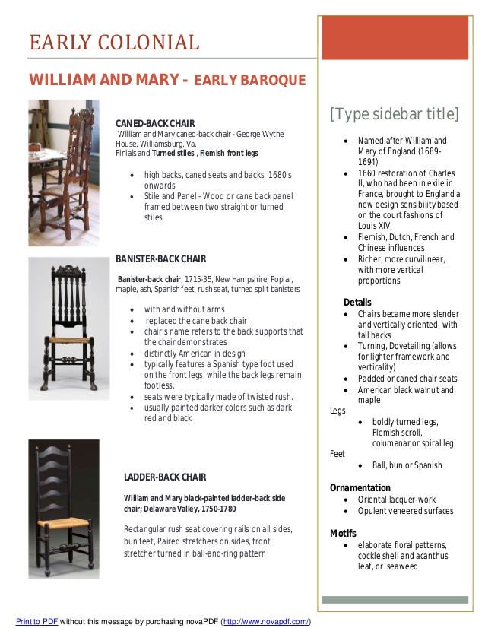

Historical Background
Naturally, in date American furniture trailed the earliest English examples of William & Mary furniture; for we should not only allow time for a certain style to become sufficiently established and popular enough for the likelihood of copying but also a short period for it to be transferred and become popular. This interval would considerably vary, according to conditions and closeness of relations. At some periods and in some places some American furniture of a new style might be made shortly after its original appearance, but we must be rather careful not to date the general product, the "run", of a particular style too early.
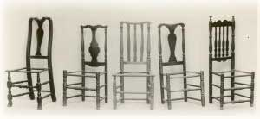
Early 18th Century Chairs.
We should also remember that, as has been said, each mode would endure later in America than in England, for it would not so soon be superseded by the succeeding type. We can only date according to known probabilities, for very little American furniture is "documented" and family traditions are so notoriously untrustworthy as often to be ridiculous. We will find wills, descriptions, and other surviving records a reliable aid, and, in later periods, advertisements.
American William & Mary Furniture
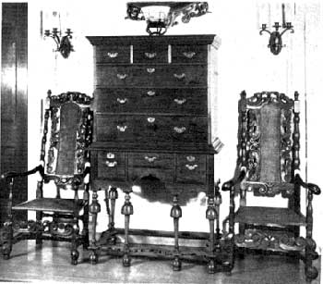
William and Mary Highboy.
The major influence on the American version of this style was the incorporation of oriental design motifs with chinoiserie decoration becoming extremely popular among wealthy colonists in the major centres of cabinet making, Boston and New York.
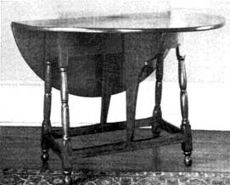
Maple Wood Butterfly Table.
The main types of furniture in demand during the early 18th century in America were highboys and lowboys, butterfly tables, easy chairs, mixing tables, fall front desks, splay legged tables, and high cane backed chairs. The C-scroll and S-scroll also became important decorative motifs particularly on the crest rails and matching stretchers of dining and other chairs.
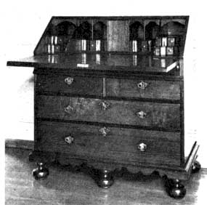
Fall Front Desk made of Walnut

iii. Queen Anne period (1720–1760)
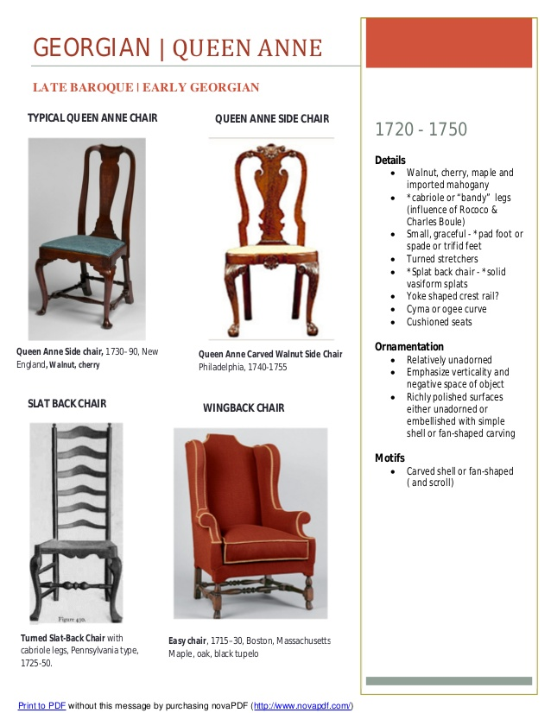

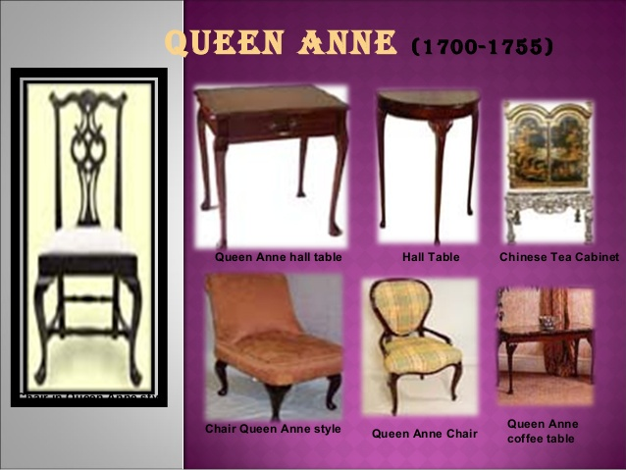

DifferencesFrDifferences from The English
The major difference between the American style of Queen Anne and the original English Queen Anne furniture was the popularity in America of the cabriole leg with pad feet rather than the cabriole leg with the claw and ball foot as in England. Additionally pieces such as the highboy and lowboy remained in demand in America while in England they had long ceased to be made.
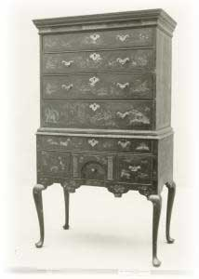
Queen Anne Highboy.
American Queen Anne furniture was more attuned to the demands of comfort, rather than mere show and display. Standard designs were altered to allow for upholstering, and there was a great variety of upholstery fabrics in use, most of it imported.
Popular new items included daybeds or chaise lounges, folding card tables, side chairs with vase shaped splats (fiddlebacks), and decorative tea tables with dished tops and cabriole legs.
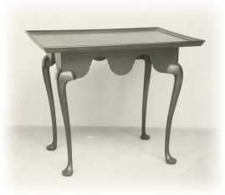
Cabriole Legged Tea Table
Japanned and lacquered furniture remained popular, as it had in the William & Mary period. The publication of the "Treatise of Japanning and Varnishing" had had a huge effect on furniture design at this time.
Cabinet Making Centres
By 1720, when the American Queen Anne style of antique furniture had definitely evolved, a number of distinct cabinet making centres had grown up. Being endowed with the natural American individualism, and not being bounded by European guild systems of training apprentices in traditional techniques, these cabinetmaking centres developed their own regional characteristics and styles.
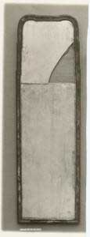
Queen Anne Mirror.
The major cabinetmaking schools at this time were in Boston and Newport in the north, New York and Philadelphia in the mid Atlantic, and Williamsburg and Charleston in the south.
Boston & Newport
The furniture makers of Boston were heavily influenced by English fashions, and this fact, coupled with a certain New England restraint, combined to produce furniture which was a disciplined and respectful copying of eighteenth century English designs.
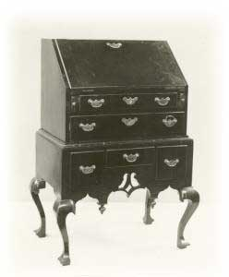
Cabriole Leg Desk.
The famous Townsend and Goddard group in Newport made furniture with flowing, simple lines, the best of it being adorned with shell carving and block and serpentine shaped fronts. Their furniture of walnut and mahogany found a ready, worldwide, market.
New York
While the Dutch period in New York had formally ended in 1664 Dutch Colonial traditions continued to have profound influence. Bodice back chairs were especially popular in New York.
Philadelphia
The furniture produced in Philadelphia is so difficult to tell from similar English made models that even today antiques experts disagree over origins. Philadelphia made furniture bears little resemblance to period furniture made in other parts of the colonies.
The South
While many southern colonists still preferred to order furniture from England yet many pieces of distinction were produced in Williamsburg and Charleston in the Queen Anne style.
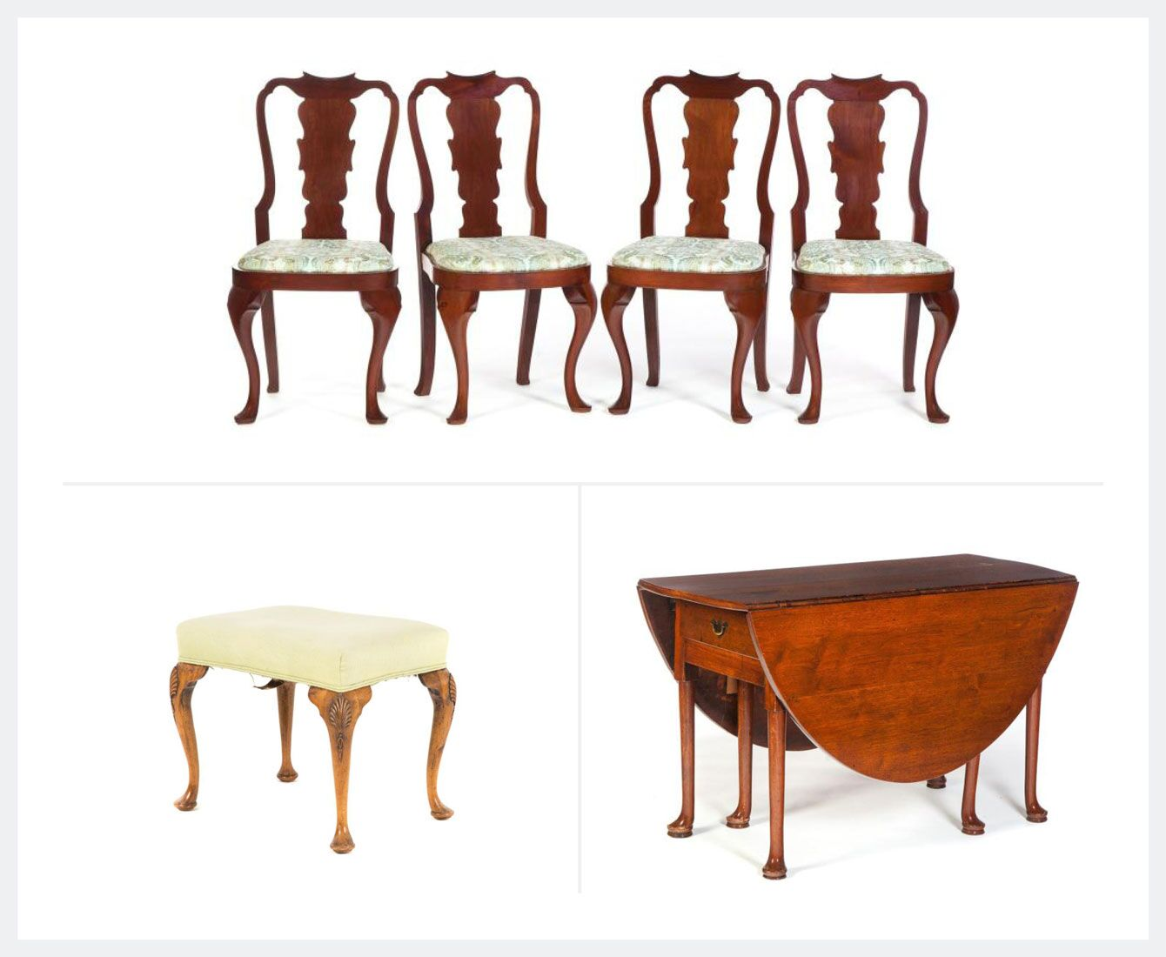
Top: Four Queen Anne-Style Side Chairs, Bottom left: Queen Anne Style Walnut Stool, Bottom right: Queen Anne-Style Oval Swing Leg Drop Leaf Table with Drawers,
Geographic Origin: Great Britain, United States
Materials: Walnut, maple, cherry wood
Though named for Queen Anne of Great Britain, the term was not applied to the furniture style until nearly a century later. The Queen Anne style is ornate and draws inspiration from earlier Louis XV and Rococo styles, yet gives substantial consideration to structure over ornamentation. Swooping S-curves, scallop and shell details, cabriole legs, and embroidered cushions are all hallmarks of the style.
The aesthetic was popularized in the United States in the 19th century thanks to the growing wealth of the colonists and the arrival of more skilled craftsmen looking to be paid top dollar for their furniture designs. While there are plenty examples of wing-back chairs and elaborate credenzas in the form, the highly practical and innovative secretary desk-bookcase may be one of the most notable designs associated with the movement.

iv. Chippandale Period

In the rococo period of furniture design in the 18th century it was the work of Thomas Chippendale, specifically his Gentleman and Cabinet Maker's Director, that had an almost exclusive sway over fashions in furnishings in America. The designs of Chippendale, a pared down, Anglicised, version of French rococo Louis XV furniture, were quickly taken up and the old Queen Anne style faded into antique history. The distinguishing characteristic of American Chippendale, as opposed to the English, was more emphasis on symmetry of line and proportion.
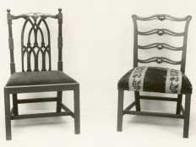
American Chippendale Chairs.
American Chippendale furniture designs were quite original and a number of new forms developed. Breakfront bookcases, kneehole chests of drawers, serpentine back sofas, kettle stands, and drop-leaf Pembroke tables. (See pictures of the original drawings.
Philadelphia
Perhaps America's most significant contribution to world furniture design in the antique period originated in the works of the Philadelphia manufacturerers and designers, like William Savery, who adapted Chippendale designs in a free style, creating expertly crafted and attractive furniture.
Chippendale Highboys
Chippendale style highboys are the major highlight of this work, richly decorated and carved with shells, vines, and tendrils in both the upper and lower halves, and often matched with lowboys of similar nature. Leaving English accomplishments in this area far behind, highboys in America were wildly popular right up until the Boston Tea Party.
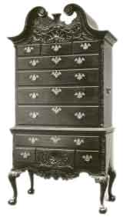
Antique Chippendale Highboy, by William Savery.
Newport
The other great center of American furniture making at this time was Newport, especially in the creations of John Goddard and John Townsend. These designers utilised block and shell carving, that was almost the rival of the Philadelphia makers in its exquisite detail. The block front design was especially used in kneehole desks, desks with flat tops and recessed centres, flanked on either side by drawers.
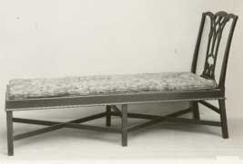
Chippendale Chaise Lounge.
The Chippendale style held sway over American until the 1770s when English styles fell out of favour, to be replaced by French ones, in the period of Federal furniture.

2. Federal style
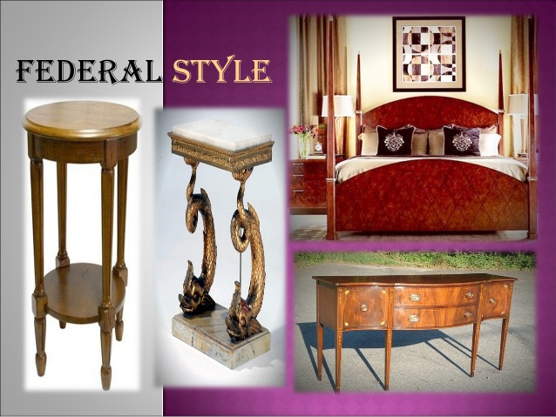
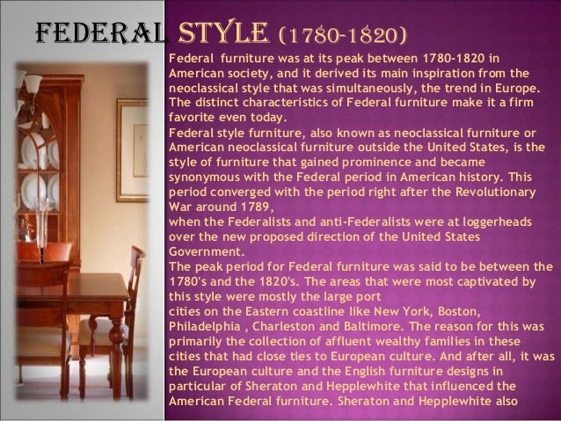
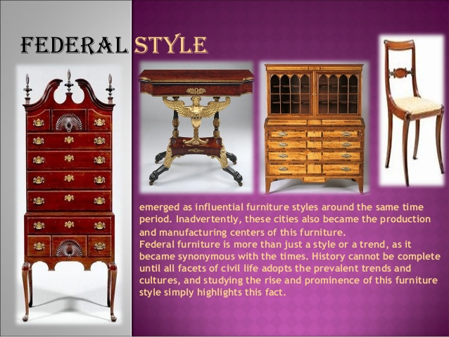
i. Federal period

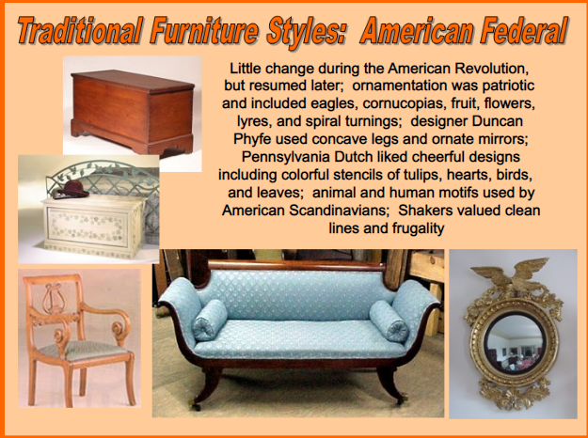
History
In 1783, the Treaty of Paris, ending the American Revolution, recognized the independence of the United States of America and a new nation was born. The war-ravaged country was given the chance to begin to build its own government, constitution and traditions and the so-called Federal period began, roughly running from 1780 to 1820.
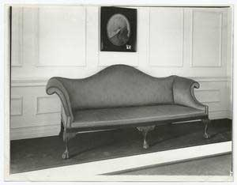
The sofa used by George Washington when living in Philadelphia as President of the United States.
Federal Style : Origins
This era, rich in history and heritage, gave rise to the unique American furniture known as Federal style furniture, which replaced the older American Chippendale style. Despite the new country's recently won independence, the English influencesof Hepplewhite and Sheraton, were paramount in the early Federal era

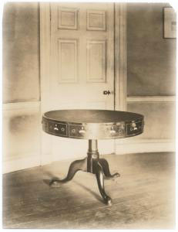
The table on which the Treaty of Ghent, 1814, was signed.

Early Styles
Early American federal furniture of this era did full justice to the elegant high society of the young nation. Ladies in silks and muslins sipped tea in the drawing room; gentlemen in tight-fitting coats and wigs discussed the stirring events of the new Federation in well-appointed libraries. Law makers and entrepreneurs, rich traders and their fashion-conscious wives, all with money to spend and a position in society to maintain, created beautiful homes and interiors in a style which is still prized by antique lovers today. In the historic districts from which the capital was born, such as Georgetown, Alexandria, and Rosslyn, Virginia, Federal furniture and architecture is preserved in an abundance of museums and show houses.
Cherry and Walnut
Dark woods were popular at this time. In Europe, mahogany was the most popular, but many American furniture manufacturers used cherry, which is just as beautiful. Walnut stained to a deep red with potassium chloride was also used by some cabinetmakers as a slightly less expensive option. Intricate workmanship is typical of Federal furniture, and many pieces featured inlays of different types of wood, or of wood scorched to give areas of light and dark contrasts. Painted or string inlays were also used for decoration. Stars and eagles, the symbols of the new nation, are often seen in American furniture instead of the classical emblems of European furnitureof this era. This is especially true of the later part of this period.
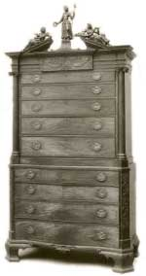
Antique Federal Highboy by Samuel McIntire.
Federal Era Designers
One of the most famous designers of Federal era furniture was Duncan Phyfe, who individualized the Sheraton style with innovations of his own. Working mainly in mahogany, he was best known for his chairs that featured concave backs, concave legs and classical motifs. Charles Honore Lannuier, another popular designer of the day, followed the French Directoirestyle, and made much use of brass and gilded ornamentation. Other designers of American federal period furniture included Michael Allison, John Shaw, John Dolan, Samuel McIntire, and George Woodruff.
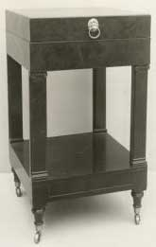
Duncan Phyfe Washstand.
Elegant and Graceful
The Federal era in American furniture produced some of the most elegant, graceful and truly beautiful antique furniture in existence. During the years when George Washington crafted a nation, contemporary cabinetmakers crafted a tradition in fine furniture that endures today. Antiques of the "American Empire" period are of enormous value today.
Federal Style Interiors
The key aspect of federal style interior design, as well as Federal furniture, home and architectural design, is the notion of symmetry and balance, of good order and alignment; outside and inside are in harmony. Ultimately we must travel as far back as ancient Rome, Greece, and even Egypt, so as to discover the origins of this style, and generally, in the modern sense, we would call it "classical" or "neoclassical".
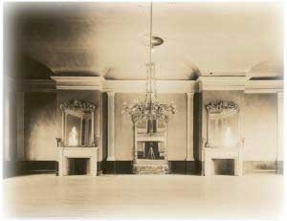
Hamilton Hall, Chestnut St., Salem, Mass., 1808, architect Samuel McIntire, 1757-1811.
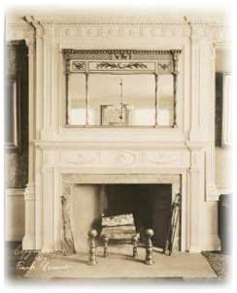
Federal Fireplace Mantel in the Adam Style.
Pierce-Nichols house, 80 Federal St., Salem, Mass.
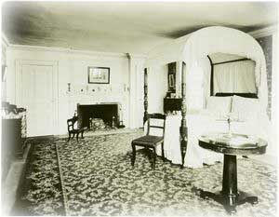
East bedroom of Pierce Nichols house.

- Designer: Hepplewhite
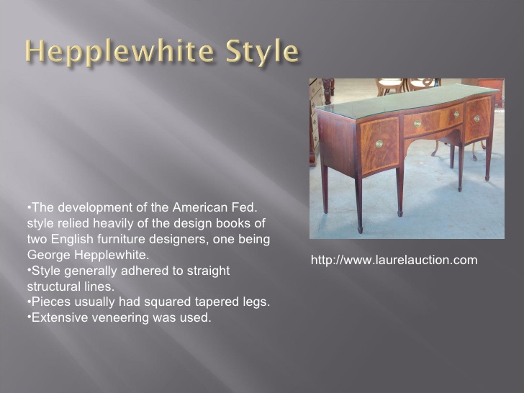
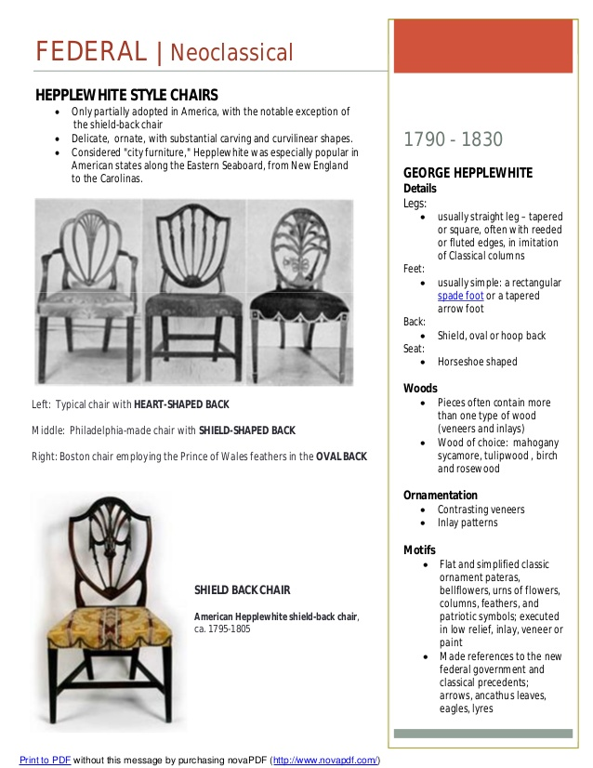

- Designer: Sheraton
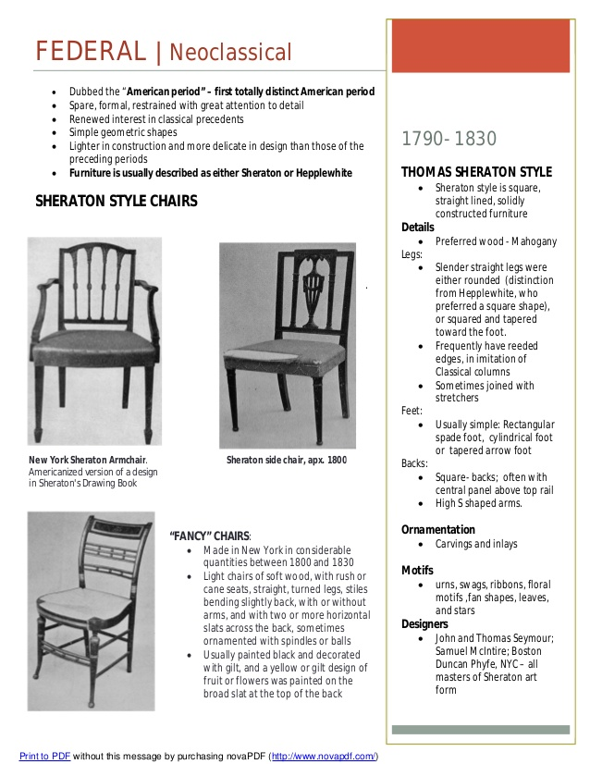

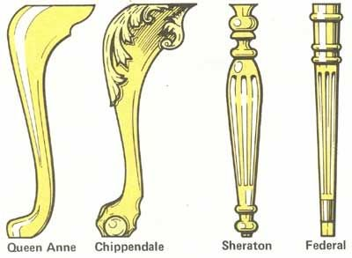

ii. American Empire (1805–1830)

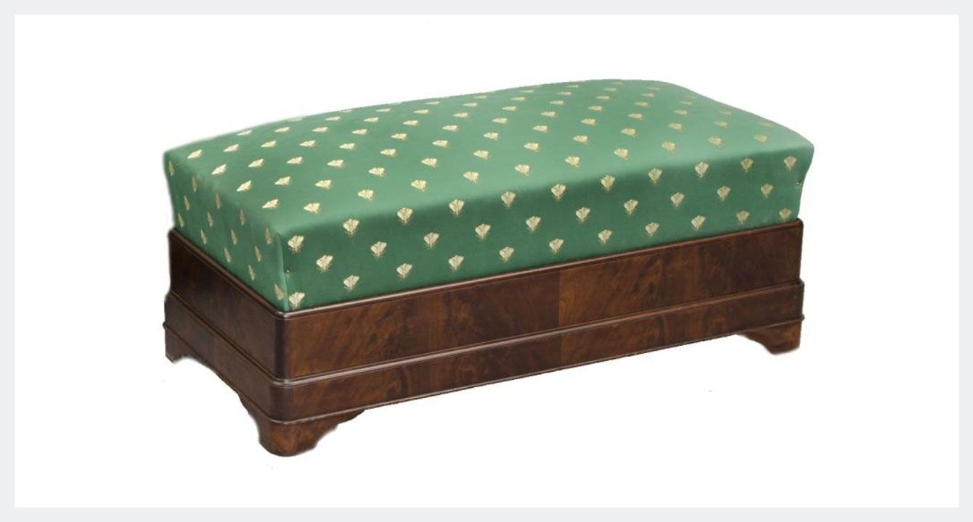
American Empire Window Seat

Geographic Origin: United States, primarily Boston, Philadelphia, and Baltimore
Materials: Mahogany, oak wood
Key Designers: Duncan Phyfe, Charles-Honoré Lannuier

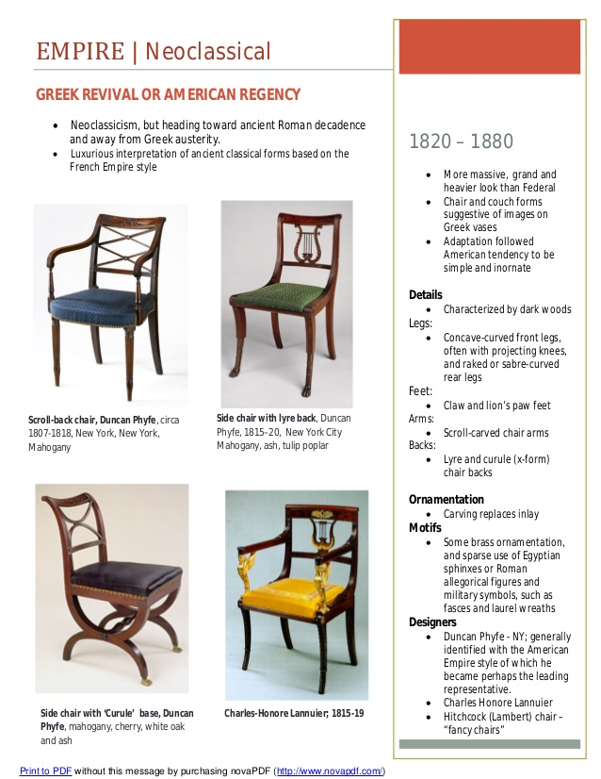
American Empire style furniture (which overlaps with the Federal furniture style) takes inspiration from the Neoclassical and the French Empire style that was popular during the reign of Napoleon. However, in contrast to its predecessors, the American Empire style was distinct in its use of patriotic motifs including stars and eagles with spread wings.
Other common motifs of the American Empire style included columns, rope-twist carvings, animal-paw feet, stars, and anthemion leaf ornamentation, as well as a style of gilding called “vert antique” (simulating aged green bronze).
Mahogany and other dark woods were highly favored materials of the style, so much so that pieces were often stained black to appear even darker. Inlays of ebony were also used in this style as well as brass metal hardware for drawer pulls and mountings. The legs of furniture from the period were substantial and the feet could be highly ornamental, including the use of lion’s paw carvings.
Boston, Philadelphia, and Baltimore all made large contributions to the style and each had its own set of signatures that make pieces from this era easily identifiable to a city of origin. There is an entire room at the White House (The Red Room) decorated in this furniture style.
American Empire Furniture
For some the period known as "American Empire", roughly 1820 to 1840, forms a simple continuum with the furniture and interiors of the Federal era, however a number of distinct characteristics can be identified.
Origins
Although the empire period was paralleled in England, in Regency furniture, the influence of English design, and designers such as Thomas Hope, declined significantly. Instead American furniture makers began to break away from things English, and took their inspiration from the Neoclassical, Grecian style of French designers of the French Empire period in France. Napoleon's admiration for the Roman Empire, his trip to Egypt, and several archaeological expeditions to Greece and Rome all influenced French, and then American, styles of decor.
Major Characteristics
The curved lines of ancient Greek furniture were used in legs of tables and chairs; classical motifs such as the lyre were used in decoration, and pillars and scrolls were often incorporated. Pillar and scroll style furniture is typical of the Empire period; this feature was not seen in early Federal furniture. The Pillar and Scroll style was very popular with clockmakers during this period, particularly Eli Terry and there are many outstanding collectors items still in existence today.
American craftsmen and designers manifested no intention of slavishly copying French models. Nor did they allow their ingenuity and inventiveness, qualities for which American cabinet makers have always been distinguished, to be held in check by the limitations of classical traditions. They adopted just what they admired, and combined it with such improvements as they considered were desirable. The result was the creation of a style possessing much originality. Except to the critic who resents the disloyalty to the parent style, American Empire furniture has many attractions. It often suggests the dignity and grandeur of the French pieces, coupled with that insistence upon utility for which the American is famous.
In the early days, pains were taken to reproduce at least some really Empire features, but, as time went on, the furniture became gradually less and less "Empire" and more and more American, and in this lies its real value to the antique collector, and furniture admirer, today.
- Designer: Duncan Phyfe
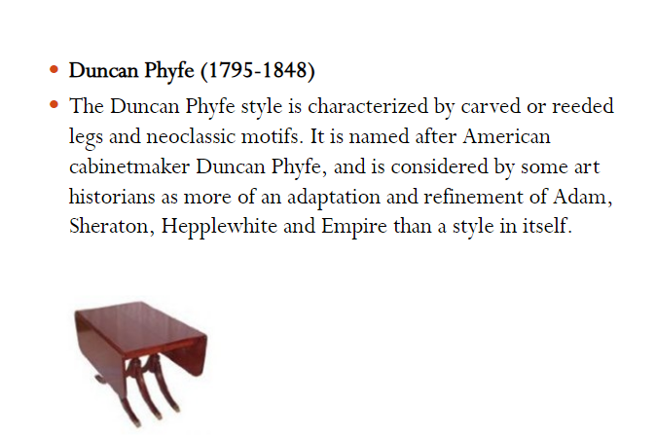
Duncan Phyfe Furniture & Biography
In the United States of the early nineteenth century the styles of the French Empire were influencing craftsmen, and eventually replaced the British type that the colony had accepted and employed. In looking at developments of taste in the new democratic republic some account must be given of the work of Duncan Phyfe (sometimes spelt Phyffe, or, according to this site's search engine statistics, even Pfyfe, and Fyfe. Phyfe's father spelled it Fife, to add to the confusion).
Biography
Phyfe was a craftsman of Scottish birth who emigrated to America in 1783, when he was sixteen years of age. He settled in Albany and worked as a cabinet maker, but early in the last decade of the eighteenth century he moved to New York, where, after a few years, he was able to produce furniture with the support of a wealthy clientele, and, on a smaller scale, was to New York what Thomas Chippendale had been to London.
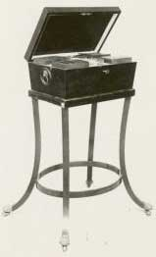
Work Box.
Furniture - Two Phases
His early work, that in the Federal era, was strongly influenced by Hepplewhite and Sheraton furniture designs, but, in the period known as American Empire French taste began to give him ideas, and the fashions of the Directoire, the Consulate and the early Empire are apparent in his work. He was a superb craftsman, and adopted foreign ideas with all the ease of Sheraton: his rendering of French Empire designs is sometimes extremely skilful. His evident appreciation for fine curves, his real understanding of ornamental values, which exercised a restraining influence on the embellishment of his furniture, and his eye for the decorative quality of wood, have given to his furniture a distinction that is marred only by an occasional hint of bad proportion in some of his tables.
Phyfe Dining Chairs
His chairs possess many characteristic Sheraton touches: backs with cross bars, diagonal bars, reeded and carved, and lyre backs, horseshoe seats, legs ornamented with acanthus, the feet sometimes terminating in paws, are all typical of Phyfe pieces.
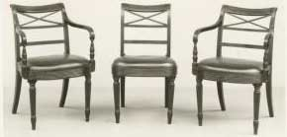
Antique Phyfe Chairs.
Tables
He made an enormous variety of tables, many of the pedestal and drop leaf type, and occasionally serving tables. Sometimes the tables with pedestals are formed by a platform on carved legs which supports crossed lyres which are immediately below the table top. Sometimes four slender columns, carved or fluted, support the table in place of lyres, and another variety has an urn-shaped turned support between the platform and the table top. Serving tables and types corresponding to Pembroke and sofa tables were made by Phyfe.
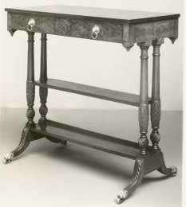
Side Table.
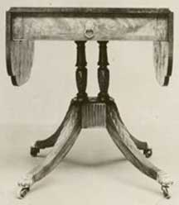
Phyfe Drop Leaf Table.
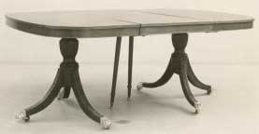
Phyfe Dining Table.
Growth, Success & Decline
A very interesting note on the considerable development of Duncan Phyfe's business and his evident prosperity was given in The Bulletin of the Metropolitan Museum of Art, New York, on the occasion of the exhibition of this craftsman's work organised by the Museum. It is said that:
Before 1800 he settled at No. 35 Partition Street, not far from Broadway. As his business grew, we find him increasing his property, first at No. 34 in 1807, then at No. 33 Partition Street in 1811. The original house at No. 35 was still his dwelling, with the salerooms next door at No. 34, and the workshop and warehouse at No. 33. Shortly after Robert Fulton's death, in 1815, measures were taken to open a street from the East to the North River, to be called by his name. About this time Phyfe acquired the house directly across from his saleshop, so that when, in 1816-1817, Partition and Fair Streets the same thoroughfare running east and west of Broadwaywere rechristened Fulton Street, and the houses renumbered, Phyfe's addresses were Nos. 168,170 and 172, with his house at No. 169 opposite. The former dwelling-house then became the warehouse. In this street Phyfe lived and worked, within a stone's throw of St Paul's, and not far from the new City Hallr He saw the city grow far to the north and pass through many changes before he retired from business in 1847, and died at his Fulton Street home in 1854.
Phyfe's best period of design lies between 1790 and 1825, and it shows how servile even great craftsmen had become where questions of fashion were concerned, when we see a designer whose early work was inspired by such masters as Hepplewhite falling into line with the prevailing decadence of taste and trend and producing models that reflected the general lack of appreciation for fine proportions and appropriate ornament.
We may quote again from the article in The Bulletin of the Metropolitan Museum of Art, for the following paragraph suggests that Duncan Phyfe's instinct for fine craftsmanship and good design was not overpowered as easily as Sheraton's under the strong wine of French Empire fashion:
The heavy, solid lines of the full French Empire style came into vogue, and much of his furniture was of this type, simplified, ornamented in a restrained manner with gilt-bronze, and possessing, in spite of its over-solidity, the qualities of good craftsmanship and material, as well as of intelligent design. With the period of black walnut and so-called "butcher" furniture, he entered with the public of his day on the downward path of bad taste. . . .
By the end of the second decade of the nineteenth century, fashion, which can not always be associated with good taste, loomed so large in the eyes of people who furnished their homes in the fashionable cities of Britain and America that it would have been difficult for a craftsman of outstanding genius to introduce good design unless he could also persuade his potential clients that his furniture was first fashionable and trendy. After Sheraton in England, and Phyfe in America, we find no great names associated with furniture making until after 1860. Furnishing becomes an uninspired business, a matter of store-keeping, salesmanship and silly conventions. Duncan Phyfe had held the line against this at least for some time.
iii. Victiorian period (Classic antique period)
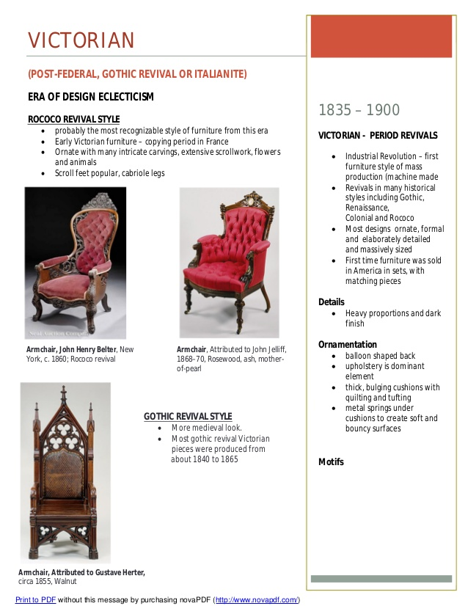
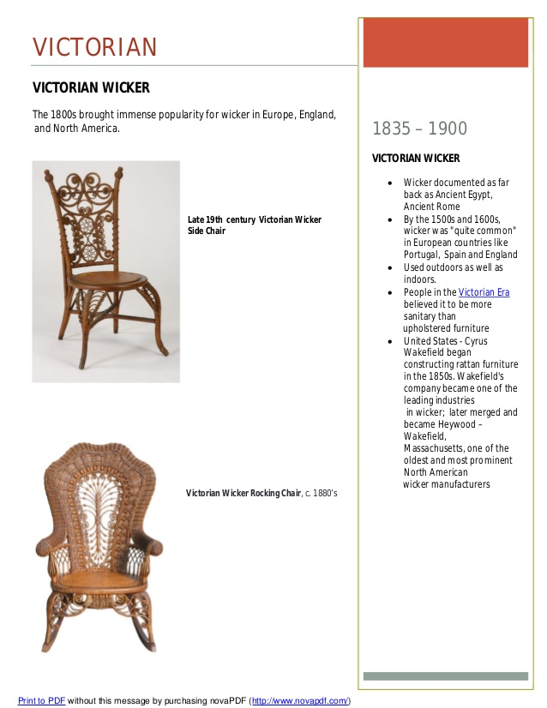

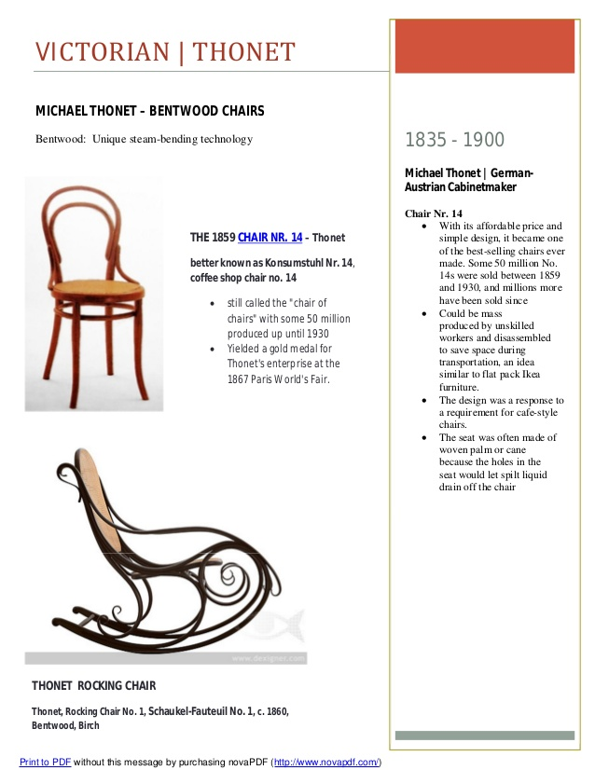

3. Rustic Furnitures
Rustic furniture is furniture employing sticks, twigs or logs for a natural look. The term “rustic” is derived from Latin “rusticus” (peasant; as opposed to urban). ... Many companies, artists and craftspeople make rustic furniturein a variety of styles and with a variety of historical and contemporary influences.
i. Adirondack Furniture
Advancements in rail and automobile transportation in the mid to late 19th century led the wealthy from New York City, Newport, Boston, and other east coast cities to spend their summers at mountain resorts, where the air was cooler and healthier, and the lifestyle less hectic. They flocked to pristine wilderness areas, such as New York State's Adirondack Mountains. The natural, rustic beauty of these mountains inspired these summer residents, with such notable names as Vanderbilt, Post, and Rockefeller, to build "camps" - rustic style estates - luxurious, yet relaxed in feel. With these "camps", Adirondack style was born.
Using rough-hewn logs, bark-covered beams, and uncut stone, Adirondack architects created main buildings with majestic vaulted ceilings and huge, stone fireplaces so big you could stand in them. These lodges were accompanied by individual guest cabins. These were not, however, your typical "log" cabins. The Adirondack camps were every bit as luxurious as the residents' mansions back home. Days may have been spent in leisurely pursuits, but come evening, guests dressed in black tie finery and great feasts were served on the best china and silver. President Calvin Coolidge, too, fell in love with the region and brought the Adirondacks to national attention when, in the summer of 1926, he moved the "summer White House" to Pine Camp, one of the luxury estates in the region.
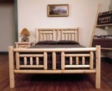
Adirondack Bed.
The Adirondack's log-style "camp" mansions needed a similar style of furniture with which to fill them. Native artisans used the materials of the region -stones, logs, twigs, and roots - to create simple, rustic designs for chairs and gliders. Teak, birch, cedar, hickory, and oak-the woods indigenous to New York -- were frequently used, often in combination to create a multi-hued design. Although many pieces looked basic, they were actually quite intricate. Ingenious inlaid designs and natural accents made each piece a work of art in itself. Many such pieces have survived and are highly collectible.
Outdoor Furniture
Chairs
The best-known Adirondack piece of furniture is the classic wooden, sloped-back, deep-seated Adirondack chair. Often accompanied by a matching footrest, these chairs were ideal for the sweeping lawns and expansive porches of the Adirondack "camps". Rocking chairs and large porch swings, constructed from branches, hickory sticks, and roots, were popular and useful for lounging on the porch with a good book during the heat of the day.
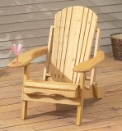
Folding Adirondack Chair.
Modern furniture makers have added a touch of playfulness and whimsy to the classic Adirondack chair. Painted chairs, in bright colors and in soft pastels, abound often coming at cheap prices from discount stores. Hand-painted chairs, with birds or flower designs, add interest to any yard. Modern technology has led to all weather plastic Adirondack chairs, especially suited to northern climates.
Adirondack Decor
Adirondack accessories are practical and functional as well as decorative. Woven, rich-hued blankets add color and warmth to the expansive living areas. Intricate woven pack baskets can be useful as well as lovely grouped together for a country look. Outdoor activities were the daytime focus in the golden age of the Adirondack camps and sports gear, such as boat paddles, fishing tackle, and tennis rackets adorn many a camp wall, then and now. Winter sports paraphernalia, such as snowshoes and sleds also make stylish wall ornaments. Framed family photos add to the homey feel of this style and are often prominently displayed, both in groups and singly. Oversized mirrors, with rough-hewn frames were featured in the guest cabins, and are a popular modern Adirondack accessory.
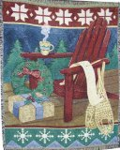
Red Adirondack Christmas Throw.
American folk art was a natural accompaniment to the Adirondack camps. Patriotic, red, white, and blue, designs as well as primitive farm scenes reflect the feigned simplicity of this style. Realistic oil paintings of the surrounding wilderness, sometimes created by the owners or their guests, helped to bring the beauty of nature inside. Photography was just becoming popular and widely available in the early 20th century and framed nature photographs, too, fit the Adirondack style.
Colors
The Adirondack color palette reflects the New York mountain wilderness. Shades of beige and brown, deep greens, and rust are commonly associated with Adirondack design. Bright accents, on such items as pillows, throws, and artwork, enlivened the rooms. Subtle prints, borrowed from nature, such as duck, leaf, and water motifs lend subtle interest to seat cushions, drapes, and tablecloths.
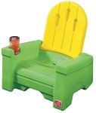
Modern Adirondack Chair.
Adirondack Style
Adirondack style is a reflection of America's majestic natural beauty and native craftsmanship and inventiveness. Adirondack furniture and accent pieces are sturdy, well designed, and beautiful. Putting together an Adirondack room requires close attention to detail. A single piece, combined with traditional furniture, can often be enough to add interest to a room without overwhelming it. A handcrafted Adirondack piece of furniture is sure to be a conversation starter. It's also a good way to add a little American history and style to your home.
ii. Amish Furniture
The Amish People and Culture
Similar to the Puritans and Pilgrims before them, the Amish people migrated to America in search of religious freedom. However, unlike other smaller religious sects, the Amish have largely maintained the culture and customs of their forebears. Striving to keep the "English" world at a safe distance, with its mass urbanization and technological advances, the Amish developed a set of rules, called the Ordnung, which govern the use of machinery, styles of clothing and other areas of daily life including furniture and furnishing styles.
Amish Furniture
The excellent craftsmanship and simple lines of Amish furniture give it a timeless appeal. The straightforward tables, straight-backed chairs, and sturdy beds created by Amish woodworkers reflect the simple and puritan culture of this hard-working, religious community. The Amish people of north-central Ohio, western Pennsylvania, and central Indiana are known worldwide for their superb handcrafted wooden masterpieces. Because their beliefs and traditions prohibit using electricity, all of the woodworking and finishing on Amish-built furniture is done by hand. Skills handed down from generation to generation keep the old-world designs and attention to detail alive.
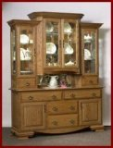
Amish Kitchen Hutch.
The handcrafted furniture created by the Amish is identifiable by its unadorned, simple lines and its precise construction. Made predominantly from oak, maple, hickory, and cherry woods using only hand tools, these handsome dining room tables, kitchen tables, and bedroom sets are found in Amish communities throughout Ohio, Indiana, and Pennsylvania. Excellent construction is a hallmark of Amish furniture. Dovetail joints and hand-mitered corners ensure that these pieces will last a lifetime, if not longer. Because each piece is made to order, it can be custom stained to match individual decors, from light maple to rich pecan to deep mahogany. Staining, too, is done by hand which gives the piece a rich, hand-rubbed finish.
Mission-style furniture with straight slats and angular construction and stoic and simple Shaker designs are frequently offered by Amish furniture workshops as are graceful sloping Windsor chairs and useful, traditional items such as pie safes and quilt racks. Gently curving, Queen Anne style legs also grace many Amish chairs and tables. As befits a community that emphasizes family values, cribs, highchairs, cradles, and other baby furniture items are commonly offered as well as furniture for young children. Rocking horses and other children's toys are common and unique handcrafted dolls are just as popular with adults as with children. The durability of these toys ensures that they'll be handed down to the next generation.
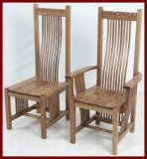
Amish Oak Chairs.
Amish furniture is perfectly suited for any room of the house. Dining rooms are warmed by large, hand-carved hutches, expansive dining room tables, and sturdy, straight-backed chairs. Bedroom sets with impressive, four-poster and canopy beds, matching dressers, armoires, nightstands, and framed, wooden mirrors add a sense of quiet style and permanence to a home. Pie safes and jelly cabinets add a touch of old-world charm to a country kitchen. Rocking chairs, an ideal gift for a new parent, are sturdy, graceful, and well suited to curling up with a good book on a cold winter's night. Offices, too, benefit from Amish furniture. What better investment in a company than to add a sturdy, oak wrap-around desk or a set of Amish cabinets or cherry bookcases?
Amish furniture is surprisingly affordable for such a high degree of craftsmanship. Regional cooperatives and showrooms in Ohio, Pennsylvania, and Indiana represent a large number of furniture makers and display samples and take orders for the craftsmen. Buyers can visit in person or visit virtual showrooms online. Often, a discount is offered for picking up the piece yourself. Because each piece is handmade, delivery can take several months, but for a piece that can last a generation, that's not too long. In addition, most Amish furniture dealers offer a lifetime warranty on their pieces.
Holmes County, Ohio
The Amish in Holmes County, Ohio have long been noted for their fine quality wood craftsmanship. Apart from the the large furniture factories and stores in the Holmes County area, there are also to be found along its back roads lots of small Amish wood shops specialising in everything from tables, cabinets, chairs and rockers to toys. In Holmes County alone over 240 licensed retail manufacturers contribute greatly to the local economy, to the tune of $75-95 million per year (2001 data).
Outdoor Furniture
Amish patio and lawn furniture, including such items as Adirondack chairs, gliders, garden swings, rockers, and picnic tables complement any home, but are particularly attractive with Midwestern Victorian architecture. Amish-built arbors, lawn ornaments, window boxes, and garden planters also make useful and decorative additions to the outdoor landscape and can withstand even the harshest winters.
Decor
Although Amish furniture can adapt to almost any design style, it lends itself to simple, country decor. Useful, yet decorative accessories, such as handmade quilts, wooden or tin candleholders, and hand-painted crockery add to the cozy, farmhouse ambiance. Baskets, flowers, and potted herbs further enhance that look. Wooden Amish handcrafted items, such as jewelry boxes, wall shelves, and coat racks are perfect accompaniments to the sturdy Amish furniture and help lend further warmth and character to a room.
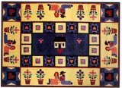
Amish Area Rug
iii. Barn Wood Furniture, Rustic Barnwood Furniture
Rustic, yet charming; sturdy, yet rough; barnwood furniture brings the feel of 19th century farm life into the living room and dining room. Originally created out of necessity, in a time when furniture craftsmen were limited to whatever materials were at hand, today's barnwood furniture is constructed from real or simulated pine, oak or cedar planks recovered from dissembled, weathered barns. These pieces carry their rich pioneer history with them to their new life as tables, chairs, and chests.
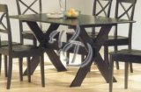
Modern Barn Dining Set.
Barn doors, too, are increasingly being recycled into use as dining tables or large coffee tables creating a uniquely American style that adds a homey, country feel to any room. Dissembling barns and reusing the planks and architectural details is environmentally responsible. Not only does it act as a unique raw material for unique and creative furniture design, it saves that many more trees from being destroyed in the name of our creature comforts.
The term, "Barnwood furniture," actually encompasses a variety of styles. "Texas", or "cowboy" barnwood furniture incorporates the straight, rough, simple lines traditionally found on ranches in the "Lone Star State", and makes use of leather and cowhide accents, especially for chair and bar stool covers. "New England", or "Yankee" barnwood style reflects the stoic, puritan lines of the northeastern states. Less structured than New England's colonial furniture, Yankee barnwood pieces have a utilitarian feel, such as a large, plank, country kitchen table. Yankee pieces, generally, have few adornments, and use only the most basic of hardware. "Montana" or "Yellowstone" style barnwood furniture brings in the wilderness of Big Sky country and makes use of hewn log construction and twisted willows and tree twigs. This style is easily recognizable by the fact that logs and trees are still identifiable as such in Yellowstone pieces.
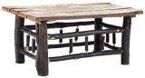
Hickory Table.
Barnwood pieces are, generally, singular works of art, simple and clever at the same time. Every piece of barnwood furniture gains something unique from the piece of wood from which it was created.
Color and Finish
Barnwood furniture is commonly found either with a natural finish or boldly painted, often in yellows, reds, and blues. Natural finishes range for honey-colored pine to rich golden pecan and maple, to deep, walnut-tones. Natural barnwood frequently has a charming patina gained from decades of harsh New England or Montana winters and the rigors of farm use. Conversely, painted barnwood furniture celebrates life with cheerful motifs and brilliant hues. The rough texture and simple style of barnwood planks lend themselves to use as American folk art. Many painted items incorporate an American flag design or simple depictions of 19th century, American farm life.
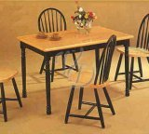
Contemporary Style Barn Furniture.
Outdoor Living
Rustic, barn wood furniture is a natural for outdoor spaces or indoor garden rooms. Hewn-log, or barn plank tables give that rustic and sturdy feel to a backyard picnic. Woven twig chairs and tables are surprisingly durable, blend in, and give a "back to nature" feel to any backyard. Additionally, the natural wood of these pieces is a perfect foil for lush garden greenery and colorful flowering plants. Yard accessories, such as mailboxes, butterfly and birdhouses, and sheds are also charming and playful when made of reclaimed barn wood.
Accessories
Indoor accessories are also fun and interesting when made of old barn wood and barn doors. Picture frames and mirror frames are frequent additions to a rustic design. Also popular, as well as useful, are rough-hewn coat trees, with branches serving as individual arms. Uses for barnwood in household items abounds and is really only limited by the decorator's imagination.
Rustic Barnwood
Barnwood furniture is unique, rustic, and highly textured. Combining this style with traditional furniture and Oriental area rugs creates an eclectic, yet warm room. A single barnwood piece is often enough to add interest to a room without overwhelming it. The rough-hewn logs of a Yellowstone table and settee, for instance, immediately draw the eye. Colorful pillows, cushions, woven throws are a good way to add color and warmth to a naturally finished barnwood piece. Prices for barnwood pieces range from affordable, around a hundred dollars, to expensive, several thousand dollars. Generally, the more rare the wood and the more craftsmanship involved in the piece, the more expensive it will be.
iv. Craftsman Furniture
In the 1840's the Arts and Crafts Movement in England rebelled against the fussy, highly ornamented and often uncomfortable Victorian style of home design. Rejecting the Industrial Revolution, with its plethora of machine-turned items made from cheap materials, designers such as William Morris developed a philosophy of design stated as "honest craftsmanship, natural materials, simple and pure design, and harmonious family life".
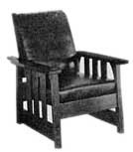
Craftsman Lounge Chair.
Gustave Stickley
This movement took some time to spread to America and only became popular in the last decade of the 19th century. At this time, American furniture designer Gustav Stickley was inspired by this movement to produce his own range that he referred to as "Craftsman Style Furniture", based on designs to be found in his magazine "The Craftsman". Craftsman furniture of this period was the first American furniture to have a strong impact on the history of furniture development worldwide.
Craftsman Homes
Craftsman furniture was just one of the expressions of a lifestyle envisaged by the originators of the Arts and Crafts movement. The movement was a breakaway in all areas of the home from the cramped and complex Victorian lifestyle. Space, comfort, a return to nature, and a home that was easy to manage, leaving time for family life, were the principles behind this movement. The Craftsman home was designed to be a place where a family could relax and spend time together, as well as being suited to an era when servants were no longer the norm.
Craftsman Furniture Designs
Stickley's designs were plain and simple, using strong horizontal and vertical lines and almost no decoration. This furniture was extremely durable due to the use of mortise and tenon joinery. The beauty of Stickley's furniture lay mainly in the quality of the wood. He used only the best American hardwoods, mainly oak, and preferred to use quarter-sawn pieces that highlight the wood grain. He also used finishing techniques such as treating the wood with ammonia to bring out the grain. Stickley's Craftsman furniture is highly prized and has an important place in the heritage of American furniture.
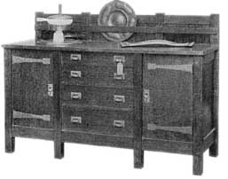
Antique Sideboard.
Craftsman Styles & Decor
Wooden slats were much used, both for chair backs and for table and chair legs. Craftsman furniture knobs, pulls and hinges were usually of copper, brass or pewter. Upholstery, when used, was often of dark leather.
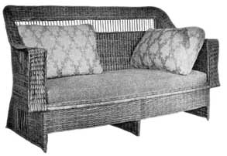
Willow Settle.
Stickley's furniture was good looking, practical and durable, but for the most part it was above the price range of the common people. However, many other manufacturers began to produce similar furniture more cheaply, and American craftsman furniture became extremely popular. Craftsman style decor is best suited to simply designed craftsman style homes, following the bungalow-style Arts and Crafts type of architecture.
Craftsman Outdoor Furniture
Craftsman outdoor furniture follows the same principles of design as that used for interiors, and also reflects the less formal, more natural style of garden layout advocated by the Arts and Crafts movement. Sturdy, good-quality wood is used, and slats are often seen in both tables and chairs.
Revival
Craftsman furniture regained its popularity in the 1980's and is much in use today. Several craftsman furniture makers of today such as the Royal Craftsman Furniture and Southern Craftsman brands produce beautifully finished, sturdy furniture in the tradition of Stickley. Craftsman furniture has also become popular amongst DIY enthusiasts and Craftsman furniture plans can be obtained for making authentic Craftsman furniture at home.
American Craftsman furniture is a practical choice for today's home, and an investment in the future.
v. Lodge Furniture & Décor
Lodge Style
Lodge style design draws its inspiration from the summer vacation and hunting lodges of the Midwest and Western United States, from Michigan to Montana. Long before jet planes whisked families to Europe, to Asia, and beyond for summer vacations, families packed up the kids and drove to the cabin or the lodge by the lake. These summer getaways were rustic, yet comfortable, with large, open living rooms and cozy bedrooms. Furnishings and construction reflected their natural setting, with log cabins and log furniture popular. Fireplaces ensured that the living area staying warm and toasty. Lodge architecture is noted for its high, exposed beamed ceilings and open floor plan. Builders used materials found in the local landscape, such as fieldstone, pine and oak as well as plentiful windows to best enjoy the sweeping landscape views.
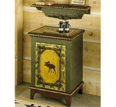
Lodge Side Cabinet.

Lodge Furniture
Lodge style furniture reflects the wildness of the great American outdoors. It is generally sturdy, rustic, and made from pine, oak, walnut, or birch. Lodge design is more rough-cut than stylized. Frequently hewn logs and sturdy twigs are used to form unique and natural-looking chairs, tables, chests and bed frames. Beautiful handcrafted pieces, such as cedar chests and hand-planed tables are common. A typical sofa has an exposed rough-cut, wooden frame with overstuffed fabric cushions in a nature print or green and brown tones. Dining room tables are large and sturdy, with seating for a whole house full of family and guests. Beds are often made of hewn logs with the bark still attached for interest, and bunk beds for children are commonly used. The fireplace is the center of many a lodge room, as much for comfort and a sense of conviviality as for warmth. Furniture is frequently grouped around the fireplace.
Outdoor
Lodge designed outdoor furniture is wooden, sturdy, and functional. Found scattered throughout the lawn as often as on patios, log-themed pieces are popular, such as picnic tables and benches made of whole and halved logs. Cushions in rust, gold, and deep green complement the colors in nature. Backyard accessories made of bark and barnwood, such as bird and butterfly houses encourage wildlife to make the yard their home as well as add rustic details.
Lodge Decor
The lodge design color palette reflects the colors of nature, and particularly of the woodlands. Greens, from light moss green to deep forest green evoke an outdoorsy feel. Browns, from light pine to dark walnut, create a warm, enveloping environment. Rusts and yellows bring in the colors of fall.
Fabrics in lodge decor have a rough, textured feel. Leather, particularly in deep green, rust, and brown tones, is frequently used for upholstery and for seat cushions and rough fabrics, such as tweed, are common. Festive bandana prints and prints with wildlife motifs are other popular themes in lodge decor. Nature prints, showing ducks, wildlife, and woodland scenes make ideal fabrics for cushions and accent pillows. Bright colored plaids, too, make ideal accent fabrics and help to liven up the lodge style room.
Folk Art and Americana, that quintessential pioneer art form, provide ideal decorating accessories for a lodge style home. Such items are cast-iron stars and flag-inspired fabric wall hangings complement the rustic charm of log furniture and leather upholstery. Woven items, such as colorful, roughly loomed blankets and fringed throws, light up the dark interior and help keep residents warm at night. Other suitable lodge decor accessories include baskets, often made of birch, duck decoys, and anything with a moose or a bear on it. Lamps made from wood and pinecone accessories are also frequently used. Area rugs, such as rag rugs and braided rugs, warm up the traditional hardwood floors. Images of moose, pine trees, and bears are popular, made into all kinds of objects, from towel holders to lamps to bookends. Birdhouses and sports items, such as fishing tackle and fishing rods hung on the wall are other ways to bring the outdoors inside.
Lodge decor is perfect for a casual, warm, and inviting home or family room. It allows residents to bring the beauty and style of a traditional vacation lodge and of the great outdoors into their home with rustic wooden furniture, the colors of nature, and woodland-inspired accessories. Lodge decor is particularly American and is friendly and accessible, yet still very stylish.
vi. Log Cabin Furniture & Décor
That rustic cabin, traditionally found in the woods or by the lake, is going mainstream. No longer relegated to weekend getaways, log cabin decor is coming to living rooms, family rooms, and even bedrooms throughout America. Based on the rustic decor of lake and mountain summer homes, log cabin decor is identifiable by its use of rough-hewn logs, both for home construction and for furniture as well as large, open spaces, paneled walls, and prominent fireplaces and cast-iron pot-bellied stoves. Aspen logs, birch logs, and cedar logs are transformed into stylish, yet rugged pieces of furniture, such as four-poster beds with tree limbs as the posts or desks with a planed piece of pine as the surface.
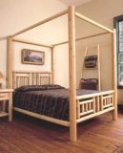
Cedar Log Canopy Bed.
Log home furniture stays true to its name with cleverly and expertly crafted log items, such as a sleek desk with branches as legs or a sofa constructed of rough-hewn logs. Rocking chairs, made from soft pine, sleek maple, or even birth or aspen tree limbs are a stylish way to enjoy an evening beside the fire. Useful items, such as pie safes and dry sinks, often adorned with punched tin, lend to the prairie feel of the log cabin room. A traditional rustic, log cabin living room might include a sofa constructed of halved, rough-hewn logs with deep green, overstuffed cushions accompanied by a birch twig rocker and a table made from a leather chest. A typical bedroom might include a bed made from cut logs, dressed in a cheerful calico print, accompanied by a rag rug and sturdy pine side tables. The log cabin kitchen centers around the table, usually a thick, rectangular piece - beautiful and functional, at the same time. Wooden benches or simply constructed chairs accompany the table.
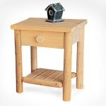
Cedar Log Night Stand.
Log cabin decor is noted for its dramatic textures - bark, rough textiles, and log home furniture. Hardwood floors are a common theme in rustic cabin decor, usually covered partially by area rugs, often rag, fur, or braided rugs. Leather upholstery, cushions, and pillows help recreate that rugged ranch look. Barnwood and roughly loomed fabric also add the prairie feel of the log cabin room.
Log cabin decor draws from the colors of nature - rich browns reflect the bark, leaves, and limbs of the forest, light moss greens mirror ponds and streams, deep greens depict the lush foliage of summer, and vibrant rusts and golds remind residents of the fading glory of autumn. Vibrant plaids and attractive nature prints, particularly those that feature ducks, moose, and bear are also popular, and help to brighten to often-paneled rooms.
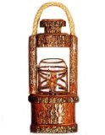
Log Cabin Lantern.
Screened-in side porches and sweeping open front porches are staples in log cabin architecture and log furniture construction lends itself to stylish outdoor furniture. Porch swings, gliders, and rocking chairs made of sturdy logs or stylish saplings help blend the distinction between indoors and out. Bird feeders and birdhouses, often made of recycled barnwood, are ideal outdoor accessories for a log cabin house.
Log cabin decor emphasizes the functional as well as the beautiful. Items, such as fishing gear and household gadgets, find their way to the living room walls as decoration. Moose and bear themed-items, anything from a lamp to a bookend, lend a touch of whimsy and playfulness to a log cabin-themed room. Quilts, blankets, and woven throws are decorative as well as useful in keeping residents warm during the long winter's nights. In addition, symbols of the Old West, such as leather saddles, wagon wheels, stirrups, and lassos make interesting wall hangings in a log cabin room.
Artwork runs to the rustic, also. Folk art, simple and primitive designs painted on old barnwood or simply forged metal works, complements a log cabin-style room. Textile art adds vibrant colors to the often dark, wood-paneled walls. Quilts, too, look festive and traditional when hung on the wall.
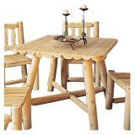
Cedar Log Square Dining Table.
Log cabin design brings a cozy and warm feel to any home. Friendly, rather than formal, log cabin decor invites guests and family alike to curl up on the sofa or pull a chair up next to the fireplace. It's a uniquely American style that draws on the prairie and pioneer spirit and tenaciousness of the first Americans and quietly inspires all of us to be the best we can be.
vii. Rustic Mexican Furniture
Mexican furniture, with its gracious, honey-toned pine cabinets and armoires, sturdy dining room and country kitchen tables, and curved headboards, has become more and more popular as interest in Southwestern design has increased. Traditionally viewed as the poor cousin of sturdy maple, oak, and mahogany European-inspired pieces, pine furniture has come of age. Mexican furniture is identifiable by its rustic lines, its intricate carved details, and its use of dark iron hardware. Pine is the wood of choice in Mexican furniture, but walnut and cherry pieces are occasionally seen. Sturdy, antique pine pieces - both authentic and reproduction -- carry with them the rich history of the Mexican colonial days. Influenced by the parade of cultures and peoples that once called Mexico home, Mexican furniture design incorporates a little bit of Spanish, a little bit of Mayan, and even a little bit of Chinese style.
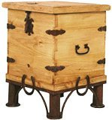
Caballero End Table Trunk.
Mexican furniture is a blend of formal Spanish colonial styling and native Mayan design. The rich ornamentation and iron scrollwork of the Spanish adorns simply constructed, straight-lined cabinets and tables reflecting the designs of the Mayans. In additional to the natural warm honey tones of pine, many Mexican pieces are brightly painted, usually in exciting colors, such as red, orange, and blue, mirroring the celebration of life that is Mexican culture.
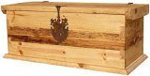
Rustic Trunk.
Natural materials: grasses, such as reeds and rush, fieldstone, and clay are frequently used in Mexican design to blend the line between nature and civilization, indoors and outdoors. Smooth leather, used for cushions, upholstery, and even tabletops reflects the ranching lifestyle of the southwest. Inlaid ceramic tiles and mosaics are used to give sold pine Mexican furniture a festive and playful air and are often seen on decorative table tops.
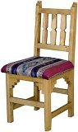
Southwest New Mexico Chair.
The Colors of the Desert
The warm tones of the desert are reflected in Mexican design and in Mexican furniture. Warm sand-colored pine combines with earthy mustard, khaki, terra cotta, and sienna hues. Finishes tend to be rustic also. Textured stucco walls and rough, unpolished clay tile floors are a common theme. Modern faux-suede wall treatments are an interesting way to give a southwestern flair and soft texture to a room. Accent pieces tend to be bold and expressive, with primary colors, such as red, yellow, and blue favored.
Mexican Patio Furniture
The centerpiece of any southwestern patio is the chiminea, a clay outdoor stove, traditionally used for cooking and today used as a focal point and for warming up the cool desert night. These stylish, conical units come in all sizes and usually sit on a wrought-iron stand for circulation. Non-traditional uses for these attractive terra-cotta pieces include planting them with flowers or moving them indoors for such uses as a towel-holder or as a vase.
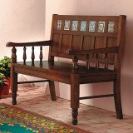
Merida Mexican Bench.
Sturdy and rustic pine furniture pieces make an attractive patio grouping. Large, solid tables surrounded by benches and chairs welcome guests and invite them to share the "mi casa es su casa" southwestern hospitality. Mexican design lends itself to gracious entertaining and pine bars and bar stools are popular, often embellished by a mosaic tiled countertops and soft, leather seats. Thick blue and green glassware are a natural accompaniment.
Mexican Design
In contrast to the muted, earth tones of Mexican furniture, Mexican design favors colorful accents. Woven blankets, festive pottery, and vibrant artwork light up the southwestern room. Cactus plants in terra cotta pots bring a little of the outside indoors. Metalwork, such as iron tableware and candlesticks as well as tin mirror frames, complement the drawer pulls and hinges on the furniture. Colorful baskets, many woven in traditional designs and tinted using natural dyes, further add to the rustic ambiance. Symbols of the old west, such as leather saddles and iron farm implements also go nicely with Mexican furniture. Traditional Mexican folk art, with its colorful, somewhat primitive motifs, adds to the celebratory feel of southwestern decor. Soft lighting, with candles and shaded lamps, is a perfect way to bring out the muted colors of a Mexican design scheme.
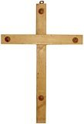
Rustic Cross.
Mexican design and Mexican furniture give a home a welcoming, warm feel. Adding an impressive antique look pine armoire or a rustic honey-toned chest with black iron hardware, making it cheerful with a colorful blanket or terra cotta planter, and softly lighting the room for a rich, romantic feel, warms even the chilliest night. You don't have to live in the southwest to enjoy this friendly design style. Mexican design welcomes everyone.

viii. Mission Style Furniture
In the early years of the twentieth century a style developed in the United States called Mission, suggested by work found in the old Spanish Missions in California and the southwest. It runs almost entirely to straight lines. At first it was perhaps rather heavy and clumsy, but developed into a lightened and greatly improved form. It is a simple straightforward style easily recognized and is very popular still in more modern times.
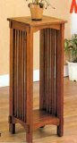
Solid Oak Mission Style Plant Stand.
Origins & History
Ponce de Leon discovered Florida in 1512; in 1513 Balboa discovered the Pacific; in 1519 Cortez set forth to conquer the countries of Mexico.
The colonization of Mexico by Spain naturally meant the introduction of Catholic missions. In the early part of the sixteenth century Mexico proper and all the newly-established central American provinces were flooded with missionaries from Spain; churches by the hundred were built and missions established on every hand, in what are now the Mexican provinces.
It is doubtful if any Spanish furniture was brought over by the early missionaries for the furnishing of their pioneer structures. Their work was attended with great hardships, long marches and struggles for a living and a foothold in the interior of a new country. And it is unreasonable to suppose that they added to the hardships of their progress any unnecessary burdens. The famous missions of today are the missions of California, and in their construction the builders utilized black oak, laurel, juniper, live oak, red wood, scrub oak, sycamore and walnut.
On arriving in Mexico the Spaniards encountered the ancient Aztec civilisation, that dominating people who possessed a civilization in Mexico before the Spanish invasion under Cortez, and who had their own tradition of furnishing. The missionaries adapted some of the Aztec traditions in line with their own native, primitive Gothic heritage.
However in the main mission ornament was necessarily ecclesiastical and to present the old Mexican or Aztec decoration as a background to the Mission furnishings is wrong, for whatever the charm of Aztec decoration, it is doubtful if the representatives of the Christian Church in the New World adopted heathen elements to any great extent.
In the early times the furnishings of these mission chapels were crude in the extreme, but in the eighteenth century the missions gathered strength and prosperity.
Early antique mission furniture craftsmen made some pretense to reflect the character of the furniture found in the missions of old Mexico and the countries now New Mexico, Arizona, Texas and California; but there was never any serious effort to conscientiously follow the style which, after all, was simply primitive Gothic - the simplest style of carpenter work made for or by the missionaries under conditions which neither invited nor permitted the exercise of an artistic touch. It was simple, crude furniture bearing naturally the influences of the Spanish architecture which constituted the environment. The woods used were those most easily manipulated and obtained.
Solid Wood
Oak is the pre-dominant wood used however it is illogical to assume that Mission furniture was ever only made of one wood.
In southern California early makers of antique furniture would have known the many Pacific coast forest yields such as Douglas fir, spruce, larch, western red cedar (arbor vitae), hemlock, redwood and big-tree, yellow and white pine, incense, port Oxford and yellow cedar, fir (balsam), juniper, yew, cottonwood, maple, alder, birch, madorna and laurel.
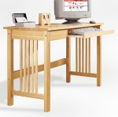
Mission Computer Desk.
In Arizona, Colorado, New Mexico and Northern Mexico, what is known as the Rocky Mountain forest yields are yellow pine, Douglas fir, fir (balsam), spruce, juniper, pinon pine, aspen, cotton wood and oak.
In other parts of Lower Mexico we find all of the sub-tropical and tropical woods, mahogany, pine, prima-vera, santa maria, logwood, Mexican rosewood, zebrawood, mesquite, aliso (alder), ash, elm, mulberry, cottonwood, silk cotton tree or ceiba, linden, china, pimienta, John Crow wood, buttonwood, black maba and salm-wood.
In Central America and West Indies, mahogany, lignum vitae, logwood, sabicu, rosewood, fustic, quiebra hacha, zebrawood, calabash, cocobola, corkwood, panama, jaqua, amarillo, laurel, sarsaparilla and cocoa-wood.
Mission Style
In contemporary mission style furniture oak is the principal wood used, and fuming or dark stains the most suitable finish. Similar work was produced in England, where it is called Arts & Crafts furniture, in Austria and Germany, and in America it is sometimes referred to as Craftsman furniture in the style of Gustav Stickley.
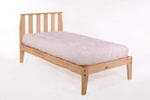
Mission Platform Bed.
Primarily today most interest in mission style furniture revolves around its use in bedroom and dining room furniture, and office furniture, and there are a great number of online stores offering it for sale at discount prices, etc. Some of them may be found in our mission furnishings page. Also plans for making mission furniture are ever popular with amateur woodworkers.
ix. Prairie Style Furniture
In the late 19th century, a young man named Frank Lloyd Wright rebelled against ornate Victorian architecture and furnishings, and chose to build himself a home that reminded him of the prairies where he had worked in his summer holidays as a teenager. Although at this point he was not a trained architect, this home was so successful that it brought him not only a career as an architect, but also the distinction of being the innovator of the "Prairie School" in architecture and furniture design.
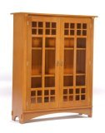
Ellis Cabinet.
Prairie Style Home Designs
Prairie style home designs feature long, low lines, imitating the horizontal lines of the prairie. Overhangs are much in use, highlighting the horizontal planes and giving an impression of affinity with the earth. Prairie style home plans aim to avoid the 'boxed in' Victorian house styles. Following the open plan wherever possible, different living areas are separated by furniture rather than walls, creating a feeling of space and family togetherness.
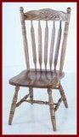
Prairie Wheat Chair, Oak.
Prairie Architecture & Furniture
Rejecting ornate Victorian furnishings, Wright designed his own furniture to fit in with his style of architecture. He chose to follow the Arts and Crafts movement's commitment to quality materials, simple lines and good craftsmanship. Similar to the Mission furniture made popular by Gustav Stickley, Wright's furniture featured geometric shapes with a somewhat mediaeval influence, made from solid American hardwoods. The horizontal lines and overhangs typical of Prairie style architecture were reflected in Prairie style furniture. As with Mission style furniture, little decoration or ornamentation was used. The furniture was simple and practical, relying on the quality of the wood and finish for beauty. The Arts and Crafts ethic of functionality, comfort, good craftsmanship and good materials appealed to Wright, and influenced his designs. Working together with George Mann Niedecken, a Milwaukee painter and interior designer, Wright popularized the Prairie style furniture with its simple lines, superior wood and incorporation of stained glass and art glass.
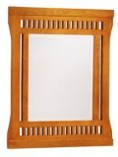
Prairie Mirror.
Prairie Style Houses
Often referred to as Prairie Mission Furniture, Art and Craft Furniture Prairie Style, or Prairie School Furniture, Wright's furniture designs influenced many furniture manufacturers of the early 20th century. When designing a Prairie style house, Wright would design Prairie style furniture specifically for that particular house, fitting in with the architecture and landscaping to produce a harmonious whole. To appreciate this, let us take a tour through an imaginary but typical Prairie style home.
Entry Doors & Fireplace
The first impression of the house is of a low, sweeping, spacious style, built to complement the landscape around it. Pillars frame a Prairie style entry door of solid wood with a heavy brass knocker. Passing through this, we find a spacious open plan living area, divided roughly into different living spaces by furniture and occasional low walls. French doors and plenty of windows feature art glass designs. The focal point of the room is the fireplace, with brick, tile or perhaps stone surround, ornamented with a Prairie style mantel clock in wood and glass.
Dining Room
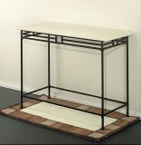
Prairie Console Table.
The dining room furniture has heavy wooden legs, and is of a rectangular or perhaps circular design, with slatted sides and backs to the chairs. Living room furniture is built for comfort, with low horizontal lines. Solid wood bookcases with art glass patterns match the window patterns, and are used as room dividers. Much use is made of lighting. Prairie style lamps follow the prevailing theme of wood and art glass, with horizontal lines and overhangs.
Bedroom
Moving to the bedroom, we find a bedstead with heavy wooden panels, placed beside a simply designed night stand with drawers. A plain but beautiful Prairie Style oak chest of drawers provides plenty of storage space. Above it is a Prairie style wall mirror with a heavy wooden frame and leaded glass. The kitchen features lots of light and space, practical horizontal lines giving plenty of workspace, and again a combination of wood and glass.
An American Tradition
Overall, the theme is light, spaciousness, practicality and natural colors. The Prairie style home is an all-American innovation, reflecting the wide open spaces of America. To quote Frank Lloyd Wright himself: "We of the Middle West are living on the prairie. The prairie has a beauty of its own, and we should recognize and accentuate this natural beauty, its quiet level".
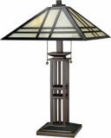
Prairie Table Lamp With Tiffany Shade.
The Prairie school of architecture and furniture design has greatly influenced all subsequent designs, in that practicality, comfort and spaciousness appear to have permanently replaced the box-like, ornate, fussy designs of previous eras.
x. Southwest Furniture
The arid, rugged, desert lands of southern California, Texas, Arizona and New Mexico, once the frontier with Spanish-owned territories, are the home of the attractive American furniture known as Southwestern style furniture.
Southwestern Furniture Origins
Many influences converged to create this unique style. In common with ranch style furniture, Southwestern furniture was often built for utility by unskilled carpenters, using whatever materials came to hand. Native Indian heritage also played its part in the development of furniture southwest style, especially in the choice of colors, fabrics and motifs. But the predominant influence in Southwest furniture is that of the Spanish conquistadors, who brought with them skilled woodworkers.
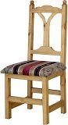
Southwest New Mexico Chair.
The Carpinteros
The carpinteros, as they were called, were part of the old Spanish guild system, where skills were passed down from father to son. Thus they brought with them age-old traditions of Spanish, Moorish and Christian designs. However, though the skills were available, the tools and materials were often scarce in these remote regions. Often working with nothing but an axe and a chisel, and having to make mortise and tenon joins in place of nails, craftsmen of this period still produced furniture with the beautiful lines of old Spain. The only suitable wood available was Ponderosa Pine, a semi-hardwood not well suited to ornate carving due to its tendency to split along the grain. Motifs were still incorporated on many pieces in spite of this, using chip-carving techniques. Hinges, knobs and pulls were made of rough iron in simple styles, forged on site by the craftsmen.
Southwest Design Furniture Charm
The appeal of Southwest design furniture is its contrast between the rough materials and finish, and the truly beautiful and elegant lines of the design. Southwest style furniture of the late 18th and early 19th century era fetches high prices at auctions and in antique shops, since it is fairly rare. However, the style has given rise to the popular Southwest home decor style, and quality Southwestern handcrafted furniture in this tradition is an attractive addition to the home.
Southwest Decor
The Southwest decor begins with the home itself, which ideally features rough wall finishes and tiled floors in the Mexican style. Cool colors, reminiscent of sandy soils, cactus plants and early dawn over the desert, are the prevailing theme, with colorful fabrics in Indian styles. The living areas are light and airy, simply laid out to reflect the simple yet elegant style of Southwest pine furniture. Southwestern dining room furniture typically features highbacked chairs around a finely proportioned dining table, with spacious and practical sideboards and cupboards to match. Southwestern styled patio furniture is particularly attractive and practical, reflecting the outdoor living style of days gone by. Southwest bedroom furniture provides plenty of storage space and comfort, with massive armoires and intricately carved bedsteads. Southwestern decor furniture is blended with accessories of either ranch, Mexican or Indian styles to give a feeling of the old hacienda.
Rustic & Elegant
Southwestern furniture is a unique blend of the rustic and the ornate, combining the elegant traditions of Old Spain with the "make do" tradition of the pioneers of Early American history. Surprisingly, this blend is a huge success and is one of the more practical and pleasing styles of popular home decor.
xi. Shaker Furniture History
Shaker furniture was made for god, the Shakers' furniture was an attempt to apply the Shaker philosophies of equality, modesty, confession and faith and the shaker search for order and harmony, to the mundane objects found in homes, chairs, tables, cabinets, etc.
Shaker Chairs
Of all the styles and forms of Shaker furniture history Shaker chairs are almost certainly the most admired and famous. As originally designed Shaker chairs were the best example of shaker faith expressed through wood, it's crafting and moulding, and remain perhaps the highest peak in shaker style furniture design and decor, and much prized by shaker antique collectors.
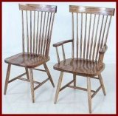
Spindle Shaker Chairs.
Shaker Side Chairs
Shaker style side chairs were made generally from maple, and to a lesser extent, cherry, birch, and walnut. These woods were taken from woodlands owned by shaker sects.
The shaker side chair was backward leaning, for a little comfort, and always made with three slats at the back. Attached to the back posts of shaker side chiars were tilting feet, one of the shaker movement's great gifts to furniture design. A ball and socket joint allowed the chairs to be rocked back on to the back legs whilst the back feet remained resolutely on the floor.
Shaker side chairs were most often used in shaker union meetings when the church members would sit opposite each other, sexes separated, and make light talk.
Peg Rails
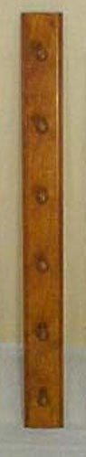
Shaker Peg Rail.
In most shaker houses peg rails at 6-7 ft height from floors were installed on walls to enable easy, and decorative, storage of chairs. At each 1 foot gap pegs were put in the rail so that chairs and other home objects such as candle boxes could be stored away when not in use thus avoiding clutter.
Shaker Rocking Chairs
Rocking chairs proper were originally designed for the use of elderly shaker believers as the rocking motion was thought to be beneficial to health.
Shaker rockers were sometimes manufactured with mushroom posts at the ends of the curved arms. Others used scrolled or rolled arms, and in later times, cushioned arms. Shaker style rockers also had four slats in the back. The shakers also developed the "sewing rocker", planned specifically for shaker women, made shorter and without arms, to allow easy access to a sewing basket.
Shaker Cabinets & Cupboards
The guiding principle behind shaker cabinets making was the desire for order and tidiness. Shaker bedroom furniture makers made their cabinets, corner cupboards, chests of drawers, blanket chests, and storage chests in small numbers, in their workshops, and with great handmade consistency and loving attention to detail.
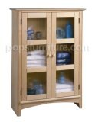
Maple Shaker Cabinet.
At the Hancock community in Massachusetts there is to be found an historic example of shaker cabinets. 48 drawers built into one wall, the drawer sizes tapering down as the wood cabinet nears the top. The cabinet drawers have simple wooden knobs and the whole design is a classic example of antique shaker furniture making.
Shaker Kitchen Furniture
Shaker furniture makers excelled in building built in cabinets for the kitchen and elsewhere which were used for the storage of cutlery, crockery, candles, etc.
The high cupboards found in authentic shaker kitchens were often accompanied by step stools fo 2,3, or 4 steps.
Shaker woodworking skill in the kitchen is well exemplified in the bread cutting table. Bread cutting tables sported a knife which doubled as a guillotine operated on a pivot affixed to a rail on the back of the lipped tops. These Shaker bread cutting tables allowed for very speedy cutting.
Shaker Dining Room Furniture
Shaker dining tables were made from long pine boards closely jointed to permit easy cleaning as table lined wasn't used in shaker houses. Shaker dining tables sat sets of four people, and so a 12 foot table could seat 12 shakers in their groups. The purpose of this was to enable the passing around food without recourse to speech.
Meaning of Shaker Furniture Today
Shaker style furniture, like it's cousins mission furniture and amish furniture, remains popular to this day and this popularity is perhaps an expression of the contemporary world's longing for a more simple life expressed in home office decor and furniture. It is a perhaps interesting thing whether a form of art so deeply bound up with religion can be successfully transferred to a world so removed from the original movement's religious inspiration.
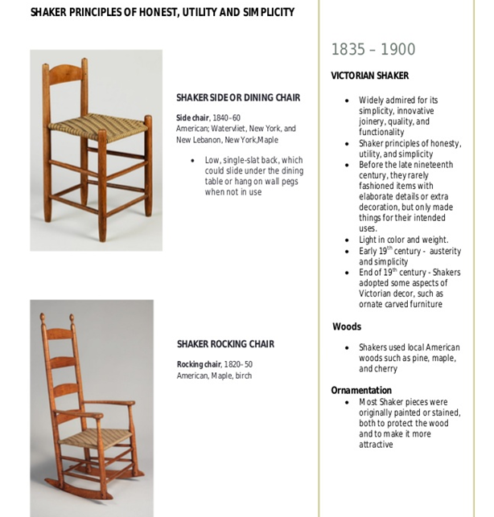

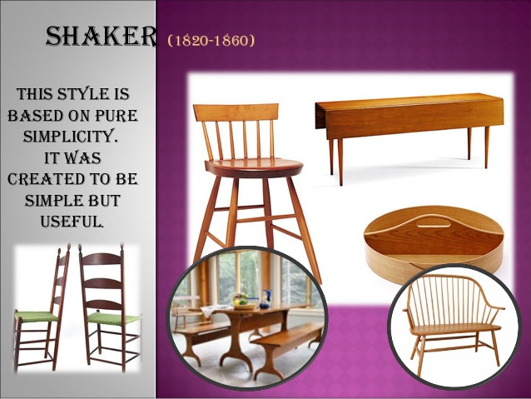

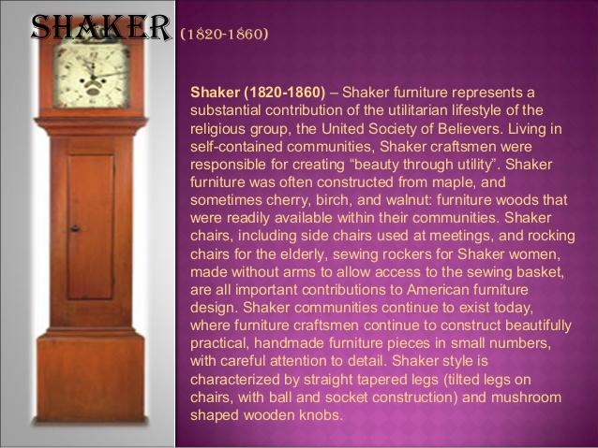
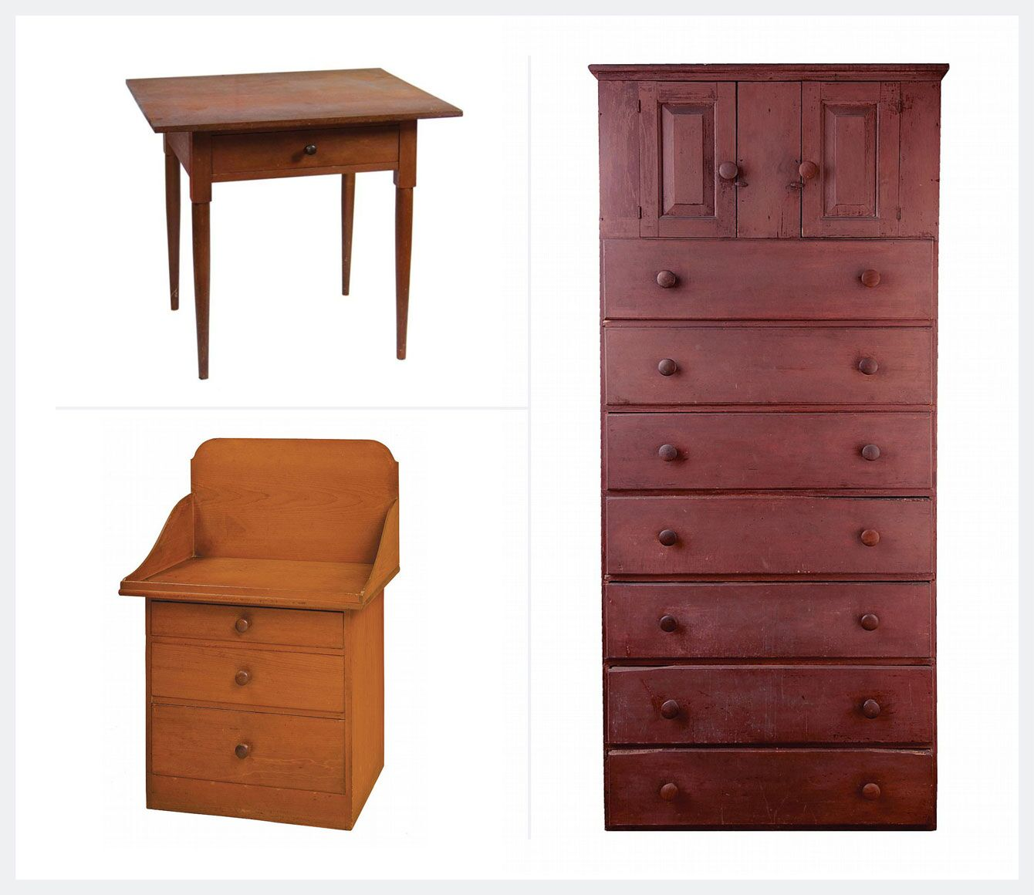

Top left: Walnut One-drawer Stand, sold Bottom left: Shaker Wash Stand, James Calver,; Bottom right: Cupboard Over DrawersGeographic Origin: Northeastern United States
Materials: Pine, maple, cherry wood
Key Designers: Tabitha Babbitt, Isaac N. Youngs
While Shaker furniture may be some of the simplest with its clean lines, unmatched quality, and no-fuss aesthetic, it is guided by some of the loftiest principles of any American furniture style. The Shakers were a devout religious sect governed by a strict set of moral and religious beliefs, which dictated a self-sufficient, simplistic and purpose-driven approach to life in which hard work was considered a form of worship. Shakers lived in communities separated from the rest of society where they grew their own food, made their own tools, and constructed their own buildings, furnishings, and items for everyday life.
Their work was to be without ornamentation and focused on utility, and so instead the craftsman and women of the Shaker movement devoted their attention to finding the perfect proportions, angles, and construction techniques. Examples of Shaker furniture include rocking chairs, tables, and cabinets. Shaker furniture was often painted in a subdued set of colors dictated by a strict set of sect rules called the Millennial Laws, and included blue, greens, reds, and yellows.
The Shaker ladder back chair is one of the easiest to spot as an example of Shaker design principles. The turned posts used in the backs resemble a series of rungs on a ladder while the woven wicker seats were easy to construct and extremely functional. These chairs were often stored upside-down by hooks mounted on the walls of the Shaker meeting houses.
Shaker communities declined steadily after the Civil War and there is only one Shaker settlement left today. The Shakers have left behind a rich design legacy, one which influences mainstream design and home furnishings still today.
Shaker furniture
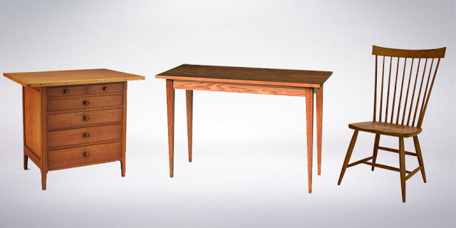
Shaker Style Furniture

The Shaker style was produced by the religious group the United Society of Believers in self-contained communities in the United States.
The identifying features of shaker furniture are...
- simple, utilitarian style
- straight tapered legs
- woven chair seats
- and mushroom-shaped wooden knobs
- rectilinear and attenuated forms
- restrained ornamentation
xii. Western Furniture & Cowboy Décor
The Western Cowboy look is perhaps one of the most 'fun' styles of popular decor. The advent of television, as well as popular movies, gave rise in the 1950's to a huge demand for all things Western. It's all about action, courage and life lived to the full - work hard, and play hard. Pit your wits against a wild bronco or a rampaging steer, then barn dance till you drop to the country sounds of the guitar, banjo and violin. It's about history, and heritage, and an era of strong men and women striving to overcome hardships.
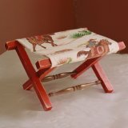
Cowboy Camp Chair.
The Western Look
Western decor combines the historic, the ethnic and the picturesque. Western Cowboy furniture can be primitive, featuring rough-sawn logs, nails and coarse fabrics, looking as if it had been thrown together quickly by a busy ranch hand. Simple bunk beds, tables, straight-backed chairs and rough-hewn cupboards reflect the style of the bunkhouse that served as a temporary home to an ever-moving labor force. On the other hand, the Western look can reflect the beauty created by a lonely cowhand, with little to do in the evenings, and something of the soul of an artist. Using the materials closest to hand - Ponderosa pine, cow hides and horns, horseshoes - beautifully polished and carved woodwork was combined with gleaming tooled leather and simple ornamentation to provide attractive and original pieces of furniture.

Western Gun and Curio Cabinet.
Native American Influences
Native American Indian influence is very much to the fore in this type of decor. Navajo wool rugs, horseblankets, fringes, feathers and beads are used to advantage, both as accessories, and as ornamentation to an otherwise plain piece of furniture.
South Western Furniture
Colors are strong reds, blues and greens, and fabrics can be leather, denim or colorful Navajo prints. South western furniture will be richer in Spanish and Mexican influence, and colors will tend towards the desert shades: oranges, yellows, mauves and deep browns. Leather furniture western style may reflect the rough, rawhide look, or may be fine leather cowboy furniture: soft, supple and highly polished.
Western Styles
Western motifs are used generously. Carved, painted or added in media such as cow horn: Western furniture is almost always richly decorated. Wagon wheels, broncos, boots, spurs, cactii and lariats decorate everything possible! A touch of the rustic can be added with such items as twig-framed mirrors, or chairs and tables in coarse wooden textures.
Childrens Furniture
Western Cowboy decor is a popular choice for a child's room. Children's western cowboy furniture is often of simple design, painted in attractive colors and boldly decorated in a Western theme.
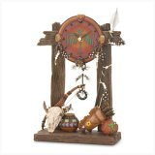
South Western Clock.
Simplicity & Imagination
Furniture Western Cowboy style gives great scope for originality and personal taste. It can reflect the simplicity of pioneer cowboy furniture, or can be composed of unique, almost outrageously imaginative creations and designs of leather, cow horn and metal. Perhaps the best effect can be obtained by a simple, well-coordinated theme contrasting with just one creative and original item to provide a talking point.
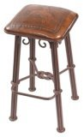
Western Iron Barstool with Leather Seat.
Home and Office
Cowboy style furniture is ideal for a log cabin or bungalow used as a weekend retreat, but it is also a popular choice both for the home and the office. Western office furniture will typically include comfortable, attractive pieces rich in leather and native wood. Rustic cowboy furniture is ideal for the garden or patio. Western decor can give interest to the living area of your home, and can also be a restful and comfortable choice for the bedroom.
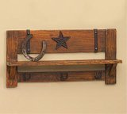
Western Wood Cowboy Shelf.
Historic Western furniture will be with us as long as there are Western movies, Western novels, Western line dances, and Western rodeo extravaganzas. It is part of the great American heritage.

F. Modern Furniture

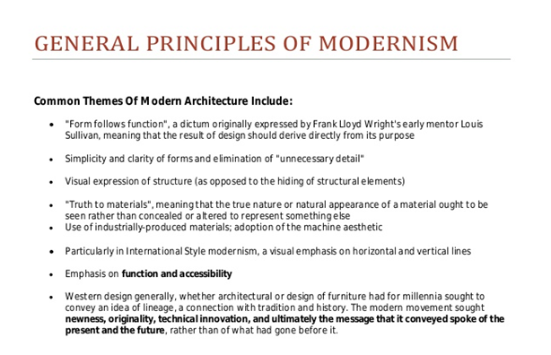
1. Arts and Crafts Style (1880–1910)
Geographic Origin: Japan, Europe, North America
Materials: Mahogany, oak wood
Key Designers: The Stickley Brothers and Frank Lloyd Wright
The Arts and Crafts style was an international design movement that started in Japan around 1880, spread throughout Europe, and eventually arrived in North America. The style marked a return to early medieval and folk styles of decoration and was a reaction to the heavy industrialization of the period.
At the same time the design aesthetic was evolving, so too was a social movement that called for a return to hand-crafted artisanship in furnishings and other now mass-manufactured goods. Intellectuals like William Morris (who was also an architect) pushed the anti-industrialist agenda of the movement, while designers like the Stickley Brothers were most notable for creating furniture pieces in the aesthetic, which can be mis-credited as Mission Style furniture.
Furniture designs of the Arts and Crafts style were often constructed of natural woods, primarily oak, and focused on form and function in harmony. Finishes were sparse and the wood was often fumed or painted. Hardwares were typically made of copper with inlays in natural materials such as contrasting wood, or crushed abalone shells. Legs were straight with small feet, if present at all.
In the U.S., the Arts and Crafts style gave way to the Craftsman style of the early 20th century, which is known for even heavier wood construction, stout appearance, and an enduring architecture style popularized by Frank Lloyd Wrightin the Midwestern United States.
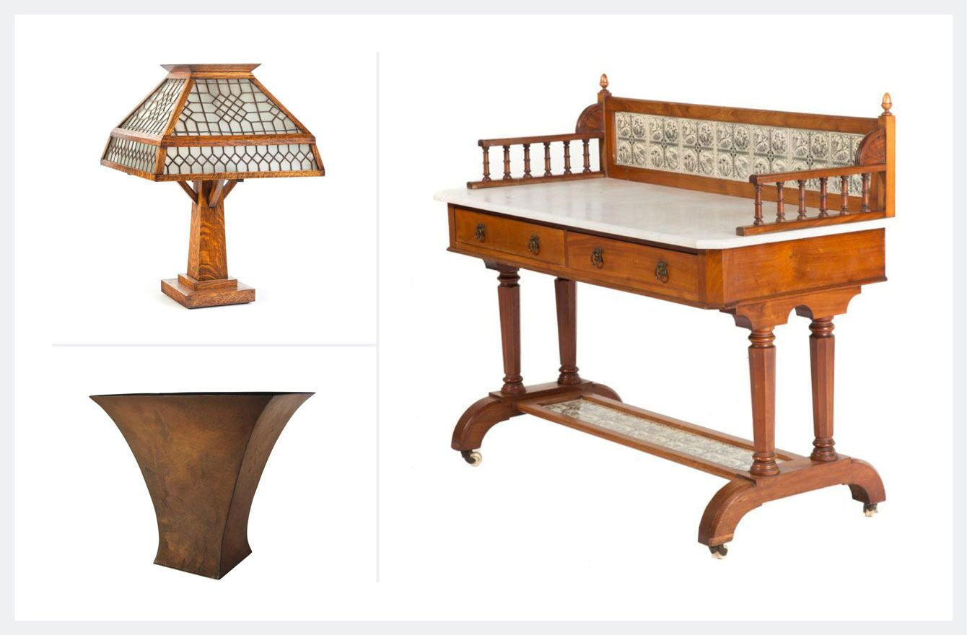
Top left: Arts & Crafts Table Lamp with Panelled Leaded Glass Shade,); Bottom left: Marie Zimmermann American Arts and Crafts Copper Vase Right: American Arts & Crafts Walnut Marble Top Server
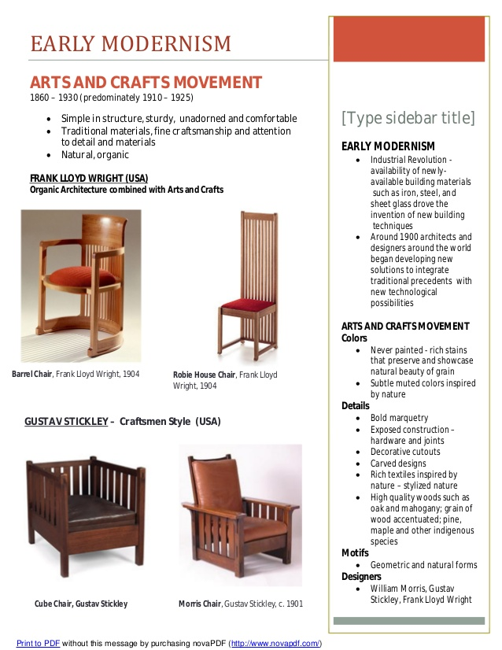
Geographic origin: Japan, Britain, mainland Europe, North America
Materials: mahogany, oak wood
Key designers: John Ruskin, William Morris, Philip Webb, Arthur Mackmurdo, and Christopher Dresser
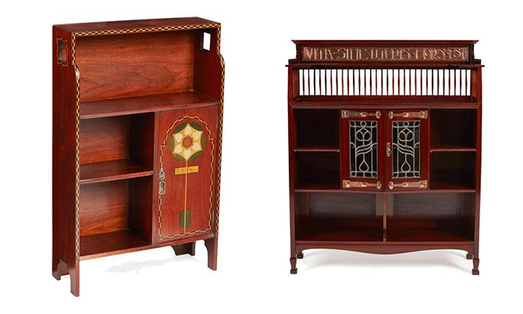
Left: Inlaid Arts & Crafts mahogany bookcase cabinet, circa 1900 Right: Shapland & Petter, Barnstaple, Arts & Crafts mahogany open bookcase, circa 1905
The Arts and Crafts style was an international movement that pushed against the heavy industrialization of the late 19th and early 20th centuries. The style, which favored a return to handcrafted artisanship and folk styles of decoration, was strongly influenced by philosophical and artistic developments in Britain. The contributions of John Ruskin and William Morris in particular were paramount and led to a greater appreciation for manual construction and the creative act of design.
British furniture made in the Arts and Crafts style typically featured rectilinear and angular forms and pared down, stylized motifs evocative of medieval, Islamic, and Japanese design. Developments closer to England also played an important role, with Irish furniture makers emphasizing the significance of sophisticated, hand-carved designs. In Scotland, influential figures such as Christopher Dresser contributed to the flowering of the Glasgow style, which incorporated elements of the Celtic Revival into the Arts and Crafts movement. Arts & Crafts furniture
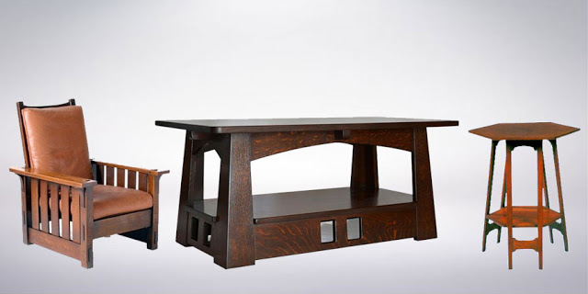
Arts and Crafts Style Furniture
Arts & Crafts furniture is simple, with straight lines and little ornamentation.The terms Mission and Craftsmen can also used to describe Arts and Crafts furniture.
The identifying features of Arts & Crafts furniture are...
- rectilinear design
- simple, straight construction
- exposed joinery
- using medium or dark stained oak
- bail handles with rectangular back plate
2. Art Nouveau Style (1880–1910)
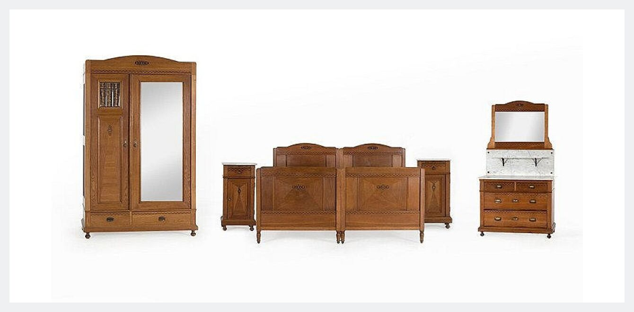
Art Nouveau Furniture from the Helmut Newton Room, around 1900
Geographic Origin: Europe, United States
Materials: Dark wood, stained glass, abalone, varnishes and veneers
Key Designers: Louis Comfort Tiffany and Clara Weaver Parrish
Art Nouveau (or “new art”) was born in Europe out of the Arts and Crafts and Aesthetic art movements. In Paris, where it experienced widespread popularity it was also referred to as Style Jules Verne, Le Style Métro (after Hector Guimard’s iron and glass subway entrances), and Belle Époque. Art Nouveau, with its organic and free-flowing lines, was a direct reaction to previous design styles which dictated strict uniformity.
Art Nouveau style furniture in the United States was considered the height of luxury in the early 20th century and was considered a decorative art style. Unlike the related European Art Nouveau style that highly valued handmade artisanship, American designs were manufactured and thus mass-produced using the latest processes of the day. However, this only added to their appeal among the U.S. elite, as they were considered state-of-the-art pieces.
One of the strongest visual elements of the movement was the graceful and elongated “whiplash” curve inspired by studies of botany and marine life during the time. The furniture designs of Art Nouveau style were complex, featuring graceful, carved wood details and high-sheen finishes. Designs often featured organic motifs including buds, leaves, bulbs, and female figures with flowing hair.
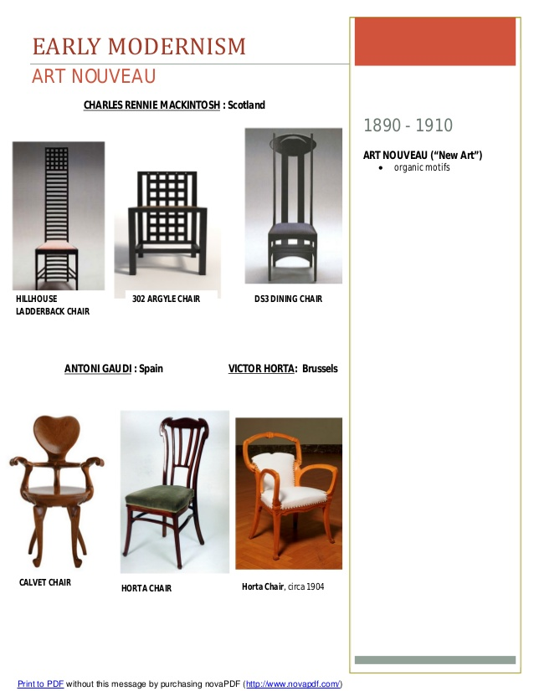
Geographic origin: Britain, mainland Europe, United States
Materials: dark woods, stained glass, abalone, varnishes and veneers
Key designers: Charles Rennie Mackintosh, Arthur Mackmurdo, Aubrey Beardsley, Archibald Knox, and Arthur Silver
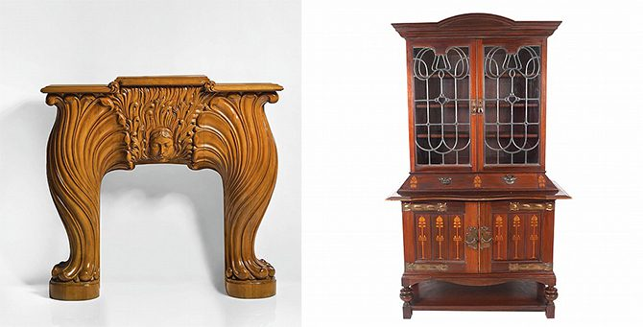
Left: Art Nouveau carved fruitwood fire surround, Right: Art Nouveau period mahogany and marquetry leaded glass paneled display cabinet,
Art Nouveau developed in Europe alongside the Arts & Crafts movement. While the two styles have much in common, like an interest in organic forms and handmade artisanship, Art Nouveau was considered more luxurious and decorative. This is due in large part to the influence of Chinese, Persian, and other Eastern styles, which contributed to the exotic yet refined decoration of Art Nouveau.
In London, the popularity of the Liberty Department, which made shopping for furniture appealing and accessible to consumers, reflected growing demands to fill entire interiors with Art Nouveau pieces. Furniture made in this style varies significantly, although common features include elongated and curvy lines, stylized flowers and other organic forms, dark woods, and eye-catching decorative materials, such as semi-precious stones, stained glass, reflective shells, and gold leaf.
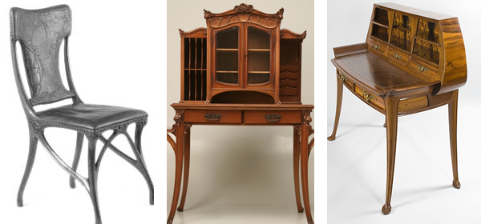
Art Noveau Furniture
The name "Art Nouveau" is French for 'new art', and it emerged in the late 19th century in Paris. The style was said to be influenced strongly by the lithographs of Czech artist Alphonse Mucha, whose flat imagery with strong curved lines was seen as a move away from the academic art of the time. Art Nouveau furniture used lines and curves as graphical ornamentation and hard woods and iron were commonly used to provide strong yet slim supporting structures to a furniture pieces.
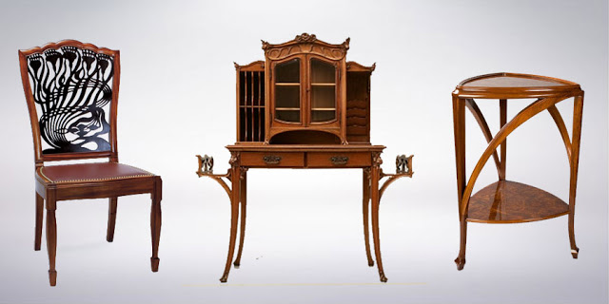
Art Nouveau Style Furniture
The name "Art Nouveau" is French for 'new art', and it emerged in the late 19th century in Paris. The style was said to be influenced strongly by the lithographs of Czech artist Alphonse Mucha, whose flat imagery with strong curved lines was seen as a move away from the academic art of the time.
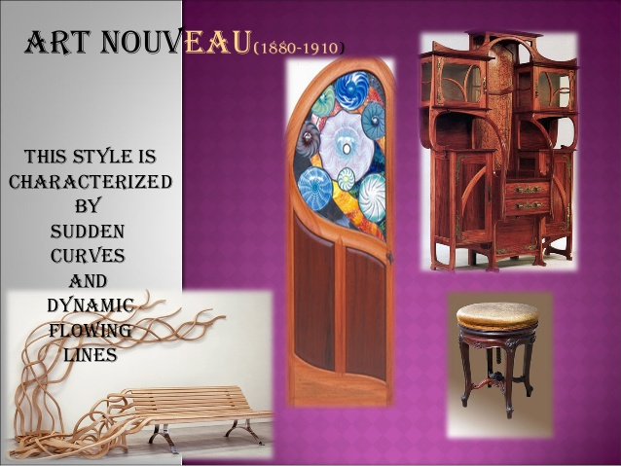
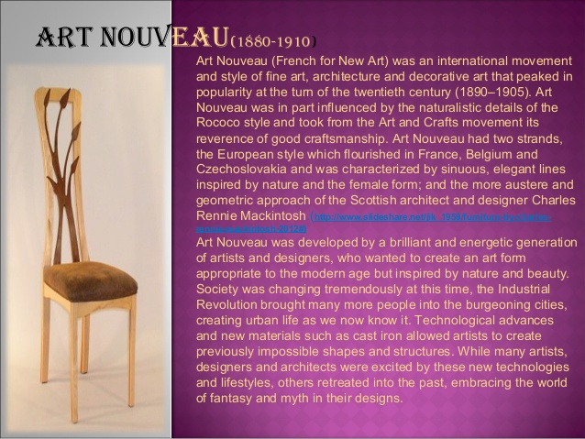
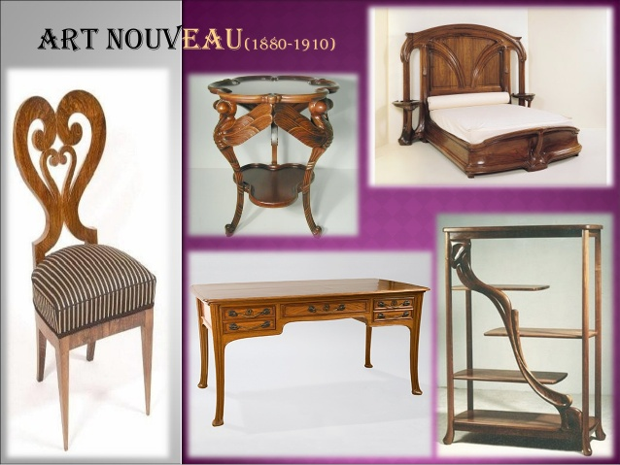

The identifying features of Arts Nouveau furniture are...
- intricately detailed
- lines and curves used as ornamentation
- inlays and veneers also used
- hard woods and iron commonly used
- strong yet slim furniture pieces

The Art Nouveau movement began in France and spread throughout Europe, encouraged by similar ideas among groups of artists focused on a desire for quality craftsmanship and a reintegration of all the arts. Because it emerged in a brief period of time in so many places, Art Nouveau was known by different names in different parts of Europe. For example, it was called Glasgow Style in Scotland and the Vienna Secession in Austria.
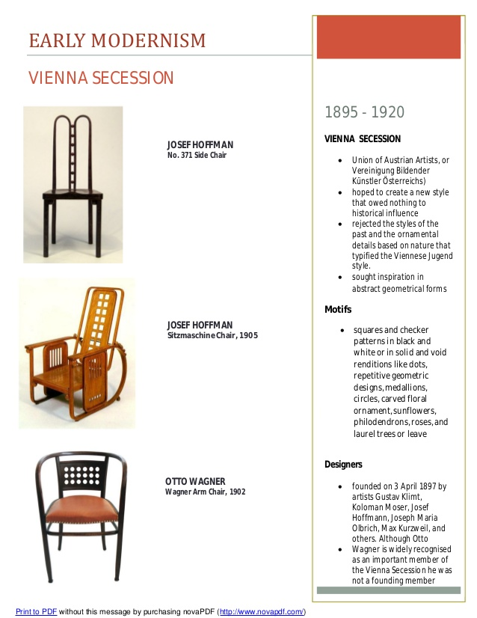

3. Edwardian (1901–1910)
Geographic origin: England
Materials: bamboo, wicker
Key designers: Thomas Sheraton
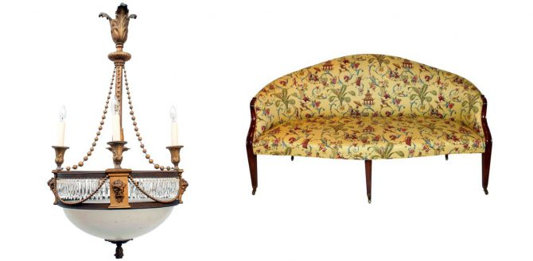
Left: Edwardian eight-light chandelier, circa 1900, Right: Edwardian Hepplewhite style sofa, circa 1910
Along with a new ruler, the Edwardian era ushered in new trends in design. While the Victorian era featured heavy, dark furniture, Edwardian furniture shifted to light or pastel colors and floral designs.
4. Bauhaus and International Furniture:
Because of the greater availability of a wider array of materials than ever before, and because of an ever-expanding awareness of historical and cross-cultural aesthetics, 20th-century furniture is perhaps more diverse, in terms of style, than all the centuries that preceded it. The first three-quarters of the twentieth century saw styles such as Art Deco, De Stijl, Bauhaus, Wiener Werkstatte, and Vienna all work to some degree within the Modernist idiom. The Bauhaus school was founded by Walter Gropius in Weimar in 1919. In spite of its name, and the fact that its founder was an architect, the Bauhaus was founded with the idea of creating a 'total' work of art in which all arts, including furniture would eventually be brought together. The furniture designs that emerged from the Bauhaus became some of the most influential designs in modern design.
The Bauhaus school was founded by Walter Gropius in Weimar in 1919. In spite of its name, and the fact that its founder was an architect, the Bauhaus was founded with the idea of creating a 'total' work of art in which all arts, including furniture would eventually be brought together.
The identifying features of Bauhaus furniture are...
- minimalist & non-ornamental
- hand crafted but appears mass produced
- organic and natural materials
- mainly black in color
- smooth and rounded shapes
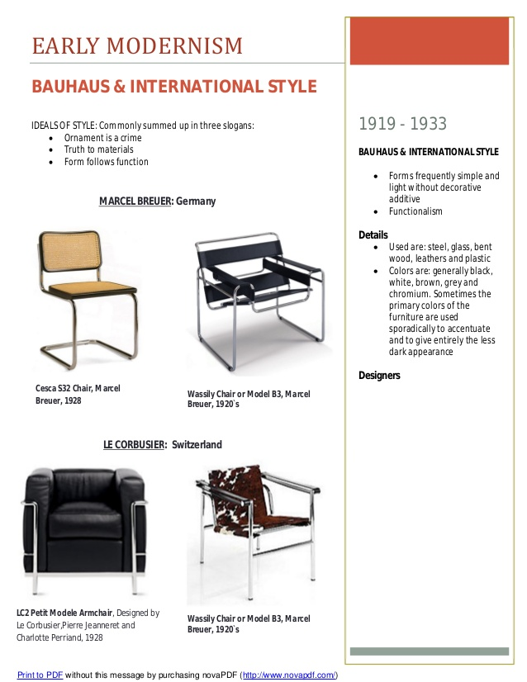
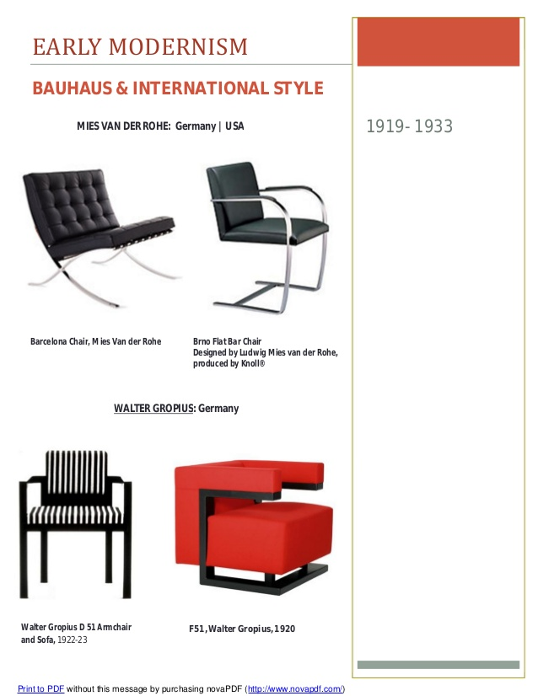
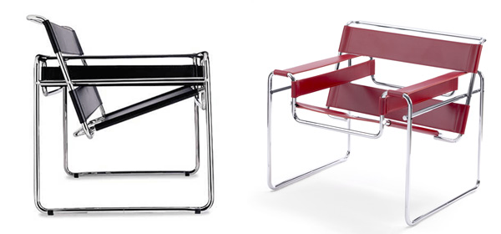
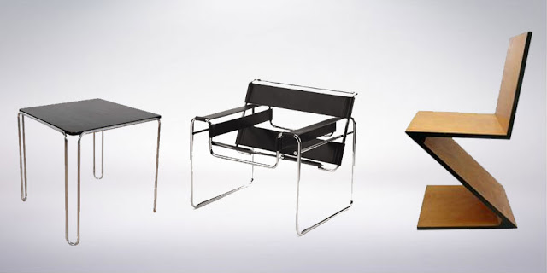
5. Destijl style (1917-1931)
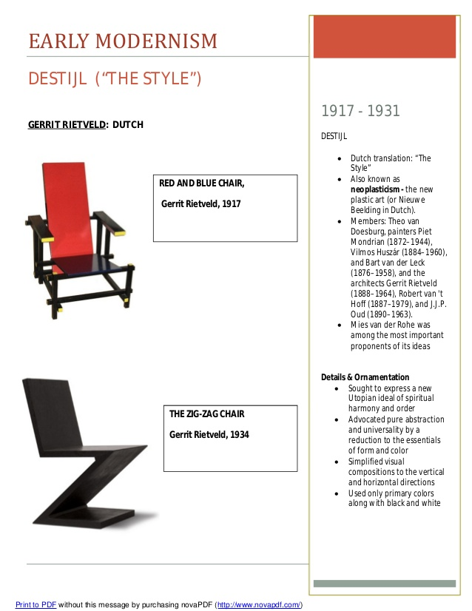
6. Art Deco Style (1925–1940s)
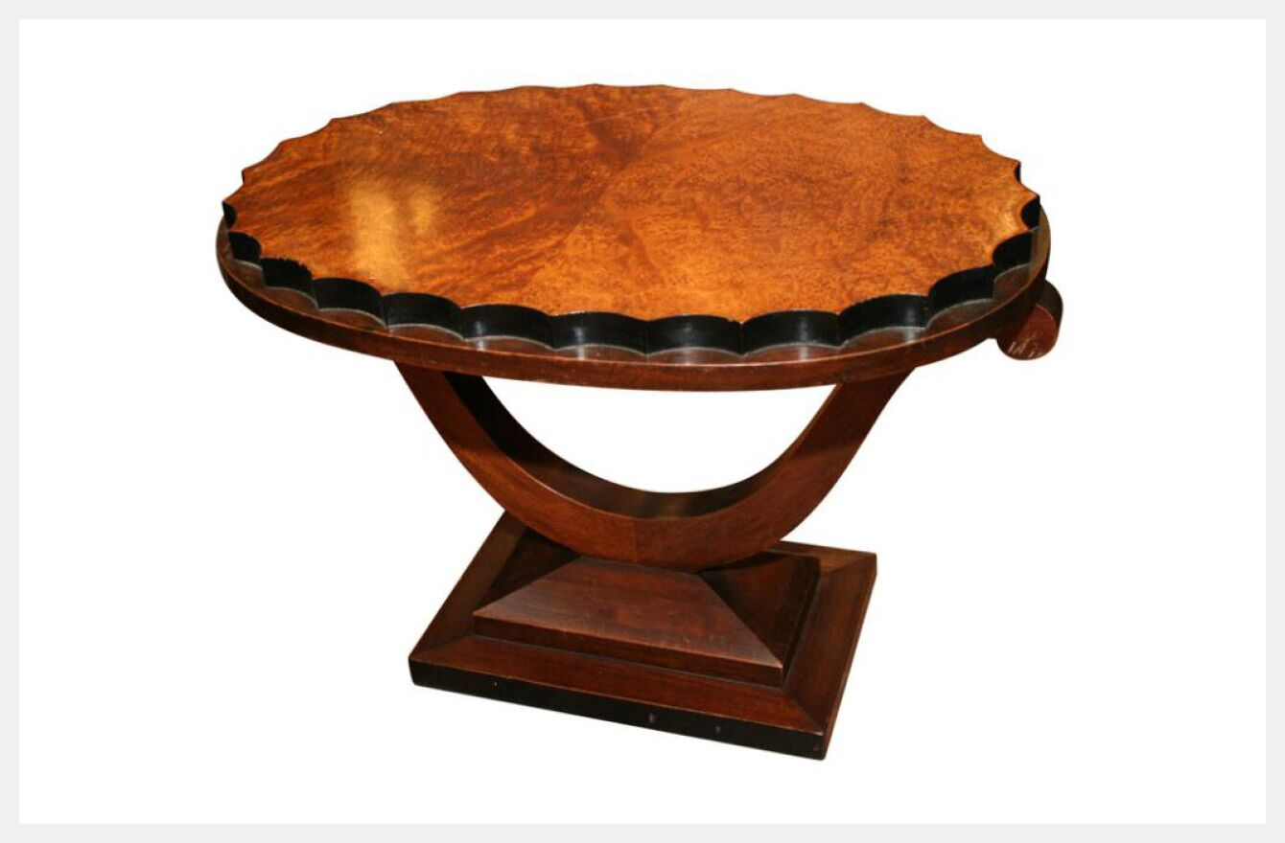
Art Deco Side Table
Geographic Origin: France, United States
Materials: Chrome, stainless steel, Bakelite, stained glass, lacquer
The Art Deco design movement was a progression from the Art Nouveau of the early 20th century and marked a move toward a machine-influenced “modern” age of design. The soft organic curves of the Art Nouveau style were replaced by symmetry and a preference for the rectangular versus curvilinear.
Other visual art styles of the day also impacted the design movement including Cubism, Modernism, and Futurism. The Art Deco design style is often marked by bright colors, bold geometric designs, and ornate metallic and other highly reflective finishes. Art Deco architecture is easily identifiable, with the Chrysler building, an icon of the New York City skyline, standing as a towering example of the Art Deco design aesthetic.
Art Deco emphasized geometric forms: spheres, polygons, rectangles, chevrons, and sunburst motifs, often arranged in symmetrical patterns. Materials used were modern with aluminum, stainless steel, Bakelite, chrome, and plastic all frequently employed in Art Deco designs. Stained glass, inlays, and lacquer were also common. Art Deco also permeated everyday housewares of the period including dinnerware, cookware, clocks, textiles, ceramics, radios, telephones, and other electronics.

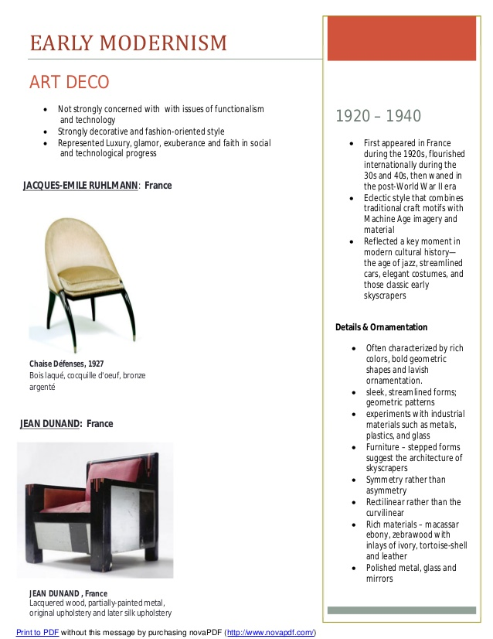
Materials: stainless steel, walnut, maple, wrought-iron, glass, ivory, mother of pearl
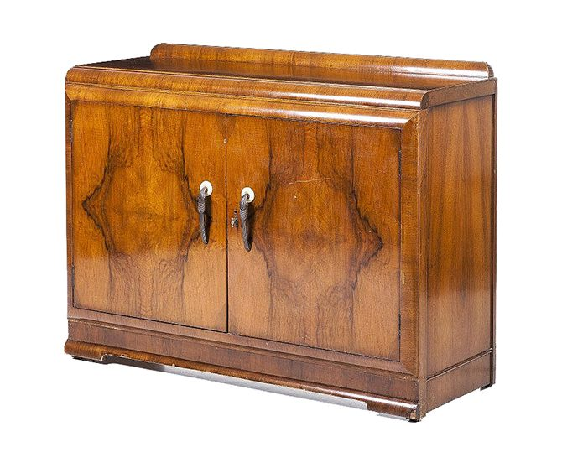
English Art Deco sideboard
Art Deco began in Paris in the 1920s and quickly spread across Europe. Its use in England was limited but notable, as the style’s distinct geometrical lines and decorative flourishes make pieces immediately recognizable.
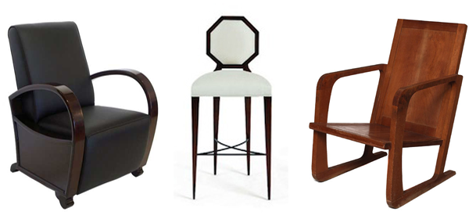
Art Deco Furniture
The Art Deco movement began in Paris in the 1920s and it represented elegance, glamour, functionality and modernity. Art deco's linear symmetry was a distinct departure from the flowing asymmetrical organic curves of its predecessor style art nouveau. Art deco experienced a decline in popularity during the late 1930s and early 1940s when it began to be derided as presenting a false image of luxury, eventually the style was ended by the austerities of World War II.
The Art Deco movement began in Paris in the 1920s and it represented elegance, glamour, functionality and modernity. Art deco's linear symmetry was a distinct departure from the flowing asymmetrical organic curves of its predecessor style Art Nouveau.
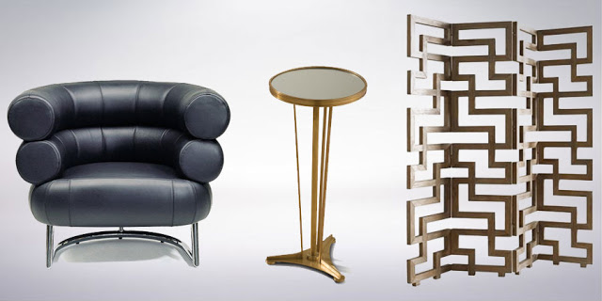
Art Deco Style Furniture
The identifying features of Art Deco furniture are...
- practical and simple designs
- founded on mathematical geometric shapes
- triangular shapes, chevron patterns, stepped forms, sweeping curves and sunburst motifs
- new materials such as aluminum, stainless steel, plastics and lacquer
- exotic materials like shark-skin and zebra-skin.
7. Streamline Modern(1930’s)
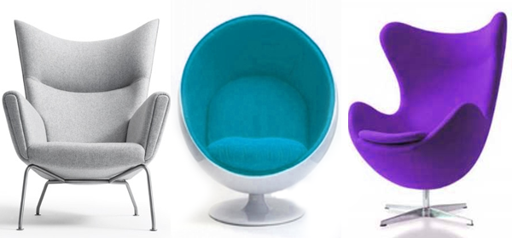
Modern Furniture
Born from the Bauhaus and Art Deco streamline styles came the post WWII Modern style using materials developed during the war including laminated plywood, plastics and fibreglass. In modern furniture the dark gilded, carved wood and richly patterned fabrics gave way to the glittering simplicity and geometry of polished metal. The forms of modern furniture sought newness, originality, technical innovation, and ultimately conveyed the present and the future, rather than what had gone before it as revival styles had done. This interest in new and innovative materials and methods produced a certain blending of the disciplines of technology and art. The use of new materials, such as steel in its many forms; moulded plywood and plastics, were formative in the creation of these new designs. They were considered pioneering, even shocking at the time especially in contrast to what came before.
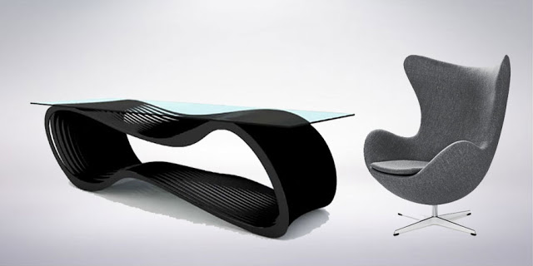
Modern Style Furniture
The forms of modern furniture sought newness, originality, technical innovation, and ultimately conveyed the present and the future, rather than what had gone before it as revival styles had done. This interest in new and innovative materials and methods produced a certain blending of the disciplines of technology and art.
The identifying features of Modern furniture are...
- new materials included laminated plywood and fibreglass
- continued use of steel, moulded plywood and plastics
- simple and geometric shapes
- regular use of polished metal
- style considered pioneering, even shocking

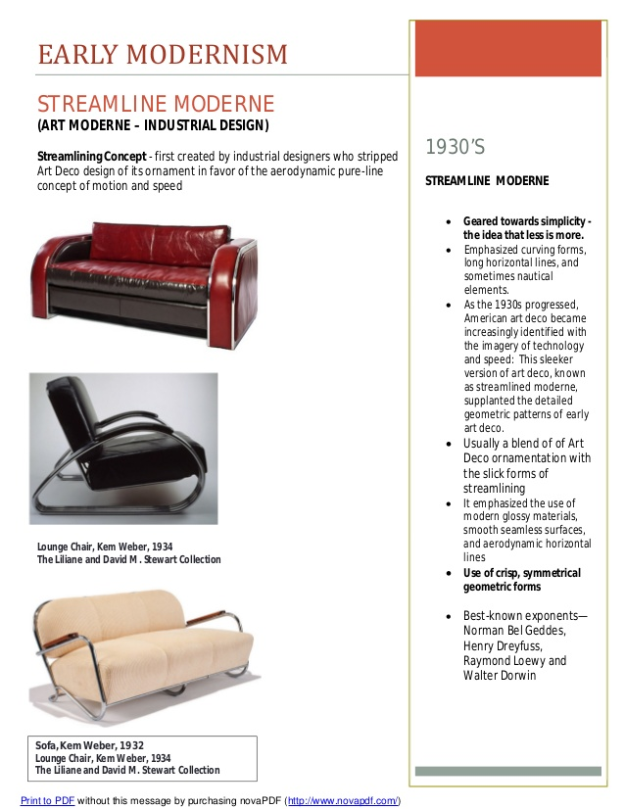

8. Mid-Century Modern Style (1933–1965)
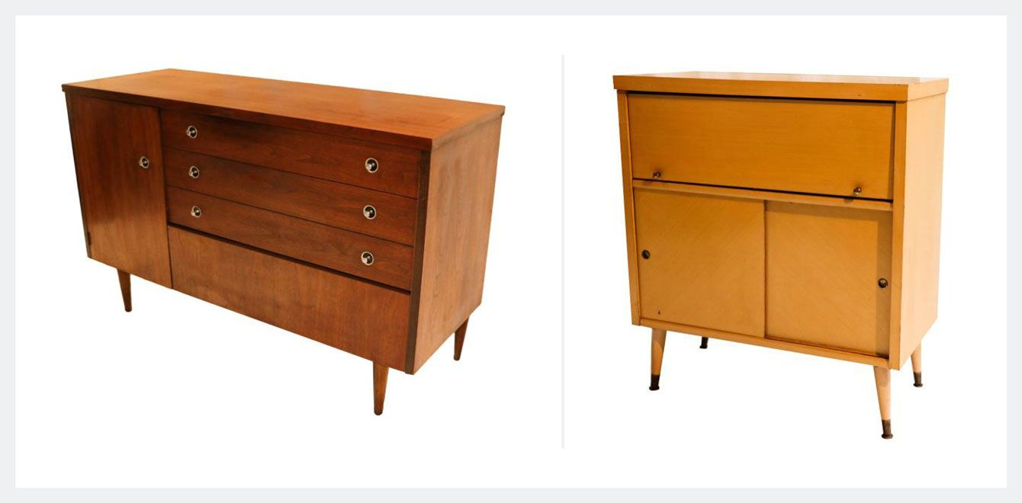
Left: Mid Century Modern Bassett Dresser Credenza; Right: Mid Century Modern Bar,
Geographic Origin: United States
Materials: Walnut wood, ceramic, upholstery
Key Designers: George Nelson and Charles and Ray Eames
The mid-century modern movement, which spanned from roughly 1933 to 1965, was primarily focused on designing natural forms with a modernist slant.
The design aesthetic gained steam in post-World War II America as young families moved to the suburbs and suddenly had a need to furnish their new modern abodes. The architecture of the mid-century movement utilized low horizontal lines and post and beam construction to achieve open and airy ranch style interiors featuring large expanses of windows used to draw the outdoors in.
Modern housewives living in these new spaces didn’t want their grandmother’s sofas and knick knacks from a bygone era; they were living in the future and wanted decor to match. The overstuffed settees and ornately carved furniture of previous eras was replaced with pieces flaunting minimalist lines and a mix of natural woods and durable upholsteries.
Angles were sleek and simplistic, structural elements often left exposed and natural materials used in abundance throughout the designs. Iconic furniture designs included those with futuristic names like “sputnik,” “atomic,” and “miracle,” making it clear that while inspirations were from nature, the movement’s gaze was toward the future and the nuclear age.
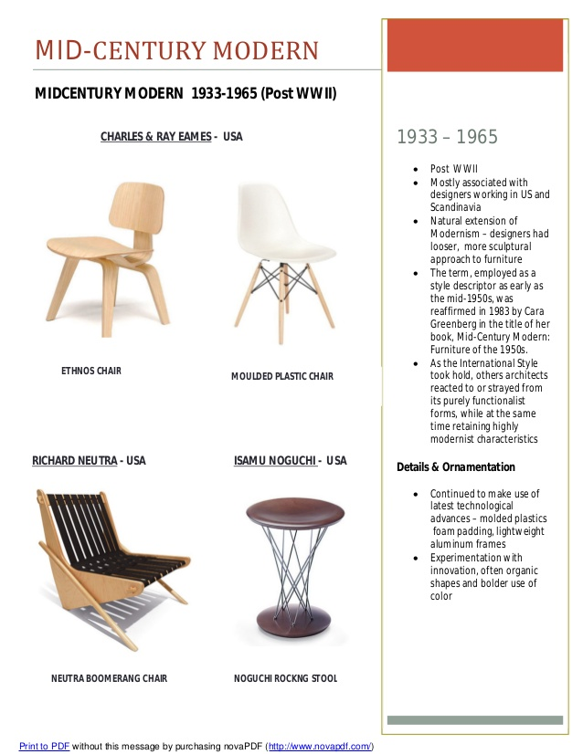

9. Other Scandinavian and Italy and us mid-century furniture(1933-1965)
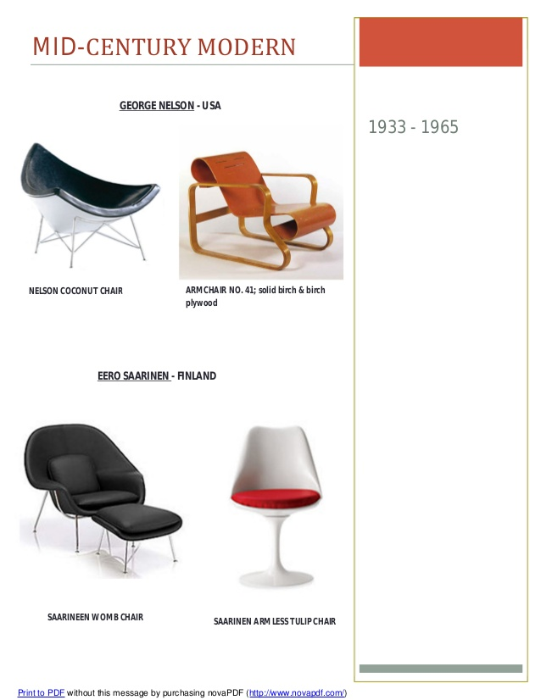
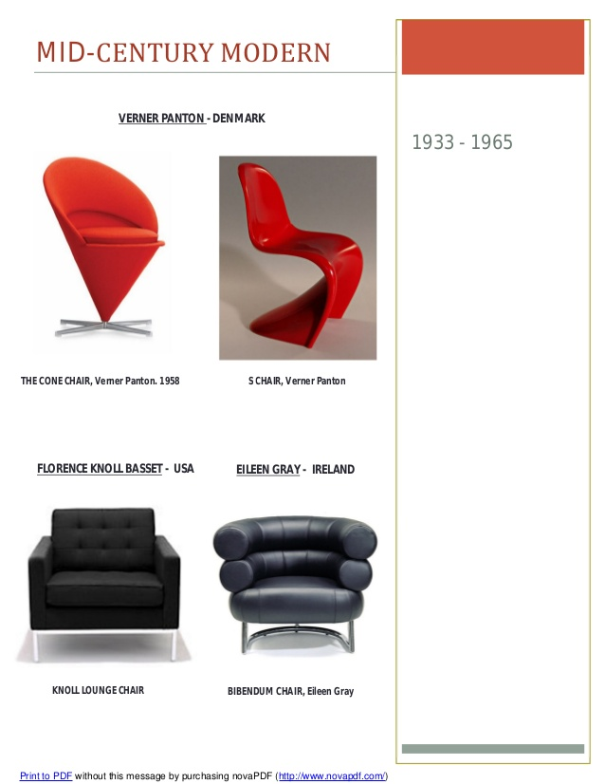
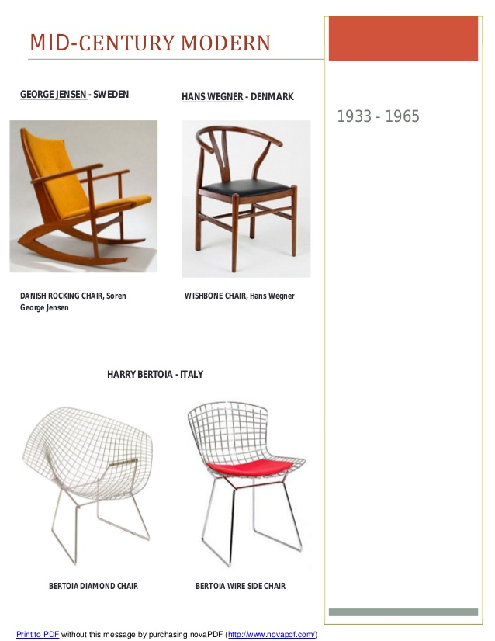

10. Post Modern Furniture(1960’s-1990’s)
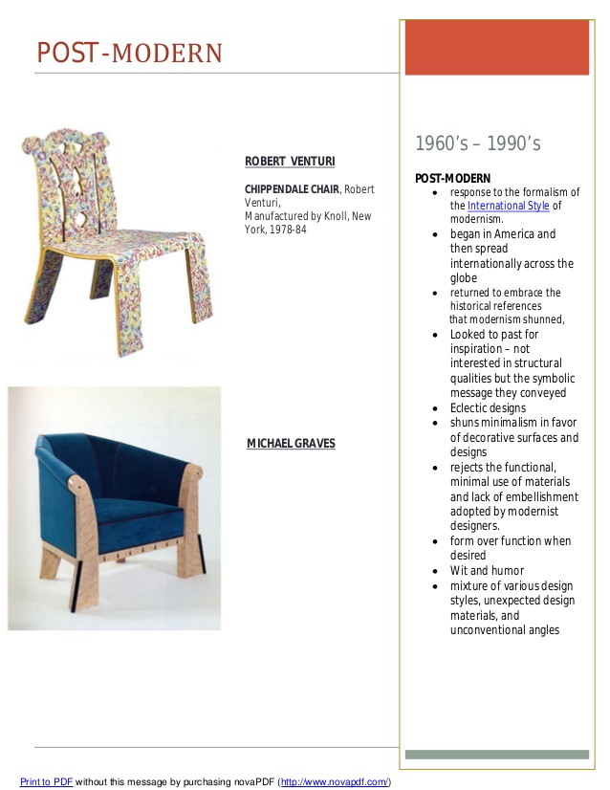

11. Minimalist Style (1960s–present)
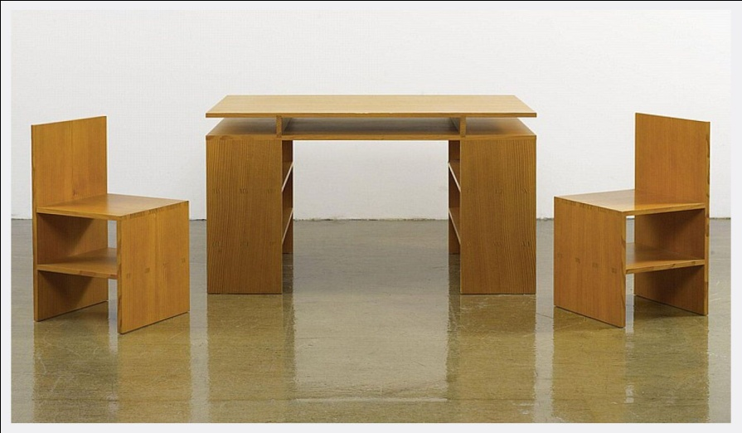
Donald Judd,
Geographic Origin: Europe, Scandinavia, United States
Materials: Metals, lacquer, glass
Key Designers: Donald Judd and Robert Morris
“Minimalist” is a term often used to describe anything stripped down to its fundamental essence. In the arts it’s often applied to sparse compositions whether they be paintings, music, poetry, architecture, or furniture. The artists and craftsmen of the minimalist movement generally felt that their art was not as much about self-expression, but rather was “objective” and tied to aesthetic goals.
Trademarks of minimalism include geometric, often cubic forms used without metaphor, balance of form, the use of repetition, neutral surfaces, and construction using industrial materials. There is a tendency toward an elongated horizontal plane and lack of partitions or separations in forms. In furnishings, this equates to long, low-profile pieces like, sofas and lounges, with single cushions in a single monochromatic palette.
Architect Ludwig Mies van der Rohe coined the phrase “less is more,” which has come to be heavily associated with the design aesthetic. Minimalism is not devoid of emotion, as some might think, and is actually closely connected to a sense of intuitive feeling, designers often consider the “essence” of a form heavily in their designs. A tenet of the minimalist design movement is that a space and its furnishings are stripped down to their absolute essential parts. Key elements in minimalist design include light, form, material, space, location, and human condition.
Through the course of early American history, furniture styles in America evolved in reaction to societal changes and geographical influences. Because of this, these nine American furniture movements each have unique characteristics that impact their stylistic elements. The revolutionary craftsmanship and style of Early American furniture created in the 17th century influenced each American furniture style that followed. Learning both the history and the variances in styles and quintessential pieces from each American furniture movement is essential for understanding their value in today’s market.
12. Contemporary (1980’s onwards)
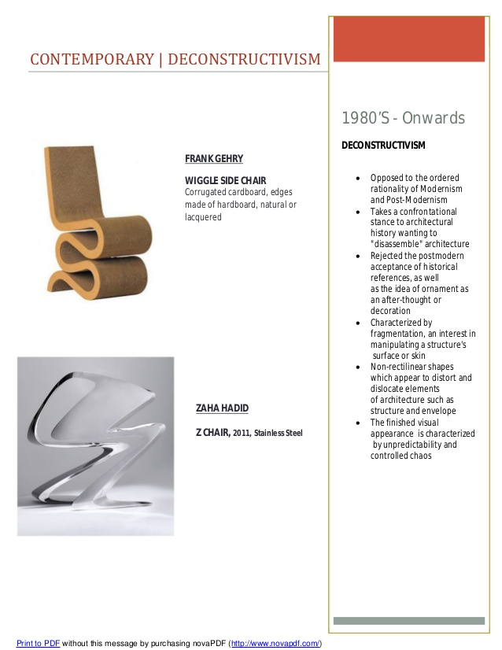

Recognizing the styles
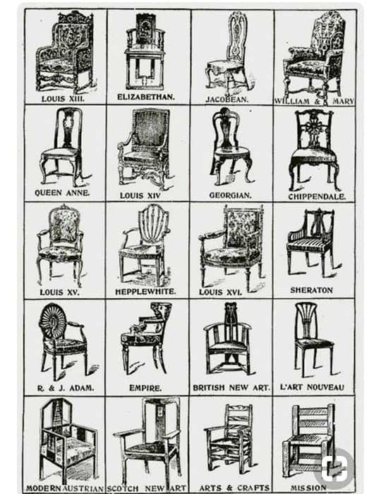

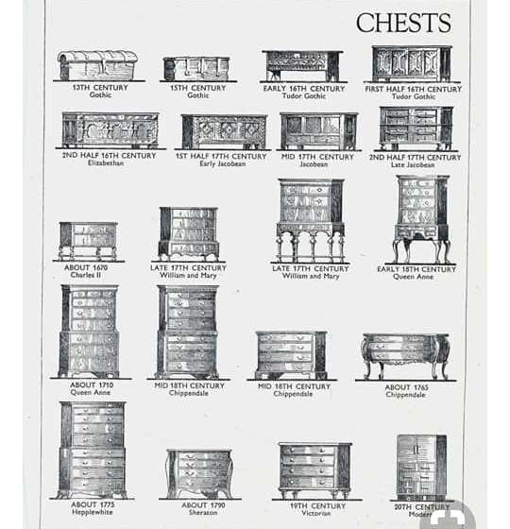

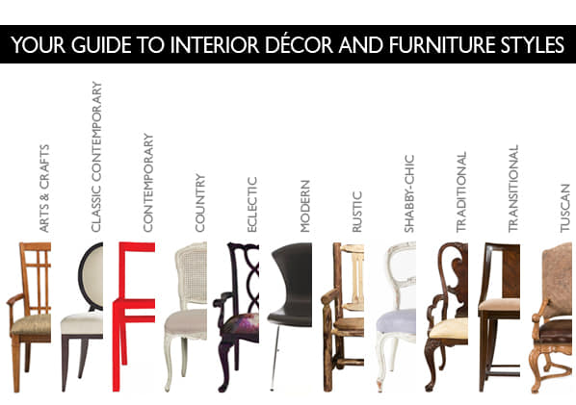
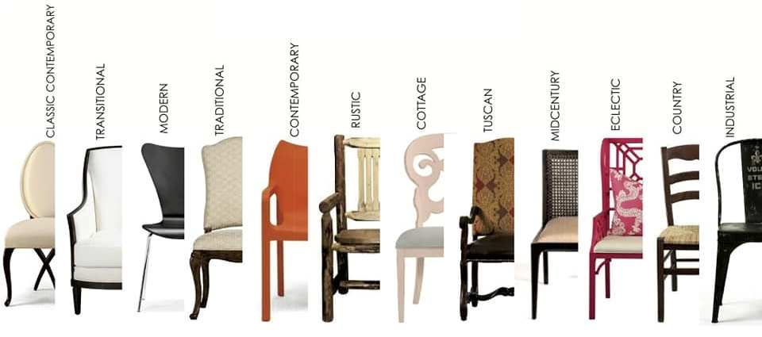

Furniture - Legs / Feet / Turning /Stretchers / apron
A. Identifying Antique Furniture Foot Styles
If every journey begins with a single step, the road to antique furniture knowledge can start with a foot - specifically, the antique foot style belonging to a chair, chest or table.
Identifying antique furniture feet can be helpful in determining the approximate age of a piece, along with the period in which it was made, helping you research and value antique pieces more skillfully. Listed below are foot styles developed in Europe and the United States from the ​Renaissance to the Empire periods.
Note: Many of these styles have been incorporated time and again on pieces made since their first use. Use them as a starting point and one possible indicator of agerather than making a conclusion based only on the foot style.

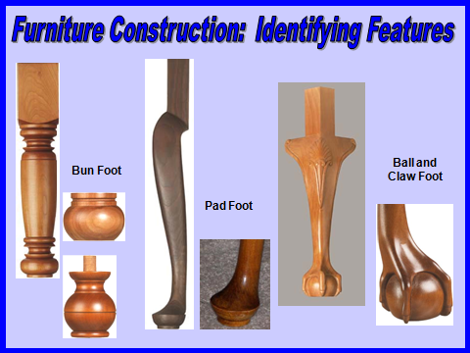

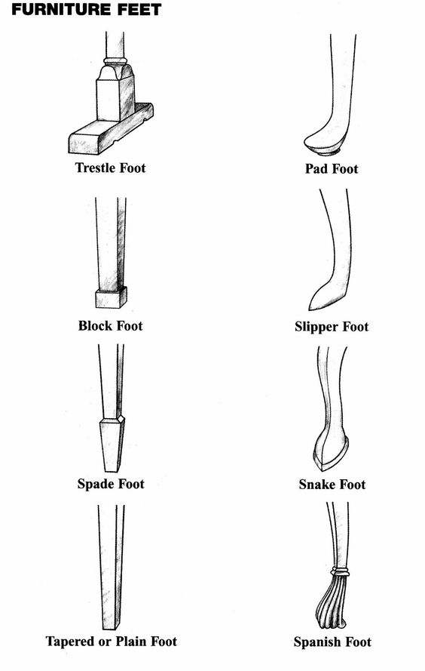
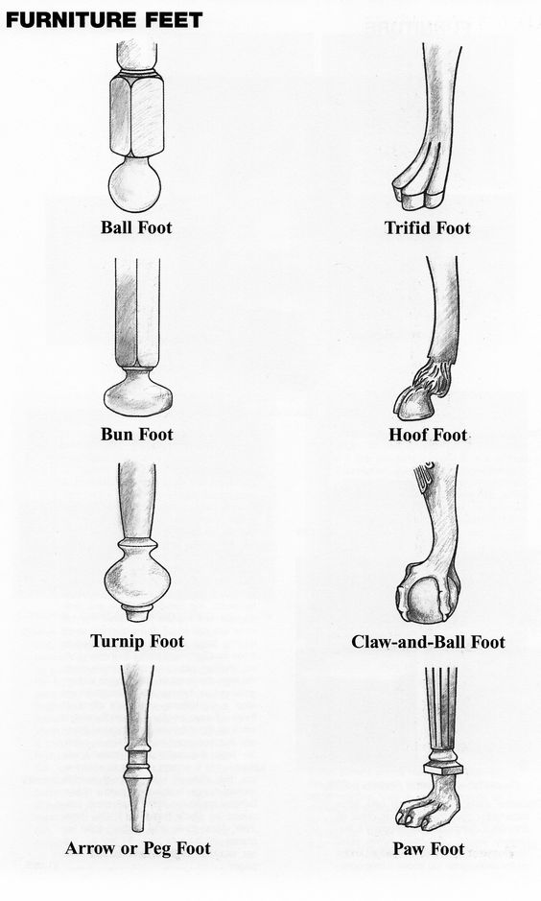
1.Arrow Foot
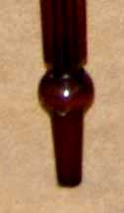
This furniture foot style consists of a tapered cylinder that is separated from the leg by a turned ring. It is usually plain, even if the attached leg is fluted (as shown in this example). A shorter, more squat variation is sometimes referenced as a blunt-arrow foot.
The arrow foot became popular in the mid-18th century and is often featured in Hepplewhite and Sheraton designs. It is especially characteristic of the Windsor chair, typical of the work of furniture-makers in colonial Philadelphia.
2. Ball Foot
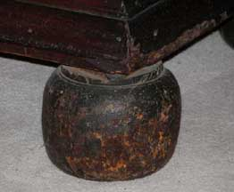
The ball foot is one of the earliest, most basic types of furniture foot styles. It consists of a simple spherical shape and is usually found on case pieces such as chests, secretaries, and sideboards.​
Dating from the early 1600s, it was especially prominent towards the end of the century in William and Mary style furniture also used on some Empire pieces. The popularity of this foot style continued well into the 1800s in American Federal pieces and "country" styles.
The bun foot, onion foot, and turnip foot, as shown below, are variations of the ball foot.

3. Ball and Claw Foot
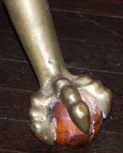
Carved to represent a bird's claw grasping a ball Derived from the Chinese dragon's claw holding a crystal ball or jewel.
A furniture foot, sometimes referenced as claw-and-ball, fashioned to represent a bird's claw gripping a ball.
They are often carved entirely of wood as seen in many Chippendale style furniture pieces. Examples featuring a metal claw gripping a glass ball are also common, especially in occasional tables and stools.
This foot type has been popular almost continuously, in variations, since it was introduced in the 1700s.
Perhaps first adapted in Europe by the Dutch, it spread to England, from whence it was introduced to America about 1735. Enormously popular as the foot of American cabriole leg furniture in the Queen Anne and Chippendale, styles. In America, a bird's claw was generally used, mostly the eagle's.
Also used in the twentieth century in the Colonial Revival cabriole leg.
4. Block Foot (Marlborough leg)
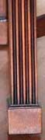
A straight, sometimes fluted leg with a block as a foot that was used in the mid-18th-century English and American furniture.
This is sometimes referenced as a Marlborough foot since it often appears at the end of the straight Marlborough leg.
This is a simple, basic furniture foot style with a square or cube-like shape. Although in existence from roughly 1600 to 1800, it was especially popular in mid-18th century English and American furniture. It was often featured in later Chippendale.furniture styles with Neoclassical influence.
5. Bracket Foot(console leg)
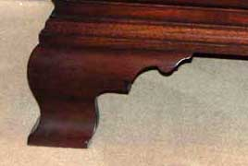
One of the simplest of furniture feet shaped like a bracket, usually with a mitered corner.
Variations include a plain bracket foot, a molded bracket foot, or a scrolled bracket foot.
One of the most basic furniture foot examples, this style named for its actual resemblance to a bracket. Usually has a mitered corner embellishment. Sometimes it is referenced as a console leg.
Variations include the plain bracket foot (as shown here), the ogee bracket foot (as shown below), or scrolled bracket foot with a curved outside edge.
The bracket foot is often incorporated in Hepplewhite and Sheraton furniture styles.
6. Bun Foot
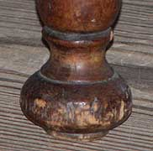
A squat version of a ball foot, flattened slightly on top and more at the bottom.
This is one of the earliest furniture foot styles consisting of a simple, turned spherical or disk-like shape. It is basically a more squat version of a ball foot, flattened slightly on top and wider at the bottom.
Dating from the early 1600s, its popularity continued well into the 1800s, both in furniture and accessories; especially prevalent on William and Mary case pieces. It has been widely used since then.
7. Cylindrical Foot(elongated bulb foot)
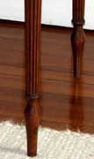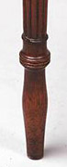

Elongated bulb feet Sometimes found on Sheraton style tables
This type of turned furniture foot, separated from the leg by a ring, is basically cylindrical in shape although it swells out slightly and then tapers down to a plain point. It is usually plain overall, though the leg above it may be fluted or reeded. It is sometimes referenced as an "elongated bulb foot."
The cylindrical foot is often associated with Georgian and Neoclassical-style furniture of the later 18th and early 19th centuries, particularly the designs of Sheraton. Although delicate looking, cylindrical feet prove to be quite sturdy.
8. Dolphin Foot
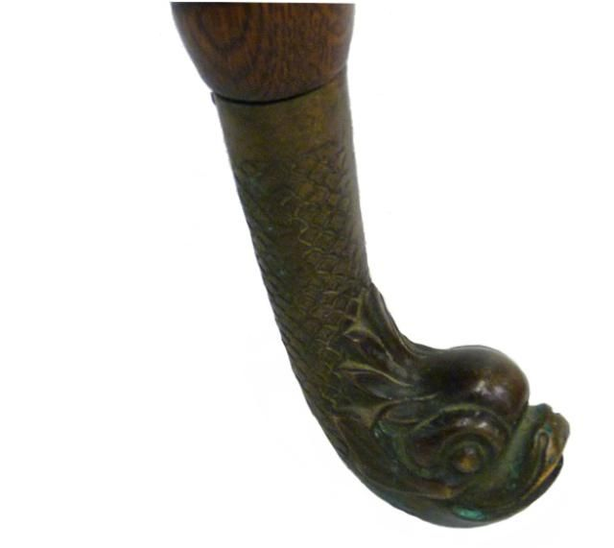
There's something fishy about that furniture foot
This is a type of carved furniture foot in the shape of a fish head. Sometimes the motif is extended into the leg or base of the piece (as shown here). Some pieces, like chairs, may have matching dolphin arms and feet.
Although the dolphin as decoration dates back to Renaissance furniture, the use specifically in a chair or table feet began around the mid-1700s. It was especially popular in ornate Regency, Empire and Biedermeier styles.
9. French (bracket) Foot
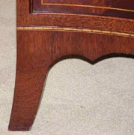
This is a slender variety of bracket foot (see example above), often tapered, with a concave shape that splays outward. It is like a shortened version of a saber leg on a chair or table (bracket feet being reserved for case pieces, like chests or secretaries). It is sometimes called a French bracket foot, in fact.
Has concave curve down the mitered edge which gives a splayed effect. Both the inner and outer edges of the leg are curved, giving the appearance of a stunted cabriole leg, or, as some would say, a light , graceful; appearance.
Almost always found on case furniture in combination with a valanced skirt or apron.
In contrast to other types of bracket feet, such as the ogee (see example below), the mitered edge is usually exceedingly simple - but this plainness of foot is often balanced by a valence or apron in the center of the overall piece. developed in the 18th century English and American furniture, including Hepplewhite ,Sheraton and Federal-style furniture.
10. Hoof Foot
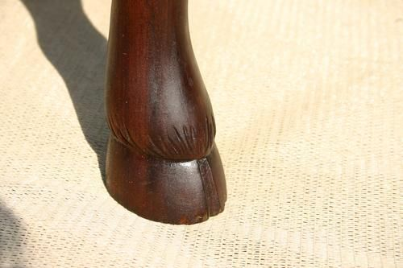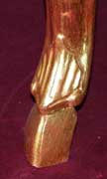
The hoof foot is an early style carved to resemble a realistic animal hoof (typically that of a deer). It developed along with the cabriole leg with which it usually appears, towards the end of the 17th century. It is also sometimes called a pied-de-biche, which translates to "deer's foot" in French.
Hoof feet are most characteristic of Régence, William and Mary, early Louis XV and Queen Anne furniture, although it continued throughout the 18th century.
11. Monopodium Foot(Lion's paw foot)
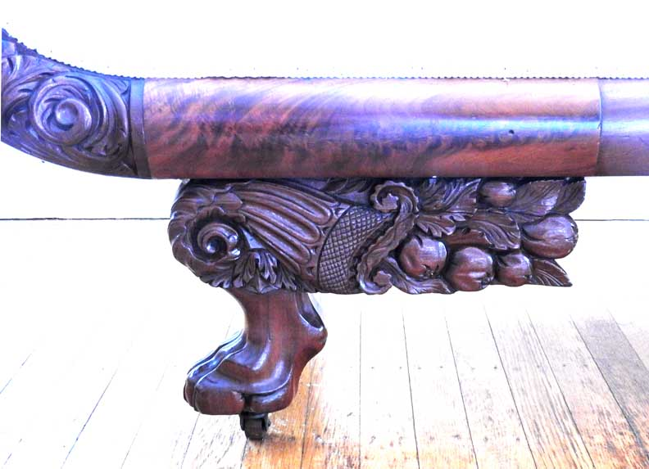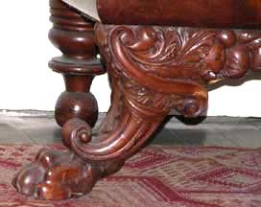
This is a type of furniture foot style, consisting of a carved animal paw - usually a lion's - with an ornate extension above, such as a scroll, wing, vine or cornucopia. It is named for the monopodium (single-base) tables inspired by ancient Greek, Roman, and Egyptian designs. The monopodium foot also appears on sofas, chairs and case pieces.
This style is typically found in Empire, Regency, and Greek Revival furniture, though its popularity continued throughout the 19th century.
12. Ogee Bracket Foot(scrolled bracket foot.)
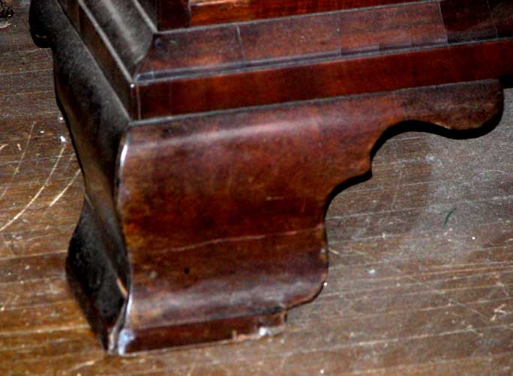
The ogee bracket foot an ornate variety of bracket foot (see above) in which the outside edge forms an s-shaped curve, with the top bulging outward and the bottom turning inward. It is usually found on case pieces. It is sometimes referenced as a scrolled bracket foot.
This style is characteristic of the undulating shapes of mid-18th-century styles, and is typically found in the designs of Chippendale, Hepplewhite and early Sheraton.
13. Onion Foot(melon foot)
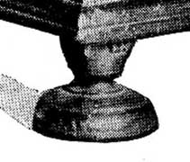
An onion-shaped turned foot of the Early Renaissance not very much used after the William and Mary Period.
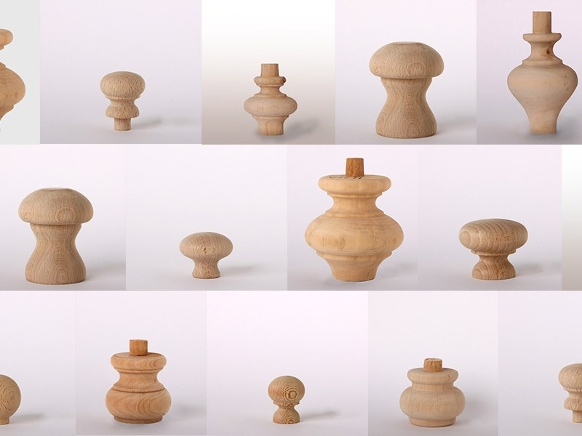
This is an early type of large turned foot - a variation of the bun and ball foot styles - with a slightly flattened bulbous shape that often terminates in a platform base. It is usually found on heavy case pieces, especially of Germanic or Dutch origin. Sometimes referenced as a melon foot.
The onion foot dates from the Renaissance and dwindled after the turn of the 18th century, though some continued use in Dutch-influenced American furniture was seen throughout the 1700s.
14. Pad Foot(Dutch foot or spoon foot)
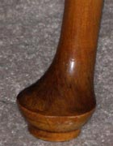
A flattened disk-like foot often found under a cabriole leg .This is a furniture foot style in which a simple, flattened oval-shaped block of wood rests on a disk or pad. It is a variation of the club foot, distinguished by the underlying disk(Sometimes a club foot resting on a disk is termed pad foot.). These are often found at the base of a cabriole leg. They are sometimes referred to as a Dutch foot or spoon foot.
The pad foot developed in the early 18th century, it is especially characteristic of the Queen Anne style in furniture.( Favored on Queen Anne cabriole legs)
15. Spade Foot
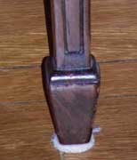
Tapered rectangular foot
The spade foot style has a rectangular shape that is wide at the top tapering to a narrower base. It is not a solid carved piece, but created by applying pieces of wood to the bottom of a square, tapered leg.
First popularized by Thomas Chippendale in the mid-1700s, it is usually associated with Neoclassical furniture in the later 18th and early 19th century, especially pieces in the style of Robert Adam, Hepplewhite and Sheraton.
16.Toupie Foot (spool foot)
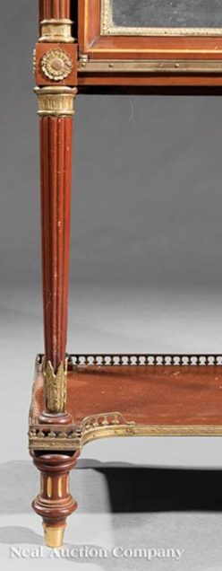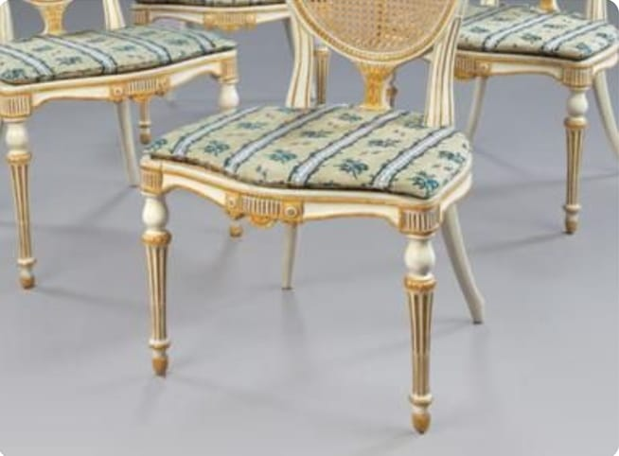

This is a type of turned foot, consisting of a rounded saucer-shaped top with larger turning in the middle that then narrows to a smaller turned end. The overall silhouette resembles that of a spinning top (or 'toupie' in French). Sometimes referred to as a spool foot.
Short and squat examples usually decorate heavy case pieces while more slender examples can be used on chairs (as shown). Dating from the second half of the 17th century, the toupie foot is often associated with Louis XIV styles.
17.Trestle Foot
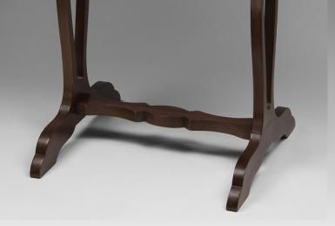
One of the oldest foot styles - dating from the Middle Ages - in which a vertical post is placed in the middle of a horizontal piece, forming the shape of a T. Gustav Stickley'sadmiration for plain, "honest" pieces led him to design several tables with sturdy trestle feet.
In the most basic forms, the two sides of the horizontal beam are flat or slightly slanted and plain, but carved, ornate versions do exist; typical of country or utilitarian furniture, such as dining tables or racks.
18.Trifid Foot (TRY fid) foot(drake foot)
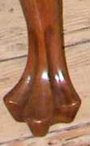
Alternative name: drake foot
3-lobed endpiece of a Queen Anne cabriole leg.
Derived from Irish furniture design.
The trifid style is a type of carved foot, characterized by three toes or lobes, resembling a stylized animal paw resting on a base - a cross between a paw foot and a clubbed pad foot. They are typically found at the end of a cabriole leg. This is sometimes called a drake foot.
Characteristic of 18th-century design, it most often appears in Queen Anne-style and early Chippendale-style pieces, especially chairs and footstools. It was especially popular, with regional variations, in Irish and Philadelphia furniture. Chairs with exaggerated proportions, winged splats, shell motifs, and trifid feet were all characteristic of the sophisticated furniture made in colonial Philadelphia.
19. Turnip Foot
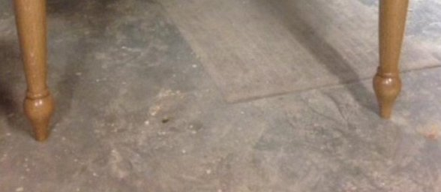
A ball foot with a small collar at the base
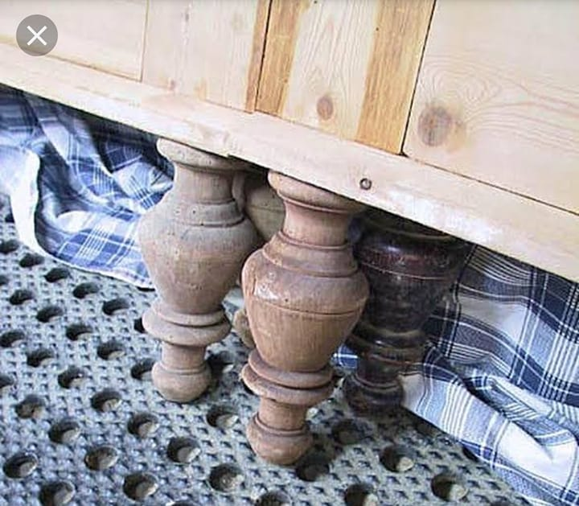
This is a rounded, turned furniture foot style in a variation of the bun foot. It is bulb-shaped with a slender neck, usually has a ring on top, and bulges outward before tapering down into a round collar or base. These are sometimes referenced as tulip feet.
Dating from the 17th century, it is found on late Jacobean pieces, and flourished in William and Mary furniture; it regained popularity in mid-19th century Renaissance Revival styles, as well as in more humble "country" furniture.
20.Whorl Foot(scrolled toe / scroll foot/knurl toe)
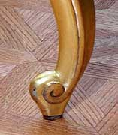A reverse scroll foot

The whorl foot, a variation of the scroll foot, is a spiral-shaped design that curves upward and inward. It is sometimes called a knurl toe.
An up-curved, carved foot done in scroll motif, terminating a cabriole leg. A flattened scroll at the end of a cabriole leg originated in the Louis XIV (Baroque) period
Used on Louis XV (Rococo) substyle pieces.
Many of the drawings in Thomas Chippendale's Gentleman and Cabinet Maker's Director in 1754 feature whorl feet.
Appears in England in the William and Mary and Chippendale periods.
21. Spanish foot(Spanish scroll foot or Braganza toe)
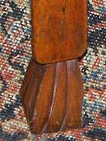
Also called: Spanish scroll foot or Braganza toe
Scrolled foot with curving vertical ribs
A hoof-like, grooved and flared foot which ends in an inward curving scroll
Introduced from Portugal during the Restoration period and used in 18th-century English and American furniture, especially on turned legs in the William and Mary and the Queen Anne periods
22. Snake foot
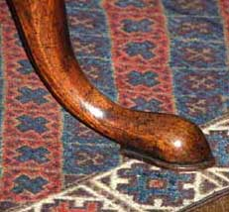
Foot carved to look like snake's head.
Narrow elongated foot swelling slightly upward before pointed end.
Found in 18th century English and American furniture, e.g., Queen Anne , Chippendale and some Federal tripod-base tables
23. Slipper foot
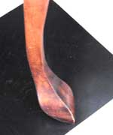
A club foot with a more pointed and protruding toe.
Popular in Queen Anne period.
24. Reeded brass foot
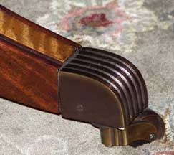
Splayed leg with satinwood veneer on the top
Leg terminates in reeded brass caps on caster
25. Flared foot
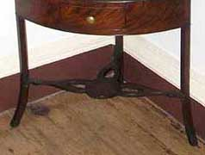
An outward spread
Found in Federal style feet.
Found in chair seats wider in the front than in the back
26. Cuffed foot
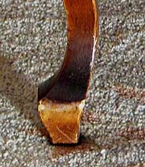
Colonial Revival and Hoosier Furniture
27. C-scroll
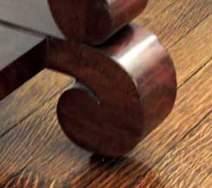
Found especially in Empire style
28. Blunt arrow foot
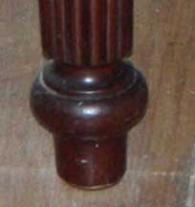Sheraton
B. Furniture Leg Styles
Leg styles are key not only to the appearance and functionality of pieces, but they can also be used to successfully identify many types of antique furniture. Furniture legs can provide clues to when a piece was manufactured, especially when considering how they are used in conjunction with foot styles.
Listed below are a number of different examples of leg styles developed in both Europe and the United States from the Renaissance period to the Empire period. Links within each description lead to more information on styles, periods, and types of antique furniture.

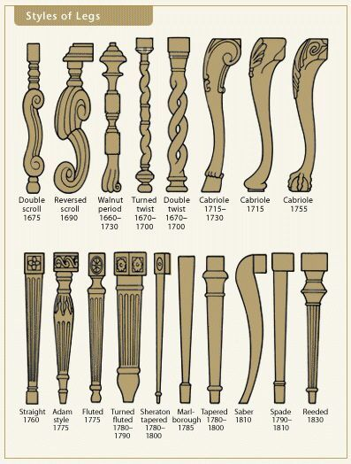
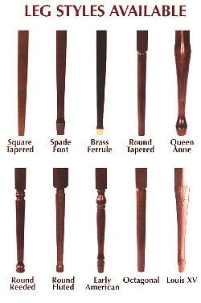
1.Cabriole Leg
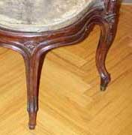
The name given to chair or table legs in the style of the first half of the 18th century:
- Queen Anne - usually with pad foot, but other foot styles were used with these legs as well.
- Chippendale - commonly with claw-and-ball foot
A curved leg with outcurved knee and incurved ankle.
The foot may be a club, a claw-and-ball, a paw or scroll, and there may be a carved ornament on the knee such as the scallop shell or the lion motif.
Originated in Italy and is a conventionalized representation of the rear leg of a leaping goat.
Modeled after an animal's leg, the S-shaped cabriole leg gives furniture a more intimate, human quality than the massive turned legs of the William and Mary style. The cabriole leg is also extremely practical; the balance it achieves makes it possible to support heavy pieces of case furniture on slim legs, without the use of stretchers.
Used on many types of furniture besides chairs.
2. Flemish s Scroll Leg
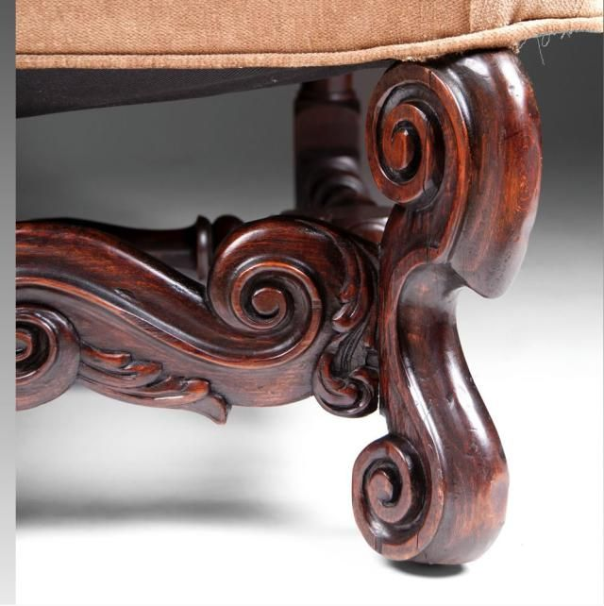
This style of carved furniture leg is characterized by scrolls at the top and the bottom, often spiraling in opposite directions. It was developed in the second half of the 17th century, and is featured in late Baroque furniture styles such as Restoration and William and Mary. It was also used in the work of Gerrit Jensen, who designed pieces for King Charles II.
These are also referenced as double scroll legs, and S-scroll leg (a variation: when the section between the scrolls is curved).
3. Fluted Leg
In this type of furniture leg a series of rounded channels or grooves are carved vertically into a straight leg at regular intervals. The fluted leg was modeled after ancient Greek columns, and it flourished in the Neoclassical styles of the second half of the 18th century such as Hepplewhite along with 19th-century Classical Revival styles.

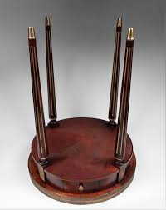
It is similar to a reeded leg, except that fluted channels are concave (vs. convex or raised). See below for reeded leg example.
4. Reeded Leg
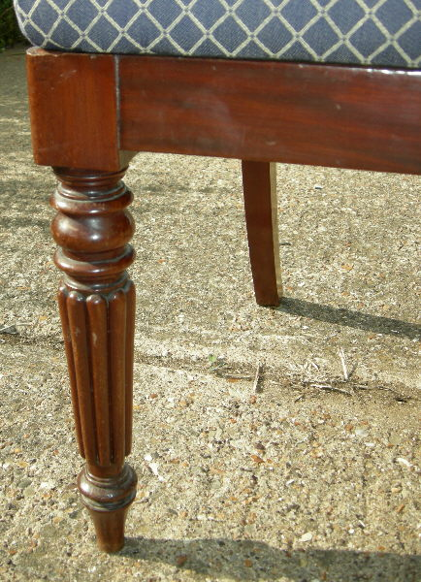
This type of furniture leg, in which a series of rounded ridges or grooves are carved vertically at regular intervals are modeled after ancient Greek and Roman motifs. They flourished in the later Neoclassical, Regency and Empire styles that developed around the turn of the 19th century. The reeded leg is often seen in Sheraton designs. These are similar to fluted legs (see above), except that the reeds are convex (as opposed to concave).
The popularity of reeded legs surpassed those of fluted legs as the 18th century gave way to the 19th century.
5. Marlborough Leg

A straight, sometimes fluted leg with a block as a foot that was used in the mid-18th-century English and American furniture.
Block foot: Another name for the Marlborough foot
It was especially favored by Chippendale.
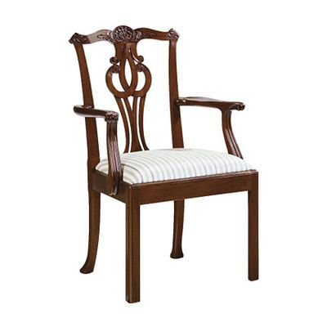
This is a straight, square, substantial furniture leg that is usually plain, but sometimes has fluted carving. The Marlborough leg typically terminates in a block foot, though can be footless as well. Some versions are slightly tapered.
These legs are typical of mid-18th century English and American furniture and are often featured in later Chippendale styles, especially chairs, tables (as shown here), sofas and bedsteads.
6. Saber Leg

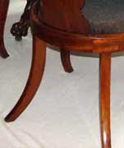
The saber style is a type of splayed furniture leg flaring out in a concave shape like a saber or curved sword. It can be round or squared, and often gradually tapers. These are usually found on a chair, stool or sofa.
Dating from Antiquity - examples have been found on Greek klismos chairs - it underwent a revival among late 18th-century designers such as Sheraton, and flourished in Regency and Empire furniture. They are sometimes referenced as sabre legs or splayed legs as well.
7. Spider Leg
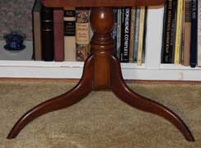
Spider legs are delicate, thin curved legs, usually extending below a round table top in a group of three or four. They typically end in spade feet or no feet (as shown here). Found on many late 18th-century and early 19th-century candlestands, tea tables, and other light, portable pieces.
Spider legs can also be slim, straight legs found on gatefold tables. The thin supports enabling swinging out to expand the table easily. This variation dates from the early 18th century and often ends in pad feet. Both types of spider legs remain enduringly popular to the present

8. spiral Leg
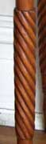
A leg resembling a twisted rope, or a support with a winding descending flute or groove.
It was originally of Portuguese and Indian origin, and became popular during the Restoration.
This style traveled westward across Europe in the mid-17th century to Portugal, Holland and then England, where it flourished from around 1660 to about 1703.
These legs are especially characteristic of Restoration and William and Mary furniture, but they enjoyed a comeback 100 years later in late Empire and Federal pieces. It was revived yet again in the mid-19th century and used on many Victorian furniture pieces. Sprial legs are sometimes referenced as spiral-twist or barley-twist (especially in England).
9. Trumpet Leg
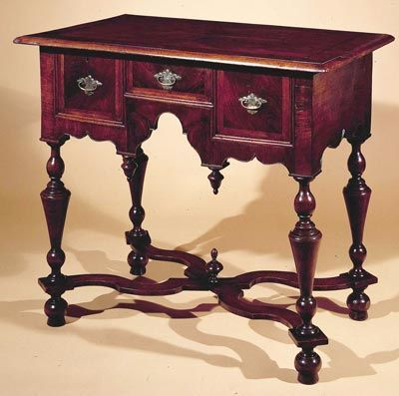
This is a type of turned furniture leg, fairly thick with multiple curves, which flares upward and outward from a narrow base to actually resemble an upturned trumpet. The top is often capped with a dome, and the end often terminates in a ball foot, bun foot or Spanish foot.
It is typical of Baroque styles, especially English Restoration and William and Mary, and usually appears in accent tables, highboys and lowboys with the legs connected by a serpentine stretcher. These are also known as trumpet-turned legs.

10. Tapered leg
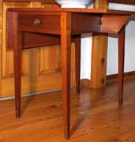
Leg narrows from top to bottom.
Found on Hepplewhite pieces.
A raised, tapered design superimposed on the existing leg is referred to as the "spade" foot.

C. Turning
An ornamental or structural element of furniture produced by rotating a wood dowel on a lathe, and shaping the dowel with cutting tools into a series of nodules, swellings, disks, etc.
Wood shaped by applying a chisel to it while it is rotated on a lathe.

Large Treadle Lathe and Scroll Saw
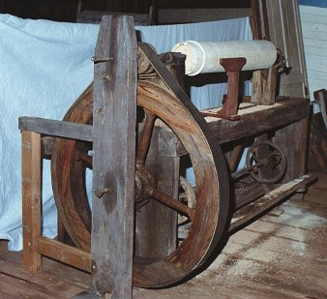
Types of turnings
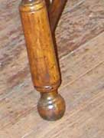 | Ball  Became popular in the Baroque period, including William and Mary style. Used as feet.  - Illustration: Windsor chair - Fairmount Park Woodford House, Philadelphia
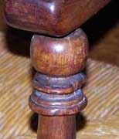 | Ball-and-ring  - Illustration: Slat-back (ladder-back) armchair - Old Editions Book Shop and Café  - Wainscot chair - Seymour H. Knox House / Blessed Sacrament RC Church Parish Office  - Cane-seated side chair - Athenaeum, Philadelphia
 | Ball-and-ring-and-vase  - Windsor armchair - stretcher - Independence Hall, Philadelphia
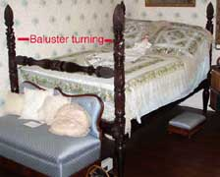 | Baluster  In the shape of a spindle column  - Illustration: Ansley Wilcox Mansion / Theodore Roosevelt Inaugural Site  - Table leg - Horace Reed House  - Corner chair - Fairmount Park Woodford House, Philadelphia
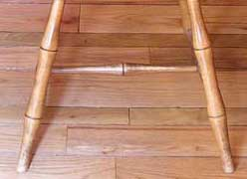 | Bamboo  - Illustration: Windsor "birdcage" side chair - Saturn Club  - Windsor "birdcage" side chair - Amherst Humphrey House  - Reproduction Federal style lacquered bamboo armchair - Kittinger Furniture Co.
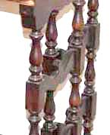 | Block-and-vase-and-ring  Illustration: Ansley Wilcox Mansion / Theodore Roosevelt Inaugural Site
Bulb-and-rings
- Windsor chair - Independence Hall, Philadelphia
- Windsor chair - Fairmount Park Woodford House, Philadelphia
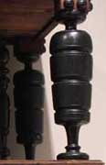 | Bulbous  Rounded or swollen  See Cup and cover (melon bulb) leg below  - Illustration: Cupboard - Winterthur Museum
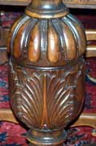 | Cup and cover (melon bulb) leg  The cover is carved with heavy gadrooning; the bulb is quartered with acanthus leaves.  Commonly used in at the end of the the 16th and the beginning of the 17th centuries.  - Illustration: Kittinger dining room table - Seymour H. Knox House / Blessed Sacrament RC Church Parish Office
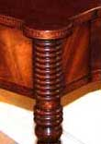 | Ring  - Illustration: Reproduction Federal card table -Kittinger Furniture Co.  - Italian Renaissance side chair leg
 | Scroll
 | Sausage
 | Spindle
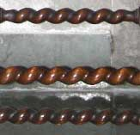 | Spiral  Became popular in the Baroque period, including William and Mary style  - Illustration: St. John's Grace Episcopal Church  - Broad spiral turnings on chair - Ansley Wilcox Mansion / Theodore Roosevelt Inaugural Site
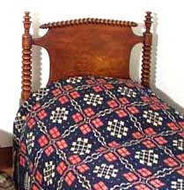 | Spool  - Illustration: Hired man's bed - Boies-Lord House (Hamburg)
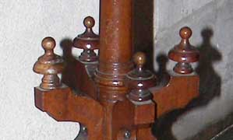 | Steeple  - Illustration: Steeple-turned finials - St. John's Grace Episcopal Church
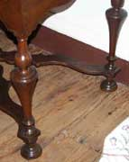 | Trumpet  Flared end that resembles the bell of a trumpet.  Became popular in the Baroque period, including William and Mary style  - Illustration: Fairmount Park Woodford House, Philadelphia  - Renaissance Revival side chair - Kelly Schultz Antiques  - William and Mary dressing table - Winterthur Museum
Vase-and-block
See Block-and-vase above
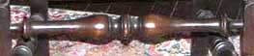 | Vase-and-ring  - Windsor chair - Independence Hall, Philadelphia  - Corner chair - Fairmount Park Woodford House, Philadelphia  - Balusters - Edward Harvey House. 91 Jewett Parkway  - 1920s dining room pedestal table - Edward Harvey House. 91 Jewett Parkway
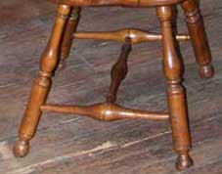 | Vase-and-ring-and-cylinder  - Illustration: Fairmount Park Woodford House, Philadelphia  - Windsor chair - Independence Hall, Philadelphia

D. Stretchers
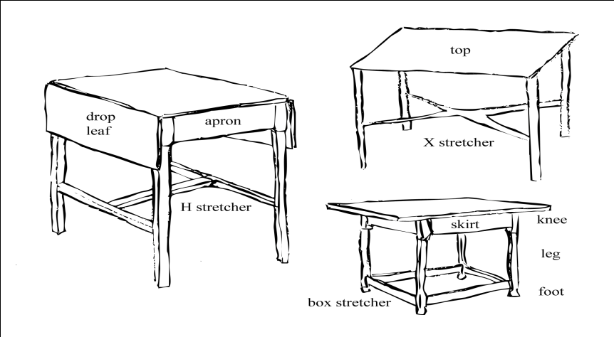
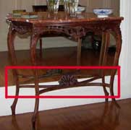 | Stretcher  The crosspiece that connects, braces, and strengthens the legs of tables, chairs, chests, etc.  Turned rod, or plain or cutout slat, used to reinforce legs.  Egyptian craftsworkers reinforced the joinery by adding stretchers, continuous stretchers, or runners to the legs of stools and chairs. Occasionally, struts were also added between the stretcher and seat rail for extra stability and strength.  - Illustration: 19th century marble Italian table - Horace Reed House  - William & Mary slat-back chair - Independence Hall, Philadelphia  - Wing armchair - Fairmount Park Woodford House, Philadelphia  - Kittinger Colonial Revival/Jacobean Revival style armchair - McCann House
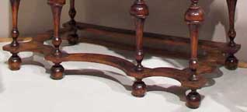 | Box stretcher  A structural configuration on the base of a chair that has a bar from leg to leg.  - Illustration: William and Mary highboy - Winterthur Museum  - Lang Collection
Cross stretcher
See X-stretcher below
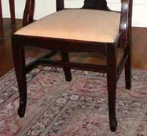 | H stretcher  A reinforcing element for chair, table, and case furniture legs. A wooden piece, or turning, connects each front leg with the leg immediately behind it. A crosspiece from one of these connecting pieces o the other forms an H.  - Illustration: Theodore Roosevelt Inaugural Site  - William and Mary wing armchair - Edward Harvey House. 91 Jewett Parkway  - Windsor chair - Independence Hall, Philadelphia  - Hepplewhite style chair - Fairmount Park Woodford House, Philadelphia  - C. 1820 English game table - Horace Reed House  - English desk-on-frame - Horace Reed House
X stretcher
Also called cross stretcher or saltier
Cross stretchers made flat or curved upward in serpentine form, with knobs or other ornamentation at the intersection.
Used to connect the four supports of a chair or piece of furniture, and to reinforce them.
Domed cross stretcher
- Illustration: 19th century marble Italian table - Horace Reed House
- Baroque writing table - Hofmobileliendepot Imperial Furniture Collection,Vienna, Austria
- Domed stretcher: Reproduction Chippendale English tea table - Kittinger Furniture Company
- William and Mary dressing table - Winterthur Museum
E. Skirt/apron types

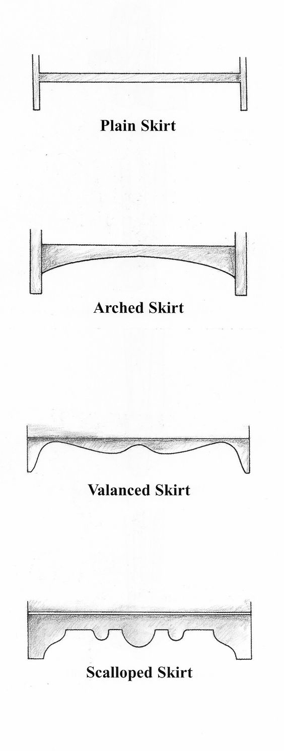

Styles of chair backs
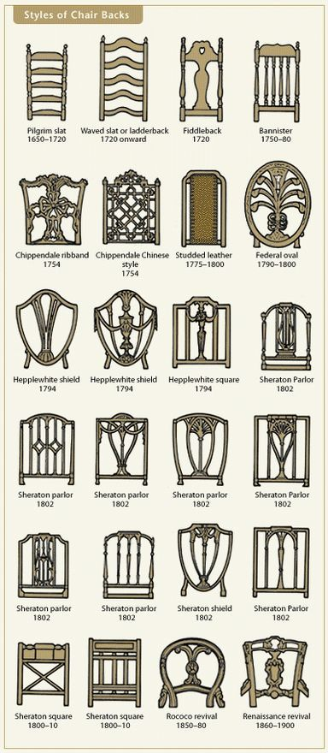
Chippendale Chair Back Styles
Chippendale furniture is named after British furniture maker Thomas Chippendale (1718-1779). The best pieces were made of mahogany; less expensive used walnut, cherry and maple.
The style is a blend of rococo, gothic and Chinese.
The Chippendale style evolved over the years in both Britain and then in the USA.
Waved Slat or Ladderback
The waved slat / ladderback dates back to the middle ages.
It's a simple design, more for function than form.
The chair width is typically narrow. a straight slat is very plain, the waved slat is an effort to add a decorative element to the chair appearance.
Fiddleback Chair Back Style
The fiddleback chair is a dining chair.
This chair style is identified by the main chair back slat in the shape of a fiddle or approximating a fiddle. The design varies, but as long as the outline approximates that of a fiddle, it falls in the fiddleback style.
This style hit the scene in Britain in the early 18th century.
Some versions have spindles in addition to the fiddle slat while some only have the large fiddle slat.
The wide fiddle slat makes for a reasonably comfortable chair. These days, it's found in country style kitchens.
Federal Oval Chair Back Style
The federal style refers to the time period after the American Revolutionary war being influenced by Georgian and Adam styles. The federal style influenced architecture as well as furniture.
Bannister
The bannister chair style adopts its name by the way it resembles a stair bannister with spindles.
It's a rather plain chair style that is still used today. Because the spindles are all the same, it's a chair style that can easily be mass-produced. Our kitchen table has bannister style chairs.
There are many different styles of the bannister chair back including high back, narrow, curved back and more.
Studded Leather Chair Back
The studded leather chair back is the only upholstered chair back style to make this list.
The leather upholstery is attached with prominent studs that secure it around the perimeter.
Like many on this page, this chair style comes in many sizes and forms - the unifying design element being the upholstered leather with studs.
In fact, the style is still used today, but usually it's with larger, wider, more comfortable chairs.
Sheraton Parlor Chair Back Styles
Sheraton furniture is a neoclassical style that was popular in England from 1785 to 1820. It's called Sheraton to credit the popular furniture maker Thomas Sheraton (1751 - 1806).
The Sheraton style was inspired by the Louis XVI style and features round tapered legs, fluting and most notably contrasting veneer inlays
We showcase several Sheraton chair back styles from both the parlor and square back styles below.
Renaissance Revival
The renaissance revival furniture period was from 1850 to 1880.
The carvings were ornate and included motifs such as flowers, fruits, scrolls and masks.
Dark woods was predominantly used.
Rococo Revival
The rococo revival period was from 1845 to 1870.
It's a highly ornate style, incorporating scrolls, shells, leaves and flowers.
The main wood types used were mahogany, walnut and rosewood so that it could be so intricately carved.
Hepplewhite Chair Back Styles
Hepplewhite furniture was on the scene from 1790 to 1815.
Stylistically, it's a federal style and coincides with the federal era.
As I stated above, I love federal style, mainly because symmetry and balance were important.
Pilgrim Slat
The pilgrim slat era was very early American spanning from 1690 to 1730.
It was at a time when pilgrims had few resources and so furniture styles were simple. This would, of course change, but the pilgrim slat chair is an example of a very simple early furniture style.
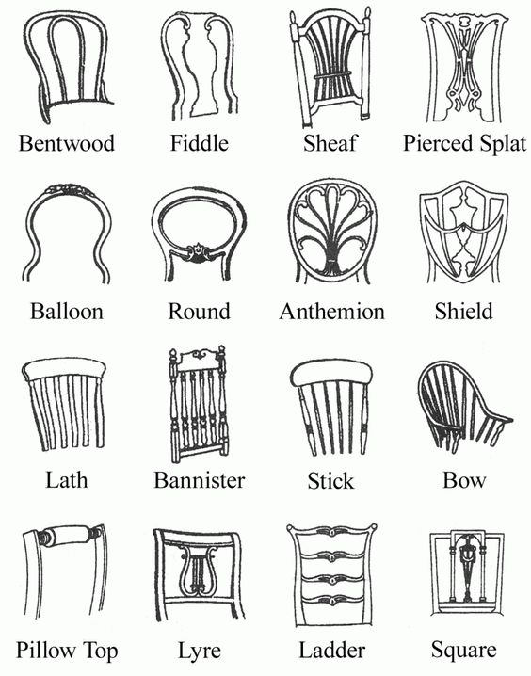
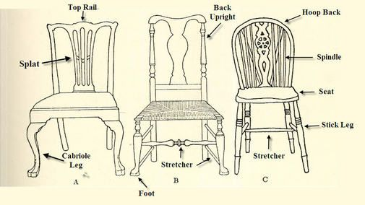
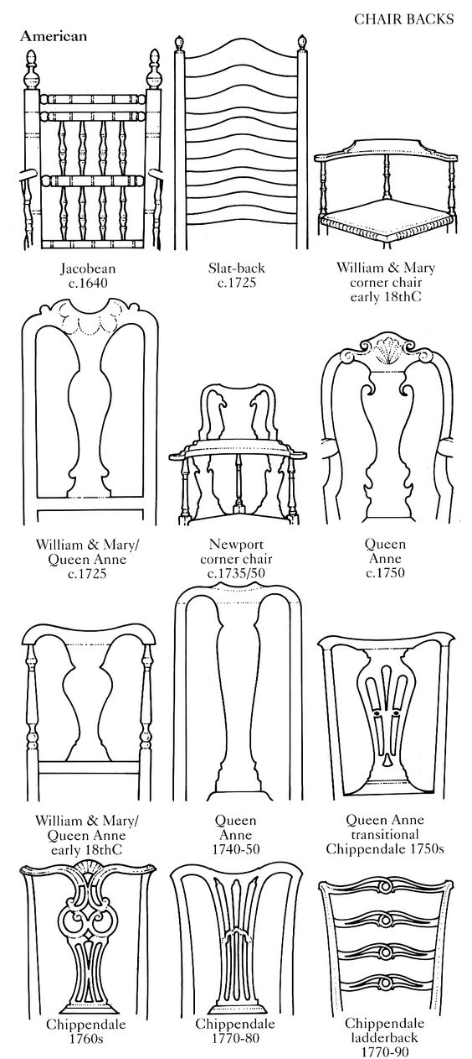
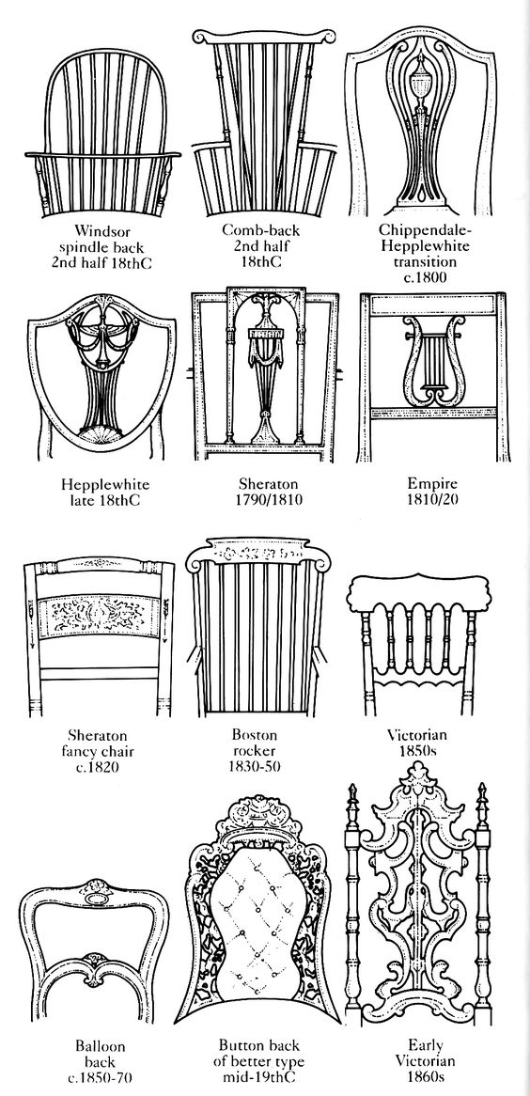
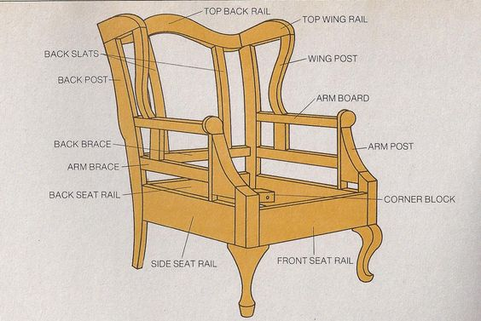

Windsor Chair
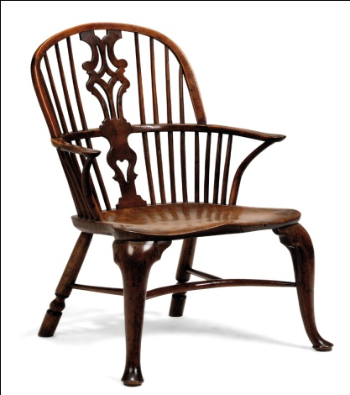

Windsor chairs are all wood with backs and sides consisting of multiple thin, turned spindles that are attached to a solid, sculpted seat. The straight legs in this chair style splay outward and the backs recline slightly. Some examples have thicker decorative splats running down the back with spindles on either side, while others consist of all spindles.
The classic Windsor chair takes its name from the English town of Windsor, where it originated around 1710. This style has been produced over and over through the centuries since then, and modern versions are still being marketed today.

Yoke-Back Chair
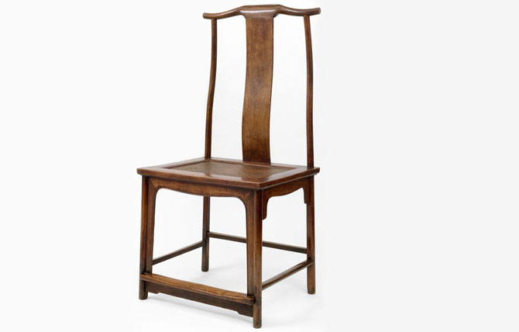

Yoke-back, or yoke-crest, refers to the shape of the top rail of a chair’s back in which two S-shaped pieces emulate the curve of an actual ox yoke. The yoke-shaped element may have protrusions beyond the stiles or be curved (as shown here). Styles of back splats used with yoke-back top rails can vary, but the incorporation of the vasiform splat (a vase- or urn-shaped splat) is not uncommon.
This type of top rail originated with Chinese chairs, but it was also widely used in Queen Anne, Chippendale, and other recognizable styles of American furniture.
Duncan Phyfe Dining Chairs, Shield Back
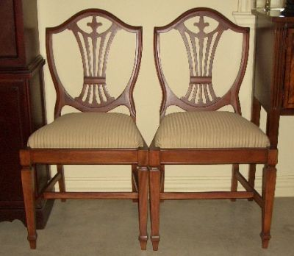
Duncan Phyfe Dining Chairs Shield Back Prince Wales
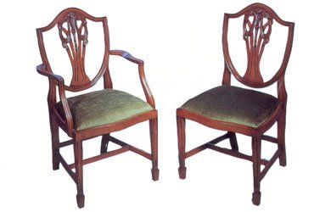
Chippendale Ribbon-Back, 1718-1779, 18th Century
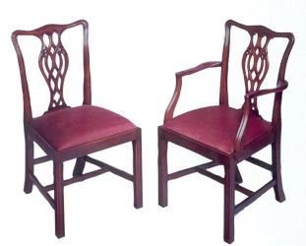
Slat Back Chairs
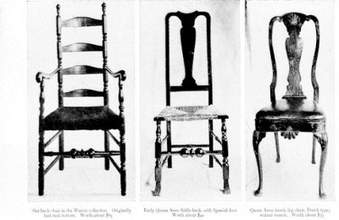

Ladder-Back Chairs, 1718-1779, 18th Century Honeysuckle
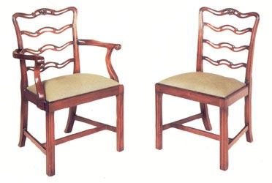
Acanthus Ribbon Back, 1718-1779, 18th Century
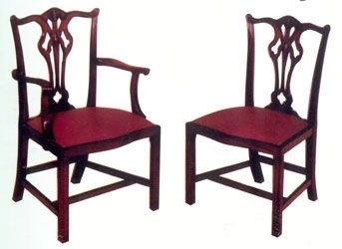

Upholstered Antique Chair Styles
Upholstered chairs have been around for centuries now and varied styles are still popular in homes today, whether antique or newly crafted. Learn more about several distinctive chair styles that were built with cushioned comfort and lounging in mind.
1. Bergère Chair Style
Bergere is a chair with upholstered sides and usually caned or upholstered.
The bergère (pronounced burr-jair) is a type of early upholstered armchair with closed sides that celebrated the change from more rigid, uncomfortable chair designs of the past when it was a brand new style. The sides are usually upholstered but can also be made of cane in some models.

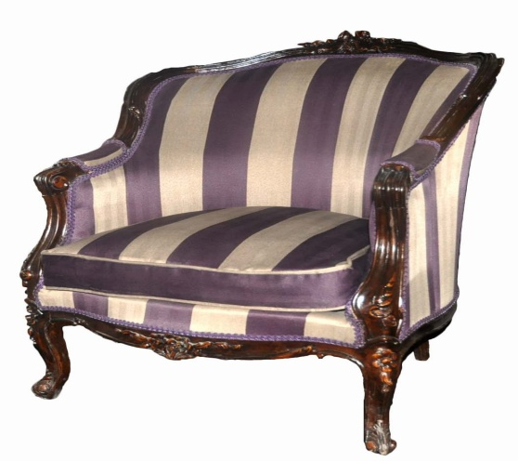
This type of chair was built for comfort with a long, wide cushioned seat. Backs can be high or low, and square, round, curved, or conical in shape. These chairs were first developed in France around 1725 at the end of the Régence period, and they flourished throughout the 18th century. They are characteristic of Louis XV, Louis XVI and other Rococo styles, but were adapted in many ways centuries later.
Woods used in the arms and back trim can be painted, gilded, or natural in tone. This style is still as popular today as it was when it first came about for lounge use in stylish homes centuries ago.
2. Fauteuil Chair Style
A Fauteuil is a French arm chair with upholstered seat and back.
Fauteuil (pronounced foe-toy) literally translates to "armchair" in French. In reference to antique furniture, it specifically means an upholstered armchair with open sides like the one shown here.

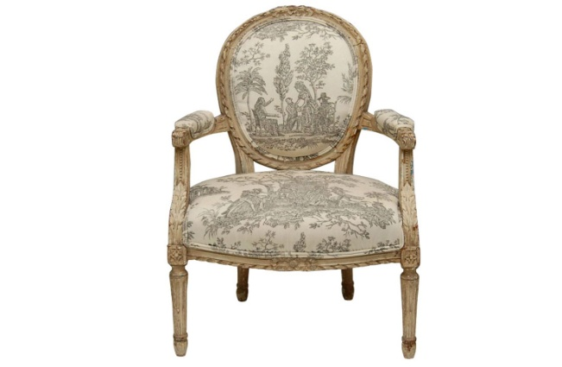
It was developed in the late 1600s in France, towards the end of Louis XIV's reign, and remained quite popular in the 18th century. The style not only became lighter and more graceful in appearance as time passed but also more ornate - the chair arms were many times upholstered to match the back and seat.
Variations include the fauteuil à la reine (Queen's armchair), which has a square, high back as opposed to a rounded one like the example shown here.
3.The Morris Chair
The term Morris Chair defines a deep, high armchair with an adjustable reclining back and cushions for the back and seat. It traditionally has spindle or slat sides and bow arms.
This chair was named for Arts and Crafts proponent William Morris, and the original chair was actually designed by his business partner Philip Webb based on folk chairs found in Sussex, England. This style was first produced by Morris & Co. around 1869.

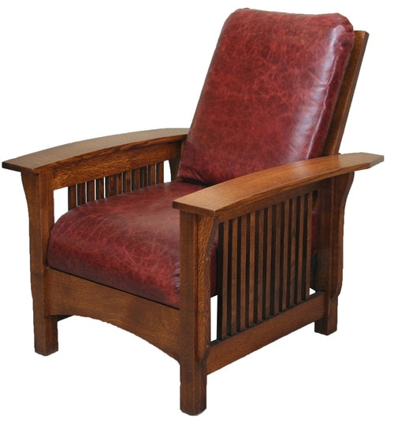

The Morris Chair was widely copied and adapted by other furniture-makers during the Arts and Crafts period including Gustav Stickley. This style is often considered to be the precursor of modern recliners and was clearly developed with comfort and relaxation in mind.
4. Slipper Chair Style
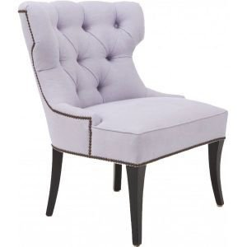
Any sort of armless, upholstered chair that sits low to the ground (around 15 inches, vs. the usual 17 to 19 inches) qualifies as a slipper chair. They tend to have high backs and rather wide seats.
They became popular during the first quarter of the 18th century and flourished in the 19th century. The style experienced a revival in the mid-20th century. Designers John Henry Belter and Billy Baldwin are both known for their slipper chair designs.
Slipper chair styles can vary enormously. From the thin, conical-backed Gothic Revival variety in the Victorian era to the squat, square-shaped style popular in Mid-Century Modern furniture, they have found a place in homes for centuries.
5. The Wingback Chair
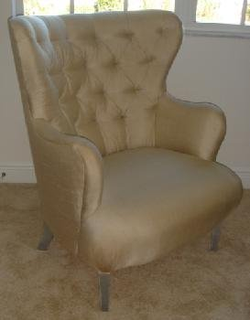
This type of upholstered easy chair, usually taller than it is wide, has two side panels or wings flanking the high back and closed panels under the arms, which are usually rolled. Depending on the period when the example was made, the legs can be straight, cabriole or (more rarely) turned with correspondingly varied feet. Pad and claw-and-ball feet are particularly common in these chairs.
Though a precursor was known in France, the most familiar form developed in late 17th-century England to protect sitters from drafts or an overly hot fire and it remained popular both there and in the United States for 200 years. This chair type is often associated with 18th-century styles such as Queen Anne, Georgian, Chippendale, Hepplewhite, and Sheraton. The wingback chair is still popular in stylish homes today.
5 Wild and Wonderful Antique Chair Styles
1. Curule Chair
The curule (pronounced kyur-ool) is a style of cross-based furniture, usually a chair or stool, in which the legs consist of two curved pieces joined in the middle, like a pair of interlocked U's or a single wavy X. And yes, you've seen this type of seating on Game of Thrones along with a variation called a Savonarola chair (shown below).

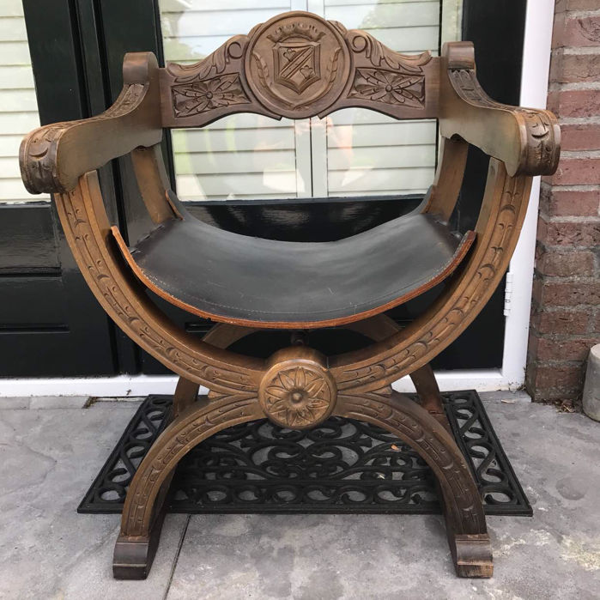
It was derived from a 6th century BC Roman seat, the sella curulis, that was backless and portable. With the rise of Neoclassical styles in the later 18th century, it was revived, featuring in Louis XVI designs and later Sheraton pieces. The curule is also characteristic of Empire and American Federal pieces, such as those designed by Duncan Phyfe, who incorporated the bent legs into chairs with tall backs.
This type of chair is also sometimes referenced as a scissors chair, or Grecian cross chair. The Savonarola chair is a fancier variation of the basic curule, as is the Dante chair.
2. Corner Chair
Developed in the early 18th century, corner chairs are typical of antique furniture pieces that could save space by nestling easily into a corner. These armchairs typically have square seats and they are placed diagonally. They have one leg in front and three others that rise past the seat to support a semi-circular or curved crest rail on top. Splats or back rests are set at right angles to each other, and the legs can be straight or cabriole. Sometimes the front leg on a corner chair is more decorated than the others. They are sometimes references as roundabout chairs or writing chairs.

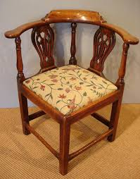
3. Gondola Chair
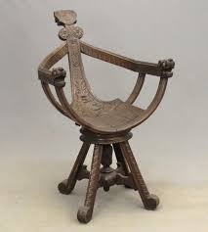
Why is it called a gondola chair? With its sharp slope, the gondola chair in profile does somewhat resemble the prow of a gondola boat.
This type of chair has a concave or C-shaped back, with sides that slope continuously down towards the seat, and splayed legs in back. Though originally applied to side chairs with open backs (like the one shown here), term now applies to any chair, open like a fauteuil or closed like a bergère (if there are arms, they too curve dramatically forward). The back is usually conical or circular, but can also be rectangular, albeit with rounded edges.
The style was developed in France circa 1760, and is characteristic of Neoclassical, Regency, and Greek Revival styles of the late 18th century through the first quarter of the 19th century. The gondola chair is sometimes referenced as a tub chair or a barrel chair, and not all examples are nearly as ornate as the piece shown here.
4. Klismos Chair
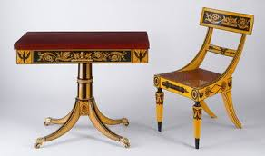
This type of light chair, supported by two sets of saber legs flaring outward in opposite directions and connected by a curved concave back panel at shoulder height, was developed in 5th-century Greece. The klismos style was revived as part of the late 18th-century Neoclassical movement in furniture, featuring prominently in Regency, Federal and Empire styles.
Some versions, especially American, have turned front legs, either straight or tapered, in imitation of classical Roman styles. They were made for use with dining tables, and are often used as side chairs. Some examples, like the one illustrating this feature, can be heavily decorated. Other more modern versions have the same basic shape, with flared saber legs, but they are toned down in terms of the elaborate detailing.
5. Savonarola Chair
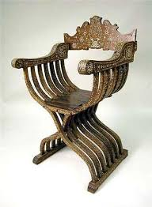
This chair style has also been used as a prop on Game of Thrones. The Savonarola is a kind of X-frame chair, in which two legs, sometimes composed of multiple slats, cross each other and rise to form the arms creating the silhouette of a wavy X. The Savonarola style was developed in late 15th century to early 16th century Italy. It was originally a folding, portable adaptation of the ancient Roman curule (see above). The difference is that it has more angular legs and the addition of a low back.
The wood was sometimes carved or inlaid, and later Renaissance Revival versions in the 19th century often featured high backs and even more ornate carving or some type of inlay. As they grew increasingly ornate, Savonarola chairs lost their portability and became more like massive thrones or chairs of state.
These chairs are sometimes referenced as Dante chairs (often simpler variations), scissors chairs, X-frame chairs, or by the more generic term curule.
Antique Couch, Sofa and Settee Styles
1. Boudeuse Sofa
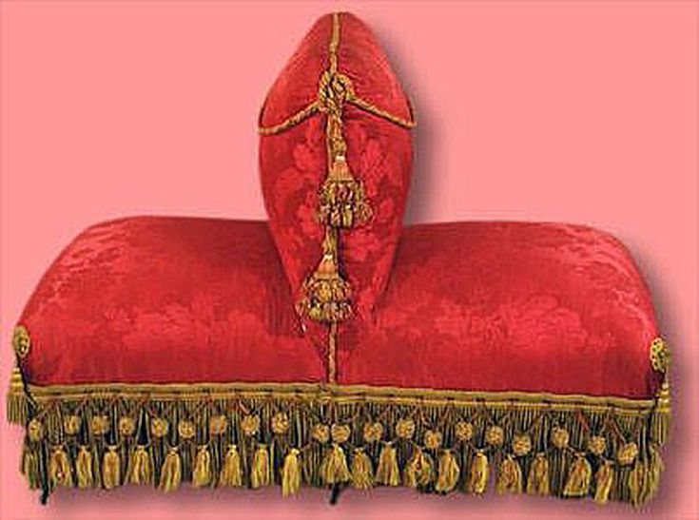
The boudeuse (pronounced boo-duhz) is a type of small upholstered sofa or loveseat of sorts, consisting of two seats sharing a common back so that the sitters face in opposite directions. Developed during the mid-19th century, probably in France, it is characteristic of ornate and luxurious Second Empire furniture, and usually employs coil-spring technology in the seat. It is also known as a dos-à-dos ("back-to-back" in French).
The French word boudeuse translates as "sulky"—typical, perhaps, of the mood of a pair of lovers who chose to sit facing away from each other on this type of seating.

2. Camelback Sofa
This popular style is an upholstered sofa or settee with an arched back that rises to a prominent point in the middle and rises slightly again at the ends. The Camelback sofa usually has scrolled arms and is primarily found in English and American furniture. It was developed in the 18th century.​
Leg and foot styles vary, depending on the exact period. Cabriole legs are typical on Queen Anne and Chippendale pieces, while tapered legs characterize those in the style of Hepplewhite (whose designs the style is often connected to), and elaborately carved monopodium feet often adorn Empire pieces.

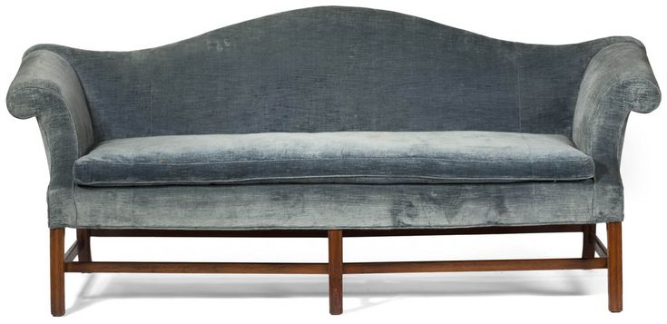
This style is sometimes described as a "humpback" sofa.
3. Canapé à Confidante Sofa
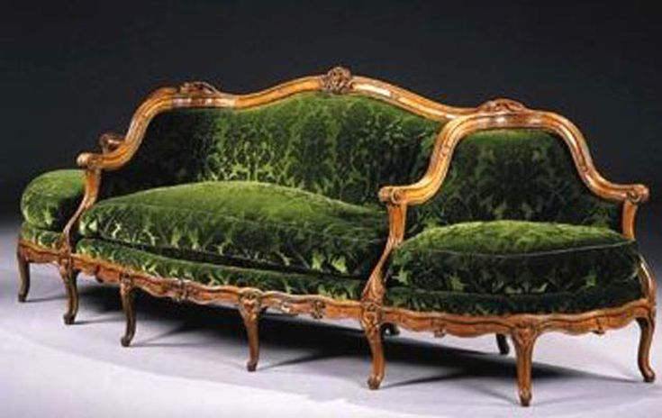
The Canapé à Confidante (pronounced kan-a-pay ah kon-fee-dahnt) is a long sofa having a seat at each end that faces outward at right angles to the main seat. The style was developed in 18th-century France reflecting the development of new types of furniture at that time. It is characteristic of Louis XV and rococostyles, as well as the mid-19th-century revivals of those styles. It is intended as seating for at least three people, not unlike an indiscret, except that the center section is usually much longer than the two side seats.
4. Chair-back Settee
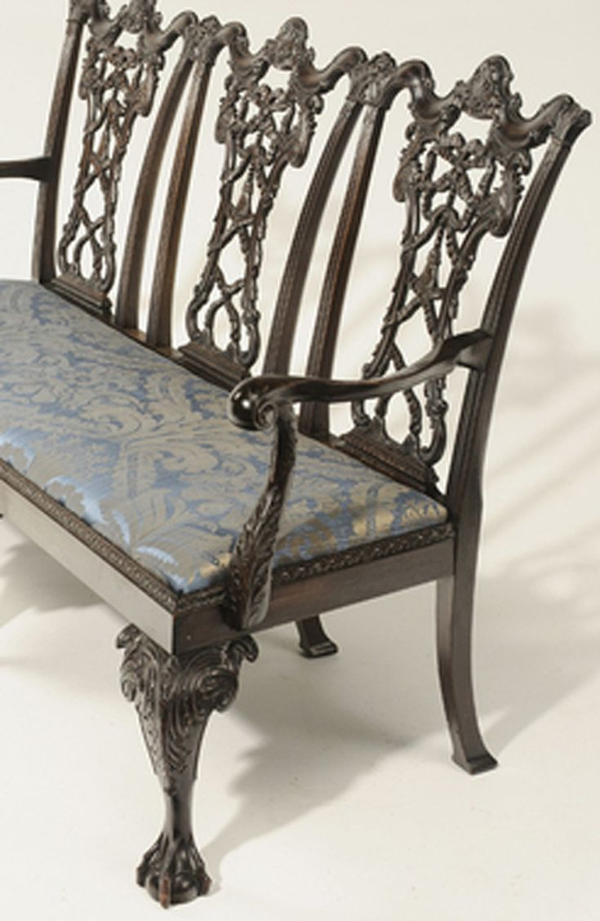
This is a type of seating in which the backrest is composed of two, three, or even more distinct chair frames so the effect is that of a series of chairs sharing a common seat. An early type of couch, it was developed in the late 17th century and continued to be popular well into the 19th century with the backs, legs, and feet reflecting the predominant styles of the period. The back chairs are usually open but can be upholstered. It is also known in French as a canapé en cabriolet.
This style is experiencing a modern comeback among do-it-yourself project fans who are combining thrifted individual chairs with interesting backs into settees.
5. Chesterfield Sofa
A Chesterfield is a type of deep, completely upholstered sofa with rolled arms that are the same height as the back which form a single rolling curve. It is traditionally crafted with tufted, buttoned leather, though other fabrics can be used. This sofa style originally rested on blunt arrow feet, but later models were stubbier, resting on ball, bun, or block feet.
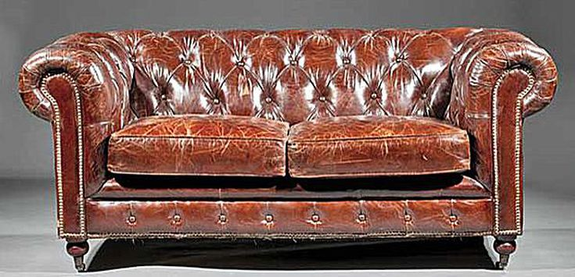
It originated in England in the late 18th century. Legend has it was named for the trend-setting Earl of Chesterfield, who allegedly commissioned one. It is typically associated with mid-19th-century Victorian styles, flourishing with the development of coil-spring technology in the 1830s.
Plush and plump, the Chesterfield sofa—like leather club chairs and wingback chairs—is an article of furniture that speaks of sumptuous libraries and gentlemen's lounges.
6. Davenport Sofa
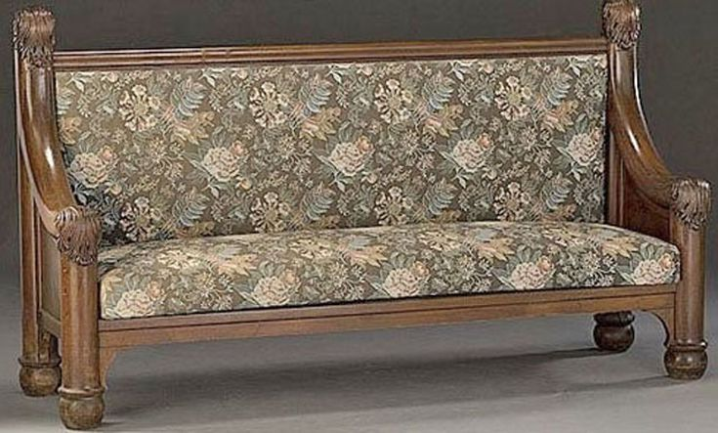
In the U.S., a Davenport originally referred to a squarish sofa, usually upholstered, with a high back and arms. The boxy style developed around the turn of the 20th century and was named for the A.H. Davenport Company of Boston (later Irving & Casson & Davenport), a firm also known for manufacturing furniture designed by architect H.H. Richardson.
Although somewhat archaic now, the term became generic and was applied to almost any sofa or couch in the Midwest and upstate New York. It was popular enough so that, when convertible sofa-beds were first developed, they were called "Davenport beds." The Kroehler Company of Naperville, Illinois, was the first to patent a sofa with hidden mattress and springs in 1909 though earlier versions may well have existed.
A Davenport also references a type of small, portable English desk and the term largely references the desk style in modern terms.
7. Indiscret Sofa
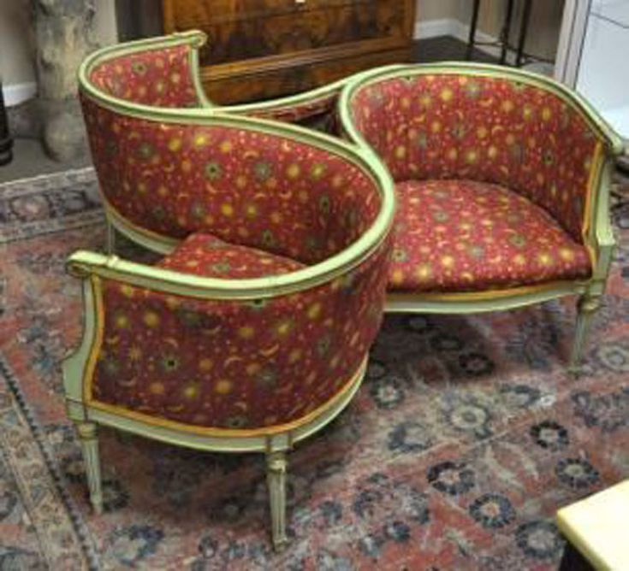
The indescret (pronounced en-des-cray) is a type of upholstered couch that can seat three people. It was developed in the mid-19th century, probably in France, and it can take two forms.
The earlier, dating from the 1830s, is a circular sofa, divided into three sections that share a single tall back in the center. The later, which emerged during the Second Empire, consists of three connected armchairs in a pinwheel pattern like the example shown here. Both types are often ornately carved, with tufted upholstery that uses the coil-spring technology so dear to Victorian hearts and furniture styles alike.
This style is sometimes aptly called a conversational sofa, and may erroneously be identified as a tête-a-tête which only seats two people.
8. Méridienne Daybed or Fainting Couch
This type of daybed, a cross between a sofa and a chaise lounge, is characterized by a sloping back that runs along the length of the piece and connecting the high headrest and footrest (though some versions are open-ended). Legs can vary in shape but the headrest and footrest, when present, are typically scrolled or curved.
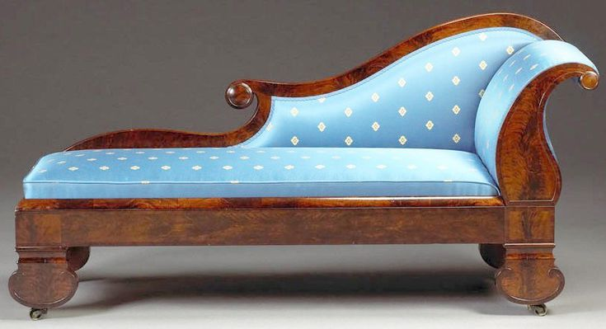
Developed in the early 1800s, the méridienne(pronounced may-rid-ee-ehn) is typically associated with English Regency and late French Empire, though its popularity continued throughout the 19th century and beyond.
The récamier is a variation. These are sometimes referenced as Grecian daybeds or fainting couches as well.
9. Récamier Daybed
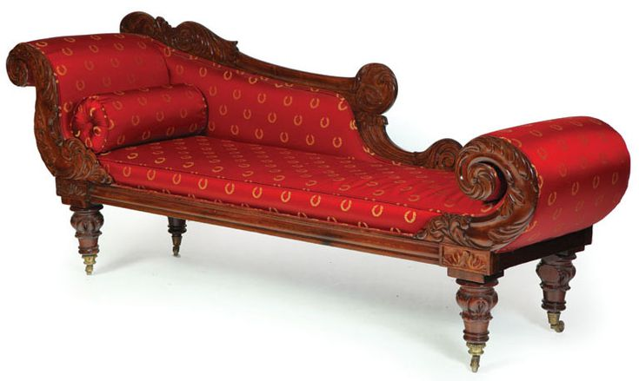
A récamier (pronounced ray-cam-ee-ay) is a type of light daybed that can double as a sofa. It has a curved headboard and correspondingly scrolled, but usually shorter, footboard. Originally backless, later versions often sported a low backrest, sometimes sloping, that ran either all or partly down the length of the piece.
Developed in France in the 1790s, it was named for Madame Récamier, a Parisian hostess and style-setter pictured reclining on one in a framed portrait. It is characteristic of French Directoire/Empire, English Regency, and American Federal styles.
The méridienne is a related style. These are sometimes referenced as Grecian daybeds or fainting couches more generically.
10. Tête-a-Tête Settee
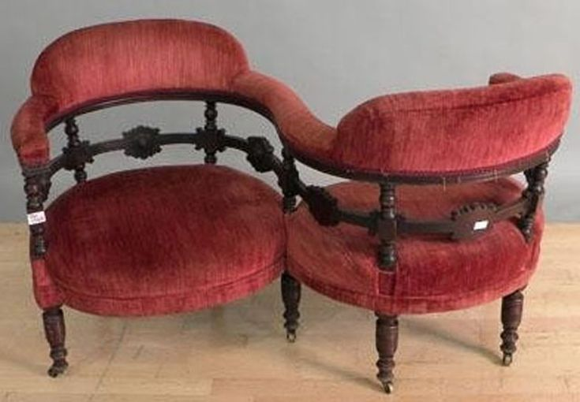
A type of settee that is basically two chairs joined together. They are conjoined in a serpentine shape so that the two people occupying it face opposite directions, but are quite close and can easily see each other in profile (the French phrase "tête-à-tête" refers to an intimate conversation).
Developed during the early 19th century, the tête-a-tête (pronounced tet-ah-tet) is usually associated with ornate Victorian furniture styles and often uses the coil-spring technology developed in the 1830s. Mid-Century Modern versions were also made by designers Salvador Dali and Edward Wormley.
These are sometimes called a confidante, vis-à-vis (face-to-face) , or gossip couch, all names suggesting private chats.
11. Windsor Settee
This is a variation on the Windsor chair: a long bench with a back and sides that consist of multiple spindles inserted in holes in the base of a sunken, often saddle-shaped seat. This settee typically has six legs which are also inserted in holes in the seat and are often splayed and connected with H-stretchers; these can be turned, carved to simulate bamboo, or tapering to end in a simple or arrow foot. Arms might be S-, paddle-, knuckle- or L-shaped.
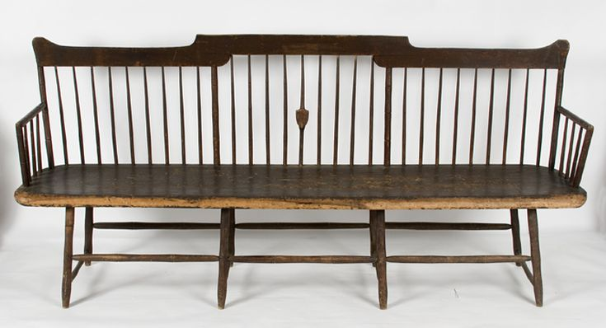
The spindled backs of the settees come in various shapes, similar to those of the chair (sack-back, bow-back, etc.) Straight low-backs seem to have been especially common. Another typical variation was the arrow-back, which refers not to the shape of the back but the spindles themselves, which were tapered and flattened at the end to suggest arrows.
Windsor settees were often made of different types of wood and so they are usually painted—sometimes quite elaborately, not unlike some fancier side chairs. They seem to be primarily an American form, developing in the 1750s most probably in Philadelphia.
Antique Dining Table Styles and Types
There are many different types of antique dining tables. Some are large, solid pieces of furniture while others are more portable and light in weight. Learn more about a number of different types of dining tables made through the centuries including those with gate-leg and drop-leaf features.
1. Butterfly Table
This is a specific type of gate-leg (see more specifics below), drop-leaf table which is characterized by two prominent wing-shaped braces that swing out to support the drop leaves. It is usually smaller and lighter than a conventional gate-leg table. A table like this would typically be used in a breakfast area or other small dining space, accommodating only two to four chairs, and would serve as an accent table when not in use.

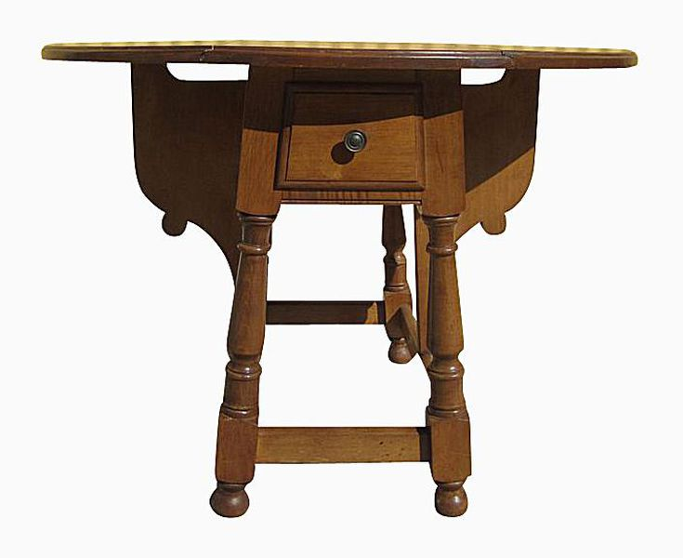
Butterfly tables are also characterized by splayed legs, which add to the sense of movement created by the wings. The table top itself can be oval or square, sometimes with a drawer as shown in the illustration. Legs are usually turned, connected with a plain or ringed box-stretcher, and rest on ball or bun feet or casters.
Thought to be American (probably from Connecticut) and developing around the turn of the 18th century, it is typical of William and Mary style furniture. Frequently made of maple, a plentiful wood in colonial New England, butterfly tables were often painted red, black or other colors.
Many variations and updated versions have been made since then.

2. Gate-leg Table

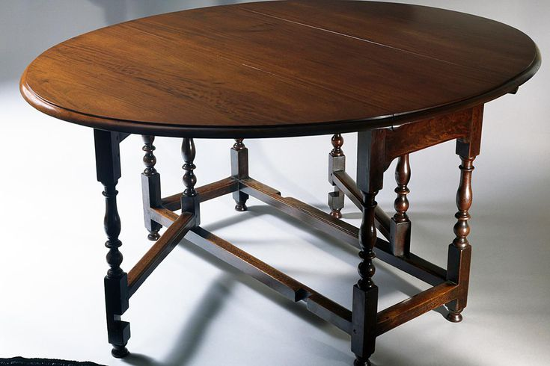
This is a type of drop-leaf table in which the sides are attached to legs that are hinged beneath the tabletop. The legs swing out, gate-like, allowing the leaves to be raised to expand the size of the table. Another style popular for dining in small areas, since it can be collapsed and displayed against a wall as an accent table when not in use.
The tabletop itself is usually round or oval, and plain, while the legs are often elaborately turned or spiraled and connected by stretchers. A single drawer is common. Most examples are made of oak, walnut or maple (if from New England), though fancier mahogany versions do exist.
Dating from the late 16th century, this Baroque style flourished throughout the 17th century and is highly characteristic of Jacobean and William and Mary furniture, representing the less formal, more intimate dining customs of the period. It was commonly used throughout the 1700s, gradually waning in favor of more graceful portable designs, such as the Pembroke table. The later 18th-century versions usually have thinner, simpler legs and rectangular tabletops.
Later versions were also made, especially during the Great Depression years in the United States.
3. Hutch Table
Hutch tables, sometimes referenced as chair-tables, are an early form of tilt-top table, in which a square, box-shaped base has a hinged, disproportionately large top. This top can be swung back and locked upright, creating an armchair with a sizeable back (usually round, but could be square or other shapes, as shown here).
Often the chair base has a drawer or compartment—hence the name "hutch." Though dating from the Middle Ages, this form was perfected in the Jacobean era, and remained popular in England and America through the early 19th century as a space-saving, multi-purpose piece of furniture.

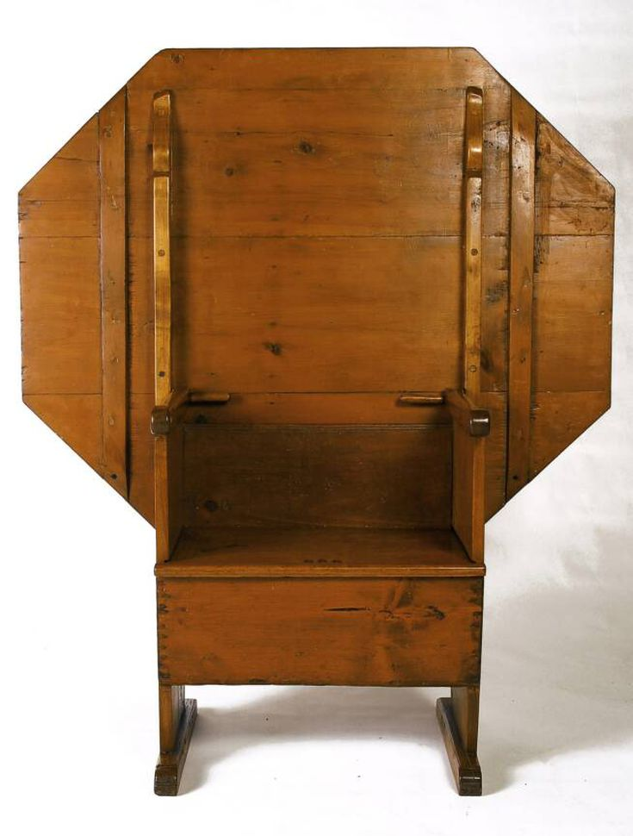
Most hutch tables are plain country pieces, so those found decorated with delicate carving are the most prized among early furniture fans.
4. Trestle Table
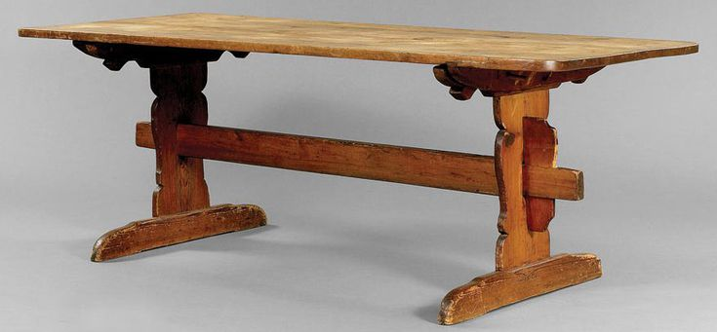
One of the first types of European table, dating from the Middle Ages, the trestle table consists of a rectangular board placed atop two or more trestles. These usually consisted of vertical posts placed in the middle of horizontal pieces, forming the shape of a T, or they could take the shape of a V-shaped pair of legs, like a sawhorse. Although they began as simple, portable pieces, trestle tables often became quite solid and ornate during the Renaissance.
This style remained the dominant form of dining table until the late 17th century, and continued to be popular in institutional and country furniture thereafter. It and was revived by Arts and Crafts furniture-makers like Gustav Stickley around the turn of the 20th century. They are sometimes referenced as refectory tables or kitchen tables.
Trestle tables have seen a resurgence in popularity in modern farmhouse decorating of late, and they are often used with chairs on one side and a bench on the other.

Types of Antique Case Furniture
Case furniture, also known as casegoods, includes many different types of antiques. Among these are various types of chests, bureaus, bookcases, and secretaries. These pieces were made for storage and sometimes had multiple uses. For instance, a butler's chest with a built-in secretary section provides a place to stow clothing and other personal items but also serves as a desk. These multi-purpose pieces can come in handy even today when space is at a premium.
Learn more about a number of different types of case furniture pieces here including the commode, highboy, lowboy, credenza, lingerie chest, secretary, and the breakfront.
A. Types of Chests, Chests of Drawers, Chests on Chests & Chests on Stands
A chest of drawers is a tall, narrow piece of furniture with multiple drawers
A chest (also called coffer or kist) is a form of furniture typically of a rectangular structure with four walls and a removable lid, for storage. The interior space may be subdivided. The early uses of an antique chest or coffer included storage of fine cloth, weapons, foods and valuable items. It is a box with a hinged lid that can safeguard your personal items. Some chests are equipped with locking mechanisms or a metal band that a lock can be secured on. In Webster’s Dictionary 1988 version, a chest is defined as a “a box with a lid and often, a lock, for storing or shipping things” or as “a cabinet as for holding medical supplies, toiletries, etc.
1. Commode
A commode is a low chest-of-drawers but later became a term for bedroom cupboards.
Commode, rosewood and tulipwood, gilt-lacquered, brass-mounts and feet, probably by Chippendale, ca. 1770. Photo courtesy of Sotheby's
A toilet is often referenced as a commode today, and there's a good reason for that. A piece of furniture meant to hold a chamber pot or pitcher and bowl for washing was often called a commode decades, if not centuries, ago. Eventually, any low cabinet containing drawers or shelves could be deemed a commode, and many of them were highly ornamental.

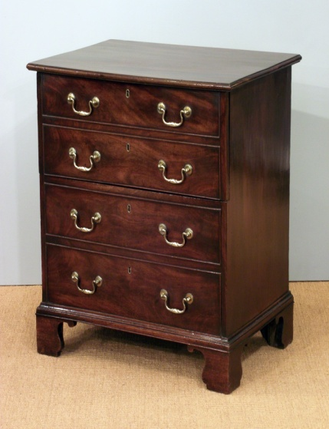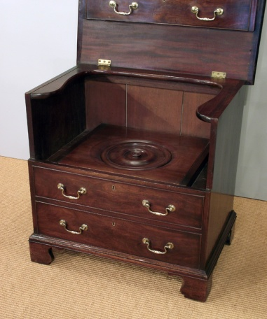

For instance, the fancy example shown here made of gilt-lacquered rose- and tulipwood, covered with intricate, floral-themed marquetry is a prime example of a commode. This one, with haughty provenance, belonged to the 10th Earl of Harrington and was purportedly made by renowned furniture craftsman Thomas Chippendale. For this reason, it sold at auction at Sotheby's in December, 2010 for close to $6 million.
2. Standard Vertical Chest/Tall boy
The vertical chest, also known as a tallboy, is much taller than the standard dresser design, with a double stack of drawers comprising a column shaped piece of furniture. Sometimes the upper half is replaced by a cupboard, which makes it into an armoire.
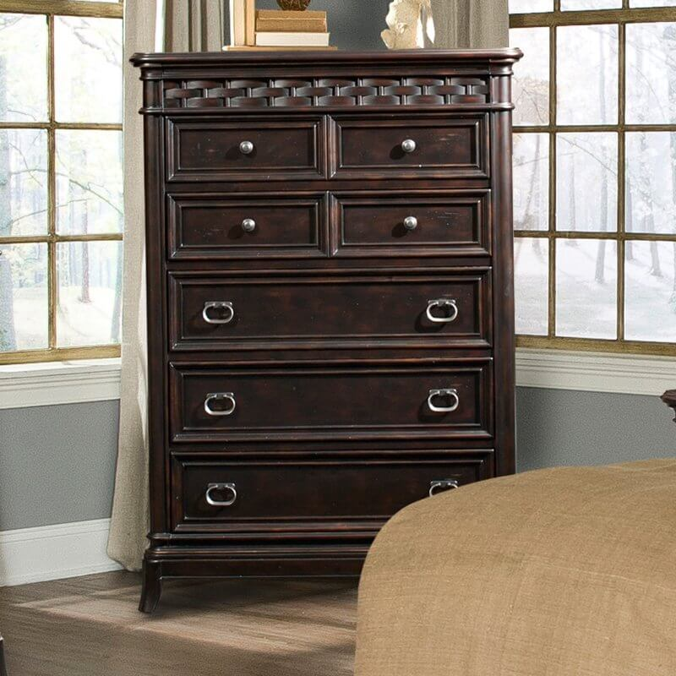

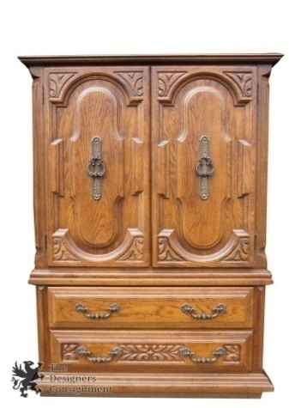
A tallboy is an item of furniture that incorporates both a chest of drawers and a wardrobe, usually as a wardrobe on top of a chest of drawers. It’s traditionally used to store clothing, as one normally would in a wardrobe and a chest of drawers. The only difference is that the chest of drawers and the wardrobe, in a tallboy, are combined.
3. Highboy (chest on chest)
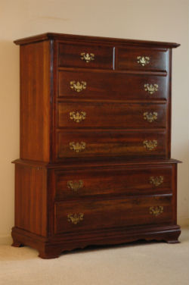
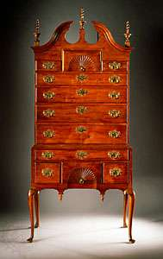
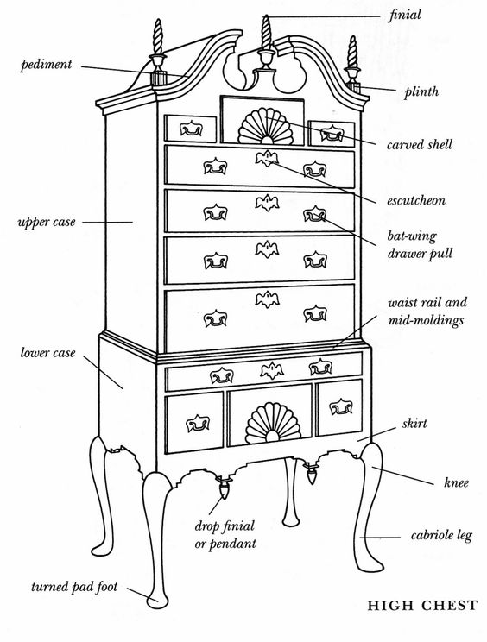
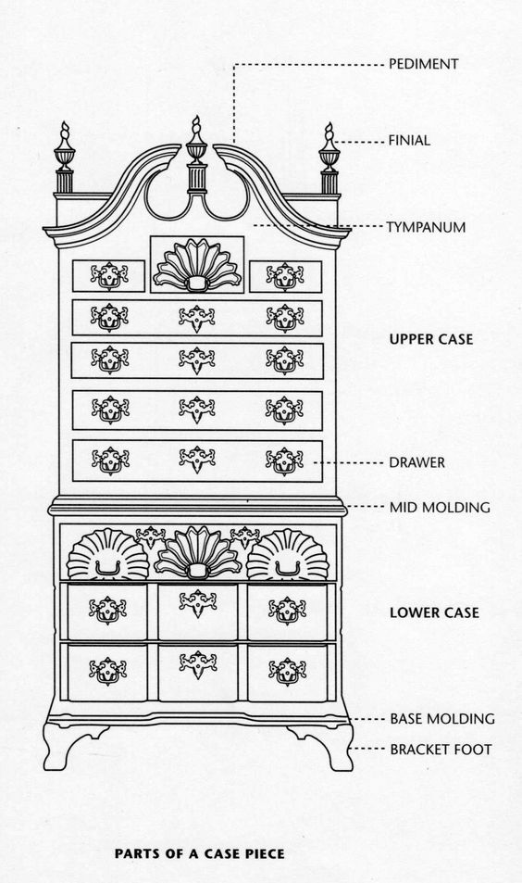
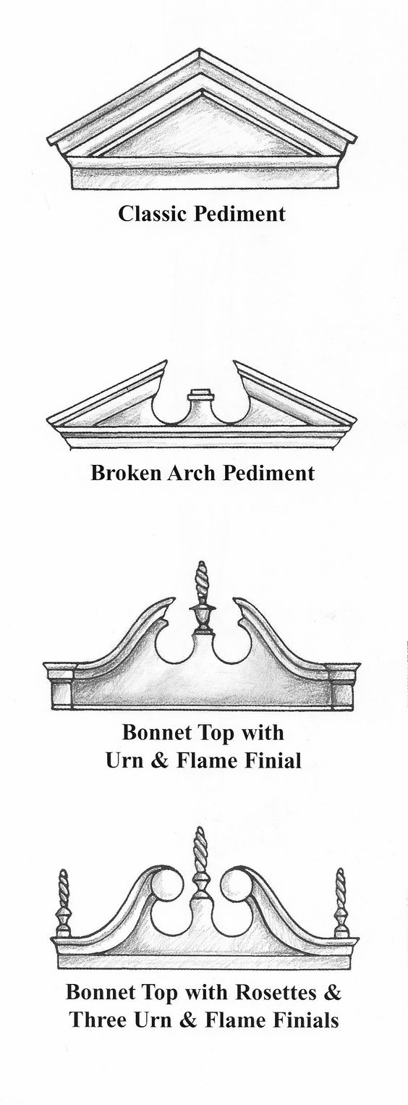

Like a tallboy, a highboy is quite similar in fashion but, instead of a wardrobe on top of a chest of drawers, there is another separate chest of drawers. A highboy is often commonly referred to as a double chest of drawers, or a “chest on chest”. Usually the upper chest will sit on top of a wider chest. Traditionally, these two chests of drawers, one on top of the other, would be separable. They would be two separate chests of drawers, the smaller one placed on top of the other to save much needed floor space. But now a highboy usually is built as a single unit. Rows of drawers can be full-width single drawers, or two or three narrower drawers in a row. (Usually the higher the row, the more drawers there are. With wide drawers at the bottom of the highboy.)
The highboy was developed in England in the late 17th century where a variation was known as the tallboy. This piece of furniture became highly popular in the American colonies, especially the northeast and mid-Atlantic, by 1730. Early varieties were typical of William and Mary style with flat tops, long ring-turned or trumpet legs and stretchers that rested on ball or bun feet. As the 18th century wore on, they became typical of Queen Anne and Chippendale styles, resting on shorter cabriole legs with pad, paw, or claw-and-ball feet and tops that became more ornate with scroll top pediments and finials.
Highboys were often paired with a matching lowboy (see example above), a shorter piece that resembles the highboy's lower half.
4. Lowboy
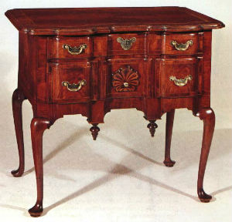
A lowboy is a chest of drawers mounted on waist height
A lowboy is very visually distinct from a tallboy or a highboy which are, by definition, “tall” or “high”. A lowboy is more of a small table at waist height (or normal table height). Usually the lowboy’s “table” surface will have drawers beneath the surface, and they were predominant item of bedroom furniture and clothing storage solution before the tallboys and highboys came into fashion. During the 18th century, lowboys and tallboys were popular pieces of furniture in England and the United States. The lowboy was used as a dressing table. Usually with brass pulls, cabriole legs and crafted from oak, walnut or mahogany . The term lowboy is still most commonly used with antique collectors and usually refers to an 18th century American dressing table (also known as a dresser or vanity).
The lowboy originated in the late 1600s in England and became extremely popular in the American colonies, especially the northeastern and mid-Atlantic regions, by 1730. Designs followed the style trends of the century, with early versions typical of William and Mary style, with long ring-turned or trumpet legs connected by stretchers that rested on ball or bun feet. Just as with the highboy, as the 18th century wore on it became more typical of Queen Anne and Chippendale styles, resting on shorter cabriole legs with pad, paw or claw-and-ball feet. One difference is that the lowboys' drawers often have nonworking locks, in contrast to those of highboys - suggesting that the highboys stored goods that were more valuable in nature.
5. Semanier or Lingerie Chest
A semainier is a chest of drawers, usually tall and thin, intended for storing linen and lingerie. It traditionally has seven drawers, one for each day of the week (the name derives from the French word, semaine, meaning "week").
Originating in 18th-century France, semainier has come to mean any seven-drawer chest these days but the term is sometimes erroneously applied to tall thin lingerie chests with only six drawers. Devoted to a single type of clothing - lingerie and stockings - this piece of case furniture was typical of the luxurious types of furniture developed in the Rococo period of early 1700s.
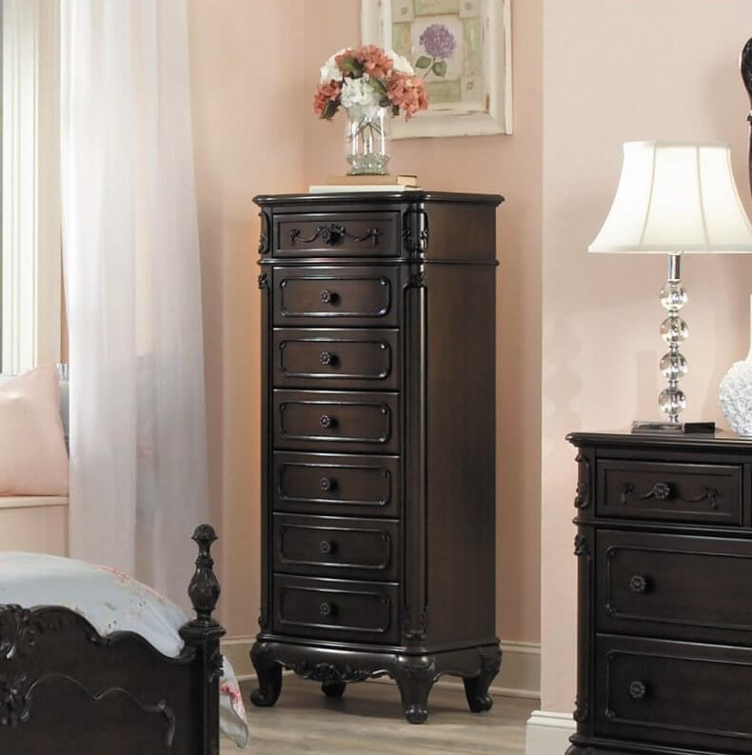
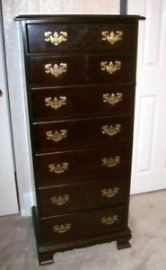
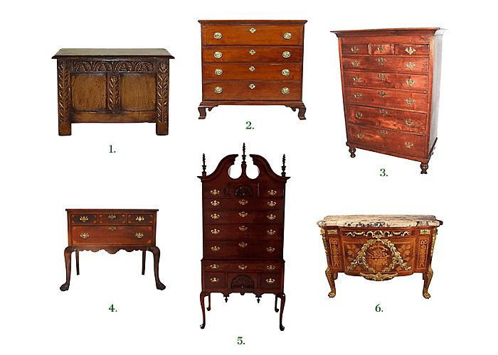
Types of Chests and Cabinets: 1. Chest 2. Chests of drawers 3. Chest-on- chest 4. The Lowboy 5. Queen Anne-style Highboy 6. Commodes

6. Gentlemen's Chest Antique Black
The gentlemen’s chest is a configuration wherein the drawer column is paired with a large vertically oriented cabinet door. This holds a large cavity where hung suits, pants, and other clothing may be stored.
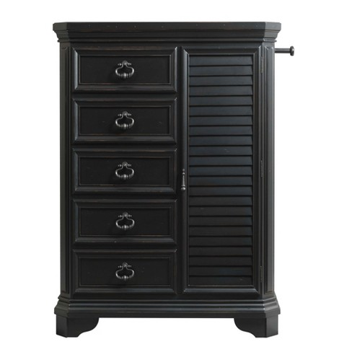
7. Bachelor’s Chest
A specifically more minimalist framing of the dresser form, the bachelor’s chest features a single column of drawers in a more squat, sometimes narrow frame. Originally, these had a slanted surface for writing, but most have horizontal surfaces nowadays.
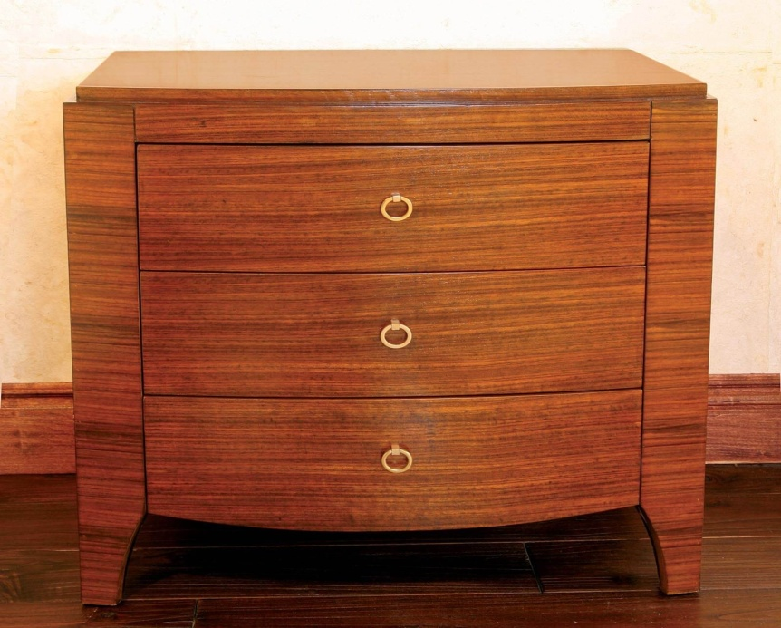

8. Hope chest
A hope chest, also called dowry chest, cedar chest, trousseau chest or glory box is a piece of furniture traditionally used to collect items such as clothing and household linen, by unmarried young women in anticipation of married life.
The term "hope chest" or "cedar chest" is used in the midwest or south of the United States; in the United Kingdom, the term is "bottom drawer"; while both terms, and "glory box" are used by women in Australia
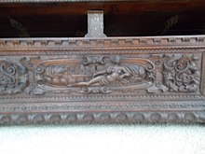
Intricate designs; typically the most decorated in the home during the prime time of the hope chest.

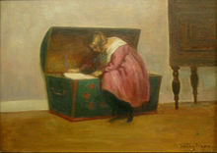
Girl inspecting her hope chest, by Poul Friis Nybo, c. 1900
Cassone
The cassone, or marriage coffer (hope chest), was a form on which the craftsman’s skill was lavished. In addition to elaborate relief work and gilding, these coffers often were painted on the front and sides and occasionally inside the lid as well, with appropriate biblical or mythological scenes. Motifs popular with the Italian carver included cupids, grotesque masks, scrolled foliage, and strapwork. The fixed writing desk is the forerunner of the writing bureau, which became an indispensable article of furniture as writing became more general.

Cassone, Italian chest, usually used as a marriage chest, and the most elaborately decorated piece of furniture of the Renaissance. Cassoni traditionally were made in pairs and sometimes bore the respective coats of arms of the bride and groom. They contained the bride’s clothes, linen, and other items of her dowry. In the 15th century, when the greatest importance was attached to suitable marital alliances between Florence’s wealthiest families, the cassone reached great heights of artistic achievement. Florentine artists such as Sandro Botticelli, Paolo Uccello, and Donatello were employed to decorate cassoni with paintings set in an architectural framework. Battle scenes and Classical and literary themes were especially popular. Fragments of a number of paintings from cassoni of this period have been preserved.
Sixteenth-century cassoni were elaborately carved with mythological and grotesque figures, decorated with gilt gesso, putti (cupids), and swags of fruit and flowers, or enriched with intarsia (mosaics of wood).
A cassone (plural cassoni) or marriage chest is a rich and showy Italian type of chest, which may be inlaid or carved, prepared with gesso ground then painted and gilded. Pastiglia was decoration in low relief carved or moulded in gesso, and was very widely used. The cassone ("large chest") was one of the trophy furnishings of rich merchants and aristocrats in Italian culture, from the Late Middle Ages onward. The cassone was the most important piece of furniture of that time. It was given to a bride and placed in the bridal suite. It would be given to the bride during the wedding, and it was the bride's parents' contribution to the wedding.
There are in fact a variety of different terms used in contemporary records for chests, and the attempts by modern scholars to distinguish between them remain speculative, and all decorated chests are today usually called cassoni, which was probably not the case at the time. For example, a forziere probably denoted a decorated chest with a lock.

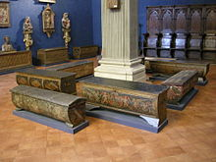
Some cassoni, in the Museo Bardini, Florence
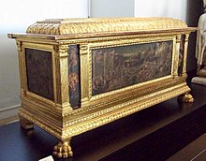
Renaissance hope chest (cassone) from Florence (15th century)
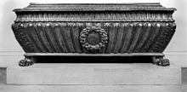
Walnut cassone in the form of an Antique sarcophagus, Rome, 16th century (Walters Art Museum)
9. Cellarette or bottle chest on stand
Northampton County, North Carolina; 1755–70
Black walnut, yellow pine, brass
During the 1700s and 1800s, affluent members of society acquired sophisticated and costly beverage accoutrements, including specialized furniture for storing drinking vessels. Cellarettes, or bottle chests, sometimes also known as wine coolers, were made in fashionable designs and materials for elegant dining rooms or parlors. Some included compartments to hold six to ten round wine bottles.
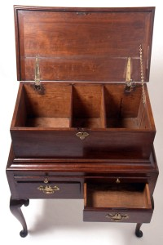
This North Carolina bottle case has a three-part compartment for wine and spirit bottles, other beverage wares, and perhaps sugar as well as drawers for storage and a pull-out shelf for workspace. Design and construction details suggest it may have been made by a craftsman who trained in Newport, Rhode Island, or was inspired by a Newport example.
Wine cooler or cellarette
Winchester, Shenandoah Valley, Virginia; 1790–1805
Mahogany, black walnut, maple, brass, copper, lead
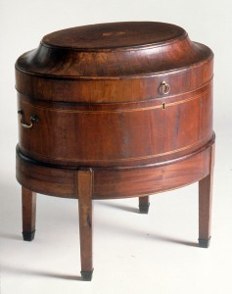
This lockable cellarette has a copper lining with center drain, indicating it was at times filled with ice or cold water. It could also function as a cabinet for storing wine bottles or decanters.
English Late 18th Century George III Mahogany Cellarette Chest, circa 1790
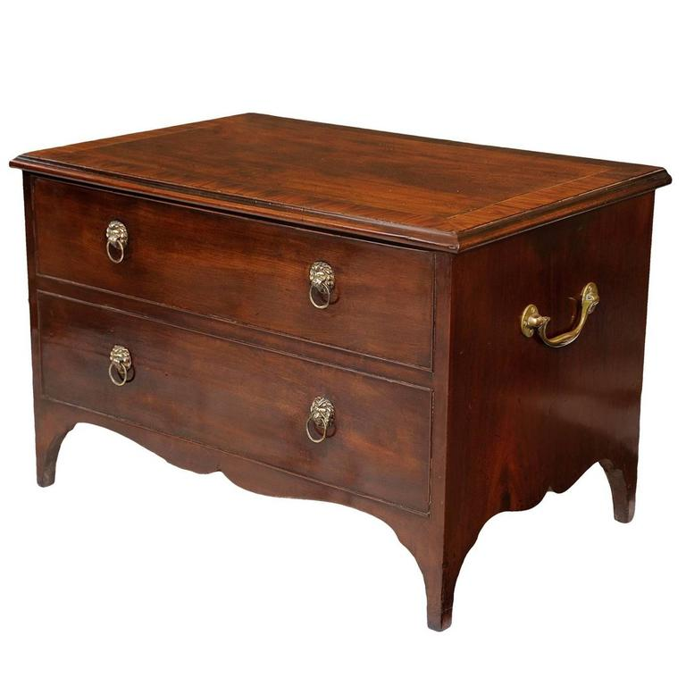
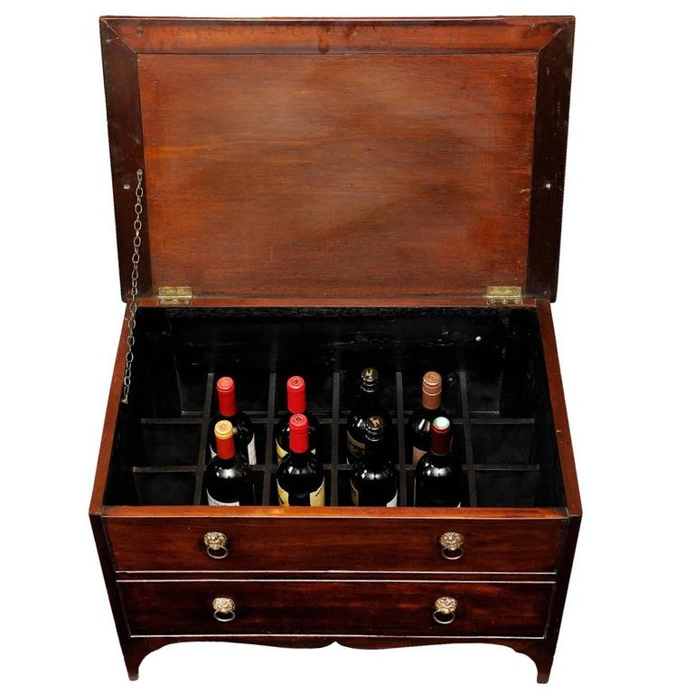

Most portable cellarettes were made of mahogany, and designs were varied. The shape was governed to some degree by the shapes of wine bottles. Early wine bottles were short and squat, but in the late 18th century they became progressively taller, a trend that was reflected in the depth of cellarettes. Common varieties of cellarettes were circular or oval, hooped with brass bands, and provided with tapered fluted legs with casters. Under the influence of the Classical Revival of the late 18th and early 19th centuries, sarcophagus shapes were also popular.
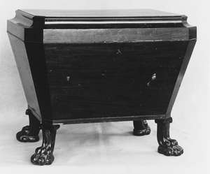
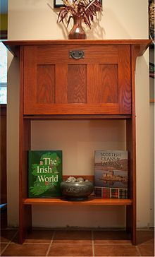
Contemporary cellarette, built in 2009
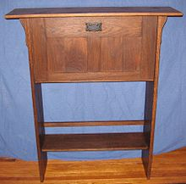
Mission style cellarette, built in 2007
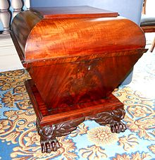
Antique cellarette - "sarcophagus" style located at Lanier Mansion in Madison, In.
B. Types of cabinets
1. Cellarette cabinet
Cellarette, also spelled cellaret, small movable cabinet designed to hold bottles of wine or liquor, primarily used from the 18th to the 20th century. It was usually kept under the centre of a sideboard or side table and rolled out for use. If it was meant to hold ice and made of silver, it was known as a wine cooler. Less commonly, a cellarette was a deep metal-lined tray with compartments for holding bottles in a sideboard.
The movable cellarette continued to be used after sideboards with built-in wine coolers were introduced in the 18th century. With the introduction of the refrigerator in the 20th century, however, use of the cellarette declined.
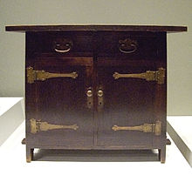
Cellarette at the de Young's International Arts & Crafts exhibition
2.Cupboard
Cupboard, type of furniture that originated in the Middle Ages as a board or table for cups. The word also may have been used for a stepped sideboard and later for open shelves, both to display plate. Since the 16th century the name has referred to a case fitted with doors.
Byzantine and Romanesque cupboards were of simple board construction, though they were sometimes decorated with elaborate painted designs. A fine example of about 1200, painted inside and out with pictures of saints on a gesso ground, survives in the cathedral at Halberstadt, Ger. Such freestanding cupboards were made for churches long before they were in common use in domestic interiors. The latter stage was reached only in the 14th century, when portable furniture began to be preferred to fixed objects that stood as permanent parts of a building. Many of the finest medieval cupboards were finely carved with Gothic designs closely following architectural motifs and forms.
Late 15th-century cupboards for food storage, such as the English livery cupboard, had ventilating holes, often taking the form of carved open tracery. Another variety was the hall, or parlour, cupboard, an enclosed version of the cupboard for display. The court cupboard, for example, was important in Tudor and Stuart times in England but lost fashion after the Restoration.
By the 17th century the cupboard was taking over the role of the chest as the principal piece of storage furniture. In certain parts of Europe, such as southern Germany, the cupboard may have developed from a chest placed on another chest, each opening at the front rather than at the top. For a long time cupboards were divided in two, horizontally, with handles sometimes attached to the sides of each section to facilitate moving.

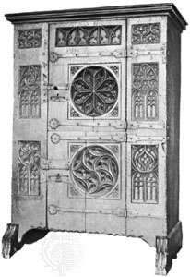
3. Sideboard
Sideboard, piece of furniture designed to hold plates, decanters, side dishes, and other accessories for a meal and frequently containing cupboards and drawers. When the word first appeared in the Middle Ages as an alternative to “side table,” it described a stepped structure used (as sideboards often have been) for the display of conspicuously valuable eating utensils. It preserved a basic table shape (sometimes with eight legs) until the 18th century. The first innovation was the substitution of hollow storage pedestals. Drawers (for napkins, cutlery, and the like) were added in the space beneath the main surface and between the pedestals. A serpentine front was popular in the latter half of the 18th century; other additions consisted of a marble top and a brass rail at the back, partly for protecting the wall, partly for propping up large plates and similar objects. In some examples a wine cooler is incorporated into the main structure of the sideboard, and there were often spaces for chamber pots.
In the early 19th century sideboards became an established part of mass-produced dining room suites, and they themselves became much heavier in design. The whole of the lower section was divided into cupboards extending to the floor. The metal rails at the back were supplanted by massive panels, usually ornate in design, and the whole piece was covered in carvings. Elaborate fantasies of design often converted the sideboard into a replica of a medieval cathedral or something equally improbable. The sideboard still retains its function in the 20th century, but stylistically there has been a reversion to simpler types, closer in feeling to 18th-century designs.
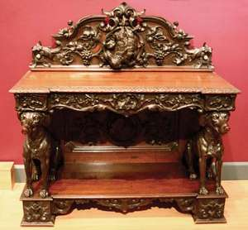

4. Court cupboard
Court cupboard, sideboard with three tiers, used mainly for displaying plate and therefore a focal point of the interior. It was a variant of the buffet and was fashionable throughout the 16th century and during the first three-quarters of the 17th, more commonly in northern than in southern Europe. Some examples were fitted in the upper stage with a cupboard, the front corners of which were set at an oblique angle to the front panel. Drawers were often included in the friezes, or horizontal bands, in the centre and top tiers.
The name is said to have come from the French court (“short”) because of the low height of the cupboard. Probably the best-known contemporary reference to court cupboards is in William Shakespeare’s play Romeo and Juliet, in which the order is given for the hall of Capulet’s house to be cleared for dancing: “Away with the joint-stools; remove the court-cupboard; look to the plate.” Court cupboards became less fashionable in the last quarter of the 17th century, though they were probably still made in country districts until the mid-18th century.
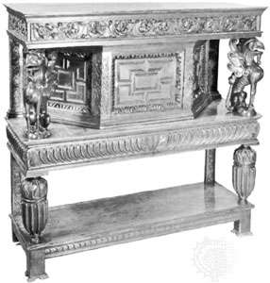
5. Credenza
A credenza is a long, substantial, rectangular piece of furniture, consisting of a flat table surface above and cupboard below, sitting on very short legs, or sometimes none.
It originated in 15th-century Italy (credenza is Italian for "cupboard"), possibly in churches, and it quickly became a popular item for the service of food and storage of tableware and linens. By the 1500s, a recessed upper section was also common. Original Renaissance examples typically boast pilasters or caryatids, cornices, and elaborate carvings. But even as its style evolved to fit contemporary furniture trends, it remained an ornate piece - especially in the mid-19th century when it experienced a surge of popularity among Victorian and Second Empire furniture-makers though almost more as a decorative, rather than highly functional furniture piece. Since credenzas were usually meant to be placed against a wall, their backs are often flat and quite plain, in contrast to their lavishly decorated fronts.

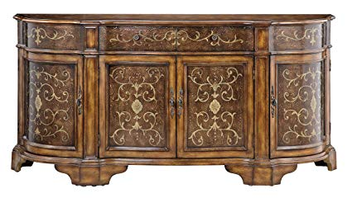
A credenza is a sideboard and is usually very elaborate with a mirror back.
The term credenza also references a type of office furniture popular in the 20th century which holds file drawers and provides space for the storage of supplies. In fact, the traditional credenza would more often be referenced as a buffet or sideboard today, while the more modern use of the term references office-related pieces made to coordinate with a desk.
C. Types of Desks
1. Vargueno/ Bargueno
Vargueno, Spanish bargueño, wooden cabinet of mixed Spanish and Oriental origin that first appeared in Europe in the late Middle Ages and became a common article of furniture in the Spanish colonial empire from the late 16th century onward. Its major component is a chest with a drop front. The interior is divided into an intricate arrangement of drawers and recesses for holding jewels, documents, and other valuables. The drawers and recesses are often inlaid with ivory, silver, or gold and are occasionally stained in bright colours. The exterior is elaborately mounted at the corners and elsewhere in iron or silver, and the front is secured by a heavy padlock or conventional lock.
Originally, the base was another chest divided into two cupboards, but later versions usually stand on a support of baluster legs spanned by intricate arcading after French and Italian Renaissance prototypes. The design of the vargueno was later copied by practitioners of the revived Spanish Colonial style in the United States.
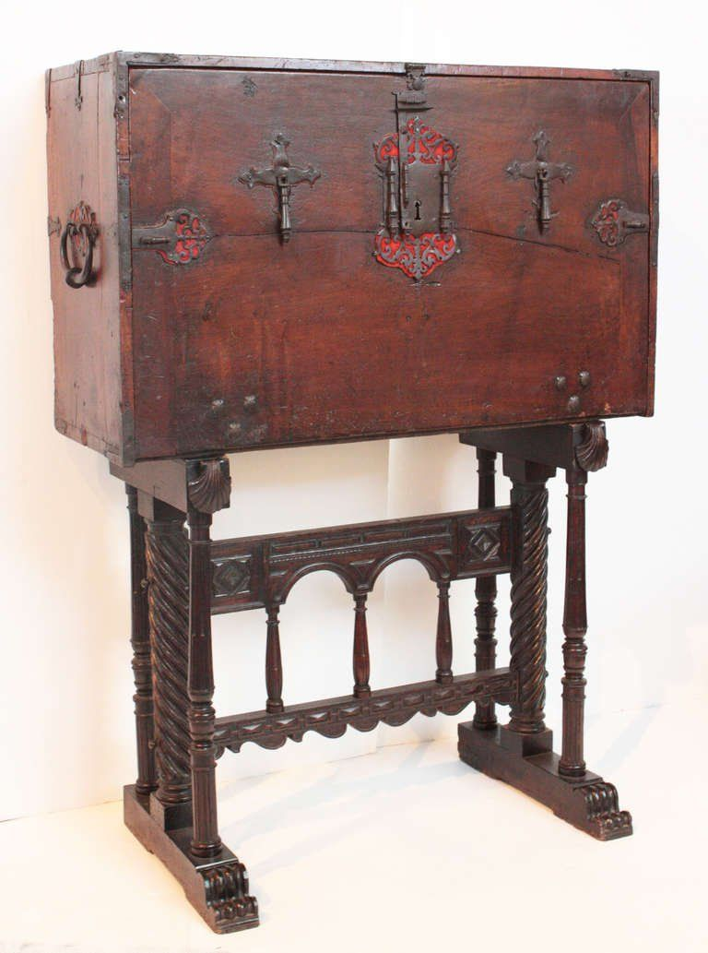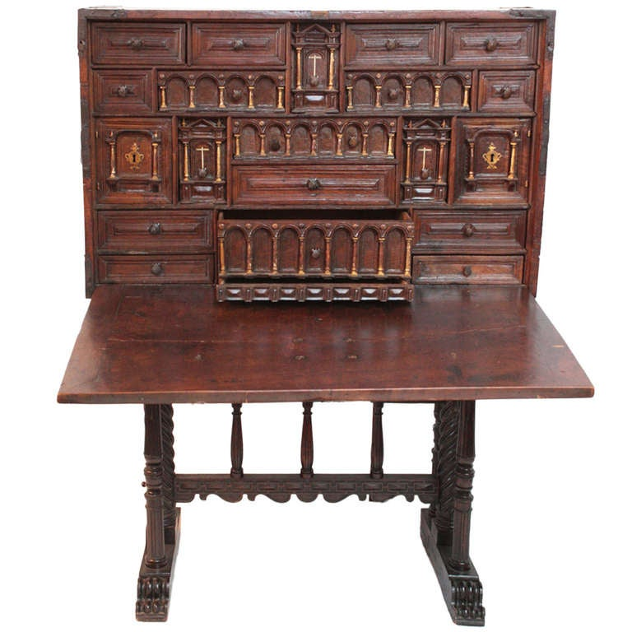

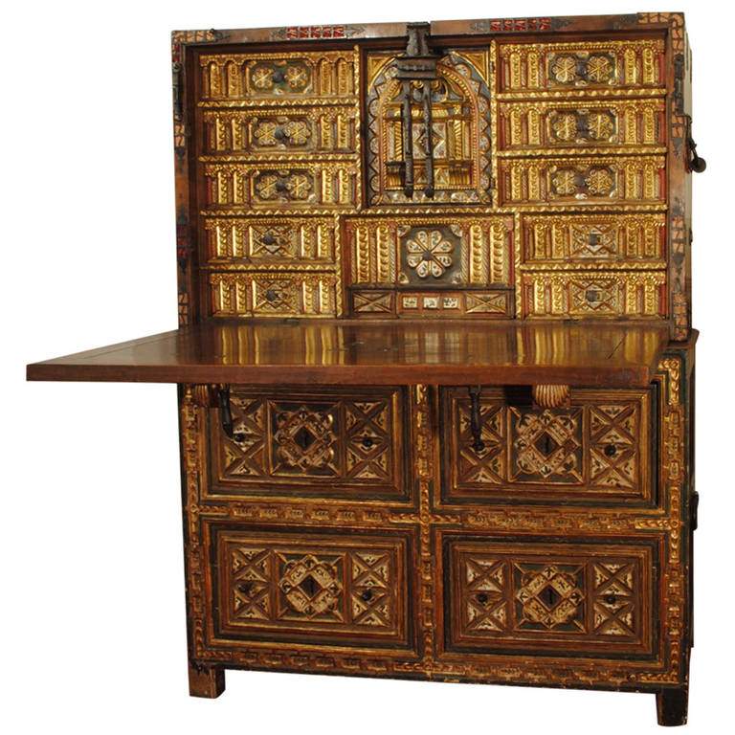
Spanish Vargueno
A form of portable desk made up of two chests. Usually with drawers on the bottom one with a hinged desk surface on the top one. The interior of the desk is equipped with small drawers, pigeonholes, etc., for storing papers and supplies. Has also been used for sewing or as a jewel chest.
2. Bonheur du jour
Bonheur du jour, small, dainty writing table, introduced in the 1760s, which became one of the most popular varieties of French 18th-century furniture. A block of storage compartments, set along the back of the top and often partly enclosed, incorporates a drawer, cupboards, and shelves and is sometimes topped by a decorative brass or ormolu gallery. High slender legs are often joined by a shelf that acts as a stretcher, and the frieze (decorative horizontal band) contains a drawer. Some bonheurs du jour are fitted with toilet accessories.
The finest examples are decorated with intricate marquetry veneers and are mounted with ormolu and sometimes with plaques of Sèvres porcelain. The earliest oval forms represent some of the finest examples of the transition between the curved lines of the Louis XV styleand the more severe, straight lines of the Louis XVI style.
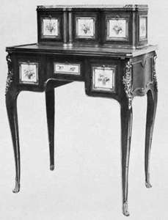
A type of lady’s writing desk. It is always very light and graceful, with a decorated back, since it often did not stand against the wall but was moved about the room. Its special characteristic is a raised back, which may form a little cabinet or a nest of drawers, or open shelves, which may be fitted with a mirror. Beneath the writing surface there is usually a single drawer, often fitted for toiletries or writing supplies.
3. Carrel
Carrel, cubicle or study for reading and literary work; the word is derived from the Middle English carole, “round dance,” or “carol.” The term originally referred to carrels in the north cloister walk of a Benedictine monastery and today designates study cubicles in libraries. Carrels are first recorded in the 13th century at Westminster Abbey, London, though they probably existed from the late years of the 12th century.
The carrels in the cloister of Gloucester cathedral (formerly Benedictine Abbey of St. Peter) represent the most complete series of carrels in existence. Built as an integral part of the cloister in 1381–1412, there are 20 of them, two to each bay, divided by short partition walls, lighted by the cloister windows, and roofed at the level of the window transoms. Each originally contained a desk.
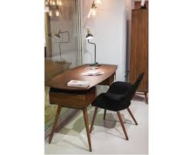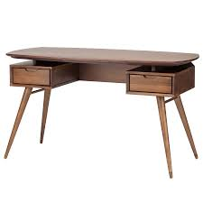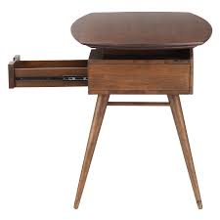

4. Davenport Desk or Ship Captain's Desk
Davenport, in modern usage, a large upholstered settee, but in the 18th century a compact desk having deep drawers on the right side and dummy drawer fronts on the left side. The sloping top of the davenport concealed a fitted well, the front of which protruded beyond the drawers and was supported by a pair of columns on a base, or plinth. The back of the writing area was normally flat and might be protected on three sides by a pierced brass gallery.
Some versions of the early davenport were fitted with a writing slide that extended the writing area at the front or side. The first desk of this type was made by the English firm of Gillow for a Captain Davenport in the late 18th century.
The Davenport is a type of small case desk, with a slanted and/or pull-out top and a row of drawers down one or both sides. Some have one side of working drawers and one side of faux drawers. Many also have small front drawers, cubbyholes, hidden compartments released by a knob in one of the drawers, or pop-up galleries.
The Davenport dates from the 1790s, developed by a British furniture-making firm named Gillows (also known as Gillow & Co.). Its name derives from the client it was made for, a Captain Davenport. Because of this military connection, and the desk's compact size and multiple compartments, furniture historians theorize the piece was originally intended to be used on a ship, or on military campaigns. They are sometimes referenced, in fact, as a ship captain's desk.
However, the Davenport became popular on dry land in the 19th century, in homes throughout England and the United States. Originally a simple chest of drawers with a swivel top, it grew increasingly ornate, with pilasters or cabriole legs in front. It traditionally rests on bun feet, often with castors to make it portable from room to room.

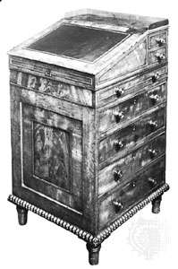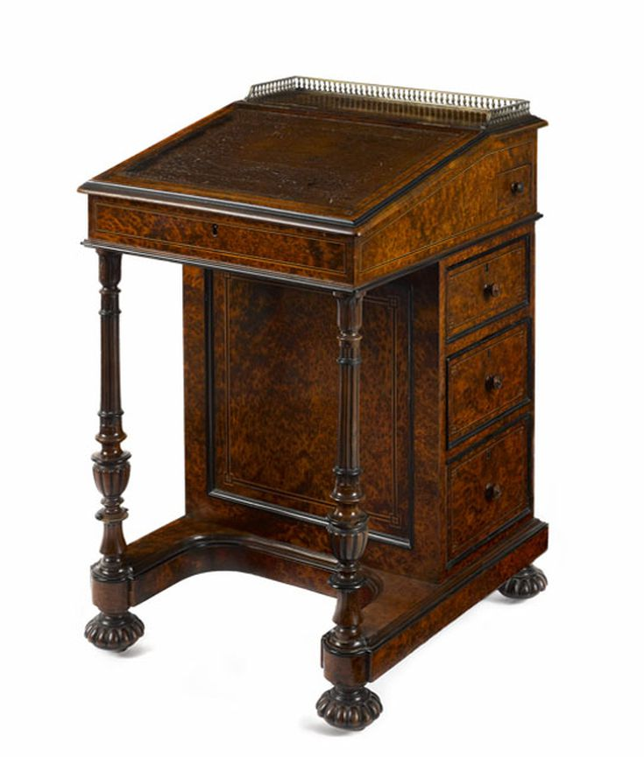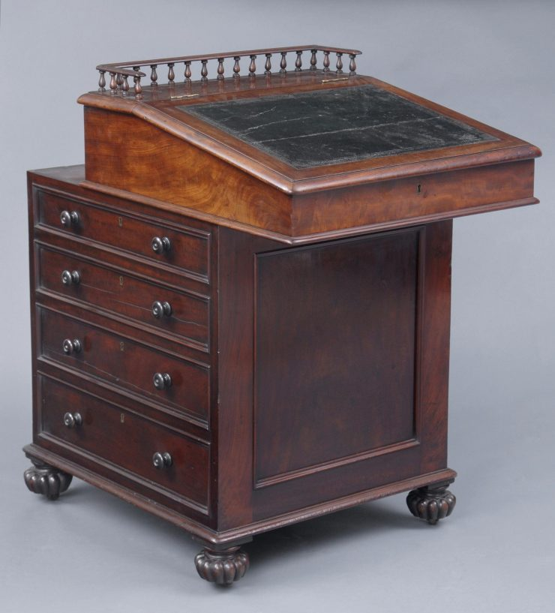
A small desk with inclined lifting desktop attached with hinges to the back of the body. Lifting the desktop accesses a large compartment with storage space for paper and other writing implements, and smaller spaces in the forms of small drawers and pigeonholes. The Davenport has drawers on one of its sides, which are sometimes concealed by a panel.
5. Lectern
Lectern, originally a pedestal-based reading desk with a slanted top used for supporting liturgical books—such as Bibles, missals, and breviaries at religious services; later, a stand that supports a speaker’s books and notes. In early Christian times, lecterns, then known as ambos, were incorporated into the structure of the sanctuary—one on the north side of the choir for reading the Epistle, the other at the south for reading the Gospel.
The rise of monasticism, with its more elaborate rituals and heavier prayer books, stimulated the demand for a mobile lectern that could be moved about the sanctuary according to need. Usually made of wood, though occasionally of metal, the lectern lent itself to elaborate decorative treatment. The desklike structure was largely superseded in the later Middle Ages by an eagle, the back of whose outstretched wings provided support for a book; this type of lectern has maintained its popularity in ecclesiastical circles ever since. As the Reformation tended to favour congregation-orientated services, the lectern was moved into the body of the church. The Gothic Revival stimulated the production of lecterns in the 19th century, when they were often used to embellish the domestic interior. The modern secular lectern is usually a tall, narrow desk with a sloping top and a ledge to hold a dictionary, book, or other papers while its user reads or lectures from a standing position.
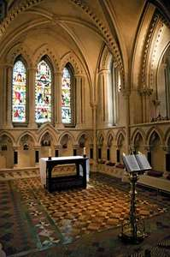
6. Prie-dieu
Prie-dieu, praying desk for one individual with a knee bench close to the floor and a vertical panel supporting an armrest, below which there is usually a shelf for prayer books and the like. The knee rest and arm support are often upholstered.
First used by the higher clergy during religious services in the early European Middle Ages, the prie-dieu became popular in the 19th century owing to the Gothic Revival and to a pietistic passion for family prayers. During this period their secular use was extended by the introduction of prie-dieu (or devotional) chairs, which followed the general shape of the purely religious version but extended the knee rest to form a low seat.
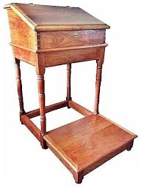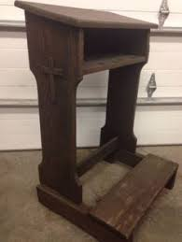
7. Rolltop desk
Rolltop desk, desk with a sliding roll top, or tambour, that encloses the working surface of the upper part and can be locked. The portion of the desk that gives the form its name is constructed of narrow slats of wood glued to some flexible material, the slats running along slides or grooves fitted into the upper edges of the desk.
First introduced into England from France in the late 18th century, the rolltop desk had become a standard piece of office equipment by the end of the 19th century and was mass-produced in large quantities. Its popularity waned, however, with the development of Bauhaus-inspired modernist furniture, only to reappear in the 1960s with George Nelson’s“action office” and again in the 1980s as a “country antique.”
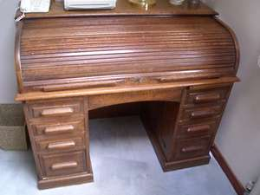
A beautiful piece of furniture with a series of stacked compartments, shelves, drawers and nooks mounted on top of the work-space. The desktop surface can be covered by linked wooden slats that roll or slide through slots in the raised sides of the desk.
8. Secretary
Secretary, also called secretaire, or escritoire, a writing desk fitted with drawers, one of which can be pulled out and the front lowered to provide a flat writing surface. There are many variations to this basic design. Early versions, which appeared in France in the first half of the 18th century, were made in one piece divided into two sections. The lower section consisted of a cupboard compartment closed in by solid or sliding doors that sometimes concealed a set of drawers; in some cases, however, the drawers were open to view. The upper section included a drop front that, when lowered, provided the writing surface and revealed an inner section fitted with various receptacles (such as pigeonholes, drawers, and recesses) for ink, paper, documents, and the like. Although this type persisted, a number of variations occurred, such as the addition of mirror doors above the upper, drop-front section and, later, the insertion of a space in the lower part of the secretary to accommodate the knees of the writer, the drawers being divided into two sections on either side of the arched recess.
Although the secretary was designed to satisfy a variety of needs, by the early 19th century the designs were becoming lighter and more elegant. The solid lower section was now frequently replaced by legs—sometimes, in the more fanciful flights of Regency designers, carved to simulate those of animals—and the unit took on the appearance of a table rather than a chest. The upper portion of these secretaries was often provided with a tambour top, which concealed drawers and pigeonholes. A tendency to use elaborate decorations of ormolu and other metals emphasizes a concept of the secretary that was to dominate in the 19th century: that it was essentially a feminine article of furniture, intended for the boudoir rather than the library. The result of this concept, especially in the period of the Second Empire in France, was that the secretary became a luxury object. In the 20th century the form tends to survive only in reproduction form, though some of its principles have been incorporated into fitted furniture units of various kinds.
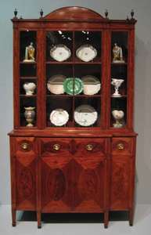

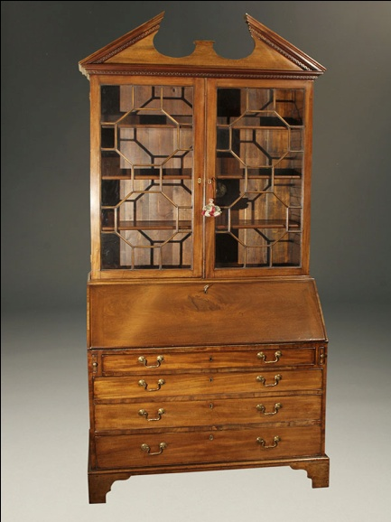

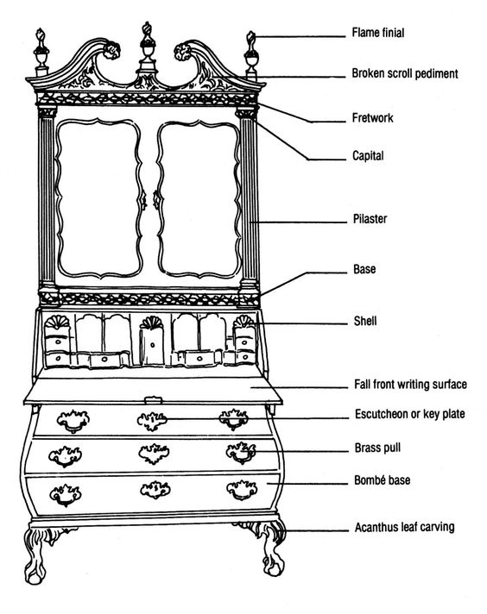
The term secretary describes a section in a piece of case furniture that serves as a desk. It is usually hidden behind a panel, which can be flat or slanted, that folds out to serve as a writing surface. This usually reveals a series of slots and small drawers to hold mail, writing materials, and a variety of desk implements. In some cases, the writing surface may slide out of a hidden compartment or appear to be a drawer until it is pulled out to reveal a writing surface.
The term is used to describe a complete piece of furniture as well. The secretary section of the piece sits permanently attached to station of drawers and may be topped with a bookcase. Doors enclosing the bookcase area can be fitted with glass panels, hold mirrors, or be made completely of wood. Drawers can encompass the width of the piece, or be in two smaller stations with a kneehole (see example above) between them.
Since the earliest versions made in France in the first half of the 18th century, there have been many variations of the secretary in styles ranging from Federal period to Rococo. While those heavy, one-piece versions with drawers and bookcases come to mind most often, by the early 19th century lighter secretaries with legs satisfied consumers wanting a bit more elegance in furniture design.
9. Bureau Mazarin
A 17th-century desk form and the earliest predecessor of the pedestal desk. It differs from it by having only two tiers of drawers or three tiers of rather small drawers under the desktop surface, followed by eight legs supporting the whole. Has cross braces between the legs, forming two Xs or two Hs on each side. Usually a kneehole desk, in that it is meant to be used sideways, with one knee only beneath the work surface. The rest of the space next to the knee often served as a lockable storage space.
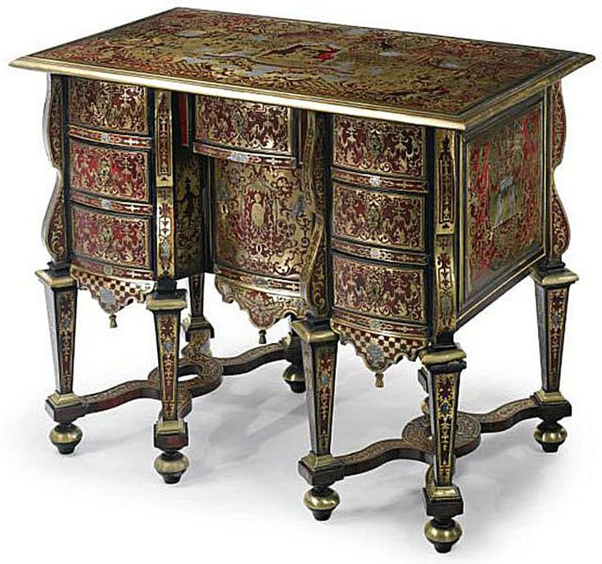
The Bureau Mazarin is an early type of kneehole desk dating from the 1660s, with two or three tiers of drawers on each side, a small central drawer and a drawer in the kneehole space as well. It usually has eight (but sometimes four) turned legs resting on toupie feet, connected with X-stretchers or H-stretchers.
Developed in France, and associated with Louis XIV-style furniture, the Bureau Mazarin was usually quite ornate and lavishly adorned with Boulle marquetry. The name, which literally means "Mazarin's desk" is a 19th-century term, referring to Cardinal Jules Mazarin, who ruled as Louis' regent from 1642-1661
10. Butler's Desk
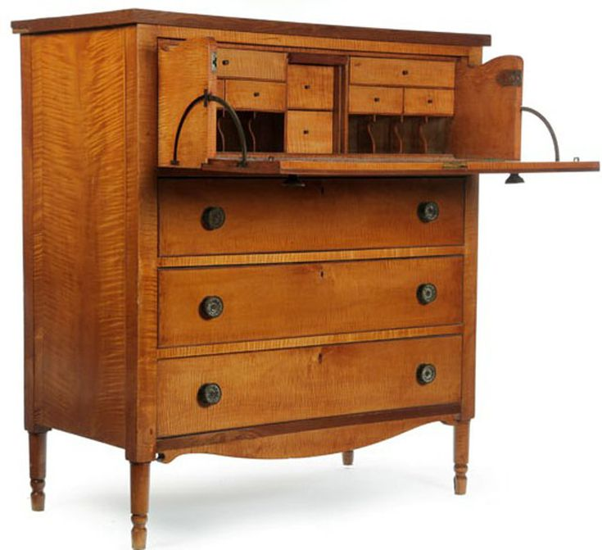
A piece of furniture designed for those in service to fine English houses to keep documents and records. It was eminently practical and based on the ever-growing needs of persons in service. The earliest form was a high desk for use by a standing person. It had many drawers of different size and had locks on both the drop front and individual drawers. Many of these desks would have a secret compartment reserved for any important documents that were entrusted to the head butler by the master.
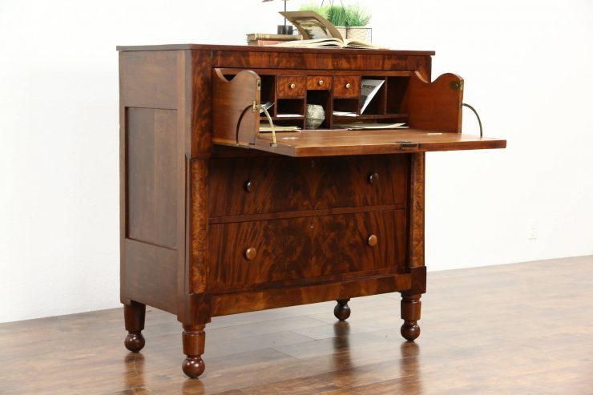
Often referenced as a butler's chest, this is a type of drop-front desk, fairly short and compact but substantial and square in shape. The interior contains several small drawers, cubbyholes and letter slots surrounding a central door. Some models also have two exterior compartments flanking the fall front. The lower half usually has three to four drawers or, occasionally, shelves behind two doors.
Dating from the late 18th century, and continuing in popularity for the next 100 years, this desk usually reflects predominant furniture styles of the period in details such as the feet or ornamentation. Sometimes referenced as a butler's chest since, when closed, it resembles a chest of drawers.
While fairly plain - as befitting a utilitarian piece of furniture - butler's desks often had fashionable decorative details. Those made during the second half of the 19th century, for example, might have had a spindled galley typical of the popular Eastlake style.
11. Cheveret
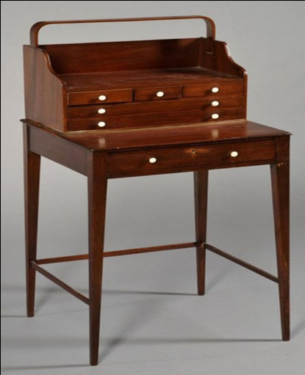
An antique desk of very small size which features a single drawer under the writing surface. It is also written with an “S”: Sheveret. Some variations are much taller and have one or two shelves built between the legs, under the main drawer and are meant to be used standing up.
The Cheveret is a variety of small, delicate stand or desk, specifically of the type commonly referred to as a "ladies writing desk." Distinguished by the multi-drawered setback chest or bookcase on the top, the smaller piece has a handle and is usually detachable while the main surface typically has a drawer underneath and often a fold-out or pull-out shelf.
The legs on a Cheveret can be straight, saber style, or tapering, and are sometimes connected with a lower shelf as well. Though probably originating in France, Cheverets further developed in England in the latter half of the 18th century, representing the vogue for light, portable furniture. They continued to be popular into the Regency period, until the 1830s.

12. Escritoire/Slant Top
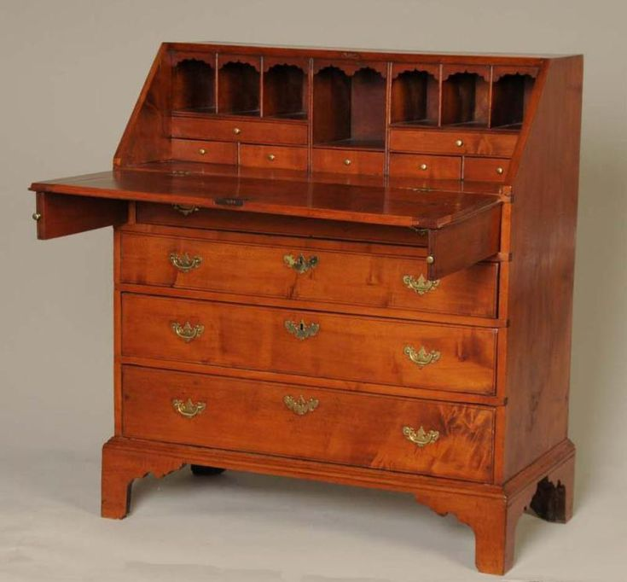
Basically a secretary desk without the massive bookcase on top of it. Downside: all writing material must be removed from the desktop before closing the top.
An escritoire is a type of case furniture, usually a low desk with a slant top. When open, this sloping lid forms a surface for writing or reading (the name derives from the French word "écrire", meaning "to write.")
Developed in the early 18th century, the escritoire grew out of - and the term may still apply to - a writing box or small cabinet with a drop-front and drawers or shelves dating from the Middle Ages, most likely from Spain.
13. Fall-Front Desk
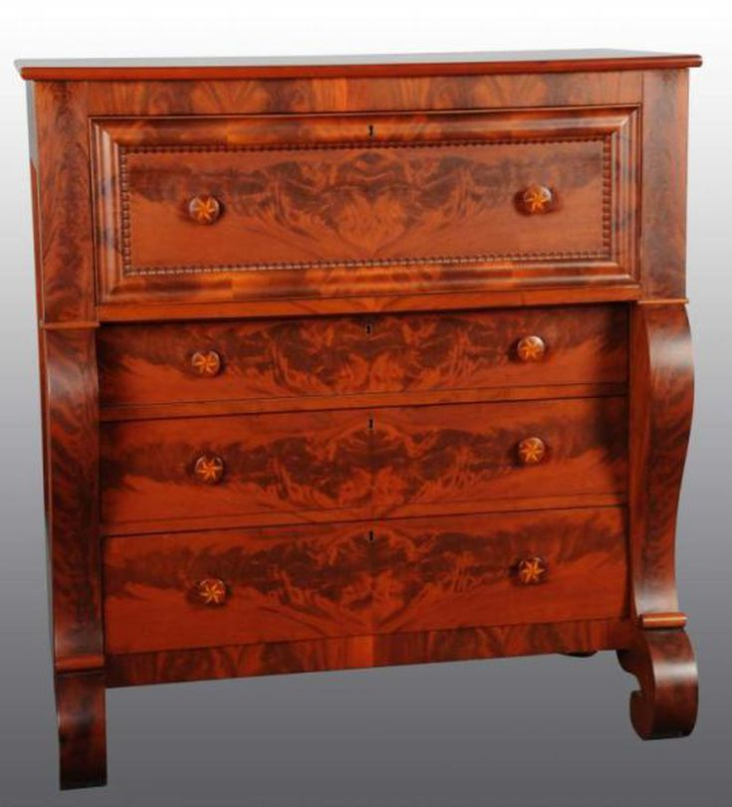
This popular type of desk, also known as a drop-front, originated in Spain in the 16th century as the vargueño. Since then it's been incorporated into many different desk styles, including the Butler's desk pictured.
Can be considered the cousin of the secretary desk – both have a main working surface or desktop which does double duty as a cover to seal up papers and other items located in small shelves or small drawers placed one on top of the other in front of the user. Thus, all working papers, documents and other items have to be stored before the desk is closed. Unlike the secretary desk, the fall front desk’s desktop panel is in a perfectly vertical position when in its closed position. Often, there are no additional shelves or drawers above the section which is enclosed by the desktop.
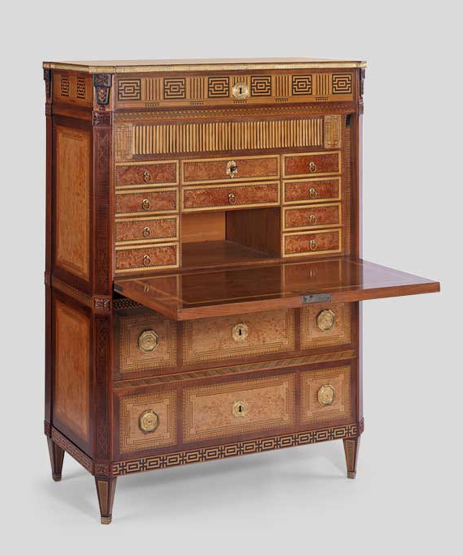

14. Kneehole Desk
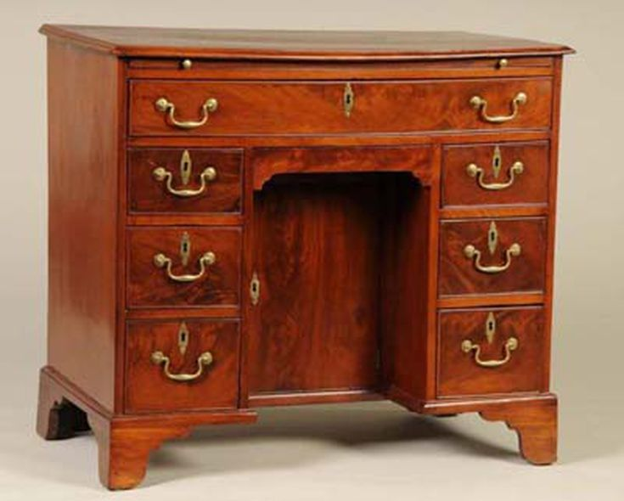
This type of flat-topped desk, first made in England in the early 1700s, features a flat top supported by two banks of drawers or cabinets separated by a space for the legs of the person using the desk. It has been manufactured in many different styles since its introduction and is still popular with companies producing Colonial reproductions.
15. Partner's Desk
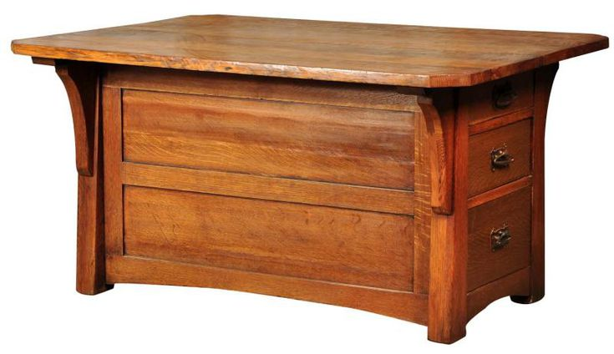
This antique desk style, popular from the late 1800s through the early 1900s, is said to have originated in England. Two-sided desks such as these were often used by bankers who wished to work together for convenience. They are the same on each side allowing individuals to face one another. Since they are essentially office furniture, they are usually heavy and well-made from quality woods such as mahogany or oak. Some examples have leather tops as well.
16. Slant-Front Desk
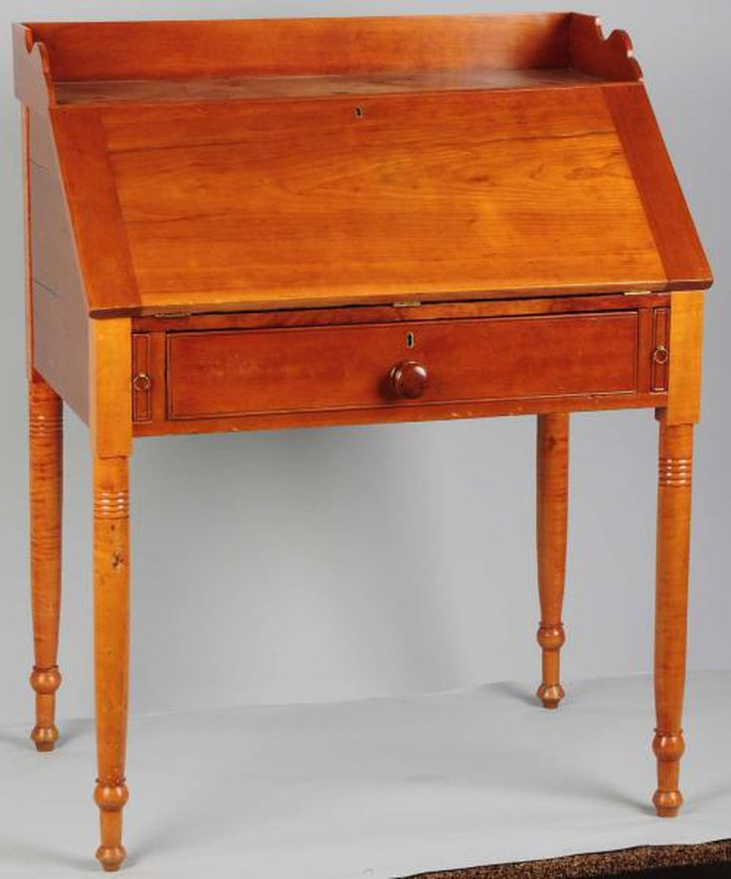
Slant-Front desks have evolved over time, with the first examples having hinges at the top. Many different types and styles have been made with slanted tops since then, including a number of those shown with this feature.
17. Wooton Desk
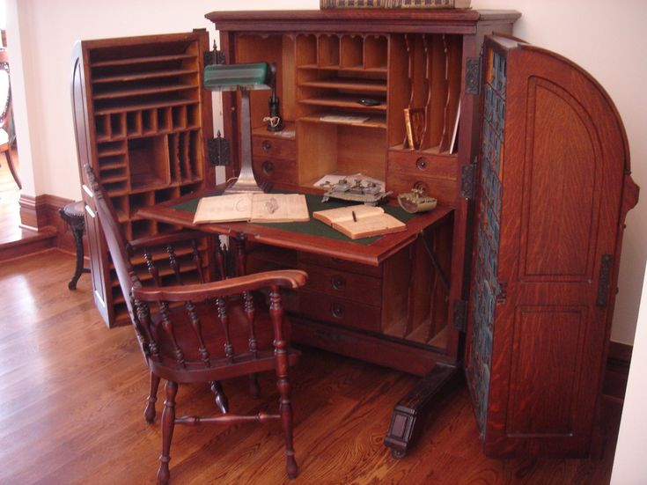
This coveted Victorian desk style was the executive's choice when it was first introduced. In fact, it was deemed "The King of Desks."
Today collectors relish finding these marvelous pieces more as curiosities and conversation starters than for their usefulness.
18. Fire Screen Desk
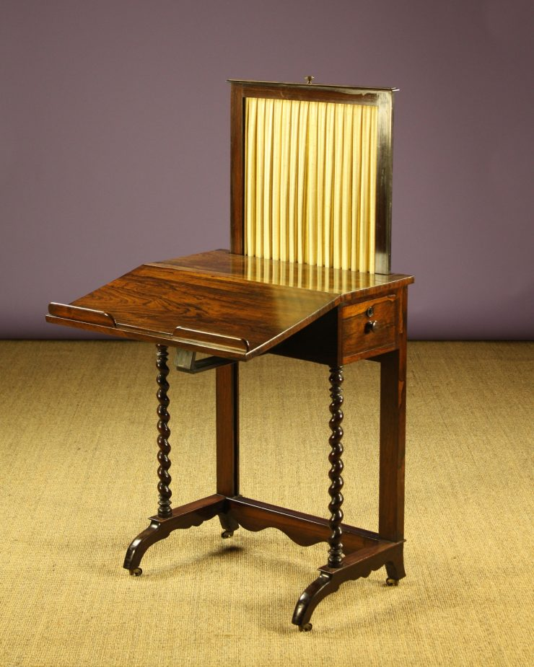
A very small antique desk meant to be placed in front of a fireplace to keep a user’s feet warm while he or she was stationary while writing. Was very popular in prosperous homes in Europe during the 18th century and slowly disappeared during the 19th, with the gradual introduction of stoves and central heating.
19. Liseuse Desk
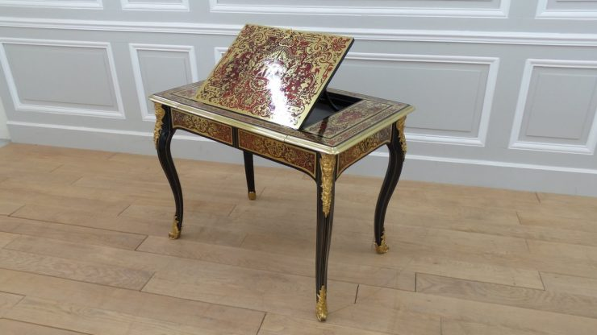
A medium-sized writing table with a small hinged panel in the middle which can spring up by the aid of a mechanism or be propped up at a desired angle to facilitate reading, or writing on its slanted surface. Many have lateral panels which swing out on both sides to give a larger desk surface.
20. Plantation Desk
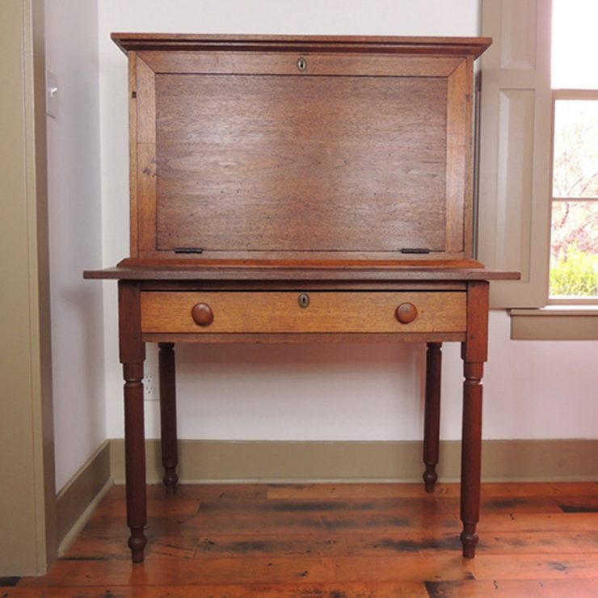
An antique desk form which is thought to have been originally used as a mail desk by postmen. It is known to have been used on Southern plantations in the United States, but it is not limited to them. Basically, the Plantation desk is a fall-front desk with a deeper stand or bottom part. The extra space or ledge of the bottom part of the desk serves as a support for the fall front, thus eliminating the need for retractable supports.
21. Secretaire En Portefeuille
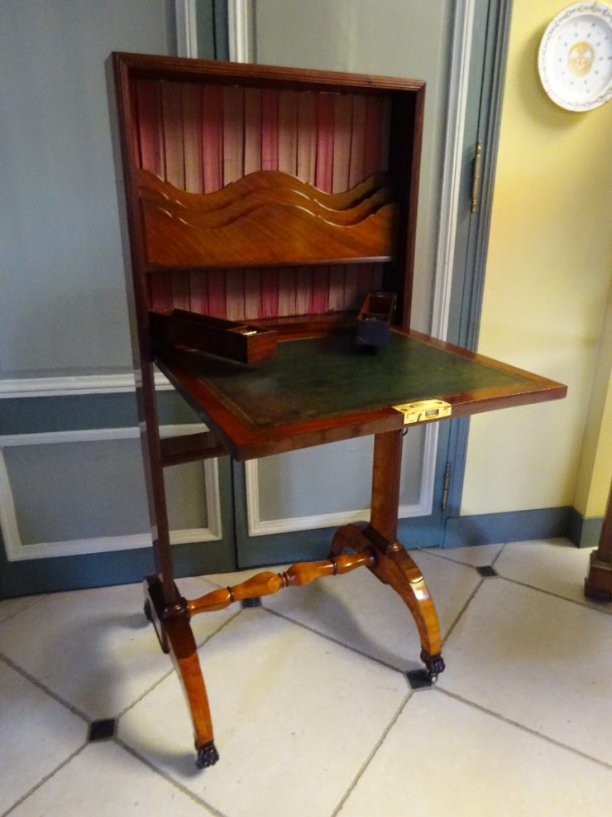
An antique type of desk which is usually mounted on rollers at the end of four jutting legs. The legs in turn support what appears as an oversize vertically mounted wooden pizza box. This is a cabinet a few inches thick, with barely enough space in it for the raised desktop surface and a few pens and sheets of paper disposed vertically. In short, the secretaire en portefeuille is much like a fall front desk which has been reduced in depth to a bare minimum.
22. Spinet Desk
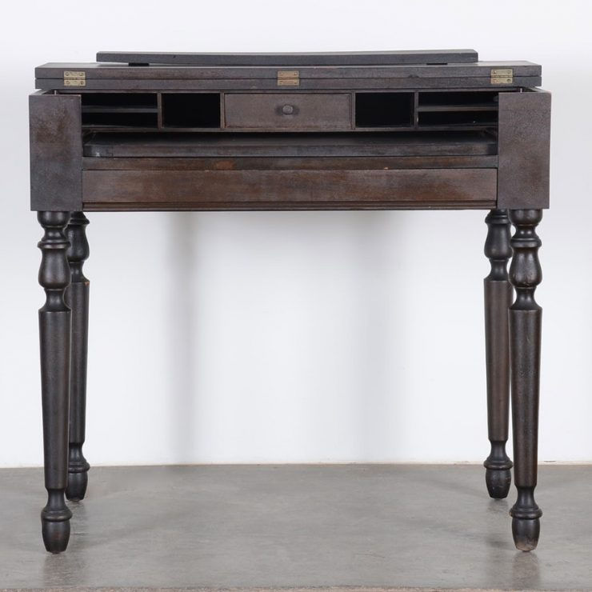
A desk shaped similar to a writing table. It is slightly higher and fitted with a single drawer under the whole length of the flat top surface. This single drawer, however, is a dummy. It is a hinged panel which is meant to be folded in, at the same time as half of the hinged top surface is folded back on to the top of the other half, revealing an inner desktop surface of normal height, with small drawers and pigeonholes in the back. In certain spinet desks the inner desktop surface can be drawn out a few inches, adding working space. The spinet desk is so named because when closed it resembles a spinet, a musical instrument of the harpsichord family.
23. Tambour Desk
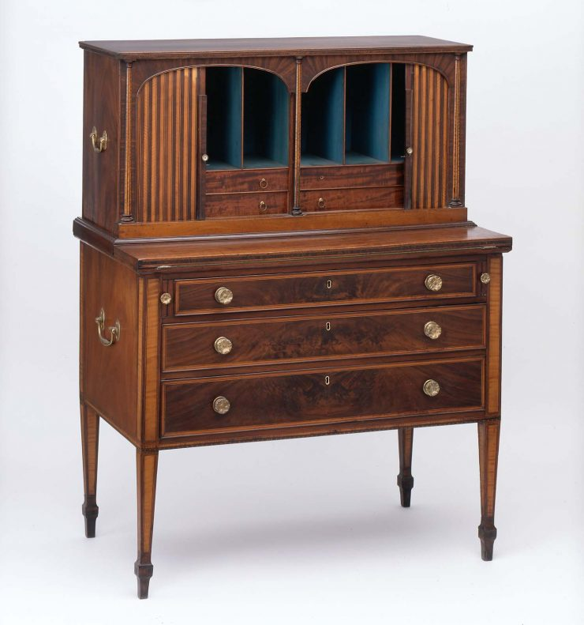
A desk with desktop-based drawers and pigeonholes, that resembles a bureau à gradin. The small drawers and nooks are covered, when required, by reeded or slatted shutters, tambours, which usually retract in the two sides, left and right. It is a flatter and “sideways” version of the roll-top desk.
24. Telephone Desk
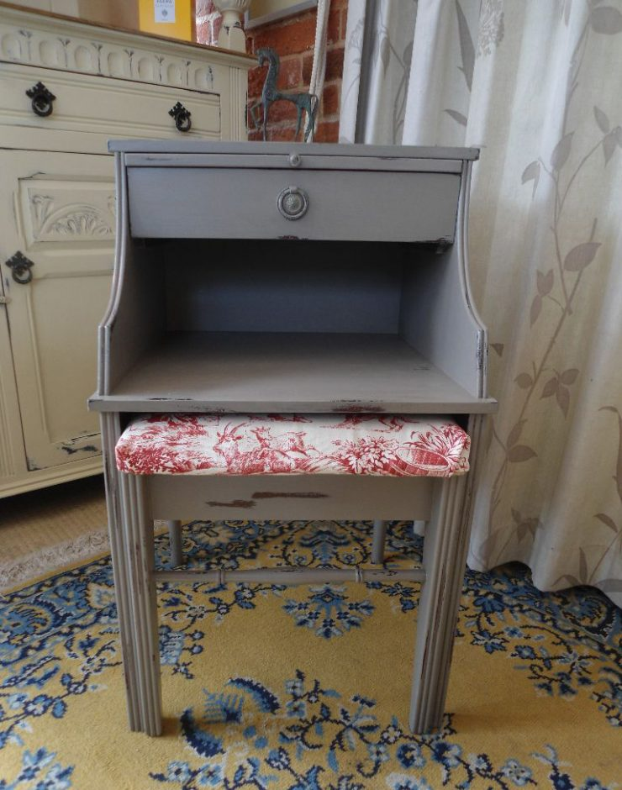
The smallest kind of fixed desk. Its traditional role is to provide a working surface barely large enough to write notes while speaking on the telephone, and in some cases to support the telephone or hold telephone books. In early generations of telephones the phone apparatus itself had a small desk built-in. This was most common in wall mounted telephones of the end of the 19th and the beginning of the 20th century.
25. Typewriter Desk
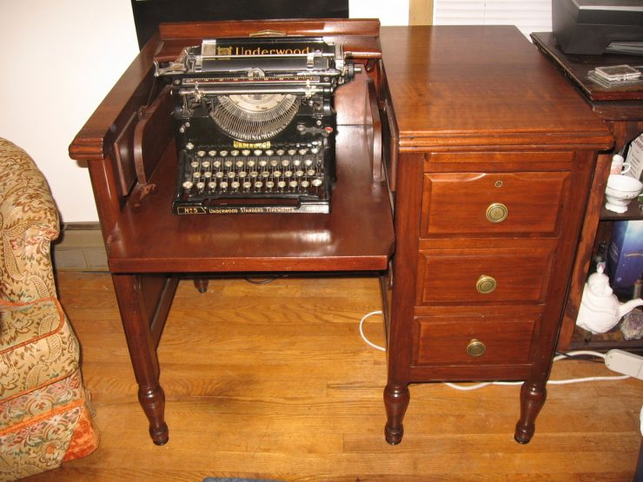
A desk meant to hold a typewriter at the proper height for the typist’s hands while still allowing a seat height that is low enough to be comfortable for the typist’s feet. This height is usually a few inches lower than the 29 inch (73.7 cm) height of the traditional desk. Without a proper typing desk or table, professional or student typists would sit on cushions or thick telephone books.
26. Mechanical Desk
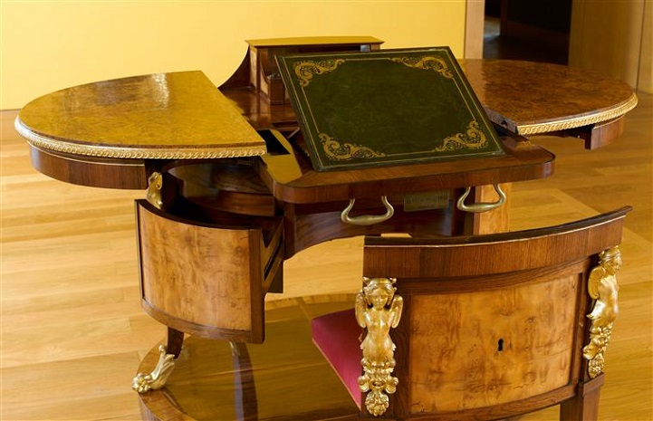

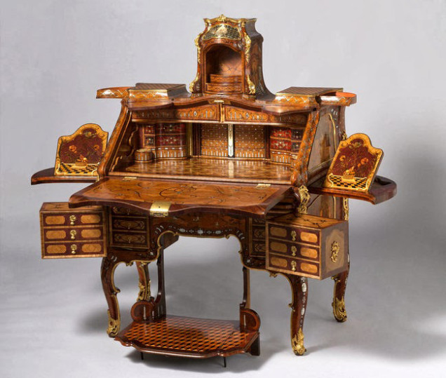
A type of desk whose name applies to a wide range of forms: At one extreme there are desks furnished with a multitude of panels that swing out while stacks of small drawers pop up when a user lowers or extracts the main writing surface or desktop from a closed position, thanks to some well placed levers and gears. At the other extreme are mechanically simple desks like the Wooton desk whose two panels open up separately by hand and whose desktop is also opened in a separate manual operation, without exploiting any gears or levers.
27. Cylinder Desk
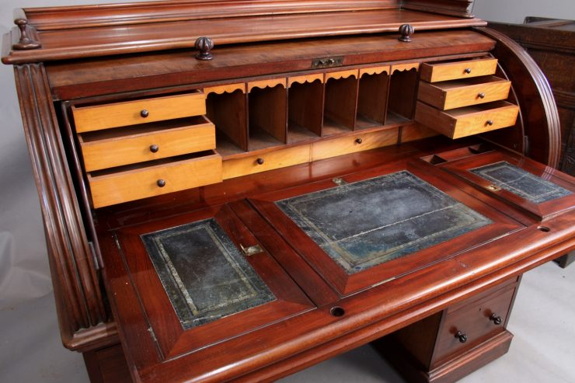
A desk that resembles a Bureau Mazarin or a writing table equipped with small stacked shelves in front of the user’s main work surface, and a revolving cylinder part that comes down to hide and lock up the working papers when the desk is not in use. It usually has a fixed work surface: the paperwork does not have to be stored before the desk is shut. Some designs, however, have the capacity to slide the desk surface out a few inches to expand the available work area.

28. Carlton House Desk
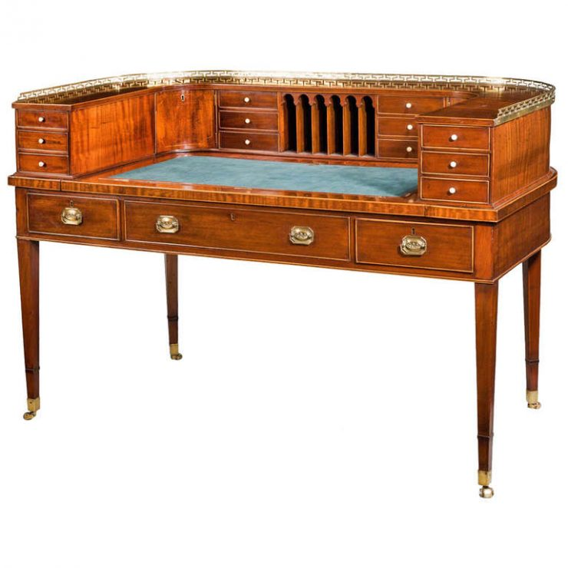
A specific antique desk type within the more general bureau à gradin form. Supposed to have been designed in the 18th century for the Prince of Wales (who later became George IV) and is named after Carlton House, which was at the time the London residence of the Prince. The desk resembles a normal writing table, but small drawers above the surface form a “U” shape around the user, instead of merely facing the user as in a typical bureau à gradin. There are usually small slopes over each of the desktop drawers at the left and right ends of the “U” shape.
29. Bureau à Gradin
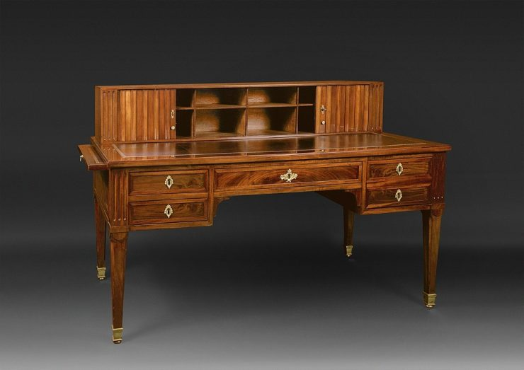
An antique desk form resembling a writing table with, in addition, one or several tiers of small drawers and pigeonholes built on part of the desktop surface.
30. Games Table
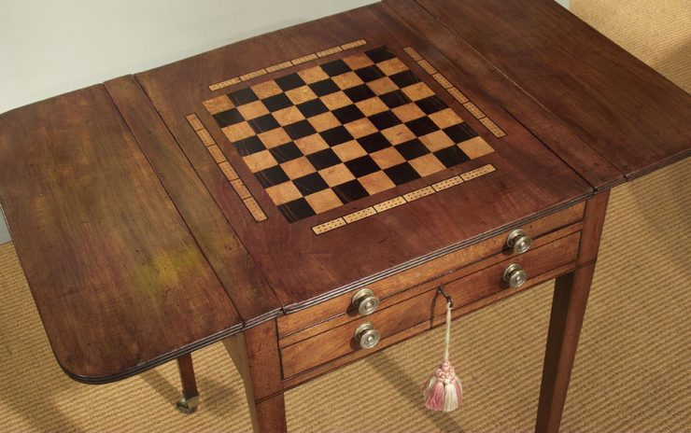
Refers to two concepts: either a designated writing table with ample storage (drawers, pigeon holes, etc.) for writing implements and paper that also has the design of a game-board (e.g. a chess board) etched onto the table top; or a designated table for playing games (often with a felt surface) that doesn’t support use as writing surface.
31. Pedestal Desk
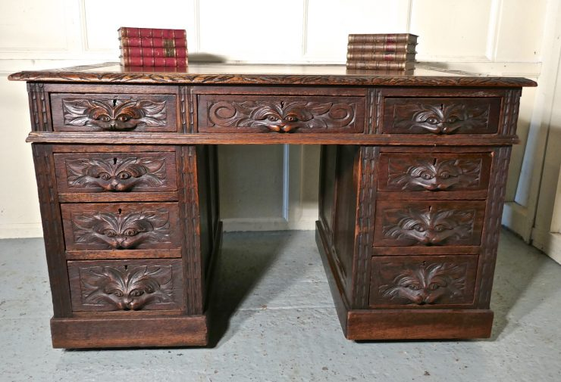
Usually a large free-standing desk made of a simple rectangular working surface resting on two pedestals or small cabinets of stacked drawers of one or two sizes, with plinths around the bases. Often, there is also a central large drawer above the legs and knees of the user.
32. Antique Pine Hutch table bench seat
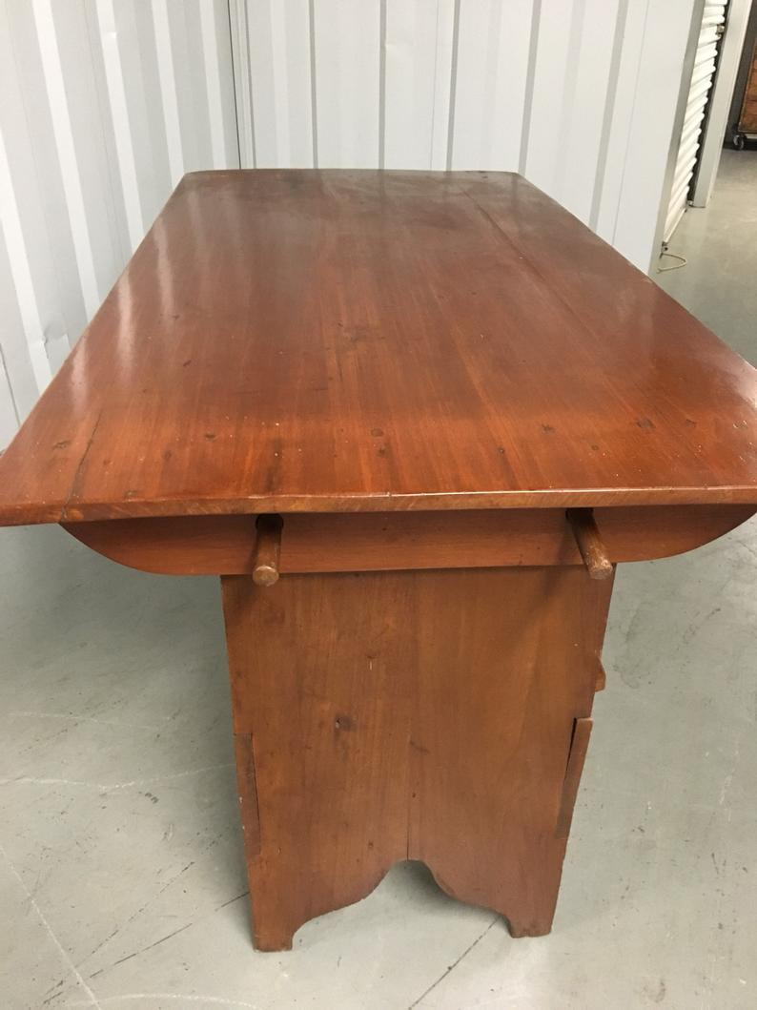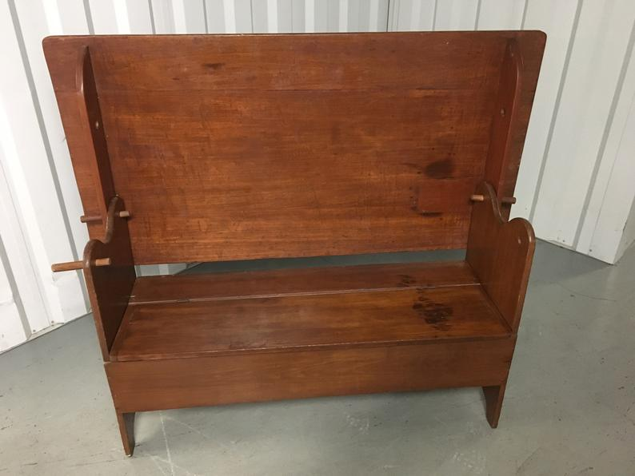

33. School Desk Chair Antique Bench

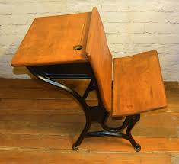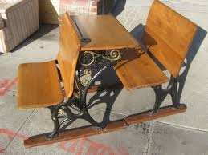

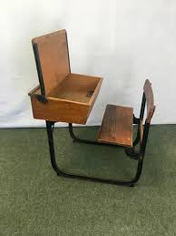
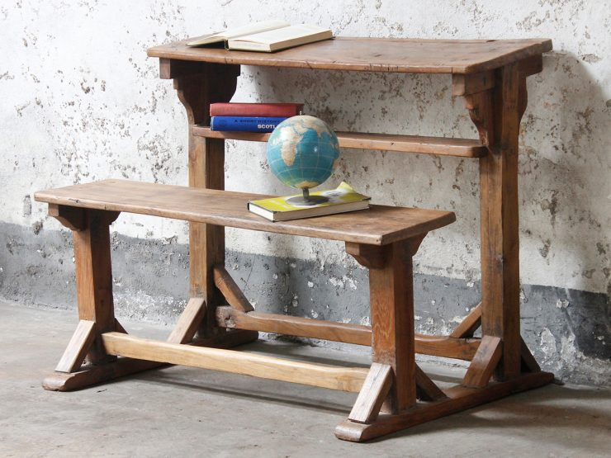

A desk combined with a small bench or a stool made in exactly the same style and material. The desk is usually not very big and meant to be placed against a wall, in a little room or a hallway. Since the stool or bench has no back it is put away completely under the desk when not in use, maximising even more the available space. The desk is usually built with a single drawer or none, and the bench can sometimes have a small storage space under its seat.
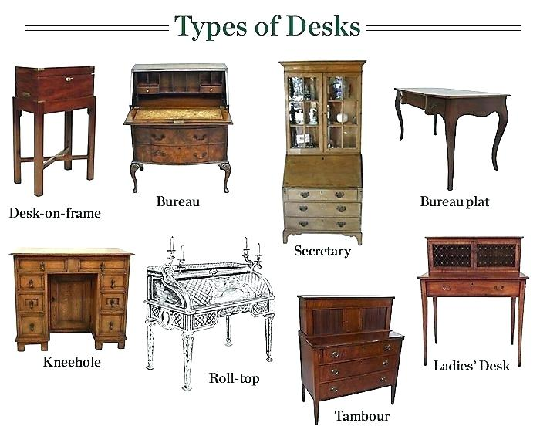
D. Bookcase
Bookcase, piece of furniture fitted with shelves, often enclosed by glass doors, to hold books. A form of bookcase was used in early times: the illuminated manuscript Codex Amiatinus (AD689–716) in Florence contains an illustration of the prophet Ezra writing in front of a cupboardwith open doors that reveal shelves holding books. Ambries (recesses in walls) were used to hold books from the earliest times. Even after the invention of printing, books were still such a rare luxury that they were commonly kept in a chest or on one shelf beneath a desk. The history of bookcases was also connected with the medieval fittings of college libraries in Britain.
In the Bodleian Library at Oxford, presses (medieval cupboards) were abandoned in favour of shelves rising to such a height that a gallery was introduced for ease of access. This system was adopted in a number of great Palladian houses in Britain in the first half of the 18th century.
Twelve oak bookcases made for the diarist Samuel Pepys are considered the earliest dated domestic examples. The first were installed in August 1666, and they are all now in the Pepys Library at Magdalene College, Cambridge.
In Italy fine built-in bookcases with pilasters, or recessed columns, sometimes with statues or carved urns on the cornice, also made their appearance in the 17th century. At the same time, the French were the first to use bookcases in which the upper part was panelled in glass instead of wood.
Breakfront
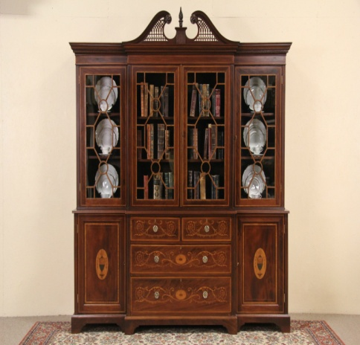

A breakfront is a piece with a front of which has one or more projecting portions.
The term breakfront describes the squared central section of a piece of case furniture (usually a bookcase or cabinet) that juts forward, ahead of two recessed sides. This is the most common use of the term. Sometimes, however, it references the entire piece of furniture.
The breakfront was developed in the latter half of the 18th century, in keeping with the angularity of emerging Neo-Classical styles, such as Louis XVI and late Chippendale, it offset the newer, relatively plain surfaces of those pieces. Designers Thomas Sheraton, George Hepplewhite, Roger Vandercruse, and Jean-Henri Riesener are known for incorporating this element in their work.

Antique Accent Table Styles and Types
1. Learning About Accent Table Styles
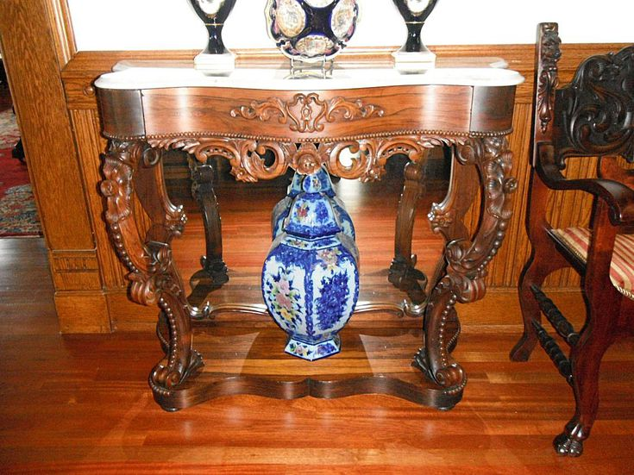
American Rococo Petticoat Console Table
Small tables used for serving food, entertaining, and decorating bare walls have been in fashion for centuries. While they've changed in form and function with different styles and practices going in and out of vogue, these useful pieces of furniture still serve their purpose.
2. Tea Tables
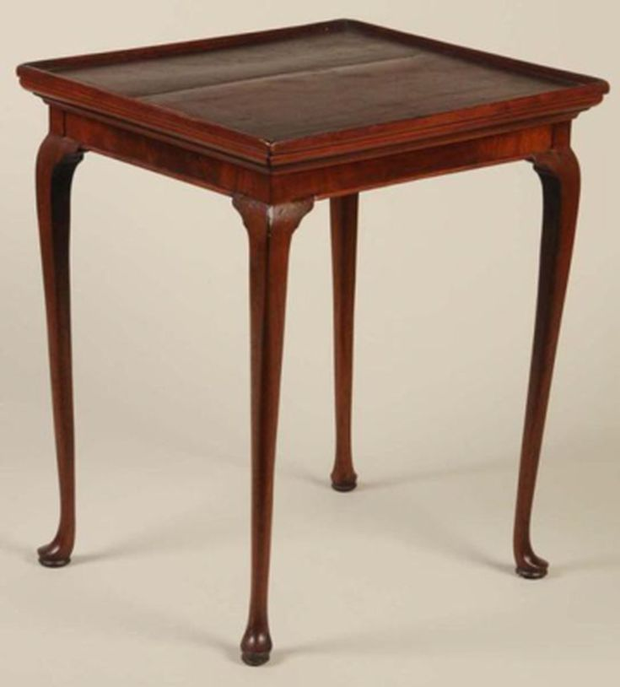
Queen Anne Style Tray Top Tea Table.
Through the 18th century right up until the 1770’s, a good number of small rectangular tables and round tilt-top tables were crafted in Colonial America, especially in Queen Anne and Chippendale styles. We usually refer to them as “tea tables,” but did they really have much to do with tea?
Service with Flair
Yes, actually, tea tables were all about tea presentation. At a time when tea prices were high and having the means to serve the beverage was considered prestigious, every well-appointed home had a tea table in its foyer, hall, or living area waiting to serve its purpose.
These tables were placed out of the way for daily use, and then moved to the middle of the room in preparation for indulgent tea parties, according to Marvin D. Schwartz’s reference American Furniture: Tables, Chairs, Sofas and Beds.
Styles, Storage, and Woods
Tea tables used during the early part of the 18th century tended to be of the rectangular variety, some of which had tray tops to aid in serving like a butler's table.
Later, round tea tables featured tilt tops so they could easily be stowed along a wall when not in use. Mahogany was widely used in tea table manufacture, but other woods such as maple were occasionally utilized as well.
The Decline of the Tea Table
When tea prices went down after the American Revolution, celebrating tea service as such a grand affair was no longer in vogue. The tea table’s popularity waned, and they were scarcely produced until Colonial revival furniture became a fad much later in history.
3. Console Table
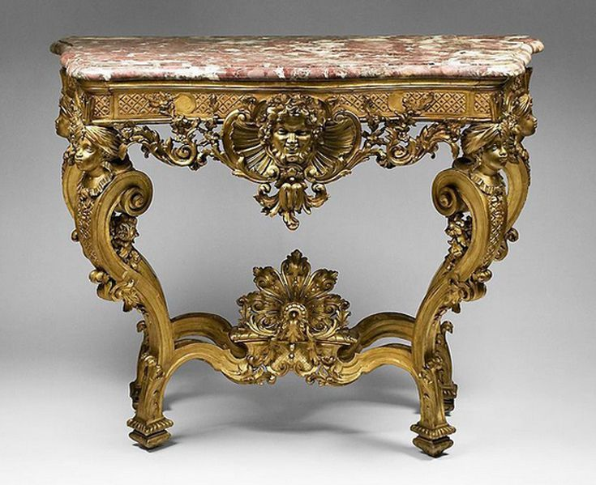
18th-century German Rococo Gilded Hand Carved Console Table With Marble Top
Originally this was a two-legged table style that was attached to a wall, usually via brackets. That early style became popular in the later 17th century, probably in France under Louis XIV, since console means bracket in French. Some are still made in this manner today.
Console table can also mean any table with at least one undecorated, straight side, which allows it be placed up against a wall, and they are usually rectangular in shape. Not always though, as in the instance of the semicircular demilune table.
Pier table is another term used interchangeably with console tables.
4. Piecrust Table
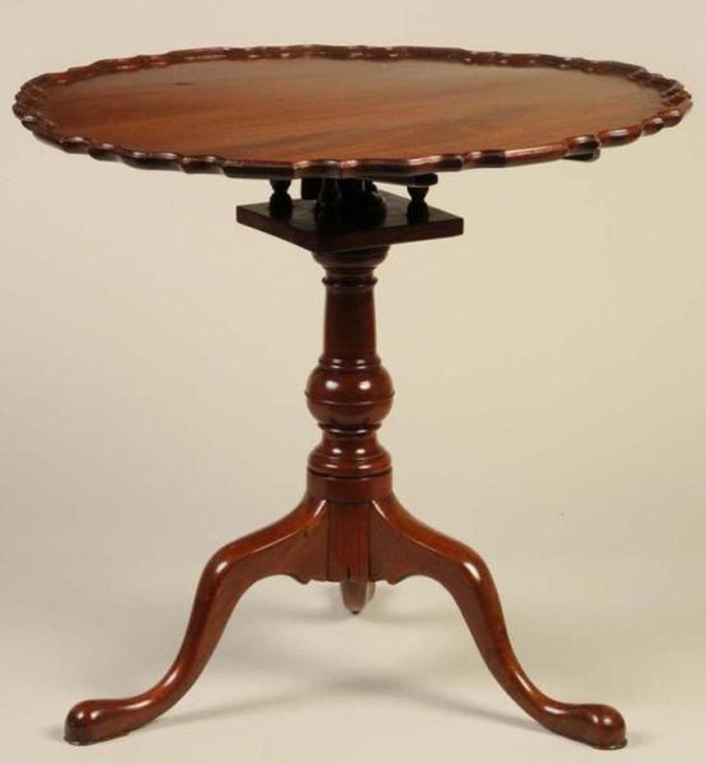
An American Chippendale piecrust table made of mahogany, mid-1700s.
This is a type of pedestal table, usually on three legs, with a round top trimmed with a raised, scalloped edge that looks like the crimped rim of a pie crust. The edging can be either carved or molded, and the top often tilts up making for easy storage against a wall in small homes.
Piecrust tables were developed in the 18th century. They were typically used for serving tea or coffee, and do qualify as a type of tea table. They are often associated with Queen Anne and Chippendale designs.
5. Butler's Table
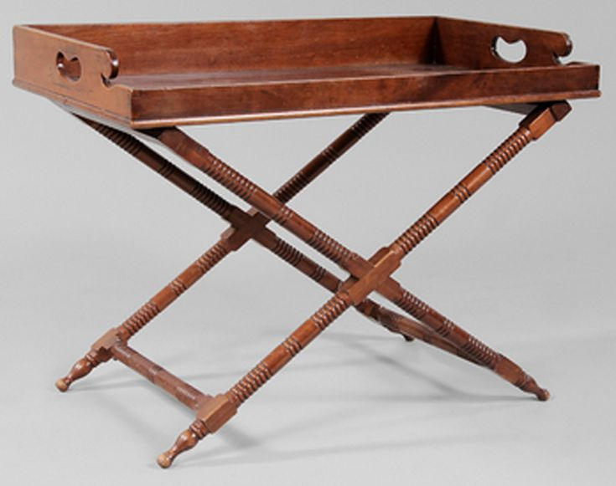
Chippendale style butler's tray-top table, late 19th/early 20th century.
This style originated as a table consisting of a tray atop a folding stand developed in England in the mid-1700s. The earliest stands consisted of two X-frames. Later examples were constructed with four legs, often joined by an X-frame. The tray can be rectangular with a fixed gallery or, in the most familiar Chippendale-style variation, have a rectangular center with prominent hinged sides that form an oval when extended. In either case, the tray sides have slots that function as handholds.
The butler's table originated as a two-piece, portable item of furniture - typical of the light, portable furniture developed in the 18th century. In the early 20th century, as part of the Colonial Revival style, manufacturers developed tables with the tray no longer detachable, but affixed to the stand or four-legged base. Knowing the difference can help you date your own butler's table.
6. Pembroke Table
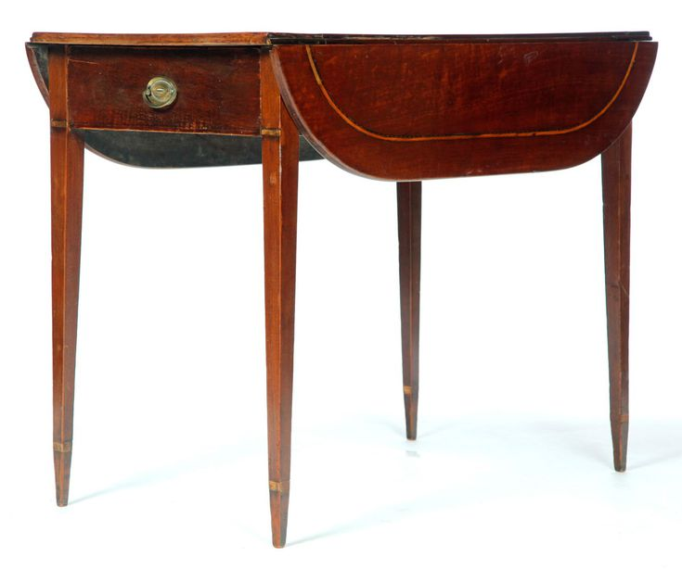
Pembroke Table in George III Style, Mahogany.
The Pembroke table is a small, light table, possessing two hinged leaves, which can be raised to increase the size, and a drawer at either end. The sides and table itself can be of various shapes, but a rectangular table with rounded or scalloped sides is the most familiar. Legs are usually slender, sometimes connected with an X-stretcher.
Dating from mid-18th century England (and possibly named for the Earl or Countess of Pembroke), it is typical of the portable furniture pieces popular at the time, and characteristic of Georgian, Neoclassical and Federal styles, including those of Chippendale, Sheraton and Hepplewhite (who called it "the most useful of this species…the long square and oval are the most fashionable" shapes).

7. Kang Table
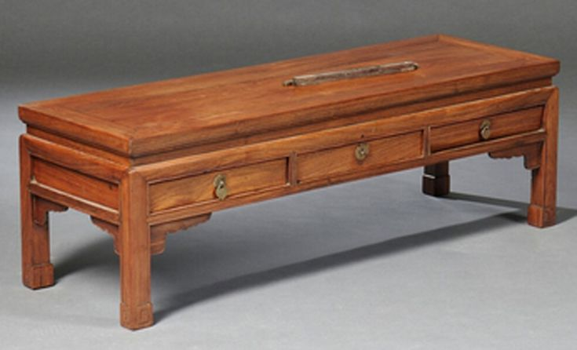
Chinese Kang Table.
This is a type of Chinese long, low table that is usually rectangular and typically with short cabriole or elephant-trunk legs and paw or claw feet (although others are used as well). They are often made of a single piece of wood.
Kang tables were originally meant to be placed on a kang, which is a raised three-walled platform used for sleeping or relaxing. Dating back to the third century BC, this style flourished in the Ming Dynasty (1368-1644) and continued into the Qing Dynasty (1644-1911), growing increasingly ornate. They are also known as Kang Ji and K'ang Chi tables.
8. Demilune Table
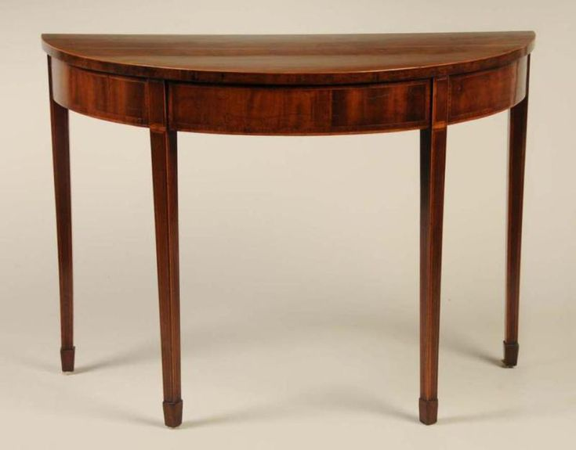
A Hepplewhite demilune mahogany table from Virginia, ca. 1790-1800.
Demilune refers to the top of a piece of furniture - usually a small table or commode - shaped like a semi-circle or a half-moon (the words demi lune translate to half-moon in French). Probably developed in France, the style came into widespread use the 1750s, and has remained popular ever since, though it's especially characteristic of Louis XVI and Neoclassical designs, such as Hepplewhite and Sheraton.
Demilune can also refer to a semi-circular table with a drop-leaf that is flipped up to form a full circle. The flat side allowed the piece to be kept against a wall, to be moved into a room when needed - a typical practice in 18th-century rooms.
9. Guéridon Table
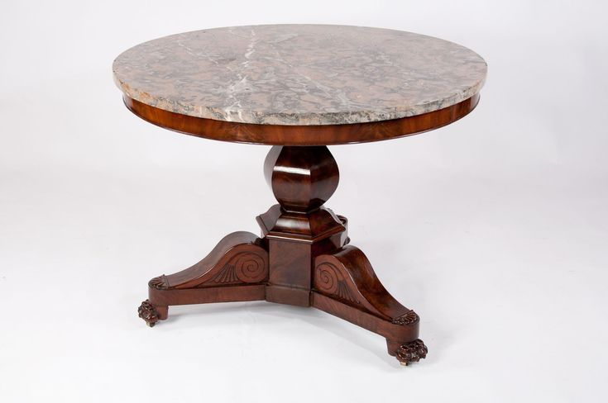
Antique French flame mahogany Gueridon Table, c. 1830.
Guéridon (pronounced gwair-ee-dawn) tables originated as candle stands in the shape of blackamoors used to hold a candelabra. They date from the 17th century and were often made in pairs. The style may have originated in Italy, but was further developed in France where it came to mean any small occasional table or pedestal with a circular top set above a tripod or column base.
Four-legged varieties developed towards the late 18th century, with a second circular tray connecting the legs in the middle. Over the centuries, guéridons changed greatly in appearance, reflecting contemporary furniture styles, but all are characterized by circular or oval tray tops.

6 Decorative Furniture Elements You've Seen But Can't Name
Antique furniture is known for decorative elements that make pieces both unique and valuable. There are a number of them that have unique names most people don’t know. Here are five terms to impress your friends with the next time you’re out antiquing together.
1. Caryatid
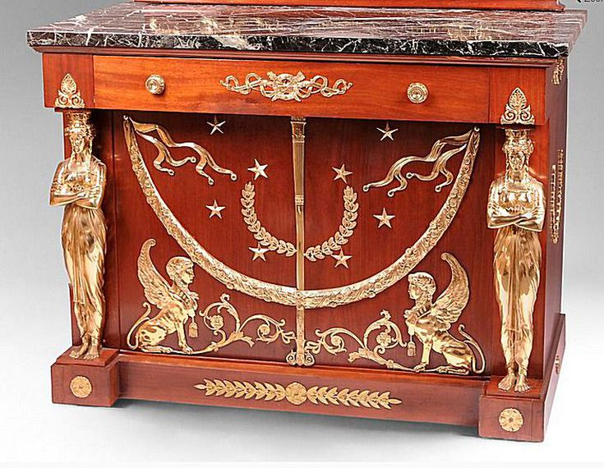
The term caryatid (pronounced care-ee-ah-tid) describes human figure, usually female, incorporated as a decorative support in furniture. The name is derived from ancient Greek architecture and named for the women of Caryae (on the losing side of a war, they were enslaved by the Greeks and forced to carry heavy burdens on their heads, according to legend.) These elements date back to the Renaissance but are also found in Empire, Regency and other ornate Neoclassical furniture styles dating to the late 18th and early 19th century. They can be used as table legs, bed posts, cabinet stands, and the like.
2. Gadrooning
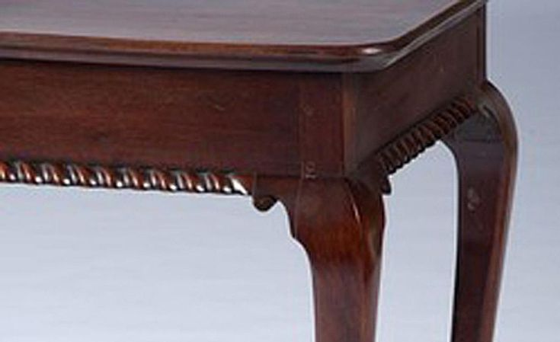
This decorative carving technique was used on surface edges, such as the bottom of a table. It has a row of fluted or reeded bands that overlap, sometimes in a rope-like way, that causes a spiral or spinning effect. It was first used on Roman furniture and then revived again during the Renaissance. It was also frequently incorporated in Neo-Classical furniture design, along with Empire, and Greek Revival pieces. The technique was used to give a sense of motion to solid pieces of furniture. Gadrooning can be found on other types of antiques made of metals, such as silver, as well.
3. Gallooning

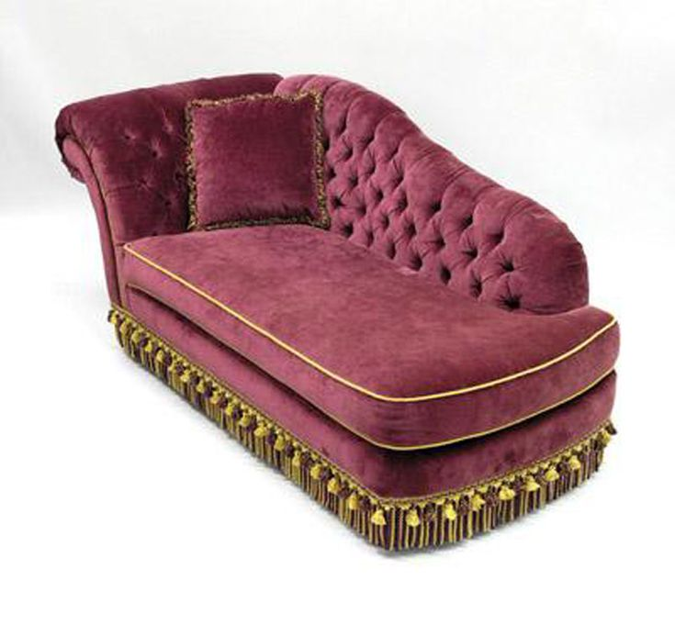
The example here has tassel gallooning surrounding the bottom of a daybed, but the term applies to any type of trimming on the edge of furniture upholstery. Gallooning can be braided or made of lace or ribbon, but it usually consists of luxurious materials like gold or silver metallic thread or silk embroidered elements. It was first used in the 17th century but is frequently seen on Baroque and late Victorian furniture examples as a final sumptuous touch to velvet and brocade upholstered pieces.
4. Marquetry
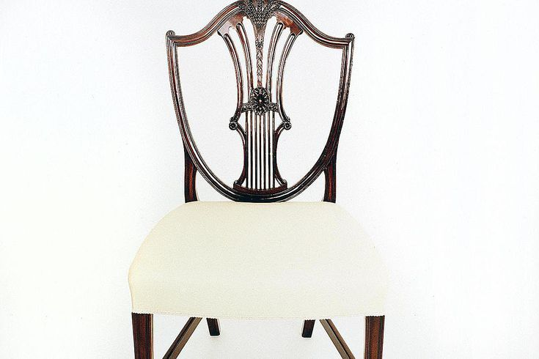
Marquetry is a decorative technique where pieces of material (such as wood, ivory, or shell) of different colors are inserted into the surface wood veneer to form intricate patterns such as scrolls or flowers. Found in furniture or decorative accessories made of wood, and was prevalent in the Federal period. Many Sheraton and Hepplewhite furniture designs employ marquetry as a decorative element.
5. Ormolu
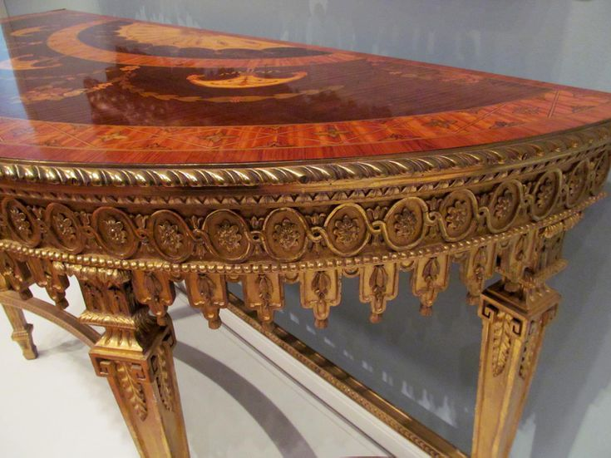
This type of embellishment is made of a metal alloy that is gilded to resemble gold, and it often acquires a beautiful and rich brass-like patina as it ages. Ormolu is applied to edges and corners as decorative ornamentation, not only in furniture but to other types of fine antiques as well. It also offers a bit of protection to corners to prevent edge wear over time. Common motifs include ribbons, bows, leaves, and florets. It was widely used in Empire and Regency pieces.
6. Tambour
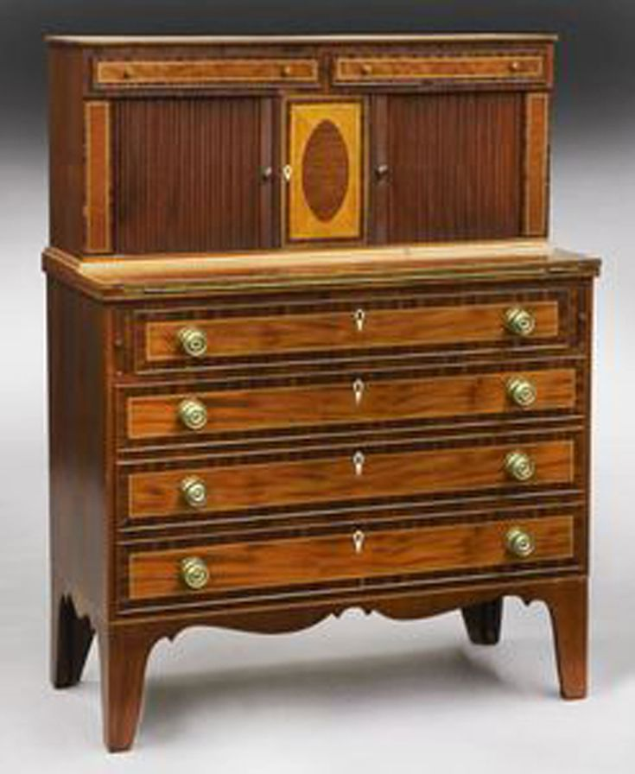
Most often found on roll top desks, a tambour is a flexible door or lid that is made of narrow wood slats. They are attached to heavy fabric like canvas, often with glue, and can be in either a horizontal or vertical orientation. The edges of the fabric are set into grooves within a piece of furniture. When it lifts or is moved from side to side, the fabric rolls around a cylinder hidden within the furniture piece.
The tambour was first used in France in the 1760s (the word is French for "drum") and incorporated into furniture designed by Hepplewhite as well. When used to conceal the inner workings of a roll-top desk, quality examples usually have two handles on either side of the tambour to help you pull down the heavy lid with ease. These retreating doors can also be found on other styles of desks (like the one shown here with a tambour on each side), case furniture like cabinets and washstands, and have also been used on lap writing desks.
5 Types of Portable, Decorative Antiques You Cannot Name
One of the best parts about researching antiques and collectibles is when you have an "aha" moment and say to yourself, “Hey, I have one of those!” This can go hand in hand with learning a new term for a familiar object.
Take a look at five small furniture pieces that you may have seen and possibly even own. Not only are they portable and functional; they're also very decorative. The stories behind each piece—from swivel mirrors to wine cabinets—are interesting and, when you learn the proper name of the piece, you'll be in the know the next time you go antiquing.
1. Canterbury
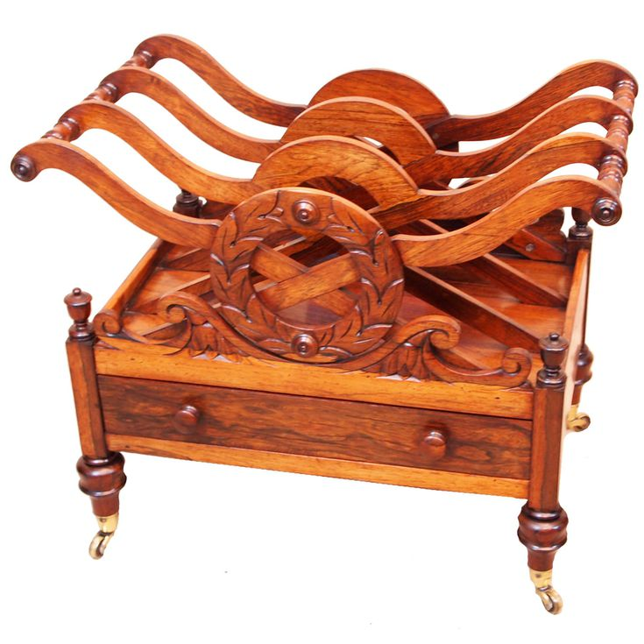
Antique Regency Rosewood Canterbury.
A Canterbury is a portable, occasional furniture piece consisting of an open-topped rack with slatted compartments for storing sheet music, music books, magazines, or newspapers.
The top rests on four legs, which are typically on casters to assist with rolling it from place to place rather than carrying it. Many times these pieces include a drawer underneath the rack, offering extra storage space.
Canterburys were developed in the 1780s in England. The style reputedly derives the name from the Archbishop of Canterbury, who commissioned one. They grew increasingly ornate throughout the 19th century.
Regency examples of the Canterbury had a simple “boat shape” with U-shaped tops on the dividing slats.
Victorian pieces often have an upper galleried shelf and panels shaped like lyres or treble clefs denoting the use for music storage.
2. Cellarette
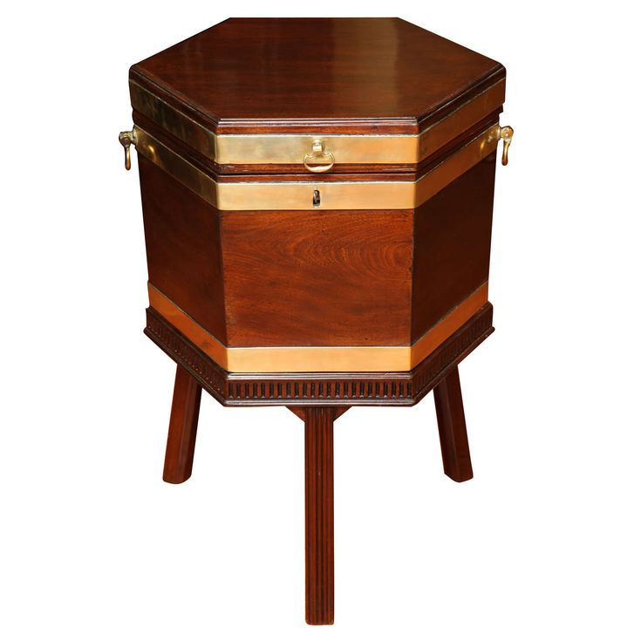
Antique George III Brass Bound Cellarette with fluted tripod base circa 1780.
A cellarette (spelled cellaret in Britain) is a hinged, portable cabinet. It is used to store wine or liquor bottles, thus the nod to the wine cellar in the name.
These pieces are traditionally made of wood and the interior is typically lined with metal or lead. Some examples are compartmentalized, and they are frequently equipped with a lock.
Cellarettes were developed around 1700, but flourished in the late 1700s and well into the 1800s. It was common to find them on display in dining rooms of the day. They could be ornately decorated or carved and came in a variety of shapes.
The earliest varieties of cellarettes resembled chests or barrels. They often stood on tall legs equipped with castors to assist with portability from room to room as needed.
Later, with the rise of Neo-Classical styles around the turn of the 18th century, sarcophagus shapes—often resting on elaborate paw feet—became more common.
In the 18th century, cellarettes progressively grew taller to accommodate taller wine bottles.
The term cellarette can also refer to a metal-lined compartment or deep tray for bottles within a sideboard, liquor cabinet, or mini-bar.
3. Cheval Mirror
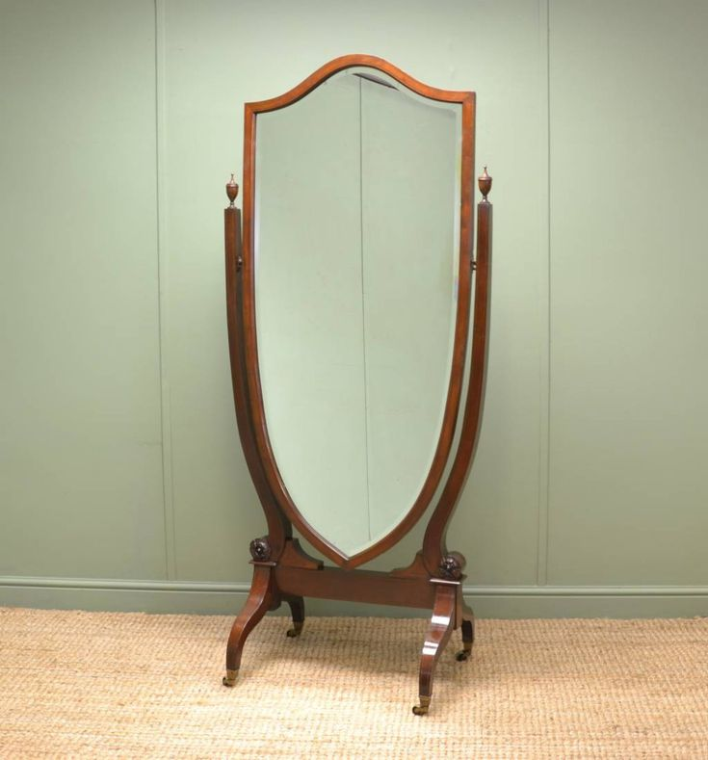
Large Victorian Inlaid Mahogany Full Length Antique Cheval Mirror, circa 1900.
The cheval (pronounced shuh-vahl) is a mirror that swivels. It is a freestanding, full-length mirror mounted between two upright posts. These traditionally rest on trestle feet and the support frame is known as a horse (the French word "cheval" actually translates to "horse"). The mirror is attached with screws, which allow it to tilt and the feet are often on casters for portability.
This mirror style was developed in the late 1700s. It is characteristic of Neo-Classical and Empire styles.
Cheval mirrors may have been named by Thomas Sheraton. He described how they may "be turned back or forward to suit the person who dresses at them," in "The Cabinet Dictionary" (1803).
This mirror style is sometimes also referenced as a cheval glass (English), Psyche (French), or a screen dressing glass.
Over time, the term cheval has come to describe any standing mirror. It's also used for smaller mirrors suspended from a frame that are part of furniture pieces such as chifforobes.
Some examples are attached to small bases that include drawers. These allow a plain table or chest of drawers to become a dressing area.
4. Taboret
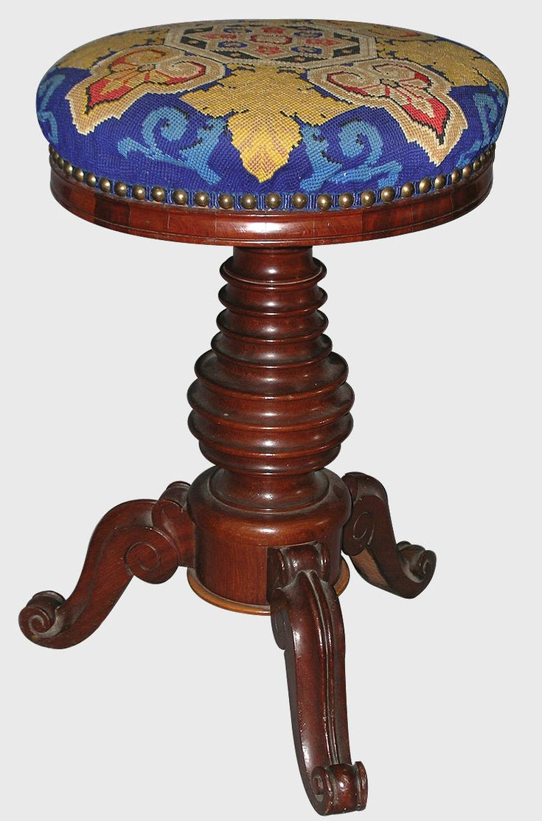
Louis-Philippe Era Mahogany Tabouret de Piano.
The taboret (sometimes spelled taboret) is a stool or side table, though it was originally a low, upholstered footstool. It stood on four legs and was round on the top, like a drum (tabour in French). The shape later became rectangular, often sitting on a curule-like base, and is highly typical of Régence and Rococo styles.
Taborets were developed in 17th-century France. In fact, in the court of Louis XIV, strict etiquette determined which courtiers could use a taboret.
These portable furniture pieces experienced a renaissance in a plainer, non-upholstered form in the Arts & Crafts movement of the late 19th century.
The term expanded to mean a stool, short side table, or even a cabinet of any shape.
5. Teapoy
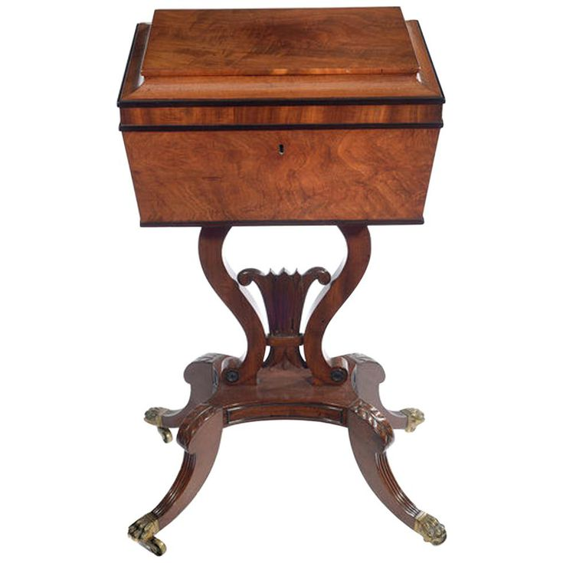
19th Century Carved Mahogany Teapoy Stamped Gillows.
,The teapoy is a small pedestal table that is used for storage. It comes equipped with a box attached to a tripod base. Usually, the box was a tea caddy, used for storing loose tea. If it was flat-topped, the teapoy could also serve as a small tea table.
Despite the teapoy's function, however, the name actually derives not from the word "tea" but from a Hindi/Persian phrase meaning "three-footed." Teapoys developed in mid-18th-century England, and many were actually made in British colonial India.
Teapoys enjoyed universal popularity into the mid-19th century, growing increasingly ornate.
Over time, the term also came to mean any stand with a box attached, even if it stood on four legs.

Antique Japanese Tansu chests
Any antique-furniture lover who believes in form following function can’t help but appreciate Japanese tansu. Meant to be portable, these ingenious storage devices were stripped down to their bare essentials – no extraneous features, not even legs, to impede their portability. Some even had wheels to make them more mobile.
But, while always functional, they still made a statement, says Dane Owen, owner of Shibui, an Asian antique store in Brooklyn, New York – “a dramatic combination of utility and beauty.” This is especially true for those made during the Meiji era (1868-1912), which is considered to be the Golden Age of tansu-making. Below you will find a tally of some of the most common tansu types along with a few rarities to seek.
As you're reading, be sure to take note that the Japanese word “tansu”, which literally means “cabinetry,” becomes “dansu” when linked with another word.
1. Step Chests (Kaidan-Dansu)
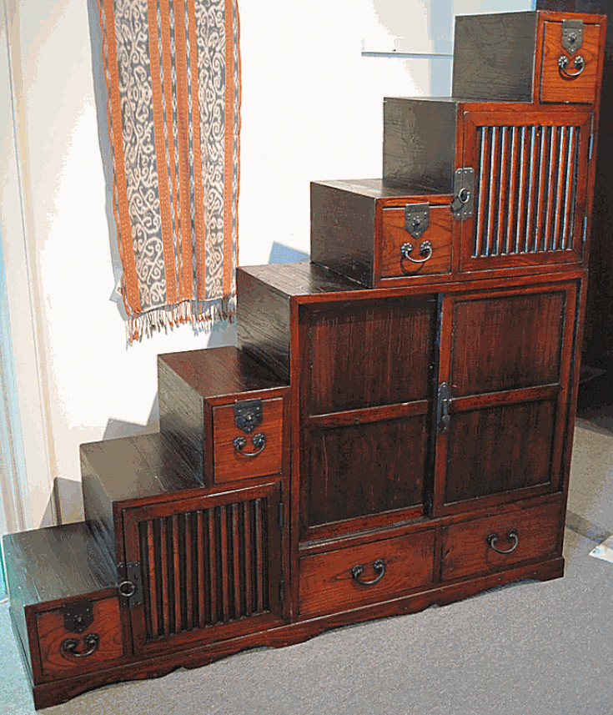
This style of chest is the one most Westerners picture when they think of tansu: the stair-step chest. A wonderful combination of architecture and furniture, it really did function as a staircase, as well as a storage unit. You can't get more functional than that.
Kaidan-dansu, the Japanese name for these types of chests, aren’t usually made of the most valuable materials – the one at left is made of sugi (cedar), a relatively inexpensive wood – but they often command high prices. This is due both to their uniqueness and their relative rarity. Everyone in a family would have a clothing chest (as shown below), Owen notes, but “How many staircases would a house have?”
2. Clothing Chests (Isho-Dansu)
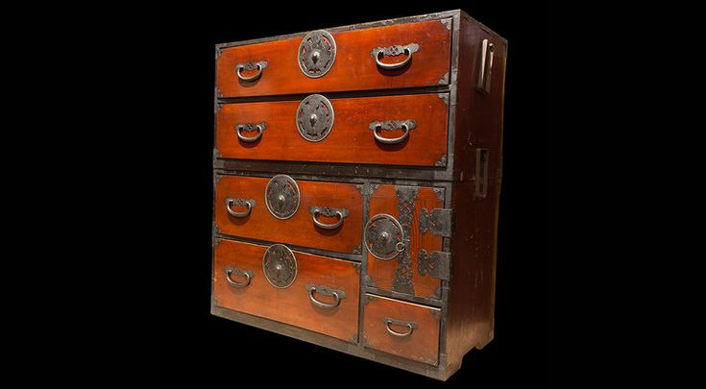
Clothing chests may be more common than kaidan shown above, but they can still be quite beautifully crafted. These pieces are usually quite colorfully lacquered and adorned with ornate iron hardware. They were popular wedding gifts in their day.
Isho-dansu came in two types. Some had single sections, like the one depicted at left. Others were double-section, which had one chest stacked upon another. The configuration of several full drawers, with a couple of small ones and perhaps a safe, is typical of isho-dansu of the Meiji era (1868-1912). This era is considered the Golden Age of tansu-making, and tansu from this period are very desirable.
3. Merchant Chests (Choba-Dansu)
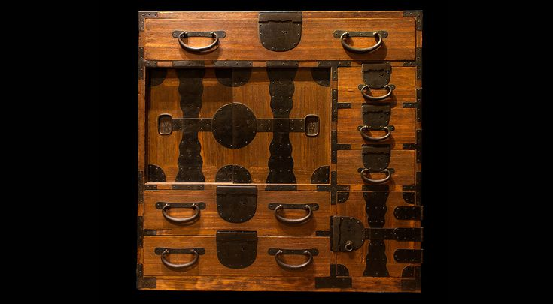
Chests for shopkeepers and businessmen were among the first tansu developed, paralleling the rise of the merchant class in Japan during the Edo period (1613-1868). No self respecting business owner would do trade without a chest of this type to store records securely.
Although a range of regional styles exists, choba-dansu are characterized by multiple compartments of varying sizes, invariably including one for ledgers – indicated by a pair of square sliding doors, Owen notes. And also – “lots of locks,” like those of forged iron on the chest at left.
See also the wheeled merchant's chest shown below, which is quite rare.
4. Kitchen Chests (Mizuya-Dansu)
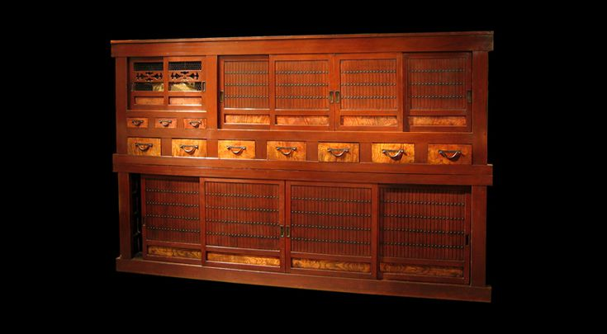
Kitchen chests, which developed in the later Edo period, were another sign of rising prosperity and the refined cooking and dining practices that accompanied it. Substantial pieces, they have large, roomy interiors and sections covered with wire, like Western pie cupboards.
Unlike other tansu, mizuya-dansu don’t have much hardware at all. They were, however, often decorated with simple, carved designs, as is the one at left. Mizuya-dansu typically have a rich, reddish-brown patina – created by cooking-fire smoke found in kitchens, Owen says.
5. Sea Chests (Funa-Dansu)
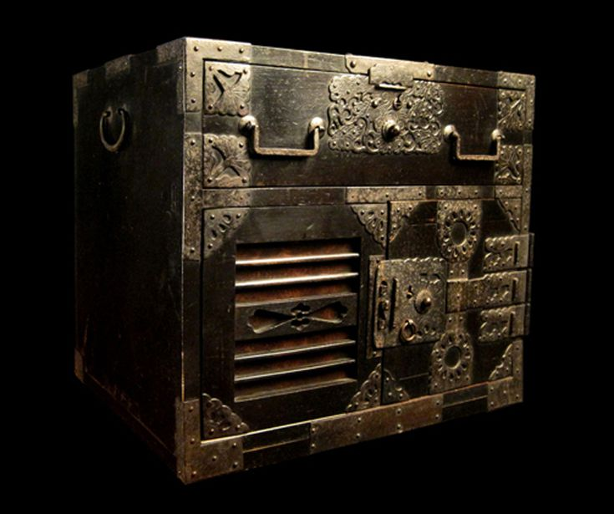
For many collectors, sea chests represent the crème de la crème of tansu. They tend to be made of the most expensive materials – keyaki wood (Japanese elm) for the exterior and hand-forged iron hardware – and of the highest craftsmanship, to ensure they’d be watertight.
Those made in Sado Island, like the one at left, are among the most valuable, according to Owen. Iron hardware was a status symbol, and the substantial amount of it on the locks and handles on this funa-dansu suggests its owner was socially prominent – or aspiring to be – and intent on traveling extensively by sea.
6. Wheeled Chests (Kuruma-Dansu)
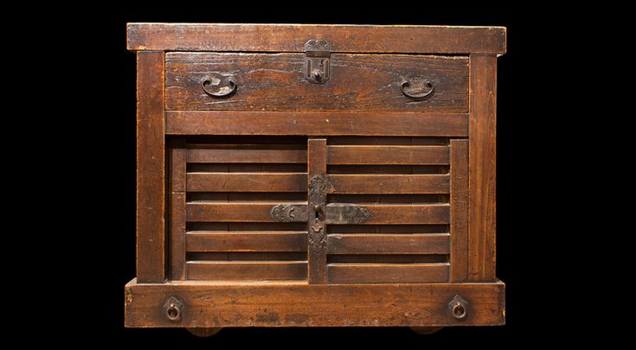
Wheeled chests were among the earliest form of tansu; references to them date as far back as 1657. Serving a variety of purposes, they’re quite large, and quite rare. The 19th-century ​kuruma-dansu at left is a merchant’s chest, made of utilitarian sugi (cedar) wood. Finding a wonderful example of Kuruma-Dansu is a holy grail piece for many fans of Japanese antiques.
Different Types of Antique Clock
Here are simple and modern antique clock designs with images. Let’s have a look in to them.
1. Solid Wood Antique Mantel Clocks:
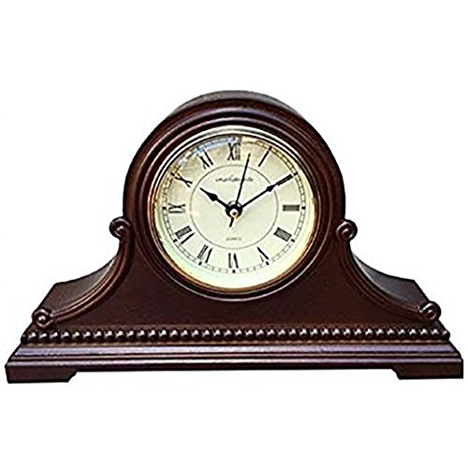
If you have more furniture inn home and planning to add more decoration then get this solid wood antique clock to make decorative statement. This is great option for tables, try this clock to gift to your dear one or this is cool gift for your grandfather too on his next upcoming birthday time.
2. Original Oak Case Antique Wall Clocks:
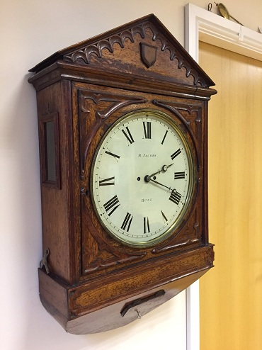
This model would definitely fit your home on the walls with no extra space covered. It also carries a perfect size to create an impression and display its elegance look. The case is made of original oak wood that would stay along your generations to come. This Antique wall clock has large proportions of 35″ tall and 20″ wide with a 14″ Dial of beveled glass door.
3. Walnut Finished Antique Grandfather Clocks:
It is the Old Antique Clock that is made with solid wood material and weighs about 22.7 kg. It is in walnut color with the model resembling grandfather type antique clocks. These clocks are with their long cases, pendulums, echoing chimes, and Roman numerals. No major assembly is required.
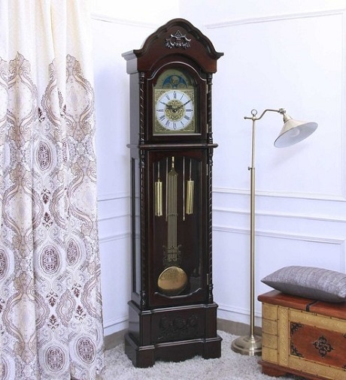
Grandfather clock, also called long case clock, tall-case clock, grandfather's clock, floor clock, tall pendulum clock (see animation) enclosed in a wooden case that stands upon the floor and is typically 1.8 to 2.3 metres (6 to 7.5 feet) in height. The name grandfather clock was adopted after the song “Grandfather’s Clock,” written in 1876 by Henry Clay Work, became popular. The first grandfather clocks featured a Classical architectural appearance, but a variety of styles have enjoyed popularity over the years. One form of early pendulum clock was wall-mounted but, because of its heavy lead weights, probably difficult to secure. It is believed that the grandfather clock was developed to support these heavier clock mechanisms.
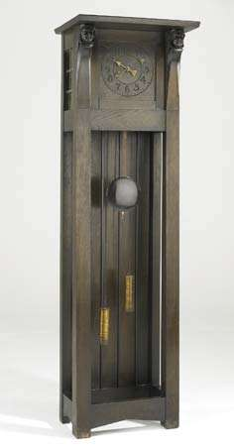
Long case
Boxwood type of clocks gets normal but shiny look for home decor. You will find wooden capital with clock hood. Get this for your room, kids will enjoy sure for this type of clock. Roman numbers are available to read easily and get old feel look for your clock.

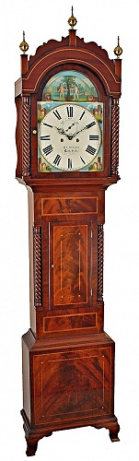
Long Case Antique Pendulum Clocks
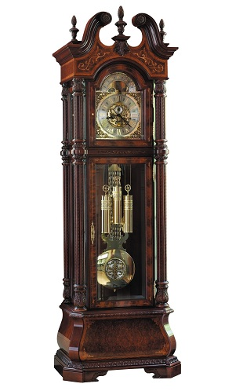
These varieties of large antique clocks are made using beech hardwoods and with a dark painted finish. It incorporates other materials such as the metals, brass and glass for the construction of other components in it. The entire pendulum set is made with brass heavy metal and is definitely an appealing one for the youngsters who mostly prefer modern concepts.
4. Ogee clock
Ogee clock, clock design that originated in the United States in the 1830s, distinguished by a case the front outer edges of which are curved into an S-shape (ogee). This shape is formed by the union of a convex and a concave line. A mass-produced variant of the shelf clock, the ogee clock stands about 30 inches (75 cm) high and is usually weight-driven. The movements were usually made of brass and were made to run for 30 hours or eight days.
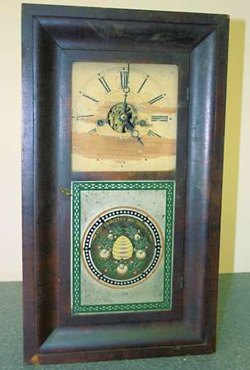
ogee clockOgee clock, 19th century.
5. Pillar and scroll shelf clock
Pillar and scroll shelf clock, wooden shelf clock mass-produced in the United States from the second decade of the 19th century onward. The rectangular case is topped by a scroll broken in the centre by an ornament such as an urn; on either side of the case is a vertical pillar topped by the same kind of ornament that breaks the scroll.
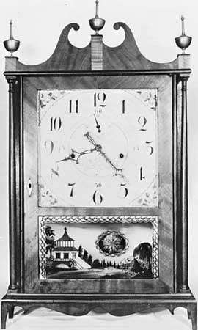
Off-centre pillar-and-scroll wooden clock by Seth Thomas, c. 1818, under license from Eli Terry; in the American Clock and Watch Museum, Bristol, Connecticut.Courtesy of the American Clock and Watch Museum, Bristol, Conn., and Kenneth D. Roberts; photograph, Edward Goodrich
These clocks usually had a 30-hour wooden movement, using oak plates, laurelwood pillars, and black cherry wood gears, though these were later supplanted by brass around 1840, when that metal became cheaper. The clocks are usually associated with the name of Eli Terry (1772–1852), who gave them their definitive form.
6. Vintage Retro 18” Antique Cuckoo Clocks:
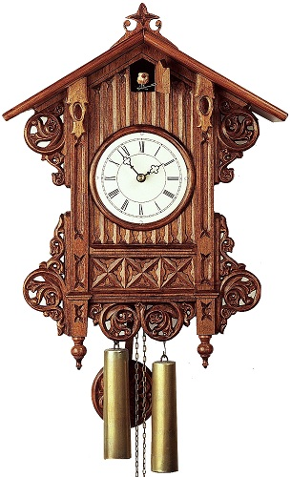
This antique wall clock is purely hand carved and it is built by the skilled craftsmen. This clock stands at 18 inches tall not including the weights and pendulum. It works with the simple technique as all other mechanical clocks. They consist of designer hands for minute and hour indications with display of Roman numerals.
7. Easily Portable Antique Carriage Clocks:
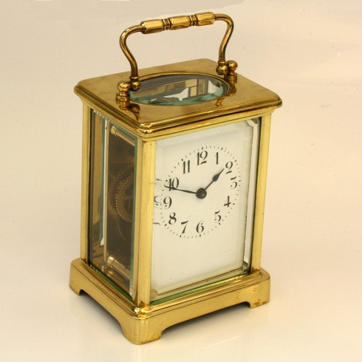
These small antique clocks have elegant and handsome look not only on a mantle shelf, but also on a desk. It measures 11cm high or 14.5cm with its handle standing up. The clock exactly measures 8cm across and 6.7cm deep with white enamel dial. The side’s panels, rear and top of the clock are glass material that allows you to view the fantabulous mechanics of the carriage clock.
8. Vintage Antique Grandmother Clock:
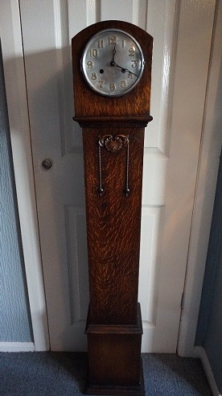
Get this wonderfully designed grandmother clock that has mechanical brass movement with brass key. It is intact with glass door along with rear inspection door. It is of chiming model and is bit heavy than normal. It measures 53 inches height x 9 inches width x 7 inches depth.
9. Act of Parliament clock
Act of Parliament clock, also called tavern clock, weight-driven wall clock with a large wooden, painted or lacquered dial. More correctly, it is called a tavern clock. Clocks of this type were displayed by innkeepers and got their name from the passage of a five-shilling duty on clocks in Great Britain, introduced in 1797 by the English prime minister William Pitt the Younger. (Many clocks were disposed of by their owners, who consequently relied more on clocks in public places, and the effect on the clock-making industry was so disastrous that the act was repealed the following year.) Actually, these clocks were first made before the mid-18th century and were in use in servants’ quarters of large houses as well as taverns.
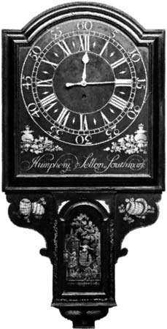
Act of Parliament clock, painted wood with gilt enrichments, English, mid-18th century; in the Victoria and Albert Museum.
10. Banjo clock
Banjo clock, type of clock, so named because its upper portion is shaped like an inverted banjo. The clock was patented by Simon Willard of Massachusetts in 1802. It has a circular dial with a narrow metal frame and a bezel for the glass, which is usually dome-shaped. The top bears a finial. Below, a narrow trunk, slightly wider at the bottom than the top, protects the weight, and at the bottom a wider compartment contains the lower part of the pendulum. Slender concave metal ornaments connect the three main parts of the clock.
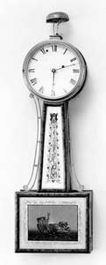
11. Bracket clock
Bracket clock, English spring-driven pendulum clock, more properly known as a table clock or spring clock. The earliest of these clocks, made for a period after 1658, were of architectural design, sometimes with pillars at the sides and a pediment on top; in later versions the pillars were omitted, the pediment was replaced with a domed top, and a carrying handle was added. The earliest were generally ebony-veneered, and later examples were ebonized (stained black). After about 1710, walnut veneers appeared on some, and mahogany cases became the norm after about 1760. Very few were ever made to go on wall brackets, and the term bracket clock first appeared in the 19th century.
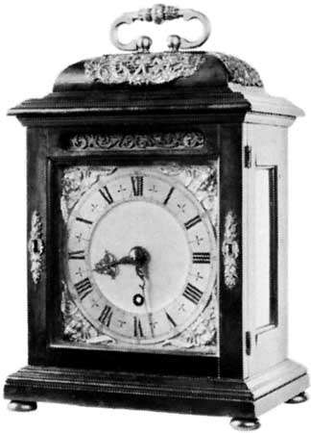
Bracket clock with dome top and carrying handle by Thomas Tompion, c. 1690; in the Victoria and Albert Museum, London
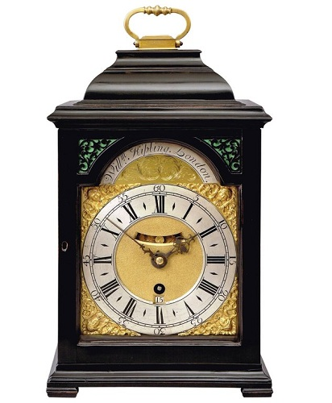
This antique style clock is with well proportioned compact ebonized inverted bell-top case. It measures W 2.54 mm x D 2.54 mm x H 34.29 cm in dimension. It has a brass handle with pierced type wood frets both at the front and rear doors. It also comprises of has a wonderfully engraved back plate on which is written the maker’s signature.
12. Isolated Old Vintage Antique Alarm Clock:
These types of antique style clocks are small in size with the alarming facility inbuilt in it. It is gold old- fashioned desk alarm clock. It has white background in its round shaped dial. The back portion is isolated and it has the classic retro style that has the origin of western countries.

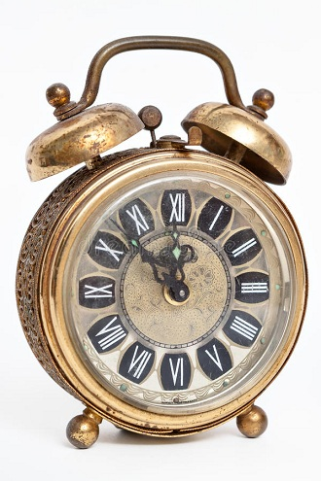

13. Fine Hand Crafted Vintage Skeleton Clock:
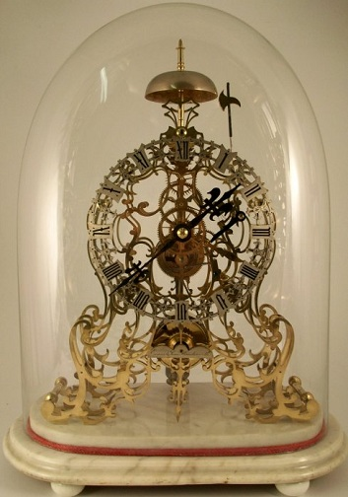
This a time-piece model antique clock with 8-day fusee movement. It has passing strike with 6 spoke wheel work. The anchor escapement is also included here in this model. It comprises with a compensating pendulum with cylindrical pewter bob and wood rod. The entire set stands on the white marble base covered with an oval glass dome.
14. Carved Antique Wooden Clock:
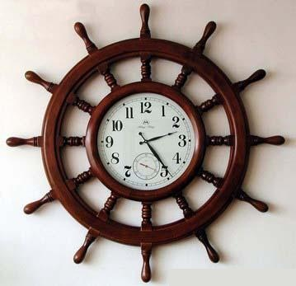
This piece of carved wooden clock is an antique craft that is handmade and is the excellent item for gift as well as for home decor. It achieves the final shade of antique brown and measure about 18*18 inches. Everyone would definitely like to have this antique looking wall clocks as their ideal home decor in all seasons.
15. French Gilt Bronze Antique Table Clock:
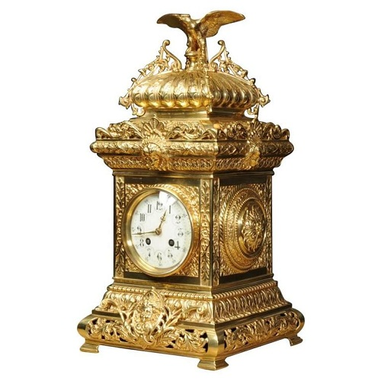
Here is the dazzling model small antique clock with its new looking shine that has been discovered from the French Gilt bronze metal. It is the original antique table clock with its classical style. The clock case is decorated with acanthus leaves and acanthus roundels to the sides. In total, the clock is beautifully modeled with an eagle seated on the cushion shaped top. It has copper enameled dial with separate minute ring and finely fretted brass hands.
16. Porcelain Antique Shelf Clocks:
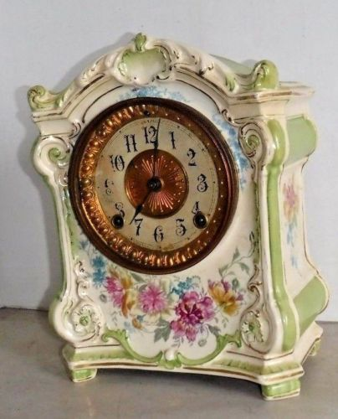
Discover the beauty of his off white and pista green shaded antique clock that can be easily kept on a shelf. This antique clock is ideal for home decors and is made with porcelain material. It has round shaped dial with white background. It has a brass touch encircled around the dial and also inside the dial.
17. Schoolhouse Style Antique Regulator Clock:
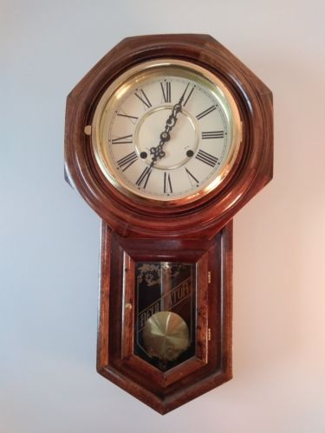
This clock has round dial with octagonal outer shape. It possesses Roman numeral with white background. The pendulum is made using brass and there is a winding key provided for it. The entire outer case is made with hardwood that elongates the total life span of the clock.
18. Analog Antique Gold Clocks:
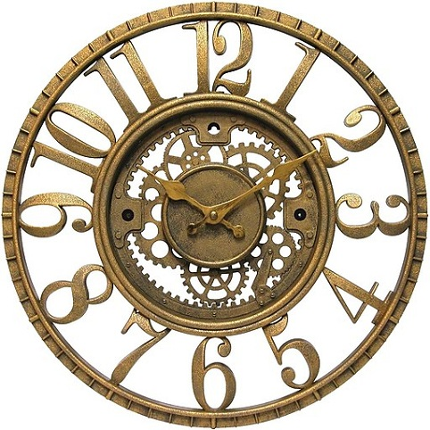
This antique looking wall clock features a conventional analog display with large gold numerals. This antique clock has a resin case for itself and has a smart antique gold finish that adds to its appealing looks. The hands of this clock make you to read the time from any corner of your home with no difficulties. It is entirely made with resin material and the color resembles gold metal with open dial for a stylish look.
19. French Antique Bronze Clocks:
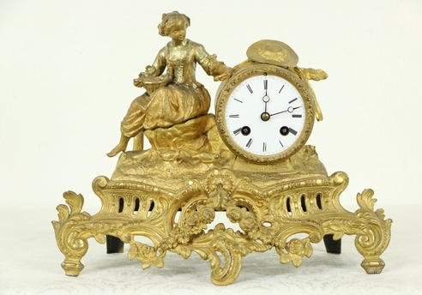
This antique style clock features a sculpture of a seated young woman feeding chicks. The brass movement of this clock runs truly to accurate, for a week on a winding, counting the hours and the half on a silvery bell.
20. Torsion Pendulum Antique Anniversary Clocks:
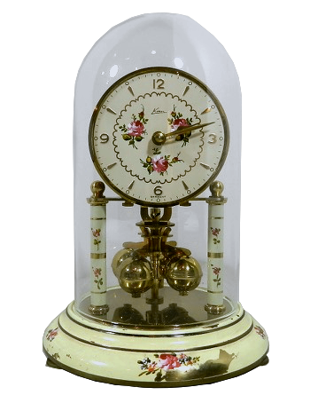
Here is the anniversary clock that is also named as ‘Torsion Pendulum Clocks’. They are known as anniversary clock because they can run for an entire year on a single winding. This clock is embedded inside a glass case with dial in a white background. The dial also has floral prints that are the highlight of this model. These types of clock are very handy and also easily accessible.
21. Wall Mounted Antique Kitchen Clocks:
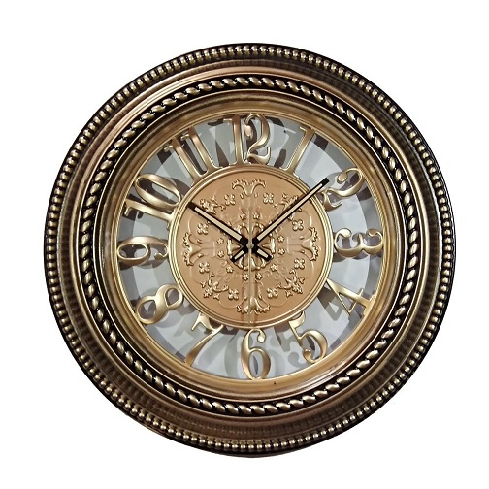
Explore this old antique clock that has overall dimensions of 15″ X 15″ (38 Cm X 38Cm). The display size of this clock is 10 inches. It provides a shiny golden metal touch with wall mounting provision. This particular model is ideally suitable for the kitchen environment. This round shaped dial clock has white background with brass embedded numerals. And has not very large minute and hour hands.
22. Spring Driven Antique Porcelain Clocks:
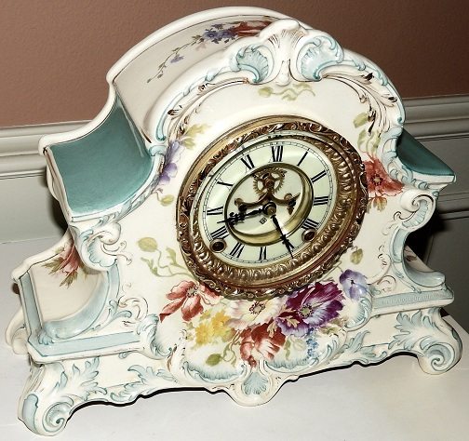
It is a very special design with unusual grey green color of this antique clock that makes it extremely appealing. The porcelain case is in excellent physical condition with 5″ diameter porcelain dial. The entire set measures 14.5″w x 11.75″h x 5″d. This has a spring-driven movement with exposed escapement overhauled. It works with eight-day jeweled pallets with good mechanical service.
23. Side Wall Mounted Vintage Antique Clocks:
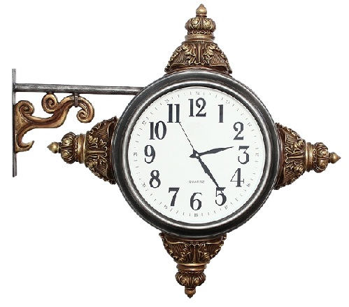
This is a range of analogue antique wall clocks to create that perfect wall attraction that everyone would like to have. The features of this wall clock including the style of handing model and the dial design, all will add character and charm to any wall of your home. This side wall mounted design clock would be 3 feet apart from the wall. It measures 86 cm x 94 cm x 110 cm in its dimensions.
24. Forest Cuckoo Antique Clocks:
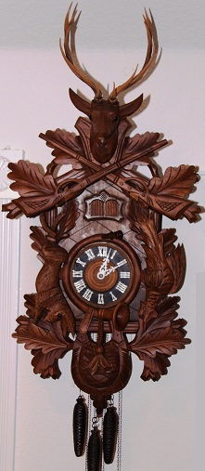
This antique wall clock has the dimension of about 19”H x 13”W, that is taken from the top of stag horns to bottom of game pouch. There is the option game of 8” hanging rabbit and pheasant large game pouch at base. It features with dark walnut case with green toned leaves. It is especially imported from Germany to get the original antique touch of the country.
25. Metal Table Antique Clock:
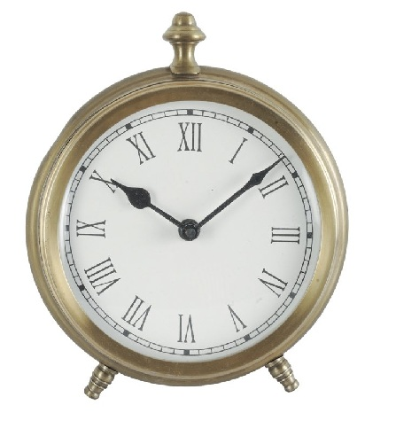
This is a vintage piece for your home decor that has three-legged table with the antique finish clock. It definitely adds an old-world charm to your home or to your living space specifically, wherever it is kept.The clock features a burnished finish. The handcrafted detailing of this antique version makes the clock a rustic and elegant designer piece. The off-white background of the dial displays standard Roman indices. And moreover as a complementary, hour and minute’s hands adds classic elegance to the space where it is furnished.
26. Designer Handed Antique Wall Clocks:
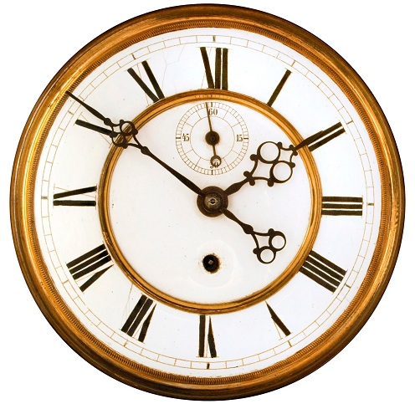
Explore this variety of antique wall clocks that are made to be more stylish and trendy all the years.This clock has the outer case made with copper and the dials are in round shape. Moreover, the background of the deal is pure white with numbers marked in black, which makes it visible for all at any angle. It also has the seconds’ hand to make it look livelier. The numbers are in Roman and the hands of the clock are specially designed for the best vintage looks.This clock is so simple in its appearance but yet gives your home a perfect interior decor.
27. Brass And Copper Antique Mantel Clocks:
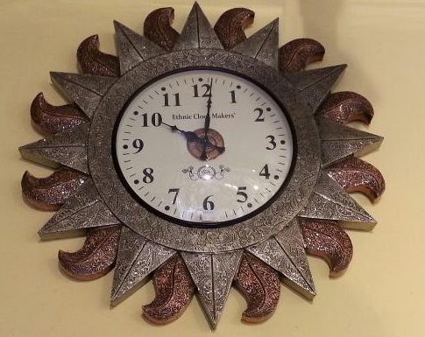
Have a glance on this heavy gauge metals’ Antique Clocks that uses both copper and bronze for its outer designed edges. It’s just gives the resemblance of the sun that is glowing with copper flames. And is thus ideal interior furniture for your home. The numbers are displayed normally with white background and it has the round shaped dial. It has only hour and minute’s hands without the presence of the seconds’ hand. But it marks clearly each minute with uniform spacing between them. The numbers are displayed in black contrast color to the background.
What else you need still? All the varieties of antique clock designs that are discussed above have their own specialties and featured characteristics that give it the perfect stand in this modern world too. There is wide diversity of models that can be used in every style of homes with vibrant interiors. You have table top clocks, large grandfather clocks, vintage ones, bracket type clocks, alarmed feature clocks and also made with metals such Gold, Bronze and Copper clocks.
Again you have the option to choose the background of the dial and also the dials’ shapes itself. You have the model displaying both Roman numbers and also contemporary numerals. You can make your choice according to the interiors that is themed in your home. Not only those wise people make their choice with these antique clocks, but also the young generations have much interest over these show pieces.

The History of the Bed
One of the many benefits of living in today’s world is the simple delight of slipping in between soft sheets on a supportive, comfortable mattress when it’s time for your nightly repose, but what if instead of your favorite memory foam pillow you laid your head on a pillow made of stone at night? If you had lived far enough in the past, this wouldn’t be fantasy – this would be your reality.
While the basics -- a cushioned spot to rest and stay warm through the night – have remained the same throughout history, the details of what constitutes a bed have changed quite a bit through the millennia. Here’s a brief history of beds through the ages.
1.Oldest Known Mattress, 77,000 Years Ago
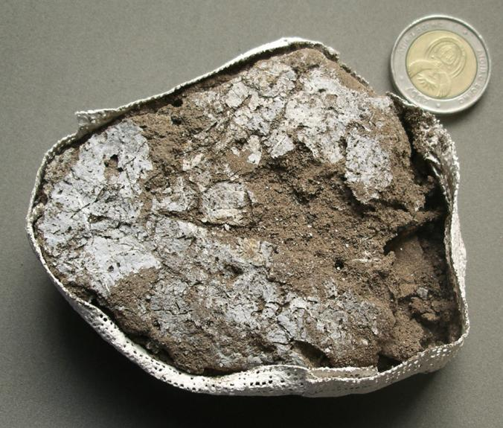
Your mattress is considered old after around seven years, but according to the National Geographic, the oldest known “bed” in the world was discovered in KwaZulu-Natal, South Africa, and dates back 77,000 years. Basically, it consisted of layers of plant material gathered into mats, which were periodically burned, perhaps to eliminate pests. The bed was around 12 inches thick and a whopping 22 square feet, providing plenty of room for the entire family. Leaves provided a cozy top sheet, and possibly also aided in keeping away bugs.
In this photo, a plaster cast holds fossilized leaves from the oldest known mattress.

2. Beds from the Early Neolithic Age: 7000 B.C. -6000 B.C.
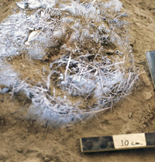
For prehistoric nomadic people, life on the move meant that nights were generally spent resting on a pile of leaves or grass mounded into a depression in the ground. At Hinds Cave in southwestern Texas, researchers speculate that the many bands of hunter-gatherers who used the spot as a temporary home slept curled in the fetal position, as the small, oval “beds” wouldn’t have provided enough room to stretch out fully. Perhaps this kept the sleeper warm and cozy during the night.
The photo here shows amazingly well-preserved leaves and plant fibers from an ancient bed in the Hinds Cave.
Much of what we know about this period comes from primitive human drawings found on cave walls or from archeological digs. In the mid-1970's, a research team from Texas A&M led by professors Harry J. Shafer and Vaughn M. Bryant carefully excavated Hinds Cave located in the Lower Pecos Canyonlands in southwestern Texas. There they discovered a treasure trove of artifacts dating back over 9,000 years left there by the nomadic hunter-gatherers that moved through the area.^{[1]} The discovery was that of grass-lined beds that the site's occupants once curled up in to sleep. Pits were created in the soft sediment and this grass was lined into the pits offering some comfort to its occupant. The size of many of these pits suggested that the occupant would sleep in the fetal position.
3.Beds from the Late Neolithic Age: 5000 B.C. - 4000 B.C.
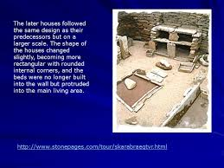
Several unearthed sites by archeologists from this period give us a much better understanding of beds, bedroom furniture and life in the Late Neolithic Age. One of the most well preserved of these sites is located in Orkney Scotland, UK, An island located at the northern most part of Scotland. The settlement known as Skara Brae was protected by dunes until its discovery. In 1850 heavy storms washed away part of the dunes to reveal the best preserved prehistoric village in Northern Europe.^{[3]} The people of this period primarily used stone in their furnishings and this can be seen in the image to the right. It shows a stone dresser which would have held tools or other important possessions. Surrounding this dresser to the left and right are ancient beds. These were huge slabs of stone that would most likely have been topped with bracken (a large fern) and covered with animal skins for warmth and comfort.^{[4]} Perhaps these could be considered early platform beds due in part to their box shape.
4.Ancient Egypt, circa 3000 B.C. - 1000 B.C(Bronze Age)
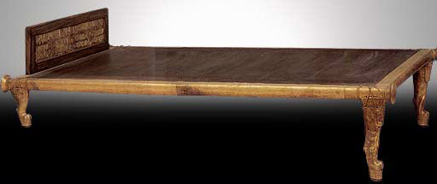

Along with their other amazing inventions and technologies, including written language, advancements in engineering, building and quarrying, eye makeup, toothpaste, the door lock, and hair shaving/grooming implements, you can also thank the ancient Egyptians for the invention of the raised bed. This kept the sleeper off the cold ground and also made it harder for rodents, insects or snakes to crawl over the bed.
Made of plain wood (if you were a commoner) or covered with gold, jewels and ebony if you were of high social status, the simple platform bed was topped with a mattress made of wool cushions. Linen sheets and a stone or wooden head support added extra comfort.

5.Ancient Rome, circa 1000 B.C. - 476 A.D.( Iron Age)
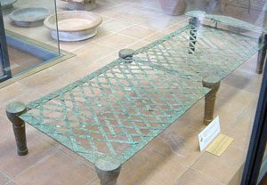
The wealthier citizens of ancient Rome slept on raised beds made of metal, with woven metal supports to hold the feather or straw-stuffed mattress. Less-wealthy people had similar beds made from wood, with wool strings holding up the mattress. If you were poor, however, you still had to make do with a mat on the floor. Whatever type of bed, you probably would have been warm underneath your woolen blanket, which was common throughout the Roman empire.
The bed shown here is in the Vatican Museum.
6. Beds during the Middle Ages: 476 A.D. - 1200 A.D.

St. James appears to King Charlemagne in a dream. Notice the ornate styling of his bed in this painting. Image courtesy of Saint-Jacques
After the fall of Rome was the period of the Middle Ages (or Dark Ages as it is also commonly referred to). A turbulent and violent time in which great struggles and hardships befell the people of Europe and abroad. Popular Frankish furniture of nobles in the era of Kings like Charlemagne would typically have been styled with bed posts and draped fabric coverings.^{[10]} This style continued to evolve and grow in popularity well into the end of the Renaissance period. This period also gave rise to Medieval designs that featured heavier construction and appearance in beds that would have been found in Saxon and Anglian designs
7. 10th century
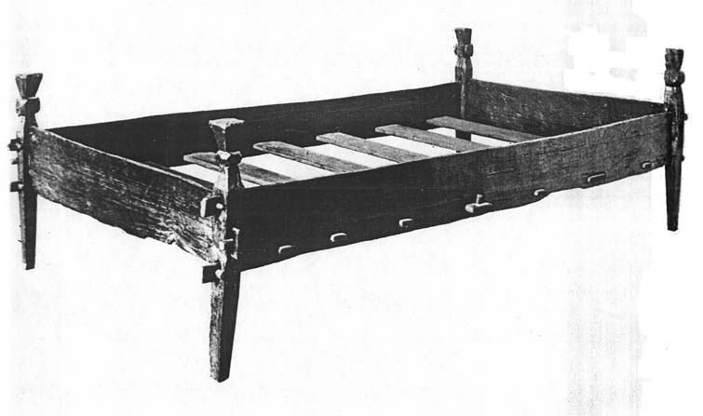
10th Century Norwegian Bed made of Beech. Taken from a Gokstad ship. Platform of the bed consisted of wood slats. Straw or hay stuffed into a sack made up this Viking mattress. Image courtesy of House Greydragon
In Scandinavia during this period, Norwegian Vikings were building wood slatted platform style beds for use in their ships. These wood beds were more basic in design from much of the rest of the world but show us a people who began integrating slat construction into their design. The 10th century bed shown to the left shows these slats actually fitted into and through the side railings of the bed. The two side rails are designed to fit through the bed post legs in order to secure them.^{[11]} This construction allowed the Norwegian Vikings great flexibility in getting them into their ships for the voyages ahead.
8. Medieval Life, circa 5th through 15th century
Bird Droppings on the Bed
Houses in the past didn't have the protective roofing that houses have today, so it wasn't unusual for bugs, pests, and droppings to fall onto the clean bedding. People then invented four-poster beds in order to keep a canopy that would catch all unpleasant stuff falling from the roof and not soil the bedding.
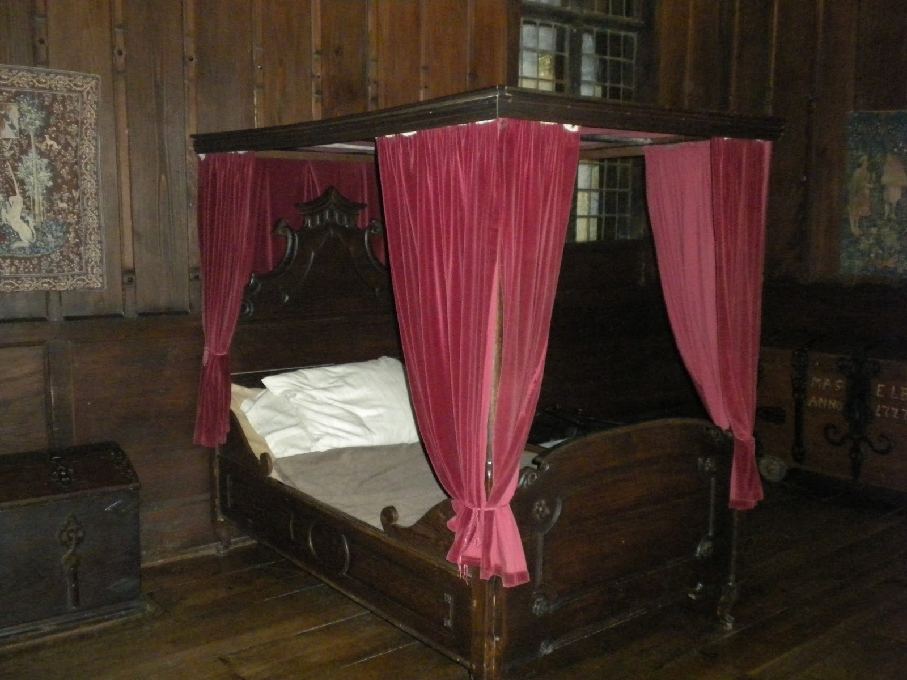
If you lived in medieval Europe, your sleeping arrangements would have largely depended on your position in life. If you were lucky enough to be wealthy, your bed was an opportunity to show off your status. Large, impressive, often ornately carved or encrusted with gold or jewels, beds expanded far beyond a simple platform during the Middle Ages.
Typically made of heavy wood, the beds of the wealthy were raised high off the floor, sometimes so high that a step stool was required to reach them. Four-poster beds were created during this time, hung with heavy velvet drapes and canopies, which served to show off the owner’s wealth and also warded off drafts and insects. The mattress was thickly stuffed with down and feathers, and sheets were made of fine linen.
As these beds were very expensive, they were treasured belongings and passed down through the generations. It even became common for royal or wealthy owners to remain in bed to receive visitors, eat meals and carry on business.
Although not as lavish as some, the bed in the photo here is typical for the period.

9. Medieval Peasant Life
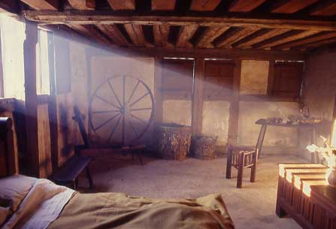

​If you were poor in medieval times, you would have slept on a hay-stuffed bag on the floor or on a simple platform. There’s a good chance your family would be sharing the bed with you, or at least be nearby; privacy was not a medieval concept. Before turning in for the night, you would have “hit the hay” in an attempt to dislodge bugs from your mattress.
Once in bed, you’d cover yourself with a rough wool blanket – no fine linens for you. Since the homes of the poor were small and families were typically large, your bed might well be used not just for sleeping at night, but also for sitting or as a table during the day.
This room is typical of a medieval peasant's hut.
10. Tudor beds of 16th Century (1485-1603)
By Tudor times, many ordinary people could afford to buy proper framed bedsteads. Sleeping on chests, boards or rough straw sacks on the hall floor gradually became a thing of the past. Some beds were magnificent structures with the head, roof and posts beautifully carved from wood. Others were quite simple, more like the trundle bed mentioned above.
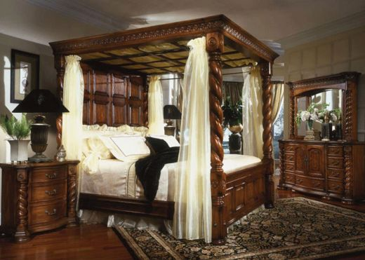
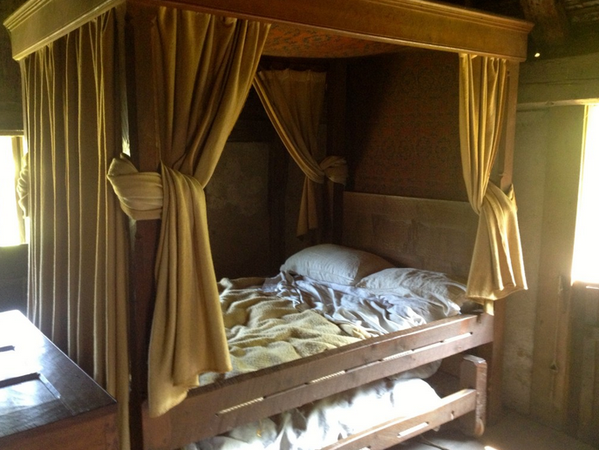
15th century English bed with trundle bed. The curtains gave the only sense of privacy in the home.
When William Shakespeare died in 1616, he left his "second-best bed and the furniture" to his wife, Anne Hathaway. The "furniture" meant the bedding and curtains. Anne was no doubt delighted. Beds were often a man's most valuable possessions. and the great playwright's bed was probably richly carved and curtained with costly fabrics. But she might have preferred his first-best bed!
A Tudor bed required regular attention. The base of the bed was held together by stretched cords, which were tightened with a special lever called a "twitch". "Bed staffs" were another essential tool. These were stuck in holes down the sides of the bed. They prevented the thick feather mattresses flopping over the edge and the occupants rolling out.
When people in Tudor times stayed at inns or hostels, they were expected to share their beds with complete strangers. If a richer person turned up, a poor traveller was thrown out of bed to make space. As Shakespeare wrote in The Tempest:"Misery acquaints a man with strange bedfellows."
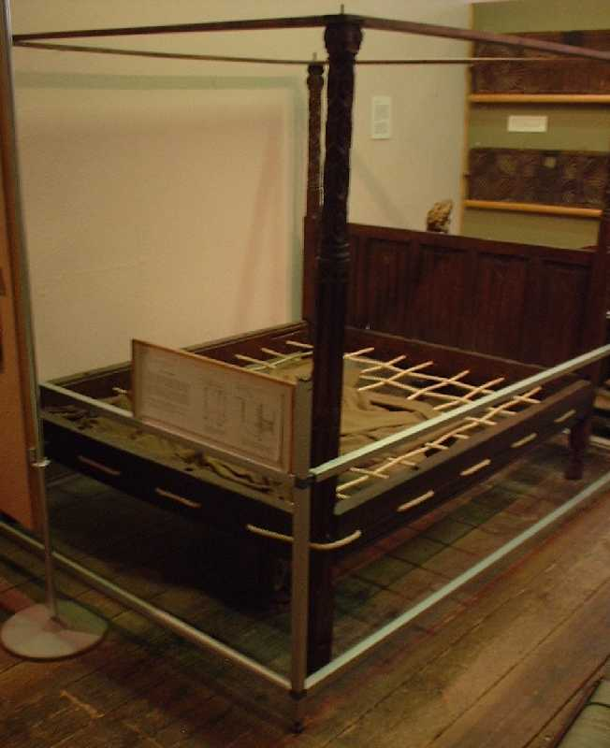
16th Century Tudor Rope Bed in the Saffron Walden museum
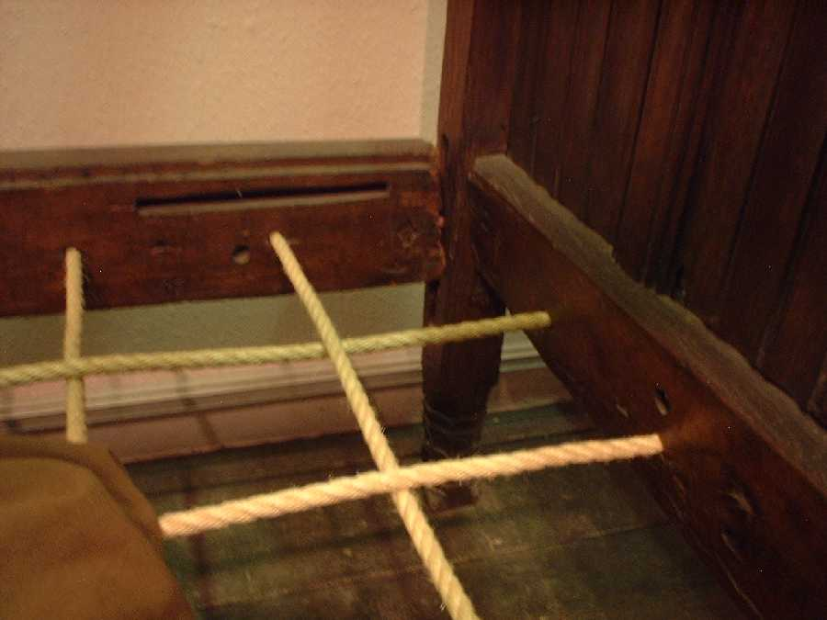
11. Renaissance, circa 14th through 17th century
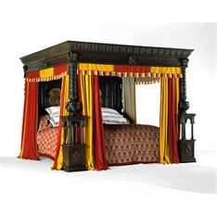
Beginning in Italy, the Renaissance was a cultural movement later spreading across Europe. The artistic aspect is probably the most noted achievement during this period but advances in the revival of learning and advancements in science also began to flourish. Renaissance furniture from this period almost always included a canopy and posts in the design. Many designs for these beds from the 16th & 17th centuries used ropes to make up the central platform of the bed. Holes were made through the side rails and the footboard and headboard of these beds. The craftsmen would then pull the ropes through these holes in a pattern much like the bed shown to the left.^{[12]}Hence what led to the expression "sleep tight" as these ropes required regular maintenance and tightening.
While the poorest folks continued to sleep on simple pallets of hay laid on the floor or on a simple platform, it was now common for those of middle-class status to have not only a four-poster bed, but also a separate bedroom to hold it. Typically, a bedroom during the time of the renaissance would be on an upper floor of the home, and would contain a bed with a trundle underneath that could be pulled out to sleep family members or servants, along with a wooden trunk to hold clothing.
For the wealthiest people, the bedchamber continued to be a popular spot to receive visitors and carry on business. The ubiquitous four-poster grew even more lavish and ornate during this period, with fanciful carvings, inlaid paintings, colorful trim, and luxurious, heavy fabric curtains to enclose the bed on all four sides when desired, along with a canopy that might be fabric or wood.
Ropes or woven straps provided support for the mattress, which was generously stuffed with down and topped by fine linen sheets and wool blankets. Because these beds were so expensive, they were prized possessions to be passed down through a family’s generations.
The fantastic bed shown here is called the Great Bed of Ware, and is currently housed in the Victoria and Albert Museum in London. Large enough to sleep eight people comfortably, the bed was never in a private home, but was created in 1590 as a tourist attraction for an inn in Ware, England. It was so famous during its day that Shakespeare included a reference to it in his play “Twelfth Night.” Amusingly, the bed has carved graffiti on the posts from those lucky enough to sleep in it hundreds of years ago.
12. Queen Anne (1665-1714)
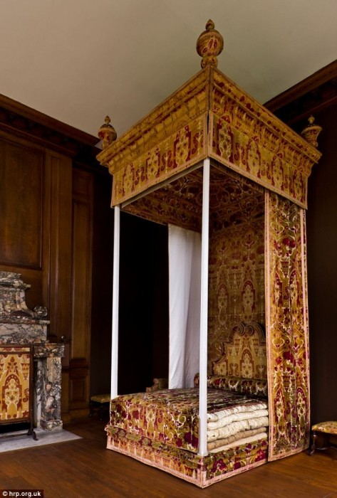
The bed designed by Queen Anne (1665-1714) of England for her death. Notice the multiple mattresses.

13. Georgian and Federalists beds and bedrooms of the 18th century
Georgians Bed In the time of James I (1603-25), rich families copied the French fashion for "covered beds", which were completely surrounded by drapes. The curtains, roof and quilt were often all covered in the same fabric. King Louis XIV of France had 413 beds, some of them embroidered with pearls and gold.
In the 1750s, elaborately carved woodwork replaced the old covered bed. Designers like Thomas Chippendale published books of exotic patterns for furniture-makers to copy. But in the 1780s, designs became simpler and Chippendale's beds started to look old-fashioned.
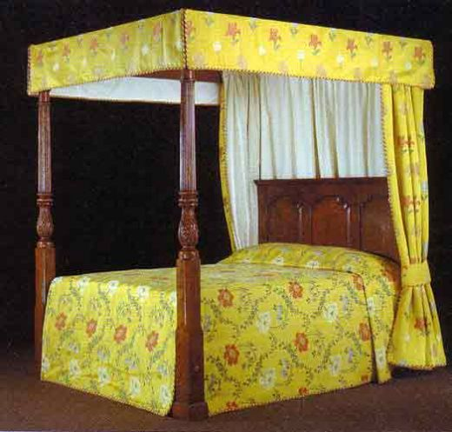
Georgian Bed
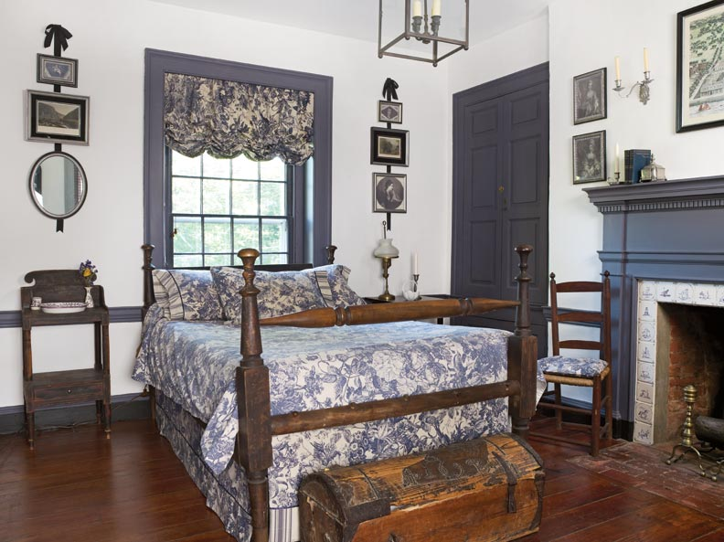
A restored Federalist bedroom in Massachusetts. This house was believed to be built in 1792.
During the 18th century, beds became simpler in style, although still often surrounded by heavy curtains. While beds were still usually made of wood, metal bedframes were starting to become popular as well. Cotton-stuffed mattresses replaced down or hay, although they were still suspended in the bedframe with a system of wool straps or ropes.
One of the biggest changes during the 18th century, however, was that the concept of the bedroom as a private space for sleep became firmly entrenched throughout all classes of society. No longer did royalty or the wealthy receive visitors in their bedroom, and it was no longer typical to have servants sleeping on the bedroom floor.
This is a typical middle-class colonial bedroom.
14. Victorian beds and bedrooms in the 19th century
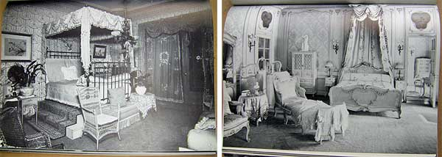
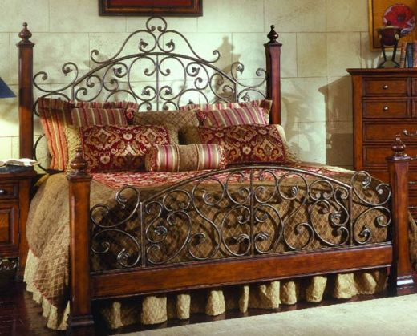
Victorians beds were sometimes so high off the ground that special bed steps were needed to climb into them Queen Victoria's bed at the Brighton Pavilion had seven mattress! In bed, ladies wore bonnets and long nightdresses. Men wore nightshirts until pyjamas were invented in the 1890s.
The Victorians could sleep in comfort after the 1820s, when mattresses were first fitted with coiled springs. Metal bedsteads became popular, and the best beds were made from brass. Servants had to spend hours polishing them, but they looked beautiful. Metal beds were also healthier than wooden ones, as they attracted fewer bedbugs.
Many sorts of portable beds were now available. Travellers carried hammocks or camp beds. The Duke of Wellington slept in his camp bed even when he was at home. The first sleeping carriages were introduced on overnight trains from London to Scotland in 1873, forty years after they became available in The USA.
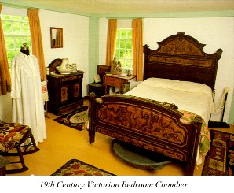
During the 19th century, bedrooms became more like the ones we enjoy today, mostly devoted to sleep ​or sex, although if you were a woman during this time, you would probably also use your bedroom for giving birth. The heavy curtains of earlier centuries faded away, although four-poster beds were still very popular. By the late 1800s, however, the posts were typically much smaller, and headboards and footboards also shrunk accordingly.
One striking advance to the bed during this time was the invention of metal bedsprings to support the mattress, instead of ropes or wool straps. While these gave more support and stability to the mattress, they were also annoyingly squeaky.
This Victorian-era bedroom shows off the fussy style typical of the period.

15. The Modern Waterbed 1883 A.D. to Present
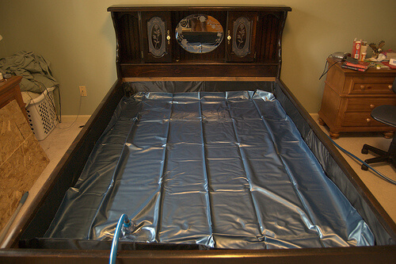
There has been much debate as to when the first waterbed was created and used. Many attribute the Persians as being the first to try the use of enclosing liquid for sleeping on. History tells us though that in 1883 the first waterbed patent was issued to Dr. William Hooper of Portsmouth, England. His bed was devised as an attempt to relieve bed sores that his patients were suffering from.^{[17]} However this early attempt at a waterbed was unsuccessful as Dr. Hooper could not control the temperature of the water and patients found his bed to be cold and clammy.
In 1968 Charles Hall created the modern waterbed design with help from fellow SFSU students Paul Heckel and Evan Fawkes. Originally they were trying to build an innovative chair out of vinyl bag with 300 pounds of cornstarch. The next attempt was to fill it with Jell-O but this too was unsuccessful. The three abandoned the chair concept and settled on perfecting the concept into a bed and created the waterbed and it's accessories like a heater, patches and repair kits.^{[18]} Typical waterbed construction consists of a MDF particle board pedestal. Inside the pedestal are cross shaped supports. Around the pedestal a raised outer framework is installed. Modern waterbeds use a heater with a thermostat to control the temperature of the water. Panels are installed over the cross shaped supports in the platform of the bed. A liner is placed inside the bed and the vinyl waterbed mattress is inserted into the frame and filled with water. Waterbed popularity soared in the 70's but even though they are now considered a fad, they are still sold throughout the world even today from a variety of vendors.
16. Bedrooms and beds of the early 20th century
The Murphy Bed: 1900 A.D. – Present
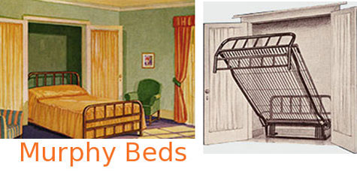
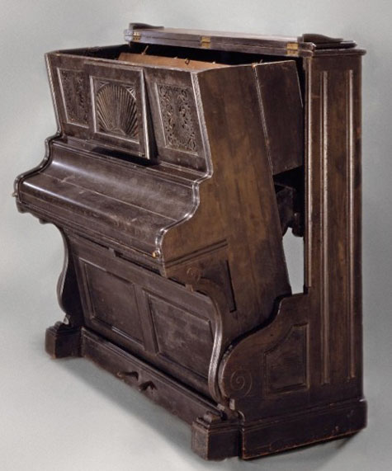
William L. Murphy was an American designer of a folding bed that has come to be called a "Murphy Bed" which are still sold today. This unique invention consisted of a folding bed featuring a steel platform which accommodated a single mattress. (Twin, Full or Queen size depending on the model.) The idea behind this bed came to Mr. Murphy as he resided in a one room apartment in San Francisco and his existing bed took up too much space when he tried to entertain guests. He experimented with folding a bed up and applied for his first patent in 1900. These humble beginnings eventually led to the forming of the "Murphy Wall Bed Company" that still exists today and is managed by his grandson Clark W. Murphy who is the current President of of the company.^{[19]} Although the Murphy Beds popularity peaked in the 1920's & 1930's, they are still popular today.
The Industrial Revolution had brought forth many technological advancements into the home, and so did the war. Coiled metal springs were made more widely available and created greater mattress comfort. Electricity was becoming more commonplace, allowing people greater time to relax, read or pursue hobbies well after dark. And the glitz and the glamour of moving pictures were beginning to influence the home. Affordable rayon allowed women to emulate Hollywood boudoirs, and steamy novels became best sellers. Women’s rights, a focus on glamour, and the 1920’s economic roar created a desire for luxurious bedroom design. Bathrooms moved out of the bedchamber, allowing the bedroom to become pretty and glamorous.
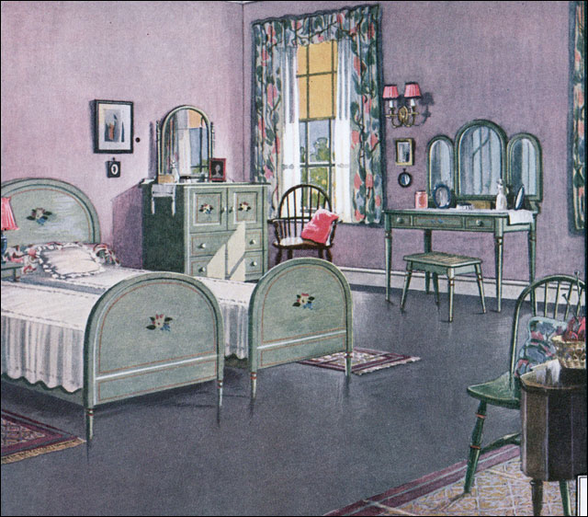
An illustration of a 1924 lavender bedroom. Catalogs at the time encouraged colorful rooms as well as DIY decorating.
Post WWII America witnessed a housing boom as soldiers returned from war and got married. No longer were young married couples living with their parents; they desired their own homes and created a demand for home furnishings. The economic rise of the 1950’s allowed couples to afford luxury in their home and emphasis was placed on domestic life. We see this in the vast amounts of suburban home developments that started to pop up across the West.
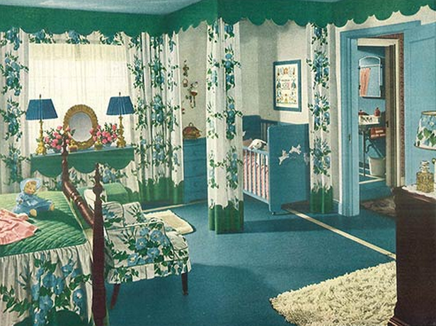
An ideal bedroom from 1944. Notice the baby crib in the corner with curtains that could be used to hide that area away from sight.
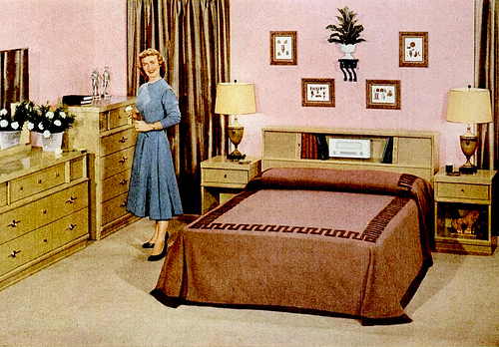
The picture here shows a typical middle-class 1950s bedroom.

The 20th century was a busy time for bed innovations: the Murphy bed and the waterbed both were invented and rose in popularity during this era. But those certainly weren’t the only mattress improvements: the two most common types of mattress today -- innerspring and memory foam -- were both developed during the 20thcentury.
Although they had been invented decades earlier, it wasn’t until the 1950s that innerspring mattresses skyrocketed in popularity to become by far the most common type of mattress. This ushered in the use of box-spring platforms to hold the mattress, creating a far more comfortable and supportive bed than those used in earlier times.
In the 1960’s a new change to the bed was introduced to America via England. It was a Scandinavian creation called the duvet and was brought to England by famed home goods retailer, Terrance Conrad. His store, Habitat, became an evangelist of this Scandinavian design, which allowed the woman (or man) of the house to make the bed in a short amount of time. Couples were literally freed from the layers of formal bedding, and the duvet characterized the sexual revolution that was underfoot. The dominating trend in the 1960’s and 1970’s was comfort and relaxation, as well as individuality in the bedroom.
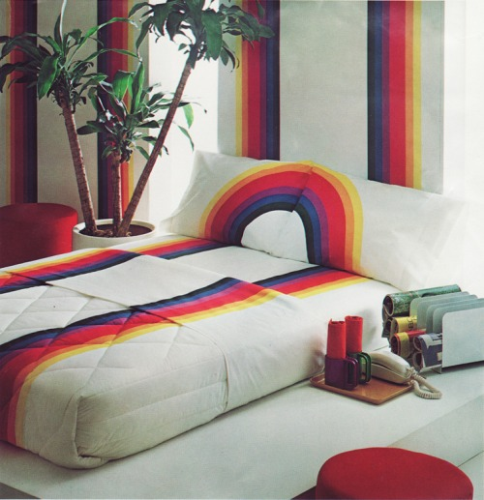
Freedom in the bedroom went beyond interior design in the 1970’s. Image from Super Seventies.
By the 1960s, mattresses and pillows were often made of foam instead of cotton or wool. Tempur-Pedic sold the first memory foam mattress in the U.S. in 1992. Today, memory foam mattresses have the highest rate of customer satisfaction of any type of mattress.

17. 21st century
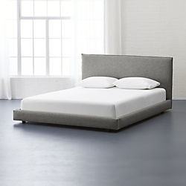
Today, you have more choice than ever before when it comes to your mattress and style of bed. Innerspring, memory foam, hybrids, latex, and air are just some of the mattress types available. While platform beds and four-posters are still very popular styles, there are many other types of bed: wrought iron, sleigh, bunk, loft, and futon, to name a few. The bed has come a long way since the earliest grass-lined pits, but the basic concept is unchanged: a comfortable, safe and cozy spot to sleep and restore your energies through the night.

A Photo Guide to Antique Chair Identification
Renaissance Style Chair
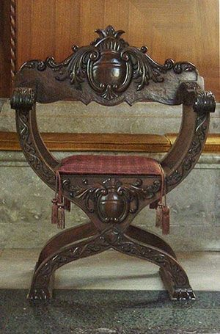

French Scallop Carved Distressed Armchairs
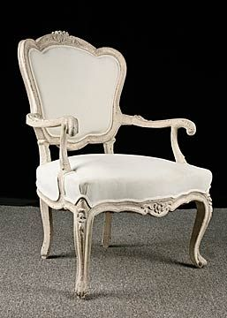
French Gentlemen's Chair
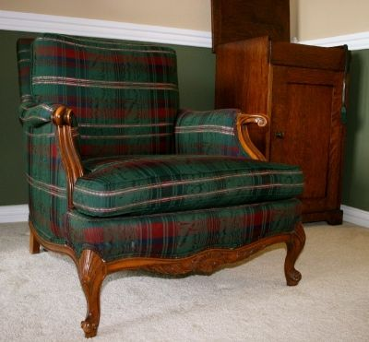

1765 Neo-Classical Chair
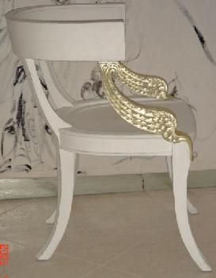
Swedish Neo-Classic Style Armchair 1765
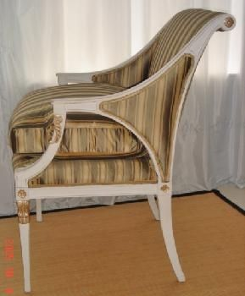
Swedish Gustavian-Square Back Striped Sofa Couch
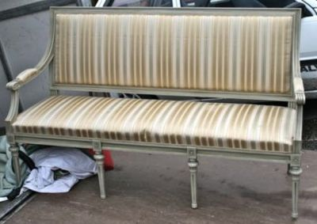
Spanish Colonial Mexican High Back Side Chair, 1900s, Hand Carved Oak
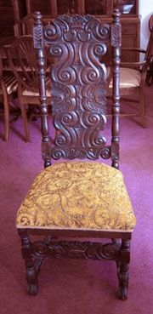
Chippendale Chairs, 1718-1779, 18th Century
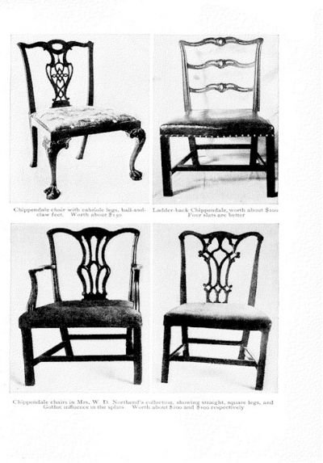
English Walnut Queen Anne Chairs
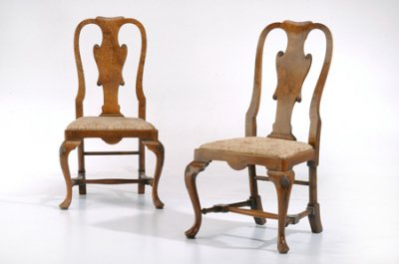
Empire-Styled Rocking Chair 1800s Solid Mahogany
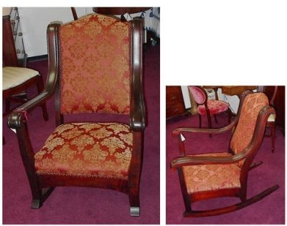
Chippendale Bench
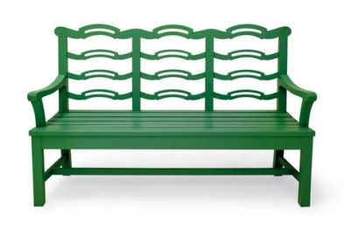

Chippendale Chairs, 1718-1779, 18th Century Gothic
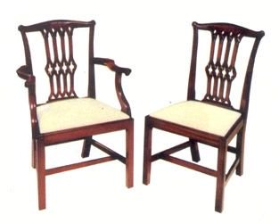

Sheraton Styles
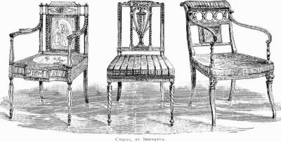
Regency Armchair 1804 by George Smith
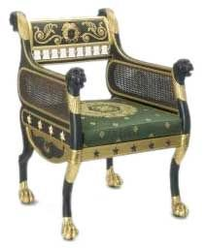

1900 Carved Mahogany Balloon-Back Chair
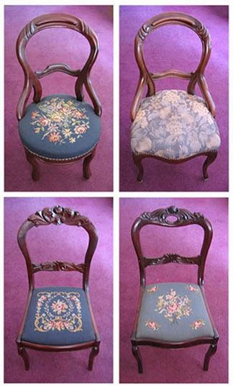
1940s Wing Chair

Barcelona Chair
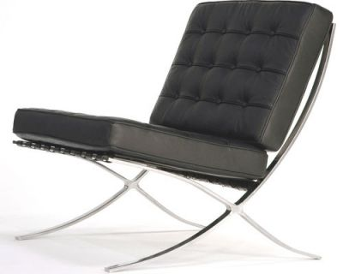
Harlow Tufted Slipper Chair
Hooded Cane Chair—1960s
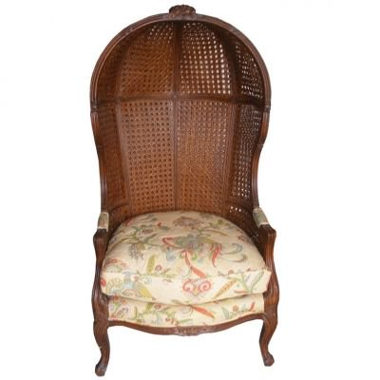

Italian Tall Slat-Back Armchair
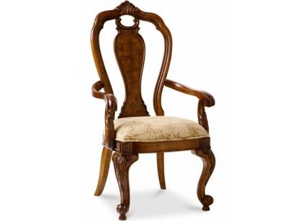
Klismos Chair
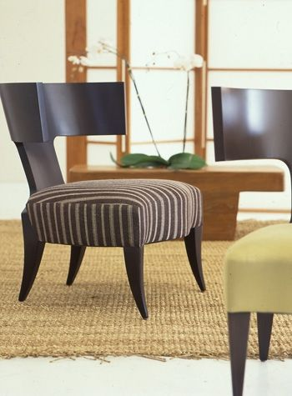
Pair Antique Abalone Inlay Cane Chairs
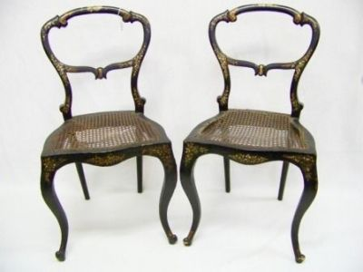
Plywood Lounge Eames Reproduction
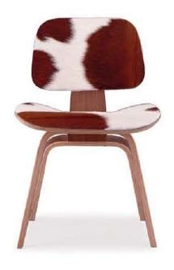
Tub Chair
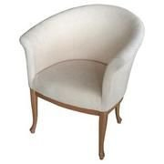

Interior Design Styles

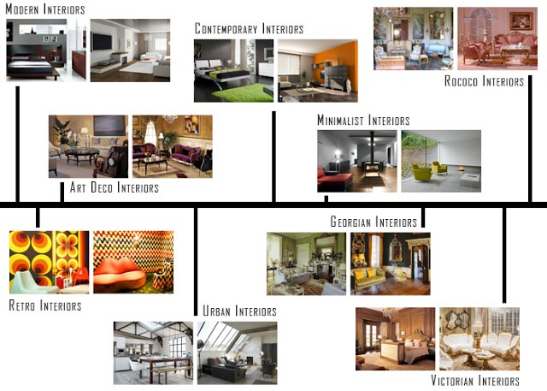
Interior Design Styles
At the start of any interior design project, you wonder what style should I choose? what style do I like? what style will look good in that space? what style will I feel comfortable with? Whether you're decorating a single room or a whole house, a bungalow or a mansion the style will change dependant on the existing space and what is appropriate for it.
The following list of interior design styles is not a definitive list but rather a selection of some of the most common or popular interior design styles, more styles exist and more are being created all the time. You should use this list to gain a basic understanding of common interior design styles and what is involved in each of them, how they differ and how to create them.
1. Modern Style Interior Design:

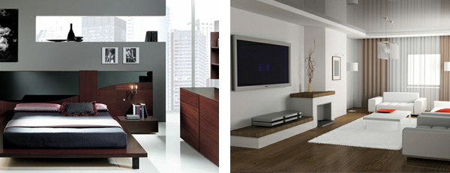
Modern Style Interior Design
The creation of the modern interior design style is credited to a group of European designers that started the Bauhaus School of Design in Germany in 1919. The Bauhaus philosophy is that form and function should combine in all designs. Modern Style design is clean-lined and focuses first and foremost on function and avoids the excessive accessories and decorative elements seen in many other styles. Some people feel the modern design is too simple, harsh or cold, however when well planned it can promote a sense of calmness and simplicity to your home.
The modern style is ideal for apartments and small spaces as it maximizes space and create the impression that a room is larger than it actually is. Minimal textures and bold geometric forms, neutral colours accented with a single bold colour along with polished finishes and asymmetrical balance are key identifying features of modern style interiors.
To Recap, the main characteristics of the modern interior design style are...
- Clean lined design
- Function before form.
- Avoids excessive accessories and decorations
- Minimal use of textures
- Asymmetrical balance in furniture and layout
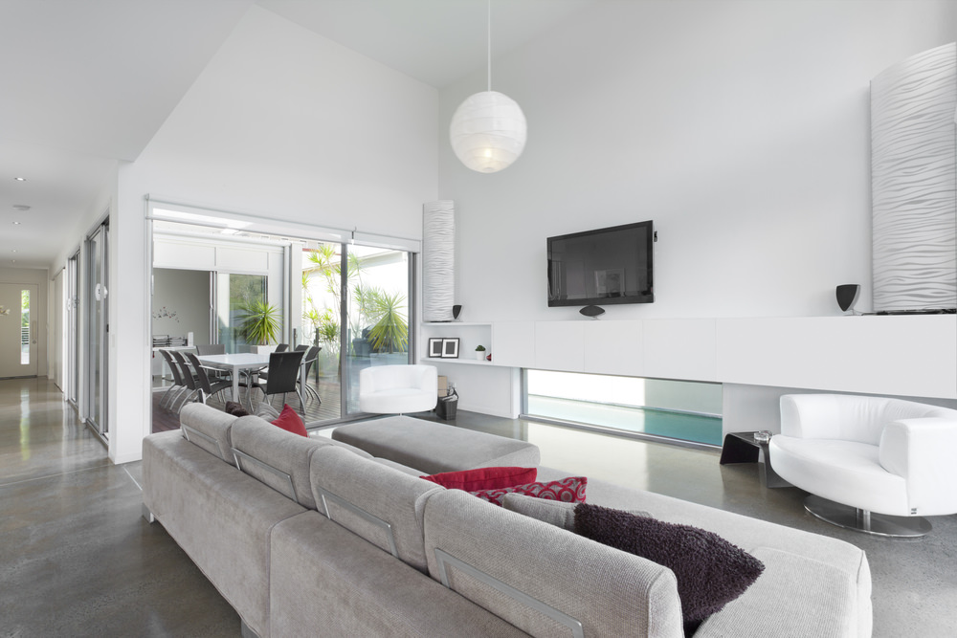
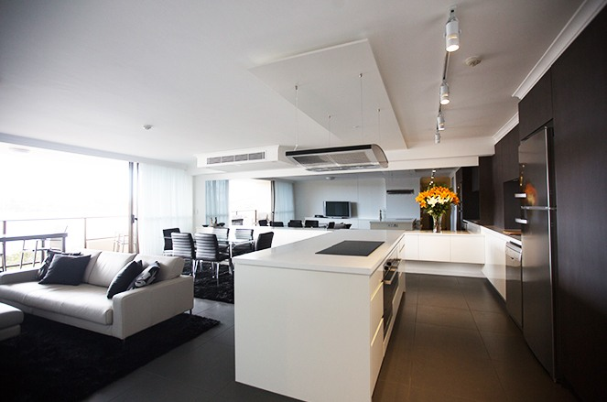
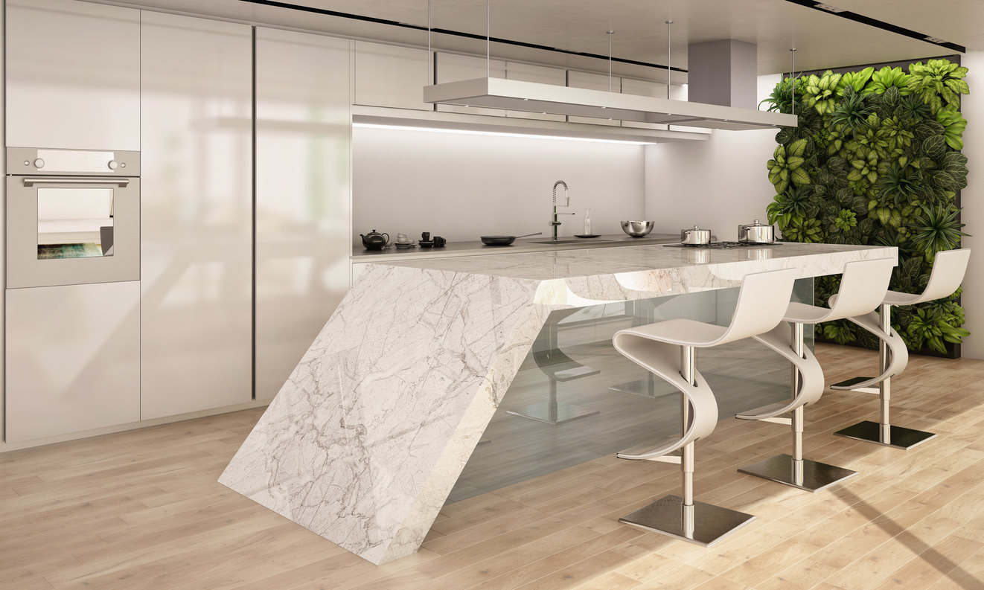
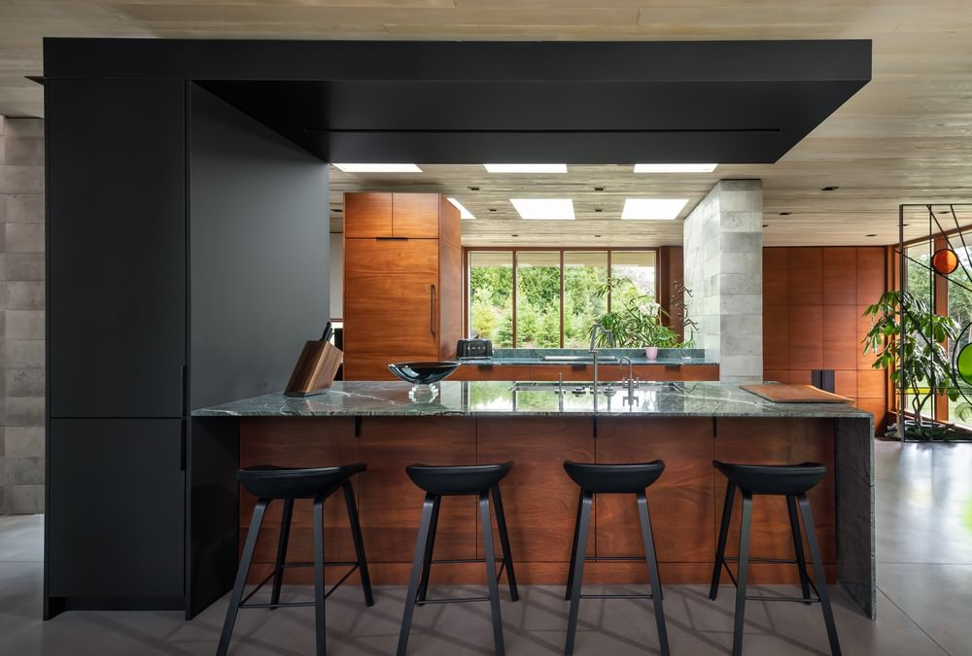
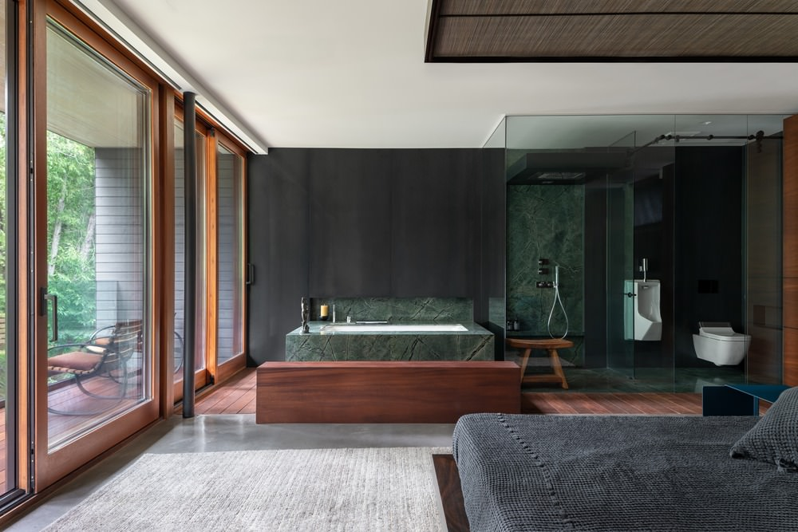
Modern style for interiors is more popular in the media than in real life. I think people appreciate the look of it and it’s definitely cool, but when it comes to living in the more austere design, people opt for warmer home decor styles such as rustic, cottage or traditional.
Nevertheless, builders and architects are incorporating modern elements to many homes which is kind of cool; but moderating it with materials, angles and lines that add warmth.
Key attributes of modern interior design style include:
- Absence of ornament,
- Intentional asymmetry,
- No clutter or chaos,
- Neutrals with primary colors and bold color contrasts,
- Geometric-patterned or plain area rugs,
- Furniture pieces have clean lines and basic shapes, made of materials like metal, chrome, or glass and are streamlined with polished, smooth and sleek surfaces,
- Art, rather than accessories, and
- Open floor plans
Modern interior designers are also described as super “sleek” since they have an unparalleled love for simple palettes and designs that are often coupled with clean, crisp angles, and lines. They absolutely hate clutter and always strive towards removing extraneous objects from the picture.
Their designs are fresh, elegant and have a sense of simplicity in every style that they create. Unlike contemporary designers, they love adorning spaces; however, they do it with such skill and subtlety that you won’t even realize there is something “extra” in the design.
Modern interior designs also include elements and materials that provide you with an overall warm and comforting feel without being too loud or bold. One of the most distinctive characteristics of these interior designers is their tendency to use monochrome palettes. Black and white are usually their go-to colors, often with hints of other primary colors like blue, yellow and red.
2. Contemporary Style Interior Design:

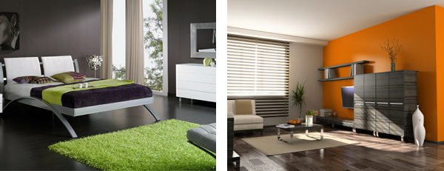
Contemporary Style Interior Design
The terms modern interior design and contemporary interior design are often used interchangeably, however there is a difference between the two. Contemporary interior design can only mean trendy looks that are in style at any current moment, while modern interior design refers to the specific geometrical, clean-lined style called modern. The fact that the modern style may also be a part of a current look or trend adds to the confusion between modern and contemporary.
Contemporary interiors are comfortable and welcoming without being cluttered and dark and is a style that is equally appropriate for offices and stores, lofts and homes. A contemporary style home can be a quiet and comfortable retreat. The key identifying feature of a contemporary style interior design is line. Line can be used through the use of bold colour blocks, high ceilings, "square" edged furniture, linear wooden floors, floor mats, bare windows and geometric shapes in wall art and sculpture. The bare space, on walls, between pieces of furniture, and above in upper areas also become just as important as the areas filled with objects. Each piece stands out as individual and unique.
Smooth, clean, geometric shapes are essential for contemporary style furniture pieces with upholstered furniture usually in black, white, or another neutral tone.These pieces should be simple and uncluttered, without curves or decoration. Sofas, chairs, and Ottomans usually have exposed legs with Beds and chairs usually having no trims or tassels. In conclusion, with contemporary interiors, less is more. Go basic, bare, bold, and structural with bespoke, unique and individual furniture.
To Recap, the main characteristics of the contemporary interior design style are...
- Refers to in style or trendy looks.
- Basic, bare but bold.
- Negative space as important as objects
- Smooth, clean and geometric shapes essential.
- Bespoke and unique furniture.
3. Contemporary Home Decor Style
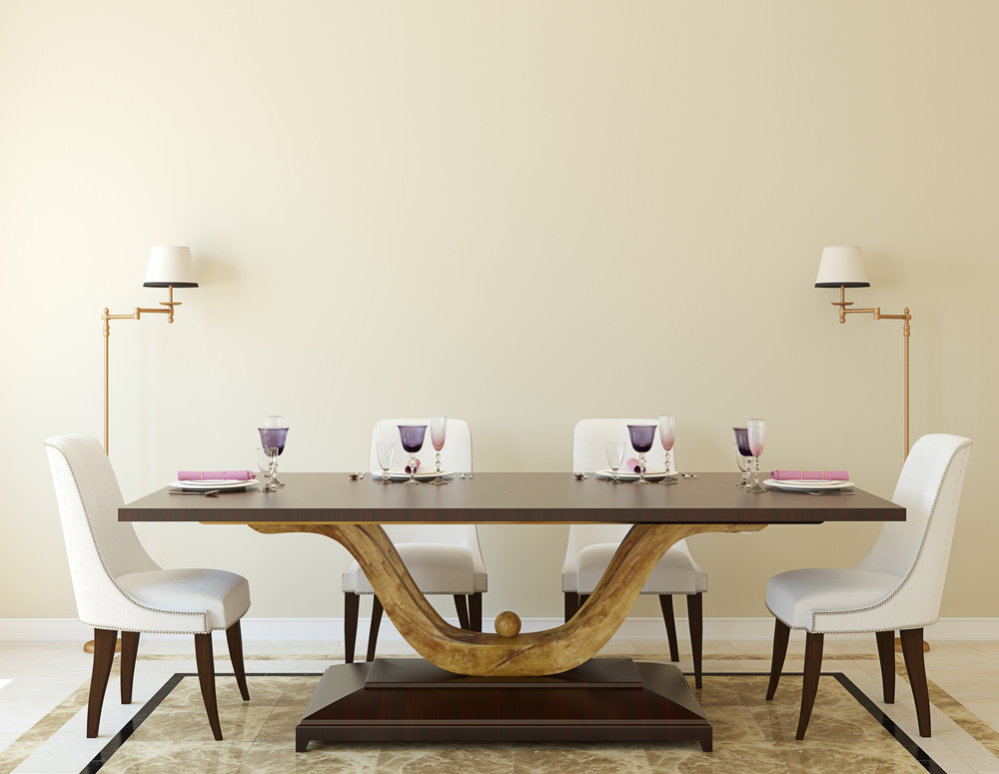
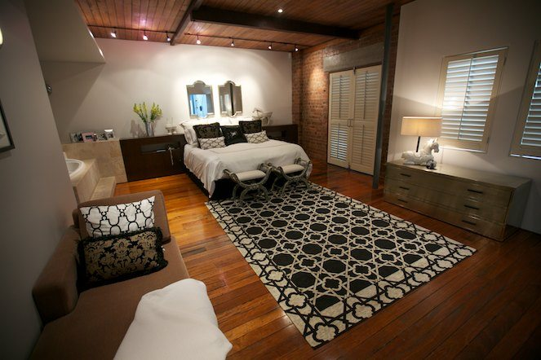
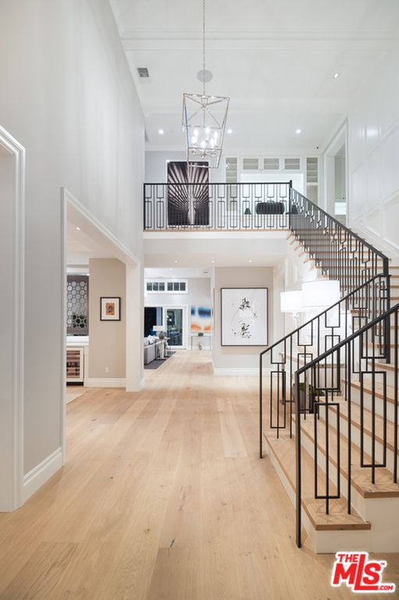
Contemporary design style is often confused with modern design style… usually references to modern are in fact contemporary design.
Contemporary design is current design which includes open spaces, plenty of light, straight lines, plenty of glass, settel and wood and in some cases unusual layouts.
Elements of contemporary design:
- Open spaces or open floor plans,
- Unusual layouts,
- Use of natural light,
- Neutral colors,
- Metal accent pieces,
- Textured and natural fabric,
- Very light or very dark wood tones, and
- Lighting design used as an artistic statement.
Contemporary designers create designs that are more fluid, in the sense that they are according to the current, trending styles; however, they don’t resort to a particular style or design. These designers also have a great sense of what’s currently in style so their designs are constantly evolving and carry a very modern touch to them.
In today’s time, contemporary interior designs include unadorned spaces that appear to be super clean and classic, along with furniture that is exposed from its legs to create more space. As stylish and modern contemporary designs may be, they are yet super elegant with intricate details kept to a minimum.
3. Minimalist Style Interior Design:
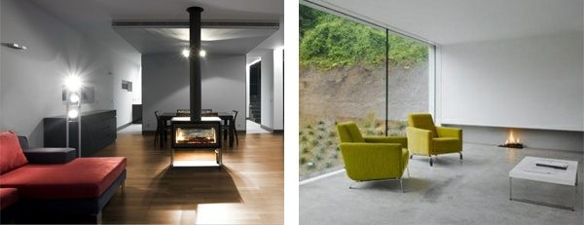
Minimalist Style Interior Design
Minimalist architecture became popular in the late 1980s in London and New York, where designers worked to achieve simplicity, using white elements, cold white or blue lighting, large spaces with minimum objects and furniture. The concept of minimalist design is to strip everything down to its essential quality and achieve simplicity. Minimalism simplifies living spaces to reveal the essential quality of buildings and conveys simplicity in attitudes toward life. It is inspired from the Japanese traditional design and the concept of Zen philosophy.
The idea is not completely without ornamentation, but everything is as reduced down to a stage where you cannot remove anything further to improve the design, or without dis-improving it. The basic geometric forms, elements without decoration, simple materials and the repetitions of structures can represent a sense of order and essential quality. The movement of natural light in minimalist buildings reveals simple and clean spaces. In order to successfully implement a minimalist style storage is key in order to allow the space to remain minimal while still retaining the essential objects you use within that space. Minimalist kitchens are an excellent example of this, where clever use of space and hidden storage is regularly used.
To Recap, the main characteristics of the minimalist interior design style are...
- Cool colours and white or blue lighting.
- Large open spaces with minimum furniture, essentials only.
- Reduced to ideal quantity.
- Storage is key to maintaining minimalism.
- Natural light used as a feature.
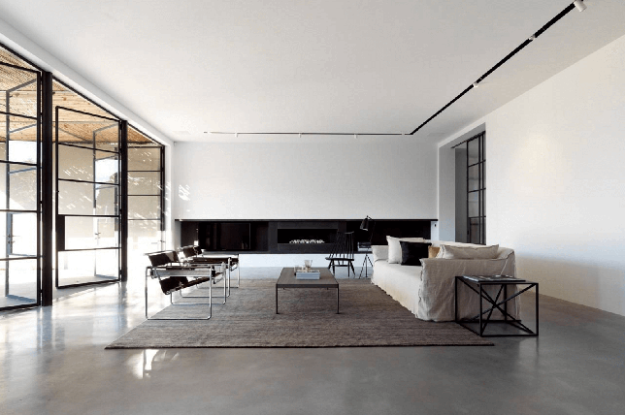
After making its mark on the design scene and understandably never fading as a major design style moment in the early 90’s, minimalist interior design is often a foolproof route in creating a warm and nuanced home that’s worth the investment and certain to never go out of style or off-trend thanks to practical, well-judged approaches.
But what exactly does minimalist decor even mean and how do you master the look with confidence and maintain it for that matter? To get you inspired, we’re sharing essential techniques to make minimal decor work as the best interior design style for your daily life. From brilliant ideas for minimalist decorating on a budget to a room by room break down, here’s everything you need to know.
WHAT DOES MINIMALIST STYLE MEAN?
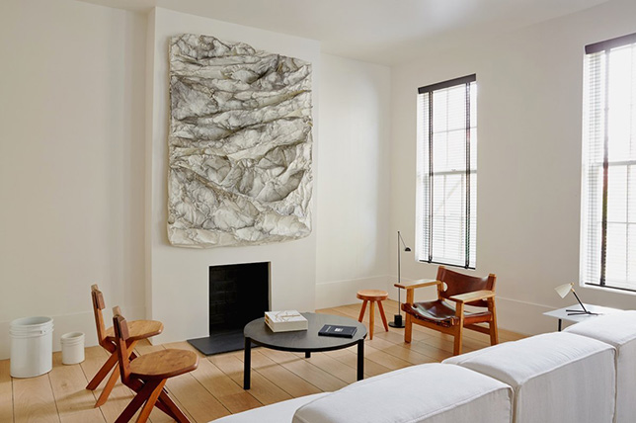
The main mantra of minimalist home decor is simplicity through and through. Keep it spare, tone decor down, pare every aspect back, and live by a “less is more” and “everything needs a place and a reason” approach.
Think clean, modern lines, a tight edit, a concise color palette, and pared down silhouettes, yet don’t shy away from creating a layered, warm, rich, and inviting minimalist home with a gallery-like setting from room to room as this is, after all, a place of comfort and refuge.
WHY YOU’LL LOVE MINIMALIST STYLE?
- Minimalist room ideas are great for making small spaces appear larger.
- Minimalist decor and practices almost never go out of style when done well.
- Because minimalist interior design is all about the beauty of the refined and the well-judged, you can save on bringing in too many furnishings and features that you simply don’t need.
- Highly attainable and easy to source, minimalist home design pieces are easier to manage to your liking, unlike other design styles that come with more puzzling variables to creatively mix.
HOW DO YOU CREATE MINIMALIST STYLE?
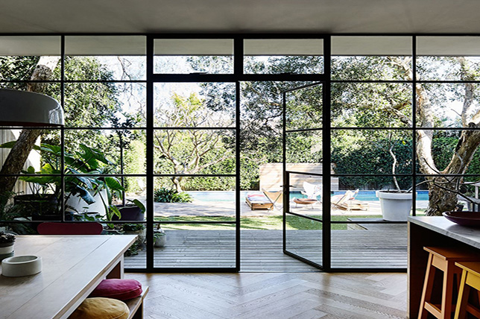
To embrace minimalist room ideas, here’s a brief look at everything you’ll want to highlight to inject your home with minimalist interior design instantly:
- Since minimalist design is all about bare-boned beauty, celebrate your homes architectural details by using them to your advantage by designing around them rather than concealing them.
- Simplicity and need go hand in hand with minimalist home design aesthetics with one never outweighing the other, as you’ll need to justify each elements existence when bringing in new items to keep a tight edit in check.
- Declutter as much as possible, invest in stylish storage and devise quick daily cleaning routes to keep with the design styles harmonious and practical spirit.
- Practice less is more, and live by it as this will always be the most trying yet rewarding aspect in mastering minimalist decor.
MINIMALIST STYLE COLORS
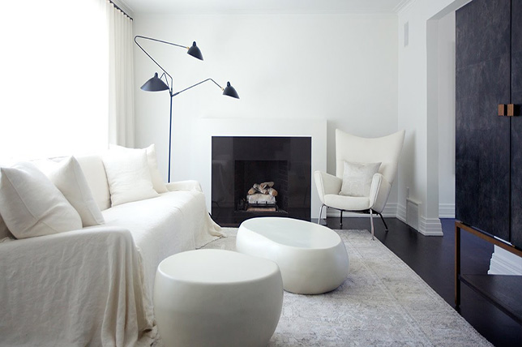
From a comforting oasis of a minimalist bedroom to common areas featuring stark simplicity, stick to a trio of hues per room that are just a few shades apart from each other for smooth consistency and a tight edit.
By creating a concise palette, you’ll have a better sense of direction in creating a well-edited, modern minimalist house grounded with neutrals that are easy to work with including whites, creams, blacks, and grays.
MINIMALIST STYLE FURNITURE
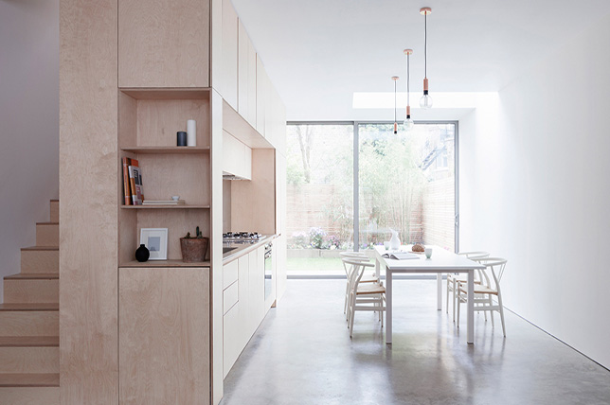
Create a mesmerizing minimalist interior with a thoughtful and considered assortment of furnishings to forge a well-balanced space that no one will want to leave. Do invest in quality minimalist home decor to get the most for your budget and as this is an utterly simple approach to interior design, you need each piece to stand on its own without attracting negative attention due to inferior construction or low-quality materials.
Skip trendy pieces that you’ll easily tire of and go for classics and future-heirlooms that will stand the test of time as the challenge with minimalist room decor is how little you have to work with, making each essential piece you do bring in all the more judged.
MINIMALIST STYLE TEXTILES
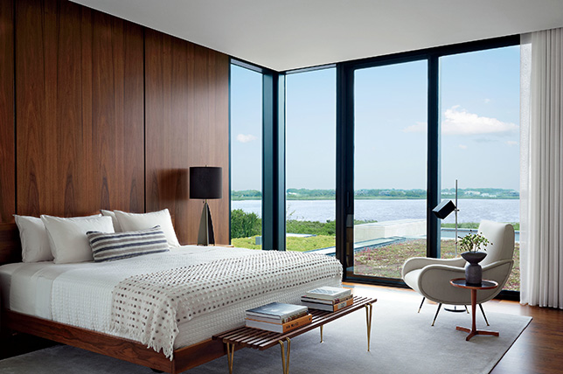
Every modern minimalist house should feature an array of tonal textiles and fabrications for quiet visual plays and for added warmth and richness throughout. Take in how the minimalist bedroom above may be utterly sparse, save for an alluring dotted throw and quilted duvet to catch the eye without coming off as heavy-handed.
For your own take on mastering minimalist interior design, stick to a core range of complementary hues and bring in the unexpected with furs, hides, and textured textiles for added interest. And when it comes to minimalist decor prints and patterns, opt for graphic extras in concise color schemes with ample negative space to keep the look light and fuss-free.
MINIMALIST STYLE ACCESSORIES
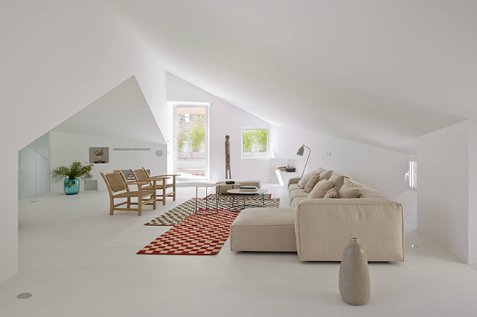
Just like with any design style, any modern minimalist house should boast its fair share of covetable, collectible accessories for shots of personality from room to room to ultimately make the space unique to you and unlike anyone else’s.
To get minimalist interior design right, use the less is more tactic and routinely edit pieces and swap them out from season to season to avoid a heavy, overstuffed and overstimulating effect. We love the gallery-like effect of the den above’s display of oversized vases set about as if they were bonafide pieces of artwork requiring a dedicated place in the spotlight, as nothing should come off as random.
MINIMALIST STYLE WINDOW TREATMENTS
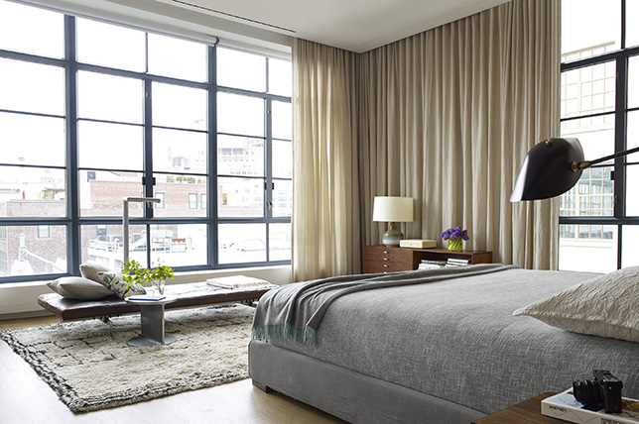
The minimalist bedroom featured above has curtains so universally appealing that they’ll add a sophisticated note to almost every design style possible.
Since they’re semi-sheer, dramatically floor to ceiling, in a warm neutral, and feature the simple, fluid lines central to minimalist design, we’d suggest giving similar options a go as they’ll work to add easy sophistication in any minimalist home while making each room appear larger.
MINIMALIST DECORATING STYLE ROOM BY ROOM:
From an envy-inducing minimalist bedroom to what it takes to create warmth with confidence, here’s everything you need to know to create pitch-perfect minimalist interior design broken down for you to take note of.
To embrace minimalist design, avoid the challenges of having so little to work with by buying quality over quantity and invest in classics that are both eye-catching and certain to keep their appeal for the long haul. The rule being that if an item doesn’t have a dedicated space for it then it must be deemed unnecessary.
Minimal Style Kitchen:
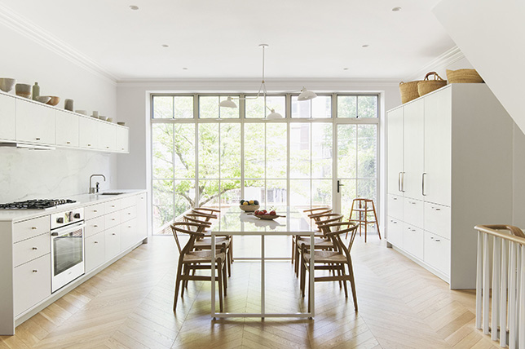
Because no minimalist home could be complete without a subtly sophisticated and distinctively modern kitchen, we’d suggest allocating a large portion of your minimalist interior design budget for this essential common room as it’s not as simple as it looks to get it right.
For starters, the spare simplicity of minimalist home design tends to highlight lower quality and poorly made features like no other so you’ll need to be sure that you source the best cabinetry and hardware you can for your budget. Once you’ve got bones of your minimalist design together, you can be more expressive with decorative touches to create depth and a studied sense of warmth.
To keep things bright and airy, Décor Aid interior designers swear by – you guessed it – a simple, black and white color palette with pops of color brought in through appliances and dishes while steering clear of superfluous clutter and unneeded prints and patterns. And along with well-crafted cabinetry, smart storage solutions are vital to keep surfaces organized and clutter-free.
Minimalist Style Dining Room:
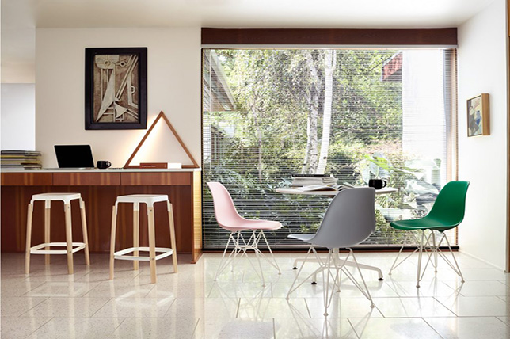
Not to be confused with on-trend yet tired takes on hotel style living, minimalist interior design calls for personality like any other design style, however in smaller doses for the right amount of quirk. We love how the minimalist design of the dining room here boasts a laid-back spirit with subtle design notes left to two simple pieces of graphic art, and colorful, mismatched seating.
Go a similar route and consider minimalist room ideas by injecting clever statement-making alternatives for seating, place settings, and accessories while keeping major furnishings like a dining table and buffet classically simple – standard, even. This will allow you the freedom to experiment without taking much risk as you can easily play with and switch out smaller items from time to time for a quick room refresh.

Minimalist Style Living Room:
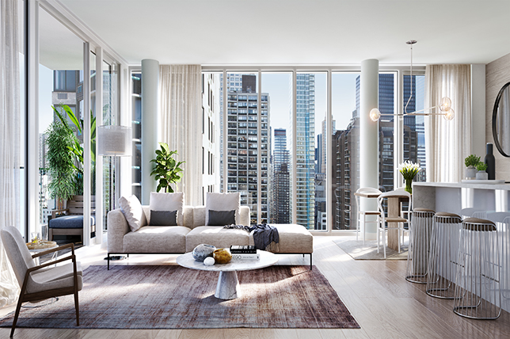
Create a feeling of laid-back luxury with a living room highlighting expertly curated minimalist decor and smart furnishing investments that are certain to never go out of style. For a maximal approach to minimalist interior design, don’t skimp out on necessary pieces to keep things spare for spare’s sake.
Instead, the real trick to creating a layered take on minimalist living lies in no-decor spots throughout a room such as the area behind the sofa above as another design style may call for taking full advantage of every spot possible. But when it comes to minimalist decor, the real beauty lies in the unspoken to let the eye home in on conversation-starting finds that’ll do all the talking.
Minimalist Style Bedroom:
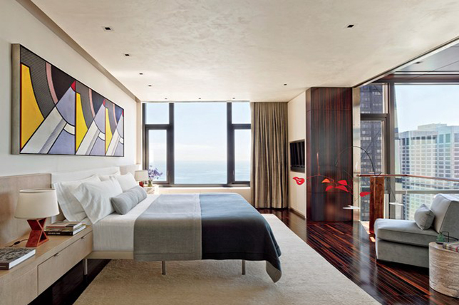
Create a masterful minimalist bedroom by sticking to symmetry, clean lines, simple silhouettes, luxe bedding, and again, just because the design style calls for minimalist interior design, that doesn’t mean you should be clinical with your approach.
Go ahead, have fun and experiment with a variety of unexpected elements not often associated with minimalist interior design so you can make it yours with your own unique stamp. Notice how the room illustrated here features a series of parallel lines and rectangular shapes that are in sync with one another while quick shots of expressive color are injected with playful art pieces for the ultimate gender-neutral statement.
Minimalist Style Bathroom:
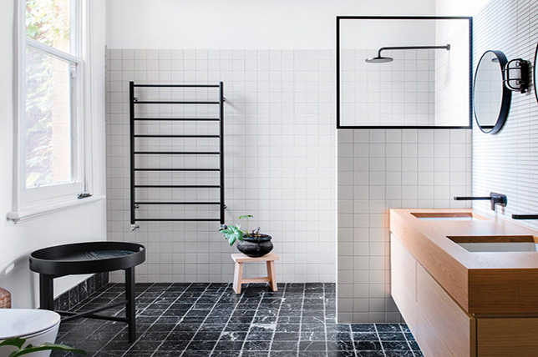
Just like a kitchen, when it comes to high traffic areas, storage is king when looking to create cohesive minimalist interior design throughout your home. And like we mentioned before, create a foundation for minimalist decor with a tight color palette of tonal shades kept to a maximum of three hues.
Note how straightforward yet full of charm the minimalist interior of the bathroom featured above comes off as via coordinating matte black accessories, clean, straight lines, and a black and white color palette with natural wood brought in for a sense of the organic. Follow suit and keep surfaces as unadorned as possible for a calming sense of cool.
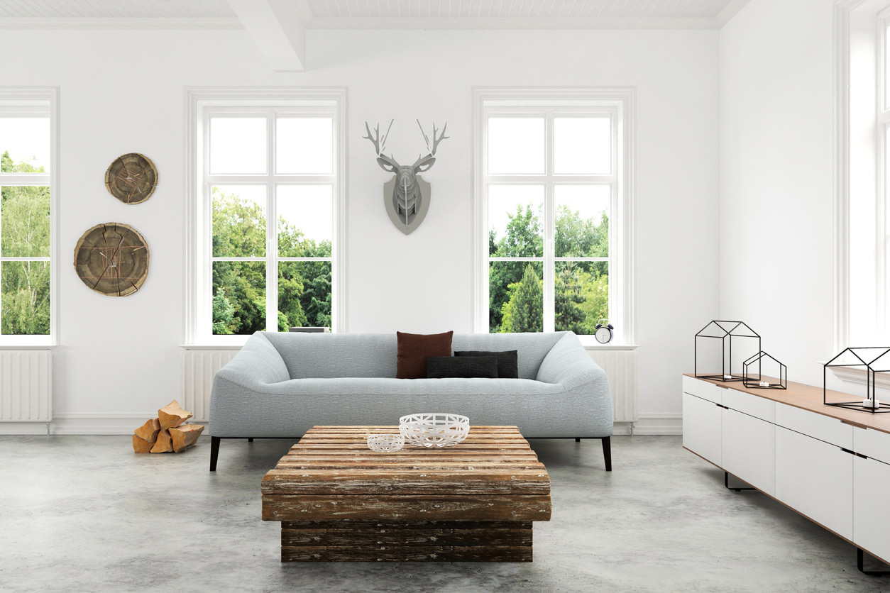
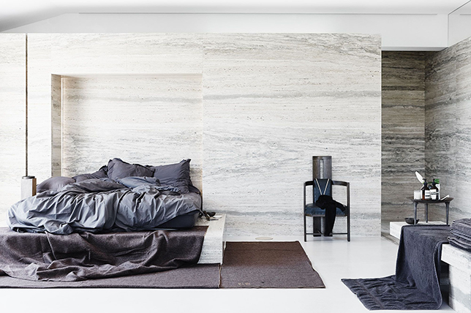
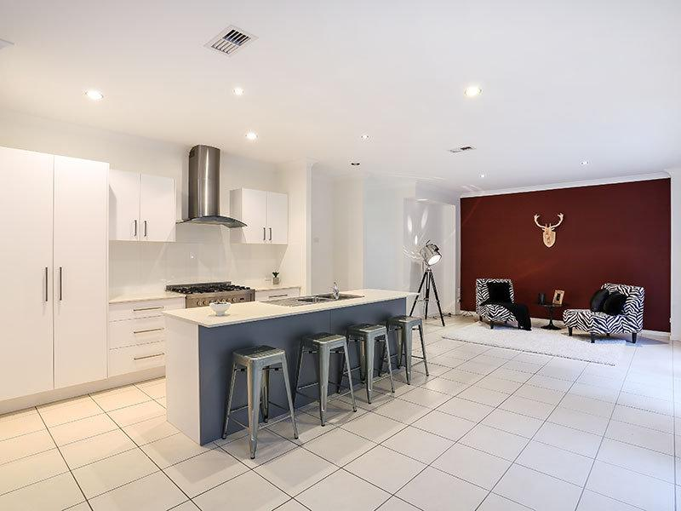
As the name evidently implies, minimalist interior designers are truly simple, low-key, and unfussy. They thrive on the principle that goes like; “less is more” so they take some of the best and simplest modern designs and simplify them even further
While not technically an established design style, we list it because it’s a style people look for. There are styles that are minimalist such as modern and midcentury design styles.
Minimal interior styles and designs consist of ultra-clean lines and streamlined furnishings that have nothing flamboyant or glitzy about them. They also pick on air and neutral color palettes that provide a great sense of warmth and coolness to the eyes.
The minimalist trend is believed to have been started sometime during the twentieth century and was initially influenced by the super simple and delicate Japanese designs. Modern minimalist interior designers always make use of black, white, and primary colors. Their designs are truly simplistic and nothing less than work of art.
4. Classic Style Interior Design:
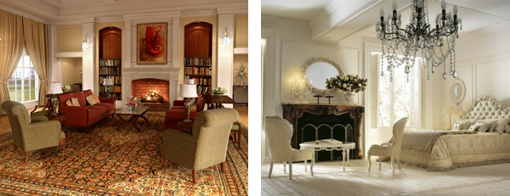
Classical Style Interior Design
Classical interior design is based on order, symmetry and balance which relates to the ideals of the Greek and Roman empires. A primary element in classical style is the use of a focal point around which visual balance is achieved, for example a feature fireplace flanked on either side by matching armchairs with an ornate mirror above. The colour palette common to classical interior design style is often inspired by nature. A variety of yellows, blues, greens, browns as well as softer, muted hues like terracottas, greys and pinks are commonly used. When accenting with whites, choose off-white if you want to stay in keeping with a more authentic classical colour palette. Choose bright white if you want a slightly more contemporary feel instead.
Fabrics used in classical interior design style tend to be elegant without being overly ornate or attention grabbing. Cotton, canvas and velvet are some commonly used in classic interiors. Natural flooring of wood, stone or marble works best in the classically styled environment as they relate well to the natural colour schemes used.
The key identifying feature of the classic style is symmetry with each side of the room mirrored on either side of a central focal point. Columns are also a feature of classic design, relating back to Greek and Roman architecture, and as such vertical, tone-on-tone stripes on the walls or curtains can represent this. The use of classical ornamentation can also be used to identify a room as being of the classical style.
To Recap, the main characteristics of the classic interior design style are...
- Order, symmetry and balance are key.
- Room ordered around a focal point, such as the fireplace.
- Natural colours and materials.
- Elegant fabrics.
5. Art Deco Style Interior Design:
Art Deco Furniture
The essential elements of Art Deco furniture were bold geometric shapes based on traditional forms. Materials were Pine or Maple for less expensive lacquered or painted pieces; Mahogany, Walnut, or more exotic woods for finer examples. Sometimes metal or glass. A thirties-style leather club chair, a streamlined birdseye maple bedroom set, or a black lacquered cocktail cabinet are all examples of classic Art Deco furniture. Shapes were strong and streamlined, and furniture was better as single pieces rather than co-ordinating suites.The popular lighting of the time was a female figure holding a glass ball which was lit. The glass of the time was not colored like Art Nouveau but sandblasted,or etched or enamelled.
Art Deco Color
Period colors were fantastic, contrasting combinations: black, chrome and white, yellow, red for hallways and living areas. Bedrooms favoured cream, beige, pale green. Painting design often included in strong geometric shapes. For best effect, this was paired with geometric-pattered rugs, faux leopard skin, and polished floors. Motifs were kept natural- shells, sunrises and flowers were popular. Fabrics were best in a plain or geometric design, and highlights added with cushions in solid blocks of color.
Art Deco Influences
Art Deco’s biggest influence was Art Nouveau. It kept the organic motifs, but discarded the flowing shapes and pastel shades for bolder materials and colors. The glamour of early Hollywood was also drawn into Art Deco design. Shining fabrics, careful lighting, mirrors, cocktail cabinets and smoking paraphernalia were very fashionable.
Famous Designers of the Art Deco Style
Eileen Gray– furniture
Raymond Templier- jewellery
Clarice Cliff- china
Wood Art Deco Furniture
Some furniture used rich hard woods like ebony or macassar, and also featured veneers, or very thin layers of wood used as a surface covering, of exotic woods like zebrawood and mahogany.
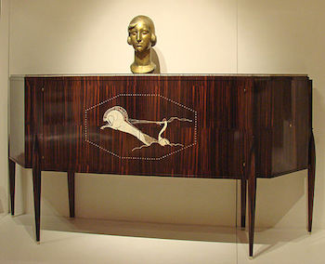
Cabinet made by J. E. Rhulmann, 1920s. This cabinet is a beautiful example of Rhulmann and his subtle use of wood grains and inlays to create a sophisticated and elegant design
Above is an an example of a cabinet by Jacques-Emile Rhulmann (1879-1933), a prominent early French Art Deco furniture designer. Rhulmann used exotic wood to great effect, allowing natural wood grains to emphasize the light linear quality of his designs. His pieces sometimes incorporate subtle curves and don't look bulky or heavy. Even his decorations, as in this example of an ivory inlay of a horse and woman, are sleek and geometric but elegant. Inlays, designs made by setting pieces of substances like ivory, brass or mother-of-pearl flush within a large surface, were a common element of Art Deco furniture.
High Contrast and Luxury Surfaces
Other Art Deco furniture incorporated modern materials like aluminum and chrome. Chairs, dressers and cabinets featured smooth, highly polished surfaces that reflected light, emphasizing their newness and modernity. Bold colors like black and red were popular. If the furniture was upholstered, it often used leather, shagreen (which is tanned shark or ray skin), or exotic furs.
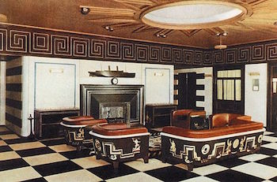
Interior of a first class smoking room from an ocean liner, 1928. The bold contrast between black and white, the leather upholstry, and strong geometric push of all decorative elements make this a textbook Art Deco interior
Above is an example of high contrast in color and style. The couch and chairs in this smoking room feature leather upholstery and bold black and white designs. The shapes are geometric but much heavier than Rhulmann's furniture.
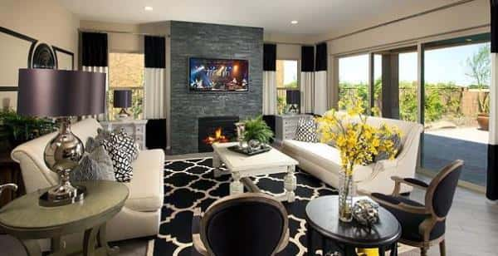
Annapolis Plan in Victoria, Queen Creek, Ariz., by Meritage Homes.
When thinking of the Art Deco style, think the Roaring ’20s. This style took off in the late 1920s to early ’30s and remained popular through the Great Depression due to the optimistic nature of the style and its simplicity. The style is suave and elegant with a forward mindset. Architectural characteristics focused on symmetry and geometrical shapes. Angular patterns and strong curves are apparent in both architecture and interior design.
Mood lighting is essential to the Art Deco style. Layered lighting with fixtures such as sconces direct light up or down to create a sultry and seductive glow. Shiny items and metals such as chrome and brass accent the sleekness of lacquered furniture, polished glass and metal accessories. Graphic patterns and sleek textiles make up most furniture designs and use materials such as vinyl, silk and satins. Patterns have geometric, rhythmic motifs and show a great amount of symmetry. While not the most common, animal prints can be used as well.
Color in Art Deco is most commonly black and white due to their classic, timeless nature, though bright colors such as peacock blues and regal purples are seen as well. A popular option is to use primarily black and white and apply a bright, contrasting accent color. Among the most popular accessories of the Art Deco style is the use of mirrors. Mirrored furniture and large ornate mirrors add to the glamor of the Art Deco style and react beautifully with mood lighting.
Distinguishing Elements:
- Strong Geometry: angular patterns, strong curves
- Heavy use of mirrors and mirrored furniture
- Iconic colors are black and white, though bright colors are used as contrasting accent color
- Sleek Surfaces: Lacquered wood, polished metal, glass and metal pieces
- Graphic patterns and sleek textiles in silk, vinyl, satin, etc.
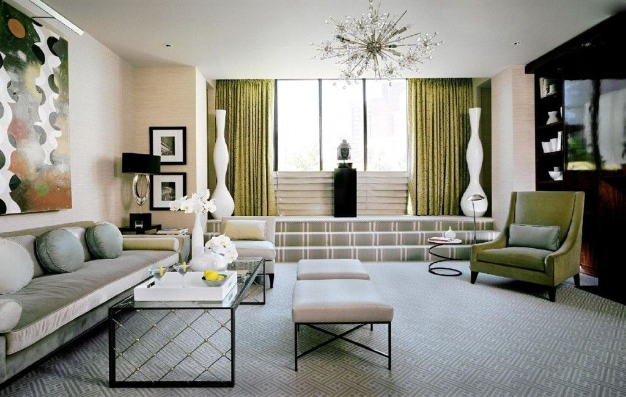
It is remarkable! Previously, Art Deco was called “sleek modernity ” or “modernity zigzag” or “jazz modernity.”
The main requirements in creating the interior in the style of Art Deco
- Houses in the style of Art Deco require compliance with certain rules of design:
- Firstly, all the furnishings (furniture Deco, accessories and materials used) should look presentable and expensive;
- Secondly, the room in the style of Art Deco should be styled in certain colors;
- Thirdly, the whole decor should be carefully selected. There must be recognized an Art Deco style in the interior, the room should not create the impression of chaos and “bad taste.”
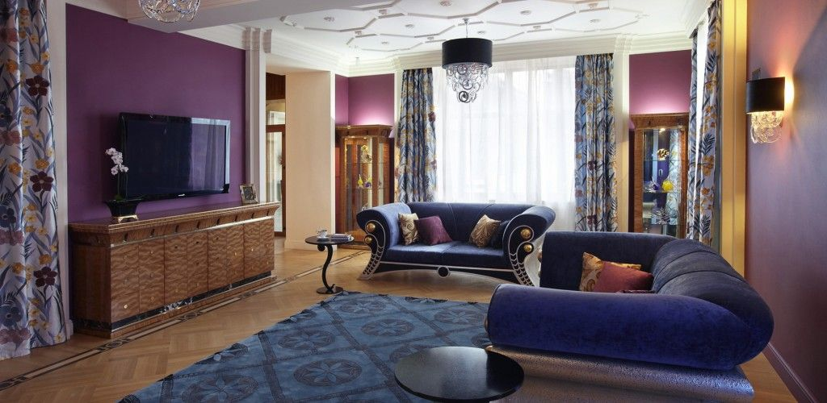
Characteristic features of Art Deco
- In the process of Art Deco interior design designers use the following elements:
- Motives of modernity: flowing lines which reminiscent the waves and floral forms;
- Valuable exotic materials: crocodile leather, ivory, pearls, precious wood;
- Custom paintings in Art Deco style with the image of women, desert and palm trees, dragons and other fantastic animals;
- Art Deco designs and Art Deco ornamentation are decorative fanciful, geometric, often constructed on the color contrast;
- Art Deco mirror is usually framed by massive frame of bronze color;
- Chandeliers are always luxurious, refined and quite voluminous.
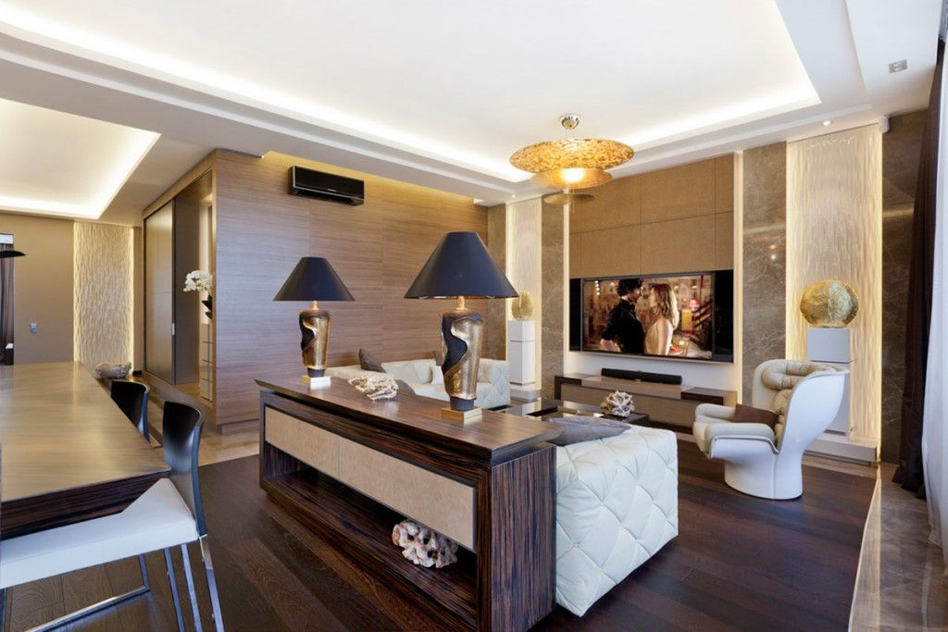
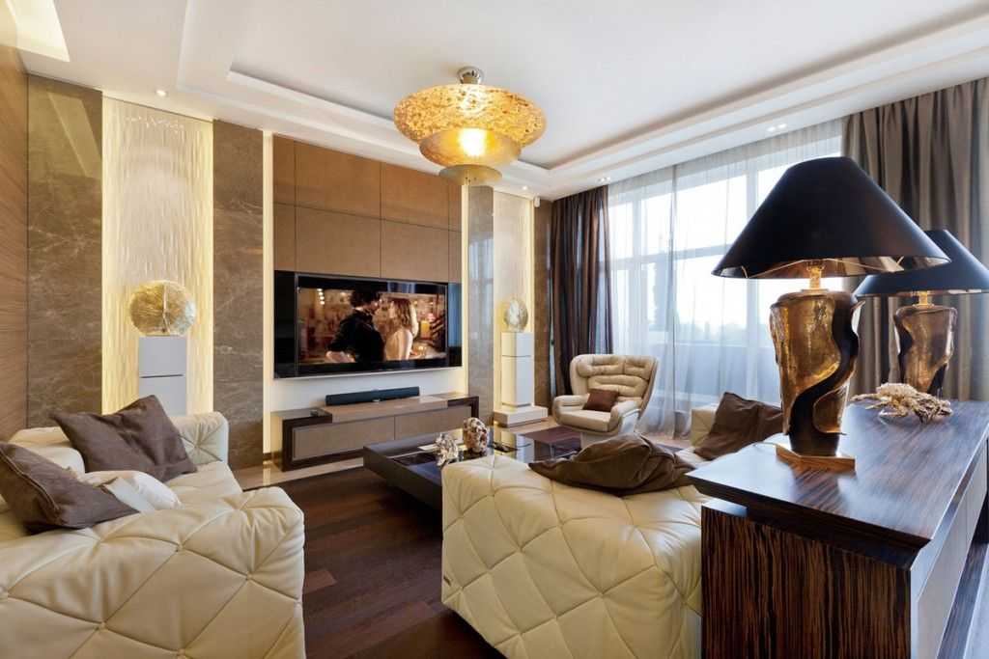
Dwelling premises in Art-Deco style. Interior details
Art Deco style in the interior of houses, cottages, apartments is quite popular today. Not only because of its eclecticism, but originally selected combinations of colors, intricate lines and clarity of forms.
- Art Deco can be brightly expressed in the interior of the bathroom through the use of contrasting tiles, mosaics, gold-plated and bronze accessories. Bathroom in the Art Deco style is the use of high-quality and expensive sanitary engineering, marble and precious stones. You can use vases with ornaments, fountains as accessories;
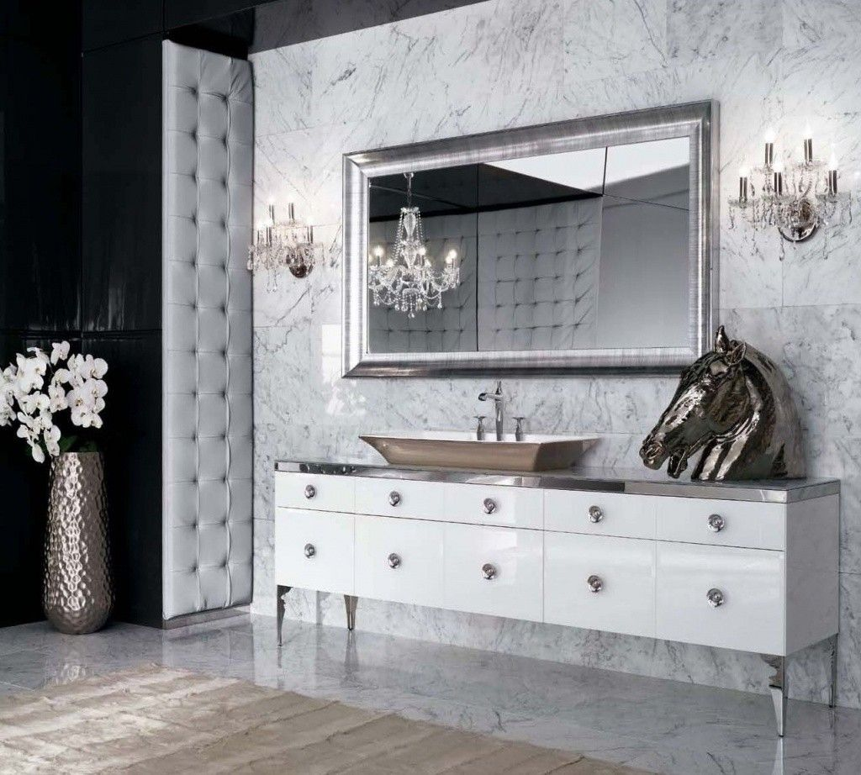
- The bedroom in the style of Art Deco involves the creation of a luxurious, but comfortable environment. “To set style” in the room help showy accessories, lamps, Art Deco and intelligently selected textiles. Curtains with drapes, silk or satin pillows and blankets will look excellent in the bedroom;
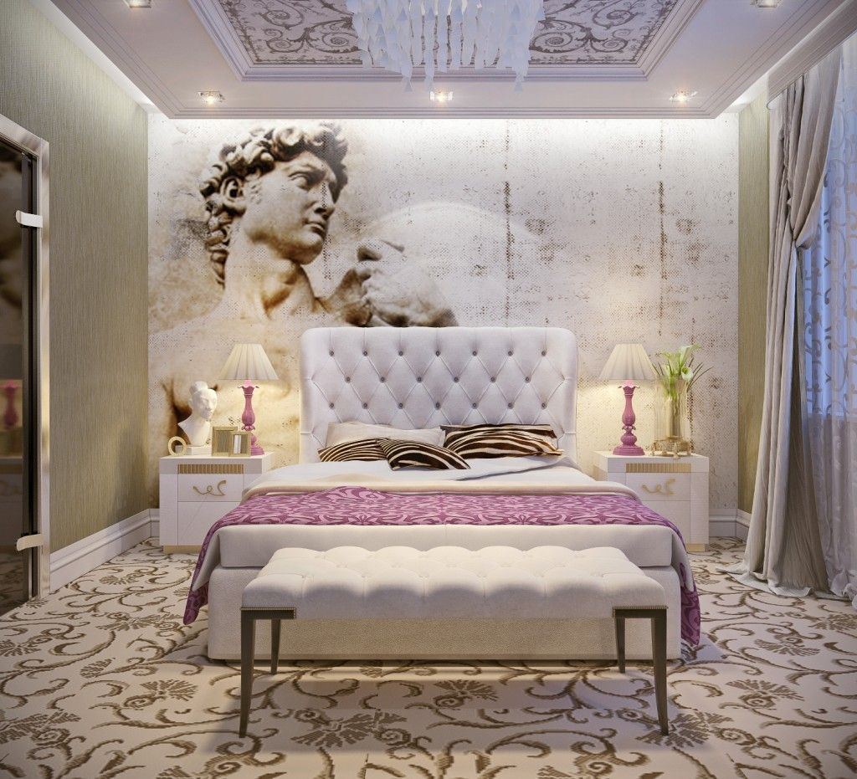
- Kitchen in the style of Art Deco can be decorated with silver-plated or gold-plated candlesticks, paintings and original vases. The facades of kitchen furniture are often made from natural wood and decorated with showy handles. The working surface may be made of natural marble or stone;
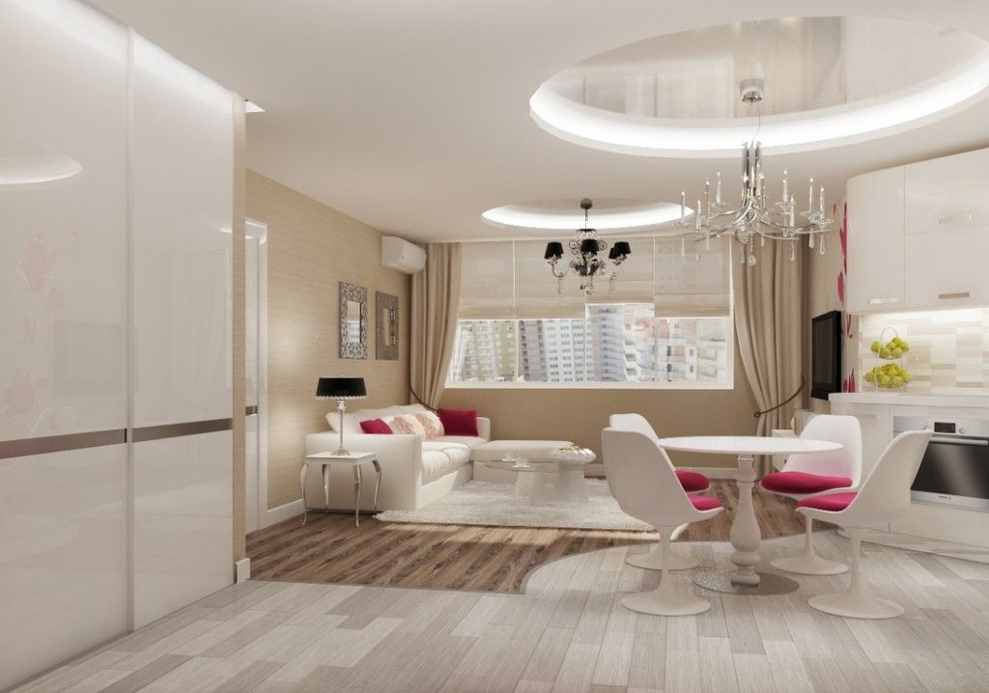
- Art Deco living room at the designing stage requires maximum attention, because this place is doing a great part of the free time. As an advocate of furniture with comfortable sofas and armchairs. As a rule, they are quite simple, and only emphasize the high cost of natural upholstery fabrics. Luxury handmade carpets, silk or velvet curtains, elegant light fixtures are decorating the interior of the living room.
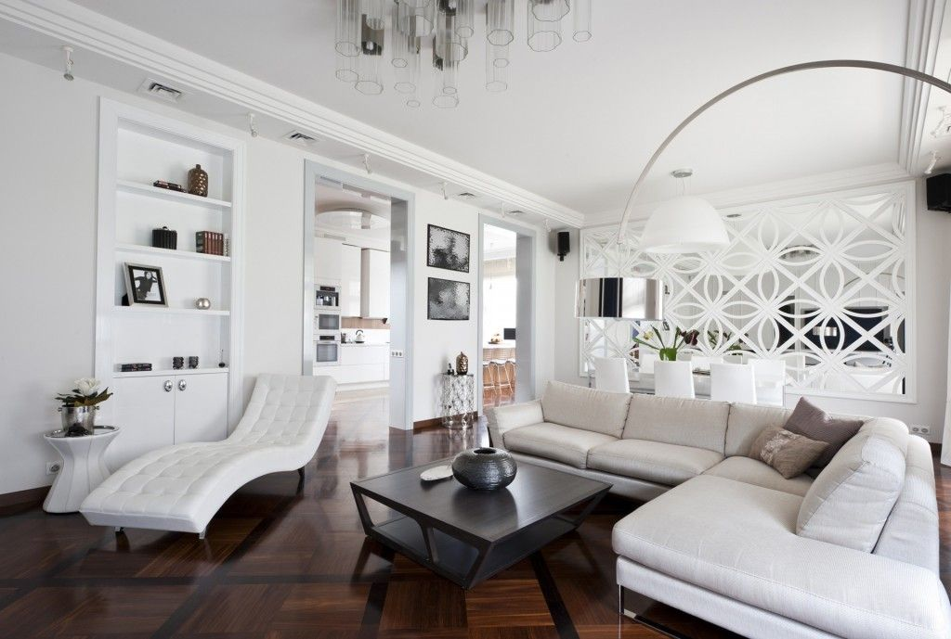
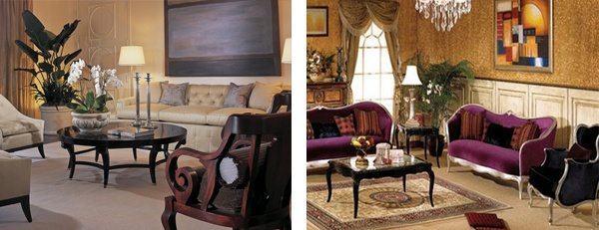
Art Deco Style Interior Design
The Art Deco style was developed following World War I, to offer people a new style for a new era. The excitement and optimism of post-war Europe and America formed the basis for this glamorous and elegant style of design. Art Deco furniture is streamlined in design. It was modern and sleek for the time while still remaining comfortable. Many designs of furniture used industrial materials such as bent chrome base that gives the piece a rocking effect. Wood pieces are highly lacquered in black, with woods used including exotic Brazilian rosewood, ebony, birds-eye maple, and light maple veneers. Upholstery is typically of velour, making the rigid structural form more comfortable.
Because Art Deco interiors were relatively minimalist for the time, colours are used sparingly. Most colour schemes include black, combined with another colour such as green, red or white while accent colours are usually chrome and/or gold. Pale blue or dove grey were also commonly used to provide a softening effect against the harsh black.
Art Deco lighting is extensive including ceiling lights, floor lamps, table lamps and wall lamps. Floor lamps include tall torchieres in wrought iron or chrome with hand blown glass shades. Some are also of black wrought iron. Table lamps of bright nickel with white, clear, frosted, or colourful glass shades are common. Wall lamps can be bronze, aluminium, steel, or silver plated base metal with opaque white or colourful glass shades. All this lighting is warm, usually orange or yellow in colour.
Surfaces in the Art Deco style are generally sleek and clean, lacking any texture in order to contrast the more decorative and ornate objects and furniture within the space. Mirrors made of nickel, chrome, or silver are decorated with motifs of deer, peacocks, roses, and geometric shapes. Bronze sculptures are sleek covered with coloured or pearl beads. Desk sets of pen and pencil on a base are streamlined in design. Door handles and candlesticks moulded of nickel, chrome, or silver have woodsy or chevron shapes. Frosted glass or black and white marble are used for vases. Inlay is common and adds colour and design. Cameo glass vases show under layers of colour exposed by etching away top layers of white or clear glass. All these decorative and slightly over the top objects were a show of renewed wealth and prosperity after the harsh rationing endured during the war.
To Recap, the main characteristics of the Art Deco interior design style are...
- Glamorous and elegant style.
- Industrial metals and lacquered wood.
- Black as a main or background colour.
- Numerous light sources used.
- Bold, colourful patterns.
- Intentionally, overly decorative.
6. Retro Style Interior Design:
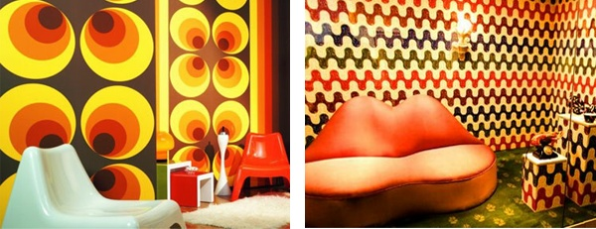
Retro Style Interior Design
Every few decades, old designs seems to make a comeback, but with a modern twist. This is referred to as the Retro style, and is an eclectic mix of old styles and new forms, or new forms with old materials and finishes. The post war fifties and psychedelic sixties saw a move towards brighter and bolder colours most likely as a backlash to doom and gloom of the war torn forties. Nowadays Retro interior designs can be described as taking a little bit of these features and bringing them back into the present in order to create a new style of interior design that is both modern and fun.
As there is so much to choose from past styles, what you decide to include will ultimately be your own interpretation of the past, and will therefore be entirely unique and individual. During each of the past few decades there have been different materials, shapes, colours, artefacts, and gadgets that have left a lasting impression on all of us, some of which may be significant in the memories from our childhood and may therefore be more suited for your personal Retro style. Nowadays, anything from the 50's, 60's or even the 70's is fashionable again. However, because there are so many different ways to go about incorporating a Retro interior style into your home, it can be difficult to recognize it when you see it. The key identifying feature can therefore only be described as an old style with a modern twist.
To Recap, the main characteristics of the retro interior design style are...
- Re imagined existing designs.
- Eclectic mix of materials.
- Classic objects used.
- Can be difficult to recognise.
7. Urban Style Interior Design:
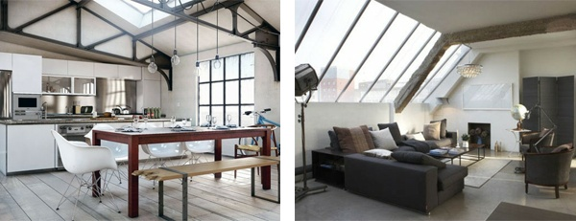
Urban Style Interior Design
Urban interiors feature non-traditional home materials and design features, often including objects that are more traditionally used in an industrial sense. The Urban style sees the use of galvanised steel, concrete floors, metal siding, exposed beams and unfinished surfaces to create a distinctly modern, bohemian look. Often random, non functional (in household terms) objects are included in Urban interiors to create an outdoor or industrial atmosphere. In more up scale urban interiors, however, the look is far more polished, with bespoke fixtures, sophisticated finishes and clever small space solutions, such as open floor plans that allow for multi-functional rooms.
This alludes to the central function of urban interiors which is to create space, sometimes in surprising ways. Combination living/working spaces have become traditional in inner cities and industrial areas, often referred to as studio apartments. Renovated warehouses might feature a concrete floor for large scale artwork or production and an upper loft for a living space. Industrial building converted into high-rise apartments, up scale condominiums and mixed-use buildings are other innovations to urban living spaces and rather that fighting the existing industrial feature within these spaces Urban interior design embraces them.
To Recap, the main characteristics of the urban interior design style are...
- Use of industrial materials.
- Exposed structural materials used as a feature.
- Unique (non functional) objects used as features.
- Aims to create open space.
- Often seen in converted buildings.
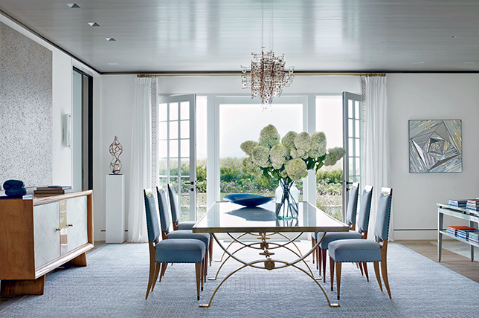
Perfect for sophisticated city dwellers, urban modern design style is the ultimate for cosmopolitan living – with nods to contemporary, modern and industrial influences, this elevated design style stands on its own. Always on trend thanks to its enviable emphasis on comfort and takes on glamorous city life – it also makes for a savvy route to create your own oasis in the city.
This decorative style is also great for an industrial loft or an modern apartment overlooking the rooftops of the city. Think light and airy spaces that take full advantage of architectural drama realized with visionary furnishings and sumptuous decor. To illustrate our take on urban modern decor styling, we’re serving a comprehensive guide breaking down the design style with cues from our decorators and their projects.
SOFTEN IT UP
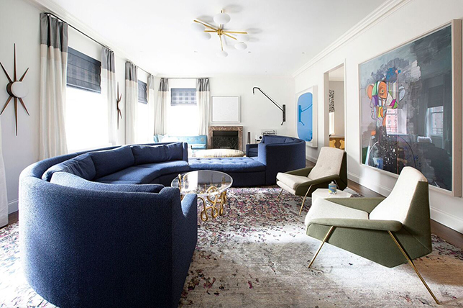
Spirited urban modern interior design is contemporary and industrial at its core, but not as aggressively so as a completely ultra-modern or decidedly industrial design. Urban modern decor often has a softer side to it; from warmer tones to highly designed furnishings to relaxed soft furnishings, urban interior decorating places equal focus on comfort and brilliant design.
Source one-off and complimentary design styles to pull a room together with cosmopolitan influence, while keeping it warm and inviting at the same time with minimal features softened by plush fabrications and rugs. This is a trusted method to keep your home feeling more playful, unique, and intoxicating in ways that ultra-modern and industrial designs are limited to.
CALMING TONES AND HUES
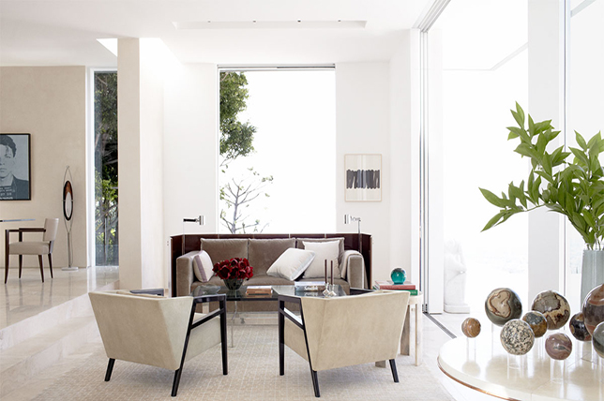
Urban modern style is all about creating a soothing and serene yet gorgeously decorated home featuring a lived-in sense of charm for everyday life. By using neutrals and introducing warm tones you’ll feel at home and inspired to make the most of your urban modern design direction.
Paint a feature wall, recess or alcove a warm and inviting color to avoid what might otherwise feel like an overly industrial space. This design is thoroughly modern in spirit, and neutrals are an essential way to ground and tie everything together.
PLAY WITH SCALE
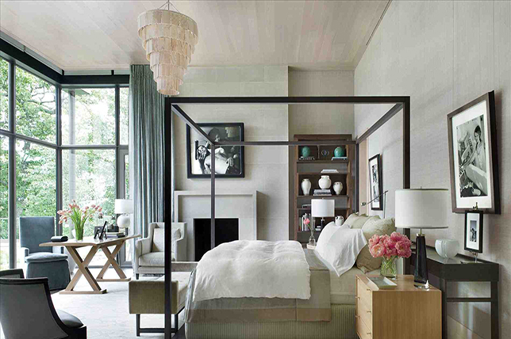
Playing with scale is a quick way to introduce interesting elements to urban modern decor without having to use a ton of various, mismatched notes. Bright tones can throw off industrial, urban vibes – but you still need a way to please the eye and keep your design vibrant.
Here’s where playing with scale comes in. Introduce oversized pieces paired with the petite, such as lighting or art for nuanced contrasts. And do play with rich mixes and experiment to ensure that your take on urban modern interior design feels exclusive to you.
SOFT FURNISHINGS
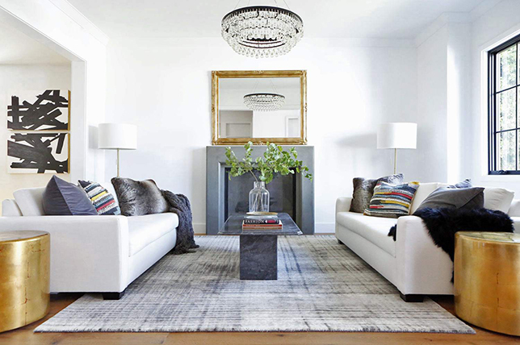
No urban modern bedroom or urban modern living room would be complete without comfortable home furnishings to soften and complete the look. Think rugs made out of natural materials in warm tones over white, gray, or wood flooring. Select natural colored throws and pillows to house on your sofa (in browns, creams, and grays) to tie in more industrial urban interior design concepts and elements.
Select extras like petite stools and side chairs in deep tones such as greens and blues to bring in additional hits of color and a feel of grown-up luxury in your space. Another way to make any room feel more elevated is to add metallic tones, such as gold and bronze, and of course mirrors, throughout your home.
URBAN MODERN ACCESSORIES
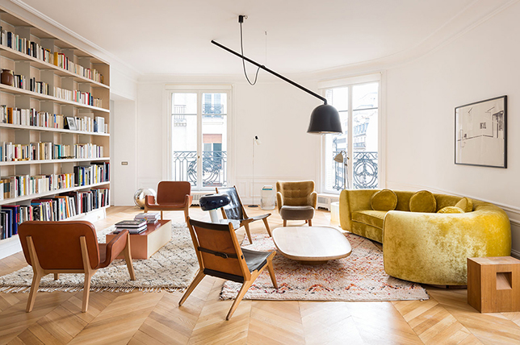
Introduce plants and botanicals for a hint of the organic and natural mixed with urban modern decor to keep the entire space light and refreshing. This also makes for an affordable way bring in color if you haven’t already done so.
Though you don’t want your space to come off as a bare-boned minimal one, keep accessories to a minimum while homing in on urban modern design that does boast personality and charm in small doses. Be sure that the decorative objects you do display are functional and purposeful as well as being beautiful additions to complete your hand at mastering urban modern style.
SUBTLE CONTINUITY
You don’t want each room to look the same, but you do want there to be a level of continuity between rooms so they flow nicely and don’t come off as disjointed. A clever and subtle way to create consistency between rooms in your home is to use a common color in your urban modern home to tie everything together.
This could be the color of your walls, the color of your furnishings or it can come through via a selection of complimentary fabrications. If you don’t want to be obvious with matching colors throughout, do use a pattern or a texture in the same way. This is a great way to create a common foundation between rooms to keep modern urban interior design ideas in sync with one another.

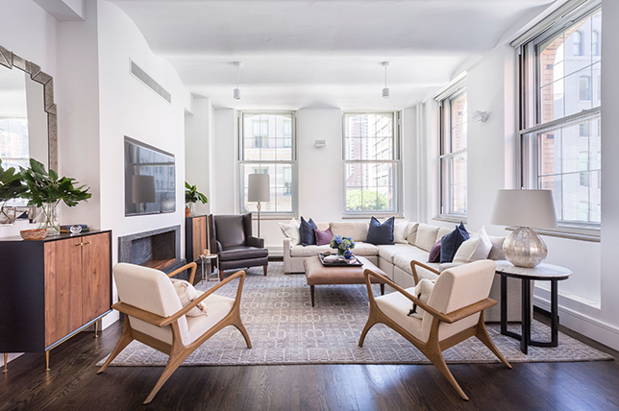
MAKE STATEMENTS
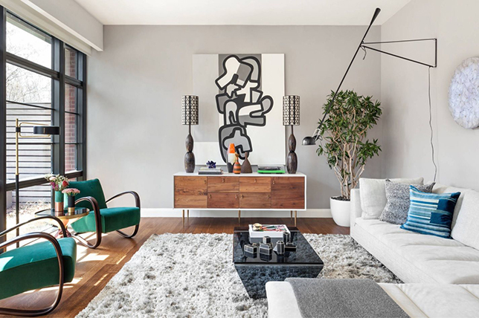
Making a distinct statement is key to adding personality to urban modern style. Each room should have at least one statement piece; whether that’s a piece of art, furnishings boasting a bold pattern or vibrant color, or intriguing lighting. That said, a statement piece needn’t be ostentatious as long as your room has an interesting element to it that makes it unique, you’re making a substantial enough of a statement.
You want there to be a talking point in your design and that could just as easily be a floor to ceiling window framed by a beautiful pair of curtains, a stunning piece of abstract art, or a fantastic vintage find full of character.
8. Country Style Interior Design:
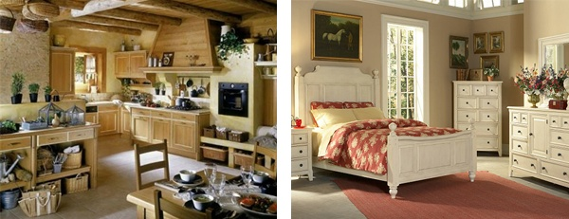
Country Style Interior Design
Country style interior design is cosy bearing the resemblance of cottage style. There are many various culturally different country style designs that have the features of the time and style that was traditional to those countries. Thus you may find such country style types as French country, English country, American country, Italian country or Tuscan, and Modern country. Each type of country style has taken characteristic features of the culture it was used in. English country is relaxed and comfortable incorporating many floral patterns as well as stripes and plaids. Natural light wood, such as oak, is used throughout the English country styles. Open space is not considered important in the country style with large furniture pieces often dominating a space with the walls often decorated with a variety of pictures, utensils or other objects.
French country style is characterized by deep and bright colours - aubergine, lavender, yellow, azure blue. colours are built into floral and animal patterns. The furniture is robust and basic. Italian country style, also known as Tuscan is warm and rustic. It incorporates such colours as ochre, terracotta, golden yellow, and green. The flooring and fireplaces are made of natural stone. Unfinished wooden pieces and textured walls accentuate the rustic feel. American country style has its main feature in simplicity. The furniture can be stained, painted or unfinished. Modern country style has an updated look. Incorporating modern art, furniture or lighting into the traditional design makes it more up to date but still cosy and lived-in.

To Recap, the main characteristics of the country interior design style are...
- Cosy and comfortable but sometimes cluttered.
- Traditional to the context, e.g. French Country, American Country etc.
- Natural and floral patterns used with plaids and stripes.
- Robust, bulky furniture.
- Rough finishes on materials.

- French Country Furniture
If you're going on a picnic, you don't take the entire dining room table with you. You take something more appropriate, like a picnic blanket. Of course, if you're still trying to impress someone, you could always consider upgrading the blanket to a fine tablecloth or silk sheet.
Furniture is very similar. In most European-based traditions, furniture styles are defined by an urban aristocracy. These styles are made for cities like Paris, but what if you want to travel to your country home for the weekend? Your urban furniture won't quite fit into rural life, so you need something more rustic. That doesn't mean, however, that the rules of style cease to matter. This is where we find French country furniture. It's a style with all the elegance you'd need, but simplified and rustic enough to fit into the countryside.
History and Definition
When we're talking about French country furniture, we aren't always talking about a single and precise style. Really, through all of French history, the rural provinces created and consumed furniture that emulated urban trends, but in simpler versions. Provincial furniture tends to be less ornate, with fewer ornaments and additions like veneers or metal fixings. Woods tend to be local walnut, oak, or fruitwood.
That being said, there are a few times that more unified French country styles emerged. The first was in the 17th-century, under the reign of Louis XIII (1610-1640). Louis XIII era furniture was big and solid but opulent and decorative, with geometric carvings, cherubs, and organic motifs.
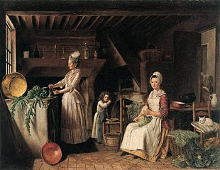
Provincial life carried different demands than urban life
What makes this era significant is the first appearance of a strong middle class in France, particularly in the provinces. These people were not the aristocrats of Paris, but they had enough wealth to envision a more comfortable quality of life and to participate in stylistic trends. This was the first true period of French country furniture, as the Baroque Louis XIII style was recreated in simpler, less ornate iterations. While less decorated, however, this provincial furniture was still elegant and stylish and maintained the basic forms and attitudes of Louis XIII furniture.
The 18th-Century French Country Style
The other era in which a more defined French country style emerged was a little under a century later, in the 18th-century. For many people today, this is the type of French country furniture that first comes to mind.
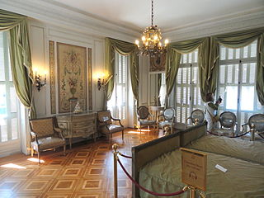
Provincial interiors tended to be a little more open, even in very refined and wealthy country villas like this
Aristocratic life in this time was encapsulated within the Regence and Louis XV styles of design. These styles were lighter in color and visual weight than 17th-century designs but were just as opulent and lavishly decorated. We can roughly term this the Rococo style, and it was all the rage among the aristocracy.
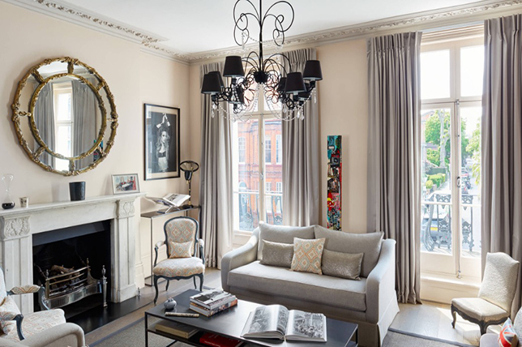
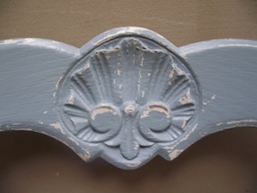
Decoration in French country furniture was often limited and reduced to a few important motifs like the seashell
French Country Decorating Style
If you are a fan of the French Country decorating style you are someone who puts comfort above all else. This is a great way to decorate your entire home or just one room if you need to take it slow and acquire one item or do one project at time. A lot of the furniture and items you will use can be found at flea markets and thrift stores and you re-purpose them. Dumpster diving and going to garage sales and flea markets can take a lot of time during the weekends when the weather permits. If you are patient, you will find just what you need. However, you can purchase French Country pieces new as well.
The good news for novice decorators is the French Country decorating style has no rules set in stone. There are suggestions, of course. But you are free to use your whimsy. The only rule is that a guest feels welcomed when they enter your home. They feel the warmth of friendship and hospitality. They know they are accepted in their jeans and sweat shirts as well as Sunday best.
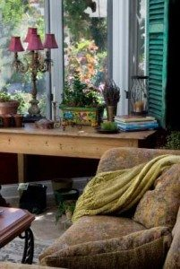
French Country Decorating
Begin with the ambiance of the French countryside and what you would expect to see in and around a French cottage. Outside there may be pastures or vineyards with plenty of green grass and wild flowers. The sky will be a beautiful clear blue and the sun is shining. Inside you will be greeted by the aroma of baking bread and glimpse the top of the kitchen table with bowls of fresh fruit and another basket of fresh eggs. The kitchen will be the heart of the home which extends into the living room and dining areas.
There are predominant colors used throughout the French country decorating style. These colors are taken from the world around the cottage. They will be inspired by nature like sky blues, greens, sunny yellows and muted golds. Since a farmer uses everything with a purpose, you will find autumn colors like the golden rust and orange from the harvest. The colors are shown to perfection with the use of natural textures. Woodwork will look distressed as will the stucco walls. This effect is easy to achieve with several paint hues. Allow your paint store of choice to give you some simple suggestions.
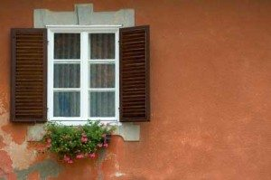
French Country Shutters
Since the wood furniture has been around for generations, it is distressed as well. This is where your flea market and thrift store finds will come in handy. In the French countryside it is common to discover dining room tables that have been painted as well as shelving, different styled chairs around the table, book cases, occasional tables, and bedroom furniture – anything wooden. For the dining room it would be appropriate to paint the chairs the same color as the table; however, you would want vintage-looking cushions in vibrant colors that pick up the table and chair color.
You may be thinking that you have quite a lot of this all ready. That is the idea. You do not have to make everything brand new. It’s a matter of combining colors, patterns, textures and lighting to feel lived-in and welcoming. If your sofa and living room chairs are in more modern, conventional upholstery, simply purchase slip covers in a French country decorating style. This would incorporate a few ruffles here and there and plenty of fabric activity like checks or florals. One look you will never see in a French cottage is something that is trendy or in vogue. (The laptop will be hidden somewhere!)
There are more items you can add one at a time to bring in the French country decorating style. Cast iron light fixtures, while heavy, will add to the aged look of the room or home. Items like book ends that have been painted black will stand out on the brightly colored occasional table. A traveling trunk with rusted metal hinges can serve as a cocktail table. If you have a fireplace it is easy to install a plank or beam at the top of the unit to serve as a mantel piece. Hanging copper pots or black iron accessories will give it the ‘home and hearth’ look.
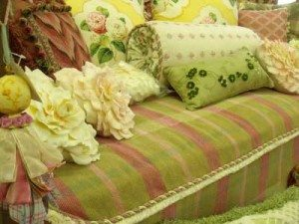
French Country Colors and Fabrics
For the window coverings shutters were and are used as well as sheer panels. If you use sheers or half-shutters you can hang a valance at the top of the window in interesting colors and patterns. Most of the time the floors were made from tiles because tile was less expensive and tiles were easier to clean when the farm or vineyard workers came in from the fields. However, you could count on vibrant but well-worn area rugs to add to the comfort of the home. Adding more interest to the interior of the cottage would be items that were made to depict everyday living objects such as farm roosters, sunflowers, grapes and greenery.
Where your flea market and thrift store really comes in handy is when you are looking for pictures for your wall. In the French country decorating style there would be numerous old-looking paintings of pastoral scenes, wooden bowls of grapes and fruit or pictures of people working the vineyards.
In adding a finishing touch to any room, don’t forget the ceramic water pitcher holding a bouquet of wild and garden flowers. Real flowers and greenery are an essential of cottage design. The flowers bring in lasting scents of the sunny outside that blend well with the freshly baked bread. Everything says, “Bonjour!”
French Country Decor Defined And How To Make It Yours
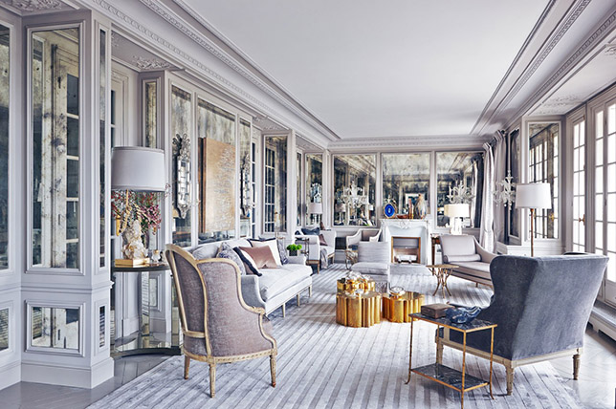
Though French country style has fallen out of popularity in recent years; being replaced by ultra-modern designs featuring abstract lines and bright pops of color, there’s something interesting about reconsidering the design style for the here and now. And since we think it’s time French country decor made a comeback due to its charming feel and warm spirit, there’s something to be said about going against the norm and opting for French country style in your home. From the more traditional feel to a more modern take on French country decor, there’s something to suit every home with easy style that’s timeless while radiating lived-in luxury.
As part of our design style series and to get you inspired for a romantic home refresh that evokes everyday provincial glamor, we turned to Décor Aid interior designers to help us craft the ultimate French country decor guide, which comprehensively breaks down everything you need to know about creating the perfect French country look with ease.
Color Schemes
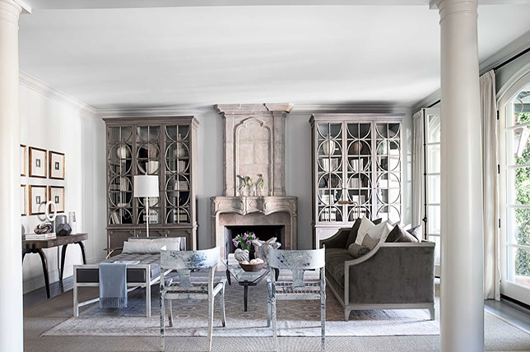
Color schemes for this style radiate warmth and subtlety. You want the palette to be the complete opposite of the ultra-modern, minimal hues of late. Choose warm neutrals with a relaxed and welcoming feel about them as this look is all about being cozy and comfortable with a refined bent.
When you walk into French country homes, you’ll be sure to notice that you instantly feel at ease in your surroundings and this just maybe, the most enduring characteristic of French country interior design, and why it feels so right for right now.
Dominant shades should be neutral and do invite an element of history into your home – think antiqued white finishes and time-worn patinas as well as fresh powdery pastels, varying shades of greige, and muted greens like a muddy olive and pale sage.
Furniture by Room
An essential element of French country style furniture is languid, relaxed lines and silhouettes boasting natural materials and a lived-in feel. Well-loved furnishings with a distressed finish look perfect for this style of decor as they needn’t be ostentatious, and should instead be simple and rustic, with hints of the ornate.
Do introduce wood and natural furnishings and contrast neutral-toned walls with darker pieces of furniture for a moody juxtaposition and added visual interest. To get you started, here’s a break down of everything you need to know from room to room:
Bathroom
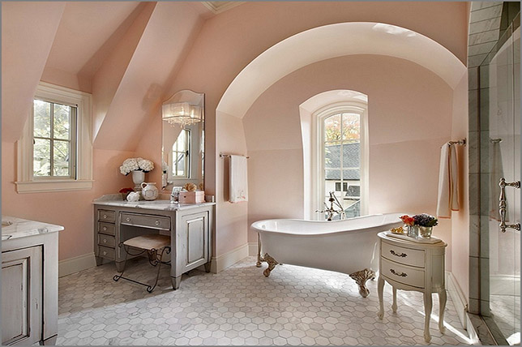
For an authentic French country bathroom, bring in the sweeping lines of a vintage-inspired claw foot bathtub placed atop a neutral tiled or stone floor. Also introduce elegance and character with handsome cast iron accessories juxtaposed with a natural woven bath mat and fresh, bright white towels.

Bedroom
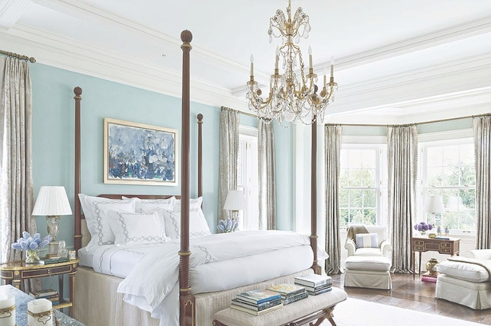
No French country bedroom is complete without a dramatic four-poster bed – if you can get one and its scale works in your favor. Opt for dark wood and an ornate nightstand to bring everything together.
And if your bedroom boasts wood flooring, create contrasts with simple yet refreshing cream or white bed linens and break it up with natural wool, linen or cotton rugs in neutral tones for added texture, luxury, and softness.
Dining Room
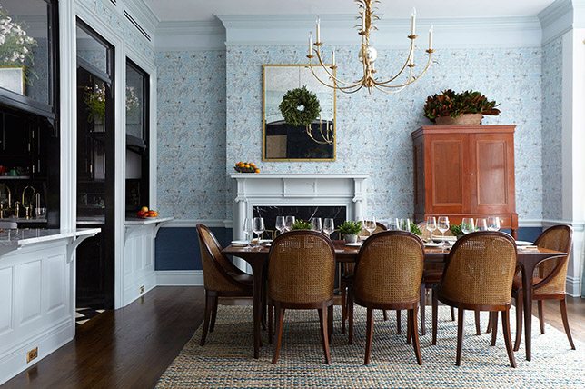
The main focal point of a French country dining room, like with any style, is often a large, dramatic dining table. For a more casual approach to French country style, select a table with a low-sheen finish to emphasize the design styles relaxed and quirky spirit.
For a more luxurious take, opt for a high sheen finish in a dark wood and pair it with curved occasional chairs with ornate carved and gilt detailing fit with an unexpected, rugged upholstery.
Kitchen
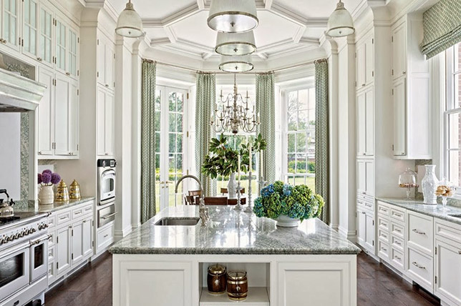
French country kitchen decor places pride in the process of cooking by prominently featuring cookware and dining ware as a main focal point. If you have space, consider a beautiful glass armoire to display plates and dishes as decorative elements.
Go for bright cream tones, copper accents, and jewel-toned accessories for a rich, celebratory vibe.
Living Room
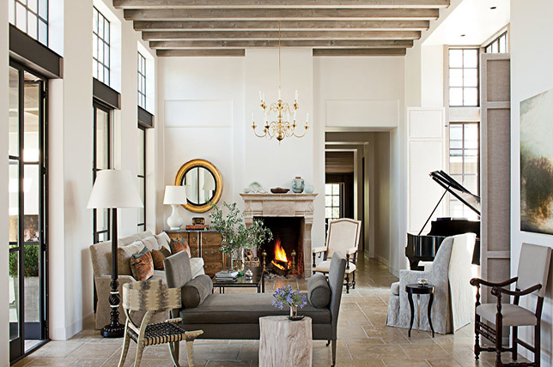
A French country living room should always boast plays on upholstery, a juxtaposition of furnishings, and offbeat extras – albeit all comfortable and plush. The room above is a perfect case in point as every piece looks as if its chalk full of intriguing personal history which altogether make for an utterly chic, yet simple common room we’d never want to leave.
For an alternative take on modern French country decor, go for a mix of tonal neutral hues and micro-patterns for a warm minimal direction that you can easily change. And since toile curtains are often a requisite in French country decor and look stunning against a neutral backdrop, they make for a considerable option.
Materials
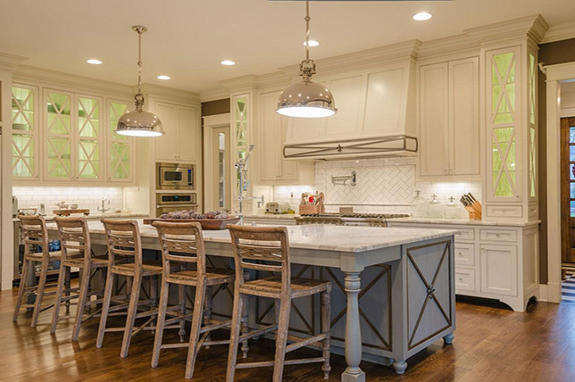
French country style homes often feature natural materials, from wooden floors and exposed wooden beams to woven rattan café seating and cotton rugs. Embrace common natural materials to create a varied, nuanced take on French country interior design that will be exclusive to you.
Natural stone and marble surfaces and floors also look stunning in French country kitchens in light tones, as do brass accents and reflective finishes.
Finishes
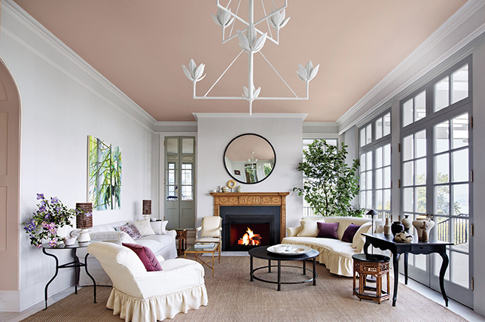
As French country decor elicits the traditional and familiar, skip on having too many pieces that look fresh out of a showroom – they should look as if they’ve lived well and have been loved over time in idyllic French country homes.
Antique furniture works well for this, or take a modern French country style approach with a relaxed yet polished shabby chic feel where distressed finishes and natural stains also work well.
Accessorizing
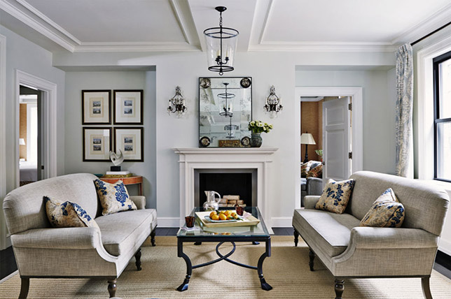
Toile (which is most often a floral-patterned fabric) is great for soft furnishings and also makes for a stunning fabrication for curtains, sofas, cushions, and armchairs. If your French country decor lends itself to something a little more luxurious, upholster a sofa and have cushion covers made in a matching toile fabric. If that would be too much for your approach to a French country living room, save it for pillows and throws.
French country homes wouldn’t be complete without traditional ornate touches finishing off a room. Whether that’s a chandelier or an intricately carved mirror brought into your French country bedroom, those gilt, polished touches make all the difference. Iron decorative items also add visual drama to French country decor and baskets and colorful ceramics will make your home feel more personalized and playful.
Moody, dark, and colorful paintings are sure to add depth, a sense of history, and even whimsy in a well-considered French country living room and scenic prints look great in a French country bedroom, study, and hallway. To emphasize the nation’s love for provincial life, bring in topiaries and vases of bulbous, uncut flowers – which French country homes are never without.

9. Rococo Style Interior Design:

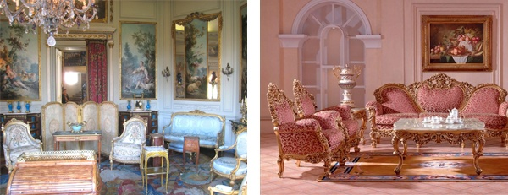
Rococo Style Interior Design
The Rococo style of interior design is flamboyant and rich with intricate and ornate features. Rococo style peaked during 1700 and 1780 in western Europe and the name Rococo means 'rocaille' in French, which is appropriate as the Rococo's ornate asymmetry was inspired by natural curves of trees, shells, clouds and flowers. Gold plasterwork is one of the key features of Rococo decorating style with lavishly decorated walls and ceilings featuring the contrast of pastels and gold. The use of mirrors was also a feature of Rococo Interiors and they were usually had intricately-shaped, gilded frames.
Rococo furniture is made of mahogany wood or gilded and upholstered in leather, brocade or velour. It also has carved and sinuous silhouettes that compliment the wall and ceiling finishing, which strengthened the ornate theme. Rococo was known for such colours as yellow, pink, ivory and gold, azure blue and cream. The combination of pastels and gold is a signature mark of this style. Rococo style favoured curved lines so previously used asymmetrical square lines and forms were replaced with circular, oval, spiral and natural forms, even rooms were designed in oval shape or arranged to avoid square form.
To Recap, the main characteristics of the rococo interior design style are...
- Flamboyant and rich.
- Lots of intricate, ornate, decorative features.
- Gold painted plasterwork contrasting with pastel wall colours.
- Multiple ornate mirrors commonly used.
- Expensive materials used in furniture, e.g. teak and mahogany.
- Curves, spirals and ovals are dominant.

10. Georgian Style Interior Design:
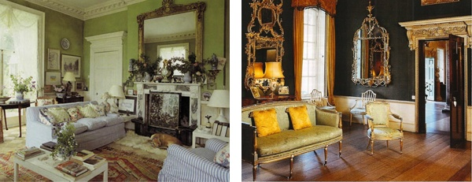
Georgian Style Interior Design
Early Georgian style was the tail-end of Queen Anne design, and this gradually became more severe in its lines and architectural detail. The style was copied from Ancient Greece and Rome, however a lot of Chinese design showed through in the interior. Chinese motifs like peonies and chrysanthemums were found in the fabric and Chinese porcelain and motif table lamps were common. colour schemes were pale and subtle cream, dusky rose, sage, pea green, powder blue. Florals were also found, and in more grander houses, gold and murals were the preferred wall coverings. Upholstery and curtains often had matching fabric.
The Georgian interior design style is characterized by delicate furniture with elaborately carved cabriolet legs, ball-and-claw feet, broken pediments, ornate carvings, piercing and gilding. Fabrics were luxurious, with colours and patterns kept subtle. A royal style extended into common houses with cabriolet legs and claw feet on chairs and baths creating an almost throne-like feel. Mahogany slowly replaced walnut as the wood of choice. The fireplace was the heart of the room and was often fully outfitted with cast iron, carved pillars and medallions, and an opulent fire screen.
To Recap, the main characteristics of the Georgian interior design style are...
- Copied from Ancient Greece and Rome but with Chinese influences.
- Decorative porcelain and luxurious fabrics as features.
- Motifs like peonies and chrysanthemums used.
- Colour schemes were pale and subtle.
- Cabriolet legs and claw feet on chairs and baths.
- Fireplace at the heart of the room.

11. Victorian Style Interior Design:
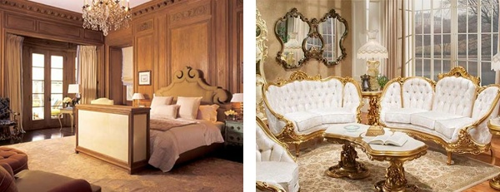
Victorian Style Interior Design
The Victorian style originated during the Victorian era and is often described as opulent and luxurious. Victorian style is the near opposite to minimalism, it is based on an excessive amount of ornate and flamboyant decorations, accessories, the more you have on display the better. But Victorian style also includes features in order to avoid clutter. The excessive decorative furniture and ornament are contrasted by plain floor and wall surfaces.
The Victorian Style uses deep hues, pastels and neutral colours contrast the rich textures against the bright shades in upholstery and wall coverings. Exotic materials and heavy woods became available during Victorian era and were used extensively in the furniture of the time but today you can find pieces of Victorian style furniture in cheaper materials. This has seen a recent revival in the style with a type of modern Victorian style emerging.
To Recap, the main characteristics of the Victorian interior design style are...
- Opulent and luxurious with excessive decorations.
- Walls and floors kept plain to contrast decorative features.
- Decorative but uncluttered.
- Deep hues of pastel and neutral colours.
- Exotic woods used in furniture.
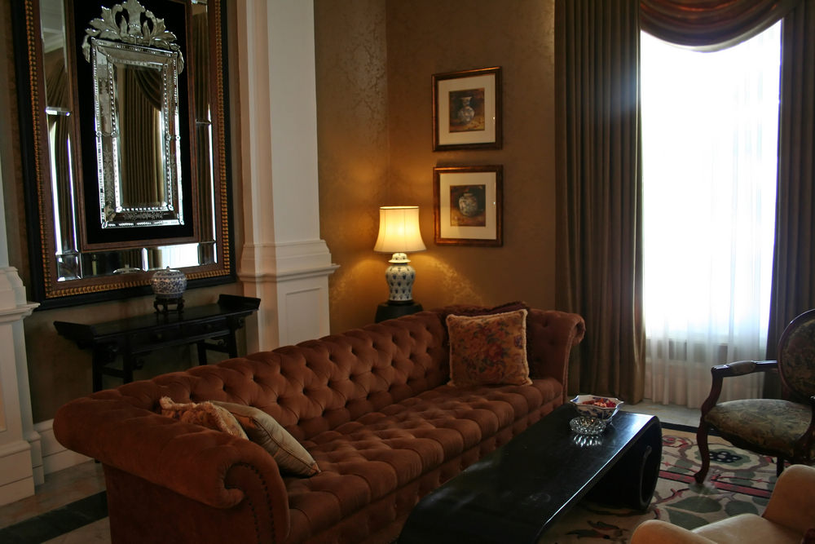
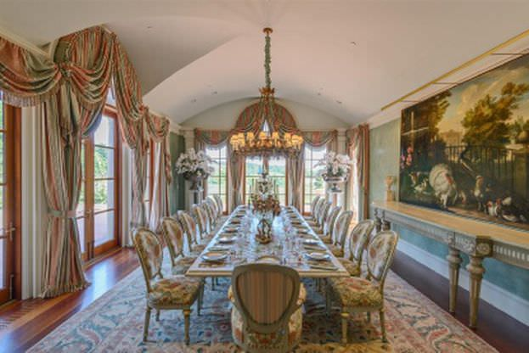
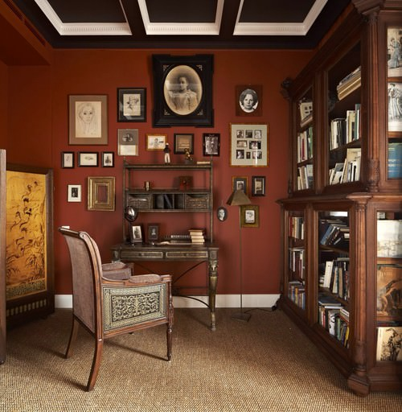
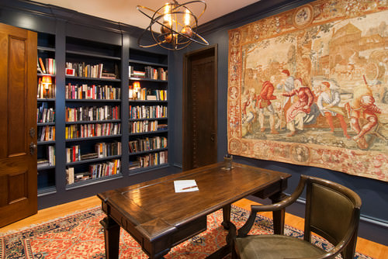
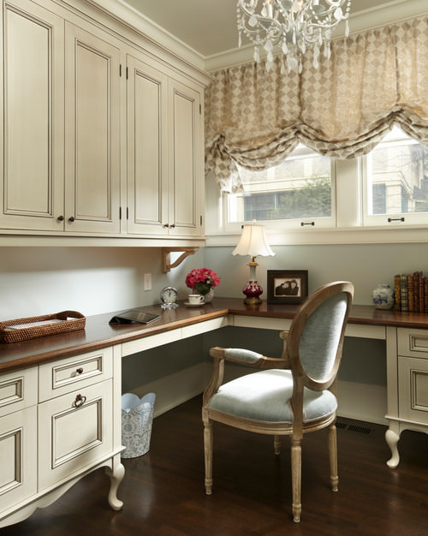
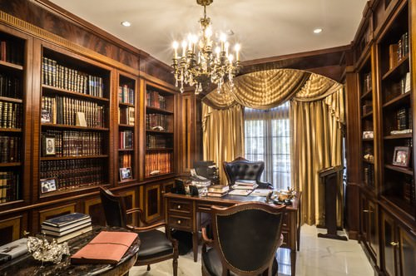
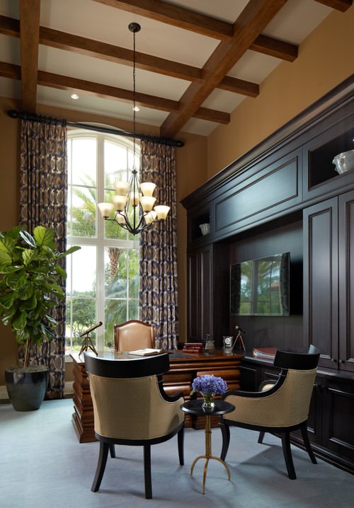
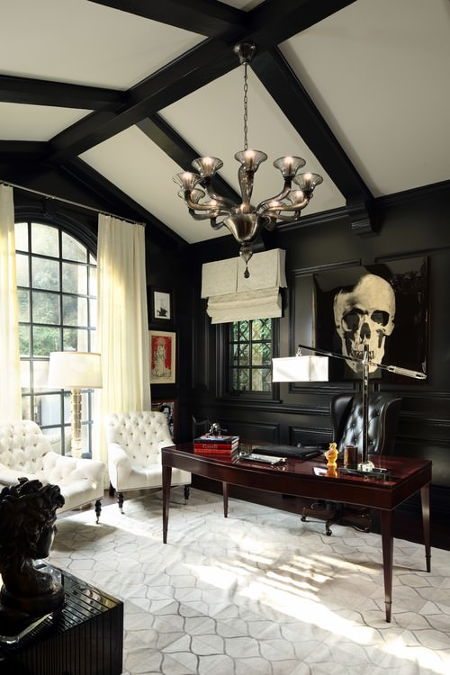
While not terribly popular these days, the Victorian style is used in older homes by homeowners looking to preserve Victorian era homes, of which there are many in the United States.
The following sets out some key design elements of the Victorian style:
- Asymmetrical designs;
- Vibrant colors
- Decorative trim;
- Textured wall surfaces with complex patterns from wall-to-ceiling wallpapers to luxurious fabrics;
- Elaborate and massive furniture;
- Extravagant accessories; and
- Bay windows, sometimes with stained glass panels, walk-out versions or built-in bench.
12. American Colonial Style
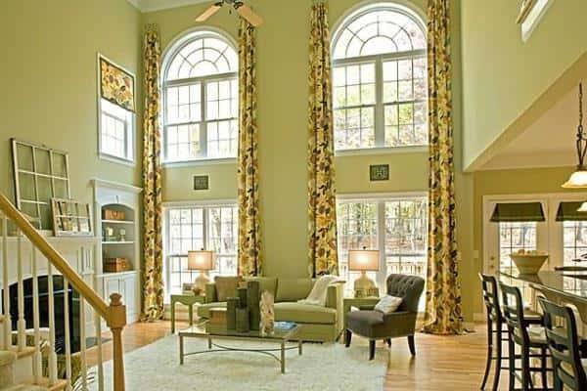
Arlington Plan in Kensington Forest, Harrisburg, N.C., by Niblock Homes.
American Colonial homes are typically two stories with five windows on the second floor and the front door directly underneath the middle window. The front door has at least one window on either side and the home often has a front porch with columns, drawing from the style’s subtle Greek and Roman influences. Paired chimneys and a stairway bisecting the home are also common characteristics. As the style evolved, glass-cut doorknobs, brass door knockers and gilt mirrors became a regular design feature.
American Colonial interiors are light and spacious with clean lines. Soft, muted colors, elaborately designed crown moldings, wide baseboards and ivory white ceilings are common wall features. Wood plays a large part in this style’s design elements, with wood flooring typically being mahogany, walnut or cherry wood. Handmade wooden furniture and cabinets are also preferred, made from pine, birch or maple with simple designs. Cast iron lamps and wall fittings, along with beautiful and ornate chandeliers, are chosen for light fixtures to create ambiance and warmth among the woodwork and muted, neutral colors.
The open spaces and iconic details such as symmetry allow for plenty of room to play and move around. Accessories to this style often include handmade quilts that adorn walls and beds.
Distinguishing Elements:
- Centered door, two stories, five windows on second story with front door directly underneath middle window, columns
- Brass knockers, gilt mirrors, cut-glass door knobs
- Soft, muted colors in interiors
- Free space and open plans
- Mahogany, cherry or walnut wood floors
13. French Empire Style
Throughout the early 19th Century the French Empire Style evolved from the court of Emperor Napoleon Bonaparte.
It used heavy classical designs and geometric form whilst retaining an air of fineness along with soft draped fabrics and highly polished veneers.
Strong colors were prevalent in interiors introduced when the French gentry returned from their military sessions in Egypt.

The Egyptian tombs that they had seen and their use of vibrant colors inspired them. Azure blues, rich greens, red ochre and acid yellows became popular for interior decoration.
Softer colors were still used, lilac being one of the most popular.
The military influence of Napoleon lead to formality in the arrangement of furniture, this was softened with the abundant use of drapery.
Carving was not popular but the use of ormolu mounts of classical motifs; laurel wreaths, urns, and sphinxes were for detailing throughout the room as well as hardware.
Egyptian motifs were also prevalent, lions, hieroglyphics, palms, winged griffins, cobras and sphinxes.
The most favored timber used for furniture was mahogany, fruitwoods, yew, elm and maple were still seen and the use of imported veneers from Africa and West and East Indies.
Most furniture had curves for example scroll backed daybeds and chairs.
The preferred decoration materials were marble and tortoiseshell and were used for ornaments.
Napoleon and the French Empire
Napoleon Bonaparte is often remembered as a military leader and a fierce ruler who commanded wars and controlled important parts of Europe. But he was also very aware of the propagandist value of art and promoted a style that he considered the best for exhibiting the greatness of France.
The French Empire (First French Empire) was a short period in the history of this nation, between 1804 and 1814. During this time, Napoleon ruled as Emperor. He gradually gained power and influence and in 1804, he was proclaimed Emperor by the French Senate. His regime was characterized by military expansion and constant wars. France conquered neighboring territories and gained control over several nations of the continent.
The French Empire was led by a totalitarian government. There were no real democratic elections or freedom of speech. However, there were significant advances in public education and religious tolerance, among other fields. Napoleon's autocratic character touched many aspects of the French life, including society, economy and artistic trends.
Style of French Empire Furniture
The French Empire style was promoted by Napoleon as a propagandist mean of showing the greatness of the empire. The government dictated guidelines and requirements to regulate the style of the artistic creations and crafts production. The furniture makers had to adapt to the Emperor's taste for massive elements and his desire to express power, and they designed accordingly.
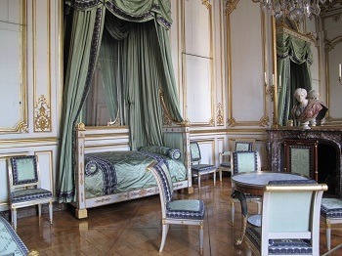
Bedroom of Napoleon in the Rohan Palace. Strasbourg, France (c. 1805)
The style spread from France to other parts of Europe, partly thanks to the military campaigns. The Empire style is often considered an evolution of the Neoclassical style, which had emerged in the second half of the 18th century and had some common characteristics.
Characteristics of French Empire Furniture
Most French Empire furniture had an imposing and massive character, meant to impress. Therefore, we find many pieces with big dimensions and also with plenty of decorative elements, which were included to make furniture look stunning and glorious.
The pieces had a rigid layout and featured basic geometric forms, often with flat surfaces and sharp corners. The compositions were symmetrical and all the elements were generally replicated on each side.
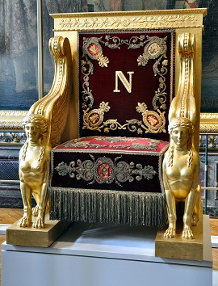
Napoleon Throne for the Senate (1804)
The inspiration came mostly from the Classical World (Ancient Greece and Rome), especially from the Roman Empire. The idealized simplicity and soberness of this civilization were admired as an example to follow.
The motifs for decoration were usually inspired both by war and by the Classical World. Trophies, spires and coats of arms were some of the military elements. Lions, eagles, deities and creatures from Roman mythology were also used. Some pieces also had sphinxes, palm leaves and other Egyptian-inspired motifs.
A peculiar element was the letter N (Napoleon's initial) surrounded by a crown of laurel leaves, which was considered a symbol of victory and glory and was used in several pieces of the Emperor's furniture.
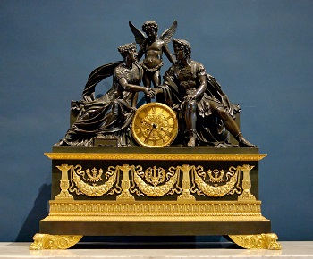
Clock decorated with Mars and Venus (1810)
Wood Sourcing and Detail Work
Until 1806, mahogany was commonly used. But because of the Napoleonic wars and the blockade he imposed on British companies, the furniture makers gradually abandoned the use of exotic woods in favor of locally-available materials.
Walnut, maple and beech became the common choices. Some exotic woods continued to be imported from the French colonies but they were scarce and, therefore, used with moderation. For example, small mahogany pieces, veneers or small ebony details.
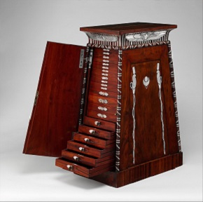
Coin cabinet made of mahogany with silver inlays (c. 1809)

The Empire Style
If you were to design an interior in early 19th-century France, you'd have strict guidelines defined to please the taste of the Emperor. Although today we have more freedom, we can still be inspired by the elegance and magnificence of the Empire style.
The Empire style takes its name from the government of Napoleon Bonaparte in France, who ruled between 1804 and 1814 and was proclaimed Emperor, though it technically started in 1800 under the Consulate and lasted until 1815. It's part of the Neoclassical current inspired by ancient Greece and Rome and was important in architecture, decoration, and furniture design. To a lesser degree, it was also seen in other visual arts.
During the main part of the Empire style's heyday, Napoleon directly influenced many aspects of decoration and design by dictating requirements and guidelines that artists and craftsmen had to obey. He promoted this style as a mean of propaganda and a way of exhibiting the power of the Empire. The Empire style spread to other parts of Europe, where it was also associated with political power.
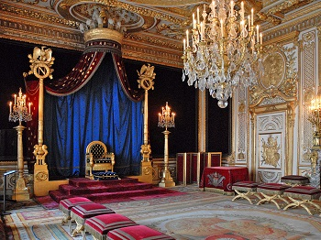
Throne Room in Fontainebleau Castle, France
Characteristics of the Empire Style Interior Design
The Empire style drew most of its inspiration from the Classical world, especially the Roman Empire. Ancient Egypt also started to be an influence after a French military campaign there awakened new fascination for this civilization.
This was a propagandistic style, so the interiors were meant to impress. They'd have an imposing character that was achieved with massive elements, symmetrical, and rigid layouts, as well as the use of plenty of straight lines and sharp corners.

Ornaments
Gilded ornaments were very popular and became a characteristic of this period. The gilding process consisted on covering different embellishments with gold leaves, to make them look like solid gold.
The decorative motifs evoked the ancient civilizations. Many interiors featured pilasters and columns inspired by the Roman Empire. Lions, eagles, vases, cornucopias, and mythological creatures were other common Roman motifs. Sphinxes and palm leaves were among the references to ancient Egypt. Napoleon's regime was militaristic, so military-related motifs like trophies, coats of arms, and spires were also incorporated to the decoration.
Colors
The rooms usually had bold color combinations. The ornamentation provided lots of golden elements that contrasted with all other colors. Light tones or even full white were used for walls and ceilings and they'd be paired with the dark green, blue, or red hues of the upholstery. However, dark tones weren't used all at once. Each room had its own palette usually with only one dark color.
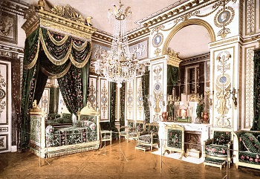
Napoleons bedroom in Fontainebleau. Green was combined with lighter tones
Floors, Walls and Ceilings
Floors had diverse finishes, the most common being parquet: small wooden pieces arrayed in geometric patterns. Some rooms had marble floors while big carpets were commonly found in the throne rooms.
Walls featured plenty of plaster decorative moldings covered with a gilded finish. It was common to use straight moldings for defining frames on the walls. The doors had the same ornamentation.
Paintings weren't very common for decorating walls. Instead, we find large mirrors that enhanced lighting and made rooms look bigger.
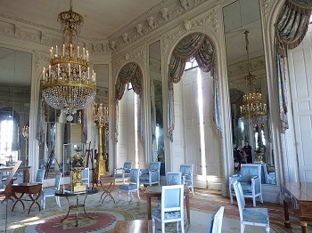
Painting room (hall of mirrors) at the Grand Trianon of Versailles
Upholstery was another wall treatment. Elegant fabrics like satin, silk, and velvet were sometimes used to cover walls. Around beds and thrones, we often find tall draped fabrics hanging from elaborate frames.
Ceilings were much simpler than walls and usually, they only featured a few moldings on the joints with the walls. Big chandeliers were often the most notorious decorative element on the ceiling. They featured plenty of candles, crystal pieces, and gilded details. During the day, most rooms had good natural lighting thanks to the big windows.
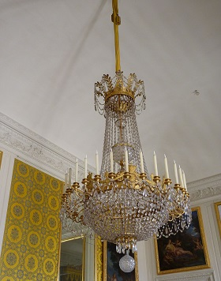
Plain ceiling with a big chandelier in Versailles

Furniture
The Empire furniture echoed the characteristics of the overall style. The pieces featured plenty of straight lines, usually had a massive scale, and had plenty of gilded ornaments. Mahogany with a polished finish was a common material. Other pieces were made with less-expensive woods and then painted or gilded.
Small rounded tables with three legs were very popular and the boat beds became a characteristic piece. Beds were usually placed lengthwise against the wall.
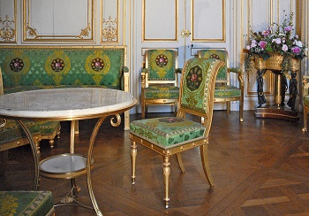
Gilded Furniture in Fontainebleau
Brief history of the Empire interior design style emergence
Empire style appeared in the early 19th century in France (this country is very prolific culture center of the World as one can see), during the brief reign of the Emperor Napoleon Bonaparte. Bombastic and pompous Empire was intended to emphasize the grandeur and sublimity of France: this effect can be achieved by using pilasters, columns, military attributes, fine wood and gold leaf.
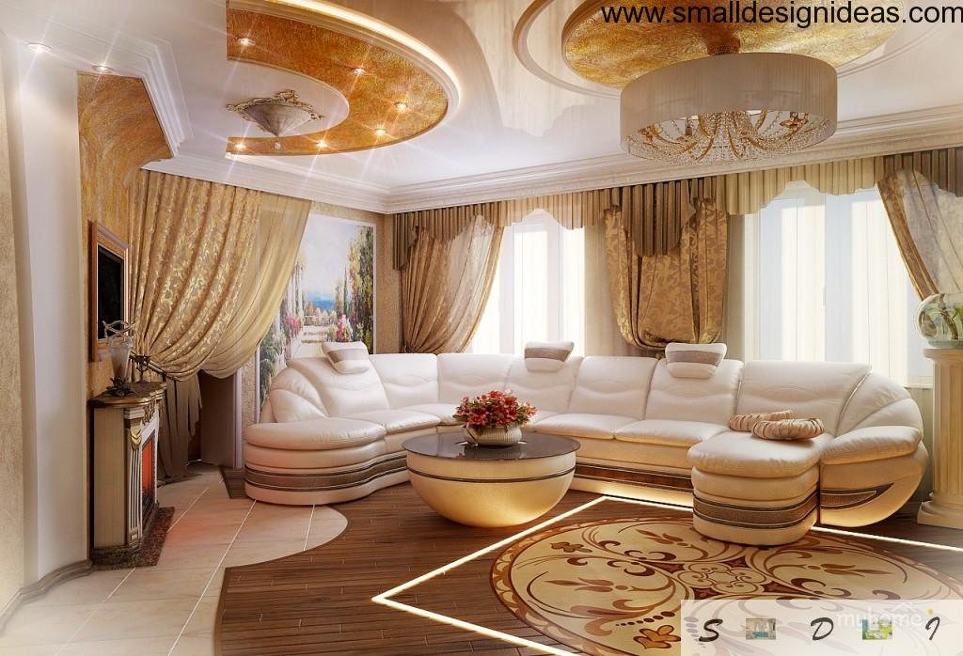
Despite the fact that the Empire combines the details and motives of several cultures, he still has a main goal – to convey the importance of the room to the human.
– Important! Interior style of Classicism and Empire have one important difference that can not be omitted. If Classicism primarily focused on Greek antiquity and culture of Athens, Empire Art it lies at the heart of the of the Ancient Rome.
Empire Today: particular style
Empire in a modern interior – is a luxury environment, peace, harmony and throughout balance.
Empire style in the interior design of apartments, houses, cottages implies pure forms, symmetry, intricate design. Empire style in a residential area is characterized by a certain coldness, however, the house, designed to suit all styles and requirements, captivates the eye instantly.
- Bedroom in the Empire style means the mandatory use of expensive fabrics (silk, velvet) and luxurious furniture. If it is hard to find suitable antique furnishings, you`ll better choose custom furniture. Be sure, it`s made of natural wood (preferably dark colors: mahogany or walnut). In addition you can find the statues in Empire style or invite specialists to paint the walls according all canons of this venerable style;
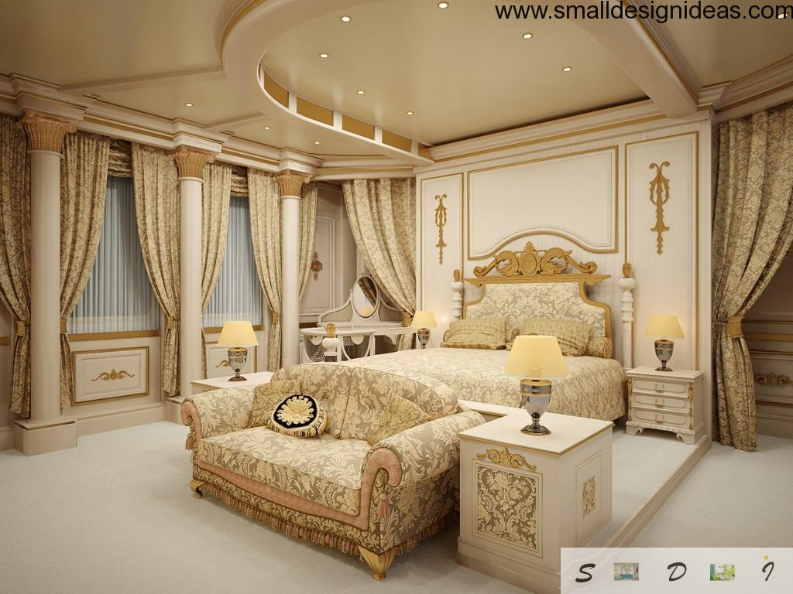
- Bathroom in the Empire style. It is a granite or marble floors, stucco ceilings, a large number of accessories and the predominance of warm pastel shades in the interior. It must be large enough to accommodate the necessary furnishings (for example, an oversized chair is a classic element in the Empire style bathrooms);
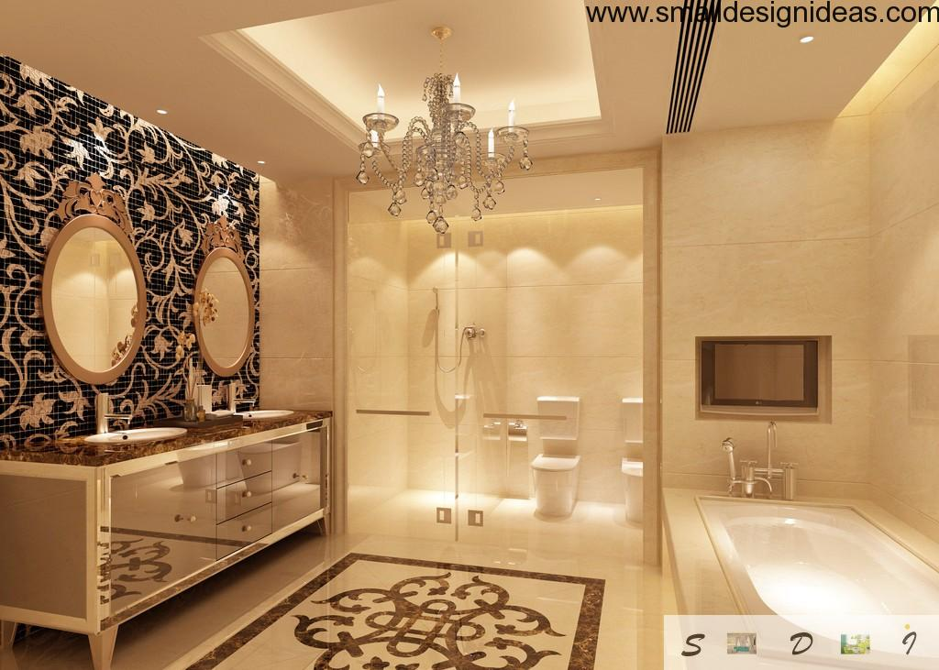
- The kitchen in Empire style is always “smart”: the facades of kitchen units are decorated with stained glass, engravings and paintings in exquisite frames at the wall. It is desirable that the window drapes were chosen to match the color of wall decoration.
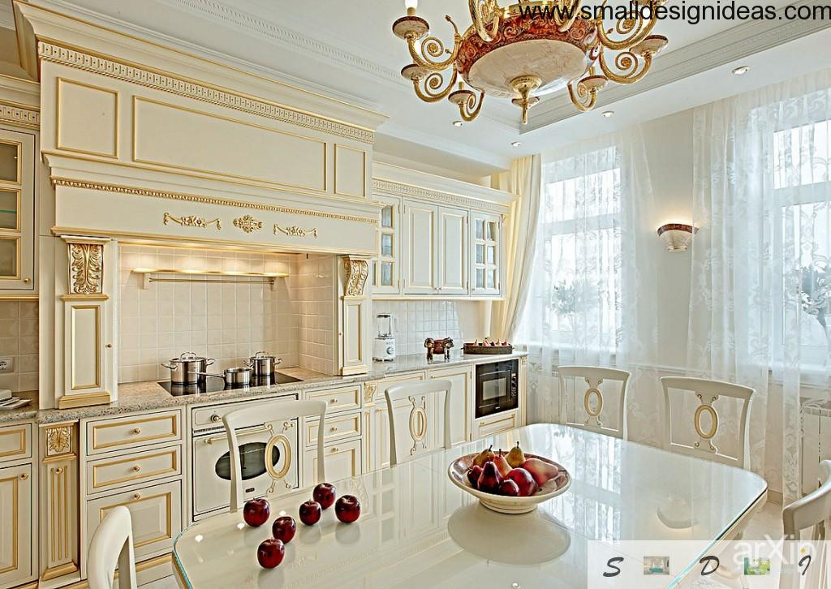
14. Japanese Design
Japanese Design – How to Create a Japanese Style of Decoration
If you believe you want to incorporate the Japanese Design Style of Decorating into your home, condo or apartment you have the type of personality that treasures peacefulness and serenity in your abode. As in most Asian-inspired rooms, there is a total lack of clutter and everything is in its place. One of the largest differences in this style of decorating as compared to the Western hemisphere is that each room will have one major focal point. There is one item that will dominate the room and all other pieces blend harmoniously without calling attention to themselves.
Orderliness is the keyword. In the Japanese Design Style of Decorating your walls will be white or another neutral color. This allows the eye to zoom in on the focal point and not be distracted by a vibrant hue. Furniture, upholstery and pillows will have Japanese designs in black, red, green and gold. Most Japanese floors are bamboo. If you were planning to purchase new hardwood or carpeting you will discover that bamboo can be an affordable alternative. Window treatments can be bamboo blinds or woven curtains in a neutral color.
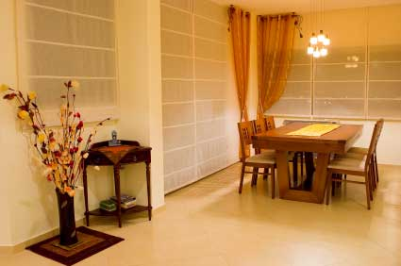
Japanese Design has two separate themes or looks: traditional and modern. The traditional style uses a lot of natural woods and elements whereas the modern Japanese home will have many furniture elements that resemble the contemporary look of western interiors. Whichever style suits your taste, each will definitely be focused on the abundant use and reflection of natural light. There will be a natural flow to any room and it will seem that each piece of furniture or element was purchased and placed with a greater plan in mind. Once you enter the room you will immediately feel at peace.
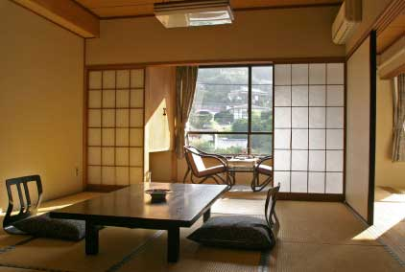
Many decorators use a Japanese shoji screen as the main focal point. Some of these screens can be absolutely beautiful using the traditional Japanese colors and trends in art. Most of them will have painted interiors and the wooden frames will be black lacquer. Some may have a hint of gold gilding in the frame. If this is how you design your room, all of your furniture and accessories will pick up a color that is prominent in the screen. Remember that your furniture should be kept to a bare minimum. You do not have to sleep on mats or sit on cushions, but you do not want any one piece of furniture to detract from your focal point. Bamboo is one of the more popular ‘woods’ used in furniture making plus natural grasses are used for floor mats.
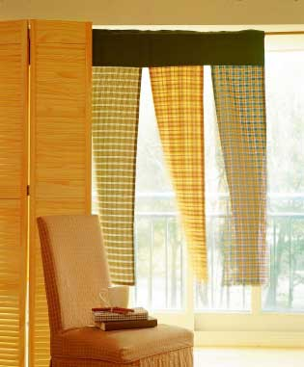
As far as decorative objects in your room you cannot go wrong bringing the beauty of nature inside. Small water fountains can bring serenity by just sitting quietly and listening to the water trickle over the rocks. If you like plants, have several live orchids where they get the proper amount of light. If you want a new hobby that will bring some balance into your busy day, go for a bonsai plant. You will need to continually keep it ‘well groomed.’
Additional ideas for decorating your room in the Japanese Style of Decorating is to bring in bamboo baskets of varying shapes and sizes for storage and to hold items for everyday use. When you are selecting your furniture and baskets do not confuse bamboo with rattan. Some people think the two are one and the same. Actually, rattan is a solid wood stem and a bamboo plant is hollow. They are both grown in the east and both contribute to a great deal of Asian decorating.
Japanese Furniture: History & Style
The traditional Japanese household had furniture and features that were directly related to the Japanese culture: simplicity, functionality, and the attention to nature and space.
Imagine that every single thing you owned had a purpose and place, and you're coming pretty close to imagining a traditional Japanese household. Great thought and care were given to the culture when designing Japanese furniture. Every piece, while simple, had a function and elegance that helped enhance the living area of the family it belonged to. This lesson will focus on the history and style of Japanese furniture.
Traditional Japanese Homes
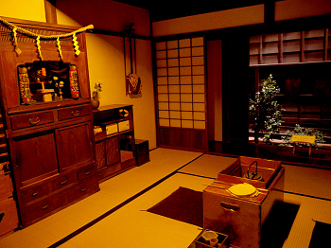
A traditional Japanese home
If you were to look at the interior of a Japanese household, the first word that comes to mind might be 'sparse'. This is because in traditional Japanese houses, from ancient times to the present, there was very little furniture to sit or sleep on. Without chairs or bedding, the Japanese generally used the floor to sit and sleep on. This is because the Japanese believe in the concept of ma, or negative space and a desire for simplicity. Objects would be placed very far apart, as the traditional Japanese believed that this space encouraged creativity.
Another common feature of households in Japan was the concept of inside and outside space. Screens, called shojiwere used to close off or open up rooms to each other and to the outside. This linked nature to the inside of their living spaces.
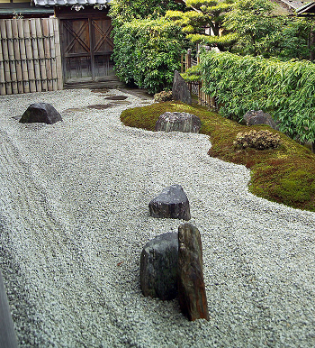
A traditional Zen Garden
The Zen rock garden was another feature of many traditional households. Rocks of all shapes and sizes would be placed asymmetrically, calling attention to the spaces between them. These gardens often featured shrubs and miniature trees, and sand that was raked into patterns. The Zen garden was a place to contemplate nature.
Types of Furniture
Even though their spaces often appeared to be mostly empty, that was not the case. There were several main kinds of furniture that could be found in traditional Japanese homes. Most of the furniture was made of wood, and much of it had handles on the sides so it could be picked up and moved if needed for aesthetic reasons or in response to a fire. Since the homes were made mainly of wood and rice paper, fires were a common occurrence.
Furniture in Japan had three main purposes: sleeping and sitting, prayer, and storage.
To replace seating and sleeping furniture, a mat called a tatami was used. Tatami mats were made of woven straw and could be arranged in multiple ways.
There were also Buddhist prayer tables and altars found in most households. They were made of wood and were usually simple in design, though wealthier households sometimes had altars that were gilded (covered with gold) and ornately carved.
A chest, or tansu, was first used in the 700s in Japan. This armoire had doors that opened and drawers. The tansu was used for clothing storage and was generally very utilitarian, though sometimes these chests had iron banding or decorations. A tansu used in the kitchen was called a mizuya, and it differed from clothes storage in that it had sliding doors to hide utensils and dishes.
A special kind of tansu was called the kaidan tansu. This was a storage chest that was in the shape of a staircase and also often functioned as one. In place of doors, this chest had drawers that were equipped with iron handles.
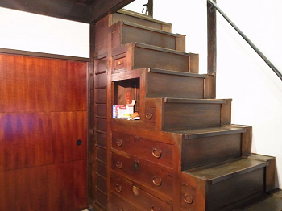
A kaidan tansu
History of Japanese interior style
Japanese style was born in the Land of the Rising sun (thanks, cap!). The constant threat of earthquakes made the light houses that do not crumble but fold down, shaken by the force of nature, most actual. Thin walls made of wood and rice paper, and internal partitions of the same material are ideal for easy, safe and beautiful property.
In Japan, it is assumed that the beauty is in a natural harmony. Therefore, the Japanese interior is not overloaded with detail. The house is perceived as if a part of the natural landscape, a place that allows you to enjoy the scenery of surroundings, the beauty of spring flowering trees, colorful bright summer or fall season in tranquil ambiance.
Functional simplicity and austere elegance, originally alien to other cultures, making the Japanese style in demand on the one hand and difficult to grasp on the other.
Currently, imitation of Japanese style is more popular: low tables, hieroglyphs as a decoration of furniture, textiles, wallpaper, bonsai, ikebana.

Japanese style in the interior of houses and apartments
To order design of the apartment or house in Japanese style means to select the discreet beauty, exquisite oriental style and minimalism.
A room in a Japanese style is filled with air, light and permeated with harmony and the spirit of the natural beauty and naturalness.
Bedroom in the Japanese style – it is a low bed, restrained color palette of interior and built-in closets or chests (things can also be hidden in concealed niches;
Japanese style in living room is exquisite charm of the spacious rooms, decorated with natural materials, the freedom and abundance of dim light.
Bathroom in the Japanese style combines understated elegance and functionality. Ceramic tiles with Japanese patterns or wood paneling, low rectangular or round bathtub, a minimum of decoration and, as a rule, contrasting combination of dark brown and beige (rarely white) colors.
Kitchen in the Japanese style is decorated with imitation of screens (headset facades), often decorated in different shades of wood with the addition of bright colors (yellow, green, red, orange). Low dining table goes in combination with the low chairs or benches. The kitchen in the Japanese style is always original decision and designer solutions.
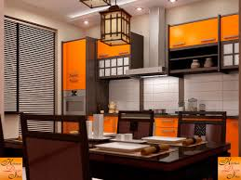
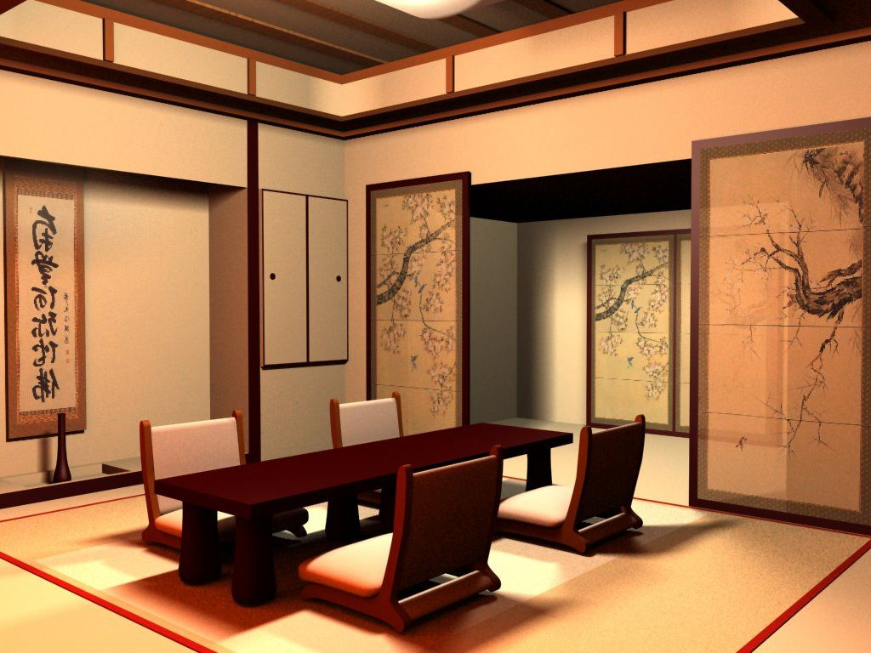
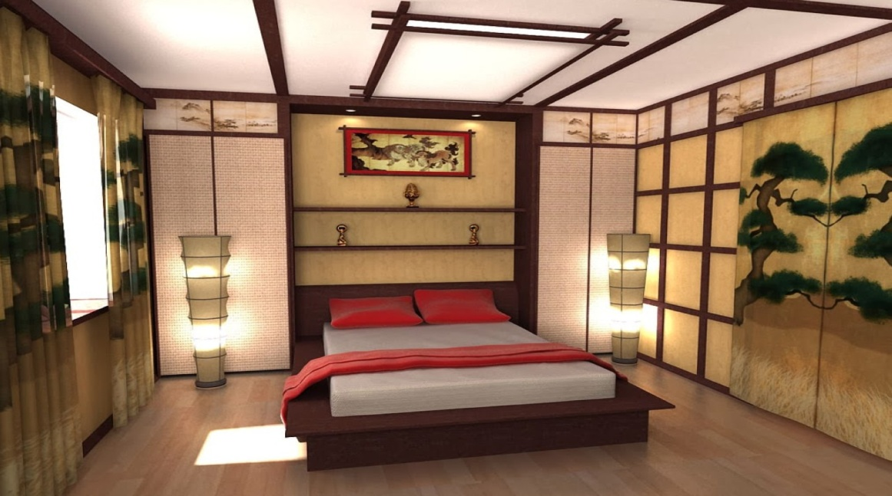
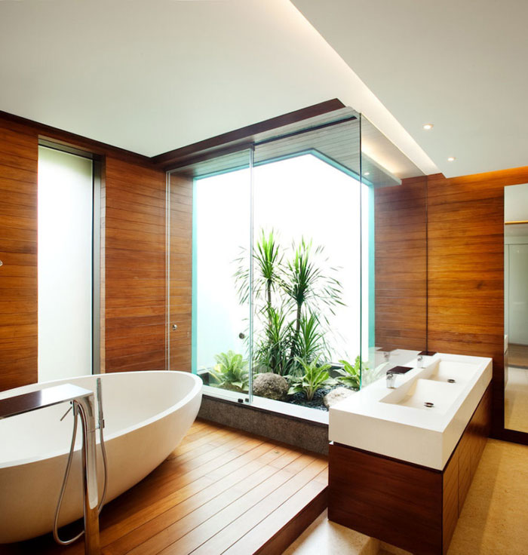

Textile
The interior in the Japanese style will be organically complemented by Japanese blinds or curtains in the Japanese style. They are often decorated with hieroglyphs, pictures of chrysanthemums, cherry blossoms or Mount Fuji. Windows may remain uncurtained.
- Living room floor can be carpeted: strict geometric shape, discreet color, fabric or bamboo.
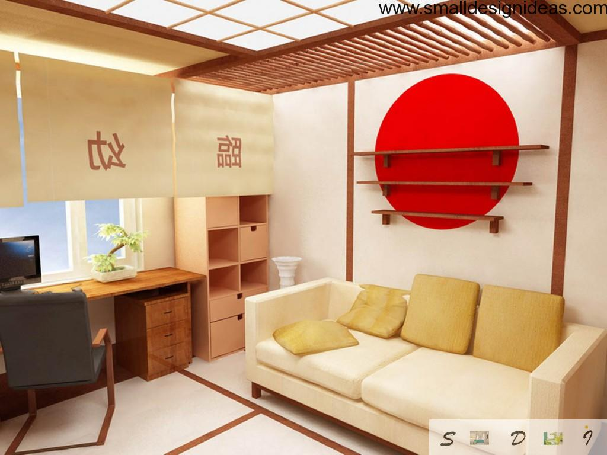
There is not much of textiles in the Japanese interior. Even the tablecloth on the table is often replaced with bamboo napkins and carpet with straw mats.
Decor and ornamentation
Traditional Japanese houses decorated only with a flower arrangement and a scroll with a haiku or a painting.
Modern interior in the Japanese style can be ornamented with decorative fans, miniature bonsai trees in ceramic pots, flower arrangement (ikebana), Japanese lamps Akari, made of wood and rice paper, elegant vases and pottery for the tea ceremony.
You can order a painting in Japanese style – light, as if a scenery, blurred with water, traditional prints depicting women in kimonos and fearsome samurais.
Decor should be placed widely, it should not be much – Japanese style does not accept the confusion, chaos and cluttering.
The ceiling in the interior decorated in Japanese style, should be either light and smooth, or wooden, with visible beams.
Wall sheathing materials can be made of wood or cork, or even be smooth and covered with white paint. You can also use pictures, paintings or wallpaper to deal with walls. Wallpaper in Japanese style can be decorated with images of blossoming ramifications, autumn leaves, dragons, carps, hieroglyphs. Thorium – ceremonial gates, facing the Japanese temples may be also present on the wallpaper.
The floor can be decorated with natural materials: rattan, bamboo, wooden planks and covered with straw mats (tatami) or discreet carpet. Japanese style allows you to zone area by changing the layer of the floor: within a single room you can form the recreation, sleeping, working, eating areas by raising or lowering the floor.

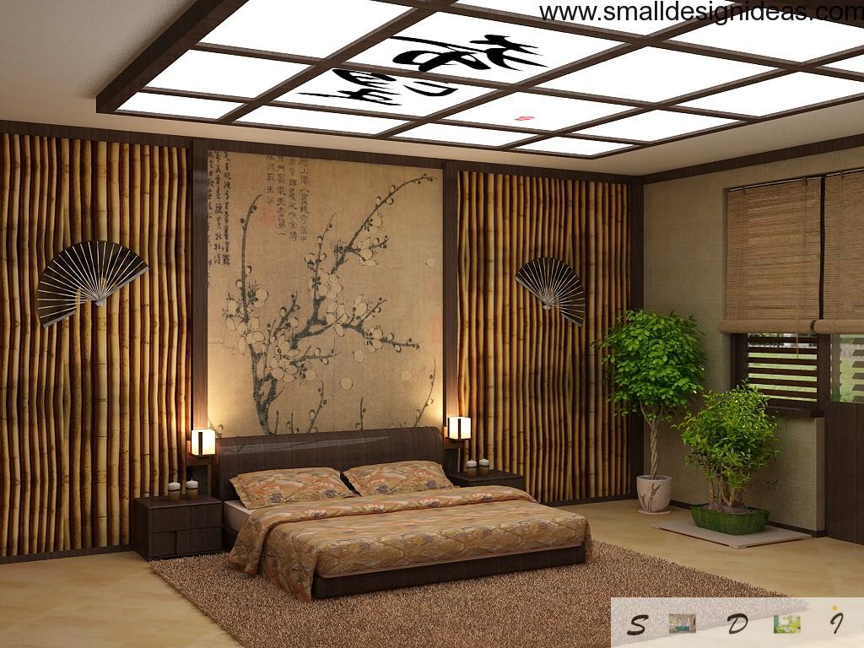
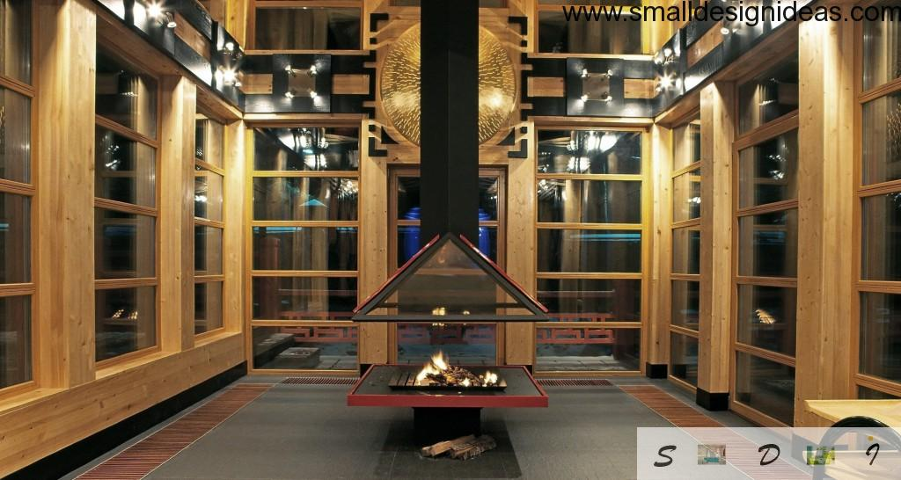
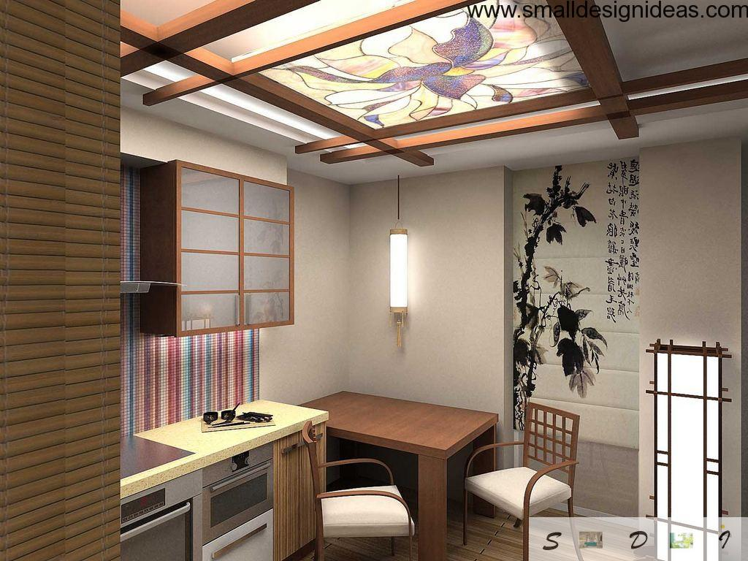
Japanese style in the interior of the apartment, office or restaurant is spaciousness, a minimum of furniture and soft, diffused light filtering through the shades made of rice paper.
Japanese interior design style of houses, apartments or non-residential premises is:
- Ascetic environment;
- Functional low-height furniture;
- Only natural materials (wood, stone, bamboo, rice paper) and fabrics (cotton, silk);
- Any room (office, hotel, restaurant, house) in the Japanese style is the territory of the harmony of man and nature;
- Natural colors: shades of brown and green, beige, white, black and bright red accents;
- The basis of style is emptiness, spaciousness and functional separation of space.
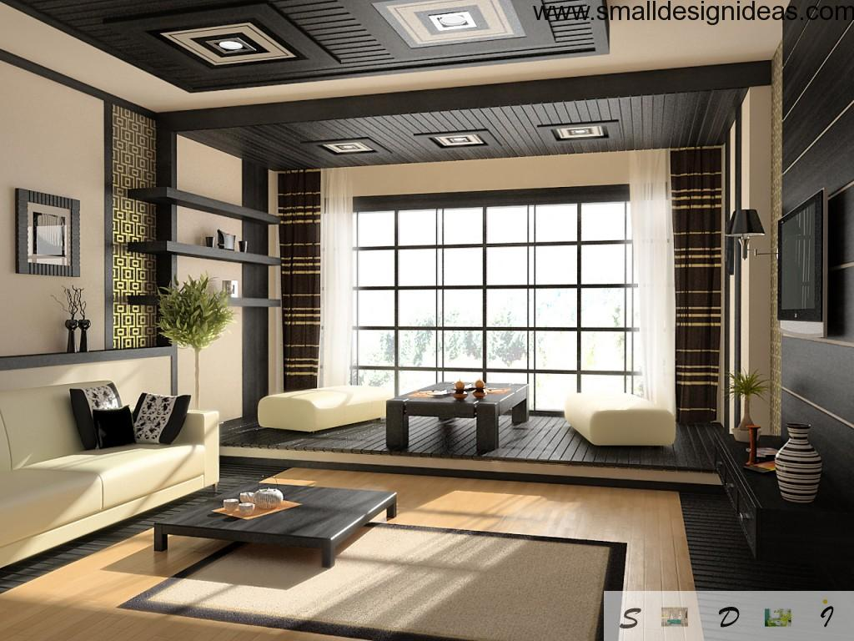
Design in the Japanese style is the concentration of Eastern philosophy and biocentric view in a laconic simplicity and beauty of natural materials. This style is ideal for lovers of oriental culture, for lovers of ascetic and at the same time stylish environment, for those who are able to enjoy the natural harmony.
15. Shaker Style
The Shakers were a religious group formed in England during the late 1700s who emphasized function and simplicity, especially in the home.
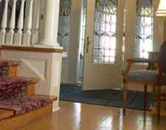
Shakers lived communally. They created large buildings and houses for groups of people. Their focus and dedication played a large role in the style of housing they created. Clean lines and basic forms characterized their architecture. This philosophy flowed through everything from stairways and windows to cabinets and hardware.
1747 to 1900
The Shaker’s were a religious sect founded in England in the late 1700’s. The Shaker’s design philosophy is one of necessity and usefulness. Once these elements are achieved, they believed in beauty. They were strong believers of common ownership and communal living and were persecuted for their beliefs.
They later immigrated to America and led peaceful lives of abstinence and celibacy. Because of their celibate beliefs, the Shaker community is slow to grow and the only way they can survive is by conversion.

Shaker Style
The Shaker’s believed first and foremost in functionality, and veered away from unnecessary decoration. However, they were strongly focused on the quality of their word so each item was generally made to perfection. Their style was open plan, simple and uncluttered with a lot of natural materials such as handcrafted wood furniture and cotton quilting, wool and silk.
"The peculiar grace of a Shaker chair is due to the fact that it was built by someone capable of believing that an angel might come down and sit on it." - Thomas Merton
Shaker furniture has changed little since its inception in the late 1700's by a Christian denomination (the Shakers) that stressed beliefs of simplicity and efficiency. Trademarks of Shaker style furnitureinclude spare design with straight lines, straightforward construction techniques and an understated beauty that reflects the modest values of the Shaker community.
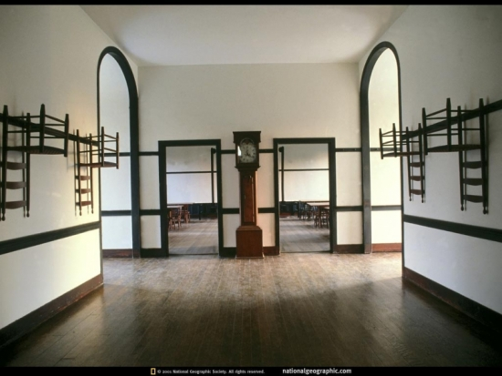
The Shakers were among the first in America to try mass production, and they were so successful at it that the Shaker name became synonymous with quality. Mortise and tenon joinery and dovetailing are a hallmark of the Shaker style. Contrary to common belief, the Shakers are not similar to Luddites, or the Amish, in that they embrace technology that increases efficiency, which saves them the time that belongs to God.
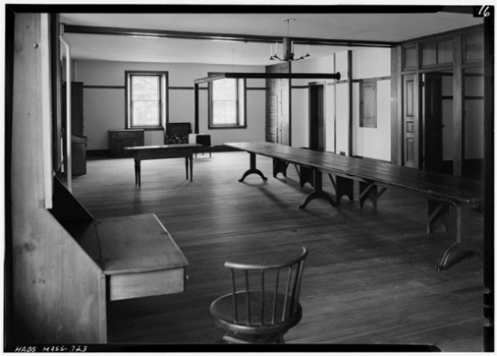
Shaker style furniture was also seen as innately American in its rejection of anything European or British, and demand among non-Shaker colonists was strong in the aftermath of the Revolutionary War. Shaker style furniture, with their famous Shaker chairs and Shaker style beds, ironically later inspired the Danish Modern movement known for its simplicity, purity of form, and grace.
While Shaker style furniture is generally thought of in a traditional context, this connection makes the combination of Modern style furniture and Shaker style furniture easy to combine within a room or house, making it a great choice for Transitional and Contemporary homes. The clean spare lines of both styles allow an easy blend, and soft furnishings can add a little warmth to the overall look.
Below are images of some of The Joinery's favorite Shaker furniture pieces from our standard line, including our Shaker Dining Table in Cherry, the Shaker Writing Desk in Cherry, and the Shaker Reverse Bed in Fumed White Oak. You can see our full range of Shaker style furniture.
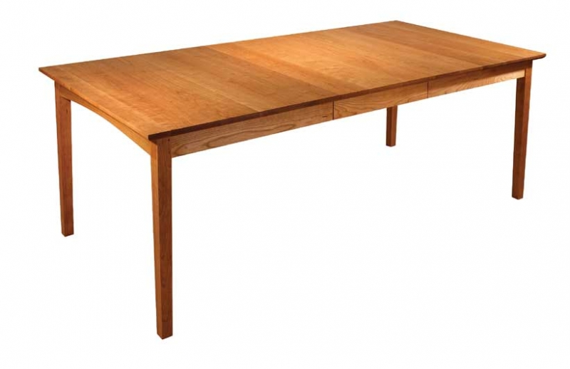
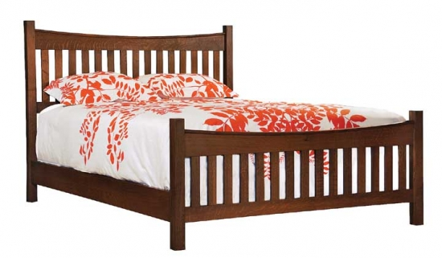
Shaker Color
Colors were rich and dark. Ruby red, forest green or blue, with heavy damask patterns were prominent. The color palette was initially restricted until the mastering of chemical process dying. Peacock greens and blues, magentas, violets and raw pinks burst onto the scene. Fabrics were highly patterned. Velvet and damask were of choice for the winter, switching to cotton and chintz for the cooler summer months. Wallpaper became mass-produced and was embraced by the masses. Paper went from the skirting board to the dado line and was pattered in flock, damask or water silk.

Limited Colors
This emphasis on simplicity included the color palette. Shakers typically used red, blue, warm yellow and blue-green to color everything from walls to textiles. When replicating this style, stick with matte paint rather than high gloss. Neutral wall colors also fit the clean, simple look.
Adding Storage
Storage is an important part of the Shaker style because it emphasizes a proper place to put everything away. If you are adding a mudroom as part of a kitchen renovation, for example, add a few peg rails. This is where the Shakers would hang just about anything to keep the room neat.
Among the other factors that differentiate the Shaker style are:
Fabrics: Shakers used natural fabrics, such as cotton, silk, and wool to make their own clothing.
Flooring: Wood floors were popular, but they were bare boards. In today's world, the practical way to create that look is to use natural wood floors with a matte gloss instead of a high gloss finish.
Woodwork: Plain woodwork, sometimes with a light stain, was used.
Uncluttered look: Get rid of all the knick-knacks and gadgets around the house. The Shakers liked their homes free from clutter and unnecessary objects.
The Shaker style is unique and can add an interesting flair to a home renovation. Whether you are renovating the kitchen in this style or incorporating furniture elements throughout the house, the results can be dramatic. A simple place can allow the eye to relax, which can be a bonus in today's fast-paced world.
Shaker style interiors and decor
The ‘United Society of Believers in Christ’s Second Appearing’ may sound like the name of an unusual religious theology, but this historical group, also known as the Shakers, shaped our interior design in an extremely pervasive and significant way. The Shaker religious sect was founded in England, UK in the 1770s, and in further decades subsequently moved to the north eastern United States. Here they set up what would be the beginning of a movement with far-reaching implications in the furniture and interior design world. The Shakers' basic principles were set upon high standards of construction with a mantra that ‘beauty rests on utility.’ Compared to the Amish, and as an offshoot of the Quaker church, Shakers believed in self-sufficiency, austerity and common ownership.
Today their furniture is world renowned for its superior fabrication and meticulous attention-to-detail. Neutral colour schemes, unadorned furniture and simple raw floors form the basis of a humble yet stylish décor and interior design. Shake things up in your domestic space, check out the following examples, and incorporate a modest elegance that will act timelessly and tastefully.
Traditional dining and joinery
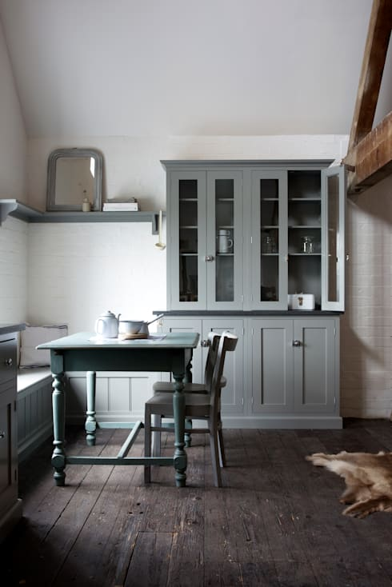

The epitome of quaint Shaker charm, this dining space incorporates a timeless design with class and elegance. Replete with a dusty blue colour scheme, the simple yet attractive table is unassuming and unpretentious. Moreover, there is a built-in seating space and pair of matching dining chairs to allow for flexibility within the room. If you are considering a Shaker aesthetic within your space, try individual cabinetry with white walls, dark timber floors and exposed timber ceiling beams.
Rustic kitchen storage
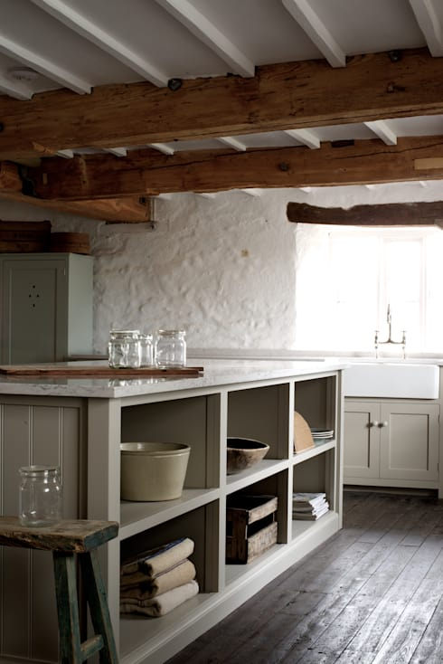
This kitchen space is an excellent example of simple Shaker style. A muted and natural colour palette is matched with a contrasting raw timber hue which brings an element of countryside charm. The rustic nature of this space is evoked through a sympathetic use of modest joinery which incorporates a humble design, and coordinates perfectly with the space. This room is however quite up-to-date and contemporary. The design is slick and well implemented, which can be seen in the fashionable simplicity that effects each section of the space. The storage area in the kitchen island is filled with well-chosen yet practical and stylish kitchen accoutrements, and further contributes to the stylish Shaker ambience.
Contemporary Shaker style
Shaker design can be implemented into a new and fashionable home easily—take a look at this example, it utilises a common Shaker aesthetic, but infuses a modern touch with stone bench tops, stainless steel appliances, and a generally modern appearance.

Simple living spaces
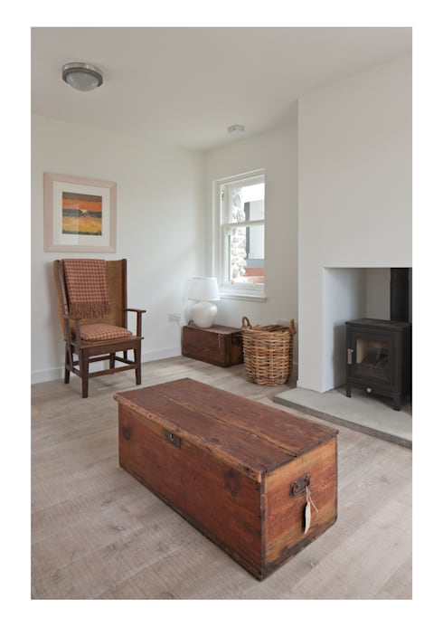
One of the best elements of the Shaker movement in design is its ability to make something simple and plain, beautiful. This room is an excellent example of that. The floors are bare timber, unpolished, and the walls are unadorned, except for a single painting that sits above a stylishly simple armchair. To emulate this style, think plain but beautiful. The walls should be understated, as well as the flooring. Choose a raw or satin finished timber, and pair your space with vintage handmade furniture that resists decoration or ornamentation. You will find the minimalism within your space evokes a sense of peace and tranquillity.
Cosy and quaint
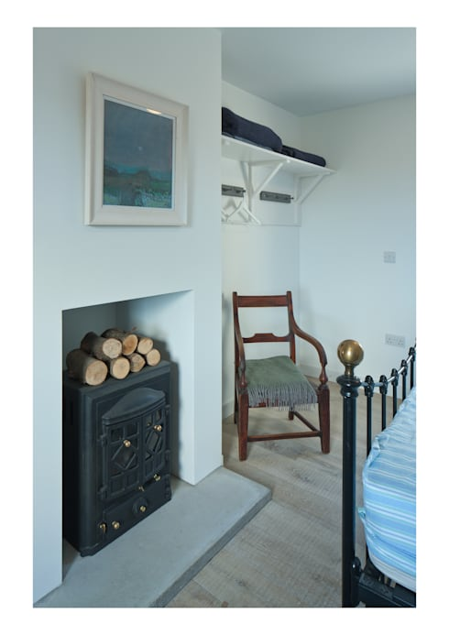
A Shaker bedroom is one that is simple, unadorned yet cosy and liveable. This room ticks all of the boxes. It is quaint, comfortable, effortlessly designed and serene. Think fresh walls, delicate artwork, statement armchair, and plain wall shelving that houses necessary adornment such as linen, and other simple country living appurtenances.
Simple glamour and elegance
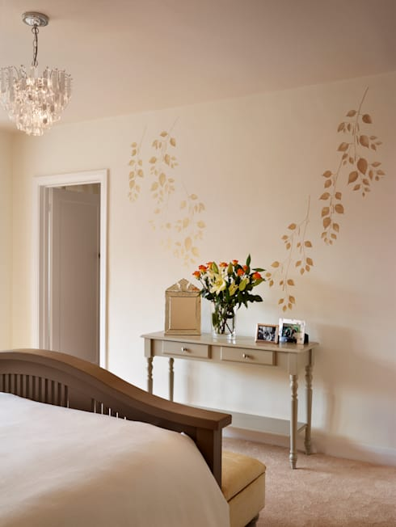
If you want to evoke a little Shaker style, but still want a bit of luxury and a hint of elegance, take a look at this example. The walls are relatively plain but are enhanced with a botanical motif that is neutral and delicate. The Shaker style console works well with the simple decoration but the room is infused with a little more elegance and opulence in the form of a hanging chandelier, and upholstered bench at the end of the bed.
16. Biedermeier Style
Throughout the early 19th Century the Biedermeier style was fashionable in Germany and Austria and to a lesser extent Scandinavia. It was contemporary with the French Empire Style, with it’s classical shapes and solidity.
The main differences in furniture were that it was more practical, less pretentious, the use of pale timber with detailed ebony inlay and only minimal amounts of carved and guilded decoration.
The interior decoration followed the same unpretentious theme; the floor was kept simple, usually bare floorboards or parquet (light timber) and the wall simply painted in bright or pale single colors.
Biedermeier decoration and furniture can be recognised by its key factors – clarity, proportion and restraint.
Decorative materials were marble and sandstone used for ornamentation. The dominating colours for the style were clair bois (pale wood) and black ebony inlay.
As mentioned this was used for furniture but could also be seen on skirting boards, doors or other small areas.
Airy light colors prevailed but vibrant contrasting colors to the pale timber could also be seen.
Soft simple natural fabrics were used for drapery.
Understated neo classical detail was simply columns, pilasters and urns. Again simple lines for chair legs, straight or sabre.
The Biedermeier Period
When things feel uncertain, sometimes the best thing you can do is to eat some comfort food. But what do you do if your entire society feels uncertain? How about buying some comfort furniture and designing an artistic movement around it? That could work.
From 1815-1848, Northern European arts changed, particularly within Germany and Austria. We call this the Biedermeier period, which serves as something of a transition between the Neoclassical and Romantic periods of art in this region. The early 19th century saw a lot of change for Northern Europe, and not all of that change was easy to handle. But, there's nothing like a good chair to make you feel better.
History and Biedermeier Arts
The Napoleonic Wars ended in 1815. It was the first calm that Europe had had since the outbreak of the French Revolution over twenty years prior, and the European people needed a break. They backed away from reform movements and liberal ideas about constitutions and rights of the people, and a new wave of increasingly oppressive governments swept across the continent.
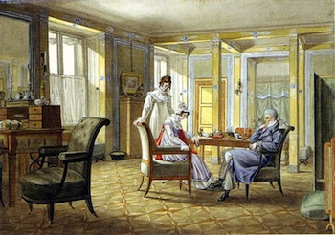
Life in the Biedermeier period was focused on private and domestic pursuits
For the middle class of Germany and Austria, there were reasons to be nervous. The middle class had only relatively recently become a large, stable part of Germany's new industrial and urban society. They were still prospering, but were uncertain about the future. At the same time, greater censorship and oppression encouraged them to become less active in politics, and they looked to private life for comfort.
Of course, as Northern European societies changed, so did the arts. Arts in this time focused on the pleasures of middle-class, private life. Paintings showed people writing letters in their studies, embroidering around the fireplace, playing the piano with friends, or sitting in the living room with the family. Later critics would derogatorily call this Biedermeier art, named for Papa Biedermeier. So, who was this- a great painter? A famous composer? Papa Biedermeier was a fictional character, a personification of content, middle-class comfort who appeared occasionally in the satirical magazine Munich Fliegende Blätter. We can think of him somewhat like the Homer Simpson of 19th-century Germany.
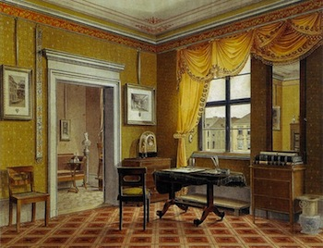
In Biedermeier Germany, there was even an entire genre of painting focused around scenes of domestic interiors
Biedermeier Furniture and Design
Biedermeier arts had a comforting appeal to them, largely as a way to reassure the middle class that their wealth and newfound role in urban society was secure. Since life was becoming more focused on the home, this meant that some of the most important forms of Biedermeier art were in furniture and décor.
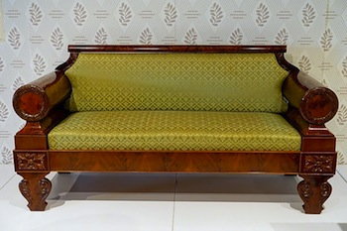
Biedermeier furniture, like this couch, was a simplified and streamlined variation on the Empire and Directoire styles
Prior to the Biedermeier period, Europe had been dominated by the elitist and regal Empire and Directoirestyles of design. Both of these were variations of Neoclassical design, defined strong geometric proportions, symmetry, and Greco-Roman motifs. However, they were also opulent, pretentious, and imperial. These were the styles of Napoleon. They didn't quite fit in a comfortable, middle-class home.
Biedermeier Style: Biedermeier Furniture
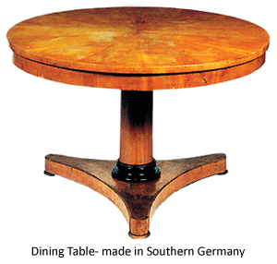
It was through a political caricature appearing in a German newspaper in the late 1840s who typified a well to do middle class man without culture, the term Biedermeier originated. Two German writers, Ludwig Eichrodt and Adolf Kussmaul named it after the typically bourgeois style of the period - Gottfried Biedermeier - with Gott meaning God; fried meaning peace; Bieder meaning commonplace and meier meaning steward. It wasn't called Biedermeier until 1886, when Georg Hirth wrote a book about 19th-century interior design, and used the word Biedermeier to describe domestic German furniture of the 1820s and 1830s. Like most styles, it did not have a name while it was being made, but was only given one after it had been and gone. The term Biedermeier is often wrongly assumed to be the name of a cabinetmaker or designer of the period. During the late 1840s in Austria and Germany, the preceding era (1815-1848) was subject to a barrage of satire, which finally led to the very furniture being mocked.
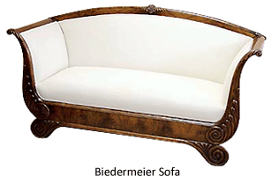
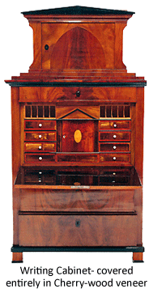
Biedermeier refers to work of literature, music, the visual arts and furniture in the period between the years 1815 (Vienna Congress), the end of the Napoleonic Wars, and 1848, the year of the European revolutions and contrasts with the Romantic era which followed it. It was the age of the Austrian Chancellor Metternich Prince Metternich, whose diplomacy and influence dominated much of the post-Napoleonic period. It was a period of conservative politics in reaction to the horrors and chaos of the French Revolution and Napoleons wide-reaching conquests. Liberalism and popular movements were suppressed. It was the heyday of the secret police. But it was also a time of great creativity. Great names like Beethoven, Schubert, Johann Strauss the Elder and Joseph Lanner dominated the Viennese music scene. Despite censorship, theatre and literature flourished. [1] It saw growing industrialization and the resulting migration from rural to largely urban life. How furniture design can reflect great historical events is provided by the emergence of the Biedermeier style after Napoleon's defeat at Waterloo in 1815. The mood of the people of Europe changed - and the style of the furniture altered dramatically to match this mood. As Napoleon had conquered most Europe, the pompous, magnificent Empire style with its grand, monumental mahogany furniture had become extremely fashionable, and palaces and houses were accordingly redecorated throughout the continent. But after Napoleon's final defeat, Europe settled down to a long period of peace. The middle classes, who were prospering, wanted a simpler style, which could be functional as well as beautiful. This style, later known as Biedermeier, is essentially Empire furniture shorn of its ormolu mounts, excessive gilding and aggressive self-importance. Its original geometric shape often leads it to being described as the forerunner of modern furniture.
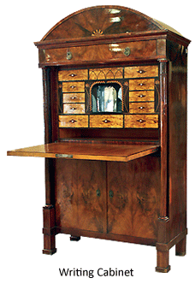
The Biedermeier furniture style is inspired by the French Empire style with modification by incorporating local German traditions particularly old peasant furniture. It is simple and elegant, consisting of clean smooth lines and honest, functional form. The pieces are generally designed on a small scale with graceful and elegant forms, devoid of unnecessary embellishment. Biedermeier furniture craftsman eschewed most forms of ornament, preferring simplicity. When there is ornamentation such as carving there is little detail in the work, although by around 1830 more detailed carving became prevalent. The main decorative motifs employed by the Biedermeier era craftsmen included simple forms of swans, sphinx, dolphins, lion paws, acanthus, lyres, and garlands. Early pieces were traditionally crafted from dark mahogany woods with a tendency towards Empire styling. In later years, Biedermeier furniture was generally fashioned from lighter woods such as birch, grained ash, pear and cherry, and exhibited a clearly more whimsical styling. In the middle class homes the furniture was designed according to the uses of day to day activities like writing, sewing and music, --each characterized by a different furniture, and quite deliberately separated from the others. This furniture was placed in the same living room in different corners or even the same furniture had a multi use, this concept created the Wohninsel, or the 'living island'.
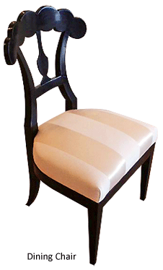
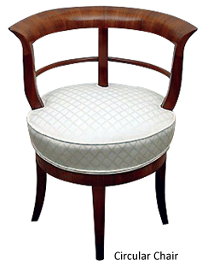
Prior to 1830, mahogany appeared in Biedermeier furniture and gradually replaced walnut. The adoption of this imported wood, which was often given a light finish, caused some craftsmen to apply matching stains and finishes to pieces made in walnut, pear wood, and Hungarian 'watered' ash. The Viennese craftsmen no longer relied on the French, German and Italian designers for inspiration. Native products based upon Directoire and Empire designs were highly original, showing a good understanding of form, balance and the use of ornament in gilded bronze. Local timber was used for economy, especially walnut veneer over a soft wood frame. Inlay served as the main decorative element, featuring the patterned graining of walnut and often reduced to a light-colored border. Sometimes, craftsmen used black poplar or bird's eye maple and colored woods such as cherry and pear became popular. Cabinetmakers decorated their furniture with black or gold paint, and often employed less expensive stamped brass wreaths and festoons rather than bronze for decorative effect and gilded wooden stars instead of the elaborate metal ornaments of the Empire style. Sometimes, they chose cheaper, new materials such as pressed paper. The Biedermeier era produced a wealth of different types of seating, with a myriad of variations on the basic scheme of four legs, a seat, and a back. From 1815-1835, Biedermeier craftsmen discovered that a chair could be given literally hundreds of different shapes. Upholsterers padded their creations with horse-hair and covered them with brightly colored velvet and calico. Pleated fabrics covered furniture, walls, ceilings, and alcoves. By the 1840s the Biedermeier style became romanticizedstraight lines became curved and serpentine; simple surfaces became more and more embellished beyond the natural materials; humanistic form became more fantastic; and textures became experimental.
The most prominent furniture designer of the Biedermeier period was Josef Dannhauser (d1830) who produced important pieces of the same style. He had a factory in Vienna (from 1804) with nearly 350 workers producing furniture, sculpture and interior decoration. He made some remarkable Empire furniture for the Austrian Imperial family. For the middle classes he produced many pieces in the Biedermeier style; there are about 2,500 drawings in the Österreichisches Museum für Angewandte Kunst (the Museum of Applied Arts), as well as numerous printed catalogues with his furniture designs.
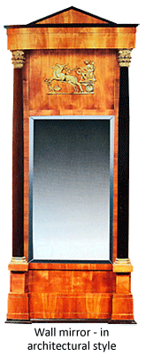
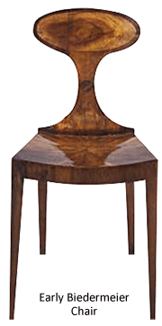
Biedermeier furniture is not an individual movement, but rather as a series of ideas stretching from Vienna to Stockholm, encompassing most of the German speaking lands, Scandinavia, Russia and the Austro-Hungarian Empire. There was at tradition in the early nineteenth century that the craftsmen travelled around Europe seeking work, which greatly facilitated the spread of ideas. These ideas combined with regional variation produced some interesting examples of furniture in the same style. South Germany and Austria produced pieces quite unlike those made in Berlin after the designs of Karl Friedrich von Schinkel (1781-1841), the great Prussian architect and designer. North Germany and Denmark were different again. Hamburg in North Germany, Copenhagen in Denmark and Gothenburg on Sweden's west coast all had close trading links with Britain, so the furniture in these regions often shows the strong influence of the English Regency style. In Sweden this furniture is usually known by the name Carl Johan after the monarch of the time, Carl XIV Johan (1818-1844). The term Biedermeier is less frequently used in Sweden. One noteworthy Swedish feature is the popularity of the native Scandinavian blond woods, especially birch.
After the World War II, there was an upsurge in the popularity of the Biedermeier furniture in Britain and America. In continental Europe, however, they have exerted a virtually continuous influence upon architects and designers since their rediscovery at the end of the nineteenth century. During this period, the furniture came back into fashion throughout Germany, Austria and Scandinavia and considerable quantities of Biedermeier Revival furniture was made. In the early years of twentieth's century it began to influence Josef Hoffmann, the Bauhaus school, Art Deco, Le Corbusier and others. In 1979 the Victoria and Albert Museum staged an important exhibition called Vienna in the Age of Schubert, which introduced the British public to the specific style. Biedermeier today in the US and Britain is an urban style for modern people. New York designers and decorators led the trend before the Europeans rediscovered the style: New York and Chicago are the main centers for the style today. In Britain the Biedermeier furniture is majorly found in London.
Biedermeier's subtle appeal lies in its simplicity, which is so easily combined with both Art Deco and contemporary furniture, creating a relaxed mood and informal atmosphere, unlike the many antique styles, which demand a more formal setting. Today, the style is increasingly popular. The world's renowned architects such as Robert Venturi, Charles Jenks, Michael Graves and Milo Baughman have rediscovered its beauty. As a result, these architects are using Biedermeier design as the inspiration for their own lines of contemporary furniture. "Biedermeier furniture is gaining a greater appreciation among today's interiors, as these pieces are especially well suited for our modern homes. With petite proportions, Biedermeier work well in small spaces and fulfill our desire for furniture that is both functional and beautiful."
Everything You Need to Know About Biedermeier Style
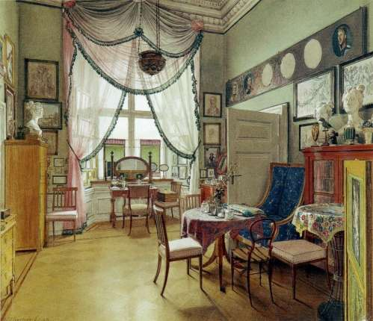
A Biedermeier interior painted by Eduard Gaertner.
More than a century before the Eameses created their simple, honest furniture designed to appeal to the everyman, a style of furnishings emerged in Germany, one whose simplicity, visual lightness, and playful geometries were a herald of things to come. Biedermeier is notable for being the first decorative movement that was created by and for the middle class, and even today, after two centuries, these pieces still feel surprisingly fresh and modern.
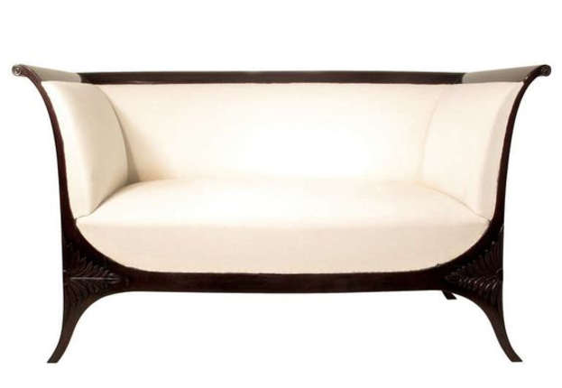

Early Biedermeier furniture, like this sofa from 1st Dibs, was especially simple in its design.
(Image credit: 1st Dibs)
The Biedermeyer style emerged around 1815, a time when Germany was in a bit of an economic slump following the Napoleonic wars, but also a time when the middle class was starting to emerge as a significant division of society, one with real buying power. Besides being cash-strapped, it was also a conservative era, one where emphasis was placed on enjoying simpler pursuits, like writing letters or having small gatherings at home. It's no surprise, then, that the middle class rejected the opulent Empire style, then all the rage in France, for one much more simple, relaxed and informal.
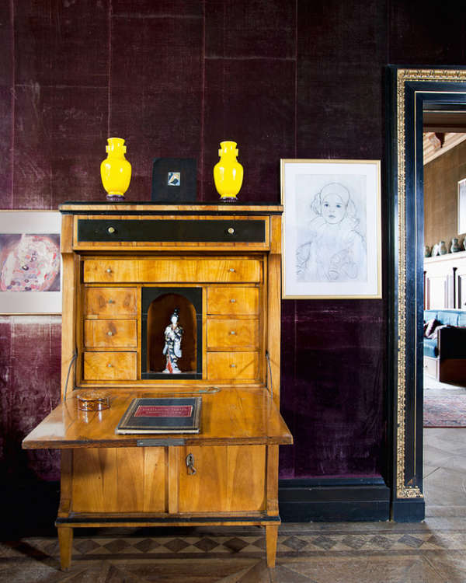
A Biedermeier secretary in the home of painter Gustav KlimtLetter-writing was an especially important pastime for the middle class during this era.
Although it kept some of the classical forms, Biedermeier rejected the dark ebony and mahogany so common in Empire furniture for lighter woods, like walnut, pear and cherry. Conveniently, these woods occurred naturally in Germany and didn't have to be shipped, which made the furniture more affordable. While Empire style was formal, impressive, gold accented and highly ornamented, Biedermeier designers embraced a more natural, relaxed look. Common features of the style are curves, playful geometric shapes and an emphasis on the grain of the wood, as opposed to any kind of applied ornamentation.
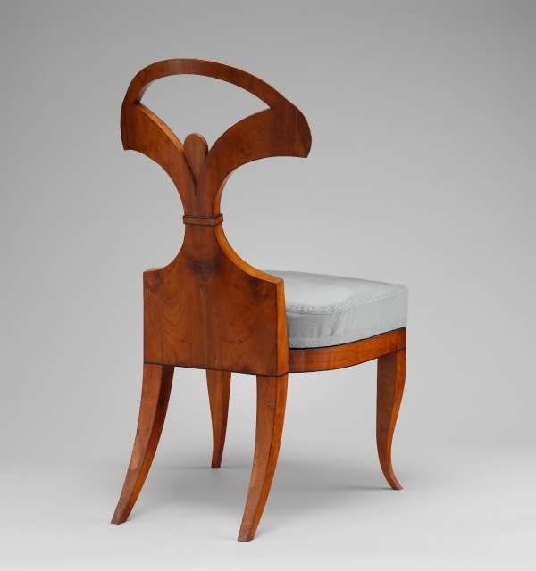
A Biedermeier chair by the Austrian designer Joseph Ulrich Danhauzers, from Mebelu Vesture.
The flat, unadorned planes, visual delicacy and playful geometries of Biedermeier pieces contribute to them feeling especially modern. There are definitely echoes of the style in later movements, like Art Deco and Art Nouveau. Some Biedermeier pieces, especially the ones that work the contrast between light woods and dark accents, would be quite at home in an Art Deco interior (with the classic influences toned down perhaps a bit).
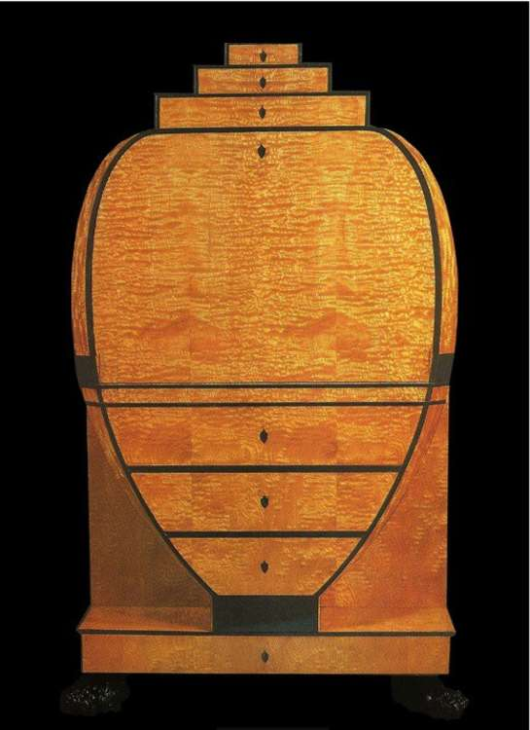
This chest from Carlton Hobbs shows the light wood, flat, unadorned planes, and playful geometry typical of Biedermeier.
The name "Biedermeier" was originally meant as a mocking one. Two writers, Adolf Kussmaul and Ludwig Eichrodt, created a character they called "Gottlieb Biedermeier", under whose name they published many satirical poems. Biedermeier was comfortably middle-class, a good citizen and without many intellectual ambitions—exactly the sort of person Kussmaul and Eichrodt found ridiculous. The same elites who found the new bourgeois absurd apparently also found their furniture a bit silly, so they applied the name to the style, and it stuck. Ironically, Gottlieb has been forgotten, while Biedermeier is a perennially loved style of furniture—although hardly affordable to the middle class.
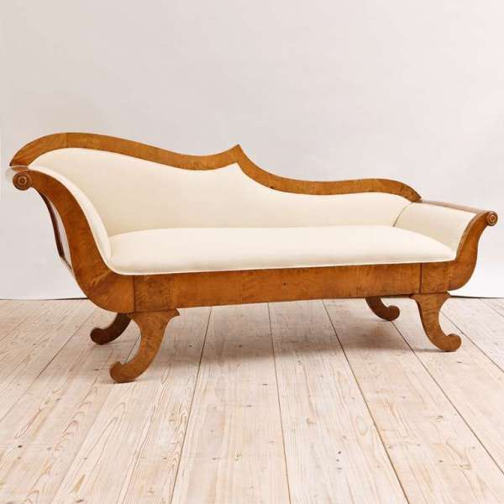
A Biedermeier sofa with some nice curves, from 1st Dibs.
Even if you're not planning on bringing any Biedermeier furniture home, it's a fun little era to visit. And hey, if there's ever a Beidermeier revival, you can say you heard about it here first.
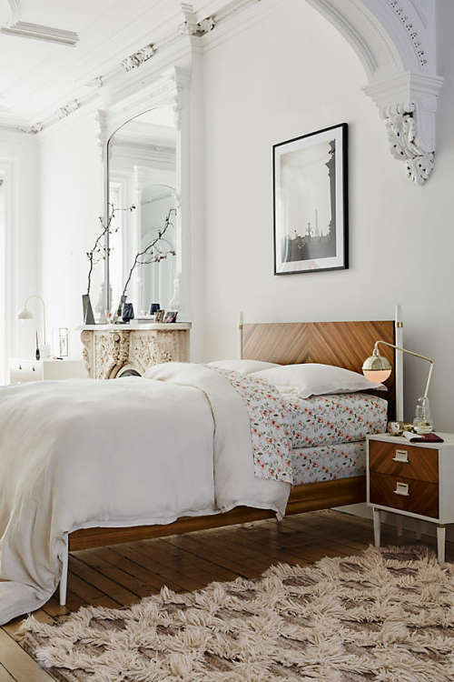
Biedermeier revival? This Geo Marquetry bed from Anthropologie feels very Biedermeier to me.
History of Biedermeier
Between 1815 and 1835, following the Napoleonic wars, a new decorative style -- less fussy and more functional than the French Empire and Directoire designs that preceded it -- emerged in Northern Europe, particularly in Austria and southern Germany. It was modestly scaled for private homes and family life instead of grand palatial halls. Fruitwoods often replaced more costly hardwoods like mahogany, and veneers and inlays provided decorative accents instead of carvings. Much later, toward the end of the century, the new style was labeled “Biedermeier” by Georg Hirth in a book on interior design. He derived the name from a mid-century fictional character, Wieland Gottfried Biedermeier, who spoofed the homely comforts and conceits of the rising middle class. "Bieder," roughly translated, means “commonplace,” “plain,” or “conventional,” and “Meier” was a typical surname.
Design Features
The typical early Biedermeier chest has an uncluttered geometric appearance featuring straight or gently curved lines and restrained decoration. Before the mid-19th century, a standard chest of drawers consisted of four long or three long and two short drawers. The bank of drawers was mounted on straight or slightly curved legs, with curved legs gaining favor later in the period. Individual drawers opened with locks and usually did not have pulls. Most decorative accents were applied to the frontal surfaces. Biedermeier furniture was designed for private homes, not palaces, so the smaller scale of the pieces is suitable for average-size rooms.
Typical Materials
Cabinetry artisans used native woods, readily available in their local areas, including maple, cherry, pear aspen and walnut. These woods produced lighter finishes that were frequently accented with contrasting ebonized trim or delicate inlay. The thickness of the woods used in veneers helps determine the age of the furniture. Earlier veneers were thicker, and later machine-produced veneers were much thinner. Furniture was sometimes decorated with black and gold paint or gilded stars. If metal ornamentation was applied, stamped brass was used instead of bronze.
How to Identify Biedermeier Chests
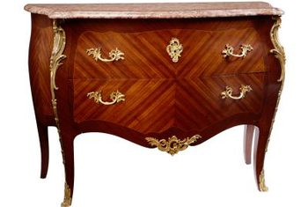
Clean lines, a shimmering finish and exquisite craftsmanship with natural woods make an authentic Biedermeier chest an instant focal point in any setting. Originating in the early 19th century, Biedermeier furnishing design influenced subsequent furniture styles and enjoyed repeated revivals throughout the 19th and 20th centuries. Biedermeier pieces continue to be admired and collected by connoisseurs of fine furniture, making them a worthwhile investment.
17. Art Nouveau Style
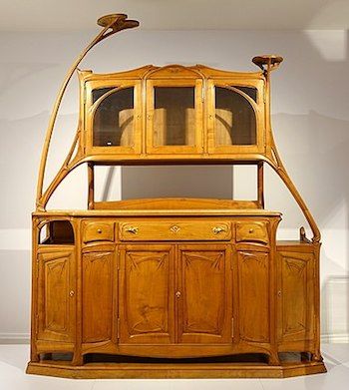
Example of Art Nouveau furniture, a buffet cabinet designed by Hector Guimard
Characteristics of Art Nouveau Furniture
One of the first things you notice about Art Nouveau furniture is a sense of long, sinuous line. It snakes around shapes and curls in organic, stylish ways. Some of this comes from the flattened space and linear quality of Japanese art, which was a popular influence among artists at the time. Some of these lines come in the form of whiplash curves, elongated curving lines that bend back on themselves.
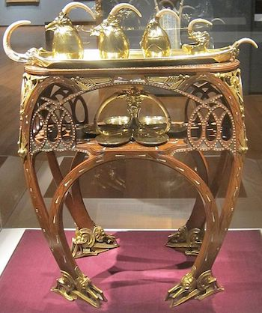
Example of Art Nouveau furniture. Notice the emphasis on curved and elongated shapes.
Art Nouveau furniture is often made of materials like hardwood, especially walnut, oak, and teak. Some surfaces are decorated by a process called inlay, where small pieces of hardwoods are cut and pieced together to form a flat decorative surface. Furniture pieces can also incorporate metals that also curve and bend in elegant ways.
Art Nouveau Style
The style consists of two distinct looks: curvy, elongated lines, or the more linear look of artists such as Charles Rennie Mackintosh. There were elements of stylised natural forms, such as flowers, roots, buds and seedpods, and the pre-Raphaelite female form was often seen also. Vertical lines, with height were a feature, with the whiplash line being prominent. From the stylised natural forms of flowers also came spider webs, peacock feathers, locusts, thistles and more, appearing on wallpaper, furniture and accents. Exotic woods, iridescent glass, silver and semi precious stones were the materials of choice in this elaborate and exuberant era.
Art Nouveau Interior
Most Art Nouveau furniture was based around the greatly influential designer, Charles Rennie Mackintosh. He was renowned for his extremely high-backed chairs in a glossy black lacquer. A more conservative option would be more curvy shapes, upholstered in stylised floral fabrics. Furniture however, was not a big element of Art Nouveau design, and the focus was mainly on beautiful and elaborate ornaments. Art glass was a must. The typical Nouveau glass was iridescent with patterns of liquid oil. Glasswork also came in more opaque matter, with detailed etched designs. Of particular mention is the Galle “cameo glass”, which has a raised design cut out of the glass with acid. Tiffany lamp -shaped like an umbrella with bold colored favrile glass between bronze and metal latticework was a symbol of the art nouveau period, very expensive, and has now had thousands of lesser quality imitaions made. Silver and pewter were also popular materials for ornaments, and it is not difficult to find Mackintosh-style clocks, frames and jewellery boxes today.
Art Nouveau Color
Period colors were elegant and subtle, and became known as the “greenery yallery”. Mustard, sage, olive, brown and gold, teamed with lilac, violet and purples, peacock blue, salmon and robin’s egg blue for the ultimate in elegance. Wallpapers included much of the highly stylized nature symbols, particularly flowers, feathers, birds and dragonflies. Fabric also featured much of the same designs.
Art Nouveau Influences
Art Nouveau shared a lot of the same beliefs as Arts and Crafts. They both believed in quality goods and fine craftsmanship, but Nouveau embraced the convenience of mass production. Rococo style also featured, and botanical research and design was strong throughout.
Famous Designers of the Art Nouveau Style
Charles Rennie Mackintosh– architect and designer of furniture and jewellery
Louis Comfort Tiffany- lighting
René Lalique- glass and jewellery
Emile Galle- ceramics, glass and furniture
Victor Horta – Architect
Alphonse Mucha – posters
Art Nouveau Furniture
The last years of the 19th century and the beginning of the 20th century are often remembered with a certain romanticism. The images of luxurious and elaborate interiors are common. Furniture pieces resembling trees and flowers became very popular and the style that emerged became known as Art Nouveau. It was named after a Parisian art gallery, which promoted innovative designs.
Art Nouveau was an artistic style that started in France at the end of the 19th century and developed until the start of World War I. It was seen in Europe and America and was especially popular in France and Belgium. Art Nouveau touched all forms of arts and was very innovative in architecture and industrial design, with creations that broke with traditional ideas coming from decades ago.
The style had some local variations in the different places where it developed, but there were some common characteristics that most pieces of Art Nouveau furniture shared. They were often inspired by nature and had abundant references to trees and flowers. Plenty of curved lines were used for the different elements of the designs. Art Nouveau searched for asymmetry, and although furniture design continued to be mostly symmetrical because of its functional nature, sometimes designers incorporated small asymmetrical details. Fine finishes were common and noble woods like mahogany, walnut, or maple were combined with more exotic ebony or snake-wood, delicately polished and varnished.
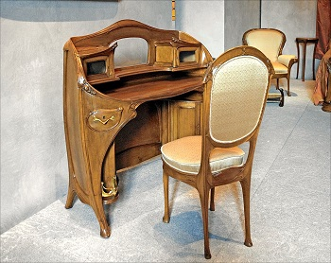
Art Nouveau desk and chair, by Hector Guimard
Art Nouveau Furniture:

Art Noveau Furniture
The name "Art Nouveau" is French for 'new art', and it emerged in the late 19th century in Paris. The style was said to be influenced strongly by the lithographs of Czech artist Alphonse Mucha, whose flat imagery with strong curved lines was seen as a move away from the academic art of the time. Art Nouveau furniture used lines and curves as graphical ornamentation and hard woods and iron were commonly used to provide strong yet slim supporting structures to a furniture pieces.
Famous Art Nouveau Furniture Designers
Art Nouveau had a relatively short lifespan, but during its years of popularity many designers created furniture and other design pieces that have become a reference of that time. The following are some of the most famous Art Nouveau furniture designers:
Hector Guimard
Guimard was a French architect, best-known for designing the cast-iron entrances to the Paris Metro. He believed in the integration of all the elements of a building, so he often designed the furniture and all the interior details for his architectural projects. His furniture incorporated curved lines and floral motifs, common of Art Nouveau, and had a subtle search for asymmetry expressed in the incorporation of small details and ornaments that were different on each side of the piece. He often used mahogany and maple with a fine varnished finish. Guimard's designs were complex and difficult to produce, so they were not affordable for the general public.
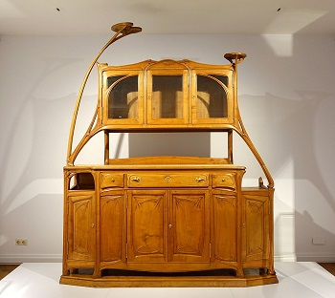
A Buffet by Hector Guimard

Louis Majorelle
Majorelle was a French furniture designer and decorator. He came from a family of furniture manufacturers, so he was able to personally produce many of his designs. His furniture pieces had abundant curved lines and he became known for the use of elaborate bronze embellishments made from curved lines and floral motifs. Majorelle often combined alder, walnut, or mahogany with exotic woods like snake-wood, creating interesting combinations of dark and lighter tones. After World War I, the designer shifted his style towards the newer Art Deco.
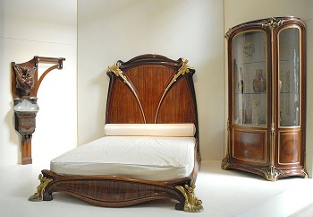
Bedroom Furniture by Louis Majorelle
Émile Gallé
Gallé was a French designer who is considered one of the most important figures of Art Nouveau because of his exquisite glasswork. He also created many furniture pieces. His designs were often inspired by exotic places like Japan or Africa. The furniture pieces usually incorporated curved lines and plenty of embellishments, which more often were ornaments rather than part of the actual construction. Gallé's work was notorious for the use of wood inlays of different species that depicted trees, birds, and even entire landscapes. He also looked for incorporating asymmetrical elements on many of his designs.
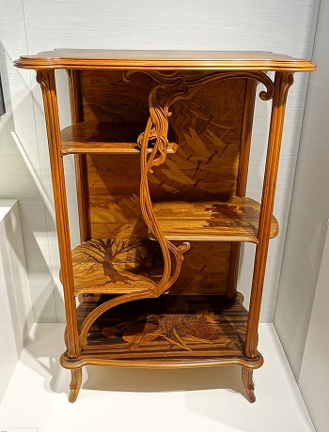
Shelf Furniture by Emile Galle
Antoni Gaudí
In Spain, Art Nouveau was combined with local influences and became known as Spanish Modernism. Architect Antoni Gaudí was the main promoter of that artistic movement and is famous for his masterpiece, the Sagrada Familia and other singular buildings in the city of Barcelona. As many architects did at the time, he often designed the furniture for his buildings. He also created sculptures and metalwork pieces. Gaudí's furniture designs incorporated the curved lines and floral motifs of Art Nouveau, combined with a more traditional Catalonian look, sturdier and not very ornamented.
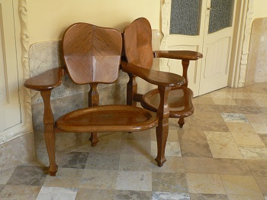
Chair by Antoni Gaudi
From the history of the origin of style
Art Nouveau was established in the second half of the 19th century in France as a style that combines many artistic movements. Initially, it was widespread in art and architecture, but quickly won the hearts of the people and began to be used in the design of furniture and accessories.
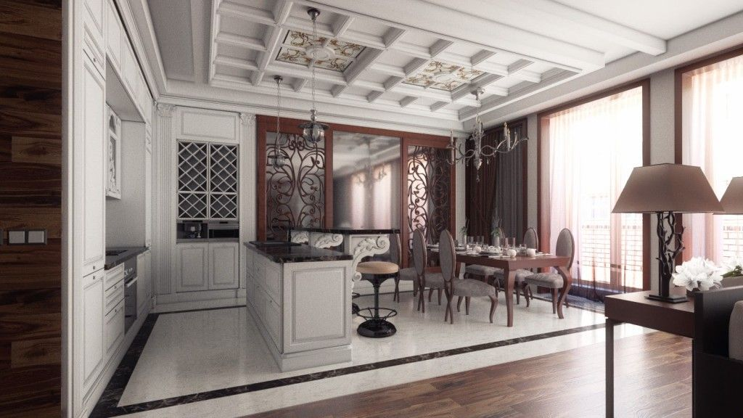
It is remarkable! Word of Art Nouveau translating from French as “new art.” In different countries the style was called differently: “Modernisimo” – in Italy, “Liberty” – in Spain and the style was “combined” with other contemporary trends and called in one word – “Modern” in Eastern Europe.
The main features of Art Nouveau interior design style
- Art Nouveau style in interior design of the house or apartment is a complete rejection of clear lines in favor of flowery and smooth contours, symbolizing the bent stalks. This is the main feature of style, its main focus.
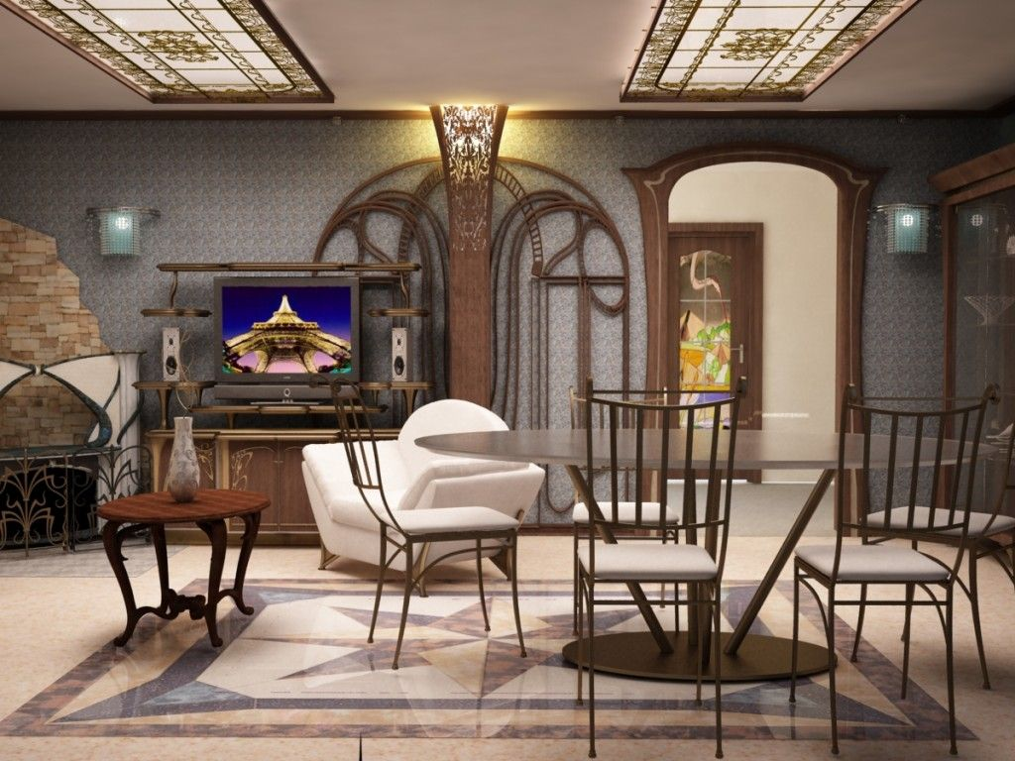
Art Nouveau interior design pays special attention to colors: a palette of shades is quite wide and varied, but it must be a natural color. White, cream and sand colors are often combined with the color of grass, leaves and stones, and they are complemented by the hues of wood and earth;
Art Nouveau style in the interior implies the combination of different materials: wood, glass, stone, etc;
- Art Nouveau in the interior of the apartment means the mandatory presence of floral motifs and images of aquatic plants (algae, lilies). Paintings with such images, textiles and wallpaper with a similar pattern will be very relevant in the interior.
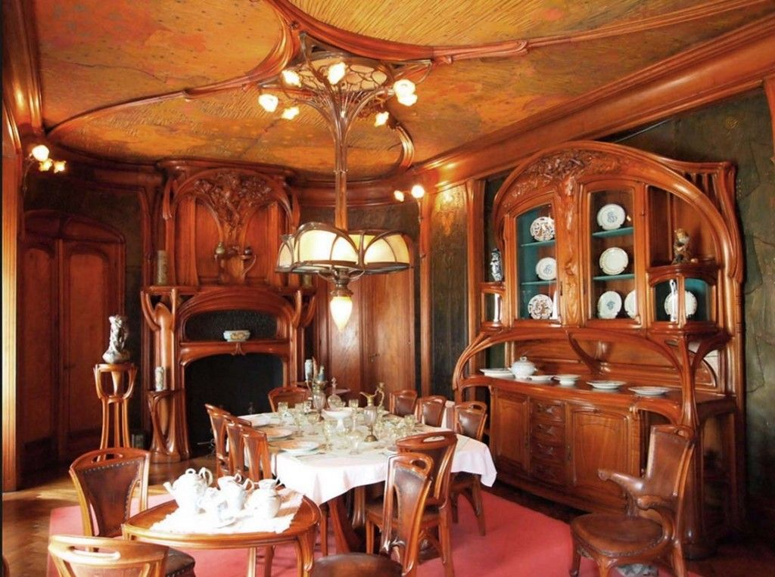
Decorativeness as the main principle of rooms` decoration
The room in the style of Art Nouveau should be framed such way that it would represent more a kind of “work of nature” than human labor. When making a room, you should be guided by decorativeness – interior elements should be styled “a-la nature” or should be decorating by floral ornaments.
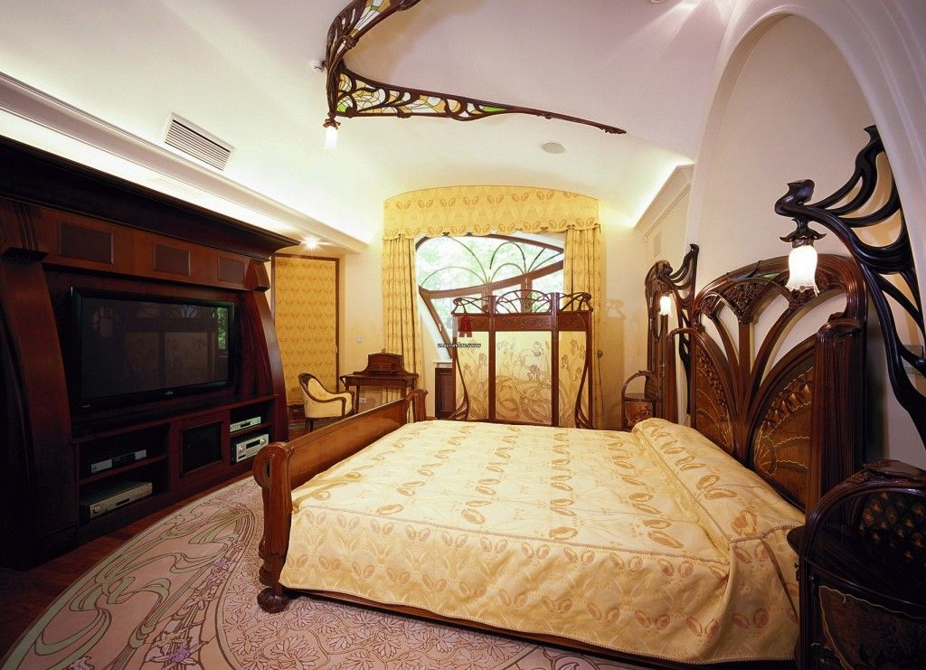
- Kitchen in the style of Art Nouveau involves asymmetry, gliding line, decorations in the form of the working kitchen arranging with wall tiles or mosaics, depicting plants;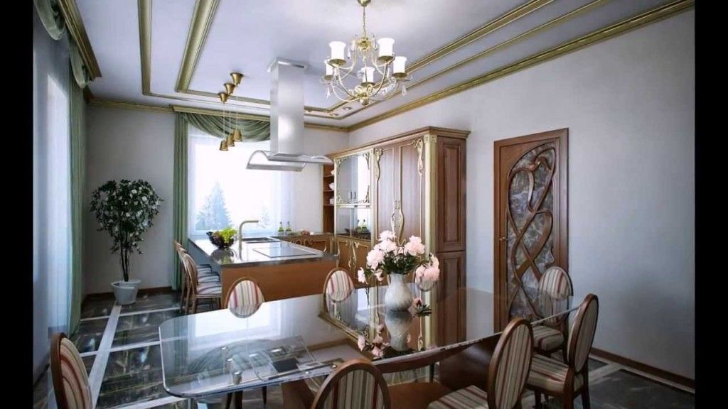

- The bedroom in the style of Art Nouveau can be decorated with spectacular mirrors (preferably in wavy and round frames) as well as asymmetrical vases can be advised for interior decoration. Walls can be garnished by the custom picture in the style of Art Nouveau;
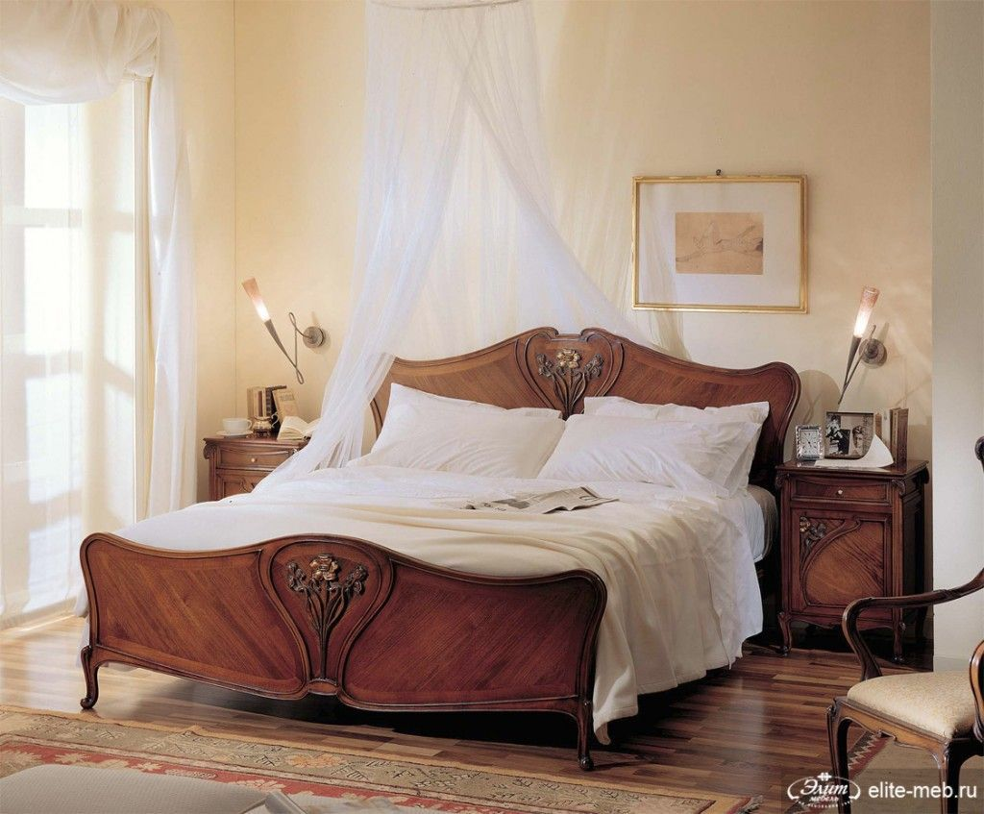
- Bathroom in the Art Nouveau style, as well as other facilities, can be decorated with stained-glass windows. Artistic Stained Glass will be appropriate for windows, doors and even lamps;
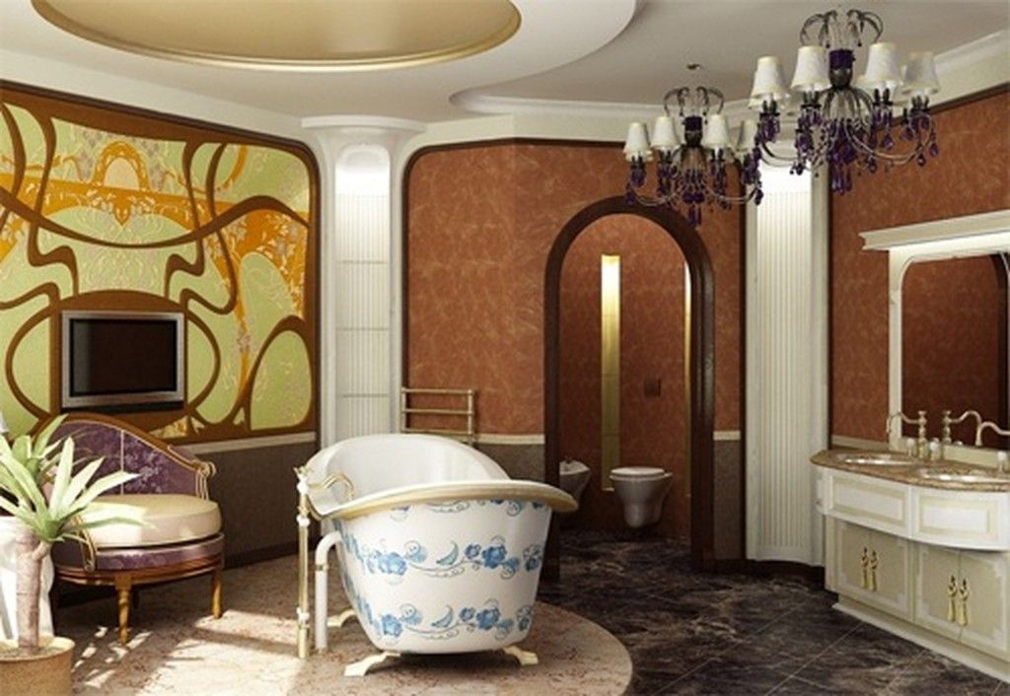

18. Traditional Interior Style
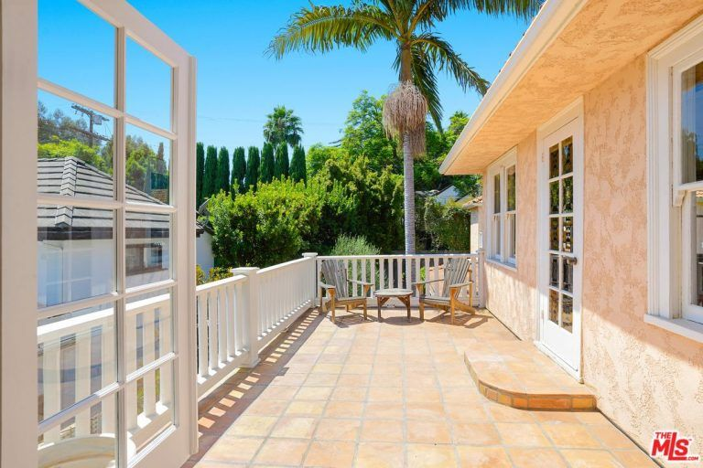
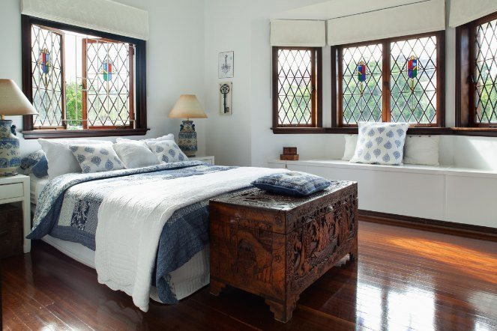
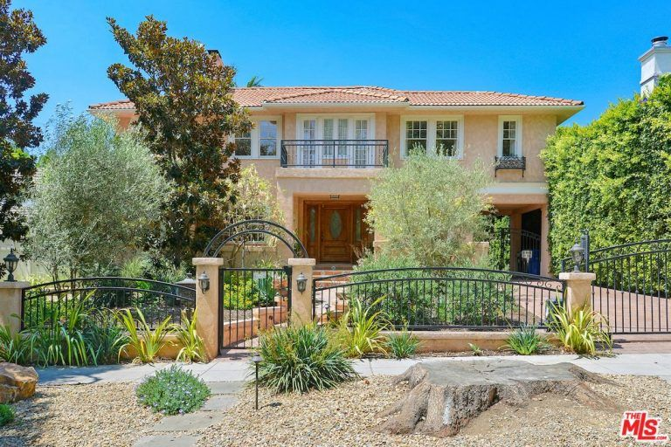
Traditional interior design style stems from a variety of old-school European styles and together are now referred to as “traditional”. Elements of this design include:
- Reflects classic European decor,
- Elaborate moldings and wood paneling,
- Built-in cabinetry,
- Elegant furnishings and antique pieces,
- Pairings of furniture and accessories,
- Neutral palette with vibrant colors for furniture and accent pieces,
- Expensive textiles like silk, velvet, cashmere or comfy fabrics like cotton or linen, and
- Intricate tile and wood floor patterns
Our traditional home decor style guide includes an extensive photo gallery that includes all rooms of the home.
Traditional interior designers are those that are heavily influenced and inspired by the old European décor that gained popularity, particularly during the 18th and the 19th century. They are big on heavy furniture and fittings that are still very stylish and elegant.
This type of interior designing is perfect for those who love decorations and styles that a have rich history behind them for instance, classic art pieces, antique elements, and symmetrical objects.
Some key markers or features of the traditional interior designs include rich tones, dark woods, and sophisticated colors. The most distinctive feature is that the walls are often painted with neutral colors so that the furniture and decorative accents can be highlighted. The ‘traditionalist’ also loves creating intricate architectural details like wood paneling, coffered ceilings, in-built cabinetry, etc.
One of the most vital aspects about traditional interior design is ‘symmetry’ which means that everything from sofas to lamps to accessories has to be in pairs. The underlying idea behind this is that there should be a balanced space centered on a focal point, which is usually the television, a decorative art piece or the fireplace.
19. Transitional Interior Design
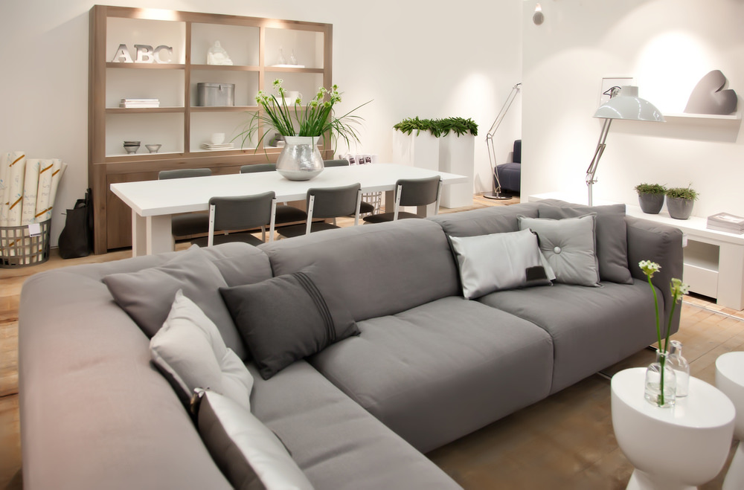
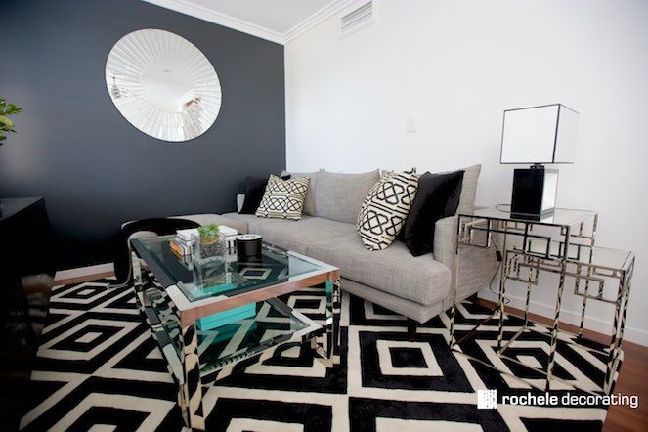

Transitional interior design style is an elusive style that spans multiple styles tying traditional or long-standing styles together with modern or contemporary design elements. It’s extremely popular right now among designers. In fact, it’s very easy to confuse contemporary with transitional and in fact for both types it’s often easy to argue a particular interior design is one or the other.
Transitional interior design elements include:
- Curved furnishings with straight-lined lacquered finishes,
- Limited use of accessories,
- Use of impactful art as focal points,
- Neutral color palette, and
- Textural elements such as wood, glass, lacquer, rattan, fabric, steel and metal.
Check out our vast gallery featuring transitional designs. Click button above.
20 . Midcentury Design Style
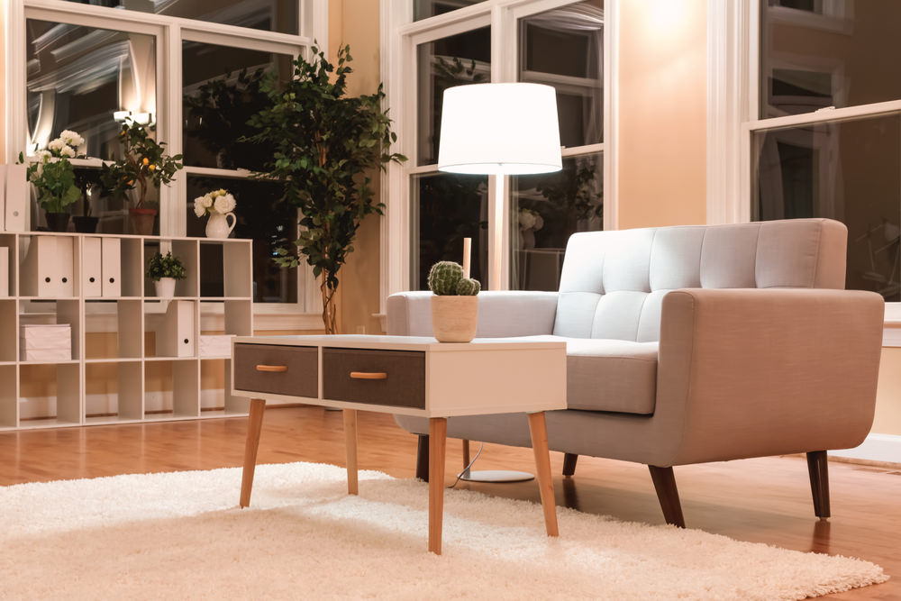
Midcentury style is a package deal. While some homes can have a different exterior style to the interior, that doesn’t really work with midcentury. The midcentury home must be midcentury outside and inside.
It’s a distinct look with clean lines, sparsely furnished, often not terribly large (but can be) and of course give off the 1950’s and 1960’s nostalgic look.
I had the privilege to do a driving tour of midcentury homes in Palm Springs and even managed to check out some open houses of a few midcentury homes. They are definitely cool.
These interior designers take you back to the 1900s with some of the most iconic interior styles and designs. Mid-century modern interior designers offer you a unique blend of minimalism and a kind of an ancient retro look. The main theme followed by these designers is “fussy-free” which is usually accompanied by crisp, simple lines, rusty metals, a lot of wood, subtle silhouettes and hues of blues and greens.
These designs are believed to be a break-free from traditional design conventions that have taken a direct plunge into the modern era.
Some typical designs adopted by mid-century modern interior designers include simple fabrications, pared-down forms, molded plastic plywood, and natural-shaped furniture like an egg-shaped chair, for instance. Their styles and designs are often somewhere along the lines of ‘contemporary’ and are super versatile, which makes the transition simply flawless.
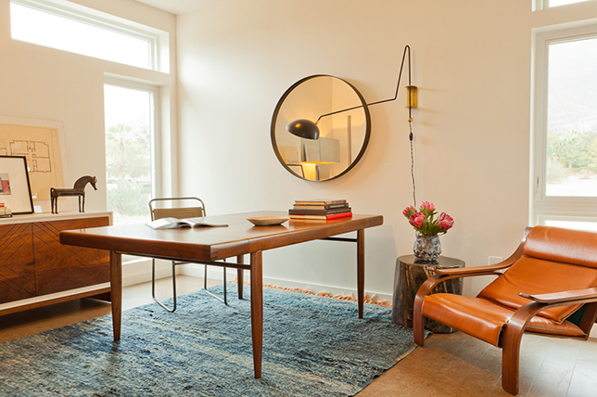
- Probably one of the most prolific interior design styles of all time, mid-century modern borrows from the best of 50’s and 60’s for a clean retro Danish inspired feel. Simple straight forward silhouettes, organic shapes, quiet fabrications, and an emphasis on functionality are hallmarks of mid-century modern styling. That said, the movements minimal bent makes it a great option when looking to update traditional style interior design with ease.
- Plus, mid-century modern furnishings look great in almost any room and make for great elements when looking to create rich, diverse, interior design styles living room. And as far as interior design styles trends go, this is one fail proof one we suggest you give a go.
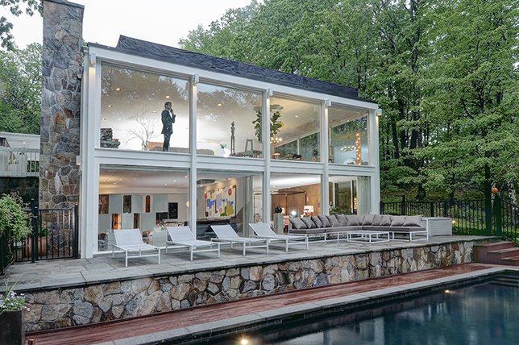
Even if you’re not a design aficionado, chances are you’ve heard of mid century modern design and have most likely been in a room featuring the design style at one point in your life or another. And for good reason as this is one timeless, forever-chic design direction that never seems to lose traction or covetability. But what does it mean?
To help you better understand this go-to design movement’s popularity and it’s endless resonance across generations, we set out to highlight what makes mid century modern design a standout among every other design style, why it could work for you, and how to make the best of it with ease.
WHAT DOES MID CENTURY MODERN MEAN?
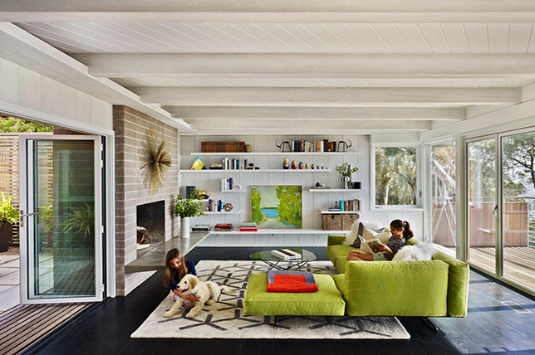
Though the term mid century modern wasn’t coined until the mid-80’s, and though no one really knows it’s true timeline, the era represents a combination of post World War II practicality, 50’s era optimism, 60’s era earthiness, and 70’s era tones and textures neatly wrapped up in a stylish ode to Scandinavian simplicity.
Call it a reaction to the decadence and gilt adorned stuffiness of interior design and architecture through to the 40’s if you will, as at the time of its inception, mid century modern decor was a complete rebuttal and restart for the senses.
The vibe is fresh and poppy, retro-tinged, and completely alluring with its dedication to comfort and practicality wrapped up in beautiful design that never goes out of style. Unlike other aesthetic movements, mid century modern decor is streamlined in design, as form follows function while highlighting the materials used, rather than making them something they aren’t.
WHY YOU’LL LOVE MID CENTURY MODERN INTERIORS?
- Mid century modern design is great for those looking to add authentic vintage styling in their home without having to go full force as today’s iteration is much more subtle in nostalgia.
- Creating mid century modern homes is fun and a great way to see even the smallest of spaces come to life with quiet design quirks.
- The perfect mid century modern house boasts charming decor that’s for sure, but it also features practical, durable, easy to source at any price design – that’s easy on the eye.
- The era also allows for more freedom and is less restricting than say minimalism or traditional interior design.
HOW DO YOU CREATE MID CENTURY MODERN STYLE?
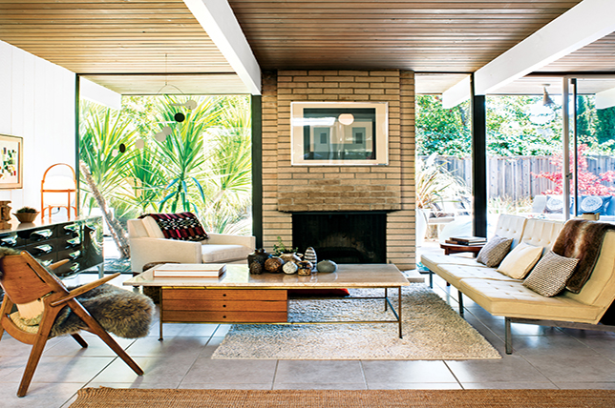
Since mid century modern design has its roots in architecture and its furnishings were originally created to highlight the era’s design sensibilities, here’s a quick rundown of the architectural details you’ll want to highlight to inject your home with mid century modern interior design effortlessly:
- Born after WWII, mid century modern design stripped away the superfluous to keep things true their original essence. Take a similar cue and keep everything structured, practical, and durable with slight design flourishes for added interest.
- Take advantage of natural elements in a room from exposed beams to wood panels to untouched brick walls to bring the outdoors in.
- Add character via abstract prints, patterns, and art that are free of cultural references and can be more easily associated with the arts & crafts movement of the era instead.
- Unpretentious to the core, one of the main reasons people continue to praise mid century modern decor is its overall casual, lounge -ready vibe, so have fun with it and keep it relaxed – just don’t go overboard.
MID CENTURY MODERN COLORS
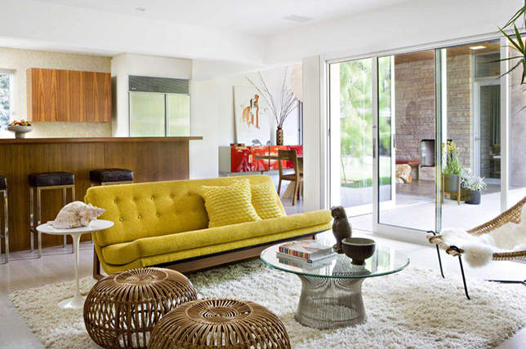
Like in fashion, the way we decorate our homes at the moment often tends to reflect the era’s energy and direction and mid century modern design happens to do just that as its kitschy, kicky bright hues that touch on the optimism of the 50’s while natural woods, greens, oranges, and earthy tones riff on the sophisticated spirit of the 60’s and 70’s.
If you aren’t blessed with an original mid century modern house, you can work the style into your home by making your color scheme work as a foundation starting point.
Think moodier hues like burnt sage, orange, and rust for a decidedly mid century modern living room, while every other room allows for a more playful take on hues including turquoise, sunny yellow, bright orange, and primary colors scattered about. Just be sure that each room is grounded with sobering neutrals to keep the mix heady and not oversaturated.
MID CENTURY MODERN STYLE FURNITURE
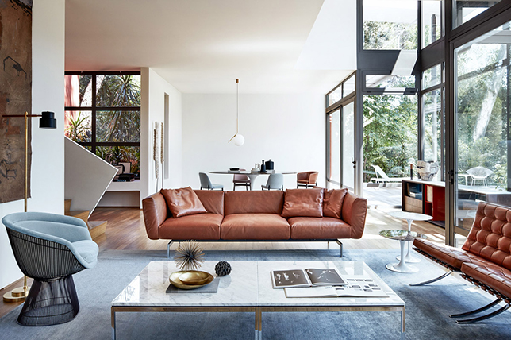
Anti fuss and formal, mid century modern design is all about clean lines, simplicity, practicality, and sumptuous silhouettes. Think new to the era materials like plastic, acrylic, and even formica when considering furniture materials.
Other hallmarks include hairpin legs, low streamlined seating, plastic shell chairs, cocooning lounges, matte finishes, and consoles with plain surfaces punctuated with facades radiating personality via design flourishes.
MID CENTURY MODERN TEXTILES
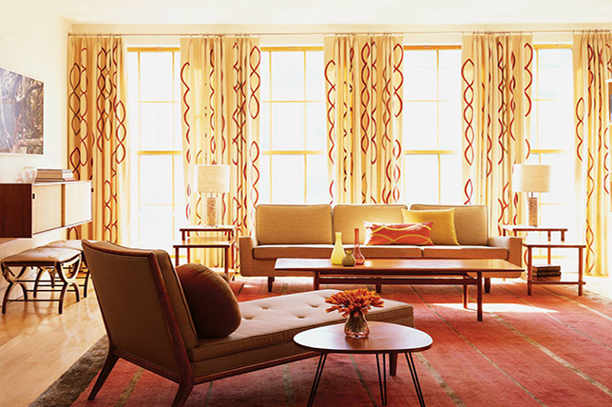
A quick look through any mid century modern home decor reference is sure to point out the obvious: the movement’s major print direction is naive, playful, abstract, full of geometrical graphics, and unfortunately a tad childish and overtly retro.
To bring your mid century modern home design into the now, source similar to the era fabrications and textiles in small doses to avoid a heavy-handed kitsch approach. Take the room above, save for the statement-making curtains and single throw pillow, the room is almost print free while homing in on just the right, concise color scheme to keep everything fresh and timeless.
Our interior designers suggest doing the same with pillows, throws, linens, and drapes as to not overwhelm the eye or appear trapped in a time warp.
MID CENTURY MODERN STYLE ACCESSORIES
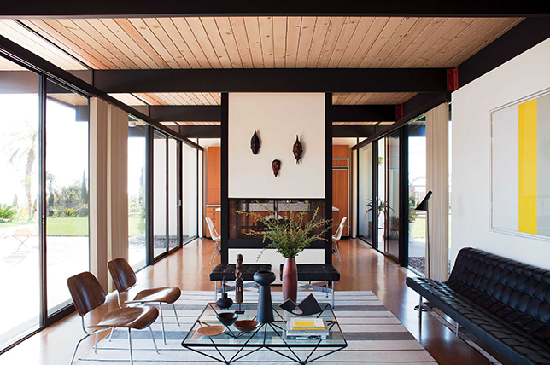
Accessories are where you can have fun with mid century modern design without having to commit too much space or overextend your budget. Take a quick survey of any of the rooms featured here and you’ll notice that all well-considered mid century modern homes share a common thread of spare surfaces and simplicity. Follow suit and bring in just a few decorative pieces that are unique enough to stand on their own.
If you’re looking for tips on how to decorate mid century modern on a budget, scour local flea markets, secondhand shops, and online auction houses like 1st Dibs for rare, one-of-a-kind finds that are sure to bring your mid century modern house fantasies to life.
For a mid century modern living room and common areas, source decorative extras that evoke the 50’s and 60’s in saturated colors, like a trio of porcelain vases with naive patterns, sculptures in varying sizes for added drama, and wall hangings and mobiles boasting graphic shapes in vivid hues for unexpected jolts of color.
MID CENTURY MODERN WINDOW TREATMENTS
With natural elements and an emphasis on the outdoors being hallmarks of mid century modern design, take advantage of every window you have and let the light in. Source sheer solid drapes, blinds, and window treatments that you can easily retract to take in the sights outside.
And though mid century modern home decor is all about clean straight lines, and playful pops of color and print, Decor Aid’s interior designers suggest going for neutral window treatment fabrications that are simple in design and symmetrical for a modern take on mid century modern home design as you should never want your decor to be all out vintage – its all about the mix.
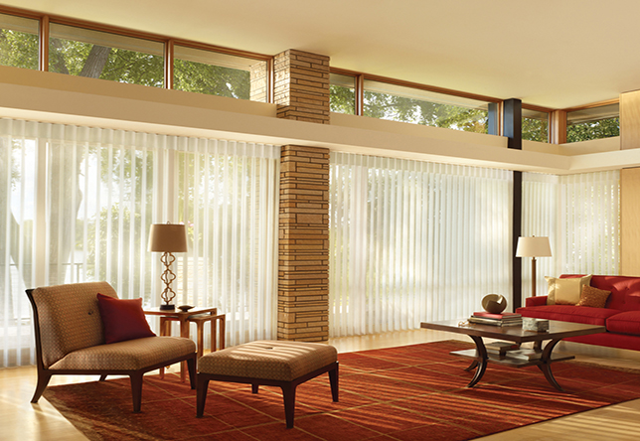
MID CENTURY MODERN STYLE ROOM BY ROOM:
By now you probably get the gist of what makes mid century modern decor so enticing, but how to make it come alive in your home from room to room?
To help you master mid century modern design with aplomb and authority, we’ll take you from room to room and break down what you’ll need to create a remarkably distinct mid century modern kitchen, a snazzy living room and dining roomfeaturing highlights of the design movement, and a comfortable oasis of a mid century modern bedroom.
Mid Century Modern Kitchen:
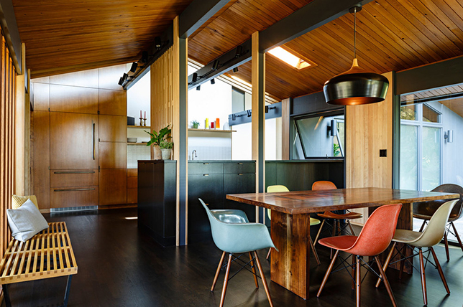
When looking to inject heady doses of mid century modern decor in your home, the kitchen can be one of the most challenging rooms to complete with an authentic hand. For one, updated appliances create a stark contrast with mid century modern design, and the scale of new appliances is often much larger.
To create an up to date mid century modern kitchen that’s warm, inviting, full of personality, and practical, think of ways to add bright pops of color, small vintage appliances and decorative extras throughout. And lucky for you, there’s a slew of well-made appliances styled after retro kitchen gadgets available at a variety of prices.
For a mid century modern design kitchen color palette, go for either high-shine or matte finishes, and cheery primary colors grounded with dark natural wood for extra impact.
Mid Century Modern Dining Room:
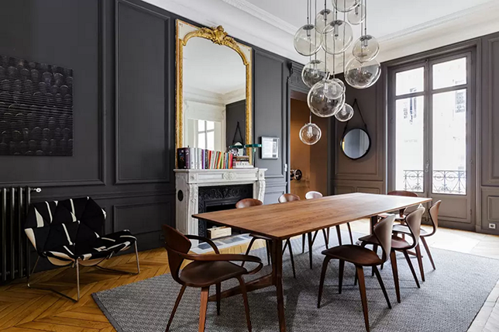
Though we’ve done a pretty good job of sourcing inspiring images that highlight mid century modern home decor and architecture, we included the Parisian dining room above as a great example of how you can bring in the era into your home no matter what its structural styling is like.
In fact, it can make for quite a heady mix as shown above. For one, the sturdy Danish inspired dining table and matching chairs give off a strong vibe that compliments the rooms moody hues and slightly feminine curves. But best of all, we like that the overall appeal of the room marries the best of mid century modern home design with a playful sense of off-kilter quirk thanks to such an unexpected mix – that still feels totally connected.

Mid Century Modern Living Room:
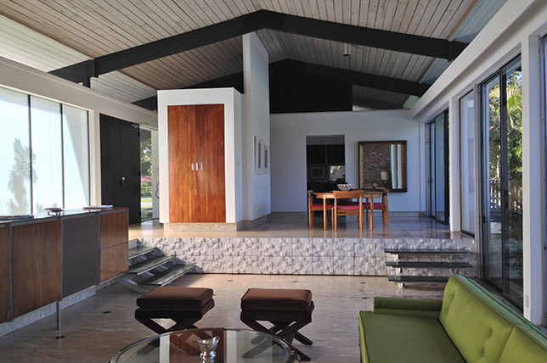
Like with any style, communal rooms are key gathering and decorative spots for mid century modern homes interior design. And as you can imagine, for good reason as these are often the largest rooms in a home and work as conversation areas to showcase a rich collection of furnishings while boasting comfortable furnishings and brilliant design.
For your own take on a mid century modern living room, go about by focusing on the harmony furnishings and objects share with each other while bringing in statement-making pieces high and low for depth and subtle nuances. Note that while this mid century modern house featured here may seem soothingly simple at first, there’s plenty for the eye to hone in on and bounce off of throughout the room.
Do bring in surprises that aren’t from or devoted to the era yet do share a similar aesthetic and silhouette as they’ll help to make your home unique to you and give you more freedom.
Mid Century Modern Bedroom:
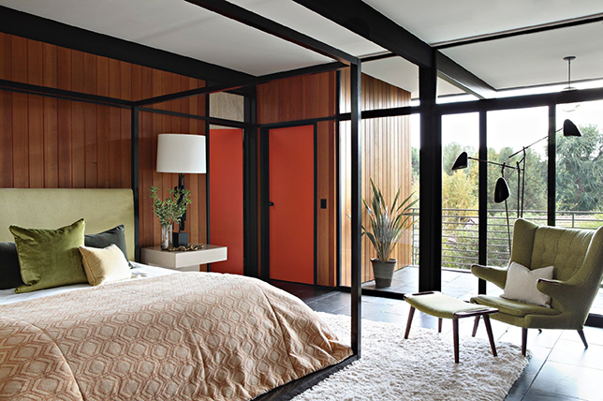
Tour any vintage and antique showroom and you’ll be sure to find a bevy of timeless and handsome nightstands, headboards, and bedframes that look timeless thanks to their clean, straightforward Danish inspired design and durable construction.
And because the best of mid century modern interior design is all about classics with a decidedly genderless spirit, you should be able to create a perfectly viable mid century modern bedroom with confidence and ease. Again, the trick here is to stick with simple lines, muted tones, and plays on texture.
Note how the bedroom featured above does just that while sumptuously echoing the architecture of the home for a subtly stimulating take on mid century modern style. Follow suit and go for extras like the oversized chair and multi-arm floor lamp to introduce flashes of playful silhouettes in any room in your home.
Mid Century Modern Bathroom:
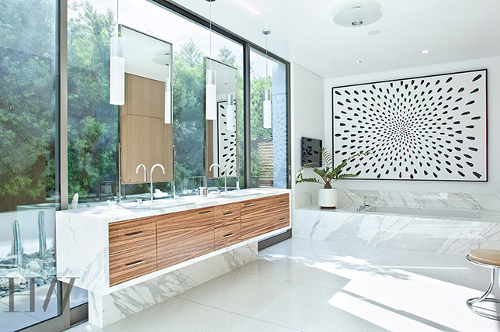
Though a bathroom isn’t necessarily the right room for mid century modern home decor and the styles vintage inspired zeal and dark woods, there are still plenty of approaches to peppering the room with takes on the style in small doses for a thoroughly mid century modern home design.
The bathroom above, for instance, features minimal marble and sleek lines for a timeless appeal, yet for a more rich, layered look, a custom vanity featuring juxtaposing wooden drawers, a simple yet oversized black and white canvas wall hanging, and a mid century modern stool were brought in for a marvelous, easy on the eye effect. Take a similar approach in small rooms in your home by adding even the smallest of details and extras to channel the era in style.

21. Shabby-Chic
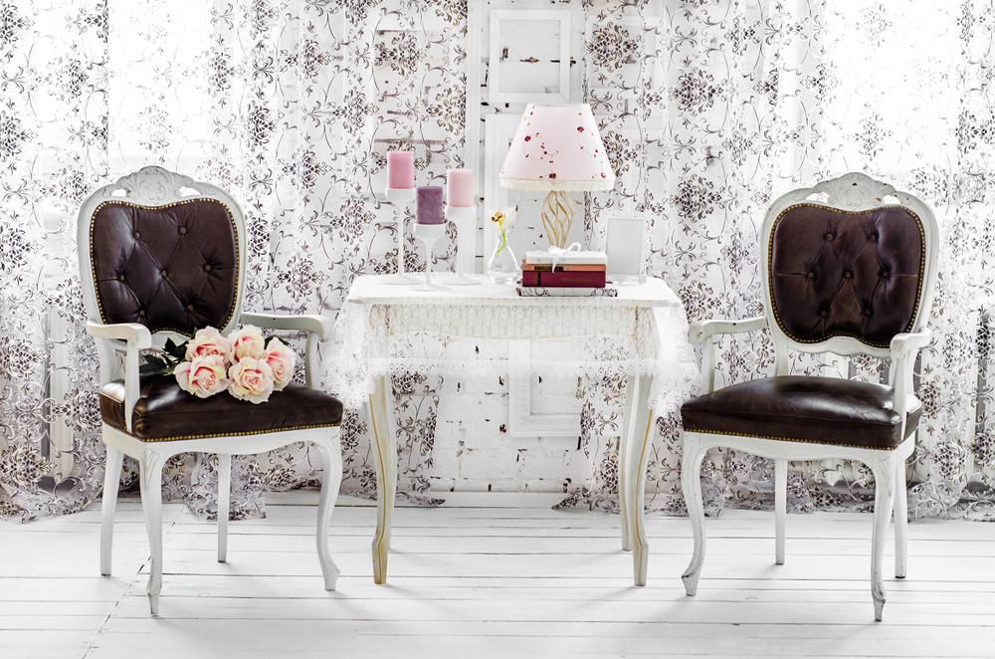
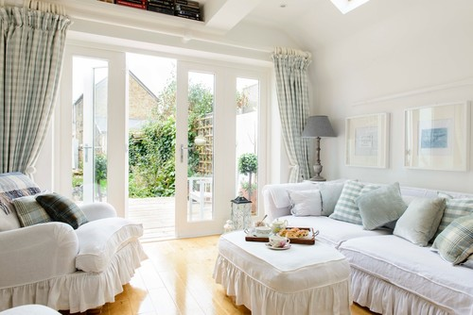
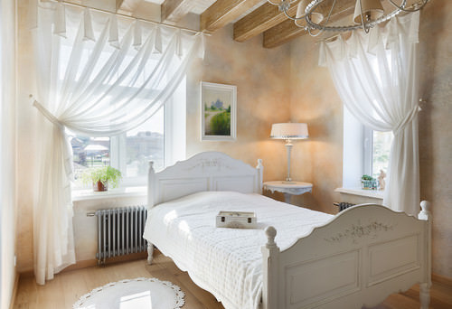
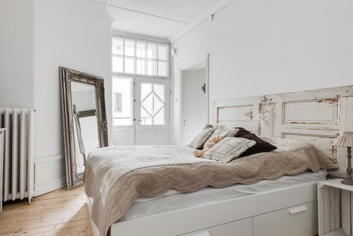
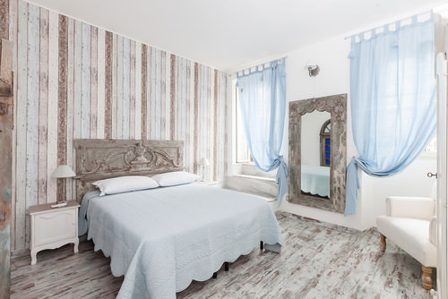
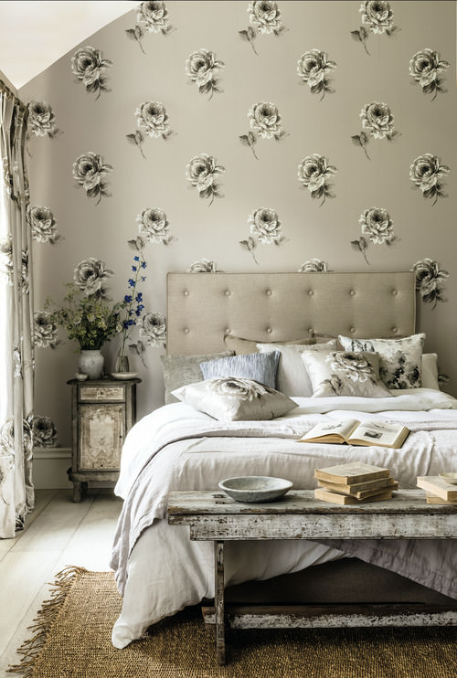
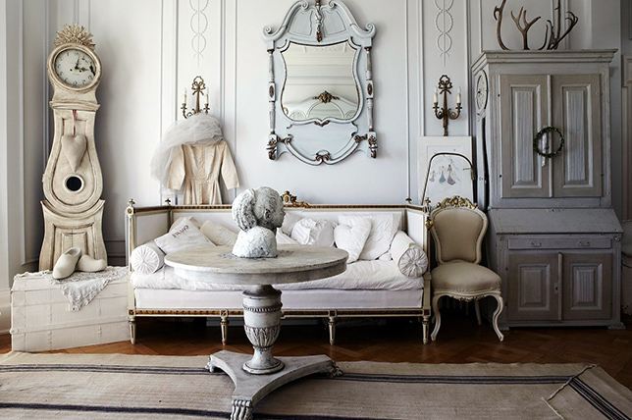
Shabby-chic is big these days with the popularity of vintage and DIY home decor. While I don’t want to say shabby-chic is a full crafty style, thee are definitely craft elements that people like such as distressed furnishings, floral prints and design elements and whitewashed floors… all of which are popular DIY projects in the home.
Main shabby-chic design attributes:
- Decor has a soft, feminine feel,
- Vintage fabrics and items,
- Distressed and painted furnishings,
- Whitewashed and pickling floors,
- Pale palettes, and
- Floral prints.
The Shabby Chic interior designers draw quite a significant chunk of their inspiration from the vintage designs and styles; however, they are more focused towards creating feminine, soft and delicate designs.
Most of the furnishings used by these designers appear to be distressed and aged and contain a very antique kind of a finish. The aim of this type of interior designing is often to blend together features of contemporary and modern styles with a scruff and ragged finish.
Some key elements include wall hangings, flimsy light fixtures, linen textiles and a mixture of white and pastel colors.
22. Industrial Interior Design
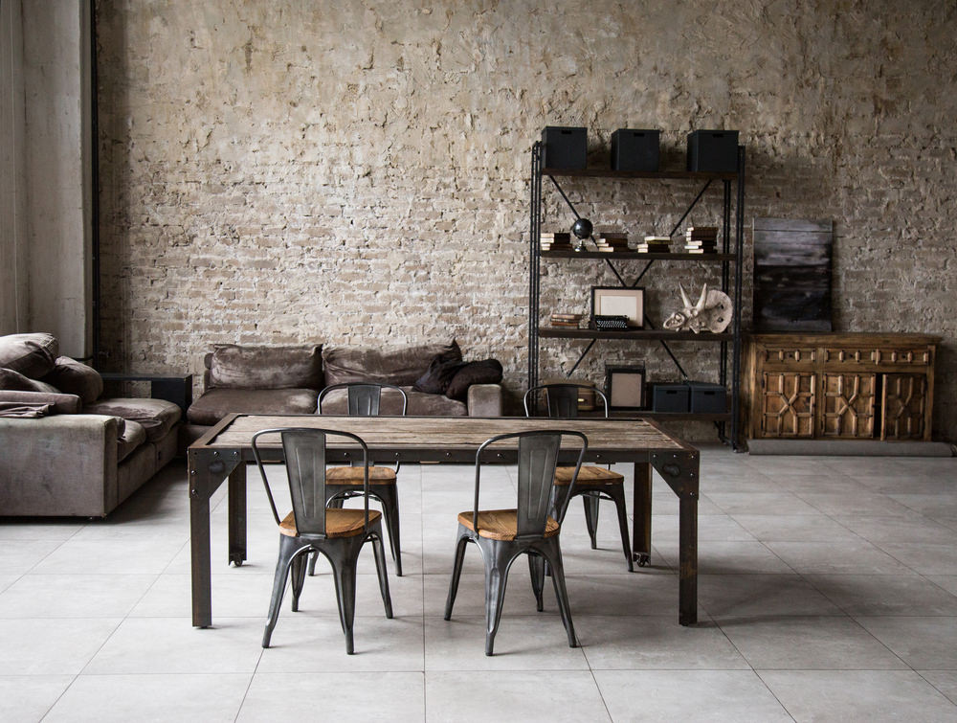
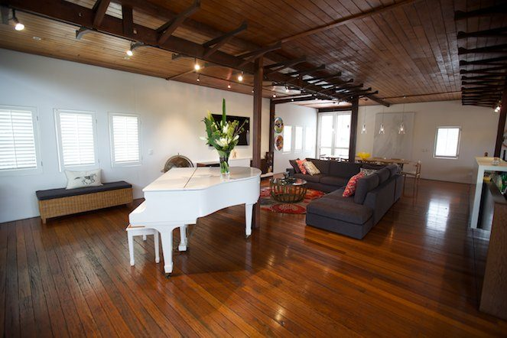
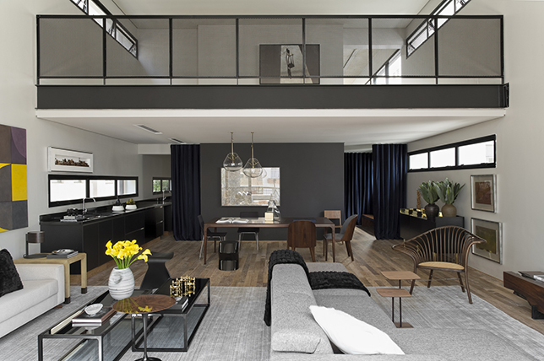
Industrial design became popular in the 1990’s as many North American city centers started enjoying a refurbishment by converting old manufacturing facilities and warehouses into condos and multi-unit residential buildings. Instead of covering up or removing all the remnants of the space such as brick walls, exposed pipes and electrical wires and putting in interior walls, developers created large, open units preserving the old floors, walls and keeping much of the pipes and wiring and beams exposed resulting in what is known as industrial home decor.
The key elements of industrial interior design include:
- Raw and unfinished look,
- A mix of grays, neutrals and rustic colors,
- Utilitarian objects,
- Large sectionals,
- Antique or light fixtures with metal finishes,
- Use of vintage and old factory and laboratory pieces,
- Wood and metal surfaces, and
- Concrete flooring.
Industrialist interior designers make everything about exposed and raw materials. As the name suggests, the majority of their inspiration is drawn from things like an urban loft or perhaps an industrial warehouse.
Some of their key elements include dangling metal fixtures, high ceilings, sparse furniture pieces, and stripped back floorboards. This type of designing is mostly all about obtaining a cold, eerie look. However, many designers may use statement lights or pieces of abstract art and photography to add in a pop of color and delicacy.
The industrial interiors are often described as ‘truly rustic and mature’ considering it thrives on the liberal use of wooden elements and exposed steel.
Have you picked out your favorite type of interior designs yet? You can even mix up elements and features of different designs and give your home a whole new look.
23. Eclectic Design Style
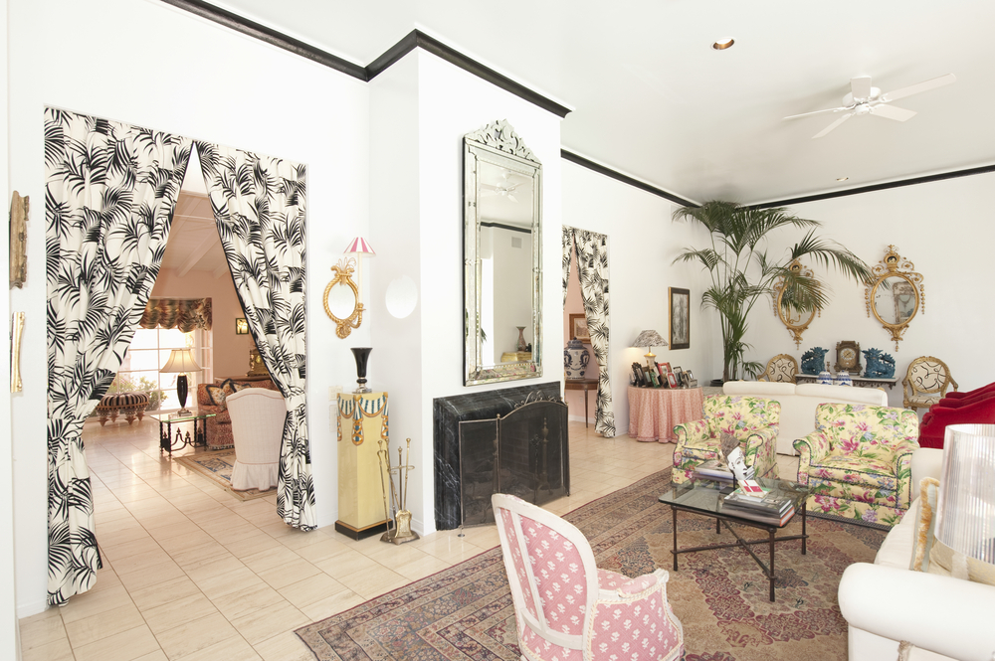
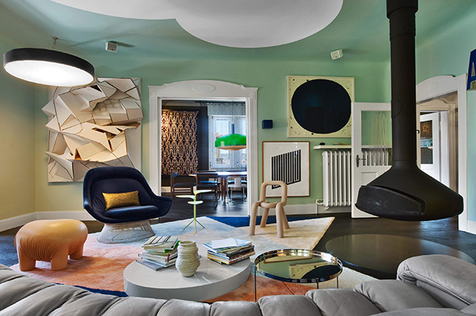
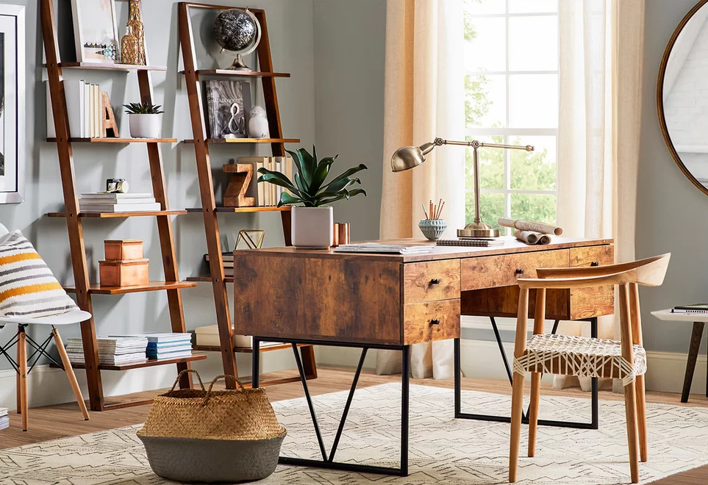
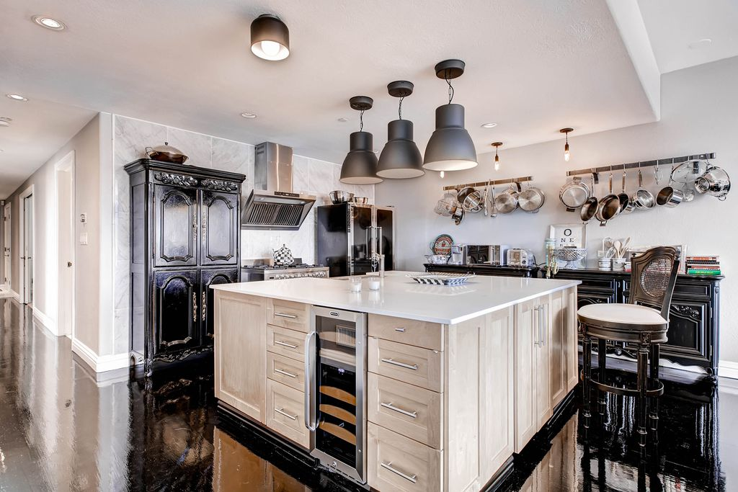
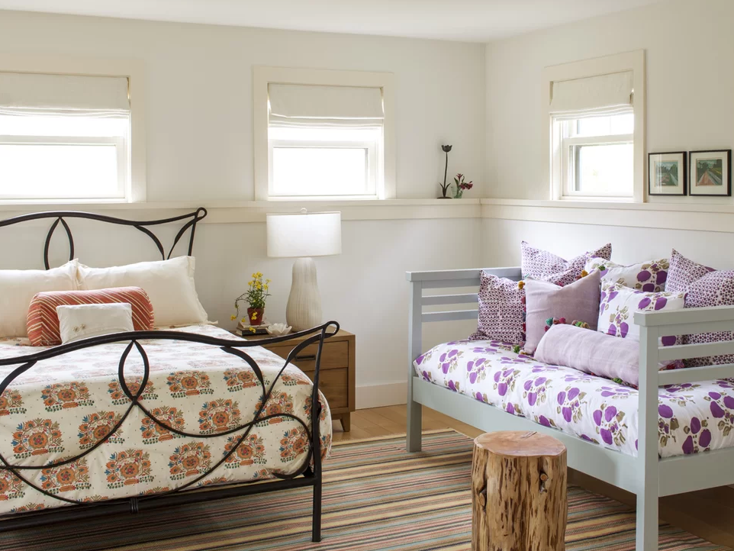
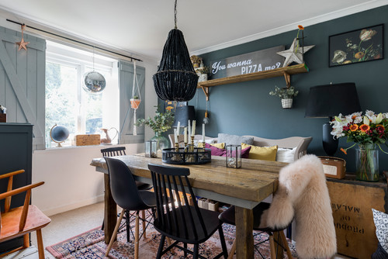
Eclectic design is a showcasing of contrasting elements including colors, furnishings and materials. It can easily be overdone to look terrible, but when done well, the contrasting aspects can be tied together to create a cohesive and attractive design.
Main design attributes:
- Varied palette with a few grounding neutrals,
- Different pieces in the room are tied together with paint, fabric or a more refined or roughed-up finish, and
- Defined by contrasts and variety.
Eclectic interior designers are best described as diverse and playful since they love mixing new styles with the old ones and creating something absolutely fresh and unique. They tend to borrow ideas from a variety of different trends, styles, and also from different time periods. These designers are all about breaking the rules and having a little fun of their own.
Eclectic designs provide a great canvas for designers to work their magic on and come up with something outstanding. From the looks of it, one might think of these designs as haphazard or chaotic, however, there is a very fine line between aesthetically pleasant eclectic designs and those that are merely created without any measured motifs or themes.
While eclectic designs are indeed very assorted and kind of like ‘all-over-the-place’, they still have a sense of balance to them and are a true definition of a ‘cohesive blend of designs, colors and patterns’.

24. Beach/Nautical Style
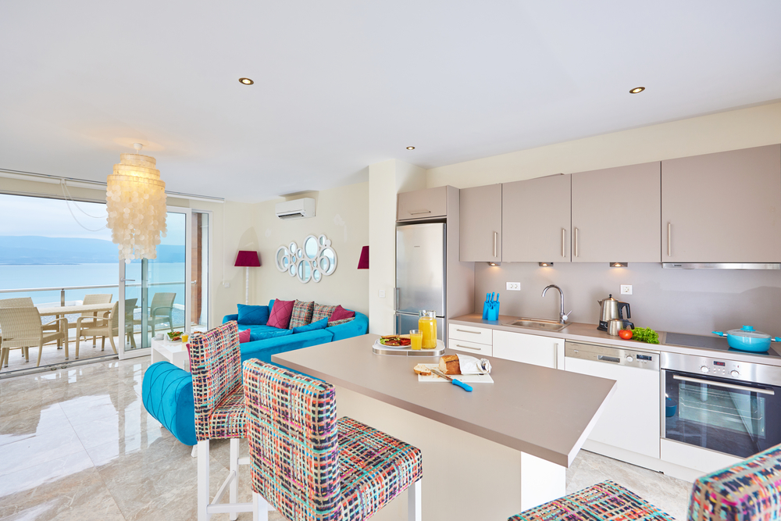

In my view the beach style should be reserved for houses on the beach. It’s kind of odd to have a nautical themed home in the burbs. This style includes light colors with splashes of bright colors such as navy blue and even bright colors, loads of natural light (i.e. windows), nautical accessories such as rope, dark wood and other items found on boats and wicker or rattan furniture.
- Light and breezy,
- Nautical-themed decor,
- All white backdrop; borrow colors from sand, surf and shells;
- Décor crafted from natural fibers and organic materials,
- Wickers tools, rattan furniture and beds with a natural oak frame, and
- Window coverings
Nautical interior designs are best described as positive, warm, and relaxing. The primary reason is that they always make you feel like you are near the ocean. Interior designers who follow the nautical theme typically make use of elements like sea creatures, ships, and anchors. Their color palettes are also full of those that you would see on the beach, which is why the nautical style is also referred to as the “beach-inspired” look.
These designers strive towards making your home truly comfortable by using an abundance of white, blue, and sand-colored foundations, along with inexpensive wooden furniture and hues of oceanic blue.
Some key characteristics of nautical designs include chic linen upholstery for lounges, unfinished wood used in chairs and tables, and sea-inspired decorative accents like jute ropes, seashells and rowing oars.
25. Farmhouse Interior Design Style
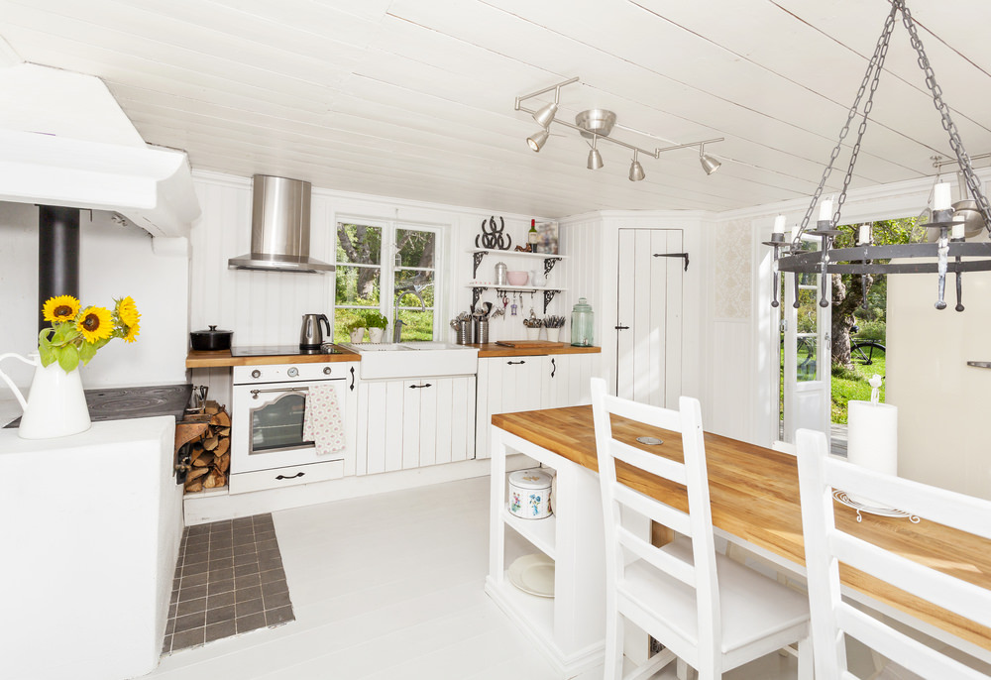
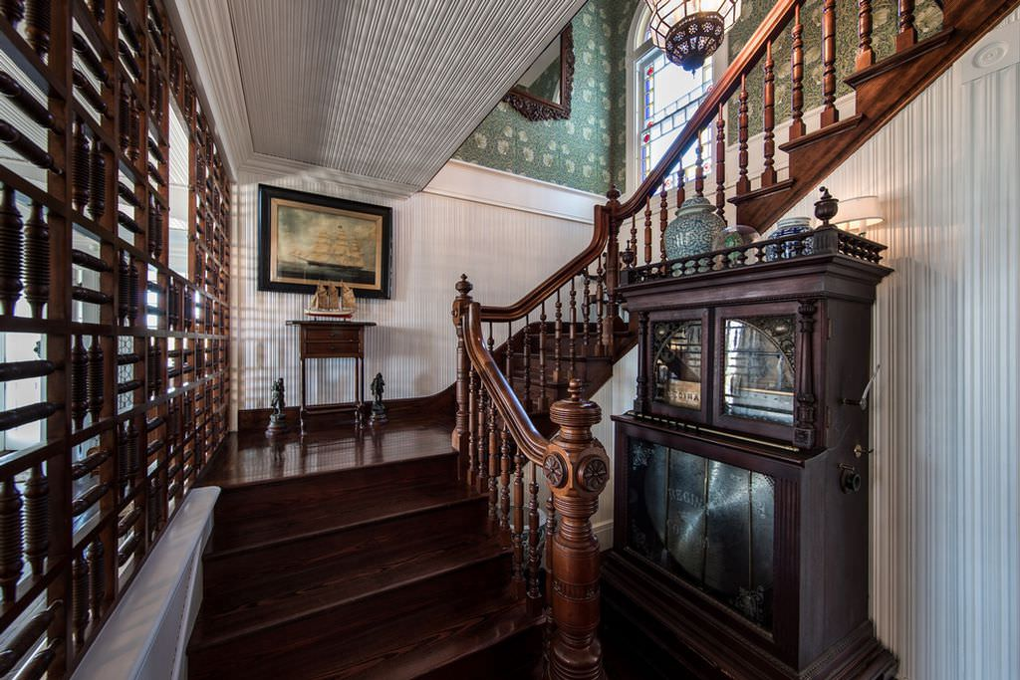
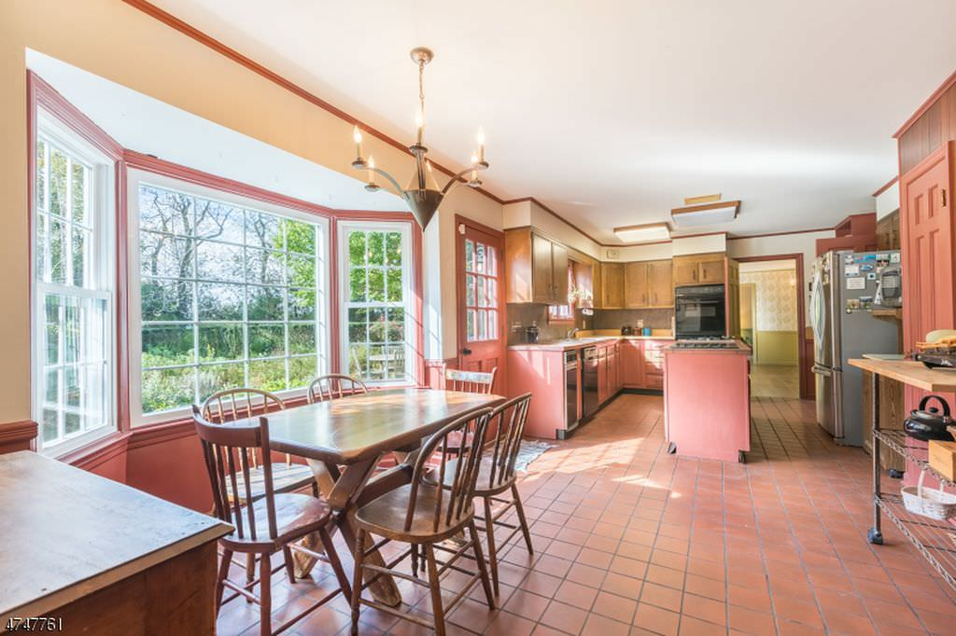
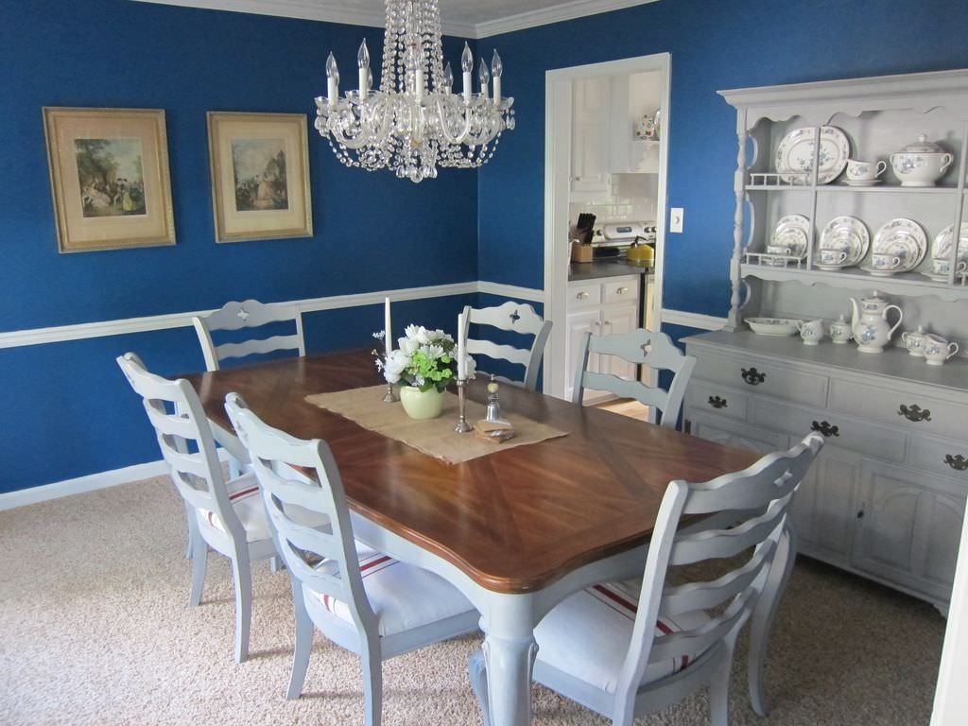
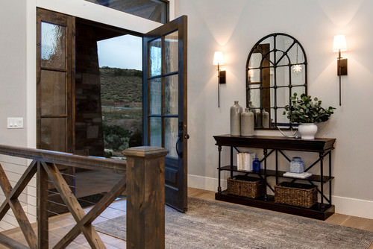
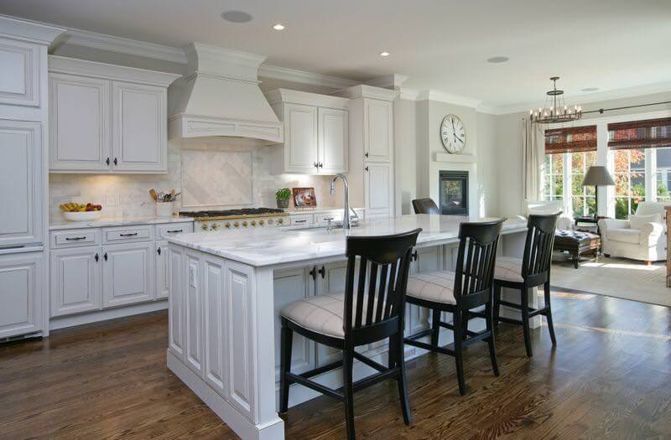
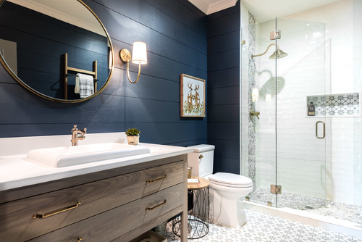
Farmhouse is similar to country or rustic design styles except that it’s typically lighter, incorporates some shabby-chic, enjoys plenty of natural wood and gives an aura of a cozy feel.
Main style elements:
- All white look,
- Dominant fireplace,
- Large kitchen and dining place,
- Open shelves and cabinets,
- “Company” parlor and “family” sitting room,
- Cozy fabrics, natural materials and textiles,
- Vintage, reclaimed or heritage accessories,
- Vintage, shabby chic furniture with a rustic flair,
- Tongue-and-groove paneling, shiplap and butt boards,
- Even ceilings with exposed reclaimed beams,
- Barn doors,
- No to glass, and
- Wide plank floors.

26. Mediterranean Interior Design Style
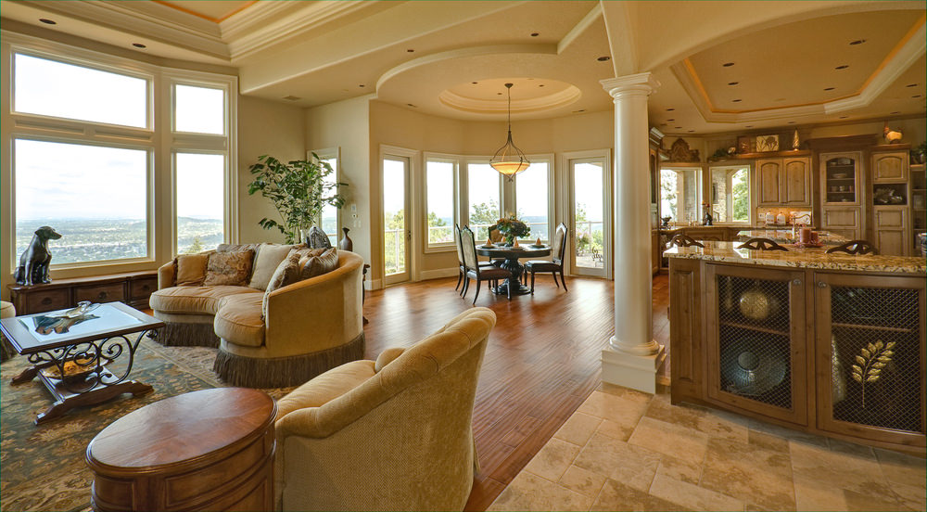

Mediterranean is a style that seems more popular than it is. A few years ago I was under the impression a lot of homes embraced the Mediterranean style, but in actual fact, it’s not that widely used. It’s distinct with plenty of ornamental styling and features including columns and arches. It also has a distinct color scheme being earth tones.
Main style elements:
- Arches
- Columns
- Ornate features including furniture
- Tile and brick
- Earth tones
- Large furniture
- interior balconies
- Tall ceilings (not always, but it’s no uncommon)
- Curves.

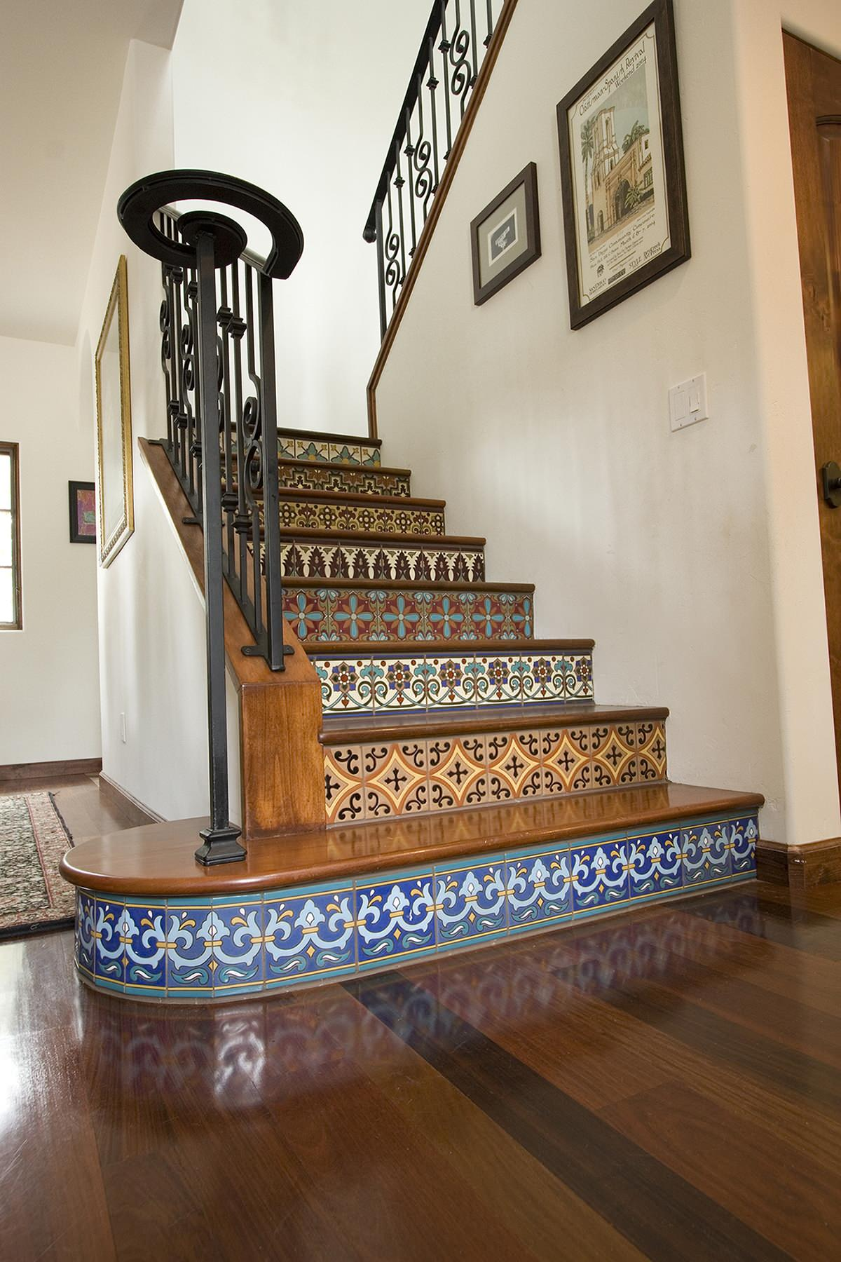
Pattern Tiles Stair Design
Hand painted tiles on stair risers. These stair risers are covered colourful stair with Catalina style tiles, which combine glossy and matte finishes. This adds wonderful depth to the patterns. Tip: When selecting patterned tiles for your stair risers, it is okay (and encouraged) to combine different patterns.

27. Craftsman Style
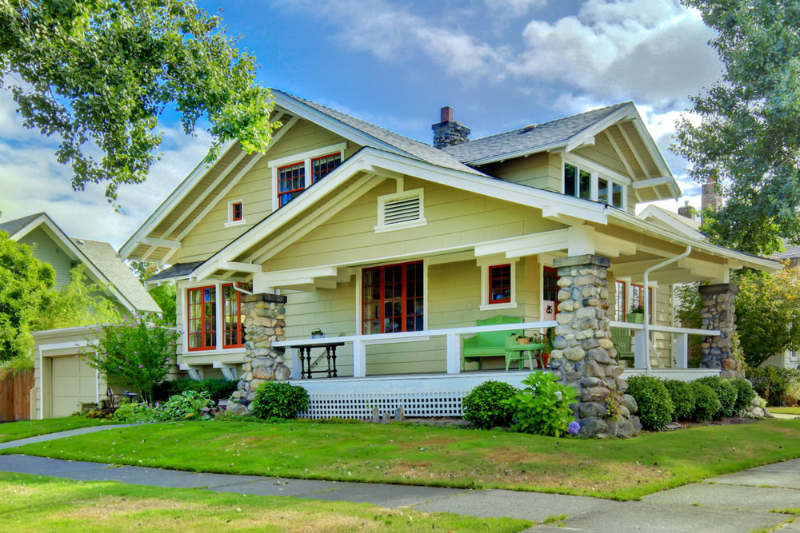
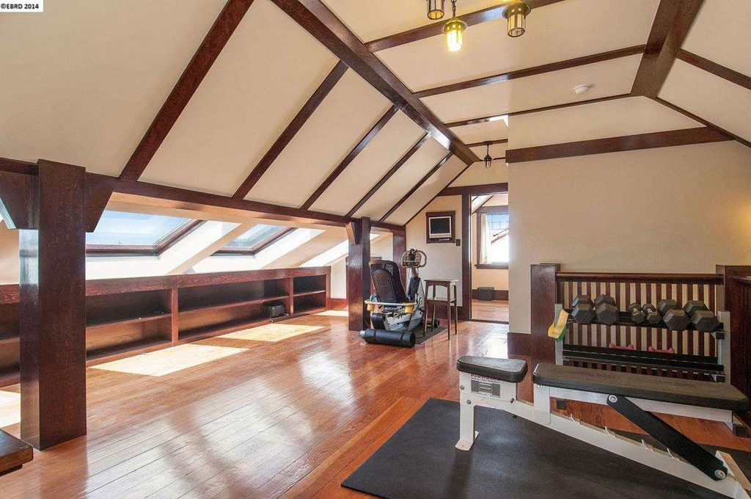
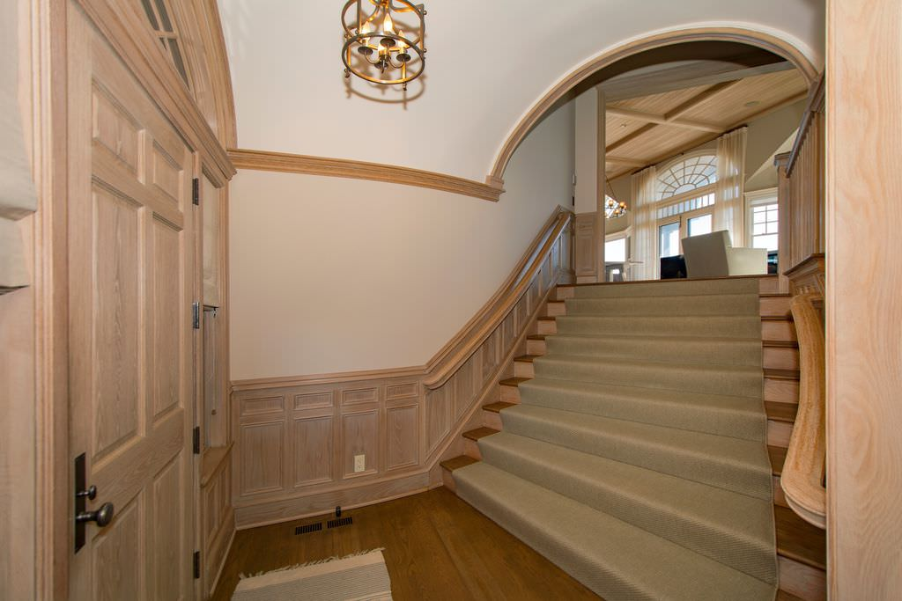
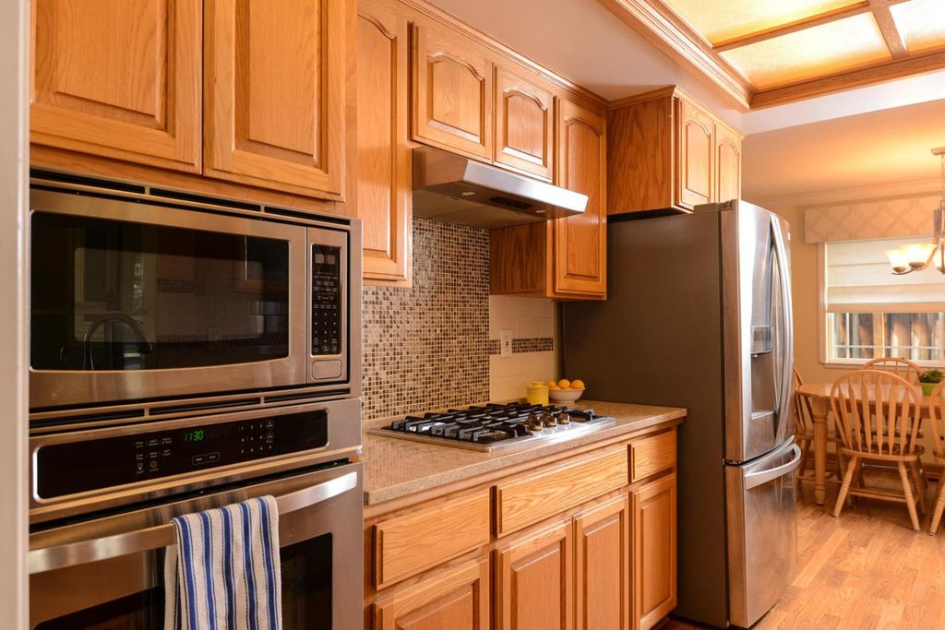
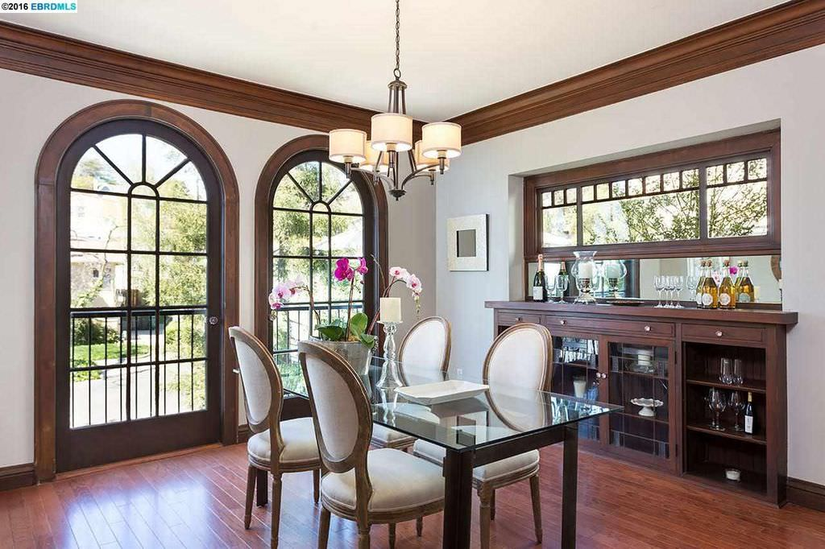
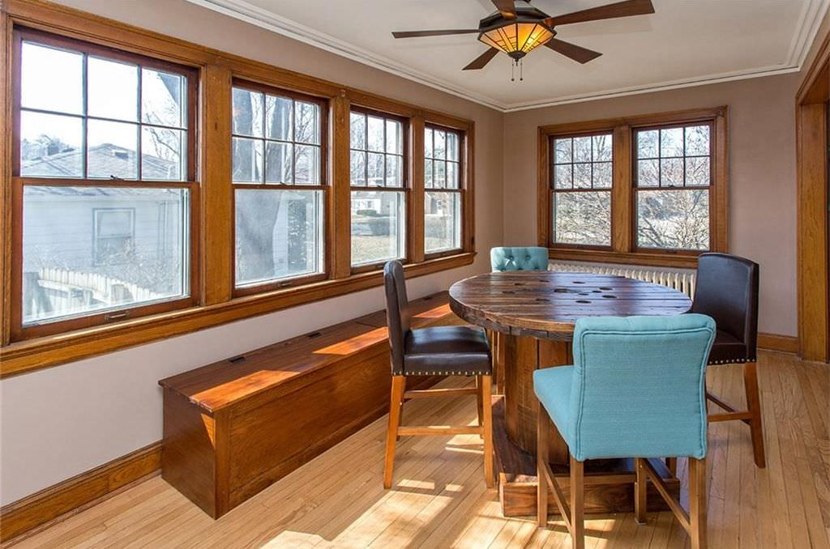
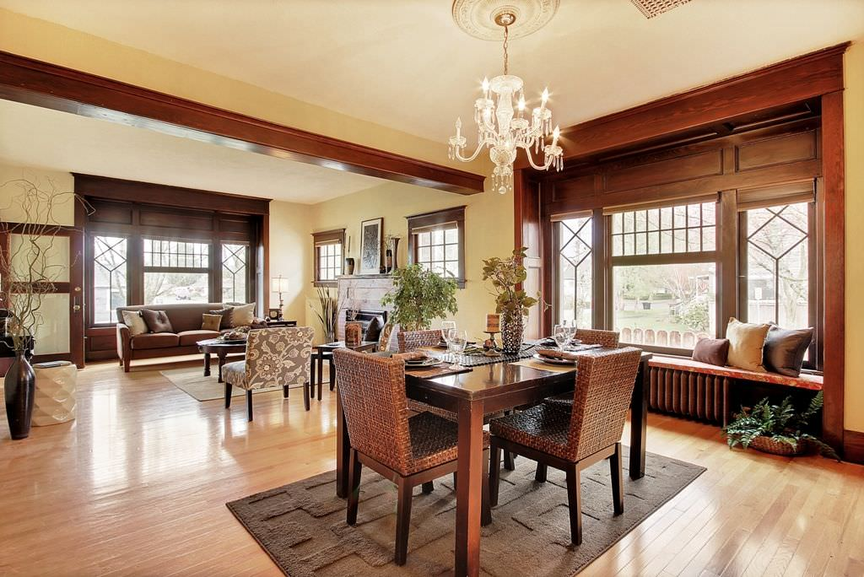
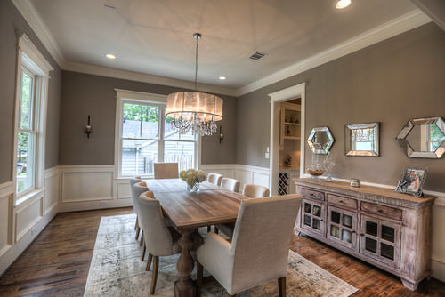
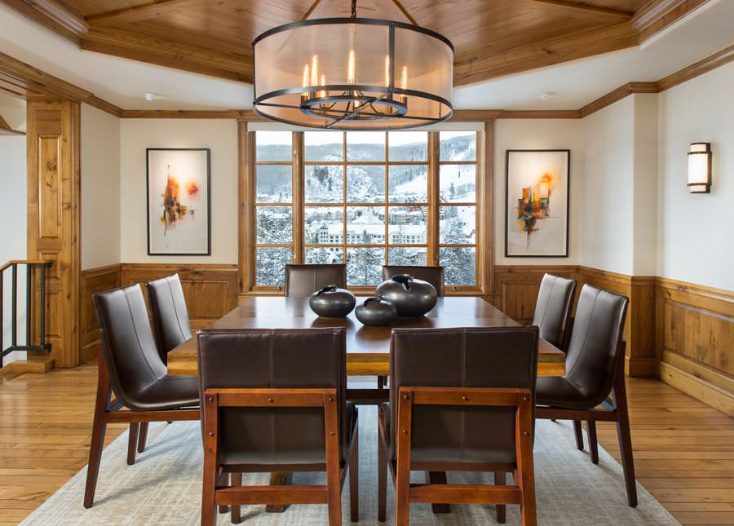
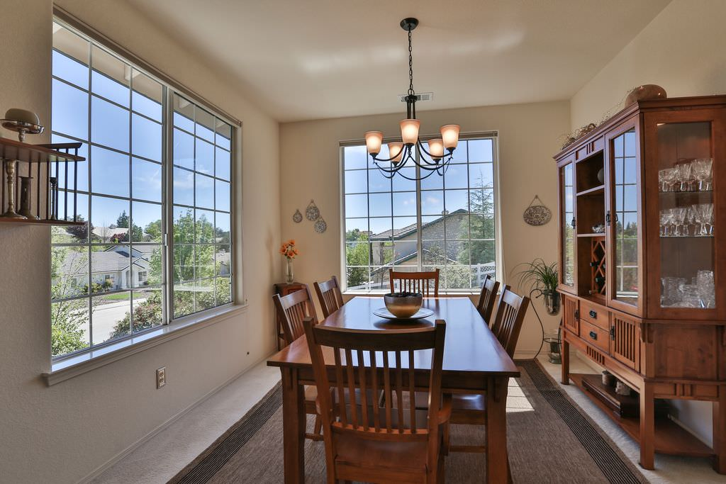

Key interior style elements:
- Open floor plan: This is definitely a much desired design feature today and so it makes sense the Craftsman is a very popular design for contemporary homes.
- Plenty of built-in wood elements such as cabinetry, fireplace mantles, bookcases, etc.
- Plenty of handcrafted woodwork including exposed ceiling beams.
- Use of natural materials such as wood, stone, brick, glass and tile.
- Plenty of windows.
- Color scheme: earth tones and plenty of wood.
28. Scandinavian Interior Design
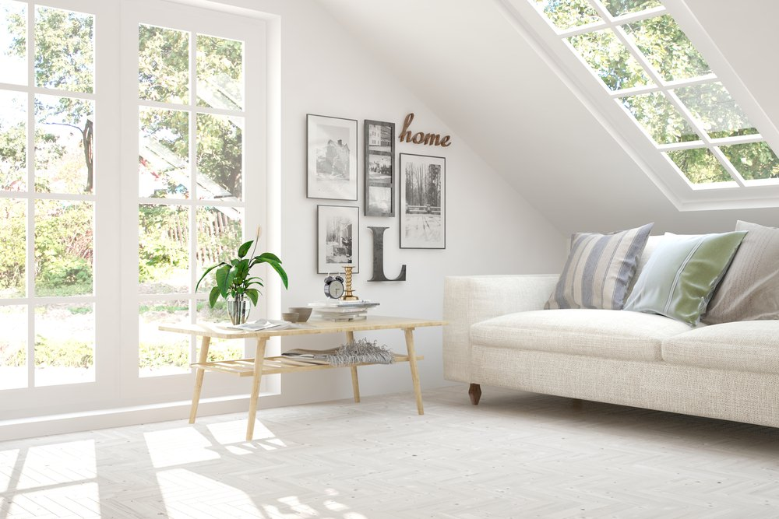
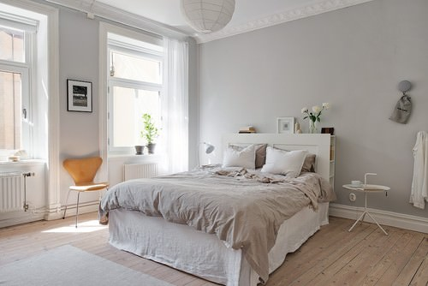
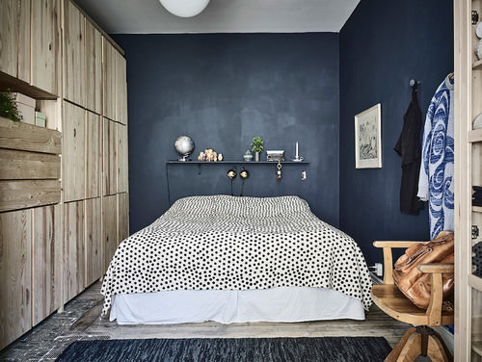
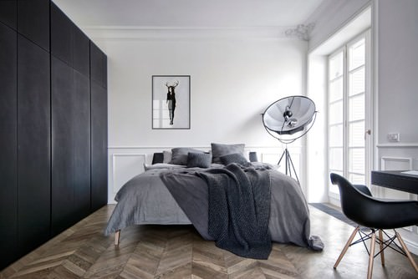
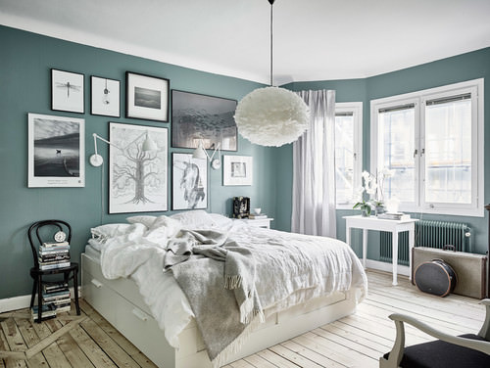
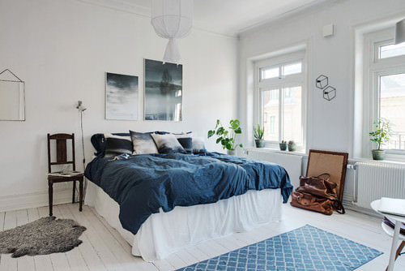
Important design elements:
- Predominantly white,
- Bright colors combine with the main white color,
- Large mirrors,
- Principles of symmetry,
- Furniture pieces are functional and stylish but not too trendy and contemporary,
- Use of light colored wood and warm colors, and
- Light wood flooring dressed up with rugs in subtle color.
Inspired by the simple lifestyles in the Nordic countries, Scandinavian interior designers provide timeless interior designs and styles that are greatly characteristic of the fjords, snow, and mountains found in those countries.
Their designs are a true representation of pared-back coziness, a myriad of textures and some clean, refined lines. They are a beautiful work of art, but always so simple and subtle. Scandinavian designs are big on space, fewer accessories, natural light flowing in, and minimal furniture that serves some purpose.
This take on the interior style and design follows the “Bauhaus principles” that make use of fluid lines, all-white color palettes, wide plank flooring and a strong focus on object proportions. The designers also ensure that they use playful accent colors, organic materials and gentle contours. Scandinavian designs are best described as modern, practical and uncomplicated.
29. Rustic Style
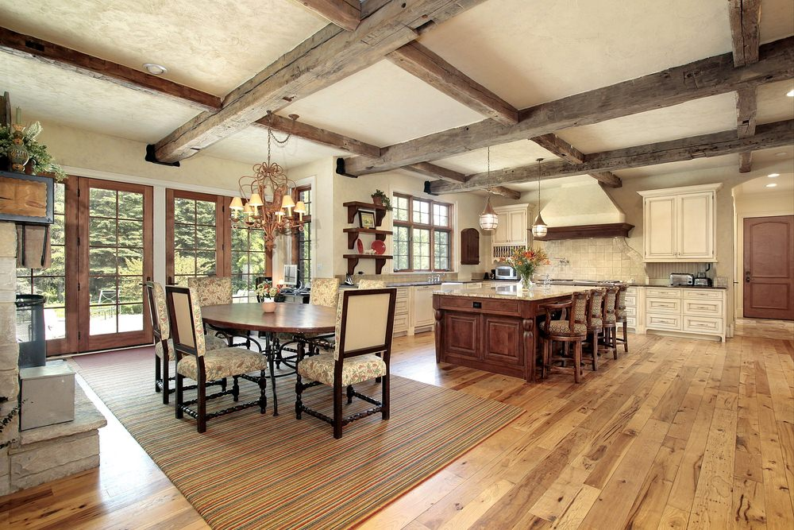
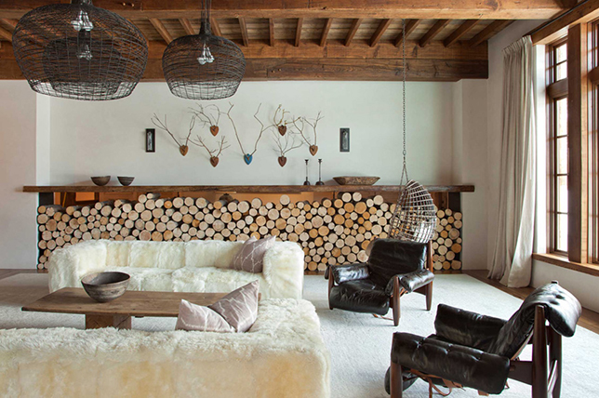
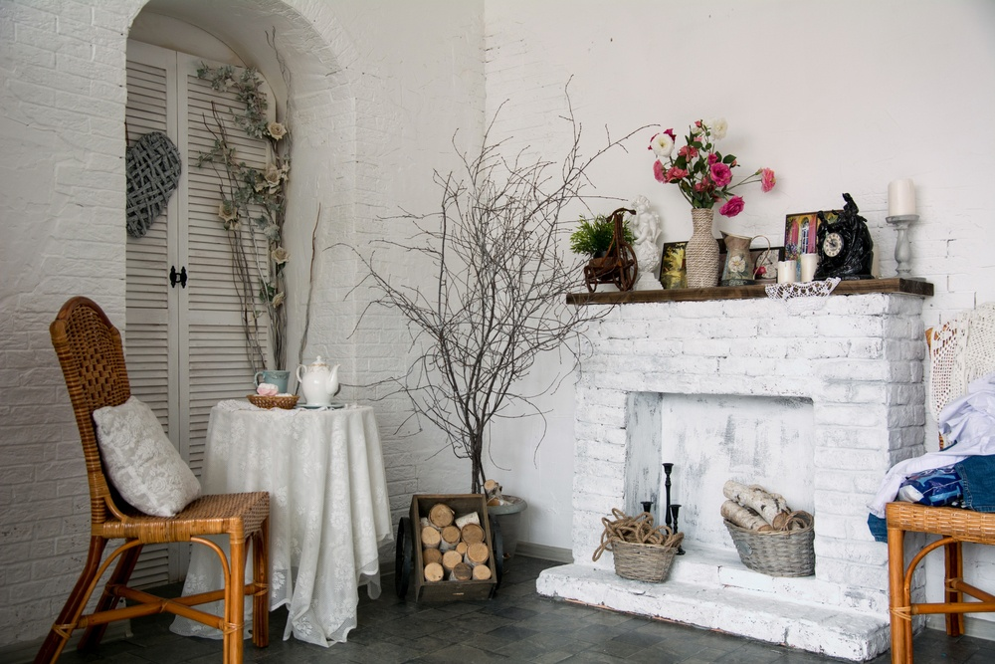
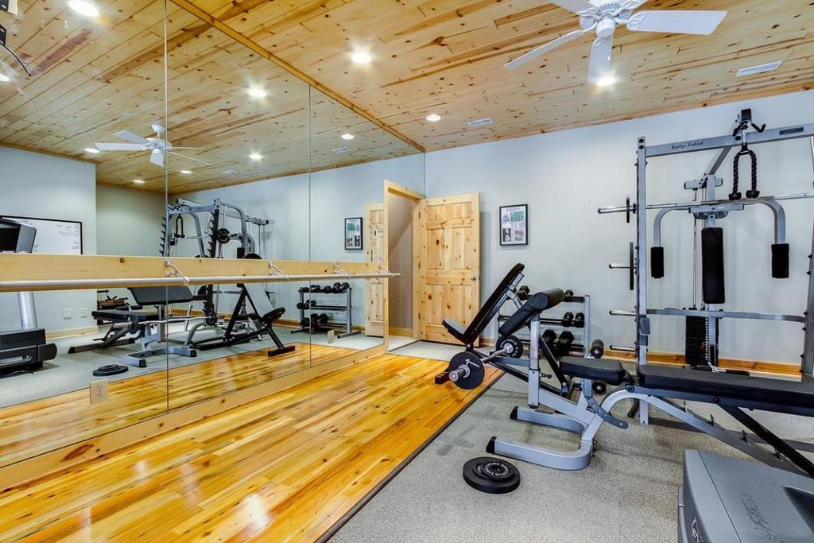
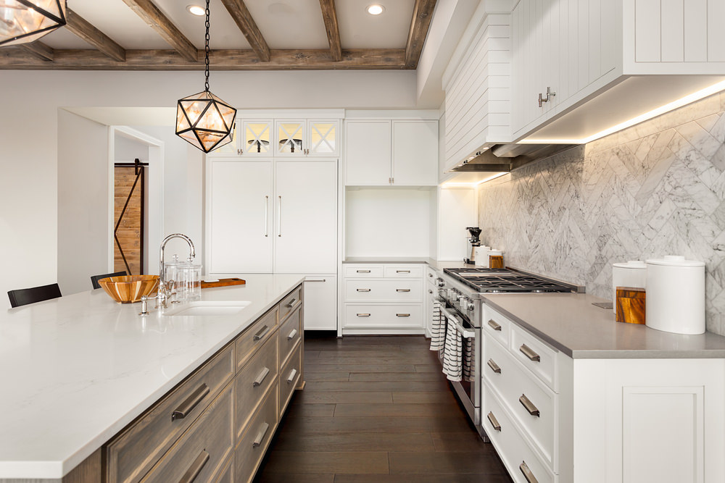
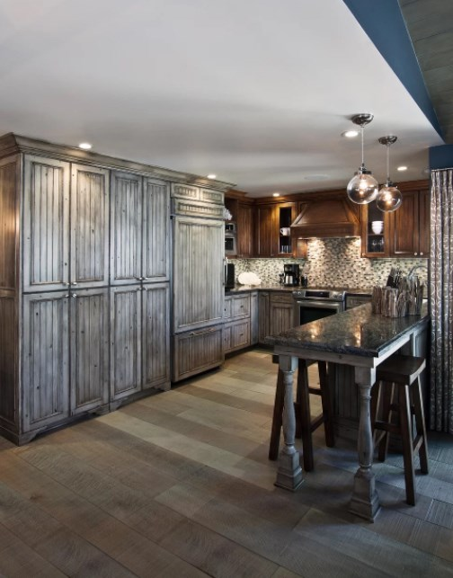
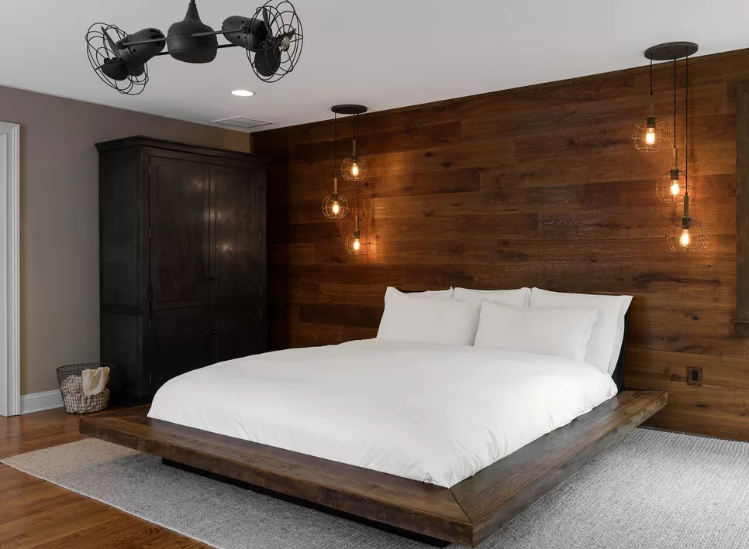
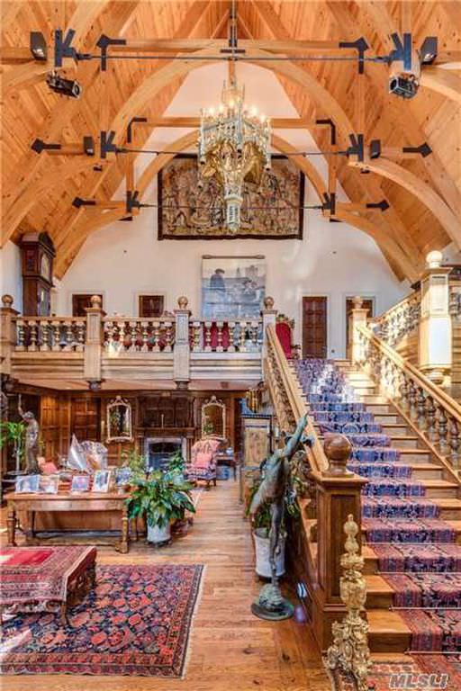
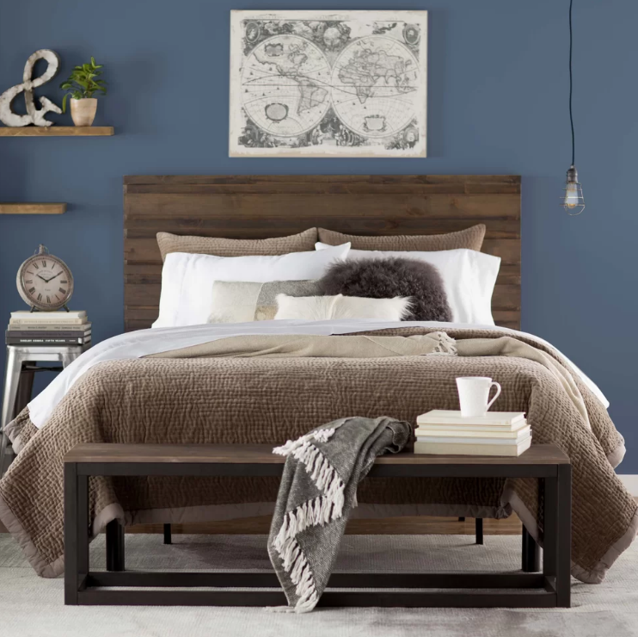
Important rustic design elements:
- Exposed ceiling beams,
- Use of reclaimed wood,
- Exposed stone wall,
- Wooden flooring,
- Cowhides, sheepskins and simple neutral-colored natural fabrics,
- Distressed and handcrafted items,
- Wood-burning fireplace, and
- Prominent staircases.
Rustic interiors are truly raw, often with unfinished elements that are typically made of stone or wood. Interior designers who follow the rustic theme derive most of their ideas, styles, and designs from natural inspiration and also tend to include accessories that mostly come from outdoors.
Most of the accessories they use consist of elaborate architectural details and dramatic features like reclaimed wooden floors and perhaps, ceilings that are decked with wood beams.
The main focus of rustic interior designers is on raw, natural, and unrefined elements that are bold and blatantly real. These designs also have quite an earthy and organic touch to them. Many people consider rustic to be really dark and heavy, however, there is a trend of ‘modern and contemporary rustic’ that has been making waves lately and it is a fresh, light, and grounded take on the ‘original’ rustic theme.
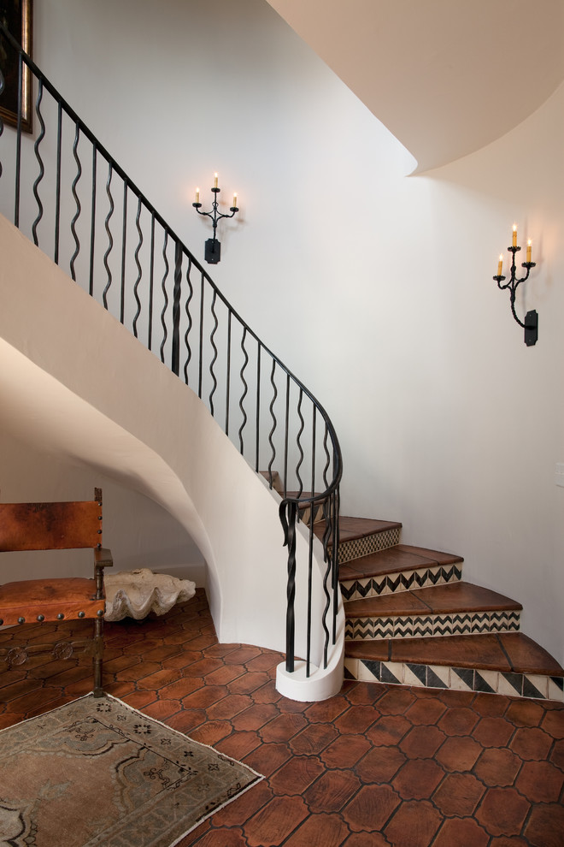
Pattern tiles staircase :Rustic Spiral Staircase Image By Thomas Thaddeus Truett Architect

30.. Asian Design
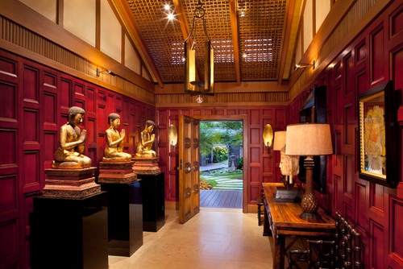
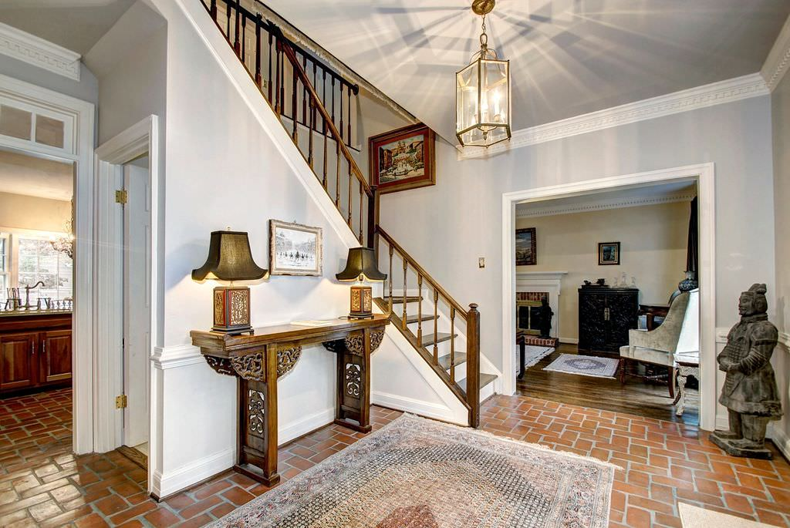
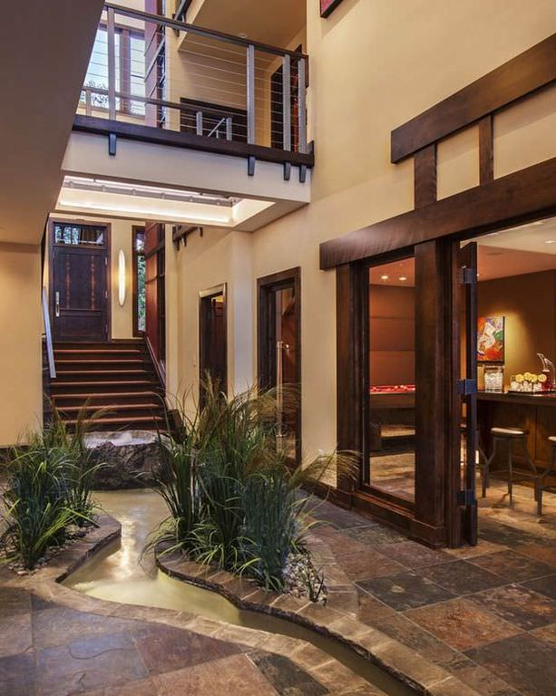
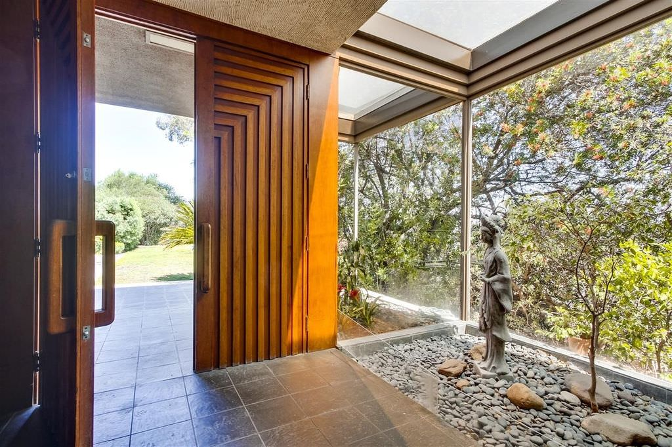
’ 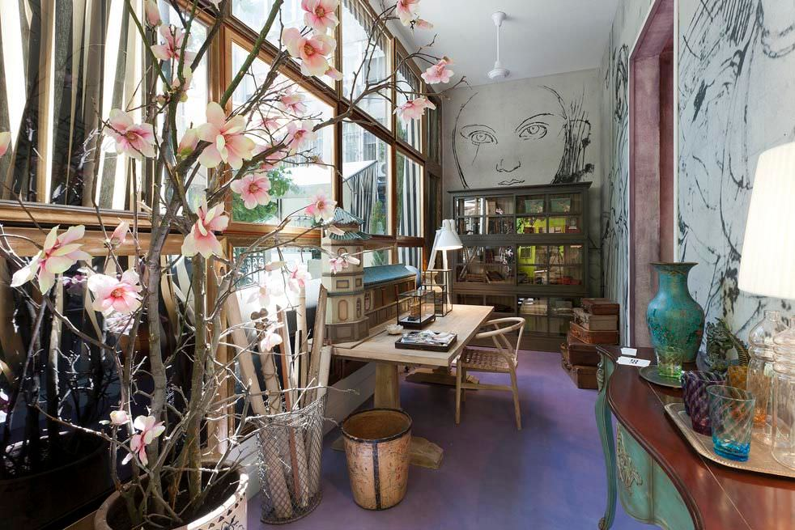
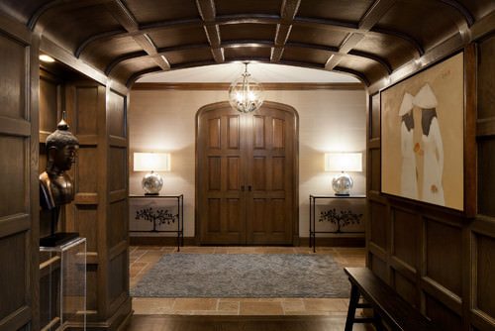
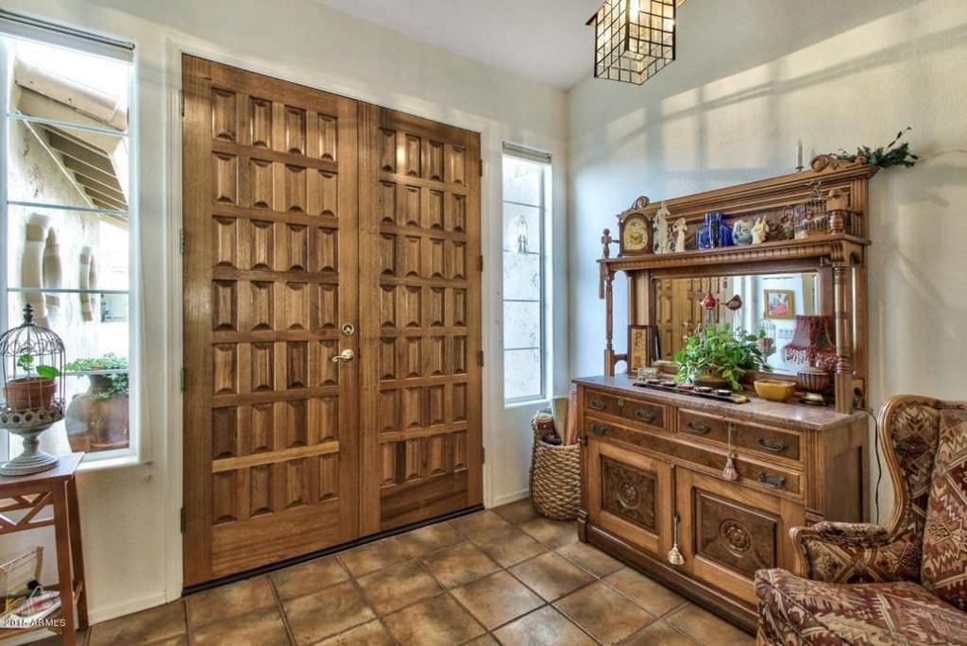
Important Asian interior design elements:
- Asymmetry,
- Altar-like alcoves,
- Reference to nature,
- Chinoiserie furniture,
- Natural materials,
- Simplicity,
- Clean lines,
- Circle motif,
- Orchids, and
- Use of curtain walls, door panels or Japanese tokonama.
31. Tropical Interior Design Style
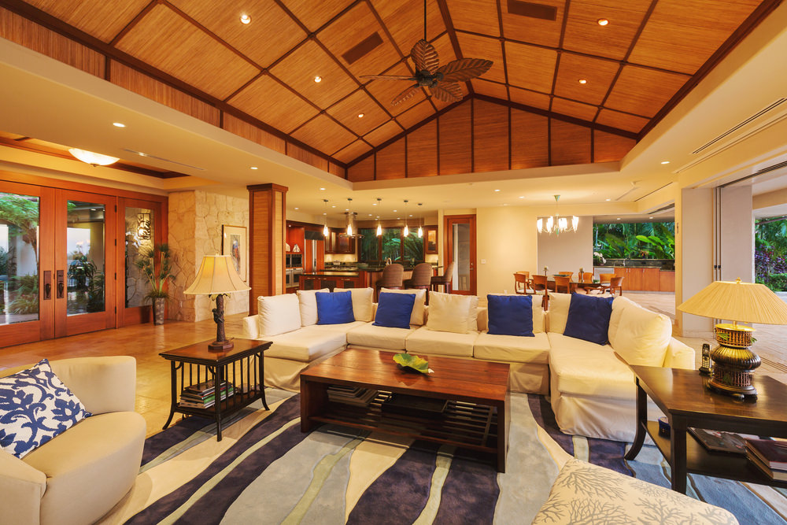
Important tropical design elements:
- Open plan layout,
- Safari-themed, jungle or beach vibes,
- Passive cooling,
- High ceilings,
- Light and breezy,
- Ceiling fans,
- Monochromatic and light, reflective color scheme,
- Predominant green nuances,
- Accessories and furniture made of tropical woods or natural materials,
- Fabrics and textiles with palm leaves or animal motif,
- Plenty of indoor plants,
- Figures and statues of animals, and
- Wooden flooring with a red carpet.
32. Southwestern Style
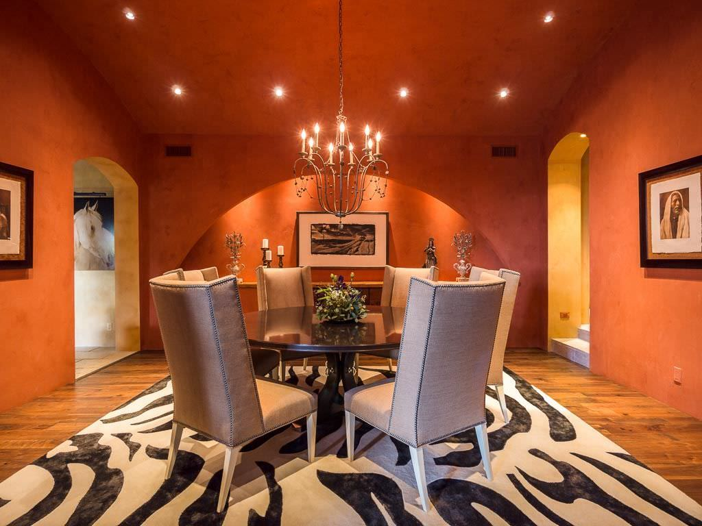
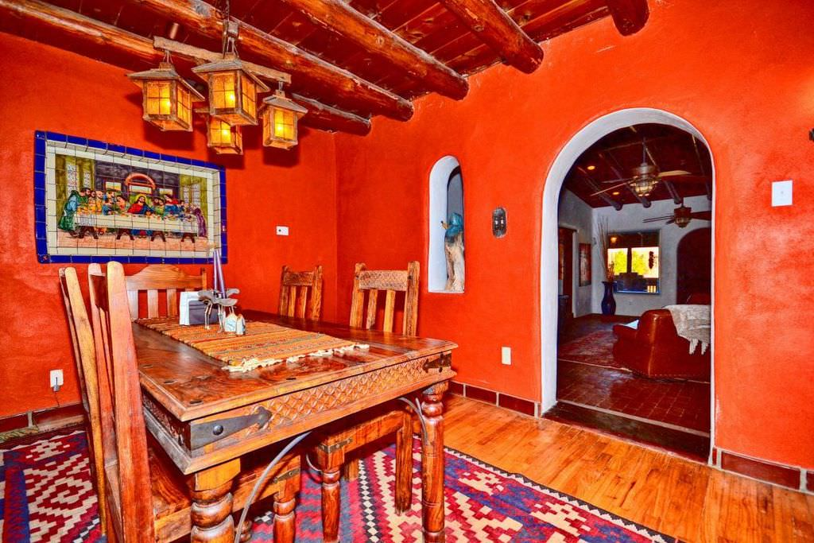
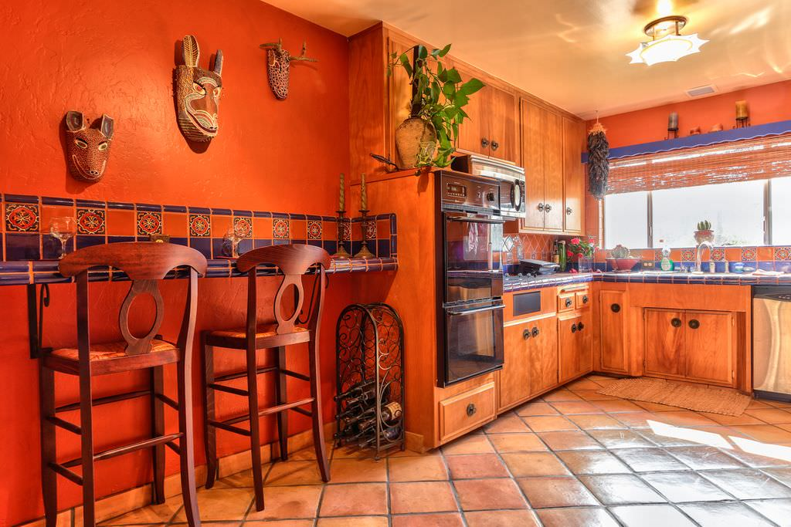
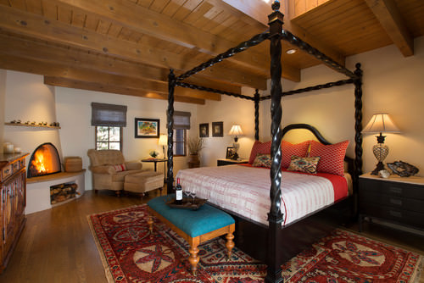

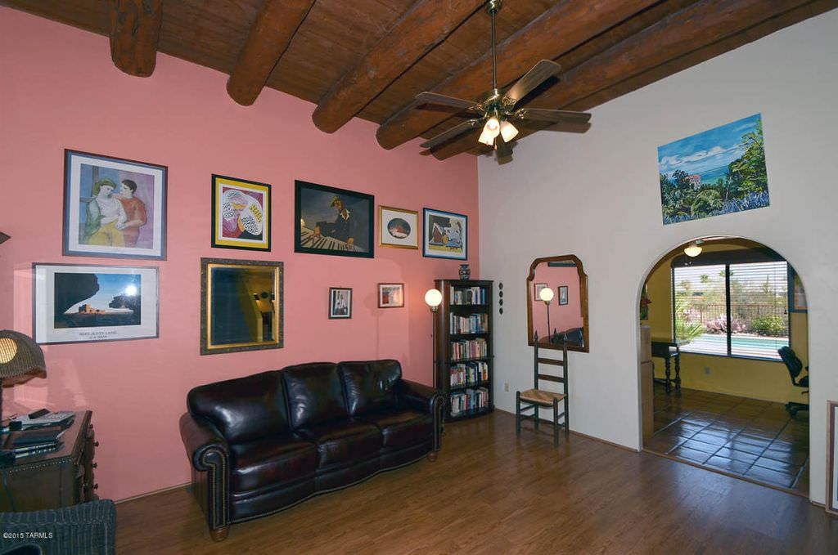
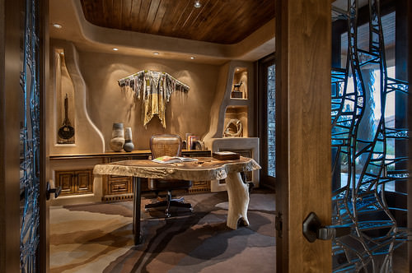
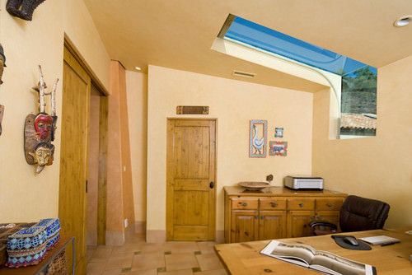
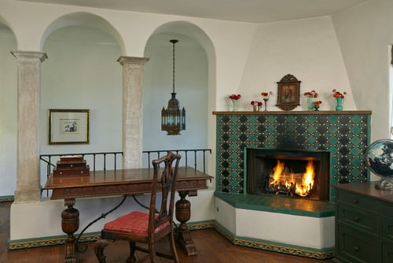
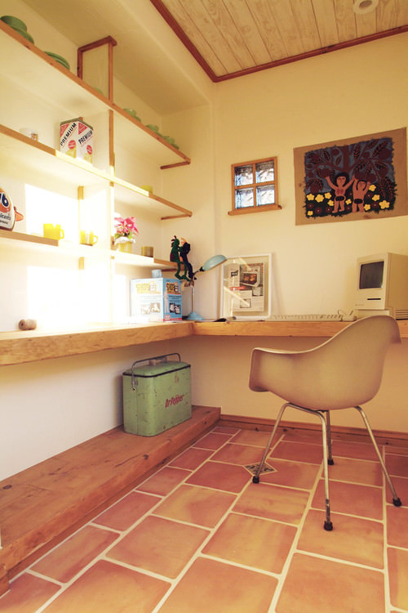

Important Southwestern design elements:
- Casement or recessed windows with ornamental grillwork facing the street,
- Mix upholstery finished and textiles,
- Bold, vibrant, warm colors (orange, red, gold, yellow, blue and desert-toned neutral hues),
- Accessories made up of dark-colored cast ironmongery, candles, dried flowers, sculptures, animal skins, pottery pieces, etc.,
- Painted wood furnishings built with thick legs,
- Large wall murals, and
- Floors made of rustic brick or terra cotta tiles or mosaic with patterned rugs.
33. Vintage
Like minimalism, vintage isn’t an establish interior design style, but it’s also a look that people want so we include it in our list.
While they come off as old-fashioned, vintage interior designers have a great aptitude for versatility, creativity, and imagination. They create absolute masterpieces that always tell a story and seem to have a rich history.
Vintage interior styling focuses on minimal clutter and puts forth a very clean, crisp, and classy display of furniture, decorative accents, and designs. These interiors also often include old frames and photographs that are usually black and white in order to give the entire space a very old yet stylish look. You may also see a variety of open shelves in most vintage designs which allow one to show off their classic vintage accessories and items.

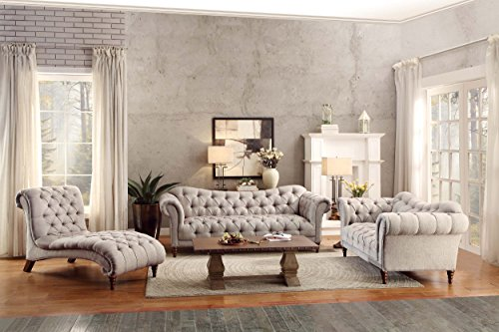
34. Bohemian
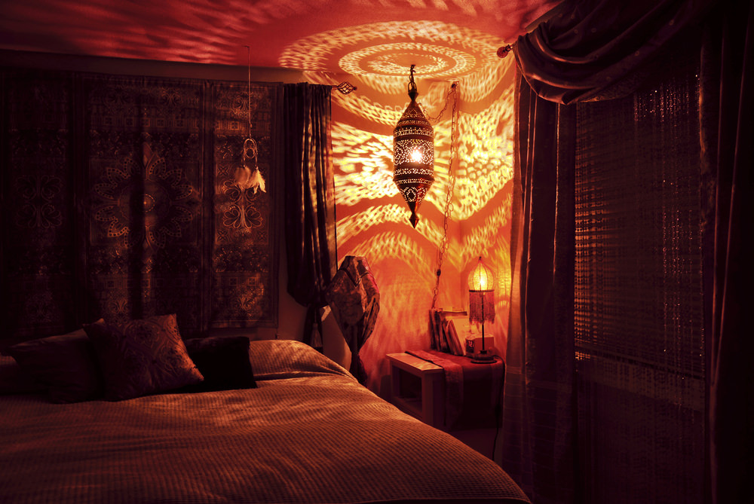
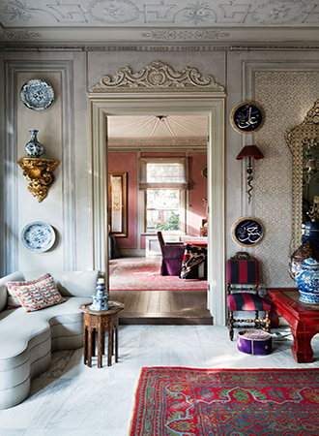
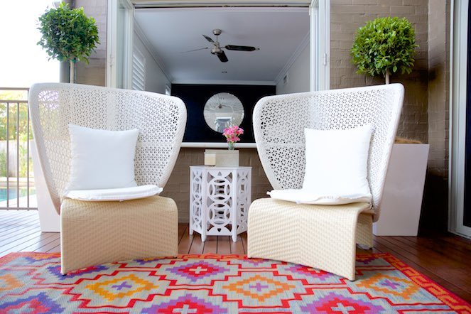
Bohemian interior designers are known for their use of those interior pieces that seem to possess nomadic and ethnic vibes. They also love playing with vibrant colors and rich patterns that appear to be bold and loud.
An interesting yet key characteristic of these designers is that they purposefully make things look messy so you will often find them mixing around different colors and a variety of elements like pillows, throws, rugs, etc.
The Bohemian-style interior is also a true representation of the avant-garde lifestyle that is known for its adventurous and carefree spirit. So, these designers also try to display these features in their styles and designs.
Some trending modern bohemian designs include those inspired from southwestern, Moroccan and tribal styles that may typically consist of animal hides, metallic accents and wood.
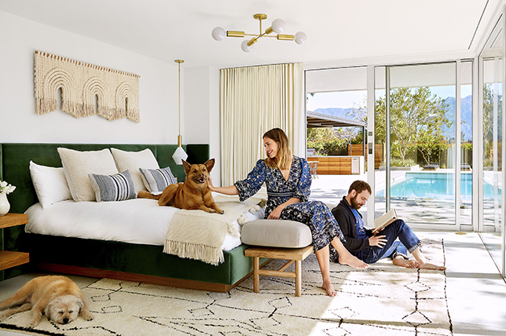
At some point or another, we bet you’ve come across bohemian design; it’s a bright, patterned, multi-cultural melange of memorable layers and elements you simply can’t miss or forget for its uniqueness. The word ‘bohemian’ refers to someone who is socially unconventional and often involved in the arts, making it a great interior design option for a rich and heady space full of visual interest and a relaxed spirit. But what makes bohemian style so distinctive and viable, and how do you get the look right in your home without coming off as heavy handed?
As we continue our Design Style series breaking down the essentials of different movements to consider for your home, we’re looking at tried and true routes to create your own perfectly curated bohemian style space with advice culled from Décor Aid designers.
SIMPLE BASE
To create a solid foundation, start with a simple base color for every bohemian style room. Warm and earthy tones make the perfect canvas, and opting for a neutral base allows you to pile up expressive color and pattern for the perfect mix without it being painfully overbearing and loud.
Saturate neutral tones with color by keeping the base tone muted to create a harmonious, soothing oasis boasting modern bohemian décor. If you do go for a bright base tone, it may be too rich and you’re certain to find yourself bored quickly with a somewhat chaotic starting point. When it comes to longevity, a neutral tone is always wise.

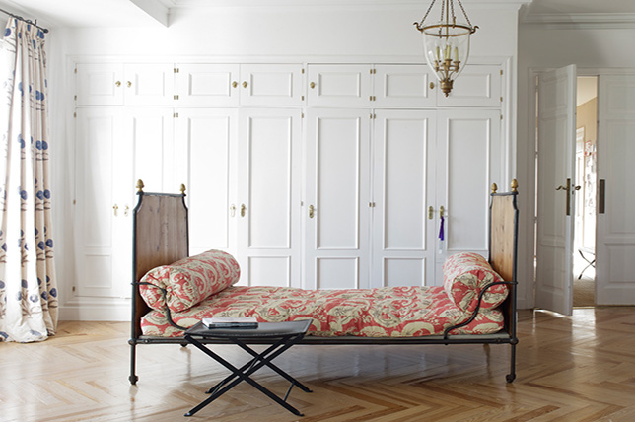
BOTANICALS
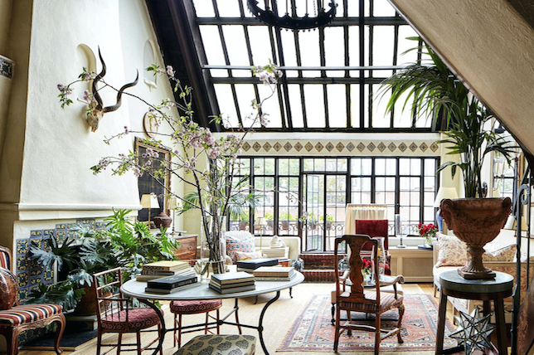
Botanicals fit perfectly with bohemian style as plants are an affordable and easy to source method in creating a relaxed vibe while adding dimension to a room. Plants also do double duty of purifying air while adding a pop of color without interfering too much with the rest of your design and confusing the eye.
Hanging plants are also an excellent bohemian addition in any bohemian space, and are a beautiful and fun way to add interest and depth. Get creative with planters and keep those featuring personality and great design in mind. From a simple woven hanging basket, to something more ornate and sculptural – a variety of different plants in different scales are an effective way in bringing your bohemian style home to life.
PLAYS ON PATTERN
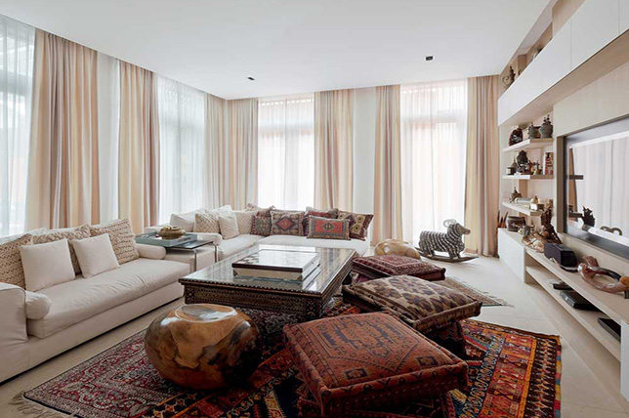
Layering similar patterns has to be one of the easiest and most cost-effective methods of mastering bohemian style while adding a decadent note to any area. From contrasting patterned rugs, to colorful cushions and throws, injecting various pattern is key here. Do have fun with the mix and contrast different patterns, shapes, scales, and styles to easily create a lush bohemian vibe.
That said, do keep a consistent color theme running throughout for consistency and to prevent a disjointed feel. Chose a selection of hues you can keep coming back to and that you can keep present with all of your elements – especially in darker, more luxurious colors like burgundy, emerald green, or a deep purple.
LOW-LYING FURNITURE
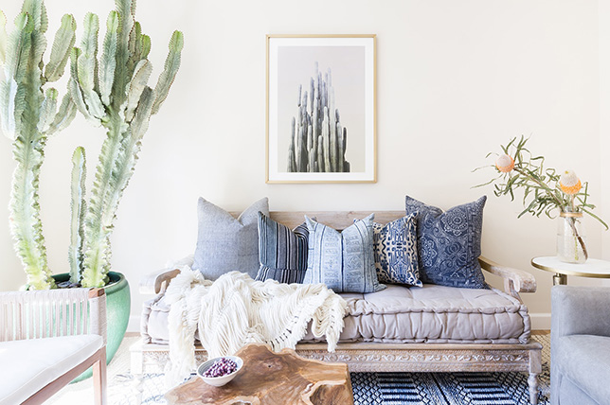
This might sound strange, but the closer to the floor you are, the closer you are to creating an authentic bohemian style house. Think low-backed sofas, scattered with plenty of plush, comfortable throw cushions, with neighboring poufs for extra seating.
And if you’re considering floor seating, to get the look be sure there’s a comfortable rug as a starting point topped with cushions of different sizes and styles, to ensure comfort. Scour local antique markets (which are great for eclectic decor ideas on a budget) for comfortable, time-worn, and well loved furnishings to complete a smart bohemian style living room that’s perfect for entertaining.
GO FOR DISTRESSED FINDS
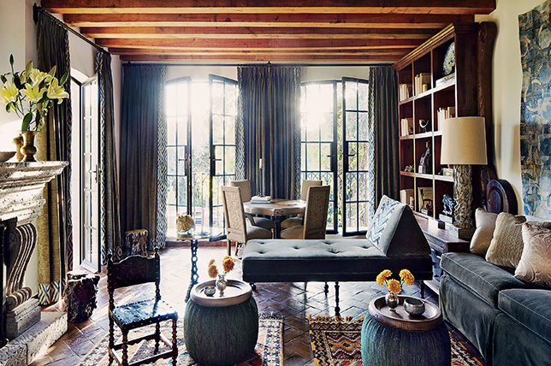
Materials and furniture should look as if they’ve lived a life before coming into your home for added charm as bohemian style is all about well-loved pieces that look as if they were sourced from a far-flung market in an exotic locale.
Choose pieces that appear to boast personal history to them (even if you picked them up in a local sale and have no idea where they came from), the more alluring bohemian design feels, the better – even in the smallest of eclectic spaces.
SHY AWAY FROM MINIMALISM
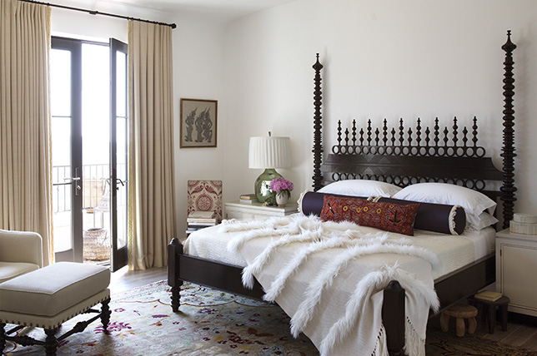
With bohemian style decor, more is more as this design style isn’t about empty surfaces and blank spaces – the look is all about indulgent maximalism. That said, keep your bohemian living room decor full of curated finds, but for a bohemian style bedroom, our designers suggest a more pared-down take.
Do inject personality throughout your bohemian home and be sure that everything you love and have collected over the years is prominently on display. Bohemian style is all about layering trinkets and treasures to tell a story, just be sure you have enough surface and wall space to highlight decor and display artwork. Bohemian home decor shouldn’t evoke a similarity to the home of a hoarder, however. Everything should have place and a purpose, yet you don’t have to be rigid with placement.
BRIGHT COLORS
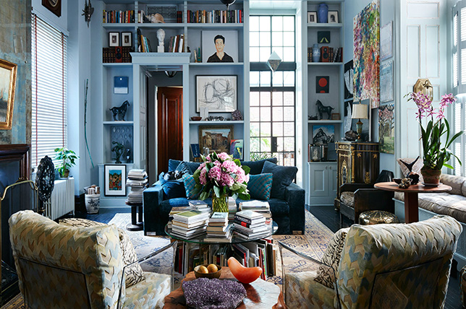
When we think about bohemian decor, bright colors and bold hues often come to mind. From pinks, to purples, to oranges, and greens – the bolder the better when it comes to luxurious bohemian interior design. Jewel tones work particularly with bohemian decor and the deep, deluxe tones instantly make a space feel comforting in a way that’s exclusive to bohemian home decor.
Consider sourcing a deep hued Moroccan bed spread for bohemian style bedroom decor and contrast it with bright linens for bohemian style bedroom decor that sings.
METALLICS AND MIRRORS
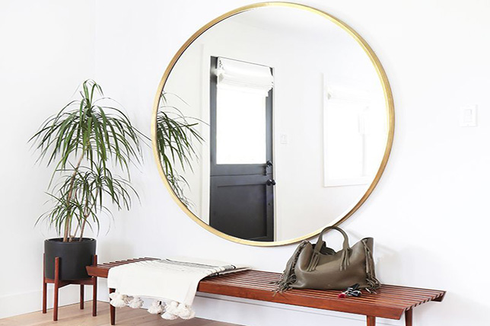
Metallic and mirrored surfaces are hallmarks of bohemian interior design, especially for making a modern bohemian living room appear brighter and larger. Metallics and mirrors also add focal points to your room, along with a sense of everyday glamor.
For a DIY challenge, how about trying your hand at making your own mosaic tiled mirror and decorative extras? Lanterns and lights featuring Moroccan design are also sure to add an interesting bohemian style focal point, and when hung low, they’ll also work to add comfort and visual interest for your bohemian house decor.
LAYERS
Layer up on bohemian style decor decorative items and textiles; whether rugs, cushions, or throws, as bohemian style is all about layering. Layer one, two, or even three rugs in different styles and patterns for a rich statement. Layers of cushions and throws will also punctuate the relaxed vibe of bohemian style perfectly.
Layering is also a terrific way to conceal furnishings that may not be in the best condition as you can cover them with multiple textiles for a clever, stylish, and textured take on bohemian decor. Bohemian decor should reveal more on a second, third, and even fourth look than it does the first as layering colors, textures, and patterns is sure to add playful visual impact.

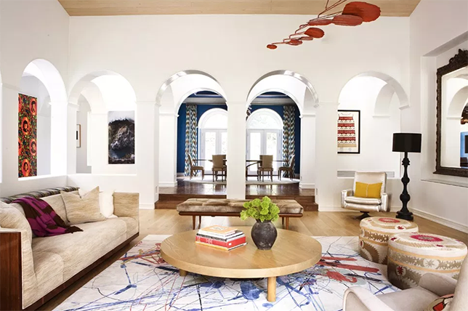
ACCESSORIZE ARTISTICALLY
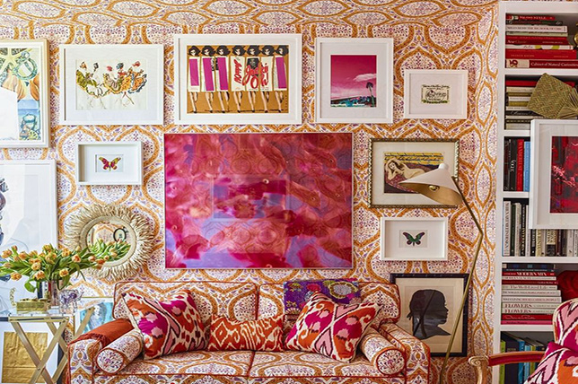
Again, accessories should give the impression that you are well-travelled (even if you’re not). Artistic accessories will add further interest to your cozy spaces and make for cultured talking points. Go bold with artistic pieces which stand out and are less than ordinary.
If you aren’t blessed with the luxury of having traveled the world collecting trinkets and keepsakes from every corner of the globe, take a trip to the local antiques store and shop for some interesting treasures to display.
35. Hollywood Glam
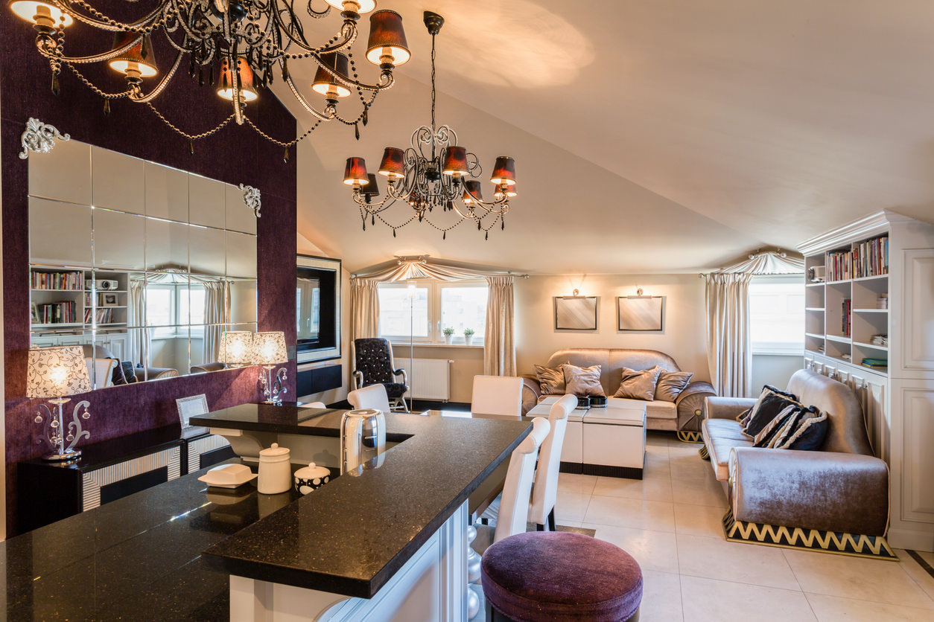
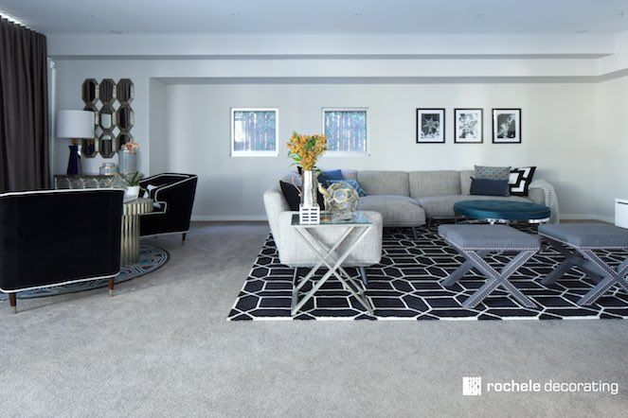
Undoubtedly, the Hollywood Glam interiors designers are by far the most modern and stylish of all. Their key characteristic is that they are super luxurious and over-the-top in their interior designs. They love to create big and bold statements with the help of dramatic and opulent design styles.
Most of their styles and designs consist of Victorian inspirations with antique furnishings, plush and velvety elements, and magnificent decorative accents. The color palettes used here are usually very bold with beautiful blends of turquoise, reds and purples.
35. Coastal
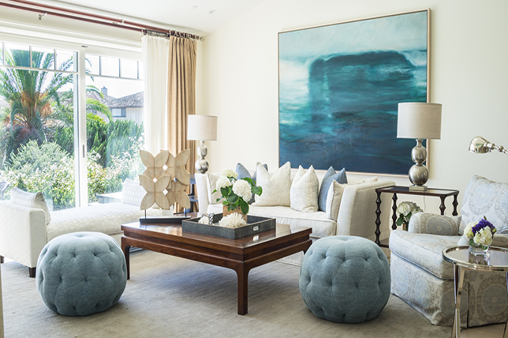
Though we’re not ones for themed interior design styles of any kind, there’s something novel and reassuring about an edited mix of coastal and beach house elements bringing a room together. Coastal interior design notes feature light, bright, and airy environs often dreamed up in vibrant neutrals to soak up the suns rays. Common coastal color palettes include shades of light blues and greens inspired by the ocean along with an array of creams and neutrals for a relaxed yet elegant finish.
Our favorite coastal inspired projects, such as this residence in San Francisco often boast contemporary interior design styles to give the aesthetic an unexpectedly contemporary twist.
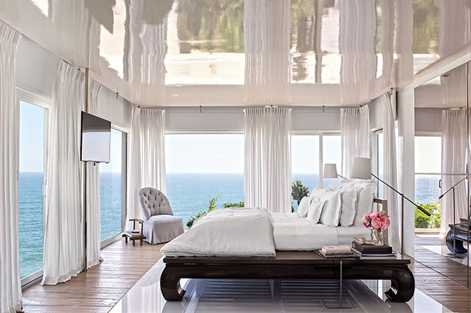
If you’re looking to bring a breezy, airy, and relaxed yet sophisticated energy into your home, coastal home decor may just be the right alluring home design style for you to consider. But what is coastal decor, and how do you bring into your home with ease and authority?
For starters, coastal style is perfect if you like clutter-free surfaces, nautical-inspired flourishes, and enjoy natural finishes with luminescent light bouncing about.
White, blue, gold, natural tones, and of course, stripes, are hallmarks of coastal style and are utilized to create a calm and brilliantly realized space for you to be at your most relaxed in. From beach house vibes to playful nautical themes, coastal style homes are elegant, refined, and quirky all at once. Best of all, you don’t have to live on the water to inject beautiful coastal design into your home with our handy guide to coastal living decorating ideas curated by Décor Aid interior designers.
Here’s everything you need to know to get started:
MAIN THEMES
Simple Color Schemes
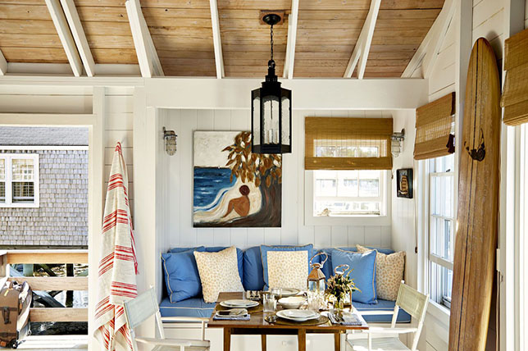
Keeping rooms fuss-free, light, and airy are standards for the perfect coastal home decor look. Coastal design features a tight selection of complimentary hues which are to remain consistent throughout the room. Use plenty of white – we’re talking white ceilings, white walls, and white furniture.
Accent throughout with a strong blue or grey to break up the room and lend it depth and visual strength. Also, be sure to make use of neutrals with furnishings and accessories such as rugs, coffee tables, and mirrors. Blues and grays will provide a nice juxtaposition to a room saturated with white while reflecting the calming spirit of coastal interior design with a subtle hint of luxury.
Natural Light
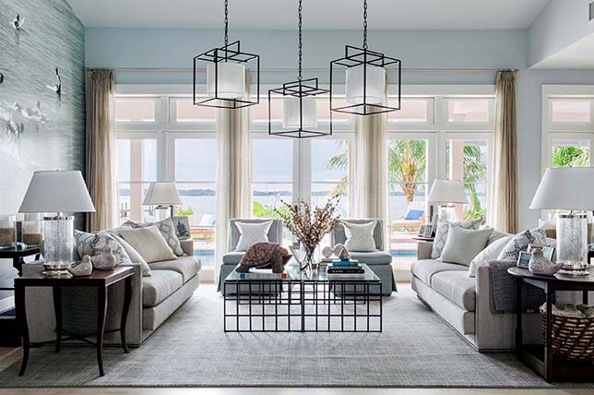
Do take full advantage of natural light in your approach to modern coastal design and open up windows with sheer ivory drapes and explore ways to let as much natural light in as possible, whenever, wherever.
Unless they’re made of natural wood, swap out heavy blinds to embrace the natural light that floods in. If you don’t have as much natural light as you would like in your room, mirror the suns abundance with gold-framed mirrors – a classic interior design tip for amping up natural light levels.
Natural Materials
Because coastal design ideas would be incomplete without natural materials, opt for the real deal rather than synthetics. Wood, cotton, and jute will work to add a touchable sense of luxury to coastal decor while providing a comfortable and cozy energy. Driftwood is a great addition to consider for any coastal home decor idea; in fact, as far as interiors are concerned, coastal design would be incomplete without a piece of on-trend driftwood, even if in the smallest of doses.
Stone works well for bathroom and kitchen flooring (it’s practical as well as stylish) and having the feel of natural stone beneath your feet will make you feel as if you are just stepping onto the beach on holiday.

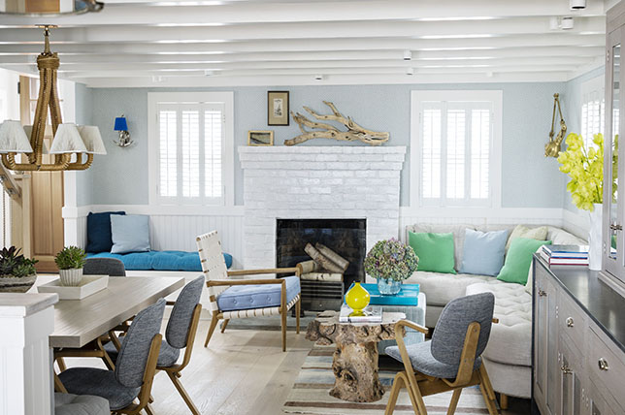
Relaxation
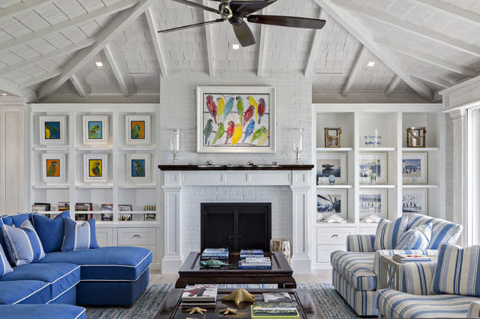
Coastal decor ideas are all about pulled-together relaxation; a light and simple color scheme, complemented by natural materials, and plenty of natural light, all working together to help you create a space you can be at ease in. That said, we aren’t suggesting your approach to coastal decor to be clinical – like always, you do need some personality that reflects you and your lifestyle.
In short, just like you would go on a beachside holiday to relax is how you should feel each time you enter a coastal style room. Keeping your coastal design aspiration clutter-free will help with achieving the right feel.
Coastal style homes would be lacking something if there weren’t decorative items that evoke beach finds and frivolity. Think shells and stones collected and displayed along shelves and tables as well as in a large glass vessel, or abstract driftwood perched up on your mantelpiece for a minimalist addition to the mix.
COASTAL INTERIOR DESIGN IDEAS BY ROOM
Bathroom
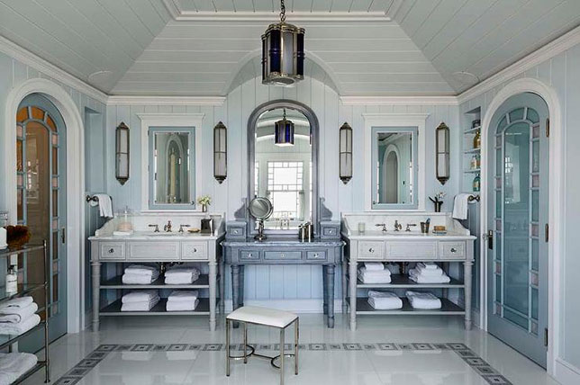
Like any room, a coastal inspired bathroom should be a haven of relaxation, but with a coastal design in mind for your bathroom, achieving the look lies in the rooms interior design foundation and decorative extras. An all-white bathroom will always mark the pinnacle of relaxation; with white wall tiles, white floor tiles, and a white bathroom vanity – you will feel more like you are in a spa than at home.
Easy to install and inexpensive to boot, shiplap has a wonderful earthy coastal feel about it and is easy to manage and clean. But if an all-white bathroom is too much for you, go for white wood paneling and select a light blue-green hue for your walls.
And since every bathroom needs a mirror, go for a circle shape boasting a thin gold metallic frame to channel coastal decor and the windows of a ship sailing away. Reflect natural light with a large mirror above the sink, or a petite nautical style porthole mirror next to your bathtub. And by putting a mirror opposite a window you’ll make the room appear to have another window to gaze out of when soaking in the tub after a long day.
Bedroom
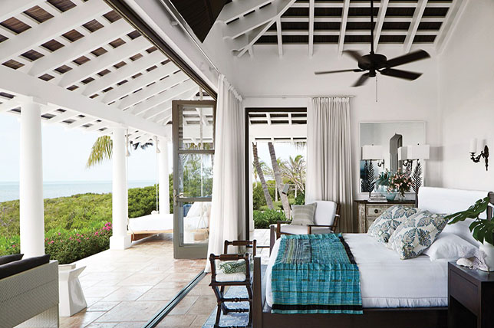
A bedroom being another dependable point of relaxation; choose luxurious white bed linens with a high thread count to add a deluxe feel and accent tonal bedding with blue and white or botanical patterned pillows and throws. If you do opt for all white bedding, source a covered headboard with a striped nautical fabrication for balance and to stay subtly on theme.
A white wood bedframe will also work to evoke charming coastal decor. But if you can’t afford new coastal bedroom furniture, consider painting current furnishings white or add coastal design details to what you already have.
Angled rugs will lend this otherwise practical design approach a sense of play and off-kilter ease. To complete the room, select a comfortable occasional chair and place it by a window to create the perfect reading nook boasting natural light.
Kitchen/Dining Room
A reclaimed wood table is a savvy addition for any coastal inspired kitchen or dining room. A light, sun-bleached look echoes go-to driftwood- but if you already have a wooden kitchen table to work with, try sanding off the current paint or varnish, for a rough and relaxed finish. Pair your table with bright white fabric covered slip chairs or go for communal bench seating for something more informal.
Blue, grey, or white cabinets finished with gold hardware look stunning in nautical kitchens, especially when paired with wooden flooring or white tiles. If you do opt for white kitchen cabinets, introduce color with a French or beachyblue backsplash and copper toned pulls and handles.
And because no coastal kitchen is complete without unique, statement-making lighting, a simple chandelier will do the trick, or for something more modern, bring in a large glass lantern inspired pendant.
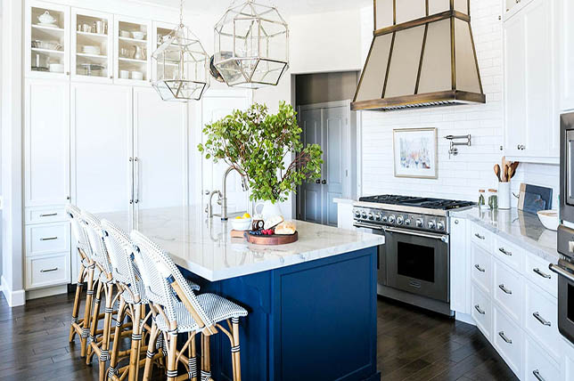
Living Room
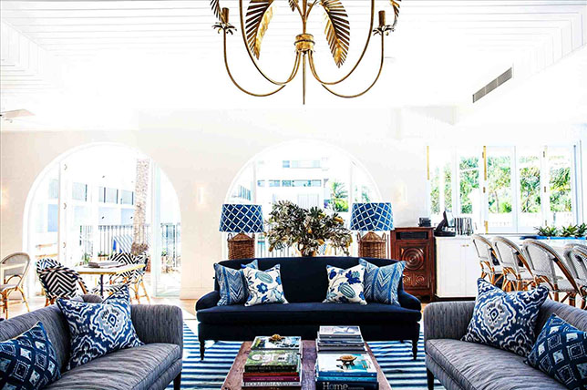
Your living room is one of your largest and most used common rooms, but how do you inject coastal decorating ideas for living rooms in your home with an authoritative hand without taking the design direction too literally as a theme? Take the look a step further and make luxurious accents and furnishings a prominent feature in your inspired coastal style living room – think soothing blues, sand tones, and ultra-bright white.
White painted floors are a standard coastal decor choice for the living room for good reason as they make any room appear larger, brighter, and often tidier. Another conversation starting coastal interior design idea to consider is to paint chair rail molding, doors, or even an accent wall in a moody yet on theme blue or gray for added depth.
A jute rug can also break up the monotony of an all-white palette while adding an earthy, natural material into the mix as well as much-needed texture. White linen upholstery can also be broken up with blue accents (think a plush white sofa with contrasting vibrant blue printed cushions).
Source white linen curtains to bring in the breeze, and if you need to block out light, consider made to measure white wooden slatted blinds. A glass-topped driftwood coffee table will complete your coastal design living room; doubling as functional art. They also look stunning in both white and natural sun-bleached wood tones.
36. Feng Shui
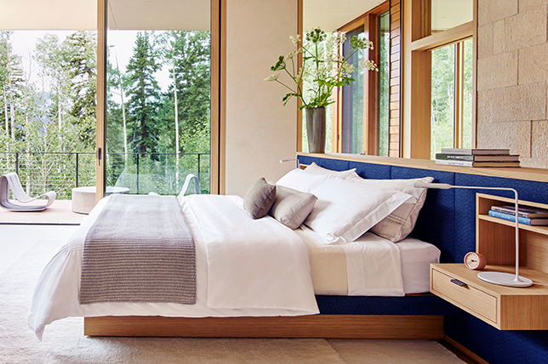
Feng shui isn’t just limited to the way you arrange your furnishings. It’s more of a philosophy to create balance in your home for harmony and is certain to add a sense of tranquility to your everyday life.
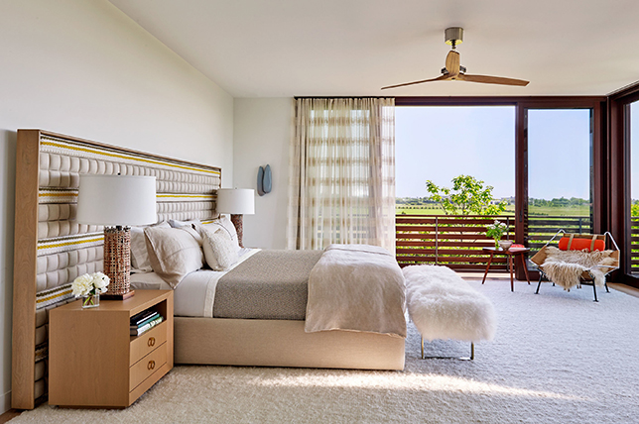
Feng shui isn’t just a way of arranging your furniture. It’s an entire philosophy of creating balance in your home for life-enhancing harmony. Whether you’re going for an uplifting eclectic, traditional, or transitional update where it matters most, feng shui bedroom ideas are sure to bring a sense of tranquility to your everyday life. To get you started on your blissful journey, we’re sharing essential feng shui house design style rules to help you create your own zen oasis with ease.
From feng shui bedroom ideas that’ll work throughout your home, to the right finishing decortouches to complete the look, here are the best feng shui style decorating ideas for home you need to know.
ESSENTIAL FENG SHUI BEDROOM IDEAS
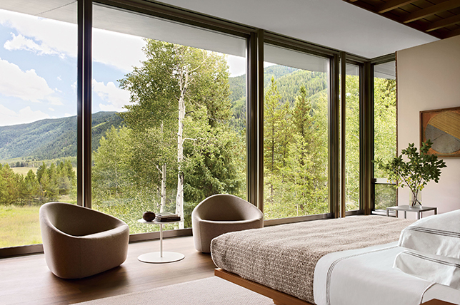
A balanced bed(platforms are best)
Keep doors closed
Have a bedside table on each side for symmetry
Avoid having your bed directly in line with your door
A solid headboard
Natural and organic linens and bedding
CREATE AN ELECTRONIC FREE SPACE
When thinking about feng shui bedroom ideas it should be a no-brainer that electronics are a big ‘no’ as they are distracting and create an environment that’s far from peaceful. Skip out on a television and workout equipment and be sure to avoid keeping your phone on your nightstand.
AIR QUALITY IS KEY
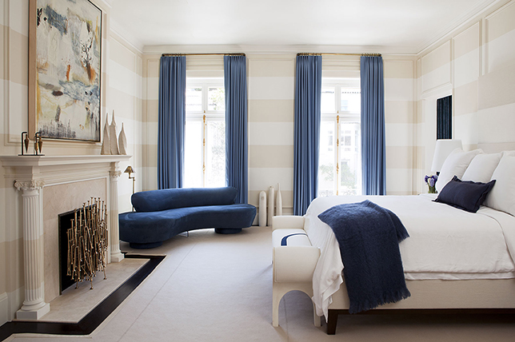
Keep the air in your feng shui bedroom fresh and full of oxygen by opening windows and bringing in an air purifier. And since feng shui ideas for home call for a mindful approach to pollutants, use essential oils vs. toxic fragrances as they have enriching healing properties.
FENG SHUI BEDROOM COLORS
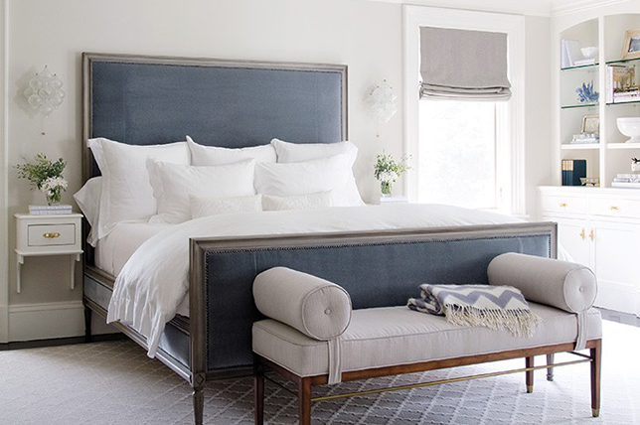
Use calming hues to create a harmonious balance of feng shui energy in any room to increase the flow of energy and opt for nudes and skin tones.
PROPORTION MATTERS
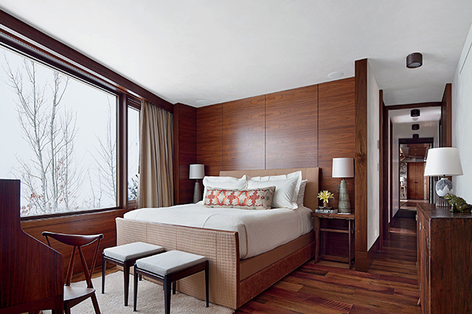
When most people think of feng shui bedroom ideas, they think of an optimal furniture layout. And while layout is certainly an important factor when it comes to feng shui decorating ideas, feng shui starts with proportionate furniture pieces. Do keep every piece’s scale in sync with one another for the right balance and visual harmony.
SEATING PLACEMENT IS KEY
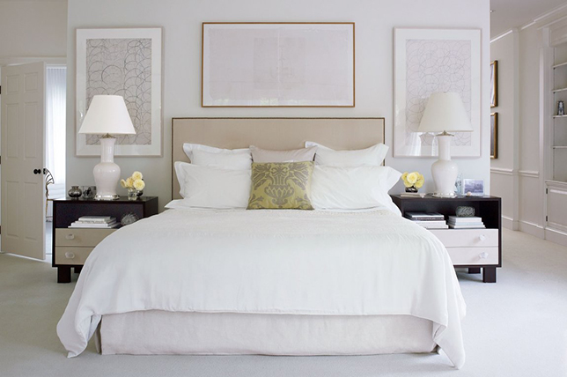
Once you’ve got proportionate furniture pieces, it’s time to start planning your layout. With each room, place the largest pieces of furniture first, and then work your way down to the smallest pieces. When considering feng shui bedroom ideas, the first piece of furniture you should place is your bed. Ideally, your bed should go against the wall that’s furthest from the entryway. And don’t place your bed right up against the wall. If you place it a few inches from the wall, it’ll make your space look a bit bigger and refreshingly open.
BED PLACEMENT THEORIES
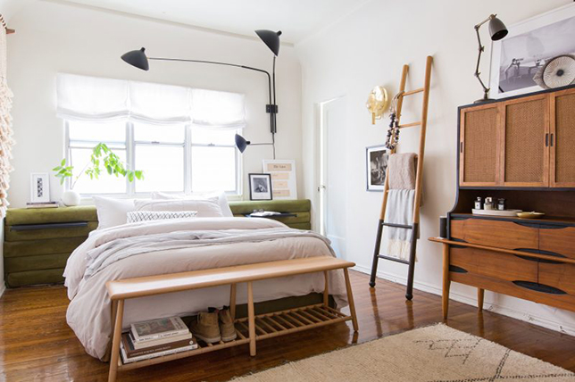
When thinking of feng shui bedroom ideas, again, the placement of your bed is key. Place your headboard against the wall that’s opposite the door. So when you’re sitting up in bed, you should be facing the door. And while it can be tempting to place your bed in a corner, center it against the wall as feng shui decorating ideas call for clear spaces and easy flow.
FENG SHUI FLOW
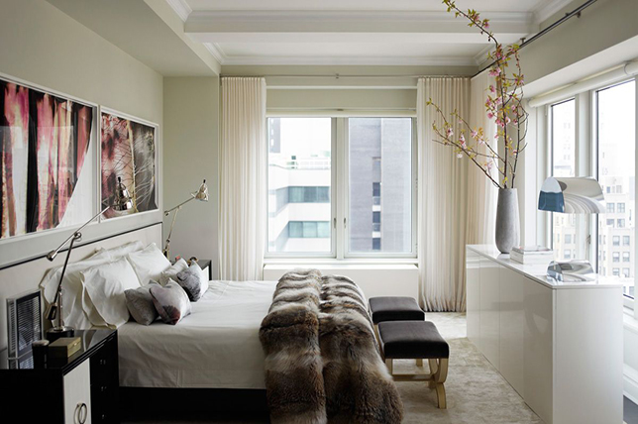
Once you have your larger pieces laid out, then it’s time to start selecting and placing the smaller pieces. When placing your smaller furniture pieces to master feng shui decorating ideas, think about how you move through your bedroom and arrange your furniture so that you aren’t disrupting any natural walkways.
Pro tip: make sure that your seating isn’t too spread out. Feng shui decorating ideas call for furniture layout to be conducive to conversation.
DECLUTTERING IS A MUST
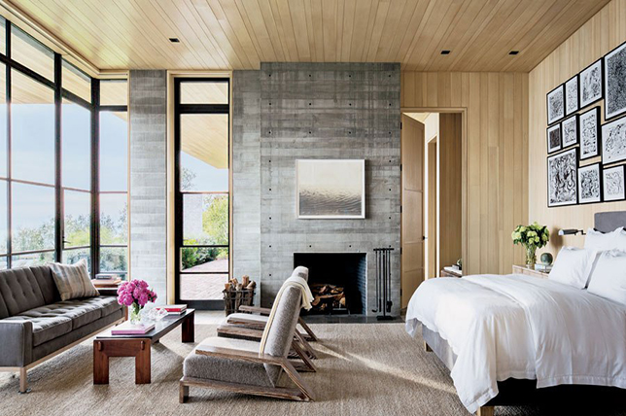
No matter how expensive your furniture is, no matter how well-designed your bedroom is, house plans feng shui style aim for mindful approaches to everyday life and won’t work to your advantage with clutter everywhere. There’s no real trick to decluttering feng shui bedroom ideas. Just get rid of as much stuff as you can bear.
PLAY WITH A VARIETY OF SHAPES
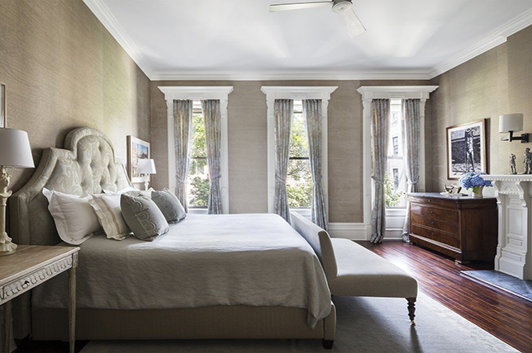
Feng shui decorating ideas are all about balance, and that applies to every aspect of your home including feng shui bedroom ideas. But one balance that often goes overlooked is a balance of shape. So if you’ve got a square table and a rectangular chaise, consider design elements that have a bit of curve and organic silhouettes.
COMPLETE THE LOOK
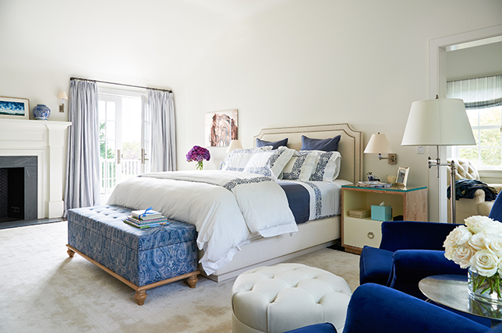
Plants, flowers, and objects with natural motifs are great ways to complete feng shui bedroom ideas. Just be sure the plants you do add are as far away from your bed as possible.
BRING IN ART
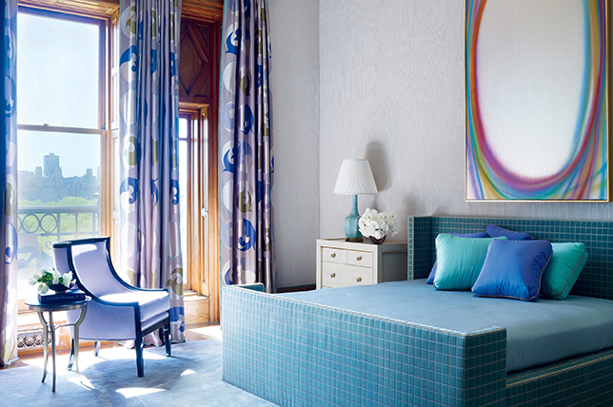
Use art to your advantage to express feelings and energy and be creative with expression as so-called unnoticeable details play powerful roles in your daily well-being. Be sure you’re connected to the art you bring in’s message to ensure that you find it nourishing, uplifting, and enriching. The best art pieces to consider for feng shui bedroom ideas should evoke emotions of love, happy relationships, body healing, and intimacy.
FENG SHUI LIGHTING
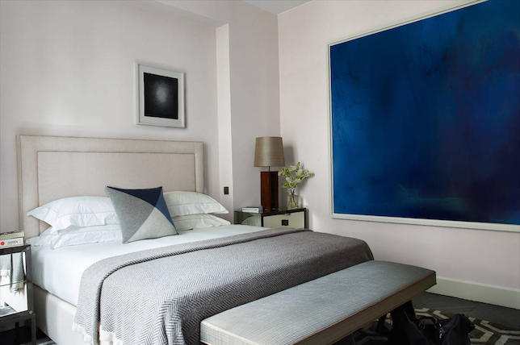
Smart feng shui style design calls for several levels of lighting in any room and dimmers are the most effective way to achieve this. Keep in mind that good lighting is an essential nutrient and one of the strongest manifestations of energy. Candles are also needed as they easily create an intimate, warm, and healing atmosphere – just be sure they are toxin-free.
FENG SHUI BEDROOM IDEAS FOR EVERY ROOM
As important as a feng shui bedroom, kitchens and bathrooms are included in the often referenced ‘feng shui trinity’ as they are equally vital for your health and well-being.
Feng shui bathroom design: Though bathrooms get a bad rep when it comes to smart feng shui style design, all it takes is some minimal mindful effort to update the energy of your bathroom. Push away bad energy by placing a mirror outside of your bathroom door and do bring in calming elements similar to those you would find in a spa.
Good feng shui kitchen design tends to signal wealth and prosperity and there are endless options to elevate and maintain the energy of the room with virtually no ‘shoulds’ to reference. So be explorative and add pieces that you love and frequently use with the freedom to change things around to create better flow and do keep the space clutter-free and organized.
37. Hollywood Regency
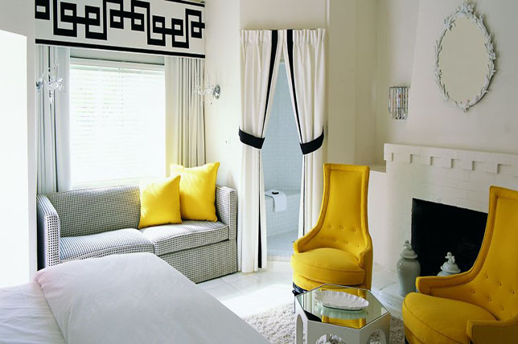
Popular from the 40’s to the 60’s and back since the mid 90’s, Hollywood Regency is one of the most timeless yet fun interior design styles out there to consider as it delightfully blends Art-Deco inspired touches and silhouettes with a grown-up sense of high-polished glamor. Think a mix of period French furnishings, clean lines, vibrant hits of color, and ultra-glam notes brought in via crystal, mirror, and high-shine surfaces and finishes.
Though it can be considered a go-to for traditional style interior design, there’s nothing old-world in spirit about Hollywood Regency interior design styles as to us, it always boasts a modern, upbeat energy.
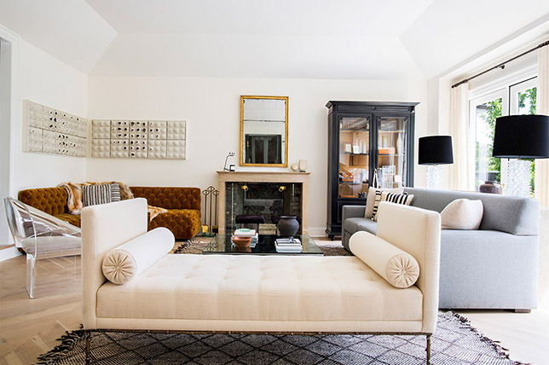
Though we’ve all seen Faye Dunaway’s legendary role as Joan Crawford in Mommy Dearest by now, what we really took note of was how grand the actress’s home was while boasting everyday ease with a luxe take on Hollywood Regency style that was nothing but enviable.
But what does Hollywood Regency style even mean? And how do you get the look in your home?
To make it easier for you, we studied Hollywood regency homes and décor to break down the design style’s codes so you can effectively manage the look in your own home with ease.
From everything you need to know to simple ways to get Hollywood Regency decor on a budget right, here’s a quick look at what it takes to master the style to add an extra touch of luxury to your everyday life.
WHAT DOES HOLLYWOOD REGENCY MEAN?
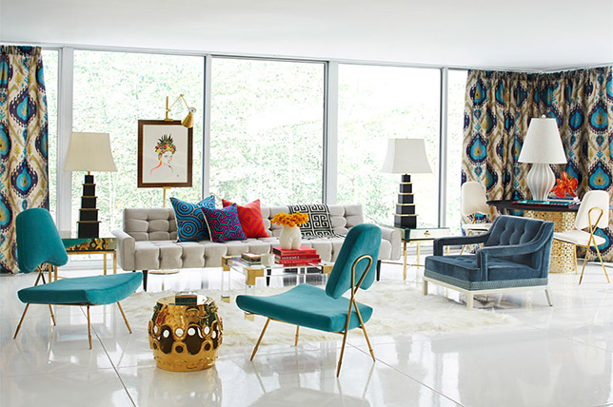
When we think of old-Hollywood glamor we often tend to think of red carpets and the Great Gatsby era but what about the film industry’s stamp on interior design?
Well, thank the Film Academy and its legion of iconic set designers for Hollywood Regency style – a timeless, enchanting mix of eras, styles, and movements mixed with the ultimate of luxury in mind.
Hollywood Regency decor is exactly what it sounds like; high-octane everyday glamor infused with the requisite high-shine lacquered finishes, metallics, and precious fabrications with a nod to Art-Deco decadence and Mid Century Modern practicality. Think dramatic, sensual, modern, uncluttered, and carefully edited with a mix of delicate and bold for a gender-neutral setting that’s timeless in appeal.
WHY YOU’LL LOVE HOLLYWOOD REGENCY INTERIORS?
The design style is great for those looking to invest in classic furnishings yet want to add a varied and vibrant urgency to their décor with cost-effective decorative extras that are easy to switch out.
It’s one design style that has a lot more freedom of expression.
It makes for a great alternative to eclectic and bohemian styles while channeling their energy in a more approachable and minimal way.
While silhouettes are straightforward if not a tad rigid, fabrications are luxurious and centered around comfort and a sensual touch.
Though its full of throwback moments, there’s nothing particularly retro about Hollywood Regency decor.
It’s quite easy and cost-effective to bring this design style into your home.
Best of all, it almost never goes out of style.
HOW DO YOU CREATE HOLLYWOOD REGENCY STYLE?
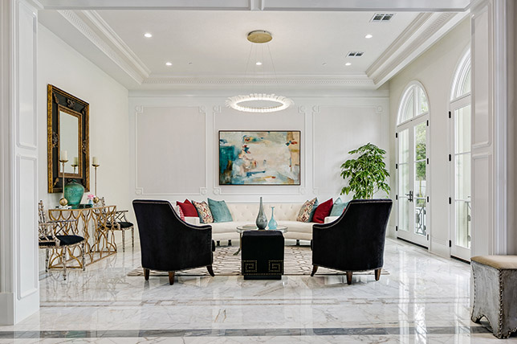
Start with a neutral toned room and pay attention to highlighting architectural elements.
Stick to a concise central color palette.
Make luxury and decorative drama the main focus.
Go for high contrasts to shine a light on your most cherished pieces.
Since Hollywood Regency interior design is all about silver screen iconography and romance, consider creating varied mixes of unexpected elements as there’s fun and freedom to be found in the movement.
HOLLYWOOD REGENCY STYLE COLORS
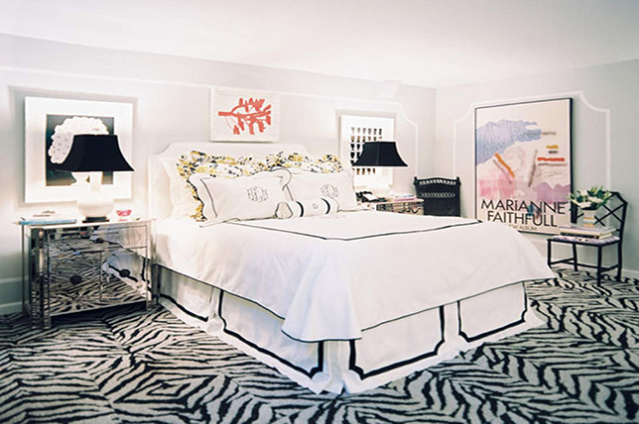
When it comes to Hollywood Regency style color palettes, keep it simple with two to three complementary hues to keep the heady mix of furnishings and elements grounded with a deliberately quiet foundation.
In fact, our interior designers unanimously suggested a timeless, soothing color palette of black, white, and gray as they’ll work to highlight the metallic surfaces and finishes so often associated with Hollywood Regency decor and are glamorous on their own when paired with sophisticated furnishings.
For a grown-up Hollywood Regency living room, go with black and white and bring in an additional color thats full of life in small doses to not overwhelm, while a classic Hollywood Regency style bedroom should be centered around soothing ivory and cream shades for extra comfort.
HOLLYWOOD REGENCY STYLE FURNITURE
Since there’s nothing casual about old-school silver screen glamor, think of Hollywood Regency style with a similar approach and devise ways to make comfort key without it becoming a major focal point.
When furnishing a room with Hollywood Regency decor in mind, there are three effective tips to consider to get it right. For starters, like Mid Century Modern, the design style is all about clean, handsome lines and uncluttered surfaces with the difference being decorative high-shine accessories that are full of life. Second, fabrications are where comfort comes in as there’s power to be found in lush, languid textiles and textures ranging from silk to fur.

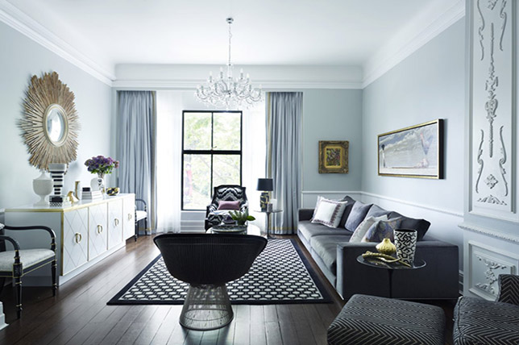
But unlike Mid Century Modern, here’s where you get to have more fun with a rich mix of elements like Louis IV chairs, ornate Art-Deco filigree pieces, hints of mod-inspired 60’s era furnishings, and straight-forward contemporary silhouettes.
And last, from a Hollywood regency living room to a kitchen, it’s all about the finish. Think mirrored, lacquered, marble, and high-shine surfaces for the ultimate in easy elegance to last a lifetime.
HOLLYWOOD REGENCY STYLE TEXTILES
Since Hollywood Regency style is all about touchable glamor, go for plush, decadent fabrications like satin, silk, fur, leather, and of course velvet in a myriad of hues from subtle to strong.
And as common areas are often the best spots to make a statement that pops with energy, consider ways to up the ante with unexpected fabrications for a truly memorable Hollywood Regency living room that will look like no one else’s. For Hollywood Regency style rugs, go for two-tone Greek key patterns like above, or tonal yetti or sheepskin, or go wild with a vibrant zebra print

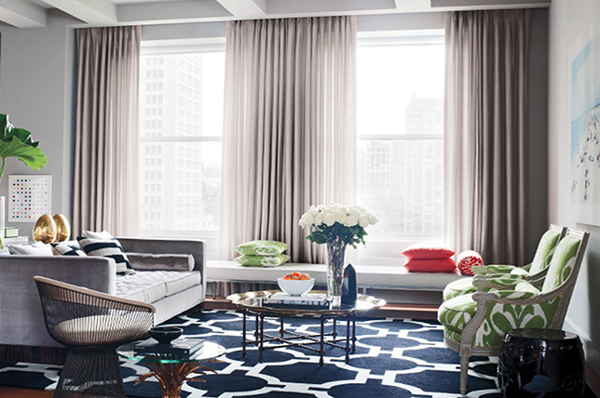
HOLLYWOOD REGENCY STYLE ACCESSORIES
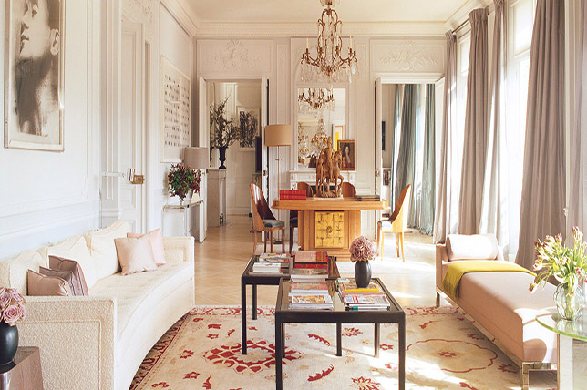
Since this design style isn’t locked down to one particular era or movement, be explorative and have fun with accessories and decorative extras for a rich, unique take on modern Hollywood Regency style. Again, go for crystal, marble, stone, and high-shine accessories to conjure the right spirit.
By keeping furnishings and architectural elements simple with clean lines and uncluttered surfaces, accessories are where you’ll be able to create a custom environment full of life and statement-making details. From Ming vases to mirrored plinths to ceramic horse figurines, have fun and be bold with your additions as a perfect Hollywood Regency room should have a layered, jewel box-like assortment of precious finds certain to delight.
HOLLYWOOD REGENCY STYLE WINDOW TREATMENTS
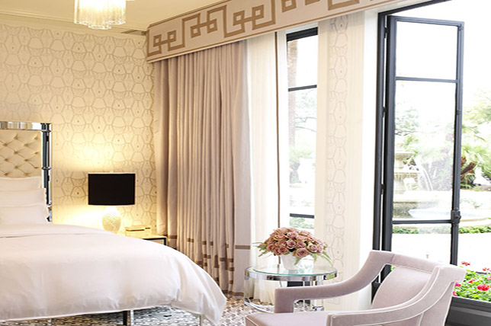
As Greek key patterns are a Hollywood Regency style signature, take inspiration from the room above and go a similar route or keep the look simple and invest in high-quality sheer floor-to-ceiling window panels that will add quiet drama while making the room appear larger, brighter, and grander.
HOLLYWOOD REGENCY STYLE ROOM BY ROOM:
To help you explore Hollywood Regency decor ideas throughout your home we’re homing in on what it takes to introduce the design style in your home from room to room seamlessly.
From a sumptuous Hollywood Regency living room with a riotous mix of elements to a soothing oasis of a Hollywood Regency style bedroom, here’s everything you need to know to get started from the smallest of details to the main attraction.
Hollywood Regency Style Kitchen:
Though a kitchen is a prominent multi-purpose common area where form follows function, there are plenty of clever ways to bring in even the smallest touch of Hollywood Regency style for everyday glam.
We love how the kitchen above has been updated with hints of Hollywood Regency decor via its three-tone color palette, clean lines, gold accents, Art-Deco inspired pendant lights, and covered range hood for a decidedly polished approach to the design style. If you’re looking for small updates for your kitchen, keep things interesting with new drawer pulls and nobs, crystal accents, and uncluttered countertops that house only the most necessary of kitchen items.
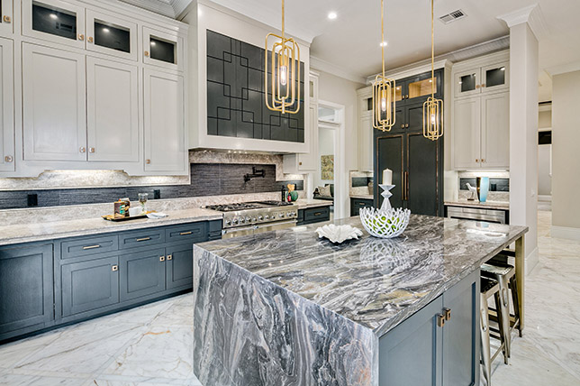
Hollywood Regency Style Dining Room:
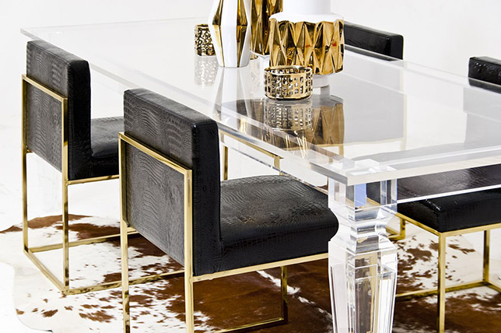
Again, Hollywood Regency decor is all about a sumptuous mix that’s grown-up and luxurious to the hilt. And this image sums up exactly what it takes to add silver screen polish to a standard dining room thanks to its structured all glass table that lets the light shine in without taking up too much visual space, textured black leather chairs with gold frames, cowhide rug for an added textural juxtaposition, and vibrant sculptural metallic vessels.
Follow suit and stick to clean lines and simple shapes that are anything but ordinary as the three main design elements above are all strong on their own yet work together for a truly sophisticated outcome that’s sure to wow guests.
Hollywood Regency Style Living Room:
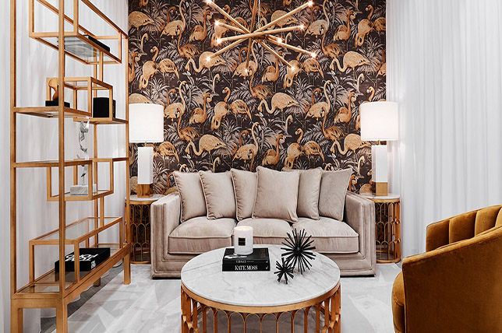
When used with a light hand, go for bold accents and hues to bring in the spirit of Hollywood Regency style throughout your home for a contemporary take on the era. However, stick to two to three hues and one to two patterns to keep things harmonious and consistent.
Though filtered with a vaguely tropical spirit, note how the Hollywood Regency living room featured above boasts just three main colors and one conversation-starting print for a message that’s concise yet joyous and vibrant. By keeping print and pattern limited to just one main accent wall, the eye can focus on various elements throughout the room with ease while not skipping a single Hollywood Regency decor detail as there are many subtle ones to take in here.
To create your own Hollywood Regency style living room with authority stick to the same rules noted before and build a mix that features decadent fabrications, metallic finishes and surfaces, a blend of design styles from Art Deco to Asian tinged, and keep the glamor quotient fun with playful add-ons that while elegant, add a sense of the unexpected to an otherwise calculated approach to décor.
Hollywood Regency Style Bedroom:
To create a sophisticated Hollywood Regency style bedroom, study hallmarks of the Art Deco era to help set the tone for the room before you begin. But don’t go overboard with throwbacks – you want your take on the design style to feel authentic to you, and not like a museum-ready time capsule.
Since attention to detail is a major priority for Hollywood Regency decor, source sumptuous fabrications, mirrored, lacquered, and reflective surfaces, tassels, and embellishments while keeping lines clean and simple. And since the movement isn’t bound to one set style, bring in various elements for an eclectic touch that’s rich with visual interest and fit for a movie star.

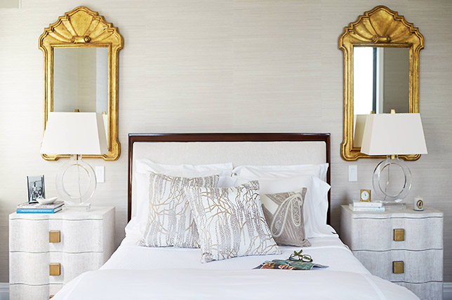
Get seductive with a moody, glamorous, sophisticated, and feminine take on Hollywood Regency style with easy to source mirrored nightstands and a dresser, an upholstered headboard, contrasting black and white hues punctuated with silver tones, and velvet and fur throws and pillows finished with tassel and fringed trim for the ultimate in retro-inspired glam.
Hollywood Regency Style Bathroom:
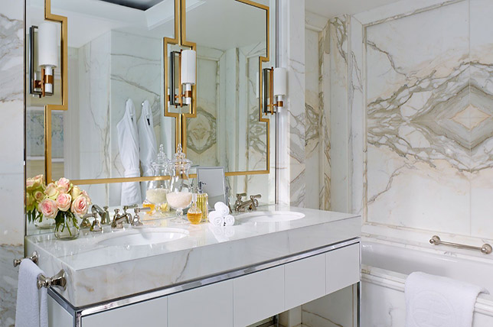
When looking to inject Hollywood Regency style in even the smallest spaces, like a bathroom per se, stick to the style’s glam drama with high-gloss finishes and dramatic metallics that won’t make the petite space feel overwhelmed or challenged. To channel the heady heyday of the roaring 20’s and 30’s, our interior designers suggest updating your bathroom with timeless white marble surfaces and a pedestal sink and tub. To transform your bathroom without an A-list budget, make it magnificent with a white and silver color scheme, mirrored surfaces and details, and crystal accents for an added feel of easy luxury.
And because mastering Hollywood Regency decor comes down to even the smallest of well-judged details, trade in plastic toiletry bottles for glass ones, bring in hotel quality towels and linens in simple black and white, and add polished silver-toned vanity accessories that will work to reflect light without taking up too much visual space.
For extra depth, consider swapping out standard bathmats with Hollywood Regency style rugs in your powder room for a well-considered touch that’s certain to evoke retro-Hollywood glamor with ease.

