Kevin Hart Keto That way, you can evaluate the supplement for as long as about fourteen days prior to submitting completely. Yet, on the off chance that you stand by excessively long, you will pass up on your opportunity to get incomparable fat consuming.
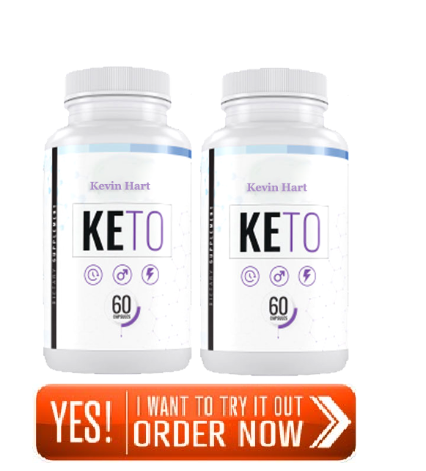
►►Click Here to Order Kevin Hart Keto◄◄
Thus, on the off chance that you are searching for preeminent outcomes, click any picture or catch on this page to guarantee a FREE TRIAL OFFER of the top selling pills before it's past the point of no return!
Kevin Hart Keto Review, When we talk about weight reduction, it is basic among everybody, and numerous individuals around you or we are confronting a similar issue. Notwithstanding, we as a whole realize that weight reduction Kevin Hart Keto is an overwhelming undertaking, and yet, it is simple likewise, if an individual is adopting the correct strategy towards their weight reduction system.
►►Click Here to Order Kevin Hart Keto◄◄
Nonetheless, shedding pounds is similarly significant these days to forestall numerous medical problems as well.
According Kevin Hart Keto to investigate, numerous individuals who face weight acquire issues, will in general have medical issues like stoutness, terrible cholesterol, hypertension, and some more. So it gets vital for control your weight at the ideal time with the correct methodology.
https://sites.google.com/view/kevin-hart-keto-/home
https://sites.google.com/view/kevin-hart-keto-review/home
https://fetchbinarydog.com/kevin-hart-keto/
https://www.realbuzz.com/blogs/posts/1468696/kevin-hart-keto-review-does-kevin-hart-keto-really-works-kevin-hart-keto-scam
https://www.realbuzz.com/blogs/kevinhartketoreviews/kevin-hart-keto-3/
https://twitter.com/Kevin_Hart_Keto
https://twitter.com/Kevin_Hart_Keto/status/1381570885581168643
https://classifieds.newsbreak.com/new-york/new-york/general/post/general-118941271-1618227419938/Kevin%20Hart%20Keto%20(Review)%20Does%20Kevin%20Hart%20Keto%20Really%20Works?%20Kevin%20Hart%20Keto%20Scam!!
https://www.spreaker.com/show/kevin-hart-keto
https://www.spreaker.com/user/kevinhartketo

