Why Should You Buy Engagement Rings Online?

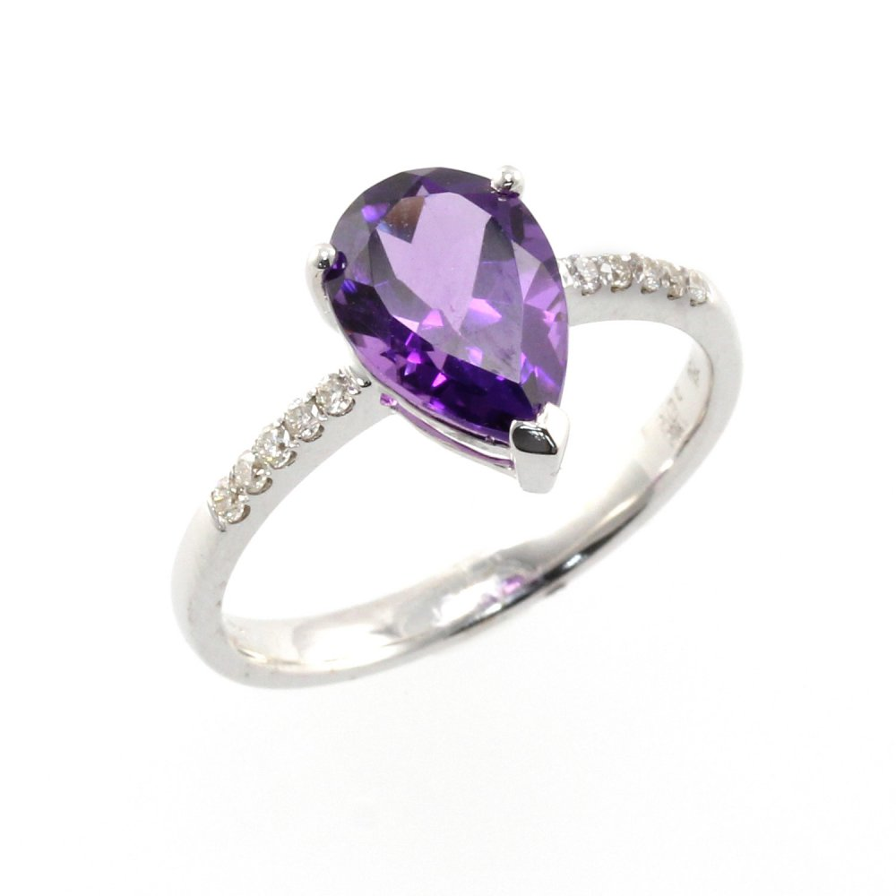
Therefore , the special day has ultimately arrived in your life which you have recently been waiting for. You are getting employed to the love of your life. We would like for you to congratulate you for the same as well as understand the fact that you would be just about all excited and eager to convey your feelings to your ladylove, however you also need something which would you need to her breath away for instance a beautiful engagement ring. We have merely on idea as to what other folks think about purchasing Peridot Rings, yet there are many for whom a ring is the most imperative purchase of their particular lives. After all, this diamond ring is the one which pours those times of sheer happiness and also delight on the one to to whom it is being gifted to help.
Even though the fact cannot be refused that there are other pricey items as well which can be considered to your beloved one, but getting an engagement ring for her shows your current commitment and a change in the approach to life. We know that acquiring a lovely diamond engagement ring is not a career which can be achieved in the blink of an eye. The thought of making contact with a jeweler at his or her store would simply shock you deep inside as there is heaps of styles and designs to choose from. You should find yourself in a dilemma which usually ring to select when there are many them with fantastic designs.
This is how the role of buying involvement rings online comes into play. Folks nowadays are buying all the things on the Internet with the comfort of these homes. So , you should phone reliable online jewelry merchants and search for the wedding ring for your wife-to-be. You would encounter so many online jewelry outlets that have various shapes and fashions in the engagement ring. It's genuine that this would be your very first time getting a ring online which easily would take your fiancée's inhale away, it would be a daunting along with chaotic task for you to choose one of the most charming one. So , there are a few things which you need to know before coming into contact with an online store and buy the ring. You should know what your ring would appear to be. Do you really think that buying a ring is one of the most crucial investments you should ever make for your ladylove?
Absolutely! An engagement ring will be the most amazing things you will ever before buy for her. It would help to make her feel so specific with a feeling that you consider a lot about this pious partnership which you are soon sharing with her. So , you should get a hoop that would suit her tastes, personality and lifestyle. To put it briefly, she wants a ring of your teeth which she can happily flaunt to her known kinds. It is obvious that you may wish to gift a ring to your better half which she can use everyday and you would be choosing a ring without actually discovering it in person, make sure that the web jeweler is a reliable in addition to professional one. You would never ever want to be deceived by the jewelry salesman if it sells you a phony one or not as described inside the photograph.

