11 Ways of Getting Rid of Allergy
by Agnes Khan – translator of ‘Philosophy of Health’ and ‘Philosophy of Life’

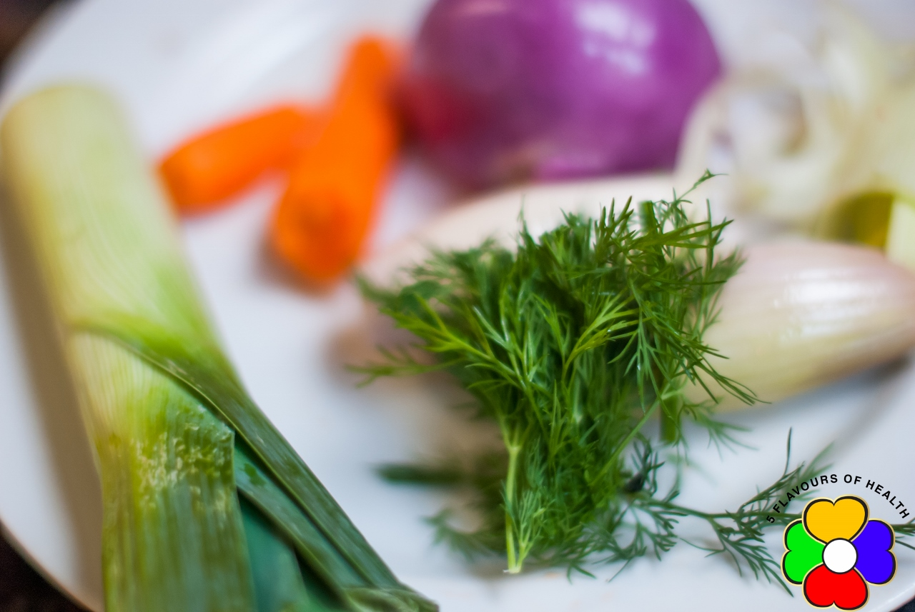

Dear Member,

You might read this article because you suffer from allergy, or maybe your loved one does, or someone you care about.
For first 30 years of my life I thought I was eating healthy food because I was following NHS' and nutritionists' guidance.
It all started when my second child was born. Almost from his birth he started to suffer from a serious skin condition, which affected his face and most of his body. He was suffering so much that I had to put him to bed with cotton gloves, so that he would not be able to scratch his face. It was such a difficult period of my life and it took a great deal of courage and patience to continually attend to my child on a daily basis.
Fortunately, it was during this time that I was recommend to read Anna’s books, and this has changed my life.
Initially we attended, where Doctor’s surgeries trying prescribed medication, to relieve the suffering of my child. Sadly, nothing seemed to alleviate his condition. In fact, it was getting worse.
Then I began to question his diet and how I might be able to resolve his sores, without drugs.

My proposal in 5 Flavours of Health is not a quick fix solution, like a fast weight loss plan to follow for a few weeks. NO – this is a way of life.
With time, I slowly started to realize how the right approach to a diet made sense. I've learned how to combine foods, use certain herbs and spices and change my way of cooking.
I can only say that within a few weeks my child had begun to recover and my whole family started to have more and more energy, feeling the benefits of changes I had introduced into our family’s diet.
As far as statistics are concern – over 50% of children in UK are diagnosed with symptoms of allergies.
This is scary, especially when the numbers are growing rapidly.

5 Flavours of Health is going to give you extraordinary methods for you to implement and understand.

I will make you aware of some facts that will astonish you but also, I will make you realize how you can help yourself and others.
This is a tragedy, that all doctors and qualified "experts" can do at the moment is to supply us with steroids & antibiotics. But you are reading this. You want to do better...
Some of the things I am going to tell you are very common and easy to apply. Some will require more time.
I am very glad to say, that all I am telling & promoting is what works and have been working for years, for people who know about it.
Certain things you may know, but the main issue is – are YOU IMPLEMENTING everything you know?

These are the titles of the topics I want you to focus on:
No 1. Eliminate Wrong Types of Food.
No 2. Introduce a Balanced Cooked Diet in Your House
No 3. Get Efficient at Your Shopping.
No 4. How does my Body really Work?
No 5. How Can I Get Better at Cooking?
No 6. Make Sure You Get It Right.
No 7. Get Closer to The Nature – Eat Seasonal.
No 8. Get Organized in Your Kitchen.
No 9. Why Do Not Talk About It to Everybody?
No 10. Action and Implementation

1. Wrong Types of Food

‘What’s right isn’t always popular, and what’s popular isn’t always right.’
(S. Draper)

I am aware that many people have been advised by their doctors after having their allergy tests done – of what not to eat.
My suggestions are based on the knowledge and wisdom explained in ‘Philosophy of Health’ and ‘ Philosophy of Life’ by Anna Ciesielska - Expert in dealing with allergies in children and adults.

If you are allergic or want to prevent allergies – FOOD that MUST BE eliminated:
- fast food and processed foods,
- fizzy drinks,
- milk, cheese = dairy products,
- juice,
- large amount of chicken
- pork,
- fresh oriental and citrus fruits (if you live in country that citrus do not grow)

In general, raw, cold and sour food products should be consumed in moderation.
Often people are asking me: “Well, how do I do it?”
My answer is: stop buying the food which is not suitable for you.
If you do not have ‘junk’ in front of you – you will be less tempted to crave for it.
This will also help your family members to become healthier.
Also, by the way, it is very beneficial and encouraging if your family members are supporting you in change of your dietary habits. However, don’t get discourage, if at the beginning, they will think ‘you are crazy’, or they will not become supportive.
Once they will see it works – they will be happy with the results…
Give everybody their time they need to adapt.
This can be sometime a big change for people and some are not ready as yet.
That is fine….
You need to be patient & focused.
Do your job best you can.

2. Introduce Balanced Cooked Diet in Your House

‘Let food be thy medicine and medicine be thy food.’
(Hippocrates)

The main principle of a balanced nutrition is to strengthen and protect all of the bodily organs. Unbalanced nutrition, scarce in some flavors, creates excess or deficiencies within particular bodily organs and leads to particular illnesses.
The person suffering allergies needs to supply the body with balanced, cooked meals through the day.
The food should be spiced with five (5) flavours in this particular order:
Only this way the food will get digested easily and our body will benefit from all the nutrients we eat and improve our metabolism and digestion system.

Just a few examples of the products and their flavors:
Bitter – turmeric, marjoram, boiled water, lamb meat
Sweet – cumin, olive oil, cinnamon, millet, corn, beef
Spicy – ground coriander, chilly, cloves, ginger, garlic, onion, barley
Salty – salt, cold water, beans, fish
Sour – tomatoes, lemon, basil, all green leaves including parsley, chicken

Any sort of allergic reactions can be got rid of by eliminating: milk, cheeses, yogurts, sweets, chicken, ham and sausages, and introducing cooked, well-balanced and warm food.

Asthma is a direct consequence of treatments for catarrh and coughs, rashes, spots etc. that do not focus on eliminating the true causes of these minor ailments.
The two major problems for people suffering from asthma are mucus in the lungs and their contraction. And here I need to ask you: How long can we function on steroids and dilatory medication?
Is this how our life is supposed to be?

To avoid allergies and asthma simply remember this advice:
We do not treat catarrh, cough and rashes with hormonal medicines, desensitizing drugs or immunizing vaccines!
That is the shortest route to all sorts of diseases of affluence: diabetes, cardiovascular problems, cancers, kidney and liver diseases and obesity.
COOK. COOK. COOK This is a solution for preventing and treating any allergies and diseases we suffer from.

3. Get Good at Your Shopping

Be careful with everything that is claimed to be healthy – it may be harmful for you.

(…) The freedom and the choices which can improve our quality of life are not an illusion. They do exist. It is only a question of being willing to see them, accept them, understand them and use them. (…) ‘Philosophy of Life’

Now, I would like to talk about very important part of our life – SHOPPING.
Yes, it is not a joke. Shopping despite what you think, can play important part in you becoming healthier person. If you bring home junk food, sweets and juices, fast food etc…. and you and your loved one will continue eating them for few years…… the consequences are not going to be great!
- Make sure that you buy the best food products you can effort.
- Plan your shopping before going out. Make a list.
The benefits you will gain:
- Great feeling - Walking down the aisle and feel satisfy that you know why you picking certain food products. (I can tell you 80- to 85% of people they pick the stuff from the shelves in shops without knowing why they buy it).
- You will gain self-confidence!
- Gain awareness of what food is good for you.
- Eat healthier
Also, you need to acknowledge one more thing:
- The quality of food we provide to our body – the quality of the bodily organ’s functionality we will get (liver, heart, stomach, kidney etc….)
- Can you see how important this part of our lives is????
You can improve your health conditions just by implementing the ‘right for you’ food.
This is customized, unique, and suitable to you and your health condition!

4. Improve your Understanding of How Your Body Works

(…) It is rather dangerous to attempt to fight an illness without knowing its true cause. Every dysfunction within the body is a signal of a Yin-Yang imbalance, which can be caused, for example, by the wrong kind of diet or bad emotions. The elimination of an ailment (e.g. cough, runny nose, fever, stomach ache, heartburn, itch, rash, headache or backache) will only augment the imbalance, and sooner or later it will recur in another place and in a different form.(…) ‘Philosophy of Health’

So, how does your body really work?

According to the Ancient Chinese, all things in the world can be divided into five vibrational families and the elements of Water, Wood, Fire, Earth and Metal. In the body, these five elements represent the five major organs - the kidneys, the liver, the heart, the stomach and the lungs - all of which are necessary for survival. Usually one of these organs is stronger than the others giving extra energy to that organ and helping people to behave in certain ways and clearly influences personality and lifestyle choices - things like food, fun, fashion, decorating, sleeping, playing, etc. and one of the organs is usually slightly deficient and needs building up. When you are strong in one element, you usually need to build up the other elements to find balance.
In the Five Element system, it is important to balance these elements within and without for optimum health. Learning to balance the five elements of food helps ensure that you receive enough nutrients from what you eat and supports the corresponding organs.
One of the best ways to create balance in the body is to eat more foods that correspond to all the five flavors: Salty, Sour, Bitter, Sweet and Spicy in a way that most suits your personal needs and health conditions.
It is also important to eat according to the seasons: Winter is the Water Element, Spring is the Wood Element Fire is Early Summer, Earth is Late Summer, Metal is Autumn.
Try to eat food that is as fresh as possible or preserved well for future use. It is best to buy locally grown or raised food or grow it yourself as this helps connect you to the place you live. The more colorful the dish or meal, the more of the five elements have been involved.
Eating the 5 Element Food way is healthy, fun, nutritious and delicious!

We all know that sleep, relax, movements, relationship, beliefs, work, love or no love, stress in our life…They all have effect on our body. Do we really pay enough attention to all above to ensure our wellbeing?
Our body, mind & spirit are inter-connected.
It is vital to know that our emotional life, our spiritual life. All these have immense effect on our digestion system, metabolism, on our mental strength, achievements at work, school, universities... and vice versa. Also, on our performance as husband or wife, employee, boss etc.
This is a process of improving your overall being.
This is a process of improving your wellbeing.

5.Cook

- Start from a simple coffee and porridge or a soup. Make something that you will enjoy eating.
- It is very important to have gas cooker. This gives us heat energy. It's much healthier than an electrical one.
- Be creative. Test what you like, what your family members like.
- Don’t explain too much to your family. Focus on cooking and on long term benefits.
- Cook with all 5 flavors, balanced the meal & serve it to them.
- If your family like your way of cooking –that is great! If they are reluctant – next time try to cook something else they might enjoy.

Suggested Menu

For Breakfast – porridge (if the person in intolerant to gluten use quinoa flake instead), cooked with water, added ginger powder, cardamom and honey…
See: ‘Philosophy of Health’ for the recipe.
Lunch – homemade soup or goulash, vegetables and rice, couscous, pasta, etc.
Dinner – homemade cooked vegetables with meat, or vegetables, grains etc.
Use your imagination and creativity!!!

Mix veg soup
Chick pea and millet soup
Olive oil + fresh onion, fry till light golden
Add ginger powder or fresh,
Salt to taste
½ or 1 chick peas can
2 spoons of tomatoes can or 2 chopped fresh tomatoes
½ spoon of turmeric
1 ½ l of broth (lamb + turkey) bring it to boil
Add 4 table spoon of millet
In separate pot boil 1l of water
Add bit of turmeric,
add 4- 5 carrots boil for 10 min then mix it and
add to the soup with broth.
On frying pan pour olive oil and 1 courage sliced for 1 min on each side
then add to soup
add fresh broccoli in pieces and boil for another 10 min.
Garnish with salt and pepper.

Barely – white kidney beans soup
Olive oil + fresh onion x2, fry till light golden
Add ginger powder or fresh, bit of red chilly and 1tsp ground coriander
Salt to taste
1 spoon of dry basil
1 spoon of dry marjoram
1 ½ l of broth (lamb + turkey) bring it to boil
Add 6 table spoon of barely – cook for about 30 min

In separate pot boil 1l of water
Add bit of turmeric,
add 4- 5 carrots + parsley boil for 10 min then mix it and
add to the soup with broth.
Add water if needed.
Garnish with salt and pepper.

6. Get it right – overcoming objections

What is stopping you or your loved one from being healthier?
What is stopping you from being happier and more successful?
Every day we come across people who suggest something what works for them.
They are plenty of diet’s plans which on the end do not work and have lots of side effects.
The side effects we normally see few months or even years later and do not relate to the diet.
Well, the truth is – once you read ‘ Philosophy of Health’ and ‘Philosophy of Life’ you will have clear picture why diets do not work.
This is a fact. And we will not change it. It will always be.
The only thing we can do to help – is to immune ourselves from being influenced from those ‘novelties’.
We can do so, once we are satisfied with our own life.
As a matter of fact, only little number of people has the courage to change it.
YOU are here – so you are only one step away from achieving it.
The other objections are: money and time.
I do not have time to cook, I work long hours.
I do not have money to buy all the expensive, organic food products to maintain good diet.
The next objection is: ‘I do not like cooking’
- I am not good at cooking
- I have no experience in cooking
In my next seminar, I am going to share with you smart answers to all those objections.
Ex: I have no time to cook
If you are suffering from allergies and if you are not happy with your treatment and solution you are getting so far from your doctors and experts;
Then you are really getting yourself into bigger health problems in the future.
You also know, that antibiotics and steroids are not a solution.
If you are in this situation – then you need to find time to do it.
In long 24h day you can really find couple of hours to cook. If you can not do that – then you are really, really need to join me on the Home Cooking Management - Tips Training.

7. Get Closer to The Nature

The Nature has been very patient with us developing world, fast moving economies…
Somewhere, somehow – we seem to lose control over our own lives.
We seems to have lost control over what and how we do.
Are we conscious of making our decisions? It is our priest’s in a church, doctor's, teachers' at school? What about the advertisement on TV, the program we have just watched?
Where are we in all these? Who does decide about your life?
Maybe you don’t know me yet. Maybe you still hesitate of what massage I have for you.
That is fine.
I am similar to you in many ways.
I was not happy when little son was suffering from allergies, my husband was suffering from hay fever, and I was looking for ‘that thing’ that would change our lives. I have found it.
It is in fact, the understanding that all we need to live our lives happy and healthy is available to us.
Are you ready to accept it?
If you accept it; then it’s easier to follow the path of Nature. (I will explain this later on)

Eat Seasonal
We tend to change our outfit in the and when seasons change.
That is natural that we wear cotton shirt in summer but gloves and jackets in winter.
How about our food?
How about our diet?
Have you ever thought about why bananas grow in hot countries?
Because bananas have cooling properties. They are there to cool the people who live in hot climate.
In cold places of the world you won’t find orchards or oranges… Why?
You can probably get my point now.
How overeating citrus fruits can benefit people who live in climate that is most of the time cloudy and rainy and cold?
The Nature is Amazing.
It’s provides us with all we need in all the seasons.
- In spring, summer, autumn and winter.
Allergic Children are more emotional than non-allergic. It is very important to remember it and not to expose them to too much stress and help them to cope with it.
Also, dress properly before going out – hat, sweater and warm jumper.

Be more active
Movements and exercise are always beneficial.
You can:
- get a video of a workout and do it at home
- join gym
- team up with somebody and do it together
- use stairs, instead of the lift as often as you can
- walk more (there are many of challenging and motivating free apps)
- spend more time playing games with your children or friends outdoors
- dance
Possibilities are endless. You need to make sure you are consistent. Only this way you will see results in improving your health significantly.

9. Get Organized in Your Kitchen

What should always be in your kitchen (or most of the time )
· Herbs and spices – basil, thyme, oregano, rosemary, marjoram, cumin, ground coriander, sweet and hot paprika, allspice, bay leaves, nutmeg, cinnamon, cloves, cardamom, turmeric, saffron, pepper (black, white, green, cayenne), chili, ginger powder, herbal pepper and five-spice powder.
· Herbs for teas – liquorice, thyme, aniseed, chamomile, peppermint, forest fruits.
· Natural coffee, chicory coffee or coffee grain, and cocoa.
· Rapeseed and multi-floral honey.
· Fats – olive oil, vegetable oils (rapeseed, soya bean, sunflower), butter.
· Mayonnaise.
· Grains – oats, pearl barley, millet, buckwheat, cornmeal, white and brown rice, semolina, couscous,.
· Flours and pasta – plain flour, whole-wheat flour, corn flour, potato starch, and various kinds of pastas.
· Meats – it is advisable to keep a weekly supply of different meats in the fridge, such as lamb, beef, turkey, chicken, veal, meat on bones, pancetta or bacon.
· Vegetables – onion and garlic should be in our kitchen all the time; but in the fridge we can always store a few carrots, parsnips, parsley roots, some cabbage, leeks and celeriac;
· We should also keep some split pea, various kind of lentils and beans.
· Dry vegetable powder (stock) – it is not necessary to use it, but if you do decide to do so make sure you use it in moderate quantities.

10. Do Not Talk About It to Everybody

My suggestion is to do what you are doing in order to get healthier, but Until you get more confident with the knowledge & understanding of what you are doing - Do not talk to everybody.
Why not?
People will maybe try to discourage you.
People will maybe asking you questions you may not have the answers yet…..
Keep on implementing, reading, cooking…
You will start feeling different.
For some people will take week, for other – months. Its depends how disciplined & focused you can be.
They could be other factors to - work, travel, unexpected event in your life, etc.
You can always join us on our exclusive FORUM at www.5flavoursofhealth.com where you can ask me a question.
You are going to transform the way you look at your world and food.
You will gain more peace in your mind, as an effect of balancing & harmonizing your body with Nature.

11. Invest in yourself

All what I am trying to tell you is to invest in yourself. Be a little selfish and maybe for the first time in life start thinking about YOUR OWN happiness and wellbeing. Not only your children, your husband or wife, your parents etc.…
NOW IT IS YOUR TIME.
In today’s fast paced, hectic world, stress is common and considered a normal part of life. However long term, chronic stress can lead to a host of health problems if left unchecked. Constant mental and environmental stress can take a big toll on your health.
What you eat and drink on a daily basis plays an important role in how your body handles stress. If you eat poor quality foods that are heavily processed, genetically modified, high in refined sugar, refined white flour, refined vegetable oils, preservatives, food additives, hormones, and chemicals you will not give your body the crucial nutrients it needs to fight the effects of stress and maintain vibrant health.
Healing foods offer the best protection against stress. These amazing foods provide the important nutritional foundation you need to maintain a healthy immune system and protect your body from the effects of long term stress.
Healing foods are packed with key nutrients that nourish, repair, rejuvenate, and help heal the body so it can remain strong and healthy. Healing foods taste wonderful and are completely satisfying. Once you start eating these nutrient-rich, organic foods daily, you will no longer crave unhealthy foods with empty calories and little or no health benefits.

