a The GREEK FOSSIL DUDE’S BLOG ORIGINAL…
MOLLUSK FOSSILS OF THESPROTIA
THE GREEK FOSSIL DUDE’S BLOG
Aggelos Mantos
Second Edition

“. During the Mesozoic era reptiles dominated most if not all environments worldwide: the skies, the marine and freshwater environments, and of course, land. The most dominant of these reptiles were the well-known dinosaurs. These creatures can unfortunately not be found on Greek rocks, and that because Greece, so Thesprotia as well, was fully submerged in a deep, open ocean environment at that time. In this environment, mollusks dominated.”

Mollusk Fossils of Thesprotia
By Aggelos Mantos

Most If not all images featured in this e-book are owned by me and are legally used. Please do not copy or reupload any part of this E-Book.

This is an Original Work by Aggelos Mantos. For more, Visit thegreekfossildudesblog.blogspot.com
Introduction
Paleontology is a form of Geoscience that has been around for over 200 years. Its goal is to study and understand life on earth before us and how it evolved. Unfortunately, this goal may never be achieved, since the only things that are left from these times are fossils, which we have a relatively small amount of. In Fact, out of the many species to live before us and go extinct (which have a ratio of 99%:1% to modern species) only few have fossilized and even fewer have and will ever be found and studied.
Fortunately, our current knowledge of the Fossil Record (If not compared to what is left) is not little. Thanks to it, we have formed a better idea of what life on earth was like before us, especially when compared to what we had 200 years ago.
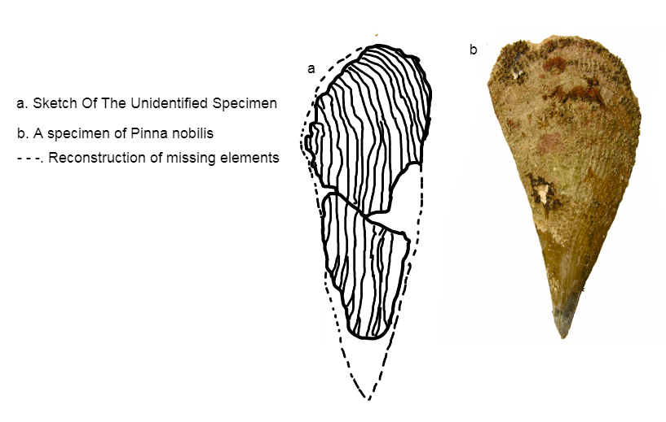
A comparison of mine between an unidentified bivalve fossil I found in Jurassic Limestone and the shell of Pinna nobilis
Our understanding of other fields, such as Geology have also advanced, which gives paleontologists more data on where to search for fossils and what fossils will they most likely find in different rocks. It also helped us form the Geological Timeline, from the very start of the earth to the current state of it.

The Field of Paleontology in Greece
In Greece, Paleontology is a kind of obscure subject in comparison to other countries. This is really unfortunate, since hiding in Greek rocks is a kind of fossilized treasure! In this book we will be referring to the Fossilized Mollusks of Greece, from still extant gastropods like Hexaplex trunculus to long extinct ammonoids like Phylloceras sp. These and many more are remnants of a now long-lost world, which has only them to prove its existence.
In this second edition of my first e-book, we will look at what kinds of fossilized treasures can be found in the county of Thesprotia. Brace yourselves and let’s dive inside the prehistoric biodiversity of the amazing county of Thesprotia!

Specimen Keys
All Specimens from the Jurassic Period (See Below) mentioned in this E-Book are part of the Aggelos Mantos Fossil Collection (AMFC) and are named in the format of AMFC-(specimen number).

Geological Timeline
When talking about fossils and evolution we must mention the geological timeline. Even though there are many Eons in earth’s history, we will only mention the Phanerozoic (which includes the Paleozoic, the Mesozoic and The Cenozoic Eras), as it is the latest and currently the only one to have complex organisms.

The Paleozoic Era
Cambrian Period (538.8 – 485.4 mya)
Ordovician Period (485.4 – 443.8 mya)
Silurian Period (443.8 – 419.2 mya)
Devonian Period (419.2 – 358.9 mya)
Carboniferous Period (358.9 – 298.9 mya)
Permian Period (298.9 – 251.9 mya)

The Mesozoic Era
Triassic Period (251.9 – 201.3 mya)
Jurassic Period (201.3 – 145 mya)
Cretaceous Period (145 – 66 mya)

The Cenozoic Era
Paleogene Period (66 – 23.0 mya)
Neogene Period (23.0 – 2.58 mya)
Quaternary Period (2.58 mya – Now)
*mya= Million Years Ago

Mollusks
Mollusks are the members of a phylum of invertebrates known as Mollusca. These creatures have been around for 570 million years, making it one of the oldest phyla. It is a really successful phylum, with many of its oldest groups (such as the nautiloids) making it to this day. They have dominated every environment and they have claimed many niches all over them. A big part of them has an inner or outer shell.
Mollusk Taxonomy Key
Mollusks are really diverse, with around 130.000 extant species having been discovered. Below is a simple taxonomy key which explains all the classes.
Aplachophora | Worm-Like Marine Mollusks which live mostly in deep waters. They do not possess a shell; however extinct, primitive members had valves.
Monoplachophora | Primitive form of mollusk which possesses a cap-like shell. They inhabit deep waters.
Polyplachophora | Flat Marine Molluscs of various sizes which possess 8 valves.
Gastropoda | Dominant class of Molluscs includes snails and slugs of all environments. Marine, freshwater and terrestrial species.
Scaphopoda | Also referred to as the “Tusk Shells”. Marine Molluscs that possess a long, tooth-like shell. Distributed worldwide. Both sides of their shells are open
Bivalvia | Dominant marine Molluscs. Their body is enclosed between two shells which are connected by two hinged parts. They are abundant in marine and freshwater environments.
Cephalopoda | Most extant species lack a shell, even though few like the nautiloids keep this trait. One of the oldest classes of mollusks. Inhabit mainly marine environments. They have tentacles and developed eyes.

Greece before Us
When talking about what kind of mollusk fossils we can find somewhere we have to consider what did that place look like in the past. For example, if it was a swallow water environment, we could expect there to be small gastropods and bivalves. However, if it was inside an open ocean you could expect things like cephalopods, chitons and gastropods (of a different family than the one you’d find in the swallow waters though). You also need to consider that in places with more sand or mud dead organisms are more likely to fossilize than in places with gravel.
Greece was for a big part of its geological history hidden under the Tethys and other Seas. Because of that, many ammonite (nautiloid-like cephalopods) fossils can be found in Greek Mesozoic Sediments. Many mollusks from the Quaternary can be found in mountains, including fossilized swallow water gastropods and bivalves. These were usually associated with “Noah’s Flood” back in the day.
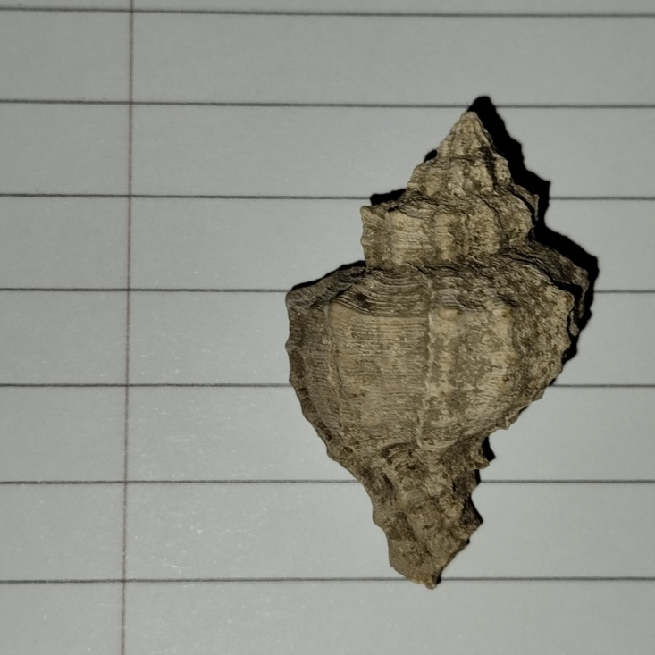
A Hexaplex trunculus specimen found on a mountain
These specimens are usually not older than 1 million years, however they are still important at some extend.

Thesprotia during the Mesozoic
During the Mesozoic era reptiles dominated most if not all environments worldwide: the skies, the marine and freshwater environments, and of course, land. The most dominant of these reptiles were the well-known dinosaurs. These creatures can unfortunately not be found on Greek rocks, and that because Greece, so Thesprotia as well, was fully submerged in a deep, open ocean environment at that time. In this environment, mollusks dominated. Bivalve colonies were all over the place and cephalopods were swimming around. This went on for all of the Mesozoic, until the Cretaceous-Paleogene Extinction (to which we will from now on refer to as “K-Pg”) destroyed entire food chains and driven many groups like the ammonites to extinction.
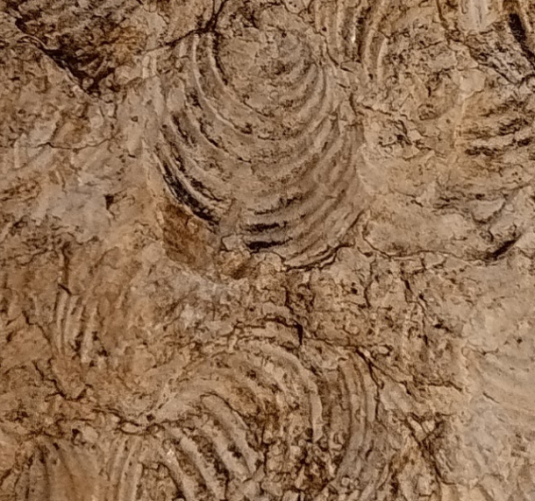
A colony of Bositra Bivalves
A big part of the Ionian Stratiographic Zone contains a kind of Limestone known as Ammonitico Rosso. Ammonitico Rosso is limestone that formed from the pelagic sediments of the ancient Tethys Ocean, which at the time covered countries like Greece and Italy. It usually has a grey or reddish color and it usually has many fossils, like ammonites.
Fact Files
Ammonites
Ammonites are a group of extinct cephalopods that evolved from the Nautiloids during the Devonian Period and went extinct along with the dinosaurs during The Cretaceous. Their most recognizable characteristic is their coiled shells, which came in various shapes and sizes. These shells had chambers inside of them, with the one that’s more outwards (as well as being the biggest one) being the chamber the animal lived in. It moved using an organ called the ‘Siphuncle”, which pumped air through the interior chambers of its body.
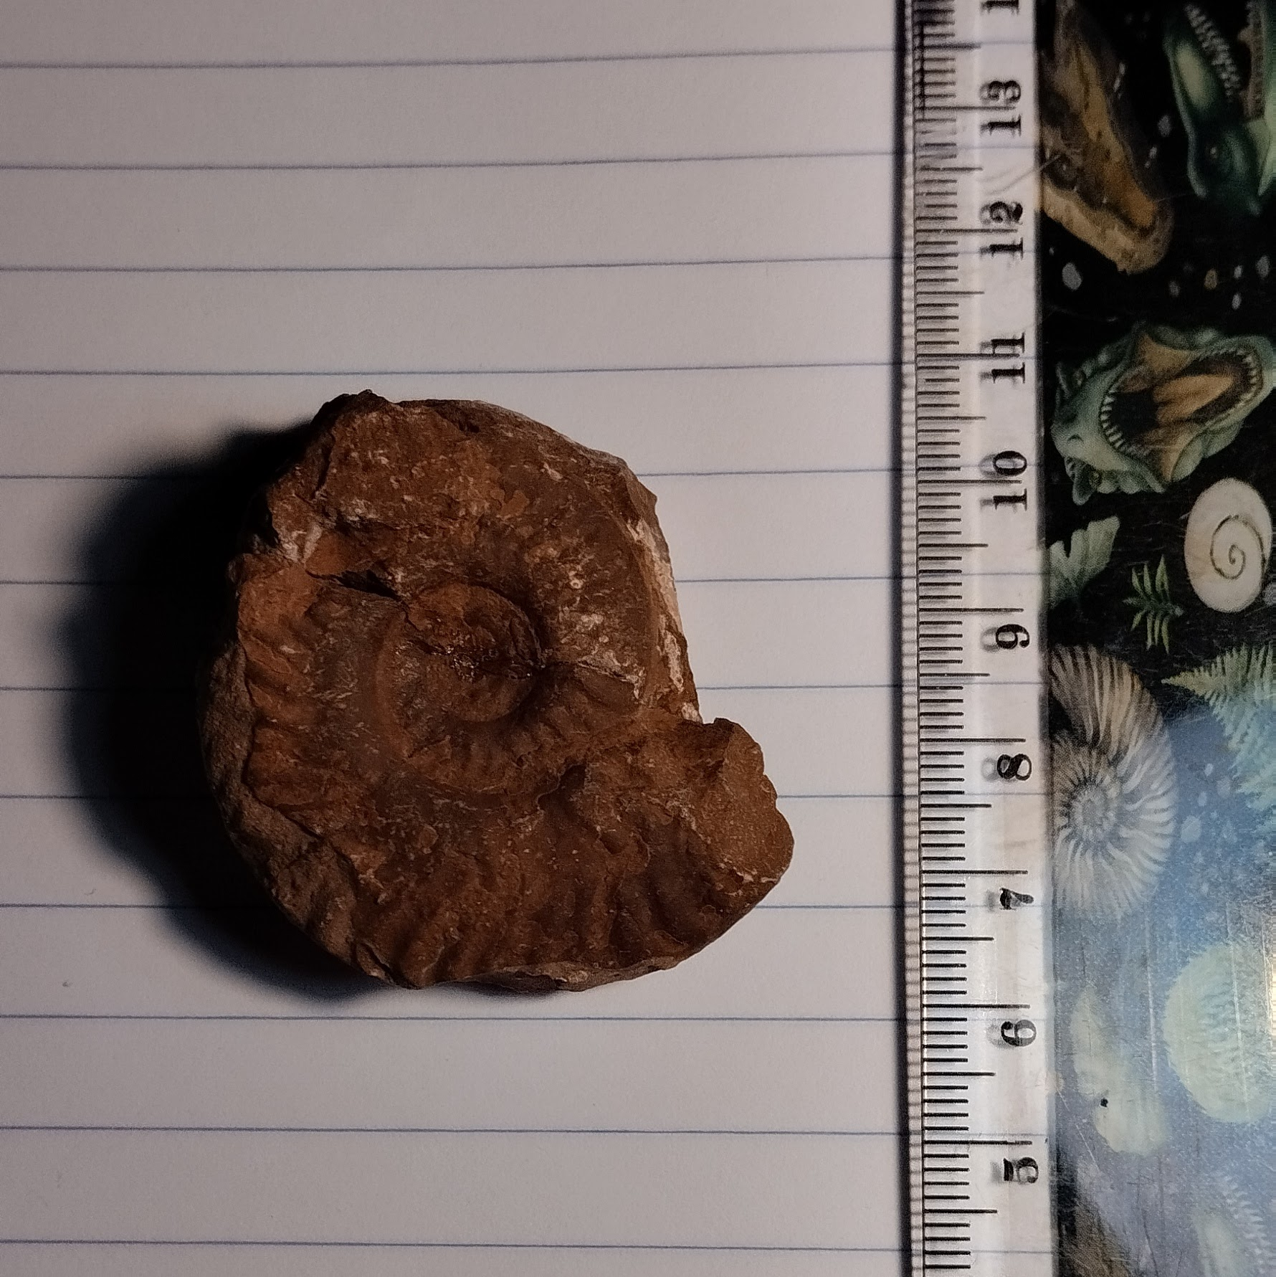
An ammonite shell

The Bivalves
The Bivalves, as I mentioned in the Mollusk Taxonomy Key on Page 6, are one of the most widely spread classes of Mollusk. They first made their appearance in the Fossil Record around 540-520 million years ago and they are still alive to this day. Some species live in colonies while others live on their own.
Their bodies are composed of two shells in which their body is enclosed. The two shells are connected by two hinges in their ends and they are held together by a muscle.

Thesprotia during the Cenozoic
Although most ecosystems globally got damaged severely in result of the K-Pg, life managed to thrive again quickly. At that point the Mollusca had successfully made it through all 5 mass extinctions know to man, and they were somehow still a diverse group which was really important for the food chain.
During the Cenozoic Greece started to emerge from the depths of the Tethys, while at the same time the modern world was forming around it. During the Cenozoic, the Greek Faunas looked like something you’d see in the Savanna: Lions, Proboscids (Elephants and their relatives) and gigantic tortoises dominated the land, while fossils from Crete support that the Gigantic Megalodon shark was present as well.
When all that was happening, mollusks started to look more like what we have today. New groups evolved and older ones went extinct, forming the modern-world mollusk fauna. In areas like the one in which I live, shell fossils can be found all over the mountains. Many different kinds of mollusks lived there, like gastropods such as Hexaplex trunculus or bivalves like Anarthocardia tuberculata. These species are still abundant in the modern-day area, even after 10.000 years time.
Fact Files:
Why are Shells on Mountains?
Shells from ages as late as the Late Quaternary are usually not commonly found in mountains like in the condition that the shells I’ve collected have. So, why does my area have these shells? Well, it is because during the time in which they were alive, the local river and its deltas were forming, messing with the area’s rocks and thus sending shells in the mountains.
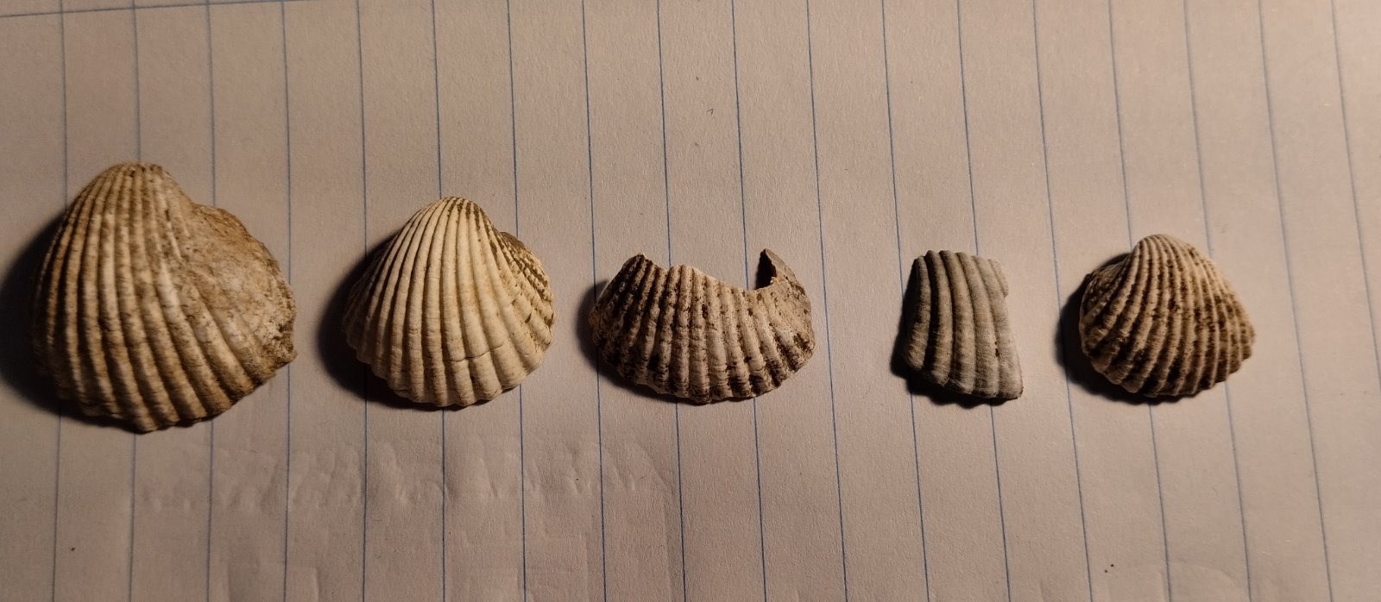

The Cenozoic’s Geological Timeline
Even though we won’t discuss the other Era’s Periods’ Epochs, the Cenozoic’s Epochs are much more heard of and will be much more useful for us to get a general conclusion of the Cenozoic’s Geological Time. Below is a diagram explaining the Epochs of each Cenozoic Period
Cenozoic Era (66 mya – now)
Paleogene | Paleocene (66 – 56 mya)
Paleogene | Eocene (56 – 33.9 mya)
Paleogene | Oligocene (33.9 – 23 mya)
Neogene | Miocene (23 – 5.333 mya)
Neogene | Pliocene (5.333 – 2.58 mya)
Quaternary | Pleistocene (2.58 mya – 11.700 tya)
Quaternary | Holocene (11.700 tya – Present Time)
Tya= thousand years ago / Mya= million years ago

MOLLUSK FOSSILS OF THESPROTIA:
THE JURASSIC PERIOD
One time, in a site located near to my home village, some workers came to dig up rocks for buildings etc. The rocks they found were not the type of rock they wanted to use, so they just abandoned the area. Quickly, people learn what was within the rocks they’ve found and went there to collect what was left. What did the workers and the people find? They found Ammonites, specifically ammonites preserved in Ammonitico Rosso. Many local education facilities, including the Information Center of Kalamas (Kalamas is the name of the local river I was talking about on page 10) which I visited with my school one day. I asked the owner for where are they found, and I went there. In the rocks I not only found Ammonitico Rosso with ammonites but also other kinds of rock with other mollusk fossils. During later expeditions I had with my friends in the area we discovered many colonies of ancient bivalves along with a diversity of ammonite species.
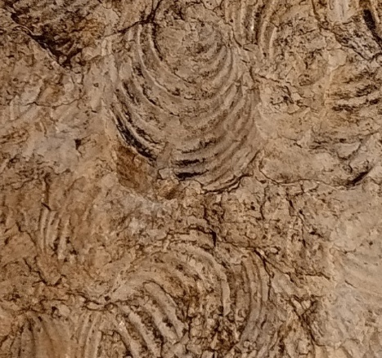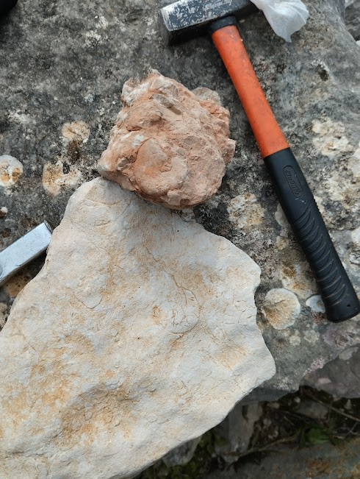
(Left: A bivalve colony. Right: A picture from the Field)
Unfortunately, little of the ammonites have been identified, and there is a chance that some of the unidentified “ammonites” are actually nautiloids. However, most of the bivalves have gotten a sort of accurate general classification, with the bivalves in the colony fossils being identified as Bositra and another specimen (below) being a possible Pinna
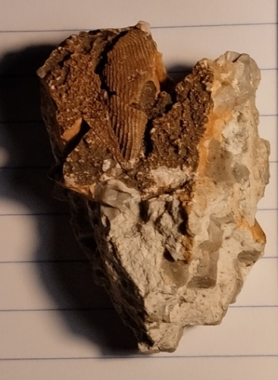
(Left: Top view of the Specimen. Right: Comparison of a sketch of the specimen with a Pinna nobilis shell)

The Cephalopods (Mostly Ammonites)
There are many genera cephalopod fossils you can find in that area, with the most abundant ones being the ammonite Arnioceras. These ammonites are found in many stages of their life, some being juveniles and some grown adults. Many specimens are preserved in a way that their bodies are cut in half, which we will mention later.
The 3 Cephalopod Genera of the Excavation site
1. Phylloceras
The Phylloceras is not a big species and it doesn’t grow over 10 centimeters in diameter. One of their main characteristics is that they have leaf-like structures in their shells, which gave them the “phyllo” (that comes from the Greek word «φύλλο» which means “leaf”). They are common and their fossils can be found all across the globe.

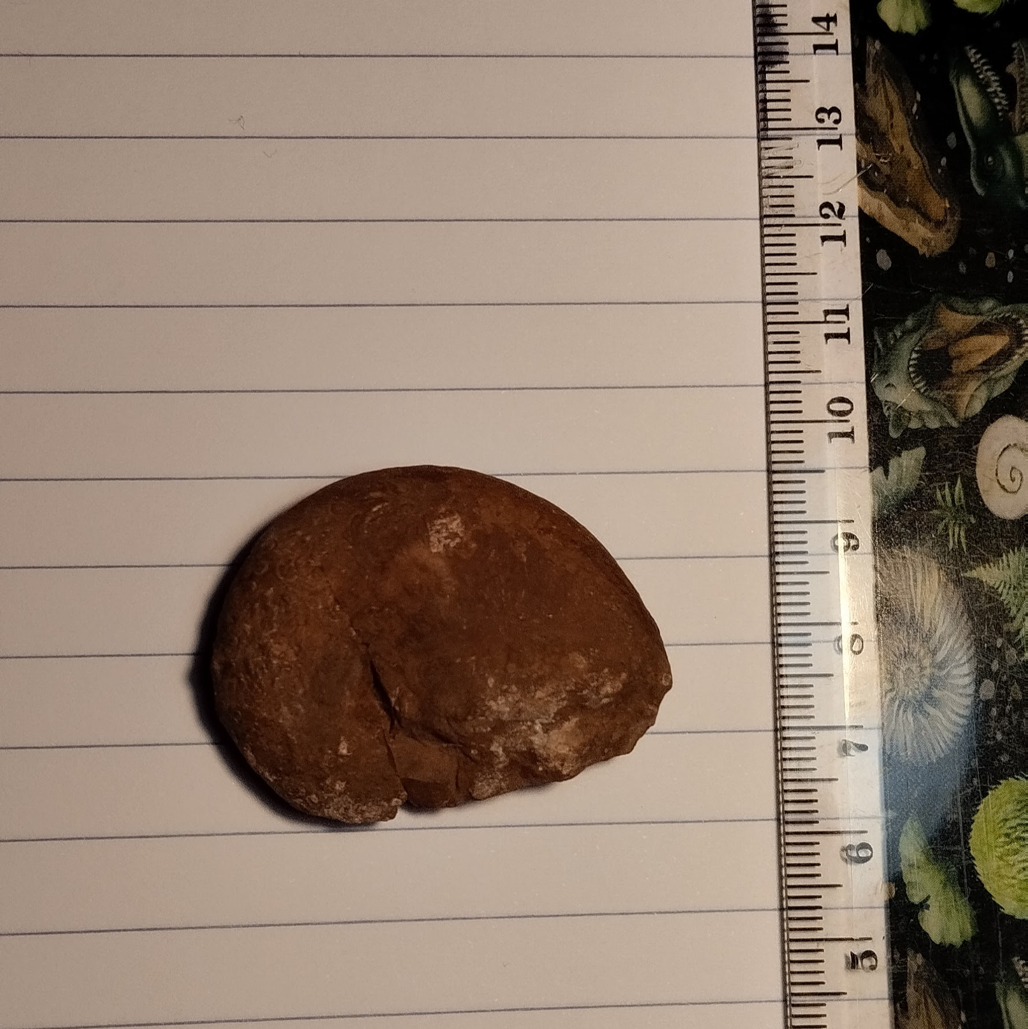
A Phylloceras fossil (AMFC-0005)
2. Arnioceras
The Arnioceras, as I mentioned before, is one the most common fossils in the site. It varies in sizes and ages and its fossils can be found worldwide.
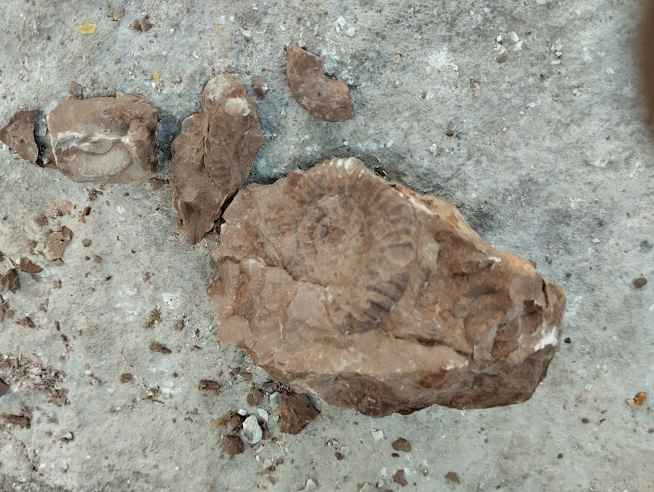
An Arnioceras fossil (Fragment of AMFC-0002)
3. Perisphinctes
Only one fossil is found in the site. The genus averages around 10 centimeters in diameter. Fossils can be found worldwide.
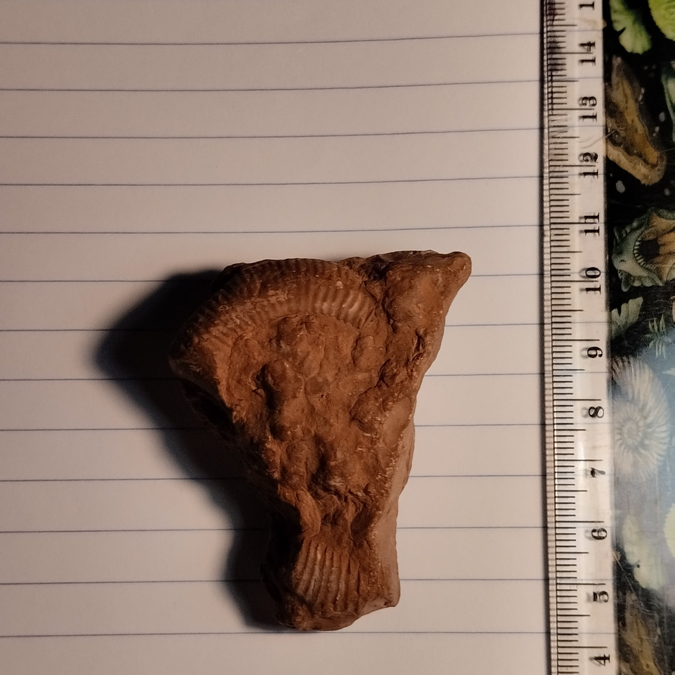
The Only Fossil Of Perisphinctes we have from this Site (AMFC-0007)
There are more cephalopod fossils from the Site; however identifying them is difficult due to their preservation.

The Half Specimens
3 Specimens from the area are found sliced in the middle. Unfortunately, 2 of the three are not preserved in Ammonitico Rosso limestone, however the only one that is seems to be of the same species as the first one to be found.
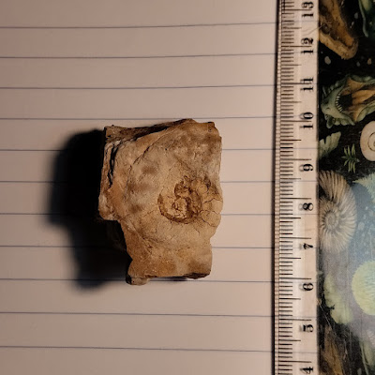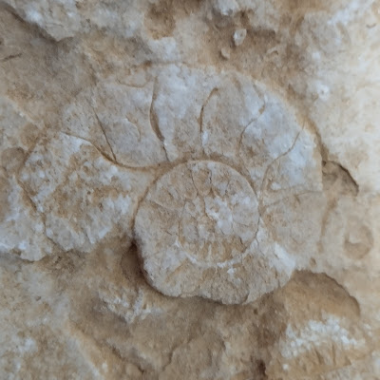
The Two Similar Specimens (Left: AMFC-0009. Right: AMFC-0001)
Similarities between the two could be noticed from the start: They have a similar chamber structure and they don’t differ in size much. I recently opened the specimen on the left and it was indeed revealed to be a Phylloceras. That means that chances are the other specimen is a Phylloceras too.
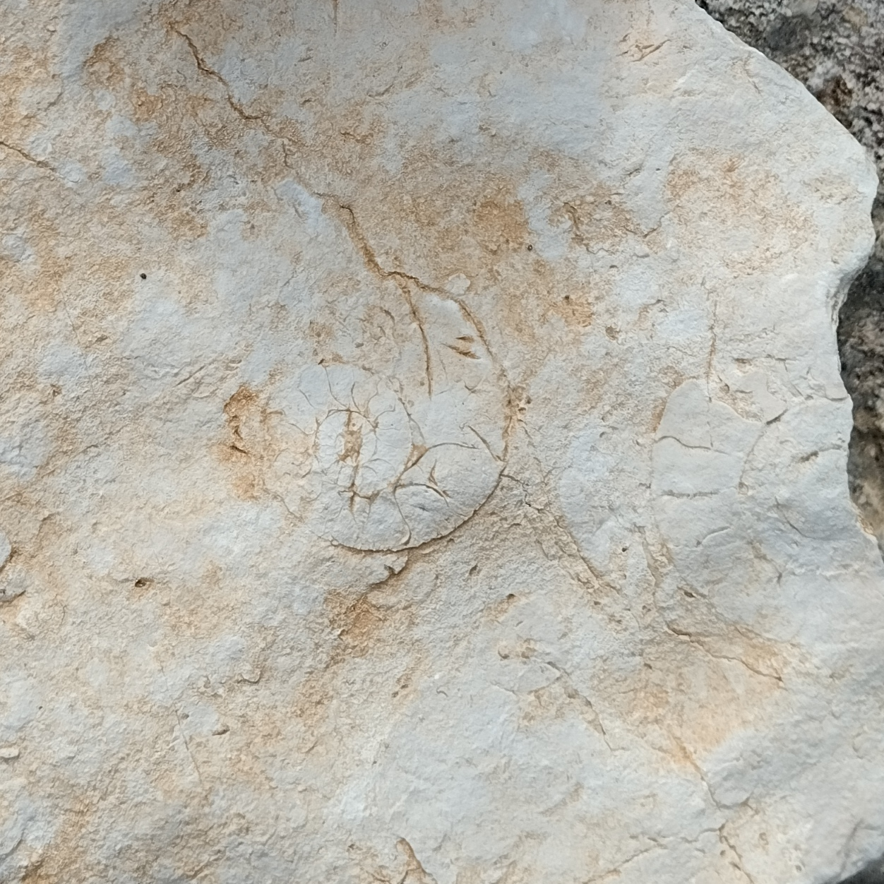
(Above: AMFC-0006)
The 3rd specimen has a different chamber structure, plus it has a bigger counterpart next to it, making it visibly a different Genus from the above. After further research, I’ve concluded it is an Arnioceras. These Guys didn’t seem to get tired of breeding at all!

Learning about ammonites using the half specimens
The title above may be wrong, since a similar anatomy can be seen in most shells of shelled cephalopods when they’re opened or split in half.
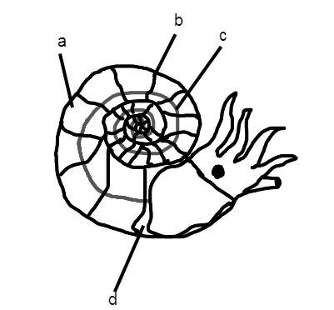
Above you can see a reconstruction of what AMFC-0006 would look like when it was alive. All body chambers except the last and biggest one are filled with either gas or fluid (a), which a long string-like organ called the Siphuncle (c) collects and ejects out of the body to push the ammonite to its desired destination. The last and biggest chamber, also referred to as the “Body Chamber” or “Living Chamber” (d). All the chambers except the living one are called the “phragmocone” (b). Most if not all of these anatomical names can be seen in many other cephalopods, including the Nautiloids and the Belemnites (which will be mentioned below).

The Bivalves
We don’t have many fossils of bivalves from this area, since they are not found in Ammonitico Rosso rocks but rather in another layer of limestone placed above the Ammonitico Rosso. I have Identified 2 Genera of Bivalves from that area, and they are Pinna and Bositra. Pinna is still abundant in the nearby coastlines, while Bositra has gone extinct.
The 2 Identified Genera of Bivalves in the Area
Unfortunately, there are only 3 specimens of Bivalves in total found on the area, and two of them (both of Bositra) have either been gifted to a museum or found by someone else in the first place, so no further studies can be done.
1. Pinna
Only one specimen of Pinna has been found on the area and it is fragmentary. It was found on a limestone rock which was above the Ammonitico Rosso layer. The genus is still abundant in the nearby coastlines.
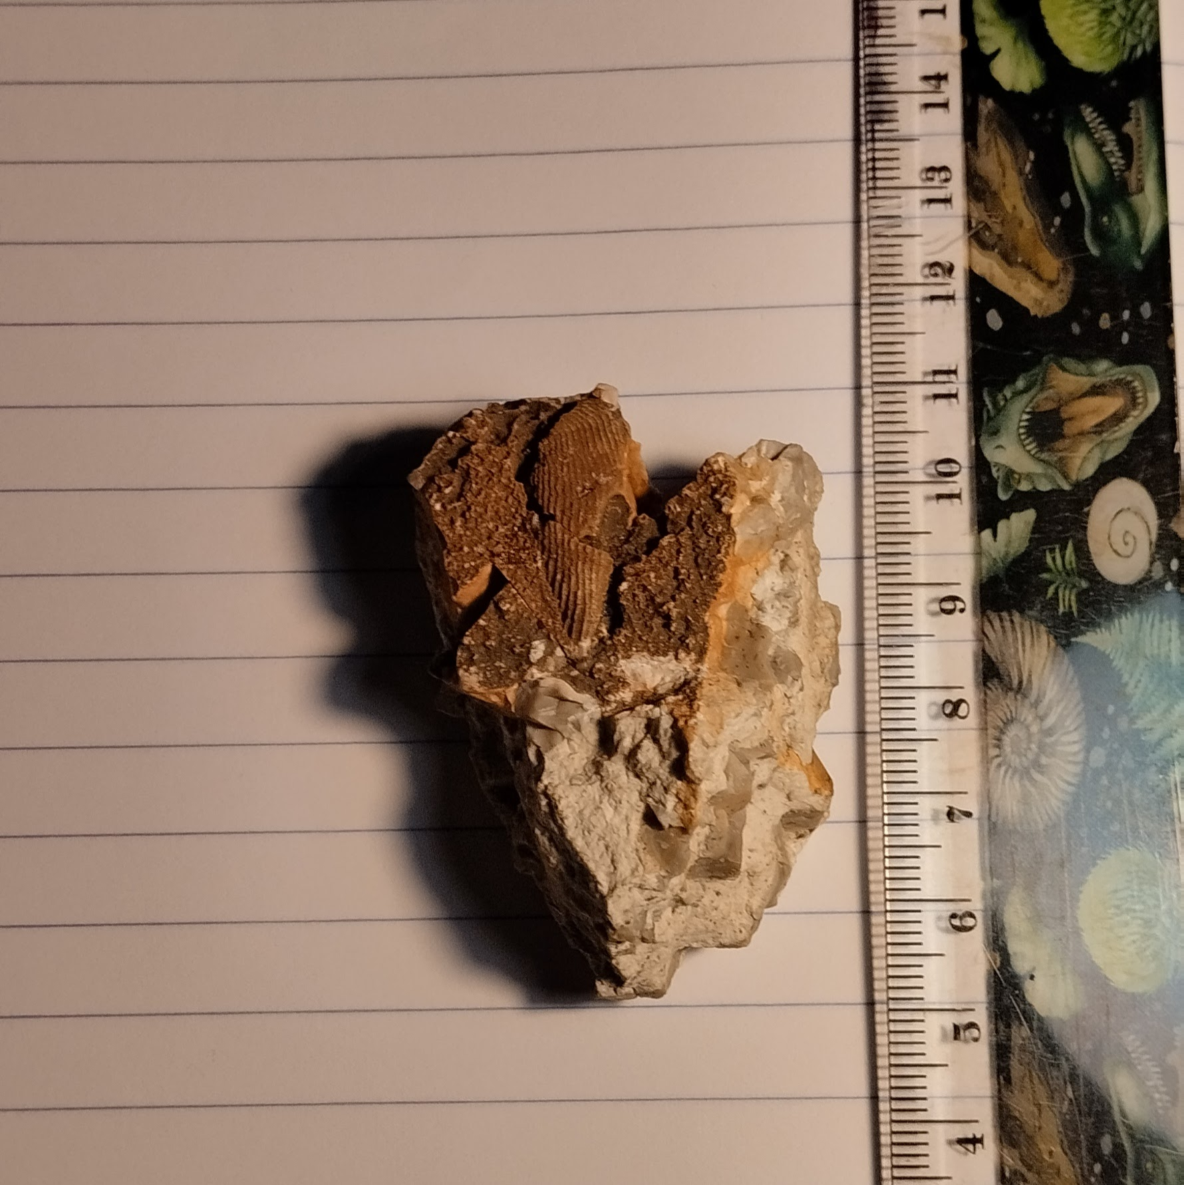
My only fossil of Pinna (AMFC-0004)
Bositra
Bositra is the most abundant bivalve in the site, with one of the fossilized colonies belonging to this Genus having more than 20 creatures in it.

It is found in the same layer of limestone as the Pinna and possibly lived with it.
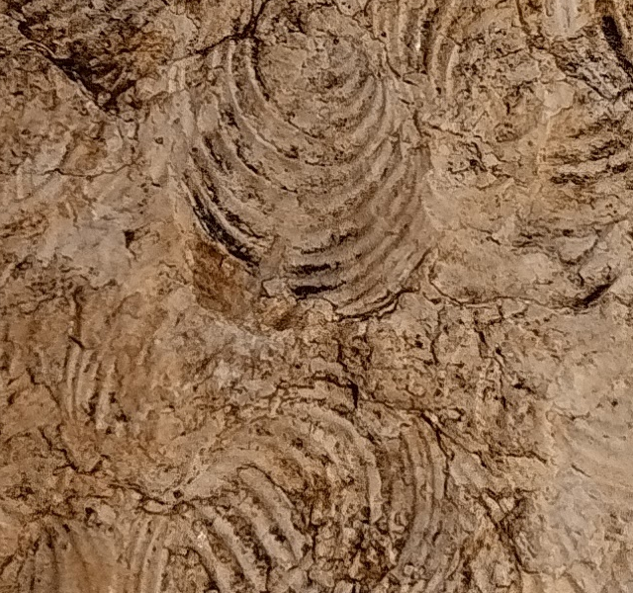
A zoomed-in part of the fossil colony (AMFC-0003)

The Fossil Record of the Jurassic Thesprotia
With this information, we can form a basic board of the mollusk fossil record of the excavation site (and possibly Thesprotia in General)
Jurassic Mollusk Genera Of Thesprotia
Cephalopods | Arnioceras sp. | Specimens:9-10
Cephalopods | Phylloceras sp. | Specimens: 4
Cephalopods | Perisphinctes virguloides* | Specimens:1
Bivalves | Pinna nobilis* | Specimens:1
Bivalves | Bositra radiata* | Specimens:1

Genera/Species labeled with an asterisk (*) are unsurely identified.

MOLLUSK FOSSILS OF THESPROTIA:
THE CRETACEOUS PERIOD
The Cretaceous Period started 145 and ended 66 million years ago. Many important things happened during that time, with the most well-known of them being the extinction of the non-avian dinosaurs (known as K-Pg) and the appearance of flowering plants. Remnants of this era can be found in the North-Western Coasts of Thesprotia, where fossils of deep sea Belemnites can be found. To this day I only have found 2 belemnites and they are both unidentified.
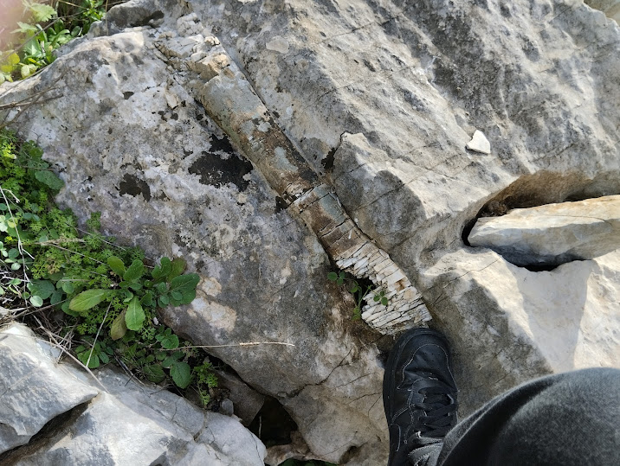
The first and biggest belemnite fossil
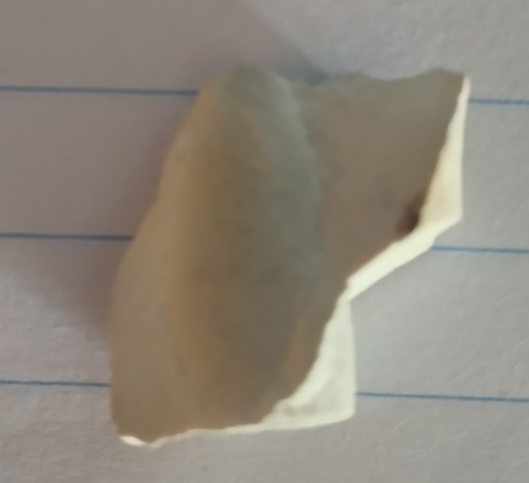
The second and smallest specimen

What Are Belemnites?
Belemnites are a group of now extinct cephalopods that resembled a modern squid. They varied in sizes and some species could reach 1 meter in length.
The Fossilized parts of Belemnites are inner shells that are made out of calcite. Belemnites were an important food source and many of their remains have been found in fossilized stomach containments of various animals.
They appeared 234 million years ago in the Late Triassic and went extinct 66 million years ago in the K-Pg.

Unfortunately, due to the lack of fossil remains of mollusks, along with the incomplete identification which is caused by the incompletion, distortion and fragmentation of the specimens, the available information of the local mollusks at the time is limited.
MOLLUSK FOSSILS OF THESPROTIA:
THE PLEISTOCENE EPOCH (LATE QUATERNARY)
During the Pleistocene the Ice Age was ending and the climates were coming closer to what we had today. The modern human species evolved (Homo sapiens); the continents started taking their modern positions and even more. Greece, now with most of its currently terrestrial areas being where they still are, had only few parts of it under the water. Most of these parts were near riverbeds, were water and sediments pushed many rocks outwards. And that’s how the local area’s river was formed.
The Mountains Of Sagiada, In which many shells have been reported
During that process, many gastropod and bivalve shells which were laying in the shores got sent upwards to the mountains by the geolomorphological changes, and after all this time, they’re still in the places they were left at 10,000 years ago. Locals have reported these shells in all kinds of places in the mountains; most of the time, they find them while digging a little bit for usually farming reasons. These shells are easy to access, since to find them you can dig a whole and look around with your hand.

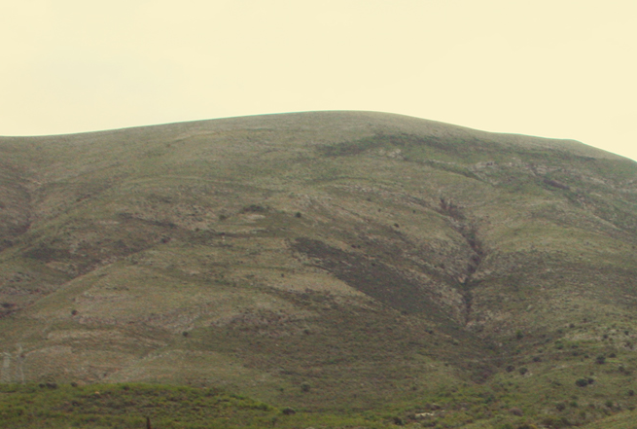

The Mollusks of the Pleistocene’s Thesprotia
Only two species have been identified from the area. However, that does not indicate there are little specimens. These fossils and their modern counterparts are really common.
Bivalves
Anarthocardia tuberculata
This Bivalve’s shells are really common both as fossils found in mountains and as shells found in beaches. They are really beautiful bivalves which can be found all across the globe.

Gastropods
Only one species of Gastropod has been identified in the area and that is Hexaplex trunculus. This gastropod, like the bivalves from before, is also common in the present day. They are have beautiful shells with fine ribs and coiling. They are less common fossils compared to the bivalves, usually found in fragments.

Anarthocardia tuberculata specimens
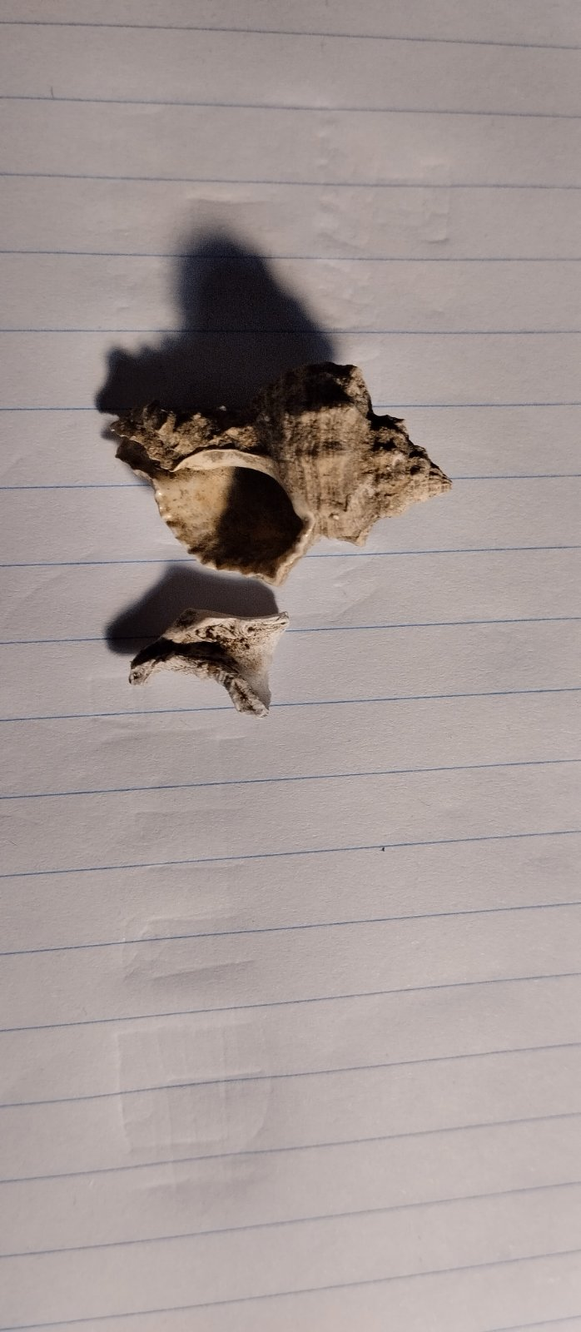
(Left: A complete Hexaplex trunculus. Right: A fragment of a Hexaplex trunculus.)

We haven’t identified many species from the area; however, we will still make a board of all that we know, since it will be useful in future research.
Gastropods | Hexaplex Trunculus | Specimens: 3
Bivalves | Anarthocardia tuberculata | Specimens: 16

Afterword
Our world has changed through the millions of years, with different animals coming and going by. Our only evidence is their fossilized remains and other rocks, since they help us understand how they lived and what their environment looked like. Unfortunately, in most parts of Greece, including the County of Thesprotia, there are indeed many fossil treasures. However, not much research is being done since as I mentioned in the start, paleontology in Greece is underdeveloped. This book’s goal was to introduce the public eye to this science and to signify the fossil beauty of specific areas.
In The Next few pages, there are just some fun facts and stuff. I hope you enjoyed reading this, since it is the first book I wrote! See you in The Greek Fossil Dude’s Blog!
Thesprotia County
Thesprotia is a county located in North-Western Epirus, Greece. It is mostly known for its archaeological sightings, such as the ancient theater of Gitana. The local wildlife is also really interesting, with many species such as birds and fish dominating the local faunas.
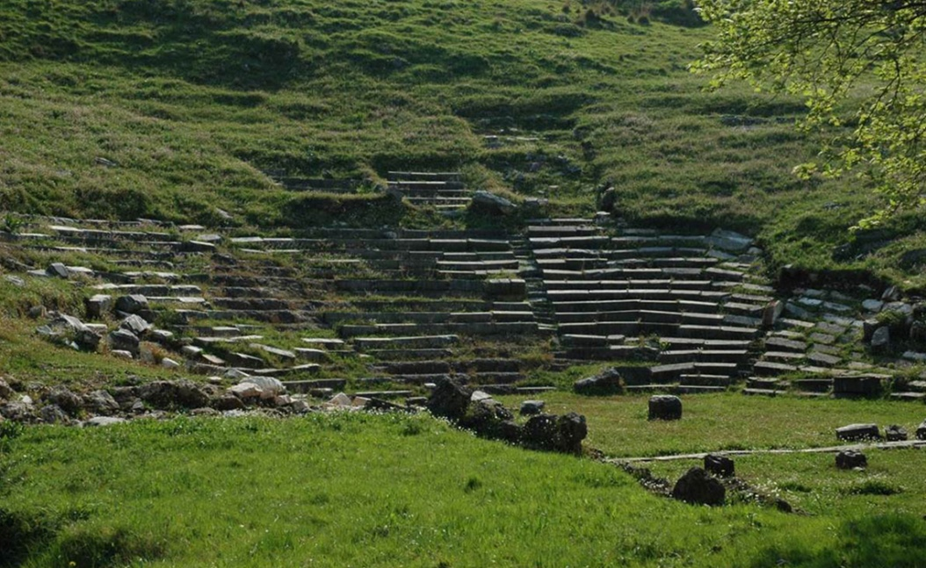
The ancient Theater of Gitana, Located next to the Kalamas River

The Rivers
There are two main rivers in Thesprotia: The Kalamas or Thyamis (which is on the Northern Part of Thesprotia) and the Acheron, which is located in the Southern Part of the County.
The Acheron is according to Greek Mythology the river which led souls to Hades, the God of Death. The river itself has many rocks surrounding it, and it also has a lot of amphibian and reptilian wildlife.

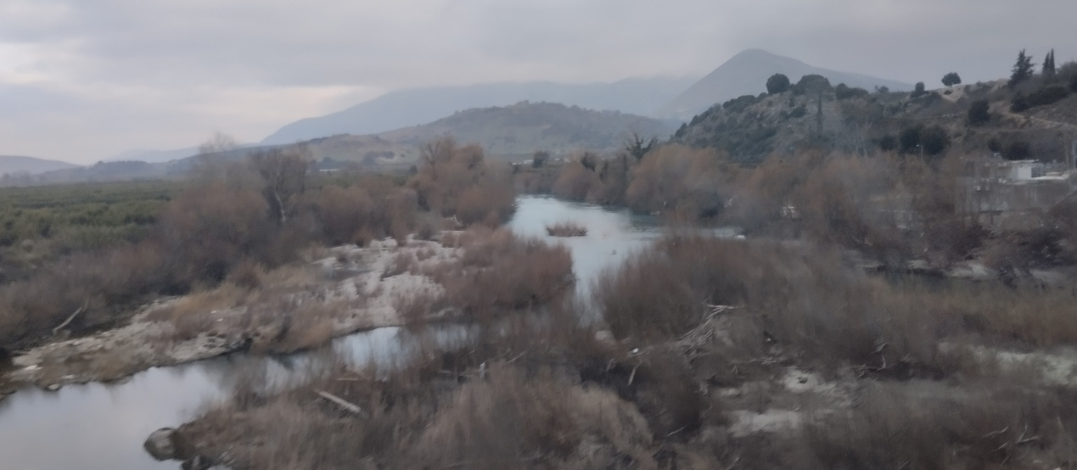
The Kalamas River (above) is full of birdlife. Many groups of birds come to live by its deltas and farmers come and build their tangerine fields around it. It is a really important factor for the local wildlife and people.

Contents
Pages 3-11 * Introduction
Pages 12-18 * Jurassic Fossils
Pages 19-20 * Cretaceous Fossils
Pages 21-22 * Quaternary Fossils
Pages 23-26 * Afterward and Extras
Pages 27-28 * Contents, Bibliography and Sources

Bibliography and Sources
Below is a list of all books and Sources that helped me make this book. They are good reads and I suggest you get a copy of them too!
Books
“Shells from the Greek seas” by the Goulandris Natural History Museum – perfect for studying mollusks, helped me with Identifying fossils from quaternary rocks and was also useful while making the Mollusk Taxonomy Key
~
“Fossils” by DK Handbooks – helped me with geological time and identifying fossils from the Jurassic Rocks.

Sources
https://wikipedia.com – Used for Information on Molluscs and For the Geological Timeline board
https://thegreekfossildudesblog.blogspot.com – Our site, used pictures from it

THANK YOU FOR READING

