

Operating Instructions

Elf Logic Rotating Tree Stand

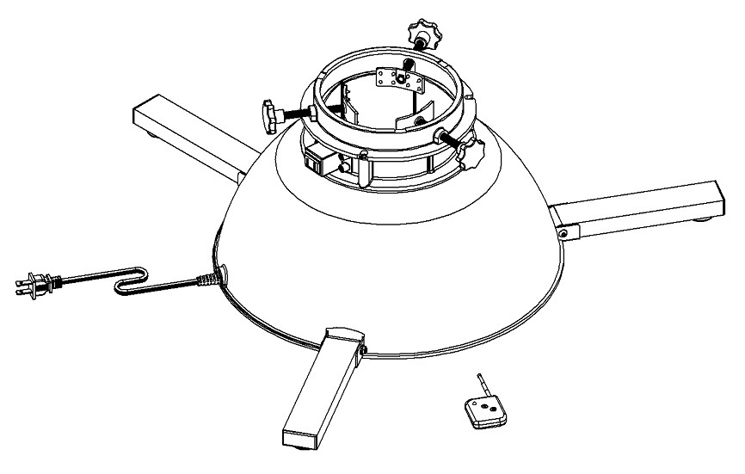

MODEL EL-RTS-R-A/B
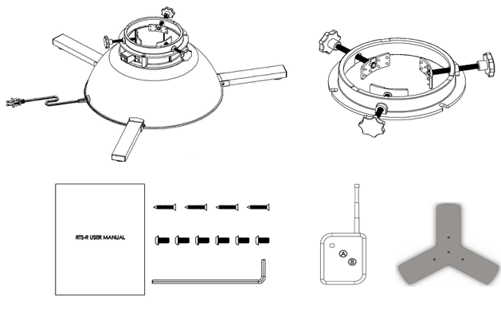
PACKAGE CONTENTS
- One rotating tree stand
- One tree holding ring
- One "Y" plate
- One remote control unit
- One tool pack, which includes:
        - One hex L-wrench
        - Six (6) M6 x 16mm screws
        - Four (4) 25mm wood screws
        - One instruction manual

safety
⚠
Read and follow all instructions that are on the product and
provided with the product.
SAVE THESE INSTRUCTIONS.

- Use the rotating tree stand only with fresh-cut, live trees. Fresh green trees reduce the hazard of fire. The trunk must have a horizontal, flat, fresh, and clean cut in order to absorb water. Always keep sufficient water in the tree stand’s water receptacle.
- Do not attempt to operate the rotating tree stand for extended periods of time. Indoor household use only. Do not use outdoors. Do not attempt to use the product for any other purpose than for which it was designed. Elf Logic is not responsible for any damage due to misuse.
- Do not connect the power plug to any other decorative outfit or seasonal product. Use the stand’s electrical outlet only for lights positioned on the tree.
- To avoid risk of fire, burns, personal injury, and electrical shock, do not assemble or operate the rotating stand within the reach of children. THE STAND IS NOT A TOY!
- Inspect light sets before connecting them to the power outlet on the rotating tree stand. Do not use the tree stand’s rotating feature while applying garland lights or other light strings to the tree. The tree should be perfectly upright and balanced before adding lights or garlands.
- Do not contact moving parts.
- Only use attachments recommended or sold by the manufacturer.
- Do not position the rotating tree stand near window drapes or other items that may interfere with the stand’s rotation.
- Do not alter the construction of the rotating tree stand. Do not use the stand if it shows any structural damage.
- Place the rotating tree stand on a solid, level, even, and secure surface. Do not place it on carpeting, as it may not be secure. If the stand is not placed on a proper surface, the tree could tip over. When positioning the tree in the stand, ensure it is centered and balanced. Uneven or inclined surfaces cause reduced stability and enhance the risk of the tree to fall.
- Do not leave the stand rotating unattended. Always turn off the tree lights when unattended.
- Do not overfill the rotating tree stand’s water receptacle. Check the water receptacle for cracks and breaks each year before assembly in order to prevent possible water leakage. It is recommended to use a heavy plastic sheet underneath the tree stand to prevent possible damage to the flooring beneath it.As water is a conductor, make sure the power cord is a safe distance away from the rotating tree stand’s water tank. To reduce the risk of electrical shock, do not put appliance in water or other liquid. Do not place or store appliance where it can fall or be pulled into a tub or sink.
- Keep the tree and rotating tree stand away from all sources of heat and open flame, such as fireplaces and candles.
- This product has a fuse to protect against circuit overload). If the fuse blows, unplug the product from the outlet and unplug any strings or products that may be attached to the product. Replace the fuse as per the instructions.

TECHNICAL SPECIFICATIONS

Maximum tree height / weight / trunk diameter | 7.5 feet / 100 pounds / 5.5 inches
Maximum combined tree light wattage | 500 watts
Electrical rating | 120V AC/5A
Rotation speed | One rotation every two (2) minutes
Packed product size / weight | 17 inches x 17 inches x 9 inches / 19 pounds

ASSEMBLy
Step 1. Prepare the tree
Before placing the tree in the stand, make a perpendicular cut on the trunk base. Measure 8 inches from the base of the trunk and mark. Remove all branches below the mark.

Step 2. Install the tree holding ring and the “Y” plate
Install Tree Holding Ring. Unscrew the holding screw knobs until screws are in the fully open position. Lie the tree down on the floor and slide the tree holding ring onto the tree trunk. The flat flange side should face the trunk base. Tighten screws.
Install “Y” Plate. On the trunk base, locate the center and mark. Attach the "Y" plate to the trunk base using the included wood screws and a screwdriver. Center of “Y” plate should align with the center mark on the tree trunk. Screws must be completely tightened.
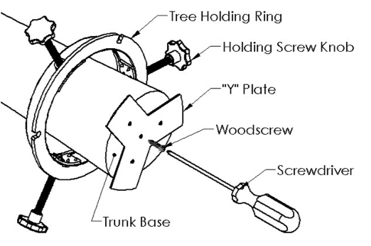

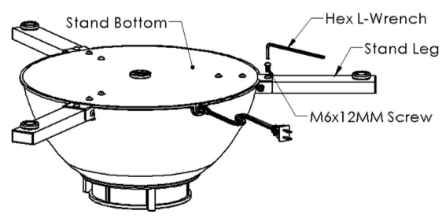
Step 3. Prepare stand legs
Place the stand upside down on a solid flat surface. Level the legs horizontally. Use the enclosed hex L-wrench to install one M6 screw on each leg.

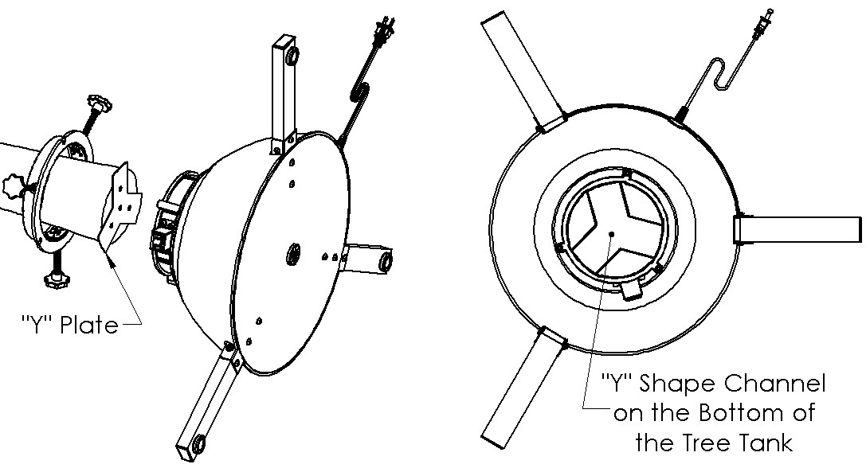
Step 4. Mount the tree in the stand
While the tree is still in a horizontal position, slide the rotating tree stand onto the tree trunk. The "Y" plate must align with the "Y" shape channel at the bottom of the rotating tree stand’s water receptacle.

Step 5. Secure the tree and the tree holding ring in the stand
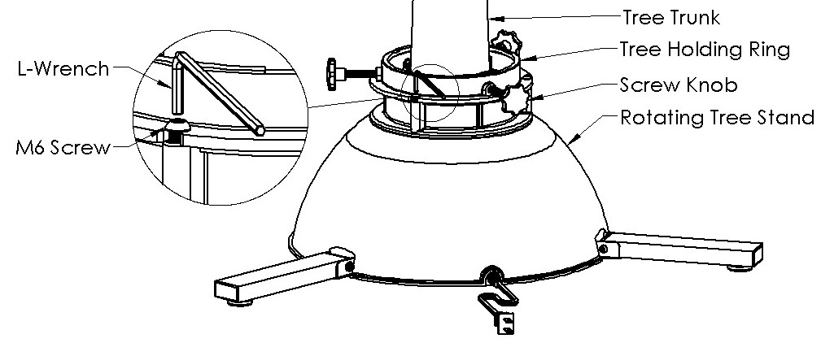
With the tree horizontal, turn the screw knobs to tighten the tree holding ring on tree trunk. Do not overtighten.
Align the three openings on the flange of the tree holding ring with the three insert nuts on the top surface of the water receptacle. Attach the tree holding ring to the Stand using the enclosed M6 screws. Do not overtighten.

Step 6. Secure the tree to the stand
Two people should raise the tree and stand together to an upright position. Once the tree is upright, adjust the tree holding ring knob screws and make sure the tree is centered and balanced. Tighten the holding screw knobs and the tree holding ring (M6) screws to secure the tree firmly to the rotating tree stand.

Operation
- Plugging in the tree stand
CAUTION:
Before plugging in the tree stand, be sure the tree is located away from window drapes or any other item that might get caught in the branches as the tree is rotating.
String the lights on the tree. Plug the lowest light string into the outlet on the top of the stand. Then, plug the main power cord into a standard electrical outlet.
- Using the remote control unit
Press the button marked “M” to start or stop the tree stand rotation.
Press the button marked “L” to turn the light string(s) on or off.
- When Not in Use
Use remote control to stop tree stand rotation and to turn the light string(s) off. Unplug from outlet when not in use and before servicing or cleaning. Do not unplug by pulling on cord. To unplug, grasp the plug, not the cord.
Do not operate any appliance with a damaged cord or plug, or after the appliance malfunctions or is dropped or damaged in any manner. Return appliance to the nearest authorized service facility for examination, repair, or electrical or mechanical adjustment.

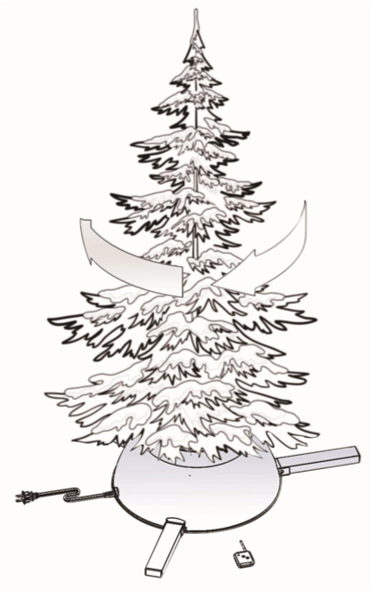

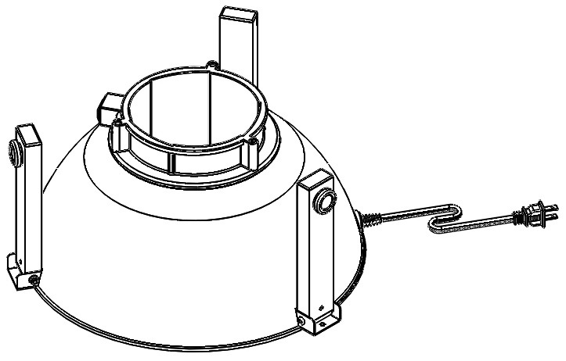
storage

At the season’s end, disconnect the power and remove tree from the stand. Clean the stand. Remove the three (3) M6 screws and fold up the legs. Place the rotating tree stand and all parts into the original packaging for safekeeping.

Troubleshooting
The stand will not rotate  The tree lights will not illuminate | Check the batteries in the remote control unit.  - Unscrew the back of the remote control unit.  - Replace the batteries and screw on the unit back.  Check the fuse in the power plug.  - Disconnect the power plug from the wall.  - Slide the fuse cover on the top of the plug to open it.  - Remove the damaged fuse and replace with a 120VAC/5Amp fuse.  - Close the fuse cover.
The remote control unit is damaged or lost | Order a replacement remote control unit at www.elflogic.com.  - The remote control unit’s serial number may be found on the bottom of the tree stand on the base plate.
A replacement part is needed | Visit www.elflogic.com for information about replacement parts.

For more information or customer service, please visit www.elflogic.com.

