Keto Slim X What's more, it will not be a dreadful idea to stock up on the off chance that they advance out once more. All things considered, taking this for certain months gets you the quality impacts. Thus, fixture any photograph to go to their web webpage and request now! In the event that it's offered out, you'll find a comparably powerful Keto Slim X tablet in its area in your buying accommodation. Go shed pounds now!
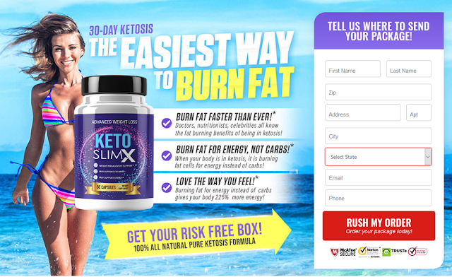
►►Click Here to Order Keto Slim X◄◄
Also, you need to look wonderful when you go out. Thus, it's an ideal opportunity to roll out those improvements a reality. With this recipe, you'll get into fat-consuming mode and begin seeing genuine outcomes, super quick. Since this recipe contains incredible fixings that help push your body to consume fat and just fat. That is the reason you will get the best outcomes here. Snap beneath to get the most reduced Keto Slim X Cost now!
This recipe in a real sense lights your body's common fat-consuming zone. By and large, our bodies like to clutch fat and store it. Yet, during ketosis, your body consumes its own fat stores all things being equal. Furthermore, that is actually what Keto Slim X Pills trigger in your body: ketosis. Ketosis is overly difficult to get into all alone.
►►Click Here to Order Keto Slim X◄◄
It requires eating an extraordinary way and never under any circumstance taking cheat days. Since, in the event that you take a cheat day, you'll get out of ketosis and return to putting away fat. Fortunately, this equation is here to assist you with getting and stay in ketosis so you can consume significant fat easily! Tap any picture to attempt it at the best Keto Slim X Cost available! At last, there's a simple method to get results, so go get yours now!
Keto Slim X Weight Loss Reviews
OK, so the thing are individuals saying about this item? For what reason is this item warming up the market? Also, how can it truly help you? Indeed, the Keto Slim X Pills Reviews give us a few signs. In the first place, we read an from Sandra, who says this recipe assisted her with beginning getting in shape in only weeks! She saw a compliment stomach in days, and furthermore saw more energy, which shows she kicked into ketosis and off consuming fat. Go Sandra!
►►Click Here to Order Keto Slim X◄◄
At that point, we heard from Jesse, who asserts his weight has consistently made him unsure. He's attempted paleo, veganism, Atkins, and more without progress. Presently, Keto Slim X is his mysterious to getting thin and saying that way.
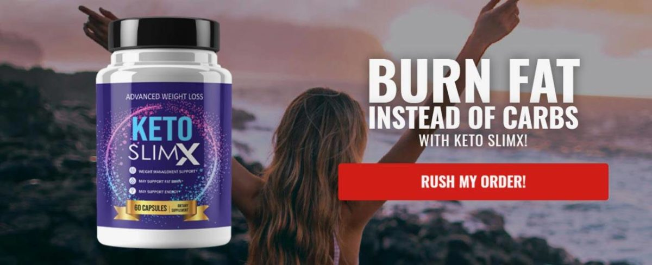
►►Click Here to Order Keto Slim X◄◄
He cherishes that the Keto Slim X Ingredients assisted his with bodying quit putting away fat and begin consuming it with extreme heat all things considered. Also, he began getting results in just a month. Do you need comparative outcomes? At that point, tap any picture on this page to attempt this for yourself! This is the simplest method to watch your life change, so don't hold on to give this a shot.
https://ketoslimxpil.wixsite.com/keto-slim-x
https://sites.google.com/view/keto-slim-x-pil/home
https://sites.google.com/view/keto-slim-x-pils/home
https://fetchbinarydog.com/keto-slim-x/
https://twitter.com/KetoSlim_X
https://twitter.com/KetoSlim_X/status/1381502900371914752

