
Louisville Memorial Auditorium
Holiday Event Rental Package!

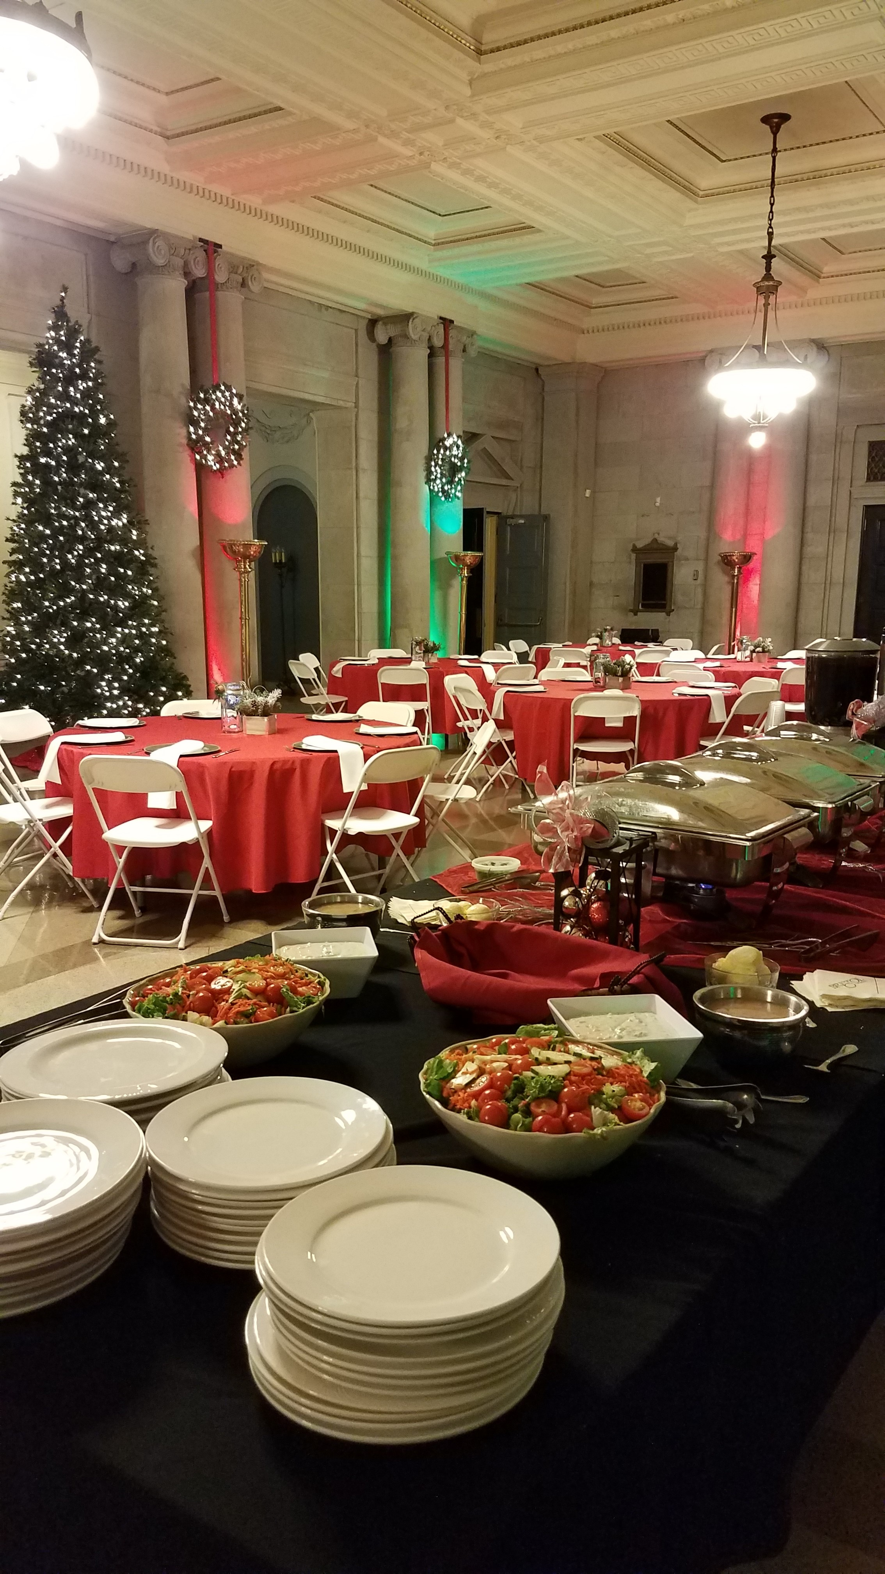
Start a new holiday tradition by hosting your company or group festivities at the historic Louisville Memorial Auditorium in the majestic main lobby, spacious ballroom, or both areas if your function requires additional event space.
Guests will enjoy the landmark’s unique architecture and history as the region’s only war memorial venue. Aside from the affordability, the spaces will be decorated for the holidays and the experienced staff can assist in coordinating your event needs.

For additional entertainment, your guests can also take a nostalgic journey back to the silent movie age when the majestic sounds of pipe organs accompanied silent movie presentations on the big screen. Guests will enter the historic auditorium and experience the world’s largest Pilcher Pipe Organ while viewing a series of vintage shorts, followed by the main holiday feature for a truly memorable afternoon or evening.
Select November & December 2022 dates.
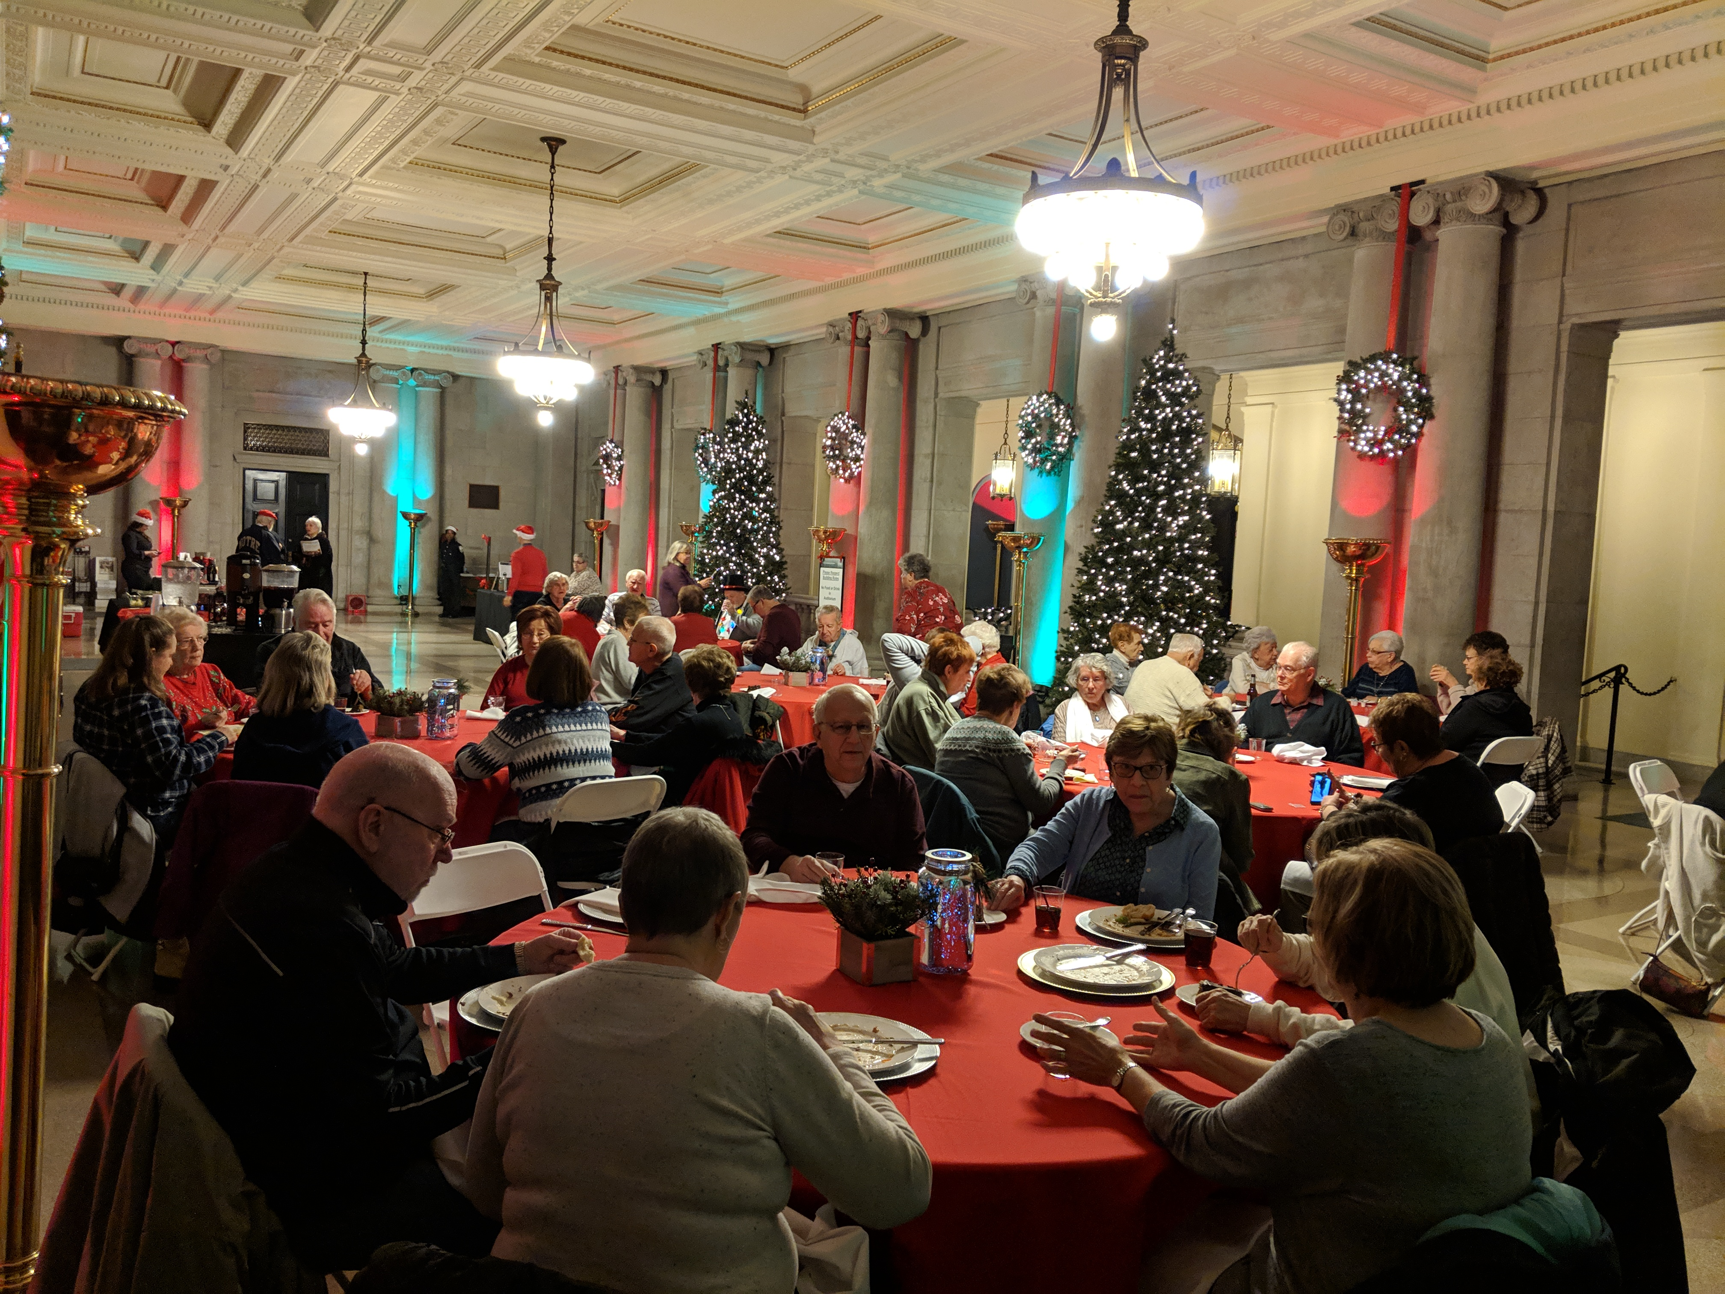
Please contact to learn about our affordable rental packages and schedule your next event:

Kelly Gream, Executive Director
502-584-4911(kelly@lmaky.gov)

 LouisvilleMemorialAuditorium |  @LouMemAud
  louisvillememorialauditorium | WEBSITE: louisvillememorialauditorium.com

Facility Operating Guidelines
Based on COVID-19 Pandemic
Compliance Update

Overview: The historic Louisville Memorial Auditorium is legally required to follow Commonwealth of Kentucky and Center for Disease Control (CDC) COVID-19 Operational Guidelines for approved events held at the multi-purpose facility.

Operational Expectations: All events contracted prior to or after the COVID-19 pandemic are required to follow up-to-date operating guidelines as outlined by Center for Disease Control (CDC), in conjunction with Commonwealth of Kentucky as outlined by Kentucky Health at Work program (https://govstatus.egov.com/kycovid19).

Event/Performance Spaces: As a multi-purpose facility, various event and performance spaces are available for rental while following approved operational guidelines.

Event Types: Currently, the facility can operate as an event venue and theater while following approved guidelines for the two event segments.

Contractual Agreements: Events contracted using rental agreements prior to the COVID-19 pandemic declaration will be honored with the understanding that all events are required to follow Commonwealth of Kentucky and CDC Operating Guidelines. If needed, an additional document recognizing that all events are required to follow such guidelines will be required to sign in agreement of policies. Events contracted after declaration of the COVID-19 pandemic will sign rental agreements with such wording acknowledging guidelines will be followed.

Rental Fees: Events with signed rental agreements and paid deposits, or other monies, will be honored with the understanding that additional fees may be incurred due to COVID-19 guidelines for operation. These charges could include security, cleaning and/or stage management related services, which are based on individual event needs.

Payment: Balances for events are contractually required to be paid in full at a minimum of two weeks prior to event dates. Event plans and schedules will be required two weeks prior, with final payment, so venue management can collect full payment for all services being provided.
Forms of payment accepted include company check, money order or bank draft.

Insurance: All clients and contractors operating in the facility will be required to have a minimum of $1 million limited liability event policy. Proof of insurance for all parties is due when client makes final payment or a minimum of two weeks prior to the event. Clients are encouraged to consult with insurance providers for a thorough understanding of policy coverage.

Security: Off-duty law enforcement officers will be the required security service. Aside from standard responsibilities, officers will handle admission process as well as overall security of facility.

Compliance to Guidelines: The goal for clients, venue management and security representatives is to ensure events follow guidelines. Venue management and security will monitor all individuals attending and working at events to ensure compliance. When situations arise creating unsafe conditions, such as individuals not wearing face coverings or not maintaining social distance, security or off-duty law enforcement officers will advise individuals to correct as needed. If compliance is not adhered to after formal advisement, venue management retains the right to request security to suspend events due to unsafe conditions.

Event Venue Requirements

Admission:

Guest Lists – will be required in advance to document guest counts, along with contact information, if contact tracing is required by health department.
Entrance/Exiting Doors – dedicated doors will be used and marked for guests.
Face Coverings – are required for all individuals.
Security – will manage admission process for all individuals into facility.

Venue Spaces:

Main Lobby – 2,407 square feet (limited to 100 guests).
Foyer – connects auditorium, restrooms & access to ballroom.
Auditorium – 1,742 seats (limited to 1,300 guests).
Stage – 1,000 usable square feet (limit to 50 guests).
South Lobby – 500 square feet with access to outdoor veranda.
Ballroom – 2,880 square feet (limit to 100 guests).
Rehearsal Halls – each space is allowed 50 guests per space.

Food and Beverage Services: Only licensed and insured vendors will be allowed to serve and/or sell products, based on approved COVID-19 preventative guidelines. Proof of operation and plans of operation need to be communicated in advance to venue management at a minimum of two weeks prior to scheduled event.

Alcohol/Wine/Beer Services: Only licensed and insured vendors will be allowed to serve and/or sell products, based on approved COVID-19 preventative guidelines. Proof of operation and plans of operation need to be communicated in advance to venue management at a minimum of two weeks prior to scheduled event.

Other: No guests, event participants, vendors or other contractors will be allowed to bring food, beverages, coolers, containers or other carriers into the facility. Clients can order in items or bring food and drinks into assigned Client Green Room for their consumption. There will be no providing of food or beverages to event participants, guests or contractors allowed inside or outside the facility by non-professional caterers.

Event Guidelines

Attendance Overview: All individuals participating, attending, working or performing at events will follow admission guidelines outlined under event requirements previously explained to ensure all activities are following approved operational guidelines.

Entertainment: Details of entire process including live or recorded performances, set-up, staging, rehearsing, performance overview and tear-down activities will need to be documented. Clients will be required to submit plans, in advance to ensure all activities are following approved operational guidelines.

Event Set-up/Tear-Down: Details of related processes including activities by all contractors working events as caterers, decorators, florists, entertainment, photographers and other rental or service providers need to be documented. Clients will be required to submit plans in advance to ensure all activities are following approved operational guidelines.

Other Event Plans: All plans concerning how various spaces including main lobby, ballroom, auditorium and stage must be coordinated and presented to venue management in advance for proper time to review and approve events are following guidelines.

Stage Guidelines: Under current restrictions, no singing or playing of wind instruments are allowed on stage. Face coverings are optional if social distancing is maintained while on stage, rehearsing or performing. Events such as weddings can have an officiant talk while maintaining social distancing including space from couple getting married and wedding party no matter the space being used.

If space is used as for dining, services will be required to following operational guidelines. Once off stage, all individuals must put face coverings back on while maintaining social distancing. Props and other onstage set pieces need to be documented within event production plans.

Backstage Guidelines: Under current restrictions, all individuals in areas backstage including dressing rooms, rehearsal halls, backstage pass-through and client green room are required to wear face coverings and maintain social distancing while backstage.

Event organizers will be required to schedule and use dressing rooms and rehearsal halls within guidelines.

- Overall Backstage Use – Event organizers are required to plan and refrain from having numerous individuals backstage by planning for off-stage staging of participants.

- Essential Individuals Backstage – Only required individuals are allowed during productions.

- Stage Left & Right Entrances – Staff, performers and other individuals must wear face coverings and maintain social distancing when using these backstage areas.

- Backstage Pass Through – The areas behind back main curtain allow guests to walk from stage left to stage right during rehearsals, performances and productions.

- Dressing Rooms – A total of 12 spaces are available and should only be used by one performer with limited household members in attendance for each space.

- Rehearsal Halls – A total of 50 guests are allowed for each space located below the stage level.

Stage Management: Will be provided by local professional non-union stagehands who are both licensed and insured. Services are charged per hour at contracted rate per hour. Assigned stage management will coordinate both load-in and load-out processes with clients, while security and venue management will supervise individuals to ensure facility guidelines are being followed.

Event Organizer Responsibilities: All assigned representatives of events scheduled will be required to follow facility guidelines, as well as provide appropriate documented plans, in advance to venue management for review and approval. Final versions of plans must be submitted two weeks prior when final payment is presented. Venue will provide stage information with questions to be completed and returned to management as other plans.

Guest Seating: Venue management will provide a seating chart for event organizers to assign allowed guests of 1,300 based on current operating guidelines. Venue management will then review and or assist, as needed, to complete the event seating chart for the auditorium and other areas of the facility being used.

Use of Facility by Guests: Once individuals enter the facility, floating sanitizing stations will be available for use while signage directs them to restrooms and auditorium entrances. Staff and or event representatives will direct guests to assigned seating which will be marked with identifying guest names.

When taking restroom breaks, guests are expected to wear face coverings while maintaining social distancing to the restrooms and returning to the auditorium. Once productions end, guests will be dismissed row by row to ensure social distancing. Upon departing, guests are expected to keep face coverings on and maintain social distancing if returning to the restrooms or departing the facility.
Announcement to Guests: Venue management will provide a concise pre-show script to be read by event organizer or representative which will outline facility guidelines, including procedures for restroom breaks and departing the facility.

Facility Cleaning Procedures: Venue will provide appropriate cleaning personnel to service events, as well as signage, floating sanitizing stations and additional hygiene amenities in all restrooms for all individuals in the facility.

Face Coverings: Clients, guests, vendors, and other individuals working or participating in scheduled events are required to provide his or her individual approved face coverings.

Emergency Situations: Any medical needs will be addressed by calling 911 for proper assistance. Security issues will be handled by off-duty law enforcement officers with venue management advisement as needed. Evacuation of the auditorium or facility for any reason will be coordinated by venue management and off-duty police officers working events.

Facility Inspection: Clients, staff, participants, vendors, contractors and guests all need to understand the facility is subject to inspection by representatives of the Jefferson County Health Department at any given time. As stated, the venue is legally expected to ensure operating guidelines are being followed. Venue management and security or law enforcement officers will collectively determine if compliance for operating is not being followed, which could lead to stopping events if needed.

Parking: Aside from the dedicated auditorium parking area located off Fifth and Kentucky streets, a variety of legal off-street parking around the facility is available for use.

Client Feedback/Questions: All clients are encouraged to communicate with venue management to ensure guidelines are understood, including addressing any questions or concerns in advance relating to scheduled events.

Venue Management Contact Information/Submission of Plans

Kelly J. Gream, Executive Director
Address: 970 South Fourth Street, Louisville KY 40203
Email: (Kelly@lmaky.com)
Phone: 502-584-4911

LMA100271

