Large Arteries of the Thorax
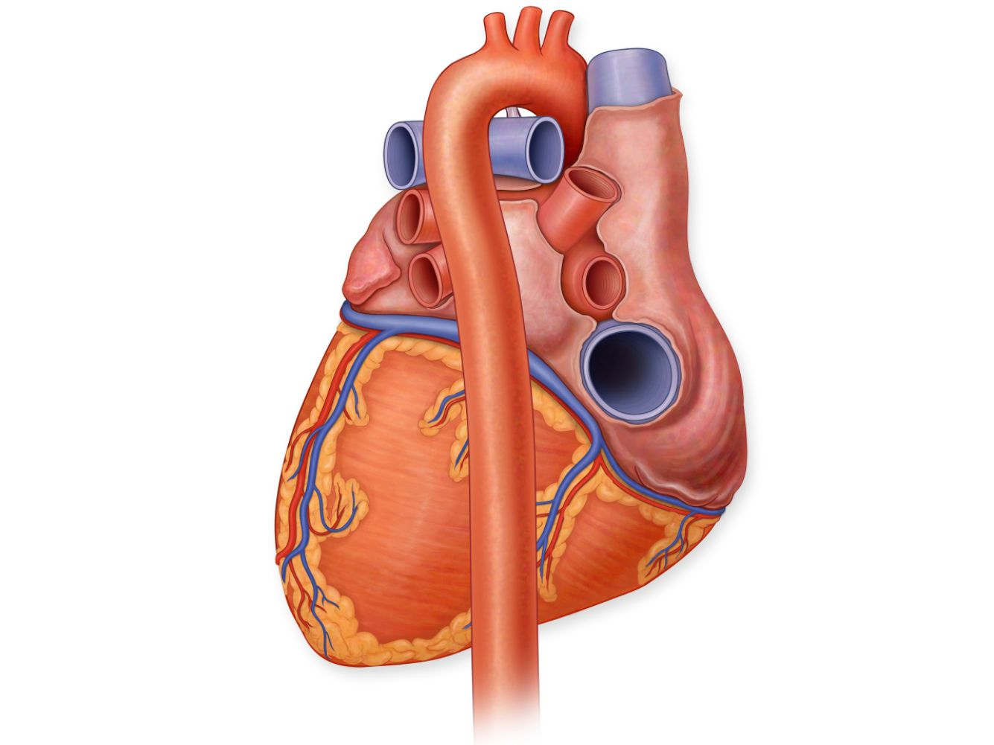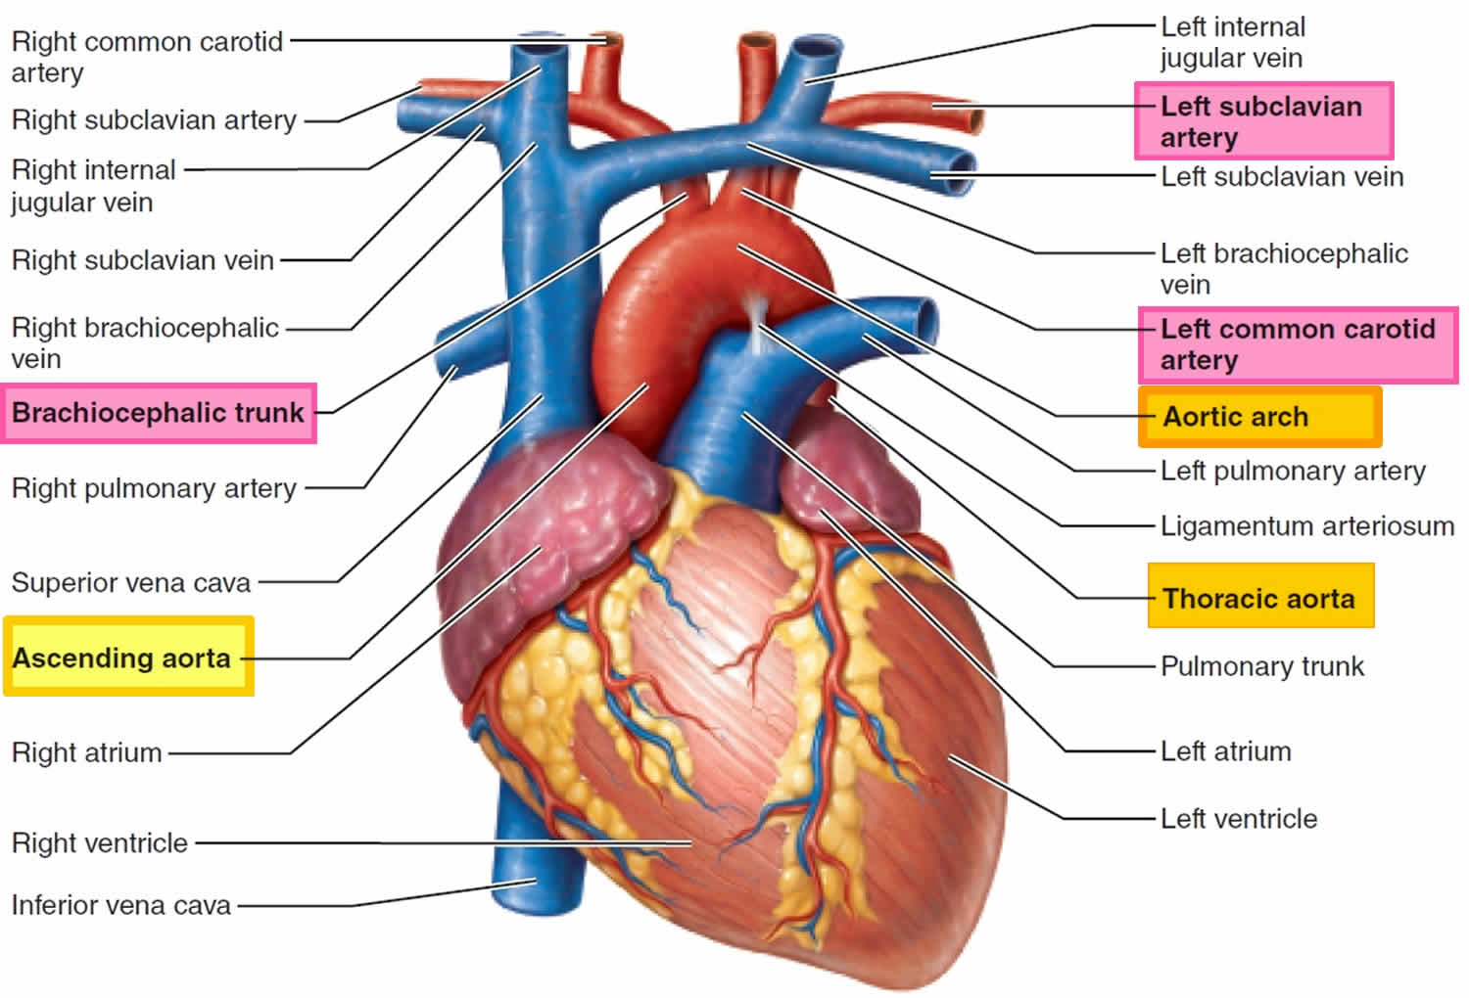
I) Thoracic Aorta
- The aorta is the largest artery in the body.
- It carries oxygenated blood from the heart to the whole body.
- It runs first in the thorax then in the abdomen.
- Its thoracic part is divided into ascending aorta, arch of aorta and descending aorta.
A) Ascending Aorta
- A short wide artery.
- It is 5 cm long with its whole length lies inside the fibrous pericardium.
- It begins at the aortic orifice of the left ventricle behind the left border of the sternum opposite the 3rd left intercostal space.
- It runs obliquely upwards, forwards and to the right to end behind the 2nd right sternocostal junction by becoming arch of aorta.
- Relations:
    - Anteriorly:
- Below: it is overlapped by the infundibulum of the right ventricle, root of the pulmonary trunk and right auricle.
- Above: The pericardium separating it from the right pleura and lung.
    - Posteriorly:
- Below, the transverse sinus of pericardium separates it from the 2 atria (mainly the left).
- Above, the right pulmonary artery separates it from the right principal bronchus.
    - On its right side:
- Below: Right atrium and its auricle .
- Above: S.V.C.
    - On its left side:
- Below: left atrium and its auricle.
- Above: the pulmonary trunk.
- Branches of ascending aorta:
- At its beginning, the ascending aorta has 3 dilatations opposite the cusps of the aortic valve called the aortic sinuses (one anterior and two posterior) which give 2 branches:
- Right coronary artery: arises from the anterior aortic sinus.
- 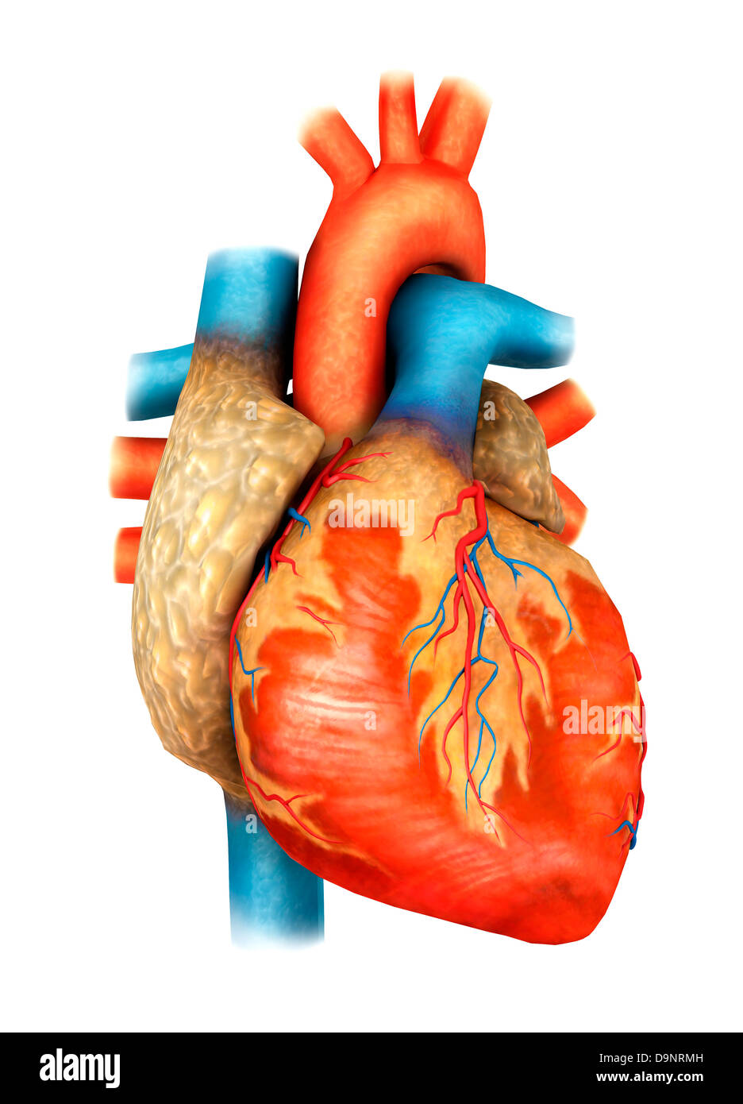Left coronary artery: arises from the left posterior aortic sinus.

Ascending aorta and Pulmonary Trunk

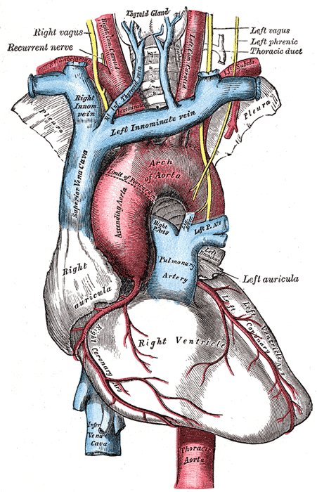

B) Arch of Aorta
- It begins at the 2nd right sternocostal junction as a continuation of ascending aorta.
- It passes first upwards, backwards and to left in front of the trachea & behind the lower ½ of the manubrium sterni, then backwards and downwards on the left side of the trachea.
- It ends on the left side of disc between T4 and T5 vertebrae by becoming the descending thoracic aorta.
- Relations:
- The upper convex aspect is related to:
  - Origins of its 3 large branches:
- Brachiocephalic artery arises behind center of manubrium.
- Left common carotid artery to the left of brachiocephalic artery
- Left subclavian artery behind the left common carotid artery.
  - Left brachiocephalic vein: runs obliquely along upper border of the arch of the aorta in front of the origin of its main branches.
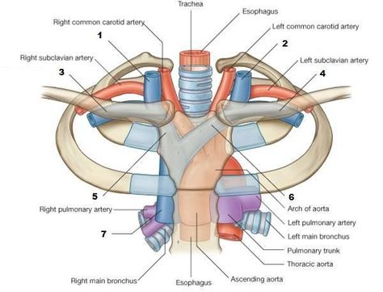

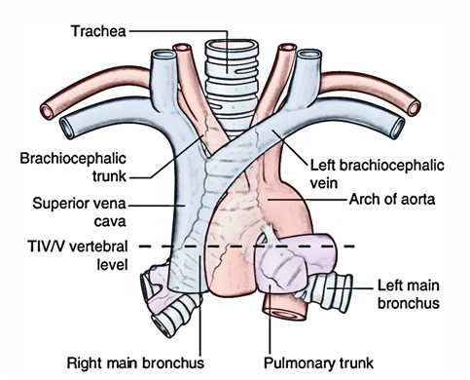

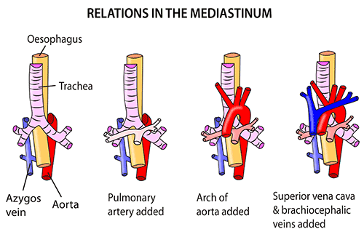

- The lower concave aspect is related to:
  - Bifurcation of pulmonary trunk into right and left pulmonary arteries.
  - Ligamentum arteriosum (fibrosed ductus arteriosus of the fetus) extends between the left pulmonary artery and lower surface of arch of aorta.
  - Superficial cardiac plexus in front of ligamentum arteriosum.
  - Left recurrent laryngeal nerve.
  - Left principal bronchus.
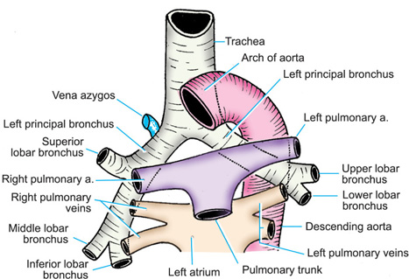

- The left anterior aspect is related to:
  - The mediastinal surfaces of the left pleura and lung.
  - The structures crossing the arch:
- Left phrenic nerve and pericardiacophrenic vessels.
- Left vagus nerve, crossed superficially from posterior to anterior by the left phrenic nerve.
- Superior cervical cardiac branch of left sympathetic chain.
- Inferior cervical cardiac branch of left vagus nerve.
- 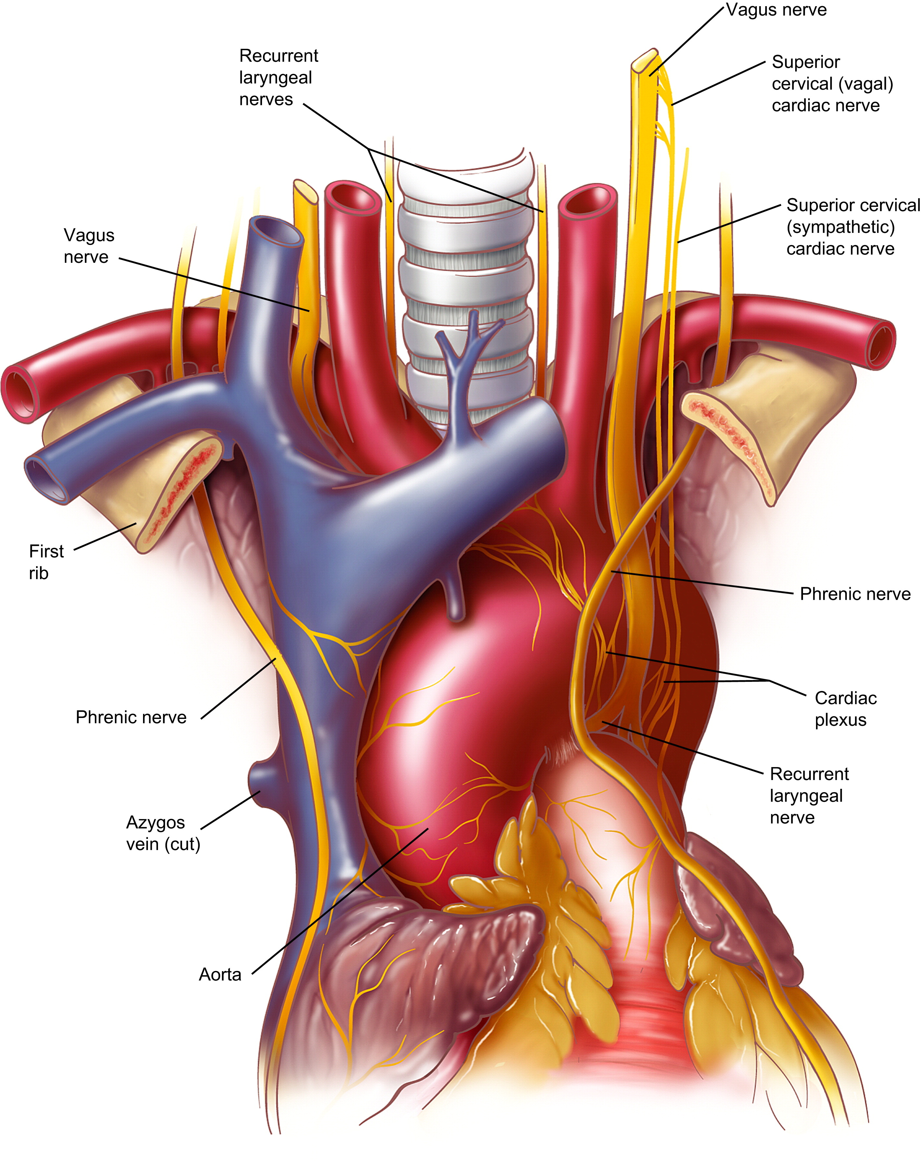Left superior intercostal vein.

Arch of aorta (relations and branches)
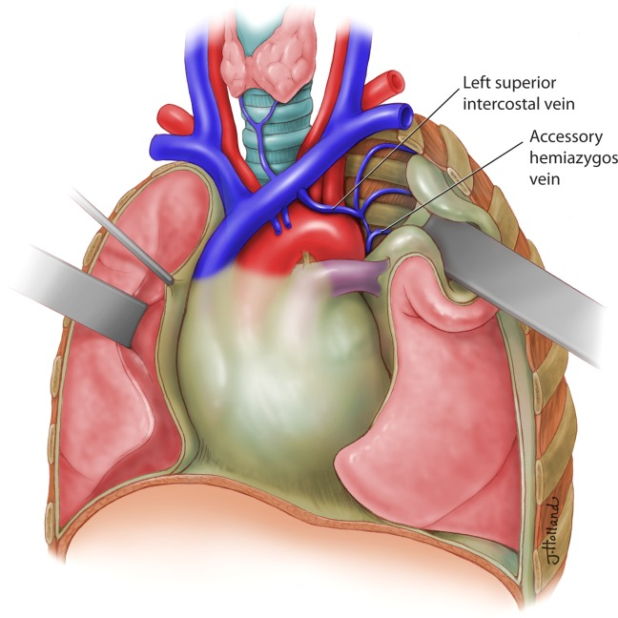

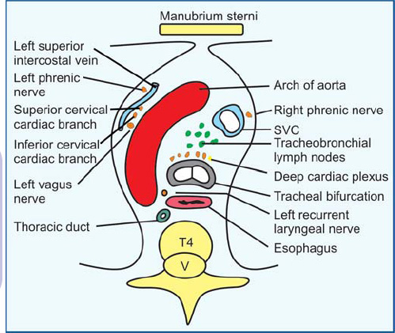

- The right posterior aspect is related to:
  - Trachea .
  - Deep cardiac plexus & tracheobronchial lymph nodes: on the bifurcation of the trachea.
  - Oesophagus: behind the trachea.
  - Left recurrent laryngeal nerve: posterior to ligamentum arteriosum then in the groove between trachea and oesophagus.
  - Thoracic duct: behind left border of the oesophagus.
- Branches: The aortic arch gives off 3 large branches from its upper convex aspect: brachiocephalic, left common carotid and left subclavian arteries.
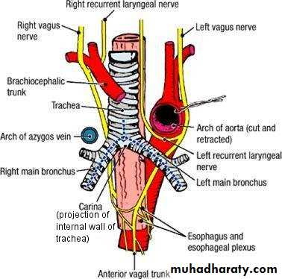

Right posterior relations of the arch of aorta
C)Descending Thoracic Aorta
- The longest part of the aorta in the thorax; it is about 8 inches (20 cm) long.
- It begins on the left side of the disc between T4 and T5 as the continuation of the arch of the aorta.
- It descends obliquely downwards and to the right first on the left side of the bodies of 3 thoracic vertebrae (T5-T7) then in front of the lower 5 thoracic vertebrae (T8-T12).
- 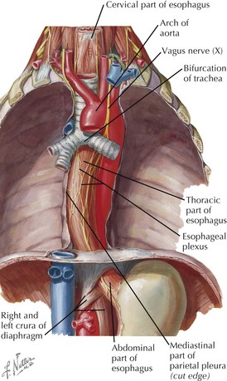It ends in the middle line at the level of lower border of T12, by passing through the aortic opening of the diaphragm to continue as the abdominal aorta.

- Relations:
- Anteriorly: from above downwards, it is related to the followings:
- The left principal bronchus.
- Fibrous pericardium & Oblique sinus of serous pericardium separating it from the left atrium.
- Oesophagus cross from right to left in front of aorta at T₇ vertebra.
- Diaphragm.
- Posteriorly: from above downwards it is related to the followings:
- Lower 5 thoracic vertebrae (T8-T12).
- The superior and inferior hemiazygos veins (cross from left to right behind the aorta at T8 and T9 vertebrae respectively).
- On its right side: from above downwards, it is related to the followings:
- Oesophagus (before crossing in front of aorta at T₇ vertebra).
- Azygos vein on right side of lower part of aorta.
- The thoracic duct between azygos vein and lower part of aorta.
- On its left side: from above downwards, it is related to the followings:
- Its upper part is related to the left pleura and lung
- Its lower end is related to the oesophagus.
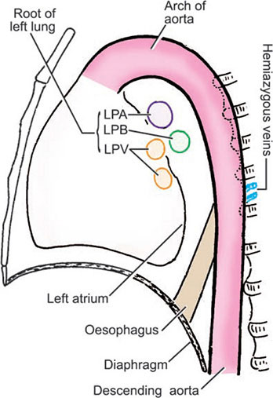

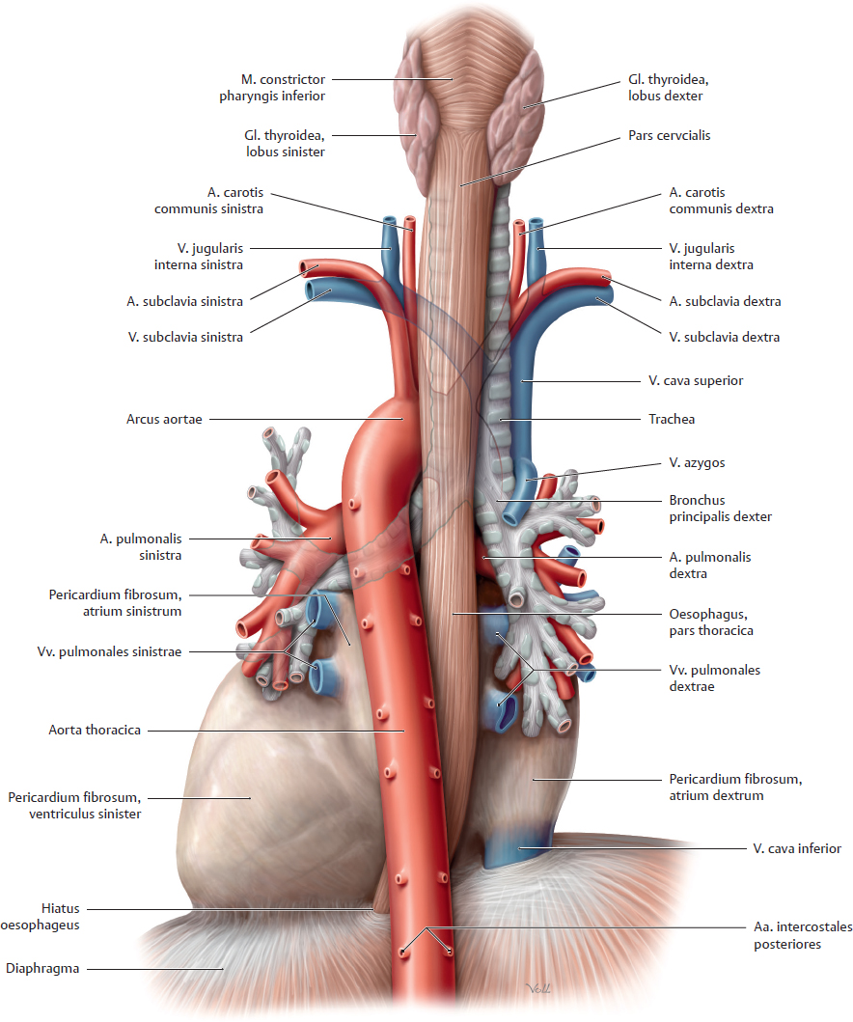

Anterior relations of descending aota

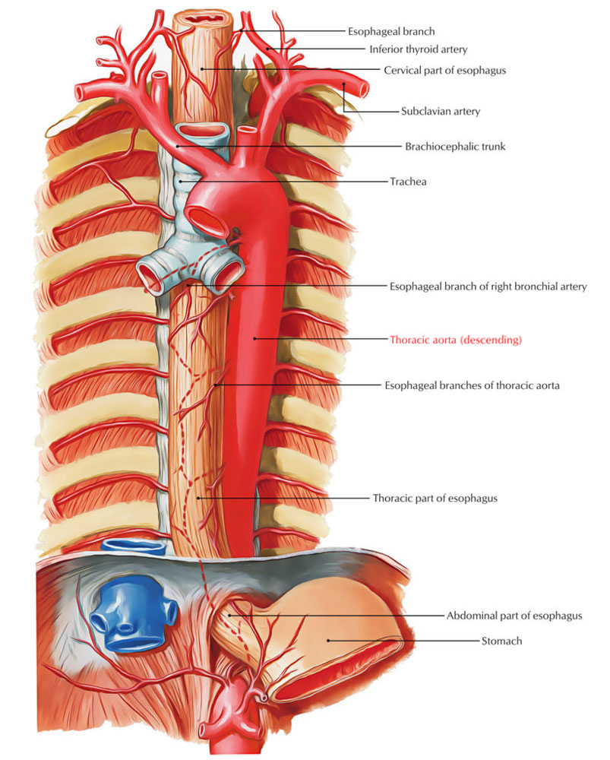

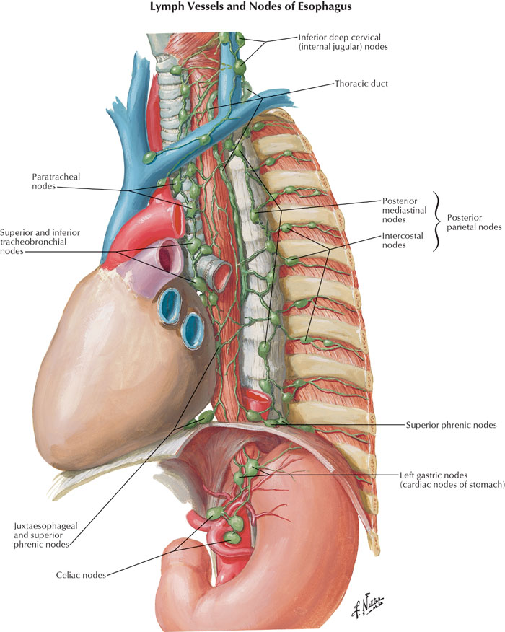

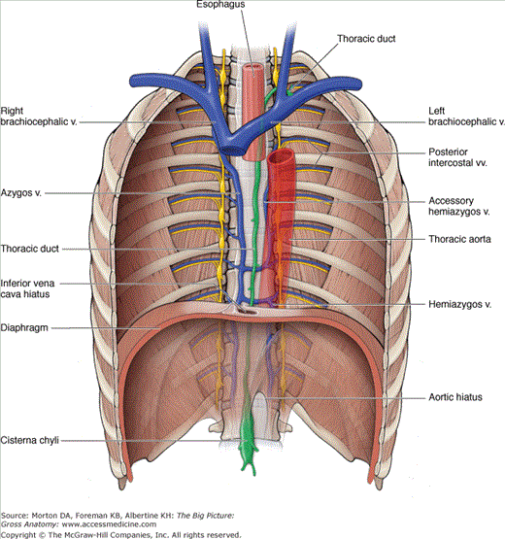

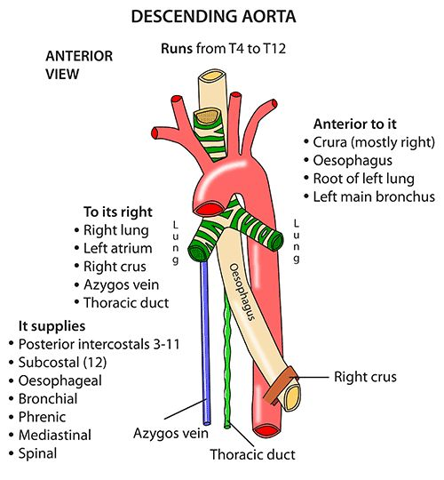

- Branches:
  - Nine pairs of posterior intercostal arteries (from 3rd to 11th).
  - One pair of subcostal arteries.
  - Two left bronchial arteries.
  - Four or five oesophageal branches.
  - Few small twigs to the pericardium, mediastinum and diaphragm.
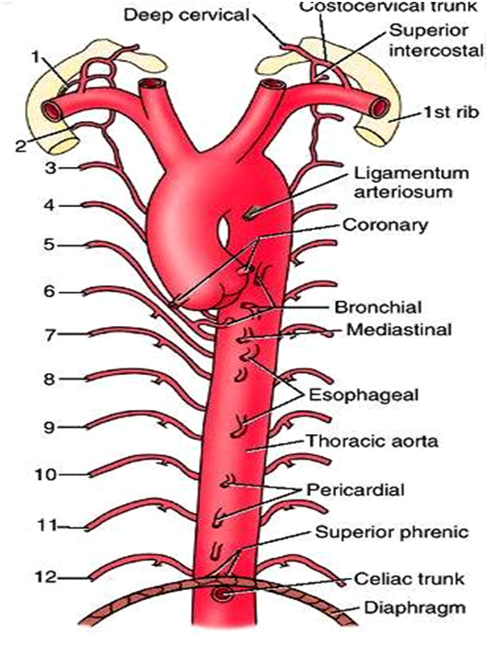

Branches of
Thoracic
Aorta

II) Pulmonary Trunk
- An arterial trunk which conveys deoxygenated blood from the right ventricle to the lungs.
- It is 5 cm long with its whole length of the pulmonary trunk lies within the fibrous pericardium.
- It begins from the pulmonary orifice of the right ventricle, behind the 3rd left sternocostal junction.
- It lies first in front of ascending aorta, enclosed together within a single sheath of the serous pericardium (both vessels develop from the truncus arteriosus of the fetus).
- It is then runs upwards, backwards and to the left, to become on the left side of the ascending aorta.
- It ends below the arch of aorta, at the level of the sternal angle (disc between T4 and T5) by dividing into right and left pulmonary arteries.
- Relations:
- Anterior: left pleura and lung.
- Posterior:
- Below: ascending aorta and origin of left coronary.
- Above: transverse sinus of pericardium separating it from the left atrium.
- On each side: Corresponding coronary artery separating it from the corresponding auricle .
- Branches of the pulmonary trunk:
- These are the right and left pulmonary arteries which enter the hilum of the corresponding lung.
- The two pulmonary arteries run horizontally along the upper border of the upper border of the heart, above the superior pulmonary veins.
- The right pulmonary artery is longer and wider than the left.
- It forms the roof of the transverse sinus of the pericardium.
- It is related anterior to the ascending aorta & S.V.C.
- It is related posterior to the right bronchus and oesophagus.
- The left pulmonary artery:
- It is connected to the lower surface of arch of aorta by ligamentum arteriosum.
- It runs in front of the left principle bronchus and descending aorta.
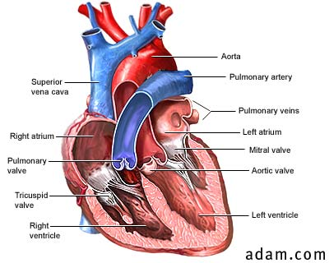

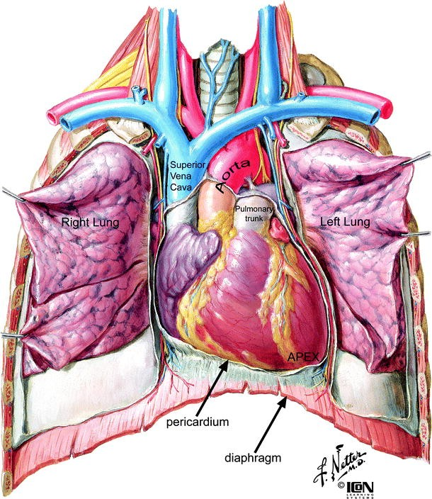
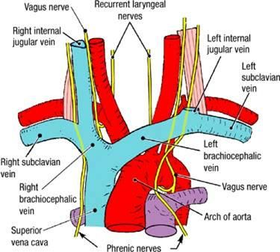

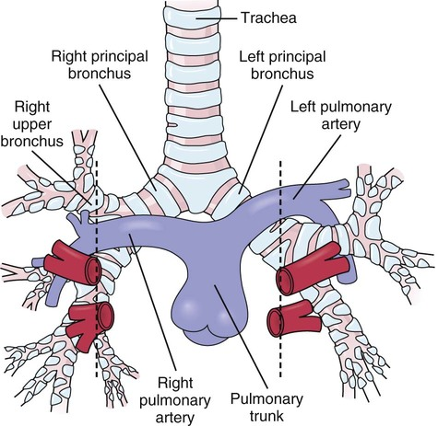

- Applied anatomy:
- Coartication (narrowing) of the aorta:
- Aortic coartication is a congenital anomaly which is classified according to the site of narrowing into:
- Pre-ductal type: (rare) affecting the segment proximal to the ductus arteriosus which remains patent with severe early symptoms.
- Ductal type: affecting the aorta at the site of attachment of ligamentum arteriosus.
- Post-ductal type:(commonest) affecting the segment distal to the ductus arteriosus and origin of subclavian vessels.
- The circulation to the lower limb is maintained via collaterals between branches of the subclavian arteries and those of the descending aorta.
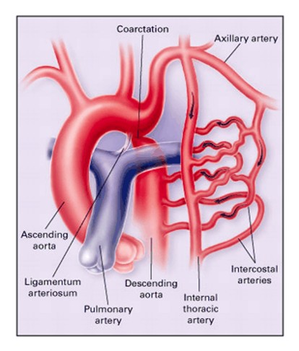
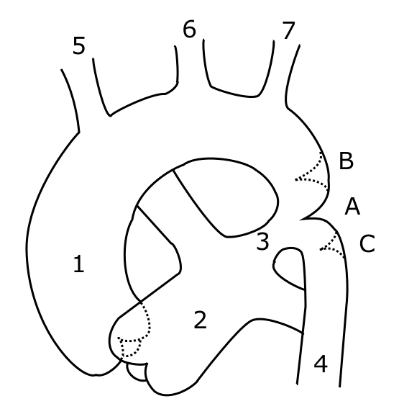

- Thoracic aorta is the commonest site for severe atherosclerosis leading to weakness of the wall of the artery with roughness of its endothelial lining.
- 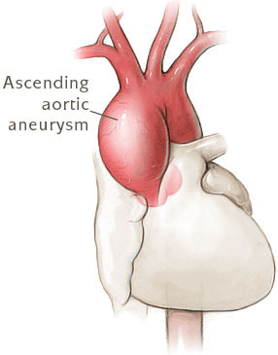Aortic aneurysm: this is a localized dilatation of aorta which may compress the contents of mediastinum causing mediastinal syndrome. Rupture of aortic aneurysm causes severe haemorrhage which is often fatal if surgical intervention is delayed.

3- Embolus is any foreign body circulating in the blood.
- Embolism may be arterial or venous.
- Arterial embolism leads to distal arterial obstruction and acute ischaemia.
- Massive venous embolism leads to pulmonary embolism with obstruction of pulmonary trunk and sudden death.
Large Veins of the Thorax
1) Brachiocephalic Veins
- The 2 brachiocephalic veins (right and left) drain the upper limbs (brachium) as well as the head and neck (cephalic).
- They also drain the anterior wall of the thorax, the upper part of the posterior wall of the thorax as well as lymph from the whole body.
- The 2 veins end behind the lower border of the lower border of the 1st right costal cartilage close to sternum.
- by uniting together to form the S.V.C.
- Right brachiocephalic vein:
- It begins by union of right subclavian vein and right IJV behind the medial end of the right clavicle.
- It descends vertically in the superior mediastinum, to end at the lower border of the 1st right costal cartilage close to sternum.

- Relations:
- Anteriorly: right sternoclavicular joint and 1st right costal cartilage.
- Posteriorly: right phrenic nerve and internal thoracic artery.
- On its right side: separated from the right pleura and lung by the right phrenic nerve and internal thoracic artery.
- On its left side: separated from the brachiocephalic artery by the right vagus nerve.

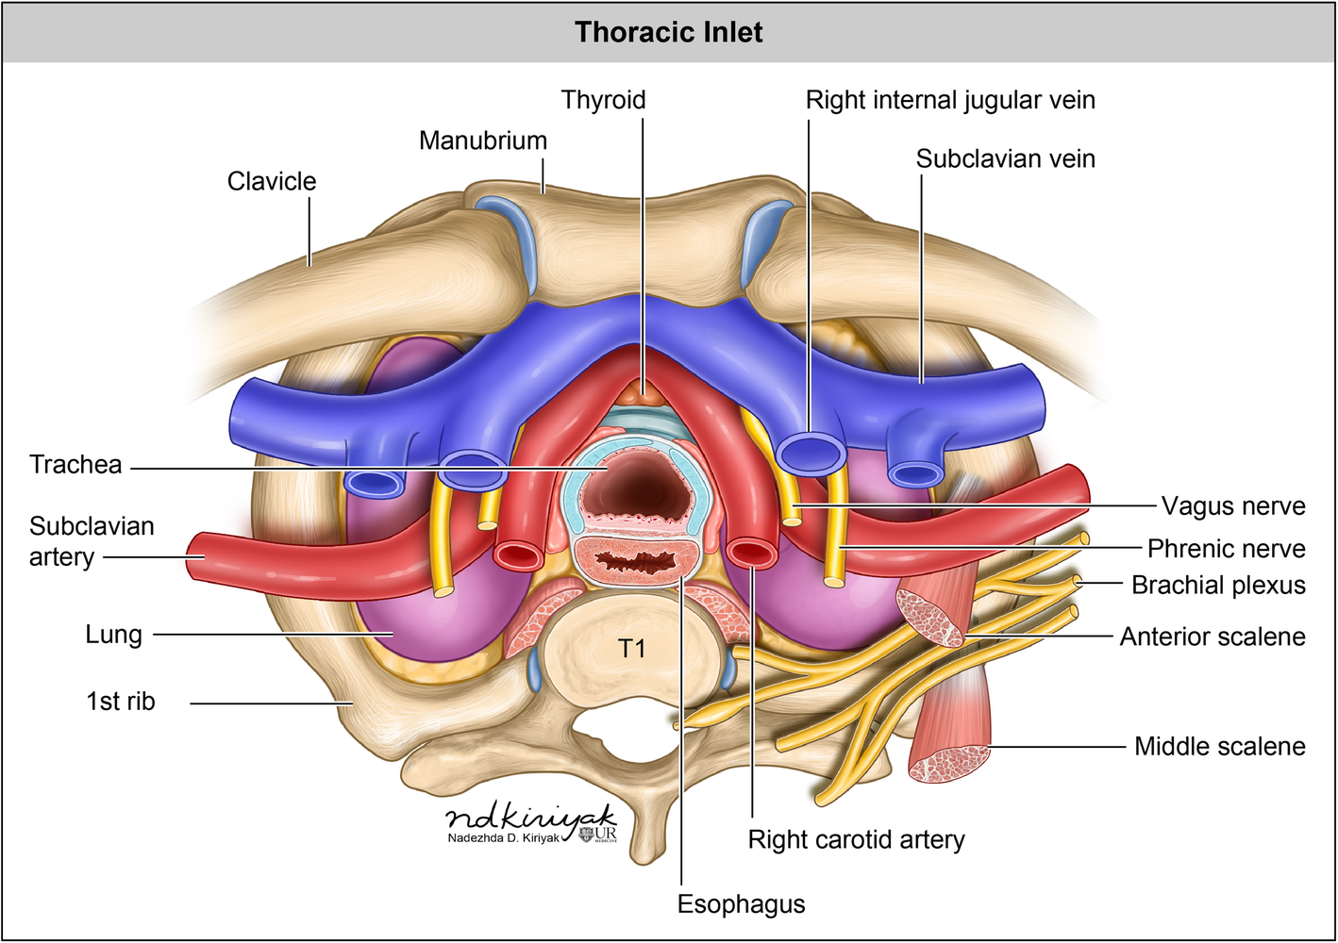

- Tributaries
  - Right inferior thyroid vein and right vertebral vein.
  - Right internal thoracic vein and right 1st posterior intercostal vein.
  - Right lymphatic duct.
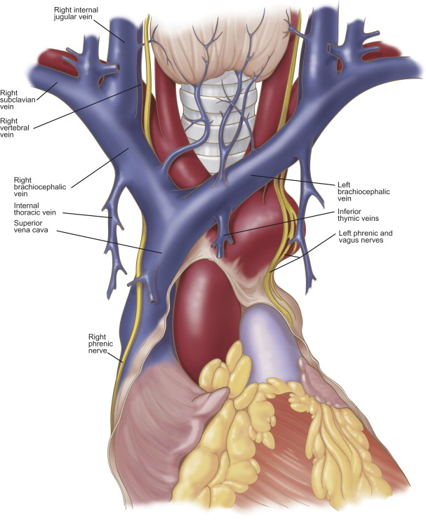

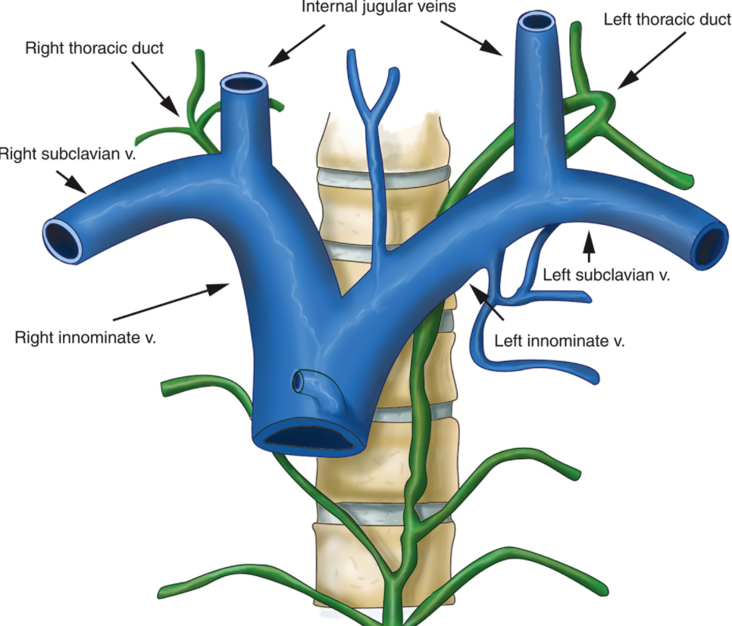

- Left brachiocephalic vein:
- It begins by union of left subclavian vein and left IJV behind the medial end of the left clavicle.
- It descends obliquely downwards and to the right behind the upper ½ of the manubrium sterni, in the superior mediastinum, along the upper aspect of the arch of the aorta, crossing in front of the origins of its 3 large branches.
- It ends behind the lower border of the 1st right costal cartilage, close to the sternum.
- Relations:
- Anteriorly: left sternoclavicular joint and the manubrium sterni.
- Posteriorly:
- At its beginning, it is related to left phrenic and left vagus nerves.
- The origins of the 3 branches of the aortic arch separate it from the trachea.
- Below: the arch of the aorta.
- Tributaries:
  - Left vertebral vein and left inferior thyroid vein.
  - Left internal thoracic vein, left 1st posterior intercostal vein and left superior intercostal vein.
  - Thoracic duct.
2) Superior Vena Cava (S.V.C.)
- A large vein which drains venous blood from upper ½ of the body.
- It measures about 2 inches long.
- Its upper ½ lies in the superior mediastinum while its lower ½, lies inside the fibrous pericardium, in the middle mediastinum.
- It is formed by the union of the 2 brachiocephalic veins behind the lower border of the 1st right costal cartilage close to sternum.
- It descends vertically to pierce the pericardium at the level of the 2nd right costal cartilage.
- 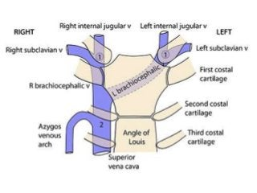It ends by opening into the right atrium behind the 3rd right costal cartilage, close to the sternum.

- Relations:
- Anteriorly: the anterior borders of right leura and lung separate it from internal thoracic artery and the 2nd and 3rd right costal cartilages.
- Posteriorly: it is related to right vagus on the right side of trachea above and root of left lung below.
- On its right side: it is related to right pleura and lung separated from them by right phrenic nerve & right pericardiophrenic vessels.
- On its left side: it is related to beginning of brachiocephalic artery (above the pericardium) and to ascending aorta (inside pericardium).
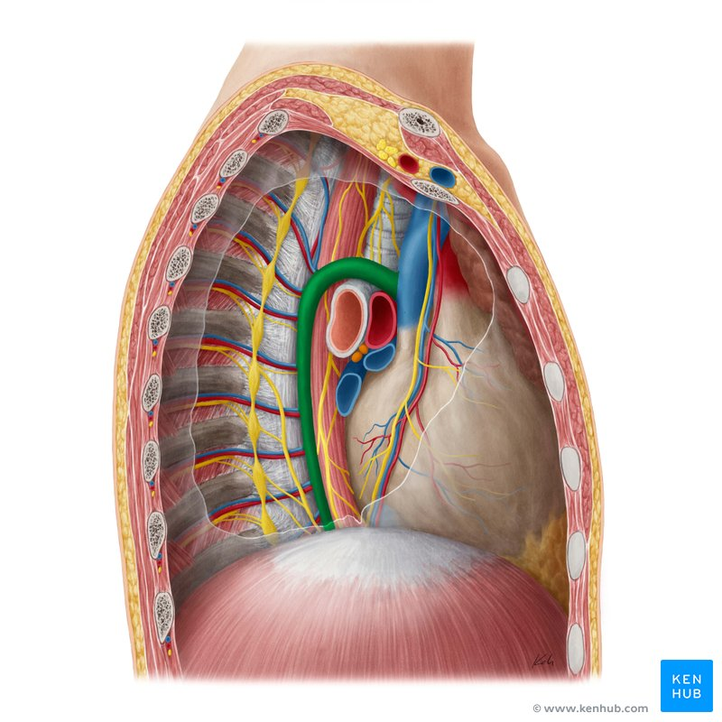

- Tributaries:
The S.V.C. has only one tributary, the azygos vein, which enters it from behind, at the level of the 2nd right costal cartilage just before it pierces the pericardium.
- surface anatomy is represented by a vertical line drawn from the lower border of the 1st right to the 3rd right costal cartilage, close to the right margin of the sternum.

