III. Brain Injuries
I) Concussion:

Pathology: Mild trauma to the head→ slight movement of the brain → generalized neural stretch in CNS → microscopic changes in the neurons without any gross structural damage → temporary loss of function followed by complete recovery .

Clinical picture:
l. The patient suddenly falls unconscious.
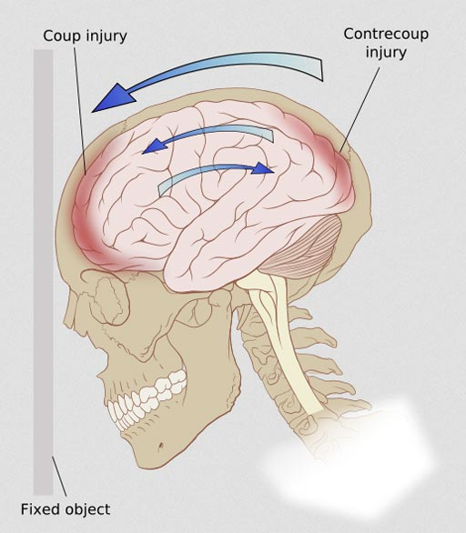
2. Eye: Closed
3. PUpils: Dilated.
4. Pulse: Rapid and weak.
5. B.P.: Low.
6. Temperature: Subnormal
7. Respiration: Slow and shallow.
8. Muscles: Relaxed.
9. Reflexes: Lost
10. Sphincters: Incontinent.
  - Uncomplicated cases usually recovers completely within
minutes & rarely hours.
  - Post-concussion syndrome: (P.C.) after recovery, the patient is still suffer from headache and amnesia.


P.C.

- Treatment: Hospitalization & observation for at least 24 hours to detect early manifestations of complications.
II) Cerebral contusion:
- Pathology : There are areas of bruising and swellings with intact pia & arachnoid matter → localized or generalized oedema and haemorrhage due to tear of minute blood vessels .
- Clinical picture :
- State of prolonged unconsciousness with evidences of focal brain damage which appear from the start of injury.
- On recovery of consciousness , there is headache , photophobia and confusion .
III) Cerebral irritation is characterized by general irritation phenomenon without localizing signs due to diffuse brain oedema and hyperaemia.
- Cerebral laceration : The pia & arachnoid matter are torn with gross brain tear and bloody effusion in CSF .
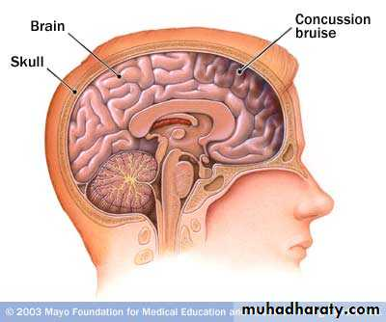
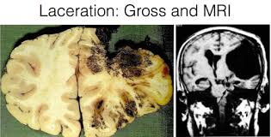

Cerebral contusion Cerebral laceration

- Compression :
- Definition: Increased intracranial tension sufficient to disturb brain function.
- Aetiology:
- Intracranial haemorrhage: Extradural, subdural, subarachnoid, intracerebral & intraventricular.
2- Depressed fracture.
3-Foreign body.
4-Diffuse cerebral oedema due to cerebral contusions and lacerations.
5-Accumulation of inflammatory products.
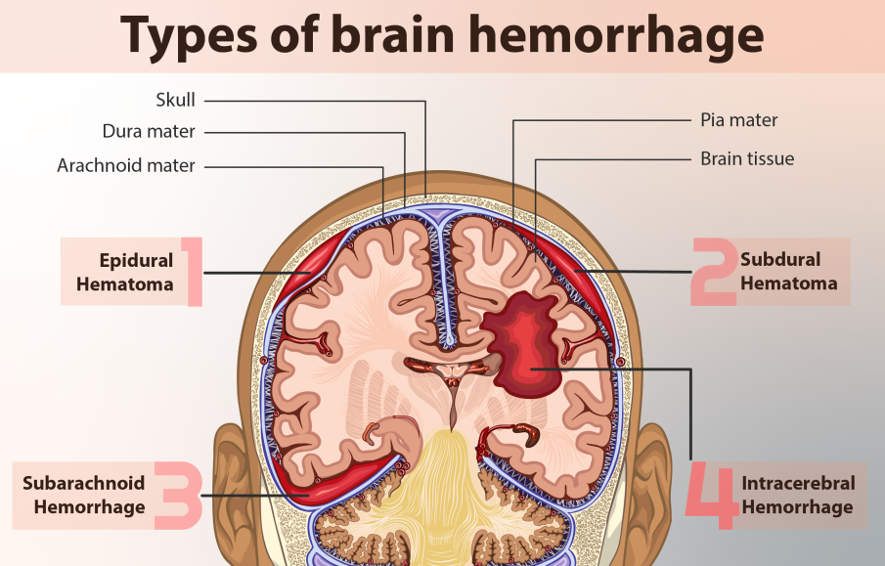

Clinical picture :

1-Progressive headache.
2-Blurring of vision & papilloedema.

3-Repeated projectile vomiting without nausea.
4-Progressive irritability, confusion, drowsiness passing to coma.
5- Cushing triad : Arterial hypertension, Bradycardia & respiration changes due to :
- Ischemia & Pressure on the brain stem .
- Cerebral ischemia → loss of upper inhibitory impulse on the brain stem centers ( VMC and vagal centers)
6- Hyperpyrexia.
7-Pupils: Constricted then dilated, at first on the ipsilateral side of the lesion then on the contralateral side.

8- Contralateral hemiparesis.
9-Decerebrate rigidity in terminal cases.

Treatment of the cause
Acute Extradural
Haemorrhage
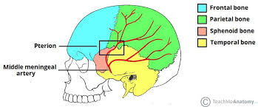

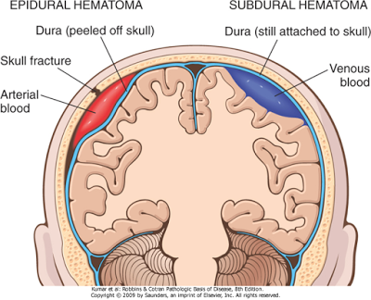
Pterion
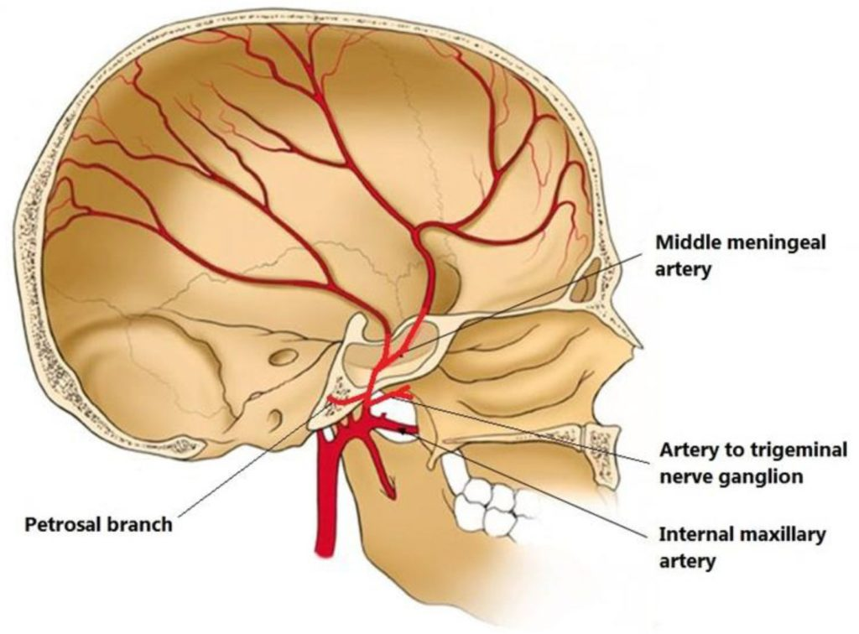

- Definition: Bleeding & collection of haematoma between the dura & the cranium.
- Incidence: The injury usually affects the anterior branch of middle meningeal Vessels because the temporal bone is thin and easily fractured and the artery lies in a bony canal at the pterion.
- Aetiology : A blow on the side of the head may cause:
a - Fracture of temporal or parietal bone on the same side (coup injury ).
b - Separation of dura from bones on the on the opposite side during recoil of brain (conter-coup injury).

The bleeding may be:
10
1. Arterial bleeding: Due to injury of middle meningeal artery.
2.Venous bleeding: More common because veins have a thin wall .It is due to injury of a diploic vein, middle meningeal vein or a venous sinus.
§ §
- Pathology: The condition passes through the following stages:
- Concussion stage :
- With inhibition of the vasomotor center low B.P.
no bleeding occurs in spite of the tear in the artery.
- Lucid interval stage :
- It is interval between the regain of consciousness and the onset of brain compression.
- It is the time needed for the collecting haematoma to strip the dura from bone & to disturb venous drainage of the brain .
- Recovery from concussion occur rise of B.P. Bleeding occur.
- Blood escape from the injured anterior division in 3 directions:
  - Outwards haematoma deep to temporalis.
- Downwards: To the middle cranial fossa.
- Upwards: Over the parietal regions & motor cortex.
C) Compression stage:
  - Early compression congestion and oedema of the brain brain irritation.
  - Late compression : occur due to
- Interfere with arterial supply of brain .
- Herniation:
- Temporal lobe herniate through tentorial hiatus cone formation compression of midbrain and 3rd cranial nerve paralysis of all cerebral functions and pupillary changes.
- Cerebellar herniation through the foramen magnum → compression of vital centers in the lower part of medulla.
  - Terminal compression: destruction of midbrain → decerebrate rigidity → death.

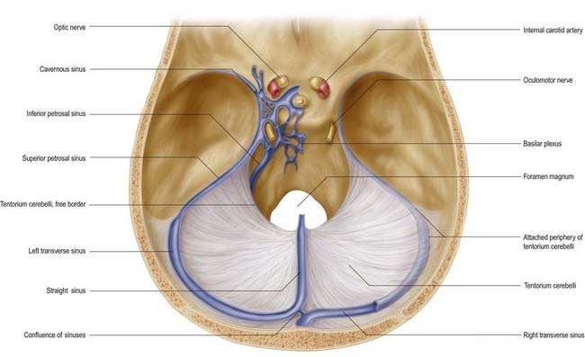
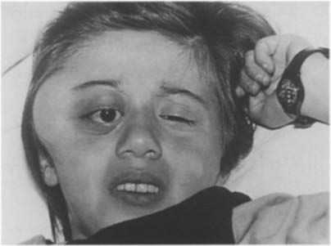

Tentorial Hiatus Hematoma deep to temporalis
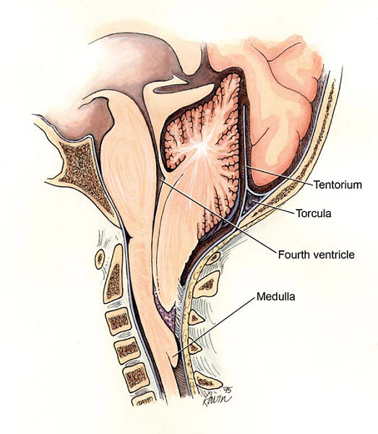

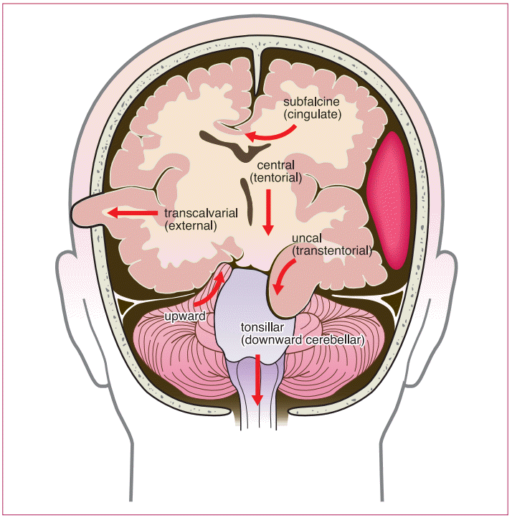

Cerebellar herniation Temporal lobe herniation

- Clinical picture: 3 Clinical stages:
A. Concussion: With or without signs of skull fracture. (mention in short).
B. Lucid interva1:
1- The patient regain consciousness for few hours (longer in venous bleeding).
2 – The patient confused with amnesia.
C. Compression:
l - Progressive headache , vomiting, blurring of vision & papilloedema.
2 - Progressive irritability & confusion followed by drowsiness coma.
3 - Pulse: At first slow and full but later on become rapid and weak.
4 - B.P: At first rise then falls.
5 - Respiration: At first deep & slow then shallow & rapid and
finally irregular with grasping before it stops complete1y.
- N.B :3, 4 & 5 are called Cushing Triad

6 -Temperature: At first there is subnormal temp. but later on the temp. generally raised and may be higher on the injured side.
7 - Pupils: Constricted then dilated, at first on the ipsilateral side of the lesion then on the contralateral side. Pupillary changes indicate late compression ( tentorial herniation affect first the oculomotor nerve on the ipsilateral side followed by oculomotor nerve on the contralateral side) .
8- Contralateral hemiparesis due to compression of ipsilateral cerebral cortex.
- In late cases, tentorial herniation push the midbrain against the edge of the tentorium on the opposite side → ipsilateral hemiparesis.
9- Localization of the side of the lesion:
  - Trauma & f racture on the same side of the haematoma.
  - Pupil constrict and dilated first on the side of the lesion.
  - Temperature may be higher on the side of the lesion.
  - Hemiparesis occur first in the contra1ateral side.

- X-ray: May show a fracture or shifting of the calcified pineal body.
- C.T.scan is diagnostic.
- N.B: The classical picture is only found in a minority of cases .
- D.D:
1. Pure concussion: Detected by follow up.
- Compression by depressed bone: Paralysis & compression
occur immediately after the accident without a lucid interval.
- Cerebral oedema: Signs of irritation without localization.
- Pressure due to infection: Longer interval between injury and infection with high fever and leucocytosis.
- Acute subdural: (Mention the table in subdural hge).
- Investigations: C.T. scan. (mention).
- Treatment:
- Urgent operation under general endotracheal anaesthesia.
2-Position :Put the patient with the site of haematoma upper most & the head is raised to reduce venous bleeding.

3-Exposure:
  - After localization of the intra-cranial haematoma by C.T scan , osteoplastic flap is done .
- 4-5 burr holes connected by a saw are done , with raising the flap which include the skin , temporalis and part of skull .
- The skin and temporalis are not dissected from the bone .
- The osteoplastic flap is turned down to expose the dura .
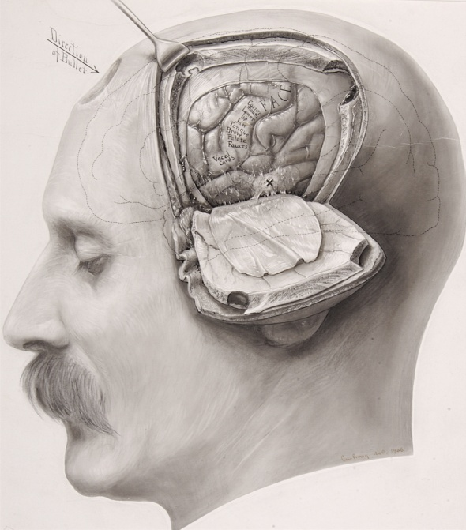
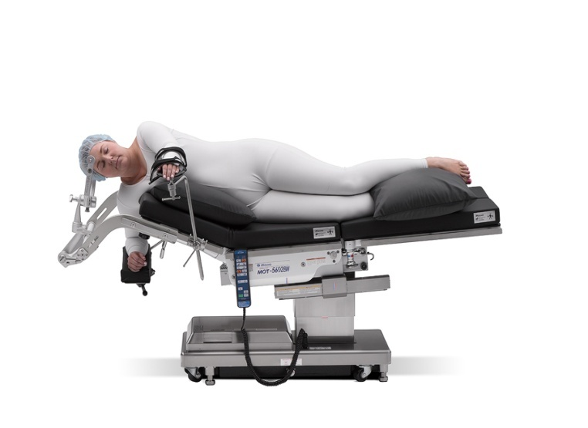

Position osteoplastic flap

4- Suction of the extra-dural haematoma .
5- Control of bleeding :The bleeding middle meningeal vessels are coagulated or underrun stitches. Rarely, if control of bleeding fails, packing of the foramen spinosum by bone wax .
6- If there are evidences of subdural haemorrhage (swelling and dark colour) , open the dura by cruciate incision ,evacuate the subdural haematoma , absolute haemostasis and close the dura.
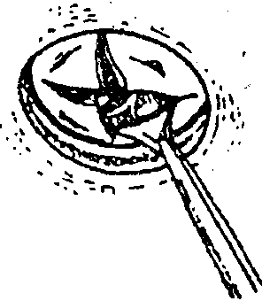

Cruciate division of the dura
7- A drain is inserted and the flap is returned to its place and fixed by suturing temporal fascia and skin .
8- Prophylactic anticonvulsant drugs for 6 weeks

- N.B:
- Exposure of anterior division of middle meningeal artery at the pterion is 2 inches above the middle of the zygmatic arch and 2 inches behind the fronto-zygomatic suture .
- Exposure of posterior division of middle meningeal artery : 2 inches above the base of mastoid process .

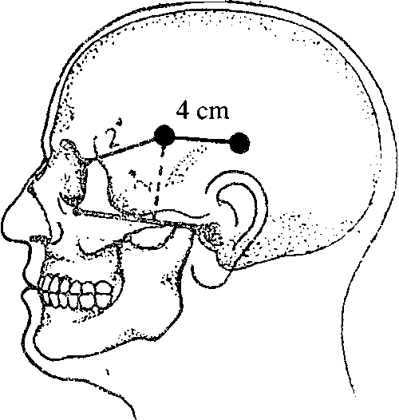
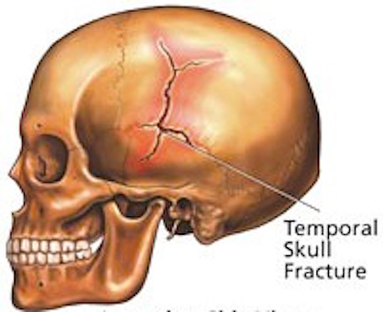

Exposure of middle meningeal vessels

Acute Subdural Hemorrhage

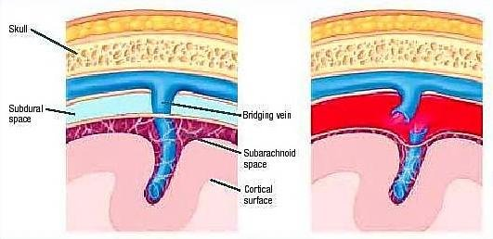
- Aetiology: Severe blow to the skull leading to rupture of cerebral veins as it crosses subdural space to reach dural venous sinuses or rarely due to cerebral laceration.

- Clinical picture: brain compression without lucid interval (Mention in short )
- D.D :

Acute extra-dural hemorrhage | Acute sub-dural hemorrhage
- Usually mild trauma | - UsualJy severe trauma.
- Lucid interval is present | - No lucid interval persistent coma
- Usually with mild brain damage. | - Usually with severe brain damage.
- Usually unilateral. | - Usually bilateral & extensive.
- Early surgery is successful. | - Due to serious brain injury & oedema in addition to haematoma mortality rate is at least 50% .
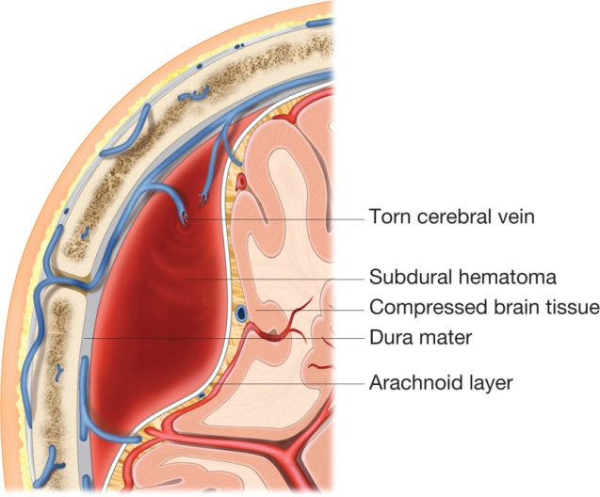
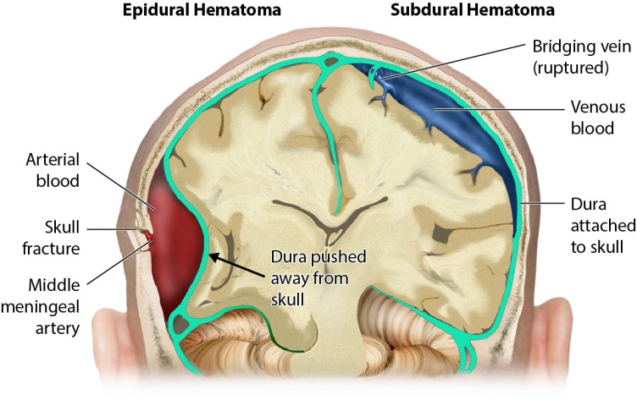

- Investigation: The most important is C.T. scan (Mention in short).
- Treatment: Urgent operation
- In case of subdural haematoma (swelling & dark colour under the dura), the dura is opened in a cruciate fashion to allow rapid decompression of the brain followed by evacuation of haematoma and absolute haemostasis.

MANAGEMENT OF
HEAD INJURY
I- First aid & dealing with life saving priorities: (A,B,C,D,E).
1. Keep patent airway & cervical control
2. Maintain adequate breathing: (Mention in short).
3. Circulation:
- Stop external bleeding from any wound
- Anti-shock measures (mention).Presence of shock in patient with head injury is usually due to internal hemorrhage in the thorax or abdomen.
4. Disability ( mention )
5.Exposure and environment .
6.Record the history of the accident is essential for follow up.
7. Immediate transfer to the hospital with the head up if the patient is conscious or on his side if he is comatosed.
II- lmmediate clinical examination:(Base level for subsequent observation).
1. Vital signs: Pulse, temperature, B.P. and respiration ( Mention Cushing triad ).
2. Assessment of the level of consciousness and evaluate the severity of head injuries by Galsgow coma scale ( see medicine ) which is based on 3 parameters & for each parameter a certain score is given.
- The parameters are eye opening, best verbal response & best motor response.
- The higher the score, the better the prognosis .
- According to the scale case of head injury are classified into mild (13 - 15), moderate (9 - 12) or severe (8 or less).

3. Head examination:
a – Scalp : Wound or haematoma.
b - Skull for palpable fracture.
c – Eye :
- Pupil for size (most important) & reaction to light.
- Dilated pupil immediately after trauma , usually due to direct injury of occulomotor nerve ( fracture base of skull)
- Constricted pupil on initial exam. and later dilated is a sign of lateralization due to supratentonial haematoma .
- Subconjunctival hemorrhage and its D.D .
- Ophthalmoscopy for papilloedema.
d - Orifices: Nose, ear & mouth for escape of blood & CSF in case of fracture base.
e - Posture: For neck rigidity & head retraction in fracture posterior cranial fossa.
4. Complete neurological examination:
a – Cranial nerves (in fracture base ).
b - Examine the l limb for muscle power, reflexes especially Babniski's as a sign of lateralization and sensations.
- Hemiplegia immediately after trauma indicates primary cerebral damage .
5. Careful examination for manifestations of brain injury .
6. Complete chest exam. for pneumothorax , haemothorax or fracture ribs .
7. Abdominal exam. for internal haemorrhage .
8. Examination of the limbs and back to detect any fracture , dislocations or vascular injury .
III) Indications for hospital admission :

1. History of loss or altered consciousness .
2. Skull fracture .
3. Swelling deep to temporalis muscle .
4. Progressive headache and persistent vomiting ( early signs of increase IC tension ) .
5.Presence of focal neurological sign
IV) Investigations :
- Once the patient is resuscitated with stabilization of vital signs , the surgeons should order the necessary investigations .
- Laboratory investigations :
- Blood gases ( PO₂ & PCO₂ ) and electrolytes .
- Urine and blood for sugar .
- Blood urea and creatinine .
- Liver functions .
- Radiological investigations :
- Skull plain X -ray: Show the followings
- Type, site & size of skull fracture.
- Foreign body in the cranial cavity .
- Pneumocranium .
- Possible side of haematoma by shifting of pineal body .
- C.T. scan is the most important investigation nowadays for any head injury as it diagnose fracture base or vault of skull, brain oedema, laceration, contusion and site, size,type & progress of intracranial haematoma
- Extra-dural hematoma is lentiform like a lemon
- Subdural hematoma is sickle shaped like a banana

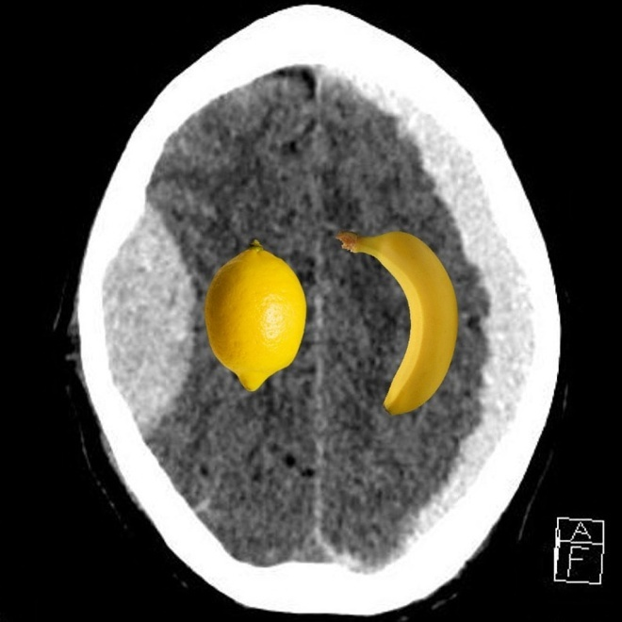

- If the patient on clinical grounds, is in urgent need for surgery, to evacuate intracranial haematoma , no time should be lost in doing investigation and surgery should be done immediately .

- Conservative measures ,continuous care and observations :
- Aim :
- Give the patient the maximum care until spontaneous recovery occurs .
- Early detection of complications which may need urgent surgery .
- Methods :
- Respiration :
- If normal ventilation is inadequate to maintain normal level of PO₂ & PCO₂ or GCS equal or less than 8 , endotracheal intubation and mechanical ventilation are indicated .
- Endotracheal intubation can be left for 7 days only after which tracheostomy is indicted .
- Insert Foley’s catheter to evacuate the bladder and estimate urine output .
- GIT: Insert nasogastric tube for feeding and enema every 2 days .
- Place : dark quite room .
- Posture :
- Conscious : Semi-sitting position
- Unconscious: Lie on his side to prevent inhalation of secretions
- Pyrexia : Antipyretics and ice backs .
- Back : Prevent bed sores by frequent change of position , massage with alcohol and talc powder .
- Physiotherapy : to prevent joint stiffness and massage of muscles .
- Drugs :
- Reduce brain oedema by mannitol 20% or as alternative frusemide and corticosteroids .
- Antibiotics for coma , open injury and fracture base of skull .
- Tetanus prophylaxis .
- Anticonvulsant drugs .
- Repeated observations for
- Level of consciousness ( most important ) and GCS .
- Pupils & reflexes .
- Vital signs: Pulse, temperature, B.P. and respiration

- Urgent surgery :
- To evacuate acute intra-cranial haematoma :
- Indications :
- Clinical manifestations of increase intra-cranial tension ( mention ) which may be due to brain oedema or acute haematoma . Sure diagnosis of hematoma by CT scan .
- Method : ( mention the operation for extr-dural haemorrhage ) .
- Depressed fracture :
- Indications : ( see depressed fracture )
- Method : ( mention the operation for depressed fracture )

