Audience survey analysis

The following will explain the findings of my survey that helped to influence structure of my music magazine.
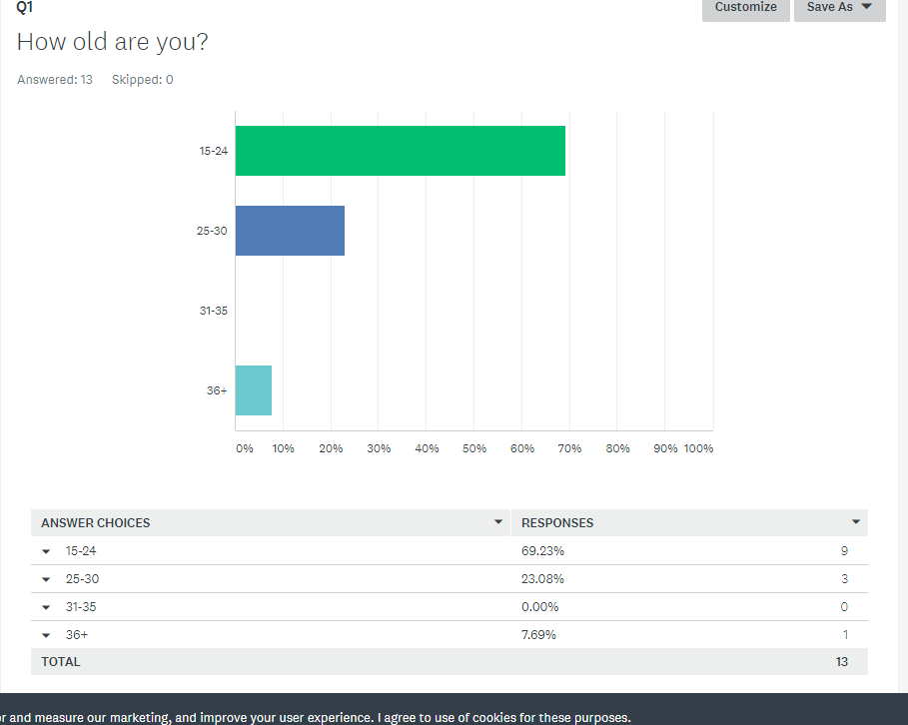

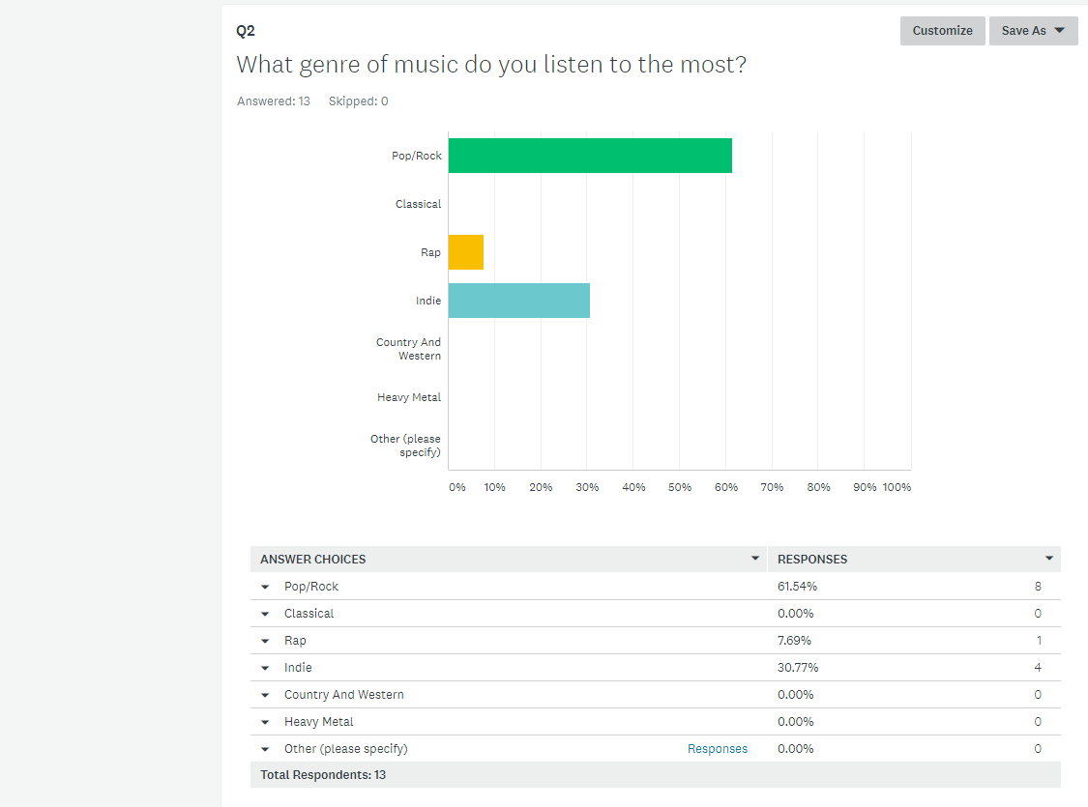
It is evident from these results that almost 70% of people who took part in the survey were aged between16-24. This means that it would be beneficial for me to target my magazine towards this age group.

It clear from these results that over 60% of those surveyed listen to pop/rock. Therefore I will create a magazine that will be of the pop/rock genre in order to meet the interests of those surveyed.

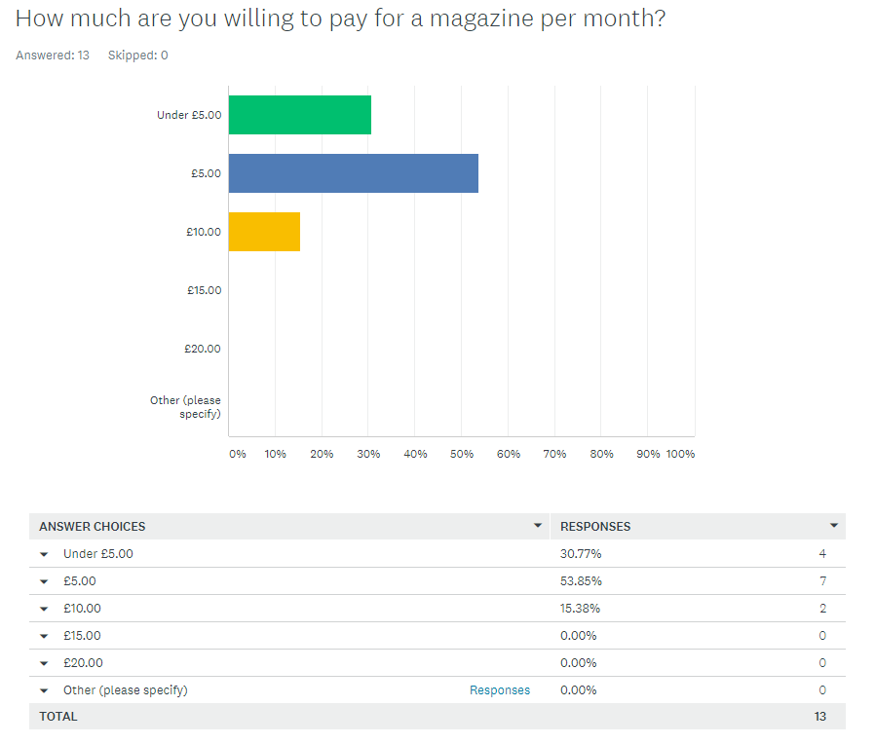
From those that were surveyed just over 80% were willing to pay five pound and under per month subscription fee. This largely influenced my decision when deciding the price of my magazine as it will cost five pounds a mouth.

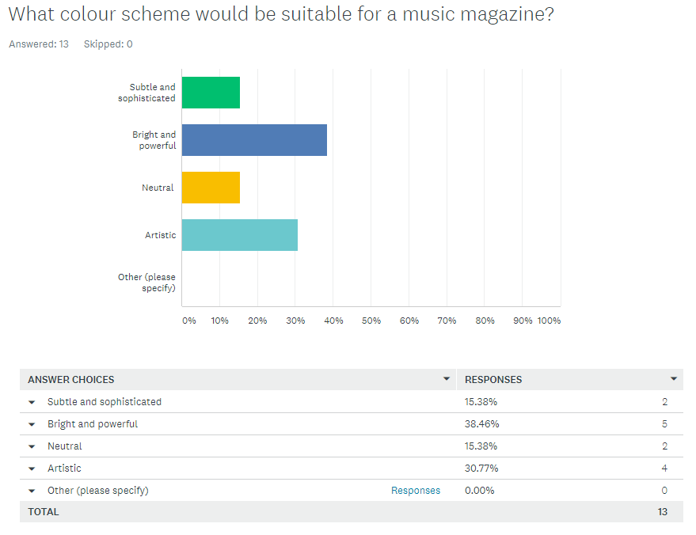

I found the results of this part of the survey very useful as it is clear that almost 40% of people who took part in the survey stated, that they felt a bright and powerful colour scheme would be suitable for a music magazine. Therefore, I will ensure that my final product follows this colour scheme.

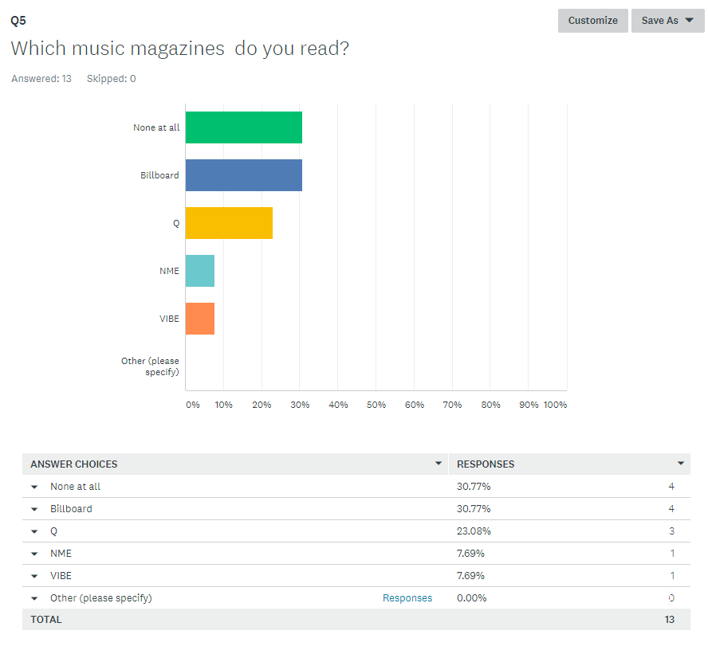
From these results it is clear that 30% of those surveyed do not read music magazines. This means that I will need to make my magazine unique in order to encourage people to read it. In addition, from the magazines listed Billboard appeared to be the most popular therefore, it would be effective for me to create a magazine that follows a similar this style.

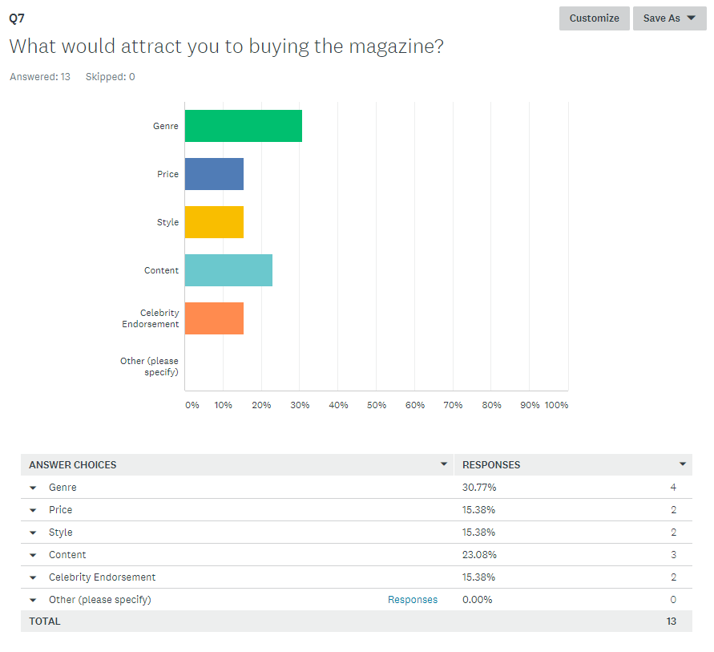
It is clear from these results that the two paramount categories that attract people to purchase a magazine are genre and content. This means it is vital that I make the genre of my magazine clear through my stylistic choices. I will also need to ensure that I produce content that appeals to the target audience and is appropriate to the genre.

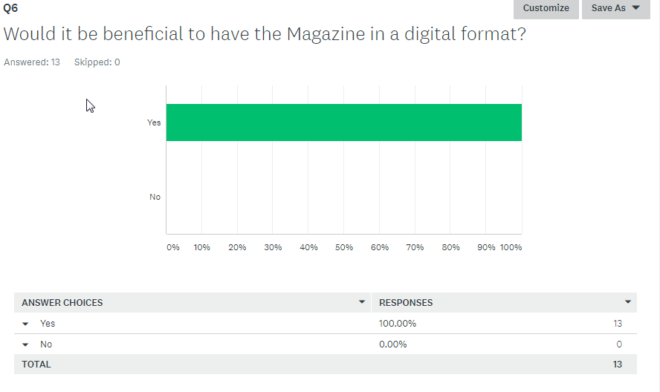
From these results it is clear 100% of people that took part in this survey believe that it would beneficial to have a magazine in a digital format. This means that it is vital for my music magazine to be digitally accessible.

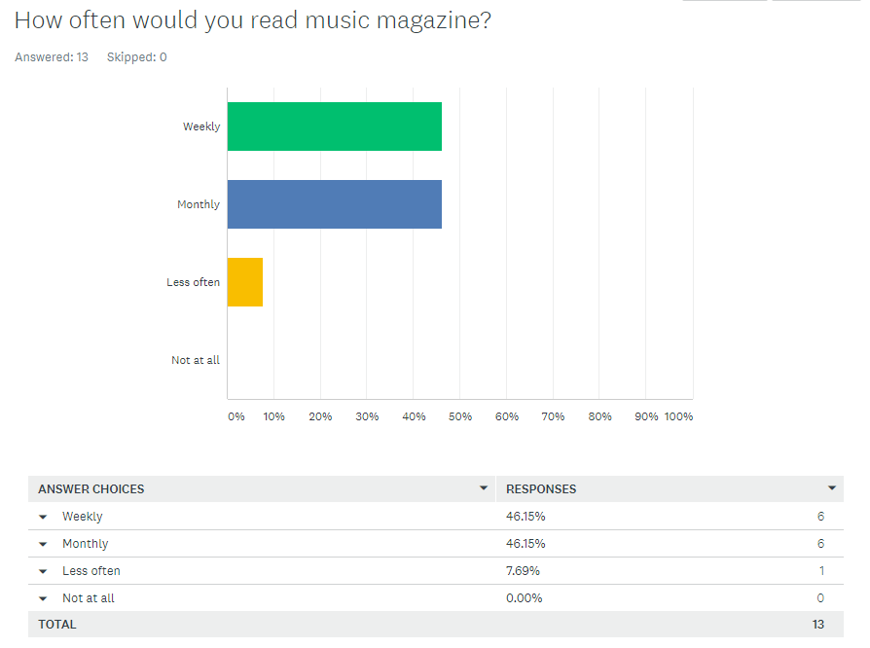

This question helped me to decide how frequently I should release my magazine. Due to the fact that it was almost and even spilt between the monthly and weekly option and taking into consideration the price the audience would be willing to pay I chose to offer a monthly subscription.

