CeleyHyga

Nova Prime Info

Celey Post 1

Celey’s 1st post begins by showing 3 perfect examples of Monica being drained. There is no misconstrued points here and the evidence is conclusive. This shows Monica certainly has a weakness to being energy drained.

Celey next begins to address the section of Supermutants post that goes into Nova’s energy absorption. About how he was hurt by pistols and got KO’d from Gladiators Heat Vision etc.

We learn from Celey (albeit with no evidence to prove to the contrary). That Nova had hardly any of the Nova force at that time. So him suffering the way he did when he absorbed the energy from the weapons and Gladiator could be linked to him not being linked to Worldmind and just from him not being a fully powered Nova Prime. Celey also states that as the story went on that Nova began to be more experienced and absorb “exotic” energies.
2 sets of scans are then shown, the first scan shows Nova absorbing Electrical energy.
Then the next set of scans show Richie absorbing the Deathstorm. A piece of energy that was many times larger than the Earth, and according to Celey was stated to have properties that would throw the laws of physics out of the window. Although Celey hasn’t actually shown any evidence of this being true. He says that this should put to rest the claims that Nova wouldn’t be able to absorb Monica’s energy.

Celey then quotes the section where Supermutant stated why you should vote for Monica.
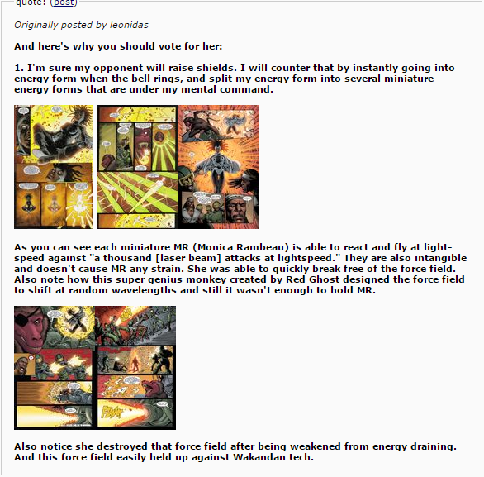
Celey points out a couple of flaws in Supermutants statement. The first one is pointing out that Monica didn’t phase out or destroy it. She merely focused on one small part that was cracking open and broke through it that way. And Supermutant states that Monica was weakened from the draining but the monkey clearly states that he planned to drain her slowly. Celey has got Supermutant dead to rights here.
Celey then states that Richie will know what strategies Monica is using due to his now extreme scanning abilities. With one scan showing even without Worldmind he is able to scan the whole of Galactus’s ship and detect the unique energy signature of Harrow.
He also tracks the energy signature of Quasar. Celey makes the statement that he lays the smack down on him later but this isn’t shown. And as such I can’t count this showing as viable since evidence isn’t shown to back up his claim.
A set of scans is then shown that show whenever Nova is hit by a certain type of energy his scans instantly pick up the type of energy and the level of how dangerous it is and inform him.
And finally a scan from a handbook that states that the Nova’s visor can see “all spectra of light”.

Celey then quotes this post from Supermutant.
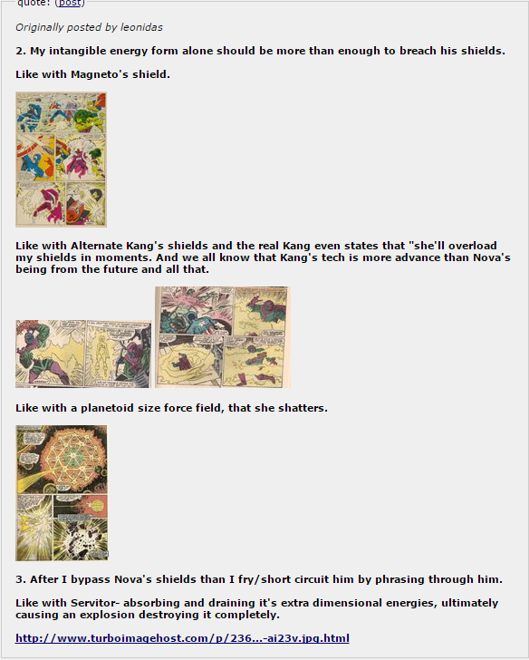
Celey begins by stating that he would much rather take Nova’s shields over Magneto’s any day. He then shows Richie’s shields holding against weapons powered by Black Bolt’s voice (obviously not hiss full power but obviously has to be a high degree and is impressive considering what it is).
His shields hang up against a Blastaar who is amped by the Cosmic Control Rod.
Celey then says that it is debatable that Monica would even be able to bypass Richie’s shield due to her having problems breaching shields previously. There are then some examples given below.
Annihilus once created a “tech based null field” that was able to stop Monica in her tracks and she wasn’t able to destroy it straight away. Despite trying to attack it in many different forms of energy. The only way she was eventually able to break through the barrier was by being slung all the way from the Sun with the aid of a satellite.
She has also been trapped by a Stasis Ray from one of Kang’s ships and was unable to escape.
Celey then shows a time that Nova was able to stop a Cosmic being known as Harrow. He then mentions that just because someone would be from the future doesn’t instantly make them likely to have better technology. Although it isn’t actually stated either way whether the tech was more powerful or not.
Celey also begins to correct Supermutant in a number of areas here. Like he mentions how when Monica destroyed the Planetoid sized shield it wasn’t through destroying the whole shield but through destroying one ship, which left the rest to collapse as one wasn’t there to support the rest.
And finally stating that Monica in fact didn’t absorb extra dimensional energies rather that she just exploded the Servitor from the inside. Celey has done a good job here of putting a great amount of wounds into Supermutants plans. Putting the BZ in his favour. Because if the things that Supermutant said here were correct then Monica is an extremely powerful character. But based on what it actually is it definitely isn’t as impressive as previously thought.

Celey then makes the argument that Monica has absorbed the energy of these beings listed.
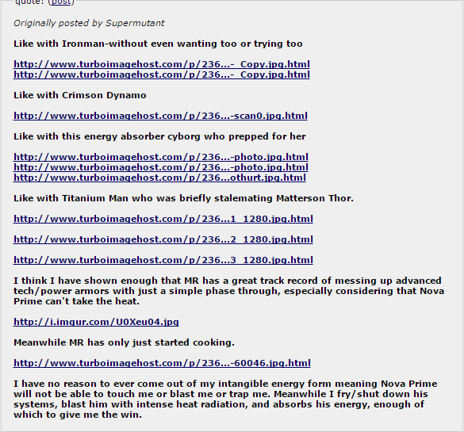
Is nothing compared to Nova Prime. And in reality it is true. The person who would come closest would be Titanium Man, and everything done by Richie eclipses Monica by miles.

