Easy Steps to Fix Microsoft Office Error Code 30125-1007?- www.office.com/setup
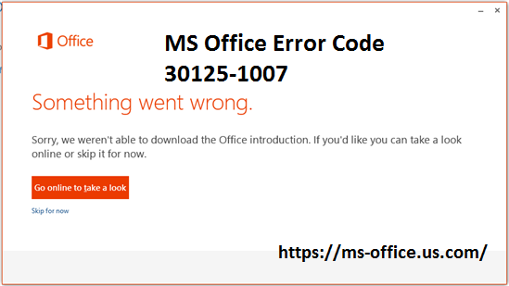
Microsoft Office is the complete productivity suite which is designed by Microsoft and it is consist of many applications like Word, Excel, PowerPoint and Outlook etc. You can install this useful software in your device through www.office.com/setup Activate Office Product Key. This software has now become very essential in our daily life. You can use this software on any device like Window OS, Mac, Computers, Laptop and Android Phones.
Visit here>> How You Can Create A Password in Windows?
Causes of MS Office Error 30125-1007:
The causes of the MS Office Error Code 30125-1007 are pre-existing office installation files, tamp and logs files, MS Office file got corrupt, MS Office didn’t update fully, Windows Update not properly installed, and also Antivirus might be blocking the office installation at office.com/setup.
Solution To Fix MS Office Error Code 30125-1007:
1. Disk Clean Up:
Disk Clean-up is used to free up disk space on your computer’s hard drive. It searches the hard drive for files which are not in use and also delete the unnecessary files. For the complete Disc clean, you have to click on Start button. Then you have to go to All programs option and then you should choose Accessories. After this, you have to select System tools. Here, you should click on Disk Clean-up option. Now, you have to choose the type of files which you want to delete. Then you have to click on Ok button. After this, you have to click on Clean up system files to delete the system files which are not in use. At the end, you have to click on Delete Files.
2. Select the Local Area Network Settings:
First, you have to click on Start button. Then, you have to open Control Panel. Now, you have to go to the internet options. After this, you have to choose the option of Connections Tab. Here, you have to select the option of LAN settings. Now, you have to turn off the option of Use a proxy 5.server for your LAN settings.
3. Uninstall MS Office:
For this, first you have to click on Start button. Then, you have to open Control Panel. Now, you have to go to the option of uninstall programs and features. Here, you have to search for Microsoft Office in the list. After this, you have to navigate to the option of Microsoft Office and then you should click on uninstall. When uninstallation process is finished, then you have to install Microsoft Office once again.
4. Re-install of MS Office:
First, you have to go to Microsoft office account. Now, you have to Sign in with your Microsoft account details. After this, you have to select new updates of office. Then, you should Install updates.
This method helps to resolve MS Office Error Code 30125-1007. But if you are still facing the issues, then you can contact to the expert of MS Office team. For details about MS Office software, you should visit to the site through office.com/setup Enter Office Product Key.

#webroot.com/safe #avg.com/retail

