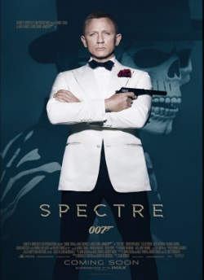
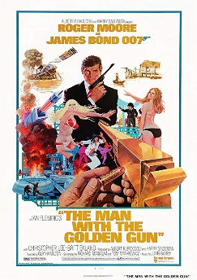
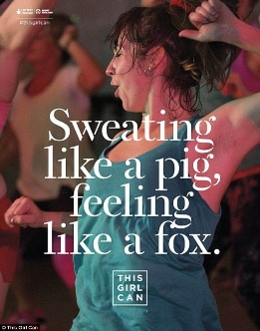
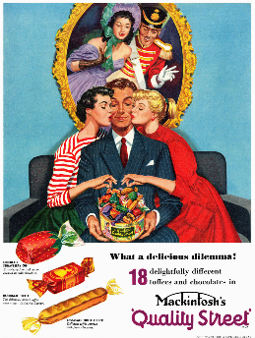
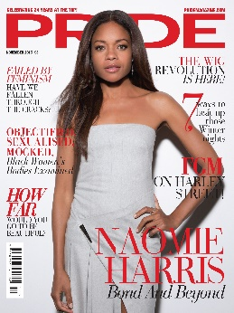
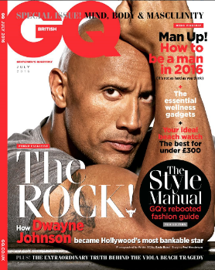

Please complete the questions below using your knowledge recall, only referring to revision material to check your answer, or support you if you are stuck. You can either type your response into this sheet or write on paper – in this instance please take a photograph of your work using your phone and send to your teacher on the One Drive ‘Hand in’ folder. Your teacher will respond with feedback as quickly as possible.

1. Write 3 bullet points about how This Girl Can represents women. Remember to back up your assertions with examples from the advert (images, text)

2. Give 2 ways in which This Girl Can reflects social contexts.

3. Apply narrative theory to This Girl Can including Todorov, Propp, and Levi-Strauss.

4. Explain how words are used in the Quality Street advert to engage the audience. Give 3 examples.

5. Identify 3 ways in which historical context is evident in the Quality Street advert.

6. Give 2 reasons why Naomie Harris might have been chosen for the cover of Pride magazine.

7. Explain 3 ways in which the Pride set cover might engage a black female audience (apart from the use of Naomie Harris).

8. Without looking at the Spectre poster, analyse the connotations of:
- body language and facial expression
- costume and props
- text/words

9. Identify 3 examples of intertextuality in the Spectre poster and explain how these appeal to audiences.

10. Explain how the Spectre poster reflects social contexts in terms of representation.

11. Apply narrative theory to the Spectre poster including Todorov, Propp, and Levi-Strauss.

12. In the poster for The Man with the Golden Gun (TMWTGG) identify 3 things which reflect its historical context.

13. Identify 3 examples of intertextuality in the TMWTGG poster and explain how these appealed to audiences at the time.

14. Write 3 bullet points about how men are represented on the GQ cover referring to both images and text.

15. In what ways is the GQ magazine cover conventional. Identify at least 3 examples.

