For many people, losing weight can be a long and daunting journey. Dieting and playing sports can become a full-time activity. When it doesn't work, it's easy to despair. Because when the pounds continue to accumulate, it is easy to fall into an obsession. It is very difficult for anyone to find it difficult to accept their body and it causes real suffering.

Click Here For More Information And Order

Buy Now !!!! Click on the Link below for more information. Hurry !!!
This is why many people turn to slim products, pills, or various and varied creams to reduce their weight and feel better in their sneakers. However, it is very difficult to see clearly among the many solutions on the market. Advanced Keto Plus is a relatively new product, and if everyone is talking, it's because the results seem impressive, if not dazzling. Advanced Keto Plus offers you a 100% natural product, guaranteeing significant weight loss in less than 30 days! So, myth or reality? We offer here our full review of Advanced Keto Plus.
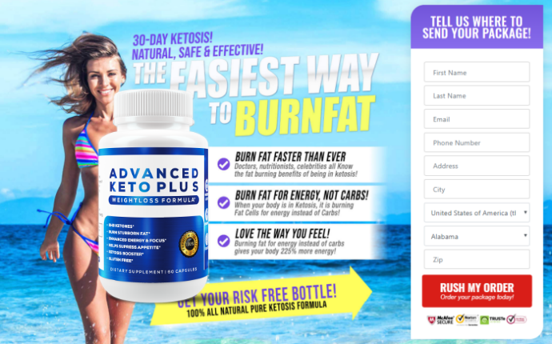
Introduction of Advanced Keto Plus:
Can we lose so much weight in such a short time with strictly natural products? If any doubt it, it is however the promise made by Advanced Keto Plus, which guarantees you a loss of 6 to 8 kilos per month.
The treatment of Advanced Keto Plus must be done in addition to a balanced diet and a program of adapted physical activities. Taking this dietary supplement is believed to increase the results of your efforts, especially by causing your metabolism to speed up.
Advanced Keto Plus acts at different levels:
- It speeds up your metabolism, which allows your body to eliminate before fat can be stored.
- The different ingredients will also help your body burn fat much faster.
- Advanced Keto Plus promotes thermogenesis: this allows you to naturally increase your body temperature which will, therefore, burn more fat.
- Many ingredients also have detoxifying properties.
- The fiber intake will allow you to eliminate much more easily.
- The flagship ingredient of this formula is saffron which reduces cravings for snacking through its appetite-suppressant effect.
The Advanced Keto Plus formula combines different ingredients that help cut hunger, burn fat more easily, and detoxify the body. Advanced Keto Plus will, therefore, make your diet much more efficient by speeding up your metabolism, but will also make your life easier by suppressing the feelings of cravings that could ruin your efforts.

Click Here For More Information And Order

Buy Now !!!! Click on the Link below for more information. Hurry !!!
A 100% natural composition
To preserve your health, Advanced Keto Plus provides you with a product made up of 100% natural ingredients. What makes the difference with this product is the guarantee that each of the ingredients is of natural origin. Besides, no side effects have been reported following the use of Advanced Keto Plus. Unlike many downright toxic products unfortunately present on the market (and which can be easily obtained on the internet), Advanced Keto Plus guarantees you a completely safe formula for your health. Why consume chemical ingredients that are bad for your health when nature has already provided you with all the ingredients necessary for your weight loss? Nature is indeed full of plants that will allow you to achieve your goals in terms of well-being.
It is more and more important nowadays to pay attention to our consumption. Part of the reason why Advanced Keto Plus is recommended by so many people is that it takes care of your health. Without selling you a miracle product, it allows you to combine the most powerful ingredients made available by nature. Indeed, losing weight should never be synonymous with danger, Advanced Keto Plus, therefore, offers you a product that allows you to lose weight quickly, without endangering your health.
Advanced Keto Plus, how does it work?
So significant weight loss only with plants and superfoods? This is Advanced Keto Plus's bet! To make up your mind about Advanced Keto Plus, let's take a look at how this product works, ingredient by ingredient.
Saffron:
Qualified as red gold, the spice reputed to be the most expensive in the world has many benefits. The main virtue of saffron and the reason for its inclusion in the Advanced Keto Plus formula is its appetite-suppressant effect. Indeed, it has the property of greatly reducing appetite and therefore reducing the cravings for snacking and the risk of cravings! But this is not its only asset, saffron is full of many benefits. It is indeed known to be an effective analgesic (especially for pain associated with menstruation). Saffron is also known for its antidepressant properties.
It is therefore a multifunction ally for your slimming program. Besides, this spice does not cause any known side effects. It is therefore a major ally, and it can only be beneficial to you!
Ginger:
This spice is also a mine of virtues. Indeed, its beneficial action on the body has been well known for many years. Ginger is also often used in Ayurvedic medicine. It is a food rich in minerals and vitamins. Ginger has a stimulating effect on the metabolism and will, therefore, help you burn fat but also eliminate toxins. Ginger will also help you get fuller faster. Ginger consumption will also cause a rise in your body temperature, called the genesis. To restore its natural temperature, your body will naturally draw on your fat reserves.
Prickly pear:
Again, Advanced Keto Plus is just aiming by offering you an ingredient with multiple benefits. Naturally rich in antioxidants, the prickly pear helps the elimination of toxins contained in your body.

Click Here For More Information And Order

Buy Now !!!! Click on the Link below for more information. Hurry !!!
Also, it is a food rich in fiber which will, therefore, promote elimination, and will also serve as an appetite suppressant. Besides, it benefits from a wealth of vitamins and minerals, essential for the proper functioning of your body.
Fenugreek:
Fenugreek is often mistakenly considered a weight gain plant. It stimulates the building of your muscles by drawing on fat reserves.
This ingredient will therefore not directly make you lose weight, but it will be a major asset in transforming your fat into muscles. Your figure will, therefore, be slimmer.
It is thanks to this ingredient that your cellulite will be able to decrease. In alliance with a regular sporting activity, it is fenugreek that will stimulate the construction of your muscles to the detriment of fatty tissues.
Bitter orange:
Bitter orange is a well-known fat burner. Its action promotes the acceleration of metabolism and therefore helps you eliminate. That said, watch out for the properties of this herb that can increase blood pressure.
If you have high blood pressure, consult your doctor before taking the bitter orange extract.
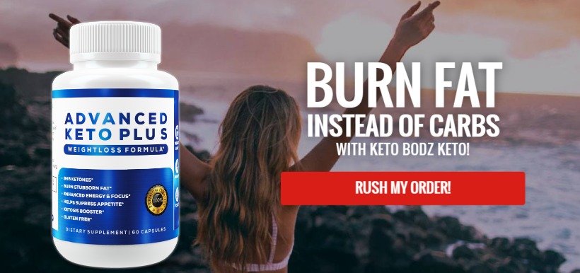
Green tea:
Green tea is a leading food supplement for weight loss. Indeed it benefits from widely documented effects on its action in favor of the increase in energy expenditure. The consumption of green tea causes your body to draw much more largely from its reserves, in particular of fats, for an unchanged effort. Green tea also helps limit the accumulation of fat. Without a doubt a good slimming ally!
L-tyrosine:
L-tyrosine is an amino acid. Its main virtue is its action against stress. It indeed stimulates dopamine, the famous "hormone of happiness"!
Reducing stress will automatically cause you to cut back on snacking, which is often linked to too high levels of stress. L-tyrosine also helps burn fat more effectively during exercise.
Advanced Keto Plus, therefore, offers you a multitude of ingredients which, taken one by one, have all proven their positive action for weight loss. However, their combined action makes it possible to multiply their effects. All the ingredients have been chosen because they have been proven to work. They are often recommended as part of the diet. By maintaining a balanced diet and proper physical exercise, you should see your fat melt away much faster, your muscles strengthen, your cellulite disappears and the sensations of food cravings are rare. However, it is important to maintain a healthy lifestyle. Without it, Advanced Keto Plus may have only a very moderate effect on your figure.
Customer Reviews on Advanced Keto Plus:
Each of the ingredients has been the subject of studies that have proven their action on metabolism. However, each individual is unique. However, opinions about Advanced Keto Plus all seem to converge. Admittedly, the product's onset of action is different for each person, but all of the opinions gathered on Advanced Keto Plus seem to converge on real weight loss.
There are many reviews of people who have tried Advanced Keto Plus. Mostly women, but also a few men, who testify to the effectiveness of the product. Indeed, many people who have struggled for years with their weight sometimes by going through diets, trying formulas called "miracles", have found in Advanced Keto Plus a real solution to their overweight.
The opinions about Advanced Keto Plus all seem to converge: the weight loss is real, and it's fast. However, it should not be forgotten that the treatment of Advanced Keto Plus must be done as part of a balanced diet (we are not talking about deprivation but only a balanced diet). It is also necessary to think about maintaining regular physical activity and adapted to each one. It will only improve the results of your figure.
Advanced Keto Plus review - a basket of vegetables
One of the concerns with taking dietary supplements is the fear of the yoyo effect. What could be more discouraging than to see all your efforts wiped out in such a short time and come back to square one, even with a few extra pounds? Opinions about Advanced Keto Plus agree on this point: after stopping Advanced Keto Plus, people do not seem to gain weight.
Satisfied or reimbursed:
If you are not convinced, know that the manufacturer of Advanced Keto Plus guarantees you satisfaction. If ever you are not completely satisfied with the product, you can request a refund for the products ordered. When we see the very positive reviews of Advanced Keto Plus, it is not surprising that the manufacturer is so sure about the results touted by the product!

Click Here For More Information And Order

Buy Now !!!! Click on the Link below for more information. Hurry !!!

How to order Advanced Keto Plus?
It is possible to order Advanced Keto Plus vials on different platforms, but we recommend that you go through their website. Indeed, you can order Advanced Keto Plus directly on the manufacturer's website and thus benefit from the many discounts offered. Also, delivery is free! You can choose to pay for your product directly on the site or ask to pay only on delivery.
You should know that the recommended dose depends on your weight and the weight you want to lose, so read the instructions on the bottle.
You will also find a lot of additional information about the product on the Advanced Keto Plus website. If you want additional information, a number is available to you to ask questions about the product and its effects.
Our Conclusion on Advanced Keto Plus:
Advanced Keto Plus has many advantages. All the ingredients contained in this product have already been proven and are the subject of serious scientific studies. The origin of the ingredients is guaranteed and all the components are of 100% natural origin. No side effects have been reported to date. It is therefore not surprising that Advanced Keto Plus is such a popular product. Indeed, many testimonials are available showing significant weight loss in absolutely record time! Also, if you are not satisfied, the manufacturer offers you a full refund of your order! The sellers of this product are extremely confident about the effectiveness of their product.
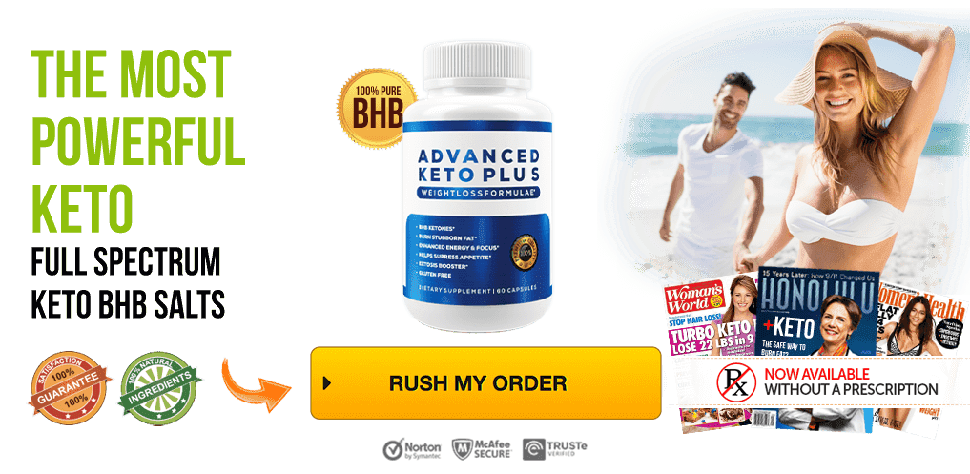

Click Here For More Information And Order

Buy Now !!!! Click on the Link below for more information. Hurry !!!
Most users report convincing results within the first few weeks. Having said that, we recommend that you take the cure for at least 30 days to get all the benefits of the product. So don't be discouraged if things take a little longer for you, we are all different! Each body will react at its own pace to the components in Advanced Keto Plus. Also, keep in mind that food supplements are to be consumed in addition to a balanced diet and an exercise program suited to your weight goal. This is because Advanced Keto Plus provides you with all the ingredients you need for your goal, but the results will only be more spectacular if you adhere to a diet and fitness regime suited to your case.
If you've been trying to lose weight for a long time and you're feeling discouraged about reaching your goals, give Advanced Keto Plus a chance. Positive opinions from satisfied customers abound on the web. Besides, the satisfied or refunded guarantee allows you to take no risk!

https://www.trentandallievan.com/forum/general-discussion/advanced-keto-plus-what-is-advanced-keto-plus-detailed-review-scam-alert
https://www.trentandallievan.com/forum/general-discussion/advanced-keto-plus-what-is-advanced-keto-plus-detailed-review-scam-alert-1
https://www.trentandallievan.com/forum/general-discussion/advanced-keto-plus-4-reason-to-avoid-read-side-effects-reviews
https://teespring.com/advanced-keto-plus-review
https://teespring.com/advanced-keto-plus-trial
https://sites.google.com/view/advanced-keto-plus-trial/home
https://sites.google.com/view/advanced-keto-plus-scam/home
https://form.jotform.com/AdvancedKetoPlusPils/Advanced-Keto-Plus
https://form.jotform.com/AdvancedKetoPlusReview/Advanced-Keto-Plus

https://medium.com/@jamesjones025/advanced-keto-plus-scam-pills-verified-review-what-is-advanced-keto-plus-bff5f3fba5a8
https://www.justgiving.com/fundraising/advanced-keto-plus
https://www.justgiving.com/fundraising/advanced-keto-plus-reviews
https://mndepted.instructure.com/eportfolios/2064/Home/Advanced_Keto_Plus_SCAM_PILLS_VERIFIED_Review__What_is_Advanced_Keto_Plus
https://utah.instructure.com/eportfolios/38817/Home/Advanced_Keto_Plus__What_is_Advanced_Keto_Plus_SHOCKING_Side_Effects_2020
https://k12.instructure.com/eportfolios/1992/Home/Advanced_Keto_Plus__What_is_Advanced_Keto_Plus_DETAILED_Review_SCAM_ALERT
https://advancedketopluspill.tumblr.com/
https://www.wattpad.com/938185248-advanced-keto-plus-scam-pills-verified-review

