Useful Information Regarding Collision Auto Body

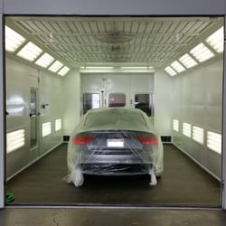
When you wish to get your vehicle fixed, it is essential that you simply turn to an experienced auto repair shop. A reputable and seasoned auto mechanic has the appropriate skills to scrutinize your vehicle. Ensure that you choose a store which can provide you with the best and desirable service. Finding an excellent store is a good deal simpler than you may believe as it only requires a little research and common sense. Before you make a selection understand if the technicians are competent and skilled enough to execute a service properly. Always would rather select a store that could offer you with the best and successful services. Only a proficient and dependable automobile mechanic can keep your vehicle in top form. If you are searching for more information on best auto body shop Keep Reading Here, look at the mentioned above website.

It's essential that you use an auto repair specialist that has expertise with all the kind of car or truck that you drive. Consequently, you can obtain an actual assessment of your automobile, together with the right ingredients. Constantly search for the Competitive Pricing & Written Estimates. Make sure they offer you each and term and detail in writing. This approximation can help you to make a final decision. Make sure in the event the approximation includes the cost of the materials being used and the absolute number of hours which are required to make the repairs.

Whenever choosing an auto mechanic, you should make guarantee they carry quality parts. A dependable service provider will give you with the finest service in every potential manner. They'll inform you about the parts they are going to replace with. A powerful store owner will ensure you which you get the top encounter with them. Only do a little research and locate a store which can provide you with the service. If you consider a few of these variables you'll get the perfect service. When buying quality auto mechanic, make sure to see numerous stores to find out the cleanliness of the shop, professionalism of the staff and testimonials they might have posted. Find a car tech you'll be able to trust and ensure that your automobile is in the great hands.

