New Update Webroot Security Solutions
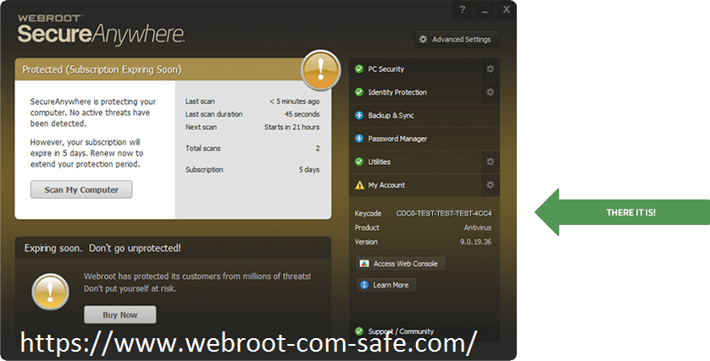
www.webroot.com/safe - Webroot Security utilizes progressed, multi-layered security innovation to confirm gadgets, protection, and individual records, for instance, music and cash connected information from today’s most unsafe rising dangers, as well as ransomware, vindictive sites, zero days and phishing assaults.

Visit this link: What to do, When “Webroot Not Installing Windows”?

Some of the recently additional protection and performance options of Webroot Security include:

Proactive Exploit Prevention: Zero-day vulnerabilities (which were up a hundred twenty-five percent in 2015), are holes in software package applications that are unknown by the software package trafficker. Webroot Security’s Proactive Exploit interference technology helps defend the holes in common software package applications by recognizing a variety of malicious behaviors that are emblems of zero-day attacks. One of the advantages of this approach is that it provides security against a large form of exploit attacks throughout the vital window once a susceptible software package is deployed till the purpose that a software package patch is put in – a method that may take weeks or months.

Emulation Technology:
In their makes an attempt to bypass the ancient security software packages, cybercriminals typically hide their malicious code in innocuous-looking files. Webroot Security’s freshly developed emulation technology hunts down antivirus-evading malware before it will compromise a user’s system. It will this by unpacking and running the suspicious files during a virtual machine for examination before the malware in these files will compromise the user’s machine. With eighty-three PC of all malware presently using anti-virus evading techniques, Webroot Security’s freshly developed emulation technology is a very important advancement in protective shoppers. sources

Prophetic Machine Learning Engine:

Ancient Webroot antivirus solutions typically place assurance in signatures of famous malware to shield shoppers. Criminals understand this, and as a effect, develop machine-controlled ways in which to deliver variation of malware designed to evade the signatures. The prophetic Machine Learning Engine anticipates new and evolving malware variants. Employing a machine learning algorithmic program, it develops applied math model that helps accurately observe and blocks each new and unknown malware.

Quicker raincoat Protection:

Raincoat users can see quicker scans and lower overall memory utilization on their devices.

My Webroot:
The discharge of Webroot Security will embody My Webroot. A next-generation net portal that fully changes the approach customer act with webroot.com/safe webroot install. With My Webroot, customers will access their Webroot subscription options, manage their accounts and devices, and find out about new threats from any device. It offers a lot of engagement with customers with smarter alerts and electronic messaging, and helps customers get the foremost of the Webroot subscription (e.g., backup, parental controls, multi-device protection).

#office.com/setup #avg.com/retail

