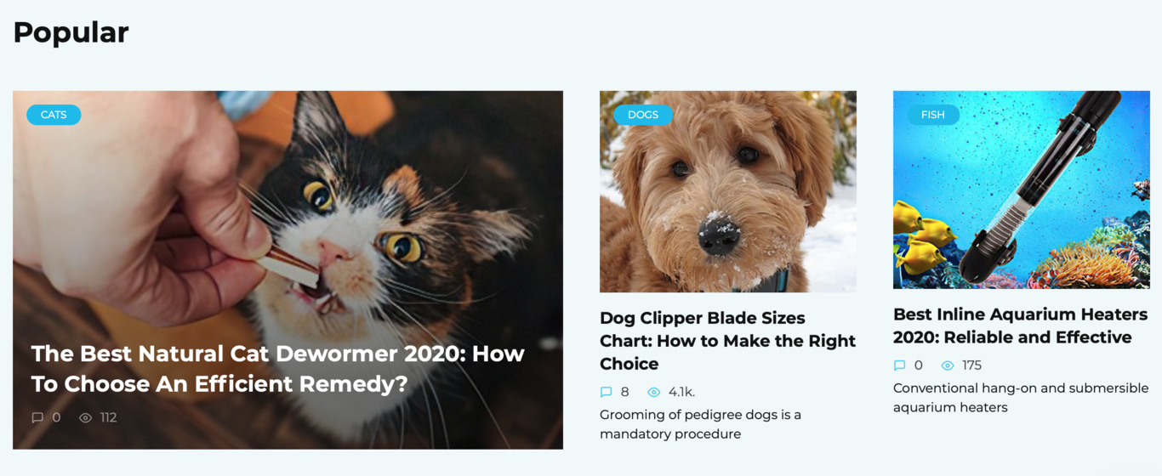

Hi my name is Jane Lapointe, I am 35 years old, I am employed as a doctor-veterinarian in a private practice , I run my website, write articles for your site about critters https://petexperta.com/. The site has a lot of helpful and practical advice for people who keep pets or are only going to have a furry friend.
Many say that it is impossible to become a veterinarian without love for creatures. I could say from my experience that this isn't the case. Love for animals only hinders abstraction and thinking in blood. Every sane individual is a struggle for me in the very first place, whether I could overcome the disorder and comprehend what is wrong. Allow me to give you an example. It happens that through sterilization or castration, the animal stops breathing. This occurs infrequently - usually because of intolerance to anesthesia. Along with the physician, who's sincerely concerned, can get confused and miss significant seconds to conduct resuscitation. For me personally, it has always been a certain task to be solved. And that I solved it without even thinking that the lifetime of a living animal is in stake. I will mention: it all concerns beginners, experienced veterinarians, of course, understands how to put feelings on the back burner. Just like any good doctor.
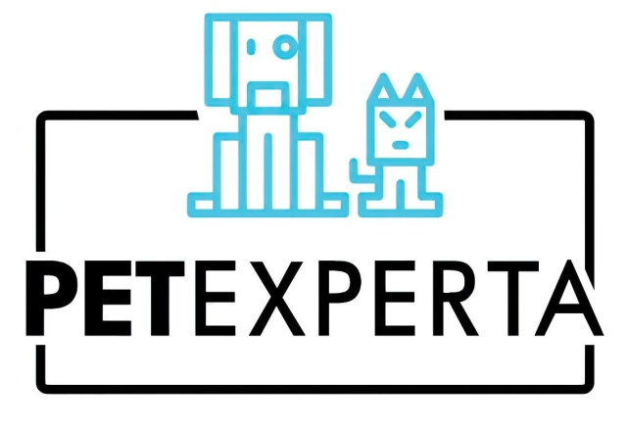
Originally, I moved into my dream - to become a vet. Because of this, I graduated from the Academy of Veterinary Medicine and Biotechnology. There is not any specialty in veterinary medicine since such. You merely get a diploma for a veterinarian - and no one cares that, by way of instance, you've practically never worked with pets. During training, they mostly teach you to work with farm animals, which is not sufficient in urban practices, in which it finds programs. Consequently, the knowledge is not sufficient to treat or function critters; you need to know everything in practice. It's apparent that nobody will take you as a physician at once, first you have to go through the path of an intern. I received most of the knowledge by viewing my senior colleagues and learning from their experience.

