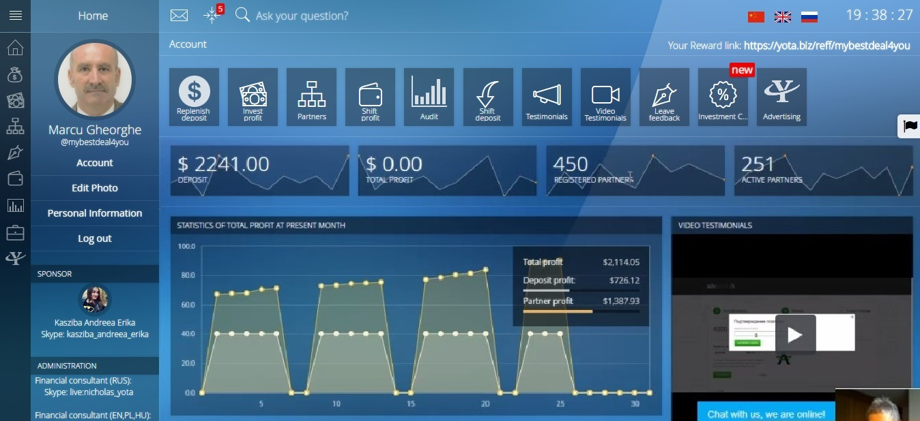
YOTA IS MUTUAL TRUST.
Story of Yota starts in 2013 when we were one of the first ones to use our work experience in financial markets in country. Years of working in financial market turned us into advanced, fast-developing and innovative investment company. Today Yota combines experience and youth, theory and practice and it is one of the most dynamic investment companies in China. We want to be the best for our clients!
Our mission is to be the best in services for our clients, keep a reputation of one of the most dynamic and innovative companies in Chinese Financial Market. We believe that every client has to obtain his own financial plan of development as well as his personal goal. We are aimed at helping you to create you personal development plan.
Together with traditional services of investment companies, Yota has created its own unique product range: Index Portfolio, Structured Products, Trust Management and Individual Investment Accounts.
Our success is based on the work of our professional team. We made Investment Process available for all the company clients.
Yota opened the European Market recently. It has offices in a few countries, but in China and America the company is well known.
The investment program offers interest between 1.5% and 3% daily, depending on the amount deposited, as follows:
- between $ 35 - $ 299 - 1.5% daily
- between $ 300- $ 5,999- 1.8% a day
- between 6000 $ - 19999 $ - 2.2% daily
- Between 20000 and 69999 $ - 2.5% daily
- over $ 70000 - 3% daily
The referral program is 5 levels of depth, 7%, 5%, 3%, 2%, 2%.
Minimum deposit $ 35. Minimum withdrawal amount $ 1.5 per day.
Yota is a step into the Future / Advantages:
- interests for different amount of deposit
- guaranteed interest of deposit
- high-rated rewards program
- qualified Brokers
- perfect strategy for investments
- personal consultant
- constant board
Join now https://yota.biz/reff/mybestdeal4you
Video: https://www.youtube.com/watch?v=dvjOQ8NMJWQ https://www.youtube.com/watch?v=O7I8J7aBuf8


