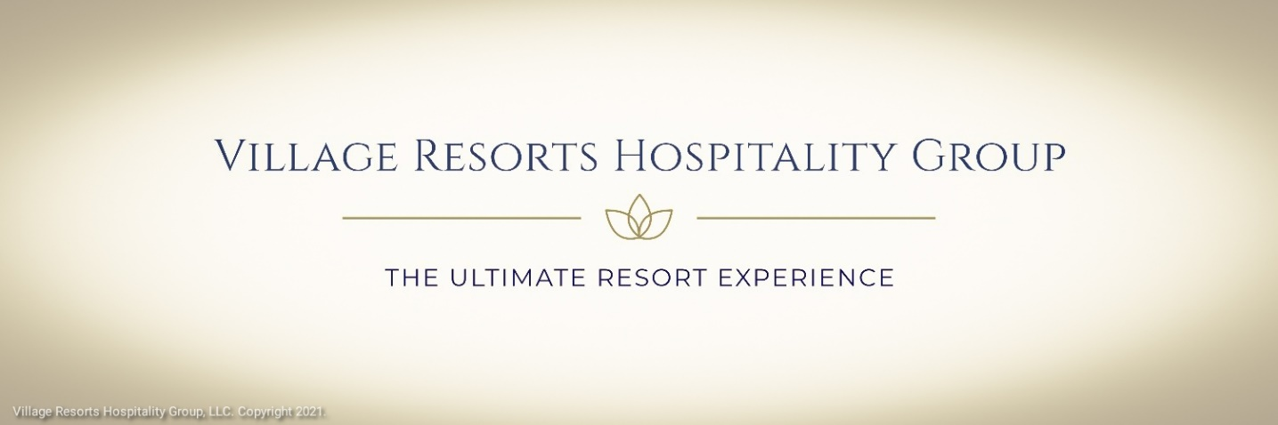

August 24, 2021


Village Resorts Hospitality Group, LLC
Office of the President
Oliver B. Mitchell III
300 Long Beach Blvd., Unit 1705
Long Beach, California
90801
PH: (725) 212-3214
oliver@villageresortsgroup.com

Memorandum For All Staff

Subj: Unfair Competition

Effective August 24, 2021, Village Resorts Hospitality Group, LLC, hereby approve, adopt, and endorse its "Unfair Competition" memorandum separately, jointly, and combined, made effective August 24, 2021.

This Memorandum issued by The Office of The President, Village Resorts Hospitality Group, LLC, to all related entities, ensures that for the good and valuable consideration, the receipt and sufficiency of which is hereby acknowledged to be legally bound and agreed as follows.

As illustrated in our bio, effective August 1, 2021, Village Resorts Hospitality Group, LLC, became the hospitality and management Company to the Downtown Hotel Resort & Spa, The Downtown Resort, LLC, Village Box Café Bar & Grill, Village Box Café, LLC, Village Boxpark Casino Hotel & Resort, Village Boxpark, LLC, The Reserve Resort Casino Hotel & Spa, BE TV, Boxpark Entertainment, LLC, and Esther & Esther, LLC, to include any and all related entities of or to any entity or company owned by the above.

The success of Village Resorts Hospitality Group, LLC, is measured by our attempt to develop products, goods, and services that are aligned with our Company's goals and strategies.

From time to time, at our sole discretion Village Resorts Hospitality Group, LLC, reserves the right to implement, modify, cancel, or change any agreement as necessary.

To combat fraud and dishonesty in the conduct of trade and commerce, we have recently adopted new structural defenses to address systemic issues related to the conduct of Our business.

Vulnerability to fraud and dishonesty can sometimes result in unsolicited and hostile takeover attempts, which can influence the operations of an organization and influence corporate decision-making, hindering our success and long-term goals.

Village Resorts Hospitality Group has reasonable grounds to believe that hostile actions or an attempt at a hostile takeover of Village Resorts Hospitality Group, LLC, or any of the Company's we may own, operate, and manage, may be present.

The latest attacks against us, we believe, are directly related to the CEO and Owner of Village Resorts Hospitality Group, LLC, and his role and involvement in unrelated and past incidents. The CEO, Mr. Oliver B. Mitchell III, is a former federal employee turned whistleblower whose disclosures sparked national discourse. A whistleblower is a person who exposes misconduct, alleged dishonest or illegal activity occurring in an organization. The alleged misconduct may be classified in many different ways; for example, a violation of a law, rule, regulation, and/or a direct threat to public interest, such as fraud, health and safety violations, and corruption. Despite the legal protections afforded whistleblowers, the CEO of Village Resorts Hospitality Group, LLC, continues to be singled out for discrimination, racism, reprisal, and excessive judicial punishment, which has led to a disruption in our attempt to offer the ultimate resort experience.

Unfair competition can result in dishonest and fraudulent rivalries in trade and commerce and damage intellectual property. Unfair competition addresses circumstances where employees and consumers can be misled or result in deceptive trade practices that can alter or restrict a company's attempt to engage in the exchange of trade and commerce. Acts of unfair competition are generally characterized by acts of deception, bad faith, fraud, and oppression severe enough that the victim is thwarted or prevented from successfully engaging in trade. Unfair competition covers many subjects; however, a variety of the most common is trademark infringement, false advertising, unauthorized substitution, bait and switch, the misappropriation of trade secrets, and rumor-mongering.

On June 10, 2021, the Founder and CEO, of Village Box Cafe, LLC, were the subject of a "blackmail and extortion" campaign aimed at Mr. Mitchell by others who we perceive display "racial and religious perceptions."

On June 12, 2021, we discovered that Google and Google search engines were inaccurately reporting and/or reflecting on its search engine that Village Box Cafe Bar & Grill "opens in August" with an unspecified date and year. At that time, Village Box Cafe Bar & Grill was set to open on October 24, 2022, in the Downtown Los Angeles area, as previously advertised. Village Resorts Hospitality Group nor Village Box Cafe, LLC, at any time furnished Google or its search engines to reflect an opening in August.

On June 19, 2021, the CEO and Owner of Village Box Cafe, LLC discovered he was the subject of a blackmail and extortion attempt. We are of firm belief that this latest attack against Mr. Mitchell is directly related to previous incidents surrounding his former employer and his effort to construct Village Box Cafe Bar & Grill.

On June 30, 2021, Village Box Café, LLC, discovered that several entities bear the words "village, box, cafe, bar, and grill" in no particular order and combination thereof to their establishments. Additionally, several entities describe themselves as a "family-oriented" restaurant. Village Box Cafe Bar & Grill is a carefully curated restaurant resort modeled and tailored with a target audience of 21 to 54 years of age generally speaking. As previously advertised, Village Box Cafe Bar & Grill is a Vegas-style restaurant resort venue marketed to consenting adults over 18.

The Mission Statement of Village Resorts Hospitality Group, LLC, is to deliver "the ultimate resort experience." Through our Mission Statement, our goal and intent are to carefully curate an environment that is stylish, upbeat, and modern as we strive to provide an environment free of fear and oppression.

The Founder and CEO of Village Resorts Hospitality Group, LLC, has contributed significantly to curating an environment that is stylish, upbeat, and modern. Village Resorts Hospitality Group, LLC, disavows any perceived discrimination, reprisal, and retaliation against Mr. Mitchell for being African American, including his sexual orientation (gay) and perceived positions regarding Village Resorts Hospitality Group operations.

The impact of unfair competition goes far beyond our CEO, Mr. Mitchell. Unfair competition and the effect can negatively impact our business model, severely impacting our goals and strategies resulting in an inferior product limiting our ability to fulfill our Mission Statement.

Unfair competition and leaked information can result in a change of control. Such a coercive tactic can negatively impact our business operations, giving our rivals an opportunity to prepare a competitive response to the detriment of our business as a new entrant into the field of hospitality.

Effective immediately, Village Resorts Hospitality Group, LLC, and all managed Companies are forbidden from and have suspended the public dissemination of Company related policies, memorandums, and concepts, regarding the details of our internal process and proceedings. We believe doing so will further damage our attempt to engage in trade and commerce and further delay the opening of Village Box Café Bar & Grill and The Downtown Hotel Resort & Spa.

Village Resorts Hospitality Group, LLC, thank you for your support and patronage as we continue to offer the "ultimate resort experience."

This Agreement contains the final and entire Agreement and understanding between the Parties and is the complete and exclusive statement of its terms. This Agreement supersedes all prior Agreement and understandings, whether oral or written, in connection therewith.

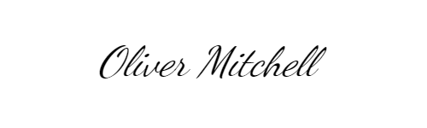
Oliver B. Mitchell III
President/CEO
Village Resorts Hospitality Group, LLC.

oliver@villageresortsgroup.com
The Ultimate Resort Experience.

