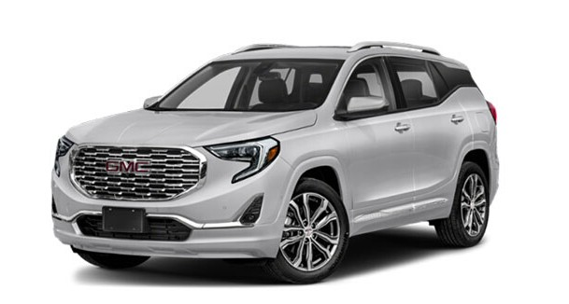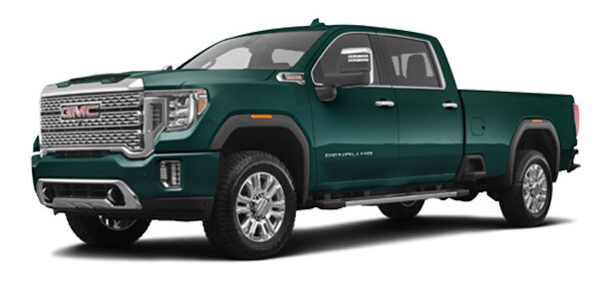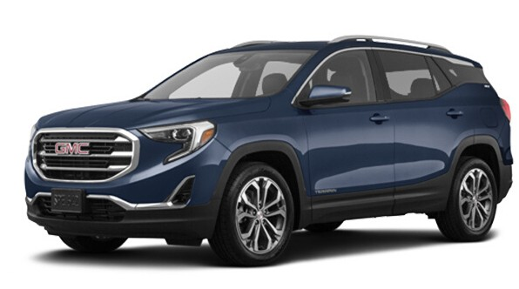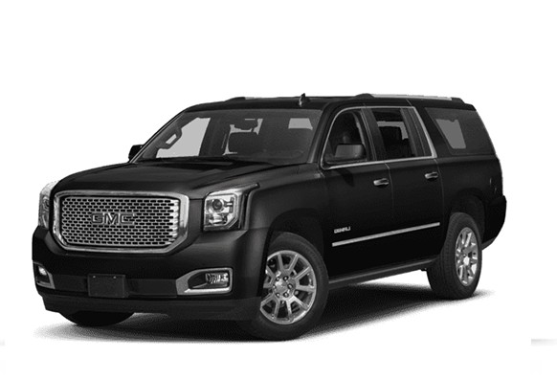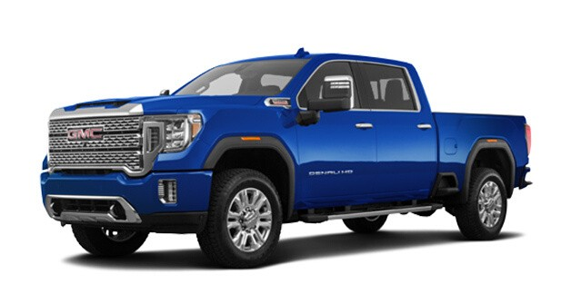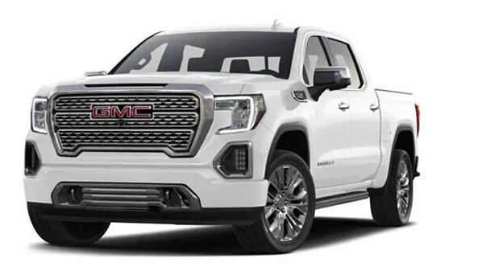THINKING OF LEASING A CAR – ZERO DOWN GMC AUTO LEASING IS HERE

Auto leasing is said to be the cheapest version to keep up luxury. Customers can easily avail the widest range of auto leasing deals on branded cars and that too even at zero down payment option. Isn’t it great? Of course, it is a great option. So, if you are thinking of leasing a car, then zero down GMC auto leasing is available here. For More Information Please Visit Our Website:
www.vipautopa.com

