PLEASE RENAME MANUSCRIPT ACCORDING TO YOUR PAPER ID.
Please write your text in good English (American or British usage is accepted, but not a mixture of these).

PAGE 1
Concise and Informative Article Title
(Limited to 8-16 Words, Relevant to the Subject, in Single Phrase, Correct Grammar & Proper Capitalization, Avoid Abbreviations)

Name of Author^{1,*}, Name of Author², Name of Author³

¹Full affiliation of first author, including country, ¹Email:..... ,
²Full affiliation of first author, including country, ²Email:..... ,
³Full affiliation of first author, including country, ³Email:..... ,

*Corresponding Author: Name of Author, ( Email:....)

Abstract: (Should contain an unstructured abstract of 250 words.)
The abstract should be a concise 200-250 word summary of the research, providing a clear overview of the study. It should include the research question in context, the purpose of the study, main methods or treatments used, key findings, and primary conclusions. The abstract must accurately represent the article without introducing unsubstantiated results or overstating the conclusions.

Keywords: After the abstract, provide at least 5 keywords, avoiding general terms, plurals, and multiple concepts. Use only well-established abbreviations and incorporate keywords naturally for readability.

PAGE 2

The "IMRaD" format structures a paper into four sections: Introduction, Methods, Results, and Discussion.

1. Introduction:
The introduction should identify key ideas of the research, why it is important; pose research question that needs to be answered and how the findings contribute to the discipline. (Introduction should not contain sub-headings)

2. Literature review/Study site:
This section is very important for your article. Review the main articles related to the main theme of your work. Summarize a number of articles which you have considered related and important for your research.

Subdivision - numbered sections:
Divide your article into clearly defined and numbered sections, should be numbered 2.1 (then 2.1.1, 2.1.2, ...), 2.2, etc.

3. Materials and Methods/ Methodology:
Select and describe the methodology you have summarized in the previous section. It can be the same as in a previous related work, a modified one you considered more appropriate or a mix of the methods you have analysed in the literature review section.

4. Results and Discussion:
This part includes the results, tables, figures, formulae with references, data source references, evaluation of validity for calculations and discussion. This part may be divided in balanced sub-parts.

5. Conclusion:
The main conclusions of the study may be presented in a short Conclusions section, which may stand alone or form a subsection of a Discussion or Results and Discussion section.

6. Ethical Approval:
All the studies involving humans or animals must obtain ethical approval from the institutional board before being carried out. Details of this approval must be provided when submitting an article; including the institution, review board name, and permit number(s).

Ethical Statement should be written as:

We obtained ethical approval for this study from The Research and Community Engagement Ethical Committee of the Faculty of Public Health University, Ethical Approval Number: XXX- XXX1/XX55.D11/PPM.00.00/2023 on 01-1-2023.

Consent requirements: Studies involving humans require written informed consent, which includes consent to participate in the research and consent to publish any identifiable data. Both forms of consent are necessary to meet ethical and legal standards.

7. Data Availability (Demo Tutorial: https://youtu.be/wnjPPG0FKq0)

Authors are encouraged to share the data underlying their study and include a Data Availability Statement in the manuscript.
Examples of data: Field Notes, Case Study Notes or Observations, Audio & Video Interviews, Surveys or Questionnaires, Software Code, And Genome Sequences.

"Open Repository" (e.g. https://figshare.com/) is like a data library. After uploading your data, include a statement in your paper directing readers to it, so they can verify your results.

Data Availability Statement should be written as:

Date Availability Statement:

Underlying data
figshare: Research on factors affecting tourist involvement in coffee tourism after the COVID-19 pandemic in Thailand – Questionnaire. https://doi.org/10.6084/m9.figshare.21310734.v3

This project contains the following underlying data:
- Coffee Tourism – Raw Data.xlsx

Extended data
figshare: Research on factors affecting tourist involvement in coffee tourism after the COVID-19 pandemic in Thailand – Questionnaire. https://doi.org/10.6084/m9.figshare.21310734.v3

This project contains the following extended data:
- Coffee Tourism - Questionnaires to Participants.docx

Data are available under the terms of the Creative Commons Attribution 4.0 International license (CC-BY 4.0).

8. Grant /Funding: Enter the funding body name, grant number (optional) separate multiple numbers with commas

9. References (Citation in text)

Ensure every citation in the text is in the reference list, and vice versa. Follow the APA Publication Manual (6th or 7th edition). References should be static text (not linked) and listed alphabetically by the first author’s last name, without numbering or footnotes. Un-cited references will be removed automatically.

Reference to a journal publication:
Van der Geer J, Hanraads JAJ, Lupton RA. The art of writing a scientific article. J Sci Commun 2010;163:51–9.
Reference to a book:
Strunk Jr W, White EB. The elements of style. 4th ed. New York: Longman; 2000.

NOTE: Figures and tables should have legends. Ensure all figure and table citations in the text match the files provided

Advice on Tables:
Please submit tables as editable text, not images. Place them near the relevant text or at the end. Each table must have a descriptive title, and units should be included in the column headings. Do not use vertical rules, and cite tables consecutively in the text.
Table 1: Temperature and wildlife count in the three areas covered by the study.
Location | T [°C] | Turtles | Sharks | Octopuses | Starfish
Blue Lagoon | 21.2 | 5 | 3 | 4 | 543
Regent’s Canal | 5.2 | 8 | 0 | 24 | 312
Shark Bay | 12.8 | 4 | 7 | 9 | 122

Advice on Figures:
Each figure or table should be referenced by its number in the text, either before or after it. Avoid using terms like "following" or "previous."
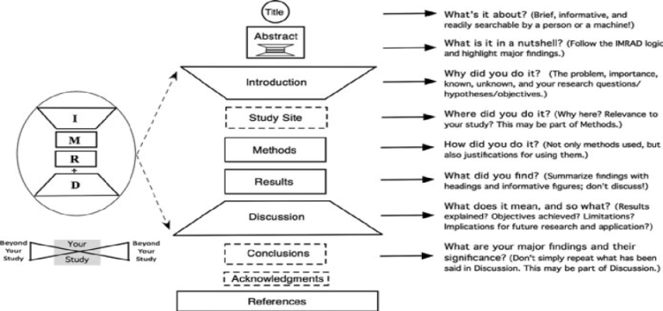
Figure 1: Diagrammatic representation of the IMRAD structure of research papers
Introduction (I), methods (M), results (R), and discussion (D).
Most original research papers today have 6–10 sections, with those in dotted-lined boxes being optional.

AUTHORS’ INFORMATION FORM

Paper Title:
Corresponding Author :
(Author Name & Email)

First Author – Information

First Name |  | Last Name
Designation |  | Department
University |  | Mail ID
Contact No. |  | ORCID ID
Residential Address

Second Author – Information

First Name |  | Last Name
Designation |  | Department
University |  | Mail ID
Contact No. |  | ORCID ID
Residential Address

Author’s biography

 | R. Salleh (Rosli Salleh) obtained his Bachelor’s degree in Computer Science from University of Malaya. Then he obtained his Master’s degree in Data Communication Networking and PhD in Computer Science majoring in Virtual Reality, Tele-surgery and Networking both from University of Salford Manchester United Kingdom. He has also obtained CCNA professional qualifications. Currently, he is a lecturer at the Faculty of Computer Science and Information Technology, University of Malaya. His specializations include Bluetooth network, networking, and Virtual Reality. His current research interests are Bluetooth Scatternet Formation, Public Key Infrastructure, Network Security, Authentication Server, Virtual Simulation, Virtual Reality and Laparoscopic Surgical Training.

NOTE: ADD ALL AUTHOR(S) & CO-AUTHORS DETAILS AS PER THE FORMAT.

