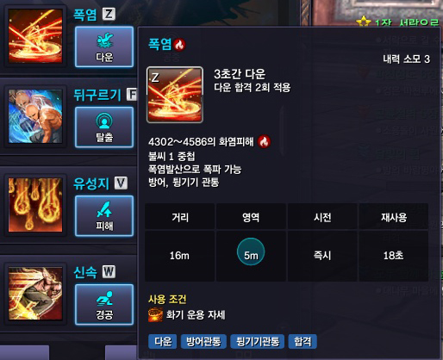
Z – Knockdown + Defend.
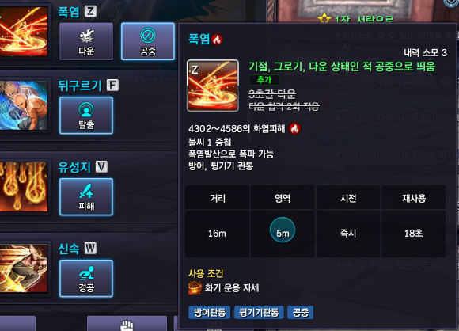
-Airborne enemy with denfed,.

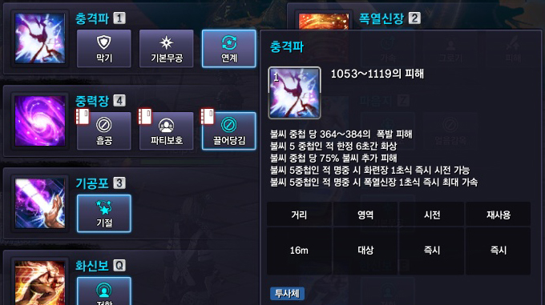

If you hit with NUM1 skill when enemy have 5 fires, you get Fully speed of NUM2 Skill.

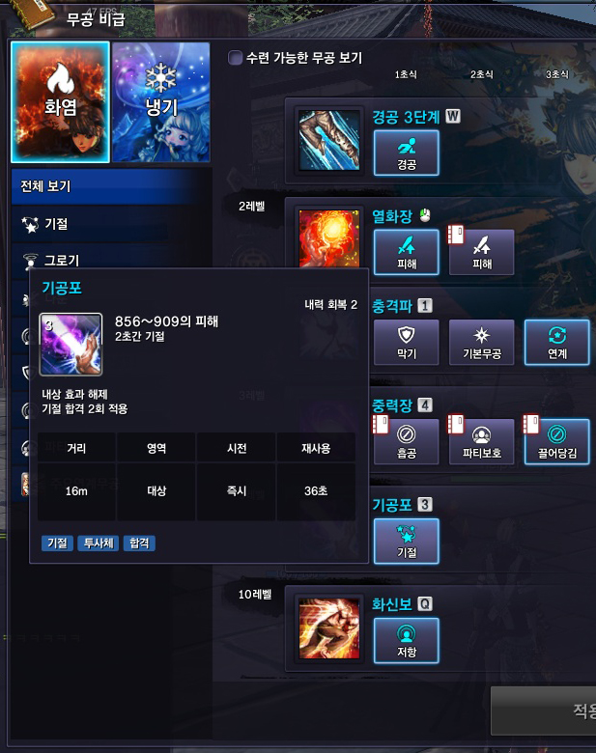

NUM3 Changed. No more Ice skill but Ability is still same. [Stun]
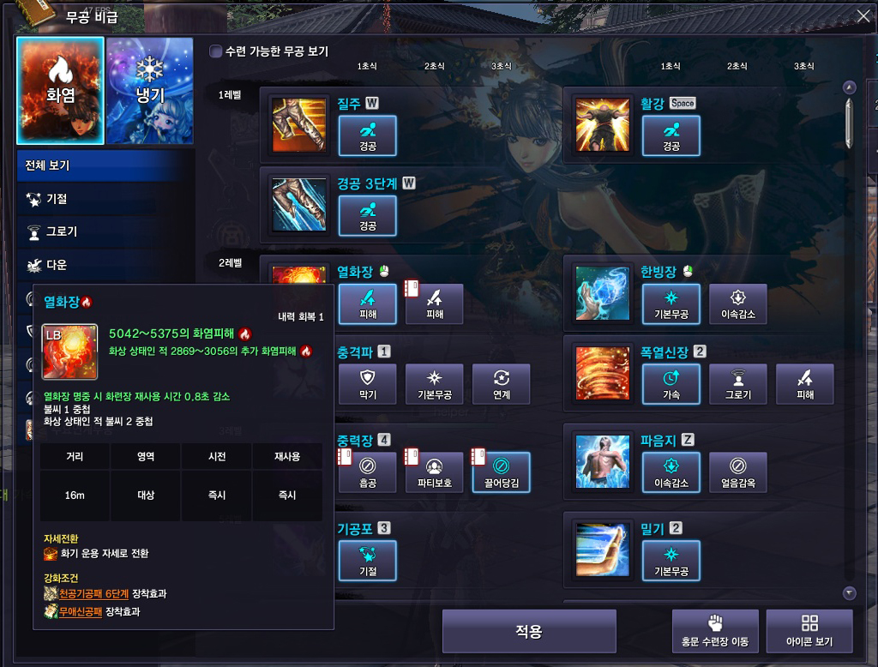
LMB Skill. Not changed.
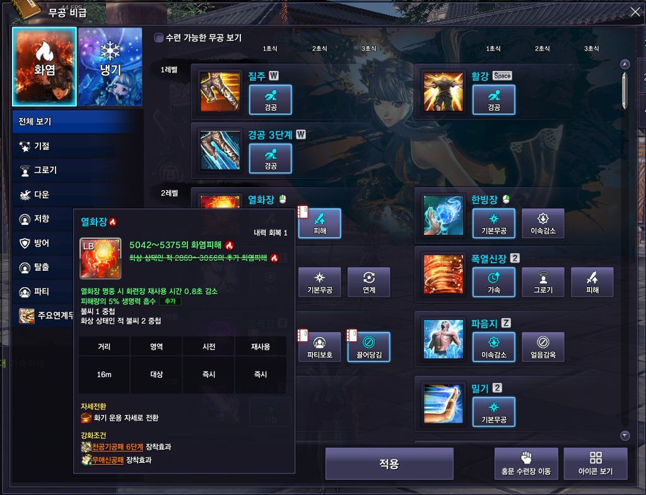

LMB Skill – No more auto explosive fire.

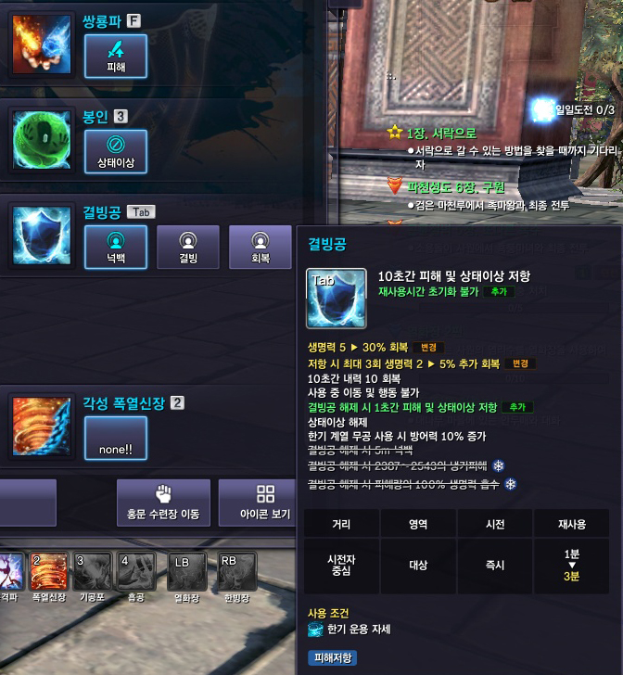

Not changed.

AND IMPORTANT!

NO MORE GLOBAL COOLDOWN FOR FORCE MASTER.
(EX : IF YOU USE NUM2 SKILL, YOU CANT USE NUM3 SKILL ABOUT 0.8secs. but now u can use.)

