Hire Affordable Skip Bins in Adelaide

’
Skip bins is a best for rubbish and west removal for commercial and residential products. GreenskipbinsAdelaide is your best choice for reasonable and consistent skip bin hire. We have been in the race of delivering affordable skip bin solutions across Adelaide for many years.
Skip bins in Adelaide are hired at Reasonable Cost.
With a neater property and every one of the dangers removed, you will have the ability to begin to consider repairing what you have lost and making your border more secure than whenever in late memory. Trust the gathering at Green Skip bins in Adelaide to help you through this troublesome time with a versatile organization which will be tweaked to your condition. Shockingly, this is a fairly fundamental usage for our skip compartments in Adelaide, so you can verify that we will give brief and capable organization when you oblige it most.

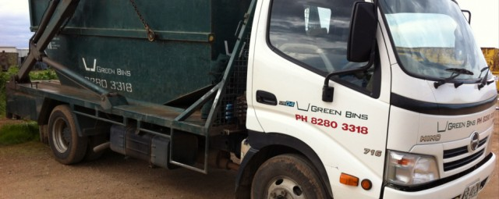
Coming to Specialist skip canisters in Adelaide tend to be a significant measure more experienced in this point. They are known not the only thing that is in any way important from white stock to resting pad reusing.
Skip Bins Adelaide for rental administrations would likewise give you a hand in evacuating the wastage that you have gathered. Thusly, you don’t have to stress over heading off to the dump yards, however simply rundown out a general pick- up time with your junk evacuating organization. They will come to take away your containers and supplant it with a crisp and a void one for the next day.
Advantages of Skip Bin Adelaide
Enrolling a Skip Bin association incorporates focal points also. If you are not satisfied, you can decrease your understanding imperatives with them. These associations would in like manner give recommendations on your skip size and sort. Also, if you oblige more Skip Bins or need to change the present model that you are using, all that you need is to make a phone call and presto! The organization would be at your portal.
We have variety of Skip Bin Hire Services in Adelaide. Leave all the hard work to us as we know exactly how to provide a great service. GreenSkipbinsAdelaide knows exactly what hard and reliable work is, as we driver for working to keep strong values within the business. We offer skip bins hire in Adelaide, as well as recycling services aimed at managing waste products in an efficient and ecologically friendly way.

For more information call us on: 0882803318 or send Email us on: greenbins@y7mail.com or visit us at: http://greenskipbinsadelaide.com.au/

