Diencephalon
- Site: It is the part of the brain which:
  - Lies between the lower parts of the 2 cerebral hemispheres.
  - Lies above the midbrain.
  - Surrounds the 3rd ventricle.
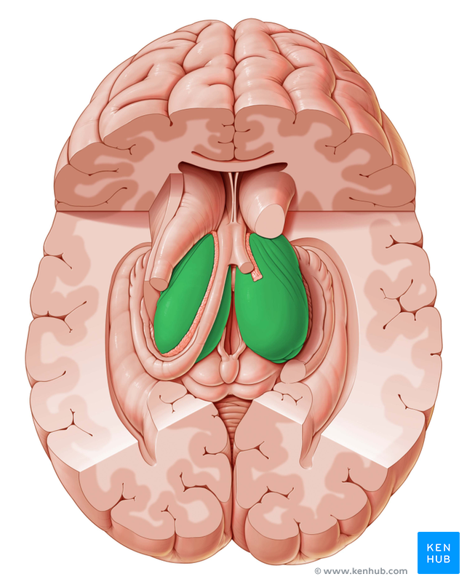

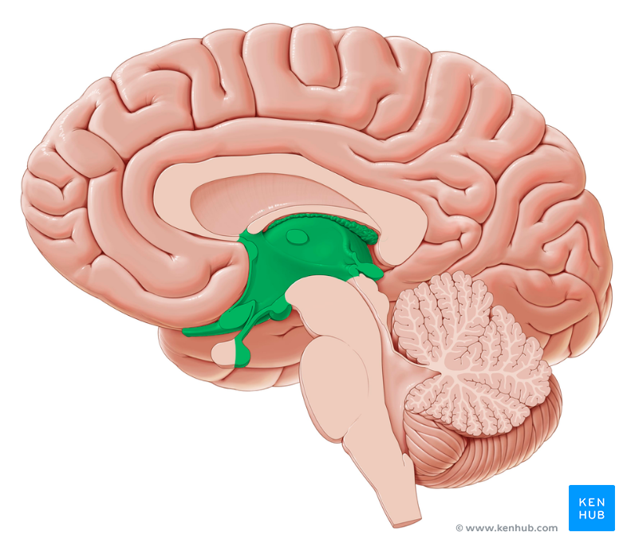

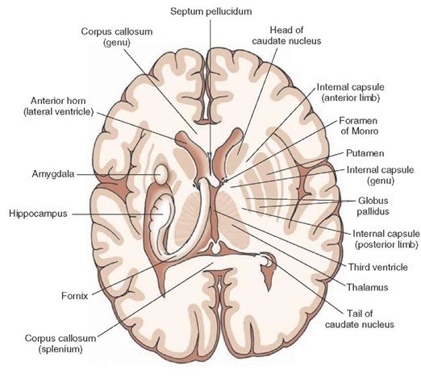

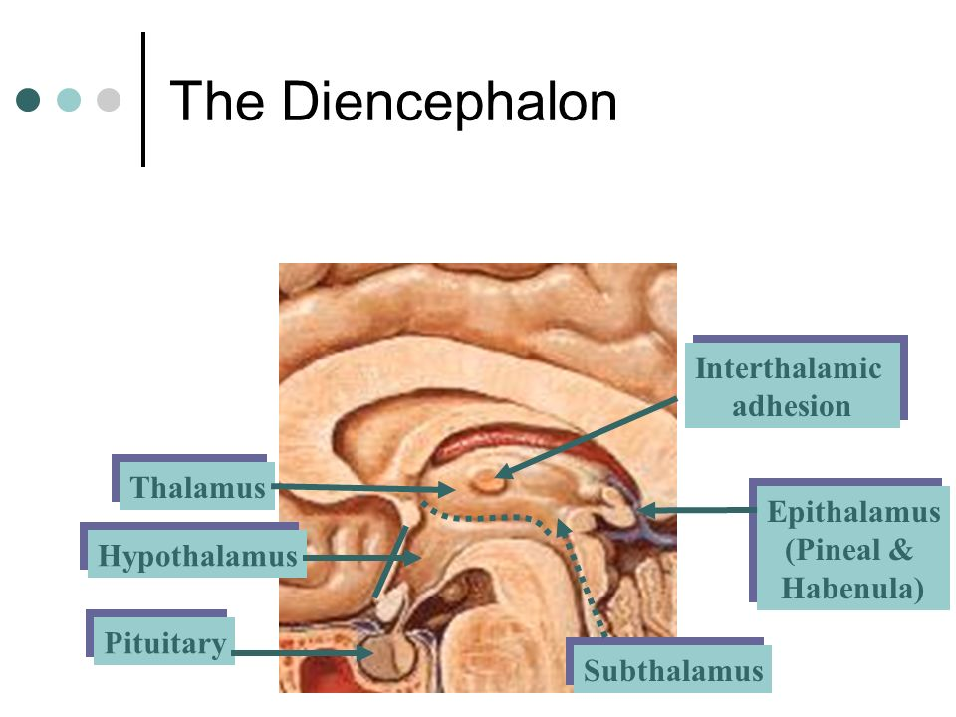

- Subdivisions: 5 parts:
    - Thalamus: Is the largest part. It is the secretory of the cerebral cortex; all ascending sensory impulses (except smell) have to stop and synapse first in the thalamus before reaching the cerebral cortex.
    - Metathalamus: Is formed of the lateral and medial geniculate bodies which are attached to the lower surface of the posterior end of the thalamus.
    - Subthalamus: Is the part which lies directly above the midbrain.
    - Hypothalamus: Lies in front of the subthalamus; it contains certain autonomic nuclei.
    - Epithalamus: Is formed of the 2 habenular trigones , the habenular commissure and the pineal gland . It is a relay station on the descending pathways from smell centres in the cerebral hemisphere to the tegmentum of the midbrain.
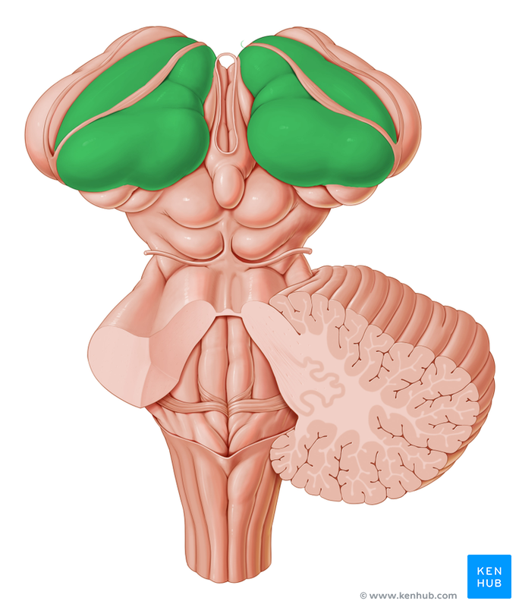
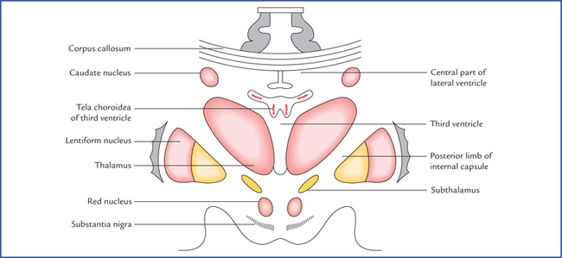

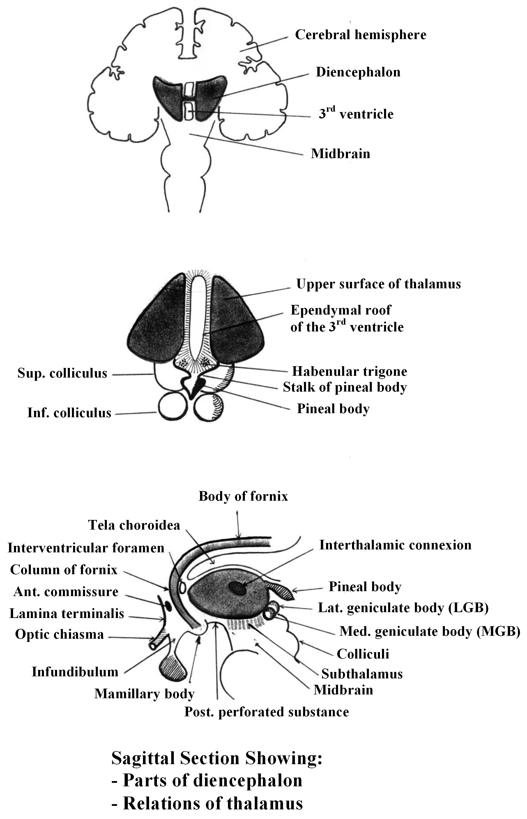
The Thalamus
              - It is a large oval mass of gray matter ( 4 cm long ).
              - Site: It is situated on both sides of 3rd. ventricle, immediately above the subthalamus which separates it from the tegmentum of the midbrain .
              - Shape and relations: It is oval in shape having:
1-Anterior end: is narrow and rounded and forms the posterior boundary of the interventricular foramen.
        - It contains the anterior nucleus of the thalamus.
2-Posterior end: is expanded & prominent called the pulvinar which overhangs the medial and lateral geniculate bodies.
3-Upper surface: Which can be divided into:
- Medial extra-ventricular part : covered by the edge tela choroidea of the 3rd ventricle and the body of the fornix.
- Lateral intraventricular part : lies in the floor of the body of lateral ventricle, covered by ependyma and partly hidden by the choroid plexus of the lateral ventricle.
4- Lower surface: is divided into 3 parts:
- The anterior part: is related to the hypothalamus
- The middle part is related the subthalamus which lies over the midbrain.
      - The posterior part is formed by the metathalamus (medial and lateral geniculate bodies).
5--Medial surface: forms the lateral wall of the 3rd ventricle , thus covered by epyndyma, and is connected to its fellow by a mass of gray matter called the interthalamic adhesion .
6--Lateral surface: Which is related:
- Above: to the body of caudate nucleus separated from it by the stria terminalis and the thalamo-striate vein.
- Below: to the posterior limb of the internal capsule separating the thalamus from the lentiform nucleus.
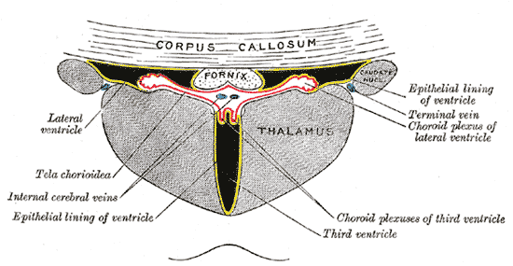
6- The posterior part is formed by the metathalamus (medial and lateral geniculate bodies).

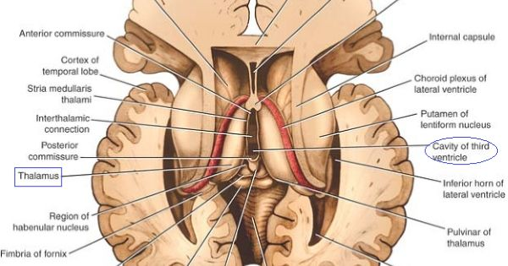

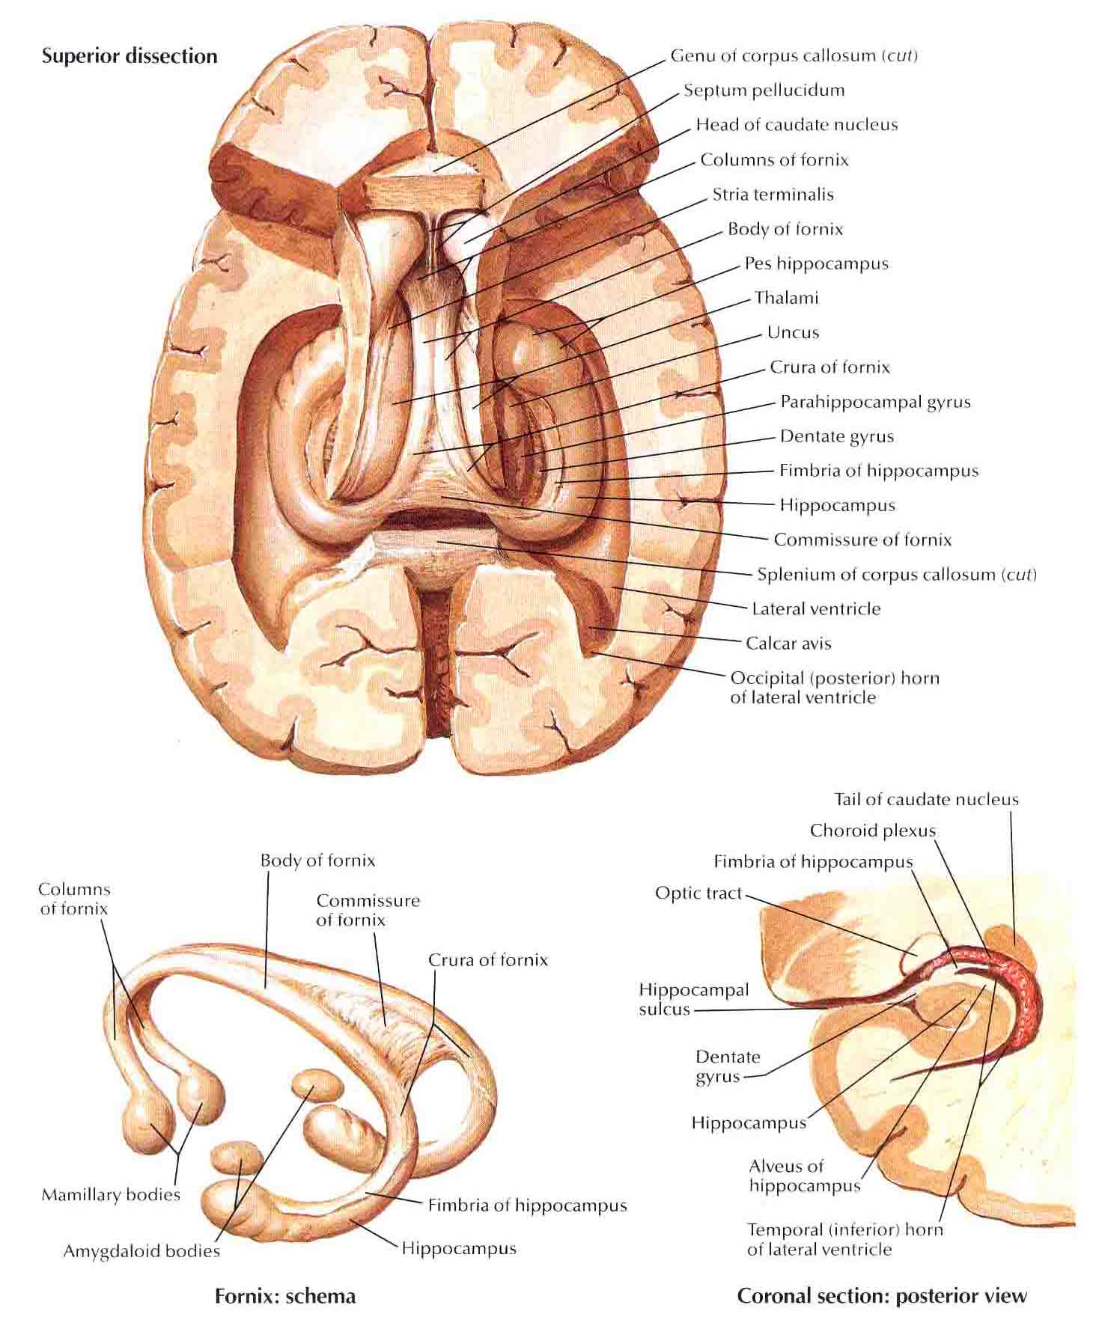
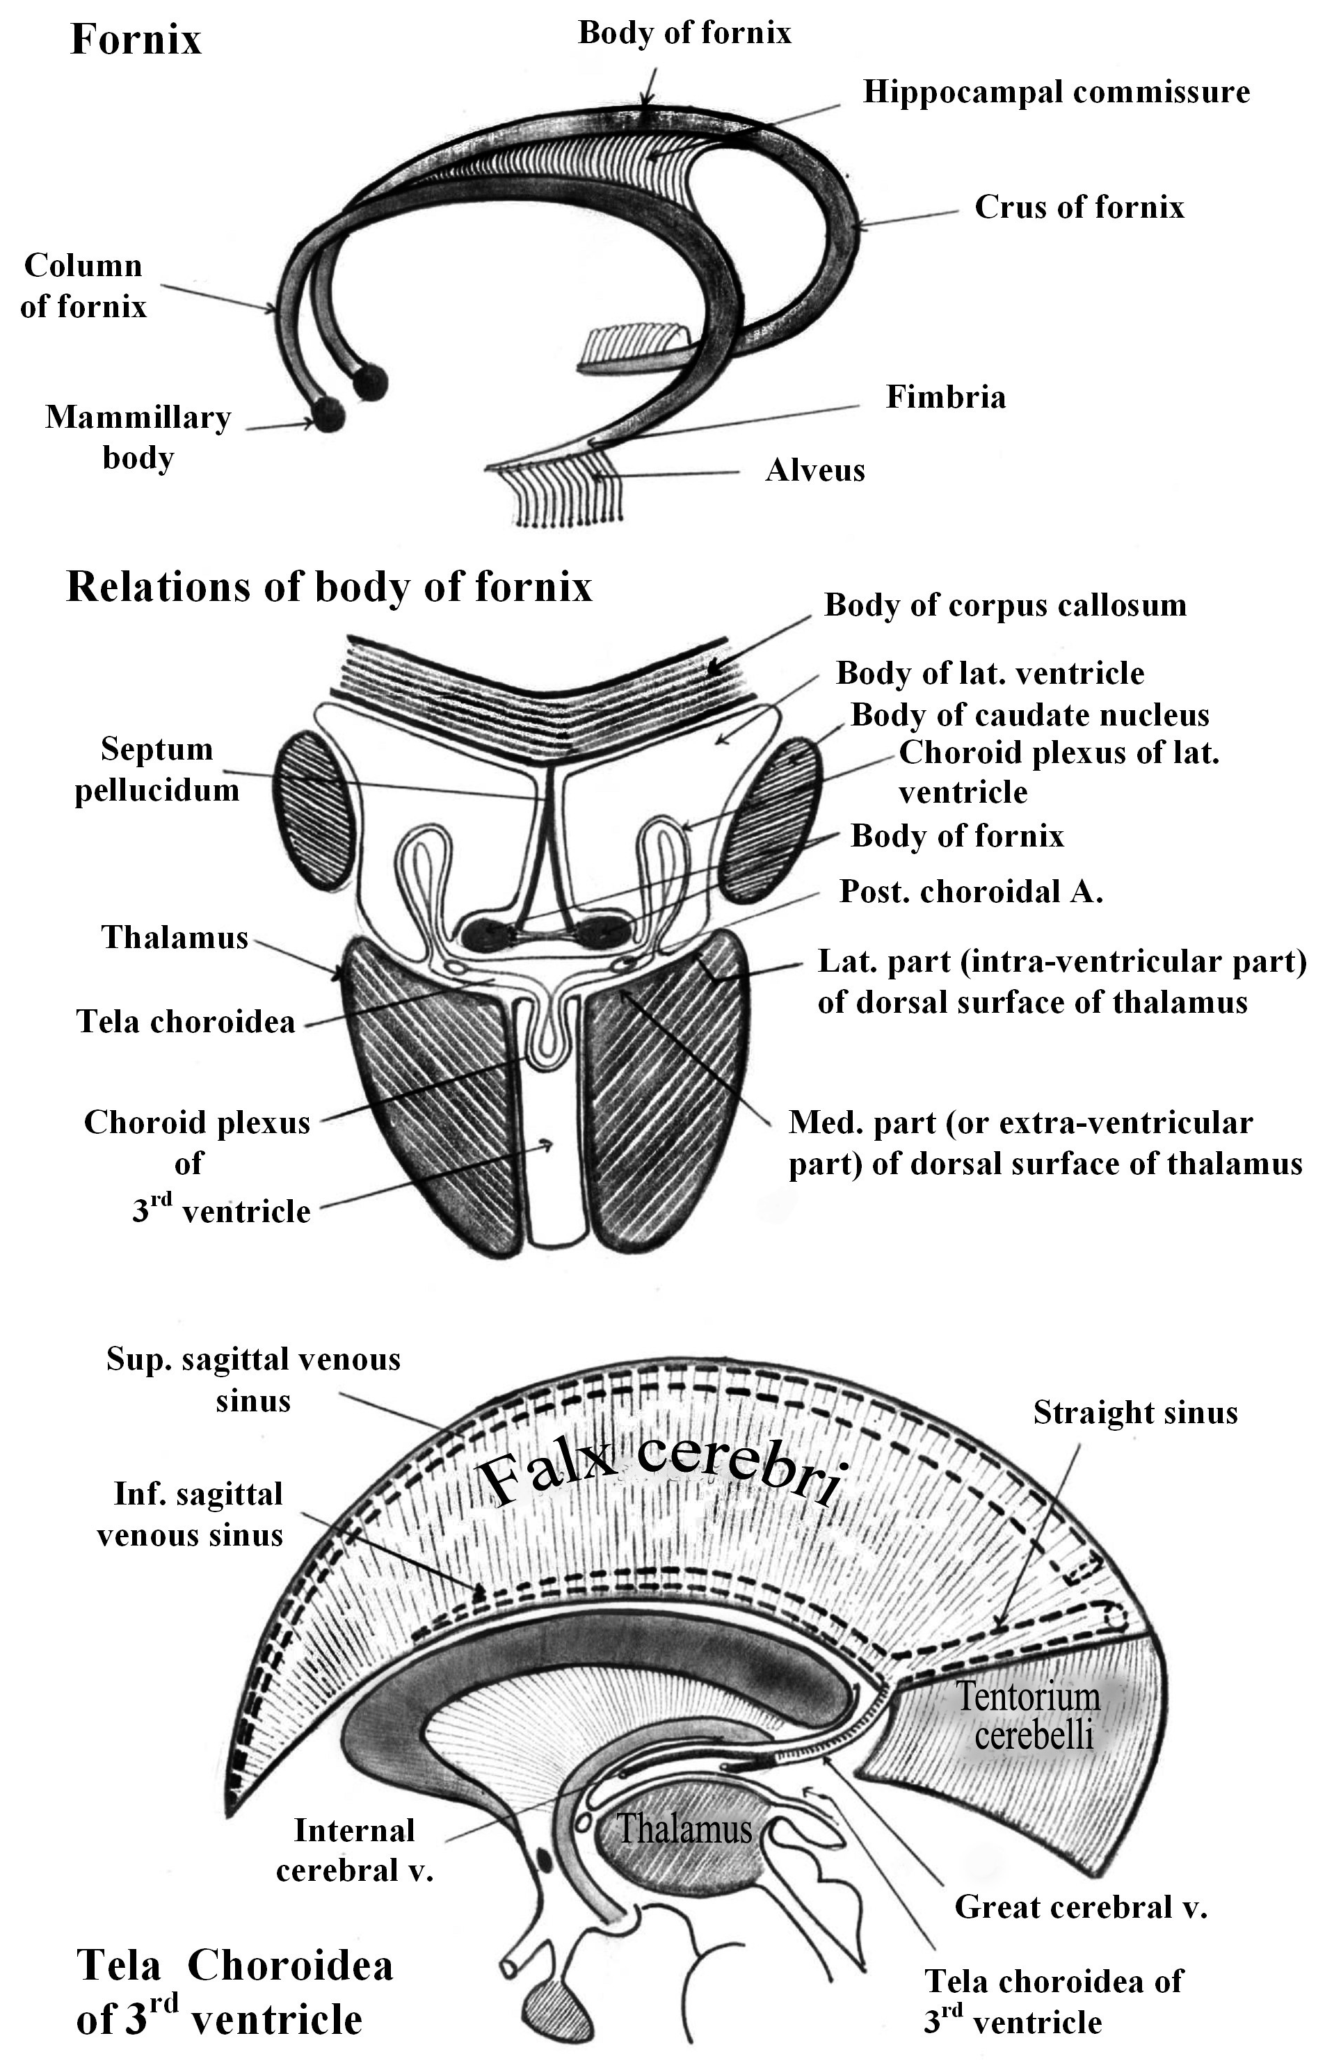
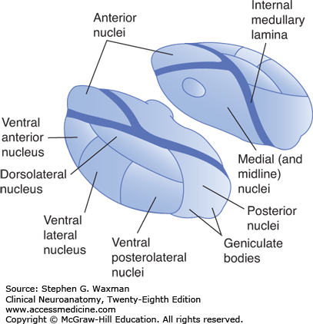
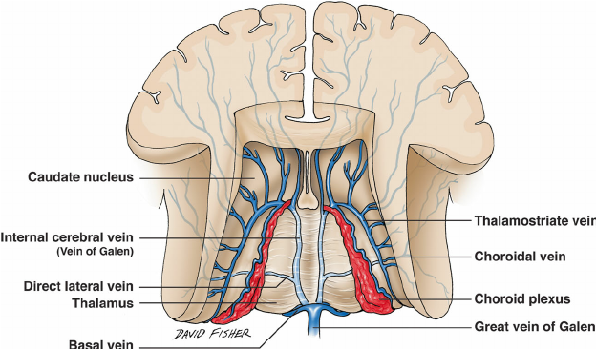
              - Nuclei of the thalamus:
  - The thalamus is divided by a Y-shaped vertical sheet of white matter called the internal medullary lamina into 3 parts:
    - The anterior nucleus:
      - Occupies the narrow anterior end of the thalamus.
      - It receives its afferent fibres from the mammillary bodies via the mammillo-thalamic tract.
      - It sends its efferents through anterior thalamic radiation to the cingulate gyrus.
    - The medial nucleus:
      - Receives its afferent fibres from the nuclei of the hypothalamus.
      - It sends its efferents to the frontal pole of the cerebral cortex.
      - It is concerned mainly with the visceral sensations & provide a center for integration for visceral and somatic activity.
    - The lateral nucleus:
      - It is subdivided into dorsal and ventral part which are in turn subdivided into several smaller nuclei; the most important of the ventral nuclei is the posterior ventral nucleus of thalamus (PVNT).
      - The PVNT can be divided into:
          - Lateral part (PLVNT) which receives:
  - Conscious proprioceptive, fine touch sensations from the opposite side of body below the head via the medial lemniscus.
  - Pain, temperature and crude touch sensations from the opposite side of the body below the head via the spinal lemniscus.

          - Medial part (PMVNT) which receives:
  - Pain, touch, temperature , proprioceptive and taste sensations from the opposite side of the head via the trigeminal lemniscus.
- The PVNT sends its efferent fibres , through superior thalamic radiation , to the main sensory area (3, 1 , 2) in the postcentral gyrus of the parietal lobe.
    - The posterior end expanded to form the pulvinar which contains the posterior nucleus:
      - It sends efferent fibres to the inferior parietal lobule. It seems to have an associative function.
- Function of thalamus :
1- The thalamus receives a large number of information from spinal cord, brain stem , cerebellum , reticular formation , hypothalamus and corpus striatum .
  - 2- The thalamus sends these information through efferent fibres via the internal capsule to all parts of the cerebral cortex (thalamo-cortical fibres or thalamic radiation) which influence the cortical activity.
3- All the thalamic nuclei receive projection fibres from many parts of the cortex (cortico-thalamic fibres) which enable the cortex to influence the thalamic activity .
4- In addition it sends fibres to subcortical centers as the corpus striatum and the subthalamic nuclei.

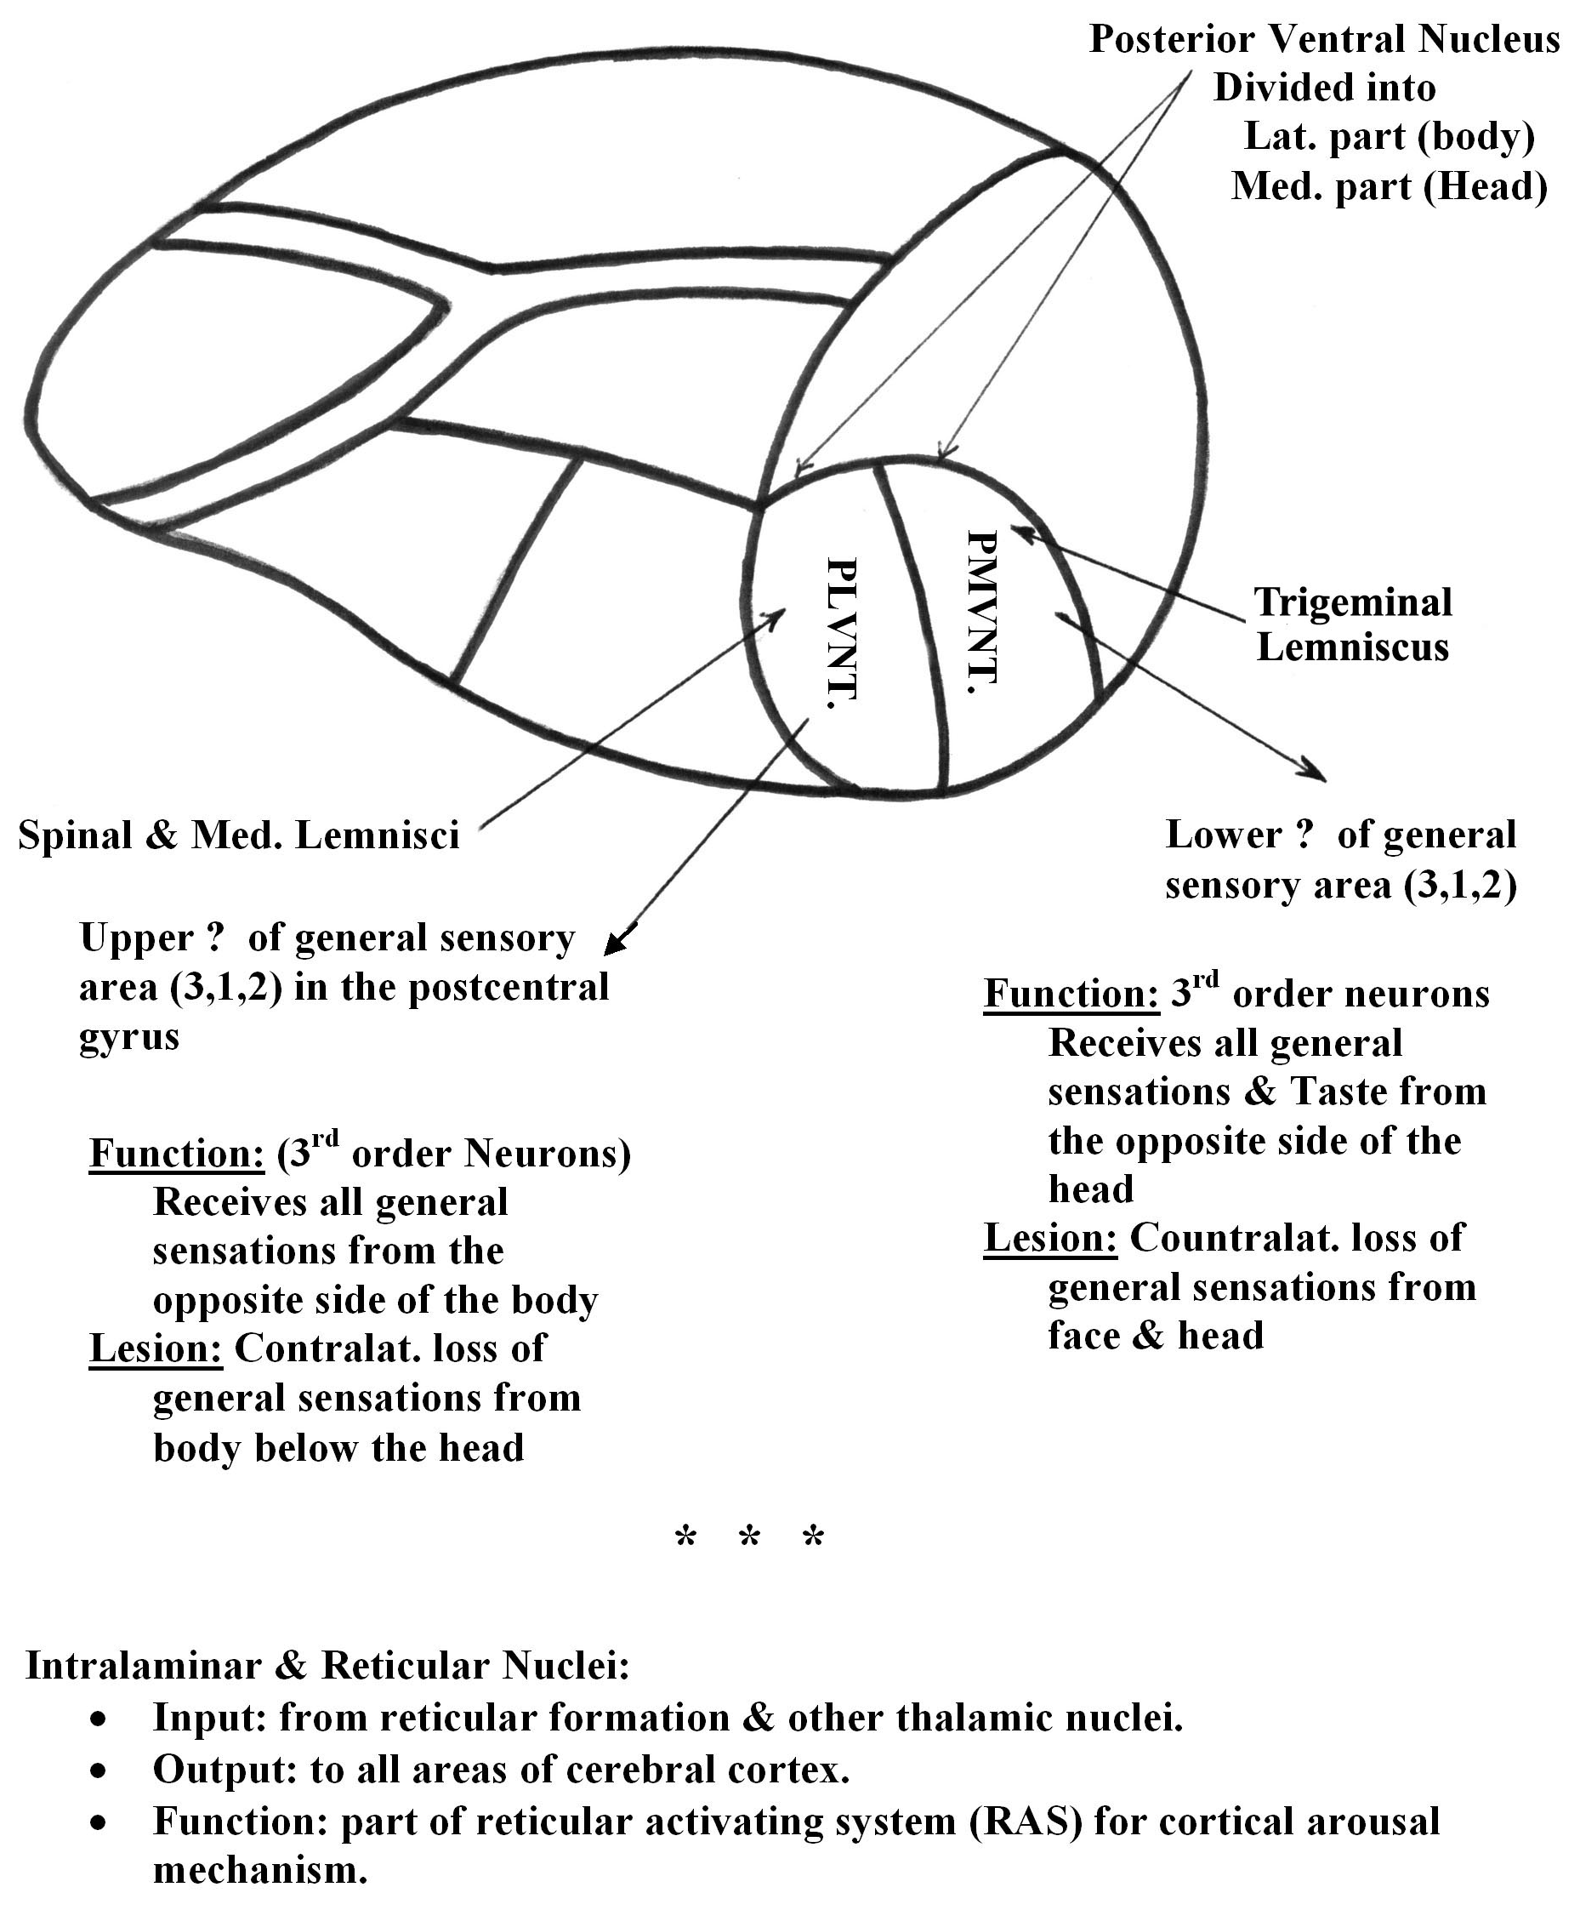
Lower ⅓
Upper ⅔

Metathalamus (Geniculate Bodies)

- They are placed on the lower surface of the posterior end of the thalamus (pulvinar).
- The metathalamus consists of the geniculate bodies .
- They are centres of hearing and vision:
- Medical geniculate body (MGB):
  - Receive afferent auditory fibres either directly from the lateral lemniscus or indirectly from the inferior colliculus via the brachium of the inferior colliculus.
  - Its efferent fibres, pass via the sub-lentiform part of the internal capsule; auditory radiation, to the superior temperal gyrus (area 41 and 42).
  - It functions as a relay station on the auditory pathway. (the 4th.order neurons in the pathway of hearing).
- Lateral geniculate body (LGB):
  - Receives afferent fibres from the optic tract.
  - Its efferent fibres, pass via the retro-lentiform part of the internal capsule , visual radiation , to the occipital cortex (area 17).
  - It constitutes 3rd order neurons in the pathway of vision. It represents the only synaptic interruption on the visual pathway from the retina to the visual cortex.

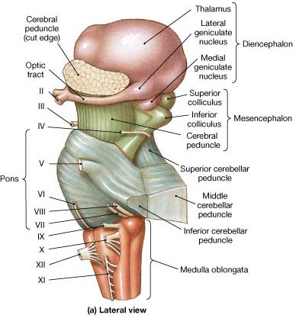
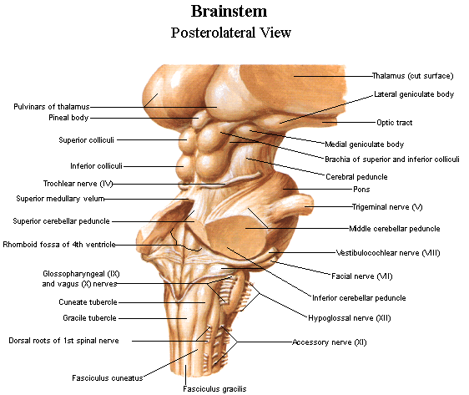
The Subthalamic Region

- It is the part of the diencephalon which lies immediately below the thalamus and connects it to the tegmental region of the midbrain.
- It can be divided into 2 parts; (posterior and anterior):
- Its posterior part contains 5 bundles which ascend from below to reach the thalamus. These bundles are the medial lemniscus, spinal lemniscus, trigeminal lemniscus, reticulo-thalamic tract and cerebello-thalamic fibers (ascending fibres of the superior cerebellar peduncle).
- Its anterior part contains:
  - Three nuclei:
    - Upper end of the red nucleus.
    - Upper end of substantia nigra.
    - The subthalamic nucleus :. It is a part of the extra-pyramidal system.
  - Two bundles:
    - The fasciculus lenticularis.
    - The ansa lenticularis.
        - These 2 bundles form pathways which descend from the lentiform nucleus to reach the tegmentum of the midbrain.

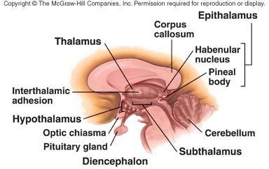
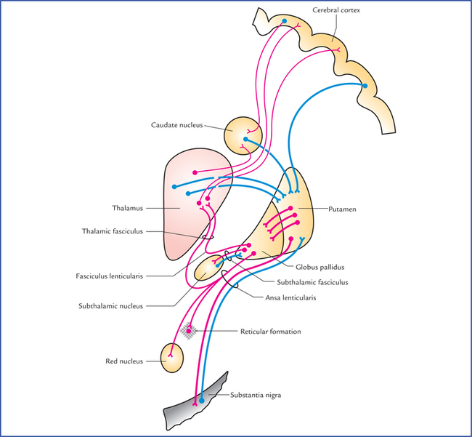
The Hypothalamus

- The hypothalamus comprises:
- Horizontal part the structures which from the floor of the 3rd ventricle (the contents of the inter-peduncular fossa); they are: the infundibulum, the tuber cinereum, the mammillary bodies and the posterior perforated substance.
- Vertical part the structures which lie in the lateral wall of the third ventricle below and in front of the hypothalamic sulcus.

