How to write new games to Your RGH / Freeboot XBOX Console
- Download Xbox 360 Game from the torrent
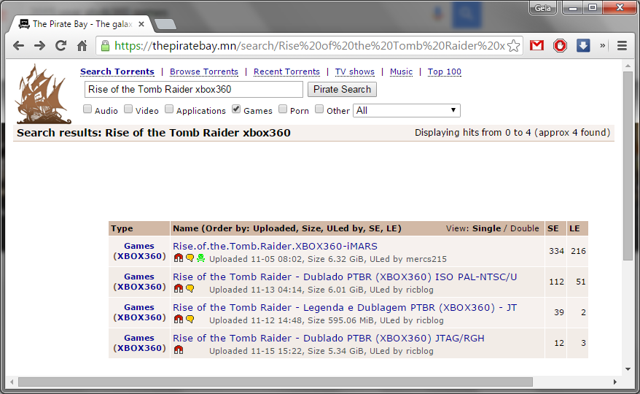
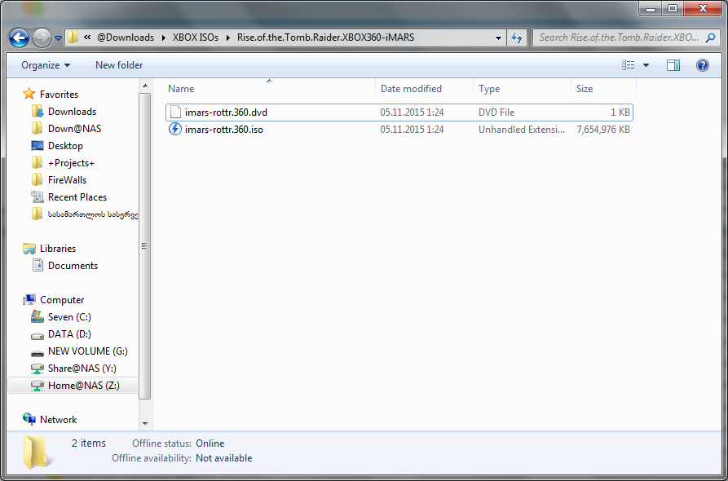

- Extract ISO file with Xbox 360 iso Extractor software
http://xbox-360-iso-extract.en.lo4d.com/
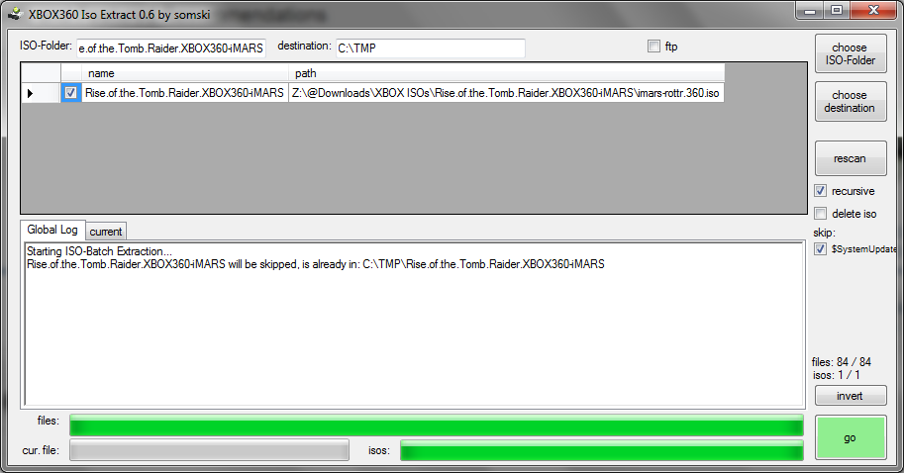

Extracted folder must look like this one and must include default.xex Xbox executable file
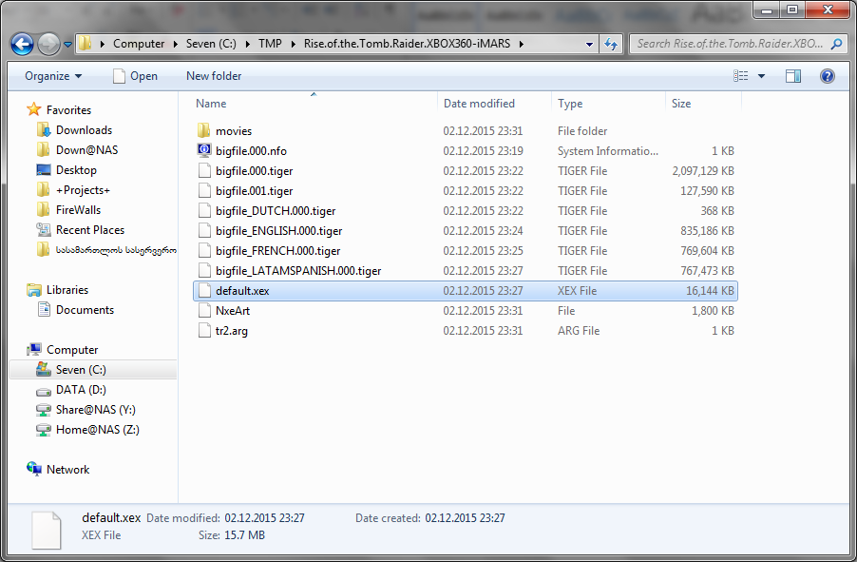
- Start Xbox and inside Freestyle Dash find your Xbox 360 IP Address:
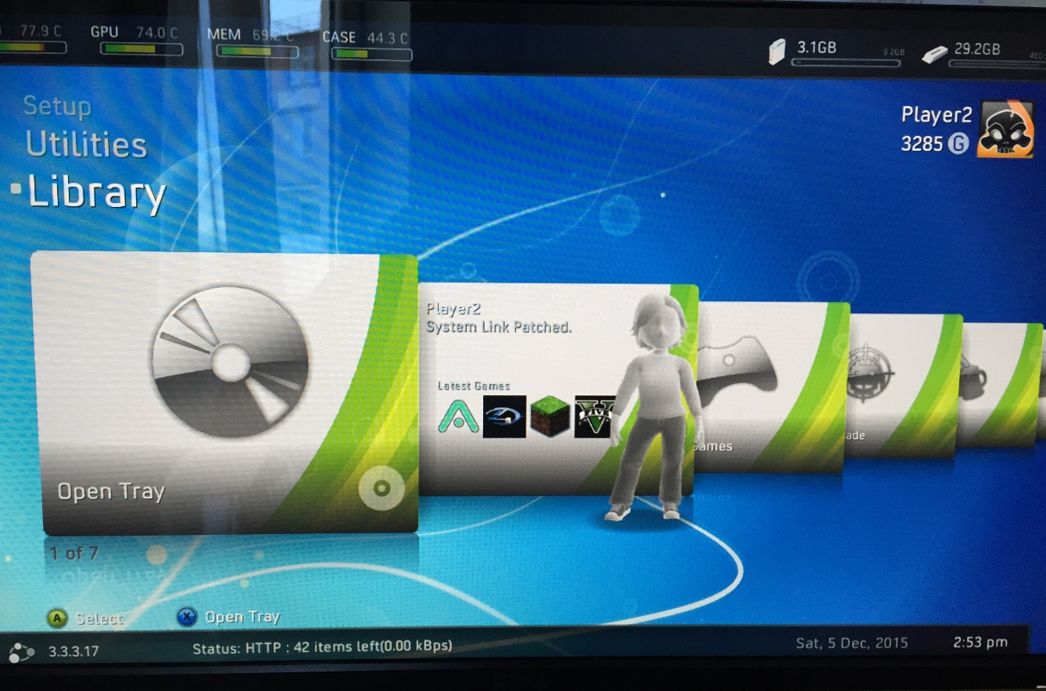
Xbox IP Address
- Make sure that “Enable Samba Server” checkbox is Checked (Like on the Picture)
(you can find this option inside Freestyle Dash > Settings>General Settings>)
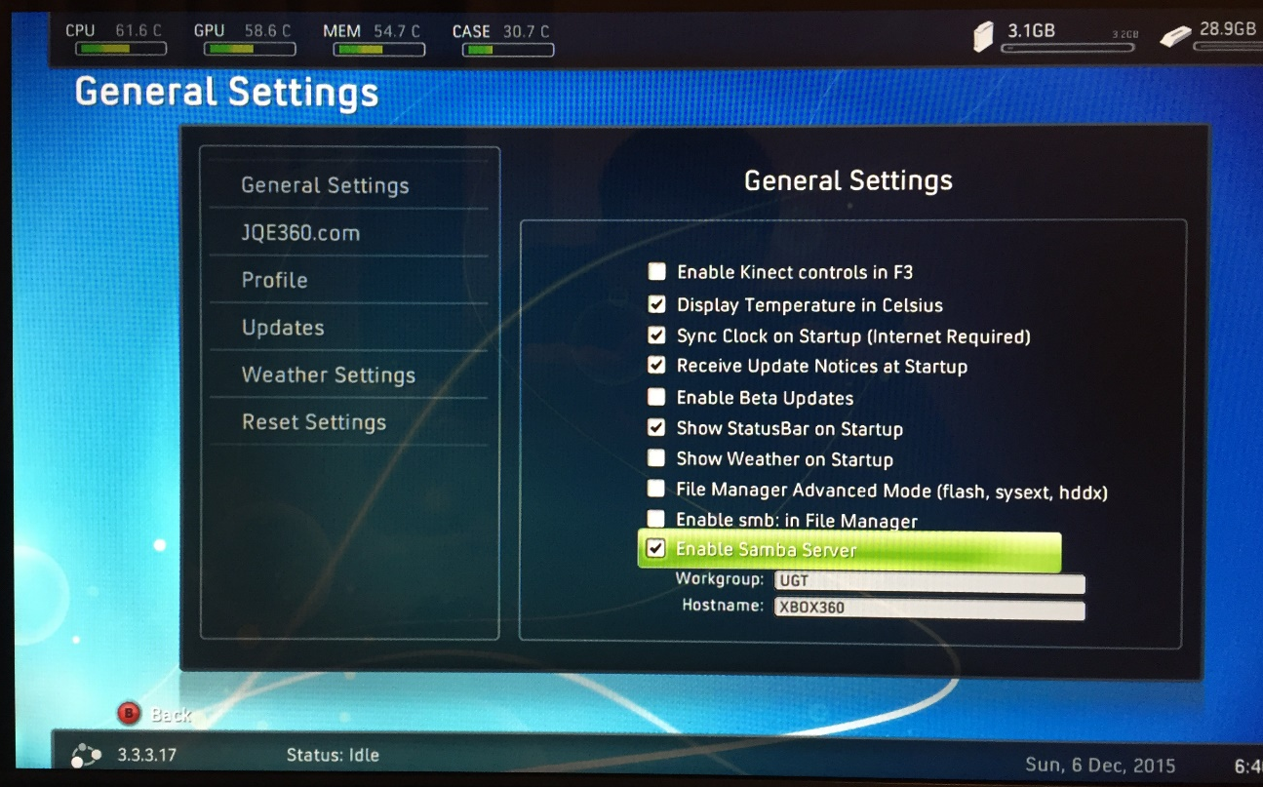

- From your windows , open network share \\Your-Xbox-IP-Address
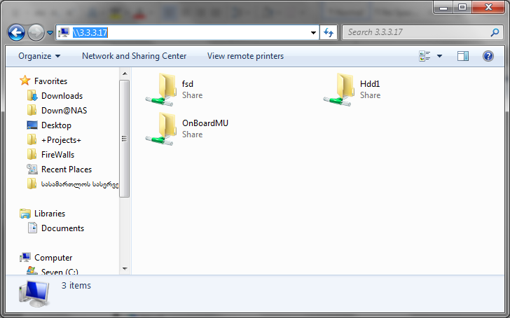

- Browse games folder:
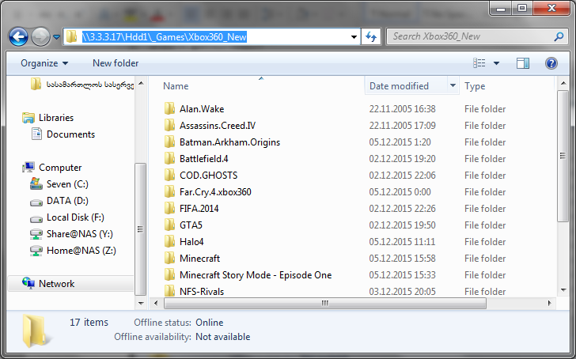
- Copy extracted Xbox game folder with all files inside \\XBox-IP\Hdd1\_Games\Xbox360_New folder
- Restart XBOX
New games must appear in your XBOX Library

