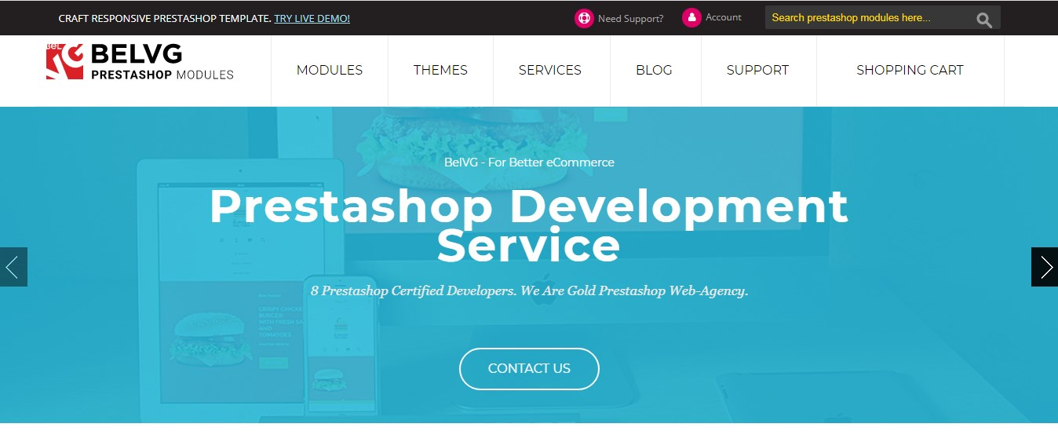

Hi. My name is Lynne L. Creighton. I am 34 years old. I have been working as a web designer for several decades now. I really enjoy my job, it's that I work with a programmer to help people with their sites and internet stores. I used to work at a business and also do everything in a group, but I chose to quit that job and do everything . I had a great deal of expertise and that I wasn't afraid that there would be no orders or a number of these.
For all my experience in site design and development, I already know plenty about how to generate a fantastic site and what's behind it. At first glance in the site you see that there is nothing complicated. But today's online shop - it isn't only taking photos and putting requests, and complex daily collaborative job of a developer, programmer, accountant, operator, warehouse employees, couriers, models, photographers, photo editor, PR and much more. This is a well-coordinated teamwork that will gradually lead to the result of the client's requirements. As a programmer I believe that the design of the site should not be some colorful wallpapers, parallax, movie, effects for focus and clicking - all restrained, the functionality dominates. Do not be fearful of problems with search engines because of non-uniqueness. Even with a typical free theme that a well-optimized system does not have issues. With a template, you'll also prevent the difficulties in further maintenance of the custom layout and its connection to the backend. My templates and other characteristics for the site I choose from https://module-presta.com/ because I like their selection and user-friendly interface which enables you to choose exactly what I need for a particular order. Most frequently I utilize PrestaShop 1.7 and there's the very best collection of ready made designs I have observed.
For me personally, the most important role would be the last result, in order that everything was just as the client wanted and nothing else. The client might also have a distinct budget. During the time that I worked for the firm we were mostly addressed by big companies that needed a serious website with superior content. Now, however, I can make simpler stores for individuals, should you use simpler solutions and understand exactly what ought to be the outcome.

