IPTV Technology - Making Television Better For The Future

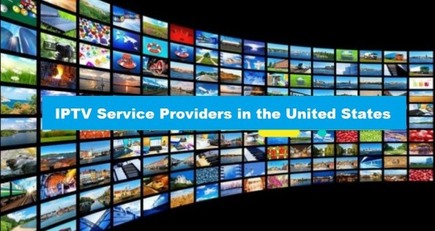
IPTV technology is currently transforming just how people will view growing media. The many benefits of iptv smarters in comparison to the classic cable or even satellite tv broadcasting methods, is that it is likely to make use of the internet to help steady stream all of its contents. Using this brand-new path towards the music it can now provide a custom way which will suit a huge variety of applications. An example could be all hotels, schools and also hospitals will benefit from it is abilities and the services With the ability to provide. If you just want to put more interactivity or maybe merely broadcast to a larger lot of people, or perhaps increase the level of quality in the picture and also the video alternatives, you can perform this without the additional outlay. This most advanced technology is able to provide you with an excellent option for all of these kinds of demands.
Inside hotels, the benefits of this IPTV technology are enormous. According to what a hotel would want to offer you its guests, this services can easily provide some stay and on-demand access to plenty of television shows, movies and online games too. There will be the option of supplying each of these without any expense with each and every room of the motel. This is a wonderful facility for those guests to gain access also. They can have the practicality the traditional TV was not capable of provide. It may well also be accustomed to broadcast useful information from your hotel directly to the guests, with regard to the guest to be able to view their bill from the comfort of the TV set. Hospitals are a additional place where this kind of service can be incredibly beneficial too. With the significant quantity of rooms and their patients, there will more than likely be a very large variety of encoding for all the patients to choose from, specifically those who are confided to mattresses, where this service provides for them a distraction from the utilisation of entertainment.
This specific technology is also something that can be used in schools too. As opposed to the early morning announcements that are constantly heard over the P. Any. System, IPTV will offer the likelihood to now broadcast a that will reach each and every area in the school. This is a good plan and can also be used when there will be a need for discussing some educational video details with multiple classrooms all in one. One other innovative use of that technology is to feed water-proof bathroom televisions. These IP enabled waterproof TVs during installation in numerous hotels and high-class homes.

