The truth unveiled about the poisonous grasshopper florida

1. Appearance
The grasshopper species commonly referred to as the rainbow grasshopper, painted grasshopper, or barber pole grasshopper, is a visually striking insect that boasts a range of vibrant colors, including red, blue, yellow, and green.
Despite their beauty, rainbow grasshoppers are relatively small compared to other related species, with females averaging 1.4 inches (35 mm) in length and males measuring about 0.8 inches (20 mm). Adult rainbow grasshoppers typically weigh around 0.01 ounces (0.28 g).
Rainbow grasshoppers are non-toxic, and further information on their characteristics can be found at: https://ofacts.org/invertebrates/rainbow-grasshopper-facts/
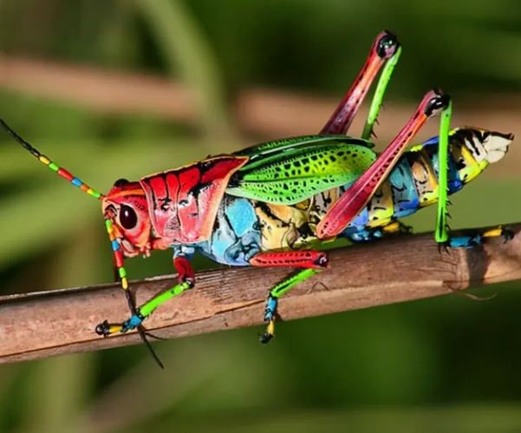

2. Range and habitat
These diminutive creatures are found throughout North America, from southern Canada to northern Mexico, with populations in New Mexico, Arizona, northern Mexico, and Texas. They prefer arid grasslands and deserts with warm weather, including dry grasslands, short grass prairie, sparsely vegetated areas, alfalfa farms, and similar habitats.

3. Life cycle and diet
Rainbow grasshoppers have an average lifespan of about one year, which is typical for insects. While adult rainbow grasshoppers are not overly selective in their food choices, their nymphs have more specific diets and tend to feed on a particular species native to the area. For instance, in New Mexico and Arizona, young rainbow grasshoppers exclusively eat Wright’s false willow (Baccharis wrightii).
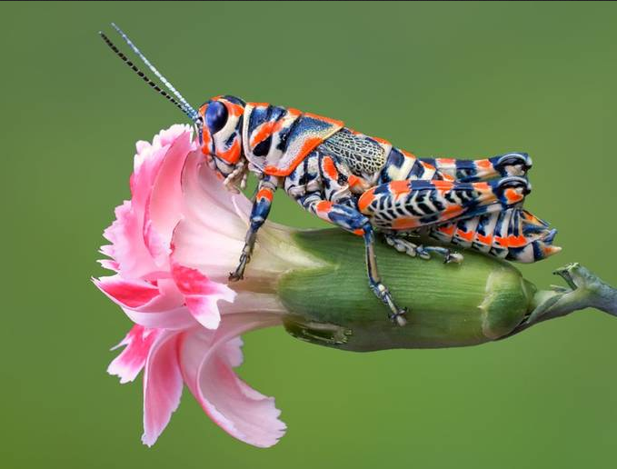

4. Conservation
The rainbow grasshopper is classified as Least Concern on the IUCN Red List, indicating that the species is not under significant threat. While it is unknown precisely how many rainbow grasshoppers exist, their numbers are believed to be sufficient to avoid being listed as endangered.

