Best Business Trip Massage in Korea
Today whether you are on vacation or on a business trip, cool massage/전주출장안마 is a must for everyone. A good massage from soft and soft hands can calm your nerves. When it comes to massage, not to mention Korean things will not go well as Korean massage parlors are the most popular. An in-depth and detailed search on the web will provide you with a list of massage parlors located in Korea that offer their services at a reasonable cost. On their websites, they have their services detailed and priced and other details.

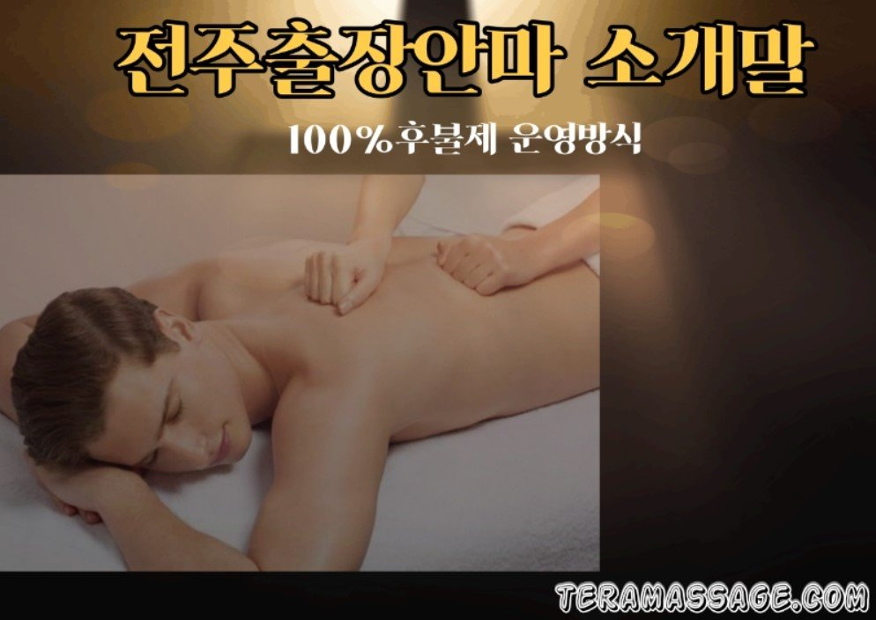

A team of highly skilled massage therapists are available through these websites. You just need to visit them once and you will surely have an amazing experience. They have a variety of massage packages designed for their customers, after checking the website you can choose the one you prefer. With their skillful hands, these Korean beauties make sure to make their customers feel happy and satisfied. Visiting there once, you will feel happy and satisfied and feel worth your money. Your stressed mind and body will relax and you will feel energized.

The best part is that you don't have to wait any longer to have this massage; they are always available to their customers 24 * 7. They are always open even on Saturdays and Sundays. Their service package is available at reasonable prices and depending on the options there is a large category and you can choose one as per your taste and preferences. The massage services available with them are excellent and guarantee to give you the greatest satisfaction. If you want to book a massage in one of these Korean parlors, you can visit one of these websites directly and after consulting with them in detail, you can directly book your appointment time only at home. These services will actually make your body feel relaxed and calm. For business people, these massage parlors have several special packages designed at discounted prices to make them feel special.

Once you visit the website https://teramassage.com you will find items designed to your liking and preferences. On their websites, they do not provide price information as it is a sensitive piece of information and thus you can communicate by phone. Rest details are available on the websites. A perfect massage session from the beauty of Korea is a dream of many so if you get the chance to do so, you should do it once. It will not only make your body feel relaxed but also help you to have a happy mind. As well as having many physical benefits, you can improve your mental health with this massage as the stress is only on the mind and it also comes to the body. So if you have a stress-free mind, things will be better for you.

