

June 12, 2022, 10 a.m.
First Sunday after Pentecost

Union Congregational Church
United Church of Christ
Elk River, Minnesota 55330
763-441-1203
www.elkriverucc.org
churchoffice@elkriverucc.org

Welcome!

Union Congregational Church, United Church of Christ welcomes everyone, no matter who you are or where you are on your faith journey.

We oﬀer worship via Facebook Live broadcasts every Sunday at 10am. You can be here in person or participate virtually during, or any time after the service. Every Sunday, the service is recorded and broadcast on Facebook. You can contact the church at any time. See oﬃce hours below.

Please SILENCE cell phones during the service.
The wi-fi password is: stillspeaking1203


VISION
God has shown you, O mortal, what is good. And what does the Lord require of you? To act justly and to love mercy and to walk humbly with your God.
(Micah 6:8, (NIV))

Union Congregational Church, United Church of Christ Mission Statement

God calls us to minister to each other. This ministry goes beyond our congregation into the community, wider world, and to the earth itself. We seek to reach those in the margins of society, to empower the powerless, and to leave this earth a better place than when we each arrived

LIGHTING THE CANDLES

PRELUDE

WORDS OF CENTERING

Open Doors for Youth is a safe, welcoming community resource where young people experiencing homelessness can access needed goods and services while building trusting relationships with helpful adults.

WELCOME

If you are in-person, we invite you to fill out the friendship pad to let us know you are here.

If you are worshipping virtually, we invite you to click a reaction button on Facebook to let us know you are with us.


is located in the Vestry. (the room off of the sanctuary)
Also, in the back of the sanctuary, is a table with items and bags for activities appropriate for the kids to work on and play with during the service. Children are welcome to sit at the table or bring the bag back to sit with parents.

CHORAL CALL TO WORSHIP 283 “Spirit of the Living God”
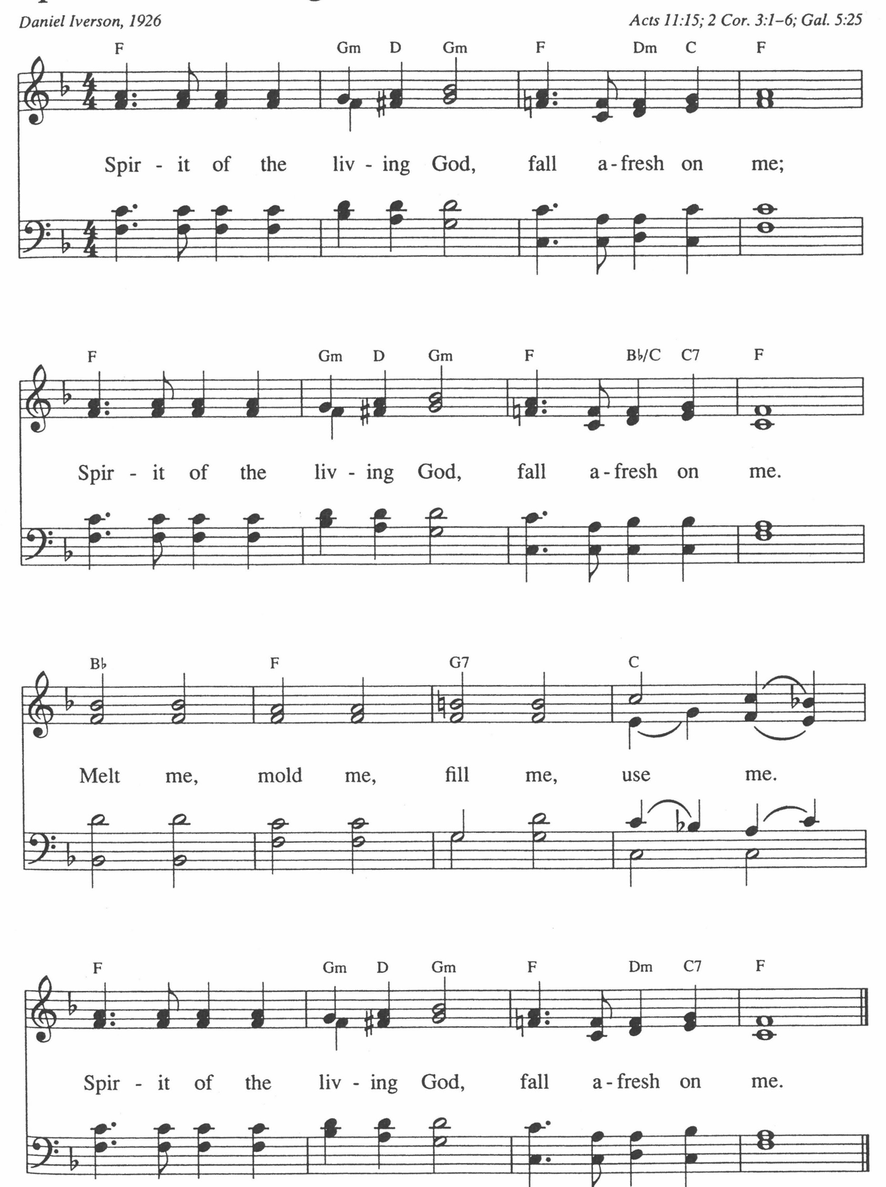
CALL TO WORSHIP (PLEASE JOIN IN CALL AND RESPONSE)

One: God’s Spirit moves among us, binding us in covenant with faithful people of every time and place.

Many: The Spirit moves within us, empowering us to proclaim the good news to all people.

One: The Spirit moves through us, making us channels of God’s love.

Many: As we gather for worship, may we be open to the Spirit of the living God, within, among and through us.

HYMN 498 “Jesu, Jesu, Fill Us with Your Love” vs.2,3,4
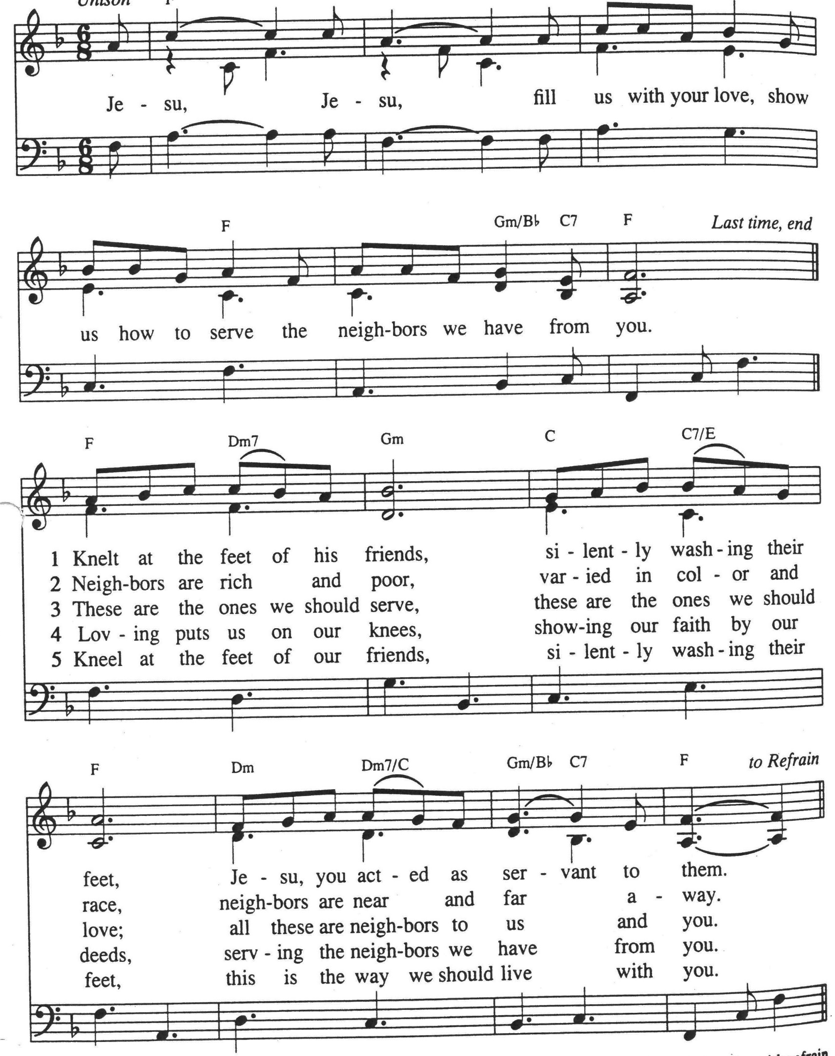

LIGHTING THE PEACE CANDLE & PEACE PRAYER

GREETING OF PEACE

In the same spirit in which we receive the unconditional love of God in Jesus Christ, let us oﬀer to one another our own sign of peace.
One: The Peace of Christ be with you.

Many: And also, with you.
SPECIAL MUSIC
SCRIPTURE Psalm 8 NRSV
O Lord, our Sovereign,
how majestic is your name in all the earth!
You have set your glory above the heavens.
Out of the mouths of babes and infants
you have founded a bulwark because of your foes,
to silence the enemy and the avenger.
When I look at your heavens, the work of your fingers,
the moon and the stars that you have established;
what are humans that you are mindful of them,
mortals^{[a]} that you care for them?
Yet you have made them a little lower than God^{[b]}
and crowned them with glory and honor.
You have given them dominion over the works of your hands;
you have put all things under their feet,
all sheep and oxen,
and also the beasts of the field,
the birds of the air, and the fish of the sea,
whatever passes along the paths of the seas.
O Lord, our Sovereign,
how majestic is your name in all the earth!

REFLECTION Open Doors for Youth – Cheryl Wold

HYMN 575 “O for a World”
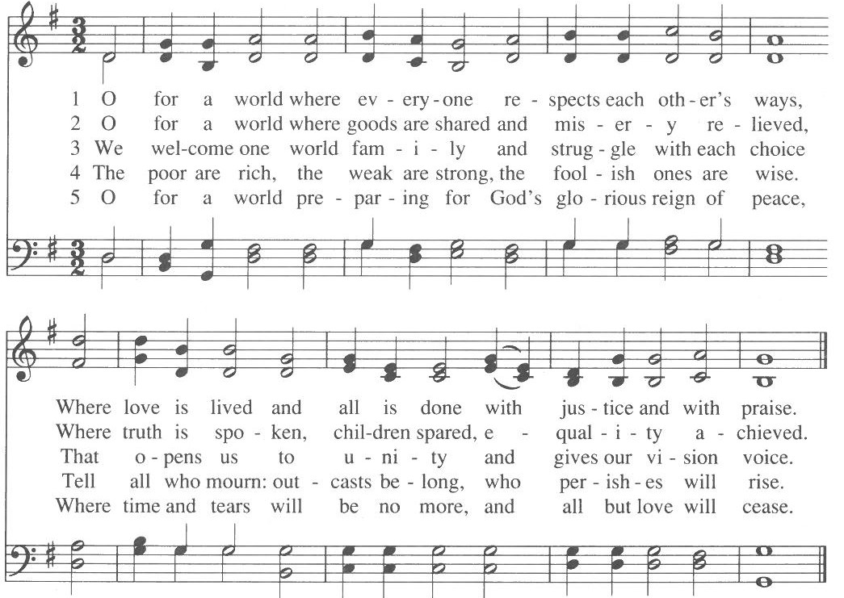

OUR TIME OF SHARING JOYS & CONCERNS, ANNOUNCEMENTS & PRAYERS OF THE COMMUNITY

THE PRAYER THAT JESUS TAUGHT (let us pray together) Our Creator in Heaven, hallowed be your name.
Your kingdom come. Your will be done, on earth
as it is in Heaven.
Give us this day our daily bread. And forgive us our sins,
as we forgive those who sin against us.
Lead us not into temptation but deliver us from evil. For yours is the kingdom, and the power, and the glory forever. Amen.

INVITATION TO GIVE/RECEIVING OUR GIFTS

OFFERTORY

DOXOLOGY 108 SPP Send Your Spirit to Set Us Free

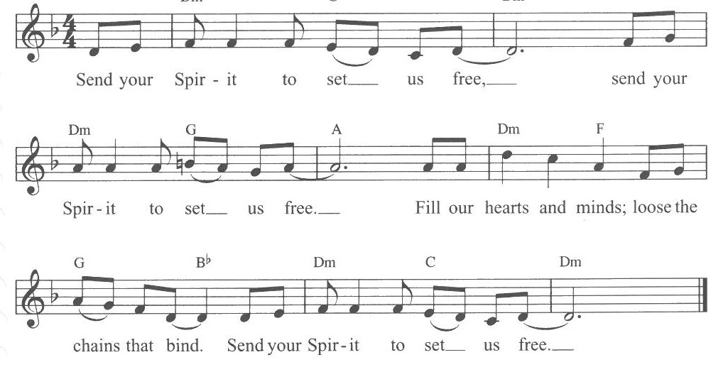

PRAYER OF DEDICATION (let us pray together)

God, bless our gifts that in this place shelter may be offered, diversity welcomed, hard times weathered, rainbows recognized. Amen.

Hymn 539 “Won’t You Let Me Be Your Servant?” vs 1 & 5
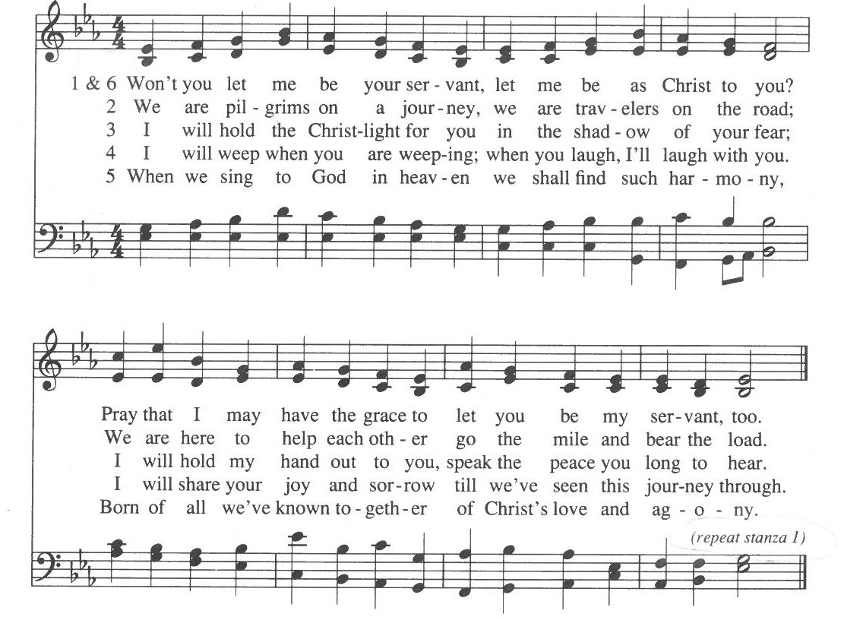

BENEDICTION
One: Inform your faith by Word and Spirit.
Many: May we transform the world by practicing the peace
of Christ.
One: Go forth as disciples, so that through your actions, you will be loving of others. Amen.
POSTLUDE

All re-printed music is licensed under CCLI 11010370

Elk River Union Congregational Church, United Church of Christ Pastor: Rev. Robin Raudabaugh Deacon: Marce Ediger
Oﬃce Administrator: Giuliana Beckwith Liturgist: Rev. Robin Raudabaugh
Senior Choir and Handbell Director: Greeter/Usher: Peterson Family Piano & Organ: Carson Schneider Children’s Time:

Announcements

Oﬃce Hours
Oﬃce hours for the church are Sunday 9:00am to 1:00pm before and after worship, Monday/Wednesday 8:00am-1:00pm. Call the church at (763) 441-1203 during office hours if you have general questions. If you leave a message after hours, your call may not be returned until the office is open. If you need a pastor immediately, please contact Pastor Robin via the information below. The oﬃce email is churchoﬃce@elkriverucc.org.

Pastor Robin is generally in the office M, T, W mornings. If you would like to meet with her in person, it is a good idea to call ahead.

Pastoral Emergencies
In the event of an emergency, an accident, or a death, even while Pastor Robin is on vacation, please contact her directly via text at 651.216.9012, phone or email revrobin@elkriverucc.org. You may also contact the church office though the response may take longer.

Church Materials
Copies of the Sunday sermon and bulletin are available in person or via Facebook, our website, and the UCC Squared Newsletter (email).

KEPT IN OUR PRAYERS
Please keep in your prayers our congregation members: Nancy Hassett, Ella Rivers, Musz Bailey, Jim Babcock, Shelley Sherper, Bobbie Berg, Susan Olsen, Joanne Burdick, Ruby Cawthra, Jane Houlton, Marion Marcott, Cheryl Wold, Judy Halgren, Bailey Rosdahl, Jimmy Stevens, Dee & Jim Stevens (Jimmy’s parents), Linda Fenton, Dave Halgren, Joan Axen, Marv and Nancy Andersen, Laurie Lazaretti, and Jim Kopperud.

SCHEDULE FOR THE COMING WEEKS

Sunday, June 12, 2022
10:00 a.m. Worship Service In-person and live via Facebook

Speaker: Cheryl Wold - ODFY

Monday, June 13, 2022
9:30 a.m. SARI Meeting

Tuesday, June 14, 2022
6:30 p.m. Virtual Bible Study

Wednesday, June 15, 2022
3:30 p.m. SARI Vigil Sherburne County Gov’t center

Thursday, June 16, 2022
1:00 p.m. O&J Meeting
6:00 p.m. Girl Scouts

Friday, June 17, 2022
6:00 p.m. Girl Scouts

Sunday, June 19, 2022
10:00 a.m. Worship Service In-person and live via Facebook

Farewell to Pastor Robin

Family Promise Hosting Week

Tuesday, June 21, 2022
6:30 p.m. Virtual Bible Study
6:30 p.m. Red Cross Training
(Outside Group)

Wednesday, June 22, 2022
3:30 p.m. SARI Vigil Sherburne
County Gov’t center

Thursday, June 23, 2022
6:00 p.m. Girl Scouts

