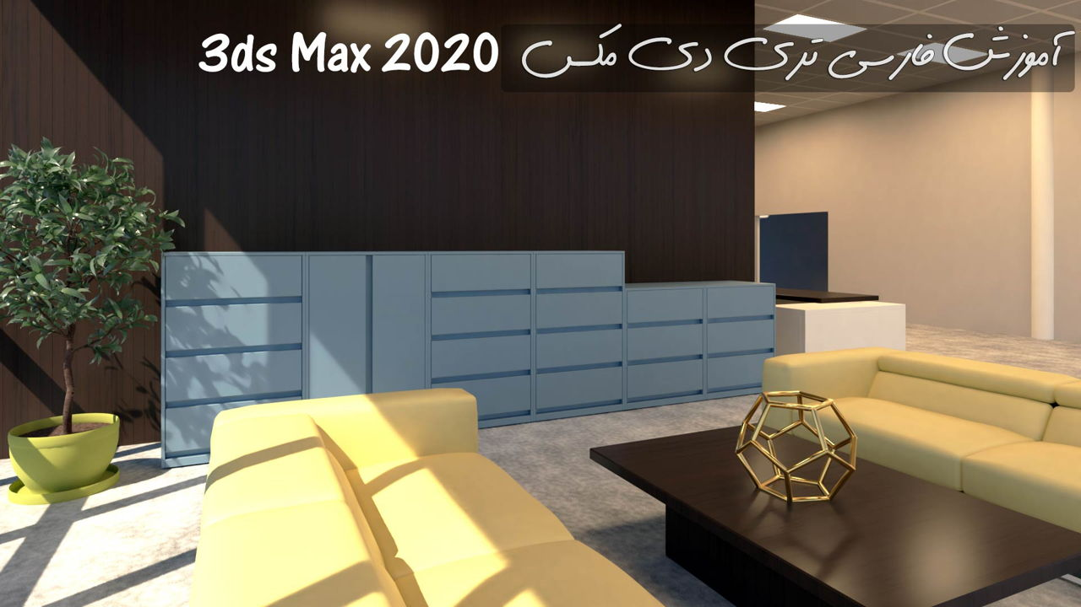

3ds Max 2020 software training course Pdf

published by
https://www.3dmaxfarsi.ir/

Welcome to the 3ds Max 2020 software training course (in Persian). You must have heard Max's name by now! Which is very popular due to its powerful modeling and rendering tools ?! On this page, in the form of a wonderful package, we will explain all the different topics in Persian for more than 11 hours.

3ds Max 2020 software, due to its power, is widely used in: rendering and architectural presentation, presentation of commercial and industrial products, development of computer games, industrial design; And it even has motion graphics and.. And has thousands of technical features and facilities such as: sculpting; There is lighting and rendering that in this training course, we will teach you all these skills.

The level of this training course is from beginner to advanced and we will start from the basic principles and we will teach you the basic skills that every 3D instrument maker must know for professional modeling and animation.

Introduction Introduction training package: In the first chapter, we will show you why 3D Max is the best and most famous 3D software in the world of computer graphics, and we will introduce this training package and introduce the topics.

1) The first chapter of the Getting Started training course: In the second chapter, we will learn how to personalize the workspace of 3D Max and we will get acquainted with the preferences that are the heart of 3D Max. And we will examine how to set up the project folders.

2) Familiarity with the 3Dds Interface 2020 3ds Max Interface: In the third chapter, we will get acquainted with the 3D Max software environment and with the interface, workspace settings, viewport personalization and grid colors viewport and grid colors, We will get acquainted. In the second step of the method of editing the basic forms of primitives; Transforming objects Move + Rotate, adjusting viewports, familiar with shading options and viewport shading modes, familiar with keyboard shortcut hotkeys, adjusting coordinate axis reference coordinate system, familiar With the Scene Explorer outline window and many more, we will discuss that these are the basic tools that are widely used to work with 3D Max, and by learning them, you can make good use of all the tools and features of 3D Max.

3) Familiarity with ready-made 3D Max Scene Layout templates: Leeouts play an important role in 3D Max. Because they are like a window that can only be seen and connected to 3D Max through it! In the third chapter, we will introduce the layouts and the most important parts of it, such as: display units, home grid setting, and و, and for more practice, we will make an architectural plan in three dimensions. And we will work on important commands such as: Array, groups, display layers. We will also teach you how to move objects between Max files and teach you how to merge scenes and work with reference objects (Xref objects) that are used to style Max files. We will give.

4) Spline Modeling: In the third chapter, we will discuss Max 2D. The basis of all 3D volumes is line and dot, and in this chapter we will fully teach the 3D dimensions of 3ds Max 2020. And we will deal with tools that convert two-dimensional sections to surfaces, such as the loft compound object. All topics such as: making two-dimensional shapes, drawing freehand splines, getting to know and editing vertex types, editing Bezier splines, how to render shapes, getting to know the Interpolation view to enhance the details of a 3D model, getting to know With two popular modifiers (Bevel modifier - Lathe modifier - Sweep modifier), insert two-dimensional logo from other graphic software Illustrator paths to 3D Max, write 3D text with the new TextPlus primitive tool and…. We will examine.

5) Parametric Modeling with Modifiers: Modifiers are one of the best tools offered in 3ds Max 2020 that have increased the flexibility and power of Max in all areas. In this chapter, we will introduce you to the great modifier tools related to modeling and teach you how to increase the detail, edit the topology of topology dependence pages.

6) Polygon Modeling: In the fourth chapter, we will discuss Polygon Modeling, which is the most professional method for modeling in 3D Max. Initially, Boolean operands, working with Quickslice, making polygons, transforming sub-objects, transforming sub-objects, working with caddy windows, making three-dimensional architectural plug-ins; Welding vertices, 3D volume refining and 3D methods of models and در will be taught to you in the form of a project.

7) Subdivision Surface Modeling: In Chapter 7, we model volumes with soft curves by subdivision surfaces. For modeling: human facial skin, car design, sofas and any body that has soft and complex surfaces, we will pay based on Surface subdivision. We learn how to build a simple model first. Then we will increase the details with the tools provided in our Ribbon tools panel and modifiers.

Summary
3dmaxfarsi.ir, create the best tutorials and video courses on: graphic design, animation, photography, script writing, illustration, video, creative writing, label and package design. Also download 3D models and textures for: 3D visualization, games, animation, movies and more. At 3dmaxfarsi, you can download aftereffect projects, movies, 3D models, sound effects and other design tools as well as all training courses.

Visit This Site to Learn More:
https://www.3dmaxfarsi.ir/category/design-tools/

