The
“YourPlayer”
System

Version: 0.4
Author: /u/upvotd

R1 – Official Release

Introduction
MyCareer is hard, grindy, and limits you to only being a role-player. A very bad role-player that only does 1 thing well. It has been known before you can simulate MyCareer by playing MyLeague, but I’ve never seen an official guide/rulebook for one. This is “YourCareer”, an alternative to MyCareer. It is however not a replacement for MyCareer, while you can actually set up online, there is no Park/Pro-Am.
Base Stats credit to nba2kmyplayer.com for table
Shot Close | 55 | Offensive Rebound | 55
Off Dribble Shot Mid-Range | 55 | Defensive Rebound | 55
Off Dribble Shot Three | 55 | Ball Control | 65
Standing Layups | 55 | Passing Vision | 55
Driving Layups | 55 | Passing IQ | 55
Standing Dunk | 55 | Passing Accuracy | 55
Driving Dunk | 50 | Speed With Ball | 60
Contact Dunk | 30 | Lateral Quickness | 60
Contested Shot Mid-Range | 55 | Pass Perception | 55
Open Shot Mid-Range | 55 | Block | 40
Contested Shot Three | 55 | Shot Contest | 55
Open Shot Three | 55 | Steal | 40
Post Fadeaway | 55 | Defensive Consistency | 70
Post Hook | 55 | On-Ball Defense IQ | 55
Post Control | 55 | Pick and Roll Defense IQ | 55
Speed | 65 | Help Defense IQ | 55
Acceleration | 65 | Low Post Defense IQ | 55
Vertical | 65 | Offensive Rebound | 55
Strength | 45 | Defensive Rebound | 55
Boxout | 60 | Other stats: | Stamina/Intangibles: 85  All other stats: 70

Player size
Okay, now choose a position, height and weight.
Apply the attribute changes to the base stats! This is what the categories mean:

Shooting Off Dribble | Shot Close, Off Dribble Shot Mid-Range, Off Dribble Shot Three
Layup & Dunks | Standing Layup, Driving Layup, Standing Dunk, Driving Dunk, Contact Dunk
Mid-Range Shooting | Open Mid-Range, Contested Mid-Range
3PT Shooting | Open 3PT Shot, Contested 3PT Shot
Post Scoring | Post Control. Post Hook, Post Fadeaway
Agility | Speed, Acceleration, Vertical
Strength | Strength
Rebounding | Offensive Rebounding, Defensive Rebounding
Play-making | Ball Control, Speed with Ball, Passing Vision, Passing IQ, Passing Accuracy
Defending | On-Ball Defense IQ, Pick and Roll Defense IQ, Help Defense IQ, Low Post Defense IQ, Steal, Block

Now we can introduce you to bars. A bar, is basically an attribute upgrade bar in myCareer. 1 bar means 3 attributes. Please note that the values in “attribute changes” are regular attributes, but “cap changes”’ are bars.
Example for bars: you have a 5’10, <200LBS player. The “STRENGTH” cap goes from 15 to 7.
The cap changes are optional, but provide a more realistic experience.

(See next page)

Height | Attribute changes (in attributes) | FT | Cap changes* (in bars)
5’10-6’0 | AGILITY +10, STRENGTH -10 | 85 | STRENGTH -4
6’1-6’3 | AGILITY +5, STRENGTH -5 | 85 | STRENGTH -3
6’4-6’7 |  | 83 | STRENGTH -2
6’7-6’10 | AGILITY -5, STRENGTH +10 | 80 | AGILITY -2
7’0-7’3 | AGILITY -20, STRENGTH +15 | 70 | AGILITY -3
>7’4 | AGILITY -35, STRENGTH +25 | 60 | AGILITY -4

Weight | Attribute changes | Cap changes*
<200LBS | AGILITY +10, STRENGTH -10 | STRENGTH -4
200-220LBS | AGILITY +5, STRENGTH -5 | STRENGTH -3
220-240LBS |  | STRENGTH -3
260-280LBS | AGILITY -5, STRENGTH +10 | AGILITY -2
280-300LBS | AGILITY -10, STRENGTH +15 | AGILITY -3
>300LBS | AGILITY -20, STRENGTH +20 | AGILITY -4

Starting player bonus/archetype
Now you can choose a general direction to your player.

Select 2 of the available categories and add 4 bars to each.

There is a spreadsheet later with all the categories in it and slots you can use. Read the following pages first, you’ll get to it eventually.
Example: I choose 3PT Shooting and Defending. I go to the table and fill out the first 4 bars of 3PT Shooting and Defending.
This does not limit you in any way. It only gives you 2 categories to boost so your player isn’t completely useless in the beginning. The only stats being capped are speed/strength, those depend on your height and weight and even that is optional.
Scroll up to look back at the categories.

Credit system

Now it’s time to get familiar with the credit system!
Credits are the currency used to buy attribute upgrades, slots and badges. Here’s how you earn them:

After a game
Use the spreadsheet to calculate the amount of credits you get → see “Setting it up”. Below are the bonus
credits that can be earned (put it in the “Bonus” part of the spreadsheet)

Bonus credits:
Win = +50c (Playoff Game = +10c, Finals Playoff Game = +50c)
Double-Double = +10c
Triple-Double = +50c
Quad-Double = +100c
Five by Five = +100c

Buying with credits

Upgrading a category:

To simply upgrade a category (Layups & Dunks, Agility, etc…), press the + button after the category on the spreadsheet. The upgrades’ price increases a bit every time.

Buying Badges:

All badges are available for every player. These are the prices:

None → Bronze | 100c
Bronze → Silver | 150c
Silver → Gold | 200c

A maximum of 5 Hall of Fame badges are allowed. To get a Hall of Fame badge, a player
must master a category. Mastering is getting all 15 upgrades of a category. A player can then buy a Hall of Fame version of the badge (the player must obtain the Gold version first).

Gold → Hall of Fame | 500c

As for mentality badges, they are all free, except Microwave.

Microwave | 50c

Buying slots:

If you run out of attribute slots and still want to upgrade him more (make a player better than LeBron basically), you can buy a slot for 300c.

Upgrading attributes other than the categories:

Things like Lateral Quickness can be upgraded with 50c per attribute, with the only exception being Free Throws (150c per 1 attribute).

Buying hotspots

Since MyLeague won’t update your hotspots (at least from what I’ve seen), you can buy hotspots:

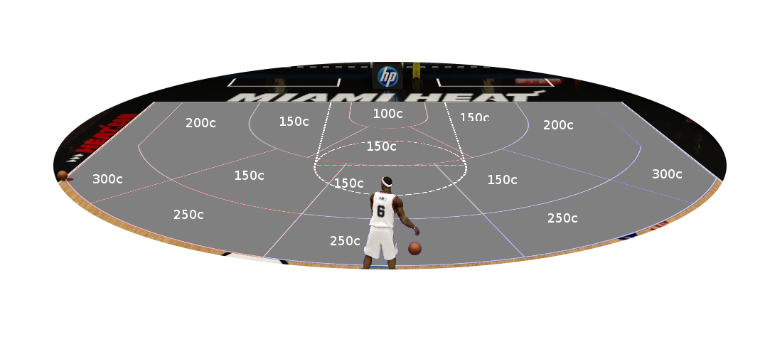
Note: to buy things like hotspots, badges, etc etc, you have to use the subtract button in the spreadsheet (under the credit total)
Setting it up

Now you’ll have to decide on a build. I recommend writing it down in this fashion:
Type | Attribute
Player name | Donald Trump
Player position | SF
Height | 6’9”
Weight | 420LBS
Starting archetype categories | 3PT Shooting, Playmaking

Let’s start.
Alternatively see the new video!

Create a player by going into Settings → Create a Player
Make him 19, set his prime start at 19 and end at the highest. Set his potential the lowest. (This is recommended so he doesn’t grow by himself and you have to earn the attribute upgrades.)
Apply the changes to the base stats, bars and caps. A table with the bars and caps is available next page, where you should fill in the first 4 bars of your 2 selected bonus categories. Then apply the bars’ values to your player (e.g. I have 4 bars on 3PT Shooting, so I add 12 attributes to my player’s 3PT Open and Contested; thus boosting them from 55 to 67.)

You can change his appearance, names, accessories, shoes and animations completely for free (you can even use the Jump Shot Creator).
After you’ve created the player, go back to Settings, and press Create a Roster.
Select Official 2K Roster or Injury-Free Roster. Now you’ll have to decide what team you play on.
Once you’ve decided, navigate to that team with the trigger buttons, and swap out the worst player (send him to Free Agency). Go to “Created Players” and copy yourself to that team. Save the roster and quit.
Create a new MyLeague. Press Y or Triangle to use a custom roster, and select the one you created. One more thing. You put everything on ‘Auto’ except the roster ones (because in the start your rating is low and you will get 0 minutes). I suggest giving yourself 12-20 minutes until you’re 70 overall or higher.

Also, don’t forget to go to MyLeague Settings → Player Lock and select yourself, so you only play as yourself! That’s it, thanks for reading!

(Alternatively, you can put him in a draft class instead and be drafted! Though you might end up being undrafted/go second round. Maybe put your potential at 99 before the draft so you get drafted high, and then put it back at minimum)

http://bit.ly/2hTDEQS
YourPlayer stat/credits calculations are finally automatic! Check it out. (Log in to Google Drive, File → Make a Copy, click on one of the Plus buttons and give it access to spreadsheets, THEN HAVE FUN, it even saves automatically!)

(attribute table not here, because read above)

Thank you for reading. We are looking for beta testers. If you’re interested please contact upvotd on reddit.
Use the spreadsheet (http://bit.ly/2hTDEQS)! Please though, I spent 4 hours on it trying to figure Google Code out haha.

Formulas for the curious:

getting credits from statline
total = ((((TwoPM*10)+(TrePM*14)+FTM)+((AST+REB)*8)+((STL+BLK )*10)+(YR*15)+BONUS) - (FLS*10) - (TOS*9 )) * DIFF

upgrading a category
u = upgrade slot number
cost = 150 * (1.083575^u)

