Carrot and Thyme
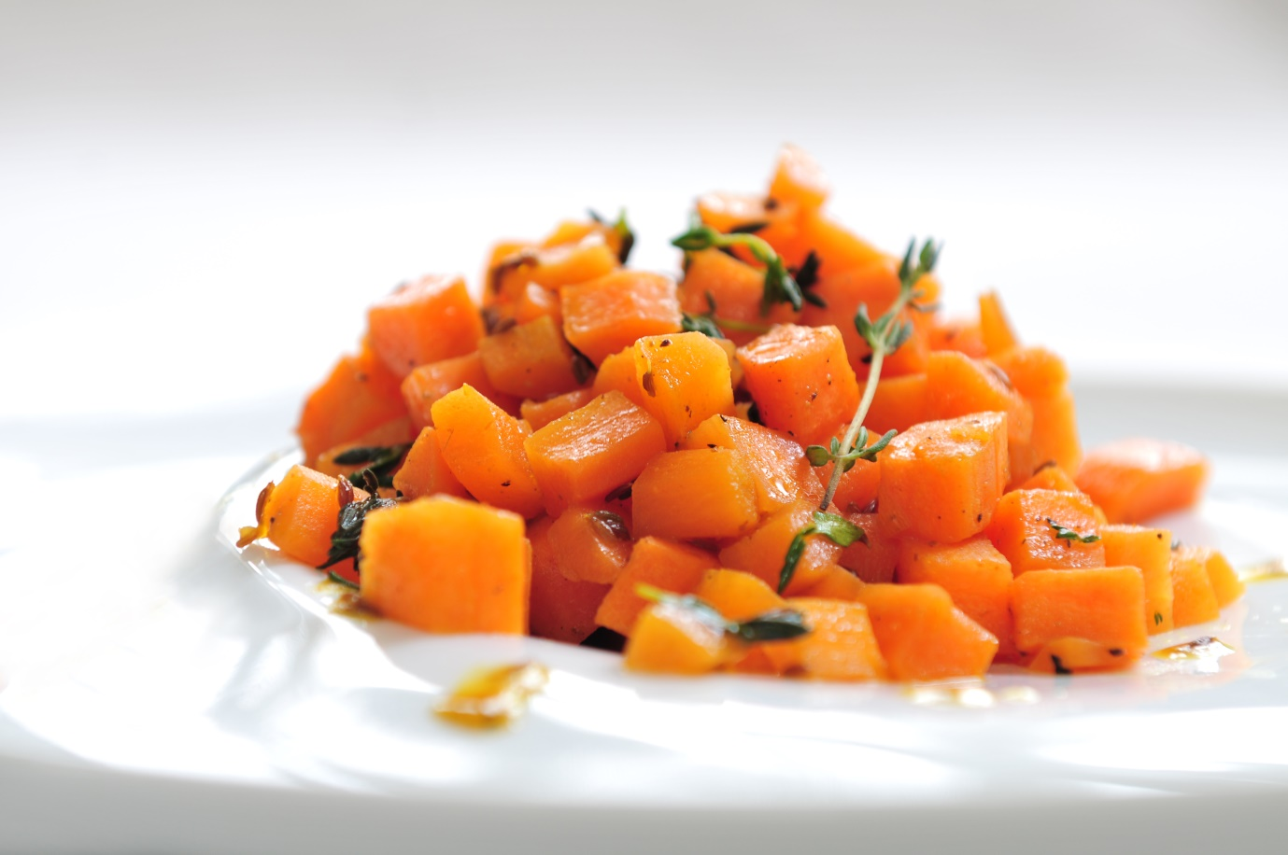
Ingredients: Preparation time: 30min
- ½kg carrots, peeled and diced
- ½ tsp butter
- ½ tsp honey
- ½ tsp white pepper
- ¼ tsp ginger powder
- Salt, pinch
- 1tbs lemon juice
- Fresh thyme
Preparation:
On 100ml of boiling water add: carrots, butter, honey, pepper and ginger.
Cook carrots in a medium pot for about 15 minutes on a medium heat until tender.
Next, add in this sequence: salt to taste, lemon juice and turmeric.
Cover, and let cook for a few minutes to allow flavours to mingle.
Drain off the liquid. Set the carrots aside. Decorate it with fresh aromatic thyme.
It is a wonderful and simple side dish.

