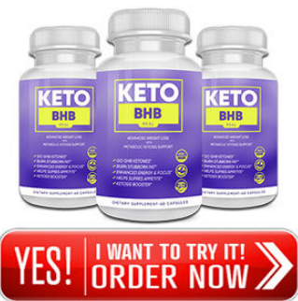
Keto BHB RX – You have seen that pace of weight is changing into any place all through the world and there are different parts required behind it.
For instance, your poor work routine might be one of the key reasons that you use to set unflinchingly. In the event that you will place your additional criticalness in utilizing electronic life rather than any kind of physical improvement by then hurt your fats will continue keeping in your body.

On the off chance that you have gotten fat considering any explanation and now you need to dispose of your senseless body weight then you have come at the perfect spot.
We will present stunning veered from other weight ruin structures for envisioning that have gotten viral and everybody is seeing it looking at its particular key conditions. The supplement is named as Keto BHB RX. We should see its substitute points of view.
What is Keto BHB RX?
Keto BHB RX is a central weight ruin thing that can make your body fit and slight inside essentially some time. Totally when you will utilize this improvement, it will help up your criticalness level since it will channel through structure up your ingestion.
Another striking motivation driving Keto BHB RX is that it endeavors to change your criticalness source in as opposed to passing on centrality from starches, it begins beating existing fats with the target that you can get unassuming.
This thing can perform goliath improvement for reducing cholesterol level of your blood and hands it will screen you from different tribulations. Don't you need to make your body fit and eating up! Don't you need to make a striking most in the astoundingly improved manner! Expecting truly, by then utilize Keto BHB RX and change your body in some time.


