Wisconsin Case Study: The Potential for State Prosecutions of False Electors

By Gretchen Knaut & Shan Wu

Table of Contents

EXECUTIVE SUMMARY 1
I. FACTS 4
A. Wisconsin Election Process 5
B. November 2020 8
C. December 14, 2020 10
D. The False Electors 12
E. January 6, 2021 18
II. POTENTIAL CRIMES 21
A. State Criminal Code 21
1. Forgery 22
2. Falsely Assuming to Act as a Public Officer 24
3. Misconduct in Public Office 26
4. Simulating Legal Process 27
5. Conspiracy and Party to a Crime 27
6. Attempt 29
III. POSSIBLE DEFENSES 30
A. Ongoing Litigation: The Hawaii Precedent 30
B. Advice of Counsel 33
IV. CONCLUSION 35
APPENDIX A 38
APPENDIX B 42

EXECUTIVE SUMMARY

In the months following his defeat in the 2020 presidential election, former President Donald J. Trump and his allies targeted seven swing states in what has come to be known as the “fake electors” scheme. These states were: Arizona, Georgia, Michigan, Nevada, New Mexico, Pennsylvania, and Wisconsin. Only one of the seven has a current ongoing state criminal investigation at the time of this writing. This report selects one of the remaining six states, Wisconsin, as a case study for pursuing additional criminal prosecutions at the state level.
The “fake electors” scheme was one among an array of fringe legal theories that Trump and his allies relied upon in an effort to overturn the election results. The scheme was to work as follows: the Trump team assembled slates of Republican “presidential electors” in swing states where Trump had lost to his opponent, former Democratic candidate and current President Joseph R. Biden. The team sought to submit these slates in place of the lawfully and democratically chosen Biden electors, hoping to thereby flip enough Electoral College votes to secure a Trump presidential victory. If they had succeeded, the U.S. democratic process would have faced collapse. Millions of voters would have been disenfranchised, making a mockery of democracy and rending the American civic fabric potentially beyond repair.
In Wisconsin as in other swing states, Trump’s campaign began laying the groundwork for post-election legal fights well before November 2020. Through a toxic combination of litigation and disinformation, the campaign spent months spreading mistrust in the electoral process and eventual election results. Following Trump’s defeat at the polls, those efforts set the stage for ten individuals to gather at Wisconsin’s Capitol on December 14, the date designated for the 2020 meeting of the Electoral College. Once assembled, the group purported to cast Wisconsin’s ten Electoral College votes for Trump—despite the fact that Wisconsin’s election results had already been tallied, recounted, and certified in Biden’s favor. By that point, the Trump team had exhausted all available legal mechanisms for challenging the outcome within the state judicial system, including the Wisconsin Supreme Court. Wisconsin voters and courts alike had definitively spoken in favor of the Biden electors. Yet the ten would-be Trump electors persisted in gathering and submitting their own votes, thereby attempting to usurp the will of the people, the judiciary, and the foundations of U.S. democracy itself. As will be discussed, their actions also potentially violated numerous Wisconsin criminal laws, including but not limited to: Forgery (Wis. Stat. § 943.38(1)), Falsely Assuming to Act as a Public Officer (Wis. Stat. § 946.69(2)), Misconduct in Public Office (Wis. Stat. § 946.12(4)), Simulating Legal Process (Wis. Stat. § 946.68) and Conspiracy and Party to a Crime (Wis. Stat. § 939.31 and Wis. Stat. § 939.05).
This report analyzes the facts and the law applicable to these events. As will be discussed in a later section, the documents created by the ten fake Wisconsin electors bore no disclaimer or qualifying language identifying them as “contingent” votes. Instead, the documents falsely identified the ten would-be Trump electors as Wisconsin’s “duly elected and qualified Electors for President and Vice President.” In appearance they mirrored the state’s actual Electoral College votes almost to a tee—except, of course, they indicated that Trump, rather than Biden, had won the presidential election in Wisconsin.
These false Electoral College votes inflicted lasting harm on a local and national scale. They damaged Wisconsin’s civic sphere, where efforts to “decertify” the 2020 election, to give the legislature new power over election administration, and to disband the Wisconsin Elections Commission are still alive and well to this day. They also fed into the warped justification for the Capitol attack on January 6, 2021, as extremists sought to pressure then-Vice President Pence to reject votes cast by the real electors in Wisconsin and several other states. As the House January 6 Committee prepares to release its final report on the events surrounding the 2020 presidential election, we can only expect another round of aftershocks to ripple across the country.
As we grapple with these unprecedented and un-American events, efforts to hold their perpetrators accountable must continue. Section two of this report explores possible avenues for criminal prosecutions in Wisconsin, specifically targeting the fake electors and those who aided them. “Potential Crimes” unpacks the sections of Wisconsin criminal code that may cover the actions these individuals engaged in on December 14, 2020 and surrounding dates. Perhaps most relevant here, Wisconsin Statute § 946.69(2) makes “falsely assuming to act as a public officer” a Class I felony. Wisconsin law also denominates certain crimes, including § 946.69(2), as “crimes affecting the administration of government.” Another subsection of the same chapter, § 946.68, “[s]imulating legal process,” may apply to the fake electors’ actions as well. State forgery charges may also be viable, since the fake electors created and signed documents purporting to be the “Certificate of the Votes of the 2020 Electors from Wisconsin.” Authoring and mailing such documents for use in official proceedings may constitute a felony under Wis. Stat. § 943.38(1). These charges are discussed in greater depth below.
This report also assesses the procedural posture of possible criminal charges. The district attorney for Dane County, whose jurisdiction encompasses Madison, Wisconsin’s Capitol and the site of the false electors’ meeting, has yet to publicly announce an investigation or criminal charges. However, the mayor of Madison recently joined calls to launch an investigation and seek appropriate charges. The district attorney is still well within Wisconsin’s six-year statute of limitations for felony crimes for the events in 2020, so this remains a viable course of action. The case for criminal charges may even expand if relevant evidence surfaces over the course of the ongoing investigations by the U.S. Department of Justice or law enforcement agencies in another state, or as part of discovery during a civil suit.
In the event that criminal charges are filed in Wisconsin, the fake electors will presumably seek to defend their innocence. Section three, “Possible Defenses,” analyzes the defenses available to them and the associated chances of success.
At its conclusion, this report assesses the viability of state criminal investigations into the fake elector scheme conducted in parallel with federal proceedings. As will be discussed, pursuing both levels of prosecution will be critical to fully rebuke the conspiracy and its perpetrators. Indeed, the future integrity of our democracy may very well depend upon it. Only by holding the ten individuals in Wisconsin and their co-conspirators accountable for their actions can we hope to repair the damage they inflicted, and to discourage others from following in their footsteps.

FACTS

Nearly 3.3 million Wisconsin voters—more than three-quarters of the eligible voting population—participated in the 2020 election. This record-breaking number was all the more impressive in light of the restrictions and dangers of the ongoing COVID-19 pandemic. Once the ballots were submitted, a multi-step process for determining and confirming the results of the presidential election began. This process would ultimately culminate in the meeting of Wisconsin’s duly elected presidential electors on December 14.

Wisconsin Election Process

Wisconsin statutes clearly outline the process for counting and confirming votes in presidential elections. Votes are first counted and tallied at the ward level. (A small number of municipalities count all absentee ballots at a central count facility.) Those tallies are then reported to the municipal clerk, who convenes the municipal board of canvassers to canvass the results. The process then moves to the county level, where each county clerk convenes the county board of canvassers to canvass the election results from the municipalities under their oversight. The county clerks then transmit certified statements containing the county results to the Wisconsin Elections Commission, the state agency that oversees elections. The chairperson of the Wisconsin Elections Commission is then required to prepare a statement certifying the election results along with a certificate of determination indicating the names of the individuals elected as presidential electors. Following a state canvass, the Wisconsin Elections Commission must produce a certificate of ascertainment “showing the determination of the results of the canvass and the names of the persons elected” as presidential electors. Finally, the governor must “sign, affix the great seal of the state, and transmit the certificate by registered mail to the U.S. administrator of general services.” This certificate of ascertainment also appears in federal law, which requires that it be submitted to the archivist of the United States alongside each state’s Electoral College votes.
Wisconsin law also provides procedures to resolve disputes over which candidate and corresponding slate of presidential electors is the lawful winner. A losing candidate in a presidential election may petition for a recount if the margin of defeat is one percent of the vote or less. Any candidate aggrieved by the recount can then appeal to the circuit court, and any party aggrieved by an order of the circuit court can in turn appeal, all the way up to the Wisconsin Supreme Court. This set of procedures “constitutes the exclusive judicial remedy for testing the right to hold an elective office as the result of an alleged irregularity, defect or mistake committed during the voting or canvassing process.” It is not unusual for highly contested races in Wisconsin to trigger recounts. Two statewide recounts took place in the decade leaded up to the 2020 election: one in the 2011 state supreme court race, and the other in the 2016 presidential election.
Determining the correct slate of electors in a presidential election is, of course, a critical step in our democratic process. Under the U.S. Constitution, the president and vice president are not elected directly by the voters. They are instead chosen by presidential electors, who are in turn appointed by each state in numbers “equal to the whole Number of Senators and Representatives to which the State may be entitled in the Congress.” Wisconsin was allocated ten electoral votes in 2020. Wisconsin statutes explain the elector selection process as follows:
Although the names of the electors do not appear on the ballot and no reference is made to them, a vote for the president and vice president named on the ballot is a vote for the electors of the candidates for whom an elector’s vote is cast. Under chs. 5 to 12 [the provisions of which regulate elections], all references to the presidential election, the casting of votes and the canvassing of votes for president, or for president and vice president, mean votes for them through their pledged presidential electors.
When voters mark the name of a candidate for president, they are in actuality voting for the slate of electors that will cast the state’s Electoral College votes for that candidate. Since it achieved statehood, Wisconsin has always assigned the entirety of its electoral votes to the winner of the popular vote in the statewide presidential election.
State law also stipulates the process for identifying those presidential electors. In Wisconsin, qualifying political parties nominate candidates for the office of presidential elector at a meeting in the Wisconsin Capitol “on the first Tuesday in October of each year in which there is a presidential election.” This occurred on October 6 in 2020, with the Democratic Party, the Republican Party, and the Constitution Party each nominating slates of ten elector-candidates. Whichever slate is chosen by Wisconsin voters convenes to cast their state’s votes in December, over a month after election day.

November 2020

Based on a preliminary canvass of county results, in November 2020 the Wisconsin Elections Commission reported that Biden and Harris had won the state’s popular vote by 20,608 votes. In response, the Trump-Pence campaign petitioned the Wisconsin Elections Commission for a partial recount of the election results in the state’s two most populous counties, Dane and Milwaukee.
This partial recount concluded on November 30, confirming and even slightly expanding Biden’s victory in Wisconsin. Updated statewide vote totals showed that Biden and Harris had received 20,682 more votes than Trump and Pence. The chair of the Wisconsin Elections Commission proceeded to issue a statement pursuant to Wis. Stat. § 7.70(3), certifying that the Democratic candidates for the office of presidential elector had won the election. In accordance with Wis. Stat. § 7.70(5)(b), Wisconsin Governor Tony Evers then executed several original certificates of ascertainment. These certificates recognized that the Democratic candidates for the office of presidential elector had received the greatest number of votes cast in the general election, officially designating them the duly elected presidential electors for the state of Wisconsin.
The Trump-Pence campaign responded by filing a lawsuit against the governor disputing his certification. Rather than taking the case to the circuit courts, which would usually adjudicate a recount challenge, the campaign petitioned the Wisconsin Supreme Court to exercise its original jurisdiction and take the case directly. The Court declined, ruling that a circuit court filing was the proper vehicle for challenging a recount per Wis. Stat. § 9.01. Accordingly, on December 3 the campaign sought judicial review of the partial recount in the circuit courts for Dane and Milwaukee counties. The chief justice of the Wisconsin Supreme Court consolidated the two actions and designated one judge to preside over the single consolidated cases. On December 11, the circuit court affirmed the results of the partial recount. Trump and Pence immediately appealed to the Wisconsin Court of Appeals and filed an emergency petition for bypass to the Wisconsin Supreme Court. The Court granted the petition. The Court then proceeded to order expedited, simultaneous briefing the same evening and held oral argument the following day, December 12.
On the morning of December 14, just before the appointed time for the meeting of the presidential electors, the Wisconsin Supreme Court resolved the matter. The Court issued a detailed written opinion in Trump v. Biden confirming the results of the recount and Biden’s victory in the state. Writing for the majority, Republican Justice Brian Hagedorn concluded: “At the end of the day, nothing in this case casts any legitimate doubt that the people of Wisconsin lawfully chose Vice President Biden and Senator Harris to be the next leaders of our great country.” The court’s ruling definitively resolved any questions under state law about the identity of Wisconsin’s 2020 presidential electors, foreclosing the possibility that litigation might change the outcome of Wisconsin’s presidential election.

December 14, 2020

The meeting of the Electoral College, and of Wisconsin’s presidential electors, is governed by both federal and state law. The Constitution allows that “[e]ach State may, by law, provide for the filling of any vacancies which may occur in its college of electors when such college meets to give its electoral vote.” It also specifies that the meeting of the electors must take place in every state “on the first Monday after the second Wednesday in December next following their appointment at such place in each State as the legislature of such State shall direct.” In 2020, that date fell on December 14.
The Constitution also lays out the necessary procedures for the meetings themselves. Electors for each state must create lists recording each elector’s vote for President and Vice President, which “they shall sign and certify, and transmit sealed to the seat of the government of the United States, directed to the President of the Senate.” Presidential electors must also transmit their certified lists to the secretaries of state for their respective states, the archivist of the United States, and “the judge of the district in which the electors shall have assembled.”
State law fills in the remaining details. Wisconsin law requires that “[t]he electors for president and vice president shall meet at the state capitol following the presidential election at 12:00 noon” on the Monday set by federal law. The same statute also establishes how to fill a vacancy if one of the lawfully chosen electors cannot, or does not, attend. When this occurs, “the electors present shall immediately proceed to fill by ballot, by a plurality of votes, the electoral college vacancy” before proceeding to “vote by ballot for that person for president and that person for vice president who are, respectively, the candidates of the political party which nominated them.” Wisconsin law thus ensures that the electors convened are bound to represent the will of the voters expressed in the November general election.
In 2020, the recount and associated appeals described above confirmed that the individuals slated and submitted by the Democratic Party were the duly elected candidates for the office of presidential elector in Wisconsin. Those individual electors were: Meg Andrietsch, Shelia Stubbs, Ronald Martin, Mandela Barnes, Khary Penebaker, Mary Arnold, Patty Schachtner, Shannon Holsey, Tony Evers, and Benjamin Wikler. At noon on December 14, these ten presidential electors convened at the state Capitol building as prescribed by Wis. Stat. § 7.75 and 3 U.S.C. § 7. In an open meeting broadcast live by Wisconsin Eye, they called the roll to ensure all were present, elected a chairperson and a secretary, cast and counted the necessary ballots, and signed the necessary papers. After the meeting, they sent official documents reflecting the lawful disposition of Wisconsin’s ten electoral votes to the president of the United States Senate, the Wisconsin secretary of state, the archivist of the United States, and the chief judge of the United States District Court for the Western District of Wisconsin. These documents included official copies of the certificate of the presidential electors’ votes for Biden and Harris.

The False Electors

At the same time in another part of the state Capitol building, a second group gathered. Unlike the meeting of the legitimate Democratic electors, which was broadcast live and attended by members of the media, this gathering was conducted in secret by members of the Republican Party of Wisconsin. Nine of the ten individuals who had been lawfully nominated to serve as presidential electors in the event of a Trump victory attended: Andrew Hitt, Robert F. Spindell, Jr., Bill Feehan, Kelly Ruh, Carol Brunner, Edward Scott Grabins, Darryl Carlson, Pam Travis, and Mary Buestrin. Tom Schreibel, the tenth nominee, was the only would-be Trump elector who did not attend. Another Wisconsin Republican, Kathy Kiernan, who had never been nominated, stepped in to take Schreibel’s place with the group at the Capitol. Once assembled, the group generated and signed documents designed to look like genuine presidential elector certificates giving Wisconsin’s votes to Trump.
Preparations for this meeting began well in advance of December 14. On November 4, when the outcome of the 2020 election in Wisconsin and other swing states was still not finalized, former Secretary of Energy Rick Perry texted then-White House Chief of Staff Mark Meadows to suggest that Republican-controlled state legislatures should “just send their own electors to vote and have it go to the SCOTUS.” The next day, one of Trump’s sons, Donald Trump, Jr., texted Meadows with a similar idea: have Republican-controlled state legislatures “step in” and advance slates of “Trump electors,” notwithstanding the results of the popular vote. Trump campaign officials led by Trump’s then-personal attorney, Rudy Giuliani, proceeded to put this plan into action. According to public reporting, “Giuliani and his allies coordinated the nuts-and-bolts of the process on a state-by-state level,” and “there were multiple planning calls between Trump campaign officials and GOP state operatives.”
Memoranda published by The New York Times have revealed discussions of the scheme that focused on Wisconsin specifically. At least two attorneys with Wisconsin ties were involved: James (Jim) Troupis, a lawyer advising the Wisconsin Trump campaign, and Kenneth Chesebro, who is originally from Wisconsin but was working on behalf of the national Trump campaign. On November 18, the same day that Trump and Pence filed their petition for a partial recount, Chesebro sent Troupis a memorandum titled “The Real Deadline for Settling a State’s Electoral Votes.” Chesebro claimed that: “Assuming the electors pledged to Trump and Pence end up meeting at the Wisconsin Capitol on December 14, 2020, to cast their votes, and then send their votes to the President of the Senate in time to be opened on January 6, 2021, a court decision (or, perhaps, a state legislative determination) rendered after December 14, 2020, in favor of the Trump-Pence slate of electors should be considered timely.”
Over a week after the Wisconsin recount had concluded and well after the duly elected Democratic presidential electors had been certified, Chesebro sent Troupis a second memorandum. Titled “Statutory Requirements for December 14 Electoral Votes,” Chesebro’s December memo expanded its scope to include six “States in controversy” and continued to argue in favor of submitting competing slates of electors in target swing states—even as it acknowledged that none of the Republican candidates for the office of presidential elector in the targeted states were “currently certified as having been elected by the voters of their State.” Chesebro wrote that “most of the electors . . . will be able to take the essential steps needed to validly cast and transmit their votes, so that the votes might be eligible to be counted if later recognized (by a court, the state legislature, or Congress) as the valid ones that actually count in the presidential election.”
The memorandum went on to overview those “essential steps” for the losing Republican presidential elector candidates to take in each of the six target states, including Wisconsin. These included: meeting on December 14 at the location prescribed by state law for the meeting of the duly elected presidential electors; filling vacancies in the event that one or more Republican presidential elector candidates opted not to participate in the scheme; casting votes for Trump for president and Pence for vice president; preparing and signing certificates of those votes; and transmitting those certificates to the president of the Senate, the state secretary of state, the National Archives, and the local federal district court. In short, Chesebro’s memo outlined the same steps that state and federal law prescribe for legally elected presidential electors—except, of course, these individuals had not been legally elected.
Two days after he sent the December memo, Chesebro did express some reservations regarding the legality of the scheme. In an email to other members of the Trump legal team, Chesebro reported concerns from two would-be Trump electors in Arizona that “it could appear treasonous for the AZ electors to vote on Monday [December 14] if there is no pending court proceeding that might, eventually, lead to the electors being ratified as the legitimate ones.” He did not discount their fears. He instead conceded that this “is a valid point — in the Hawaii 1960 incident, when the Kennedy electors voted, there was a pending recount.” In a later email, however, Chesebro mollified his own concerns. He framed a legal action that the group planned to file with the United States Supreme Court as the “pending court proceeding” they needed to provide legal cover for the Trump electors. Chesebro went on to push Trump-affiliated lawyer John Eastman to file legal papers designed to lead the Supreme Court to hear an election case from Wisconsin. In a December 24 email exchange with Eastman, Chesebro argued that the “odds of action before Jan. 6 will become more favorable if the justices start to fear that there will be ‘wild’ chaos on Jan. 6 unless they rule by then, either way.”
As the contours of the scheme sharpened, the ten would-be Trump electors in Wisconsin proceeded to gather at the state Capitol building on December 14. In order to get into the Capitol building in the first place, the group had to take several extraordinary steps. One of the fake electors, Bill Feehan, recounted the saga in a podcast that aired the week after January 6, 2021. Feehan describes “a secret meeting place in Madison” where the group assembled before traveling to the Capitol building with “armed security.” He noted that they had to arrange to be let into the Capitol, which was closed to the public due to the pandemic. Open records requests later revealed that then-Wisconsin State Senate Majority Leader Scott Fitzgerald had reserved a room in the building for their meeting. Feehan claimed that these “super-secret” measures were taken “for security reasons”—though the “super-secret” nature of the meeting seemed undermined by the fact that he also reported that the attendees took pictures of themselves at the meeting.
Despite receiving news of Wisconsin Supreme Court’s ruling earlier that day—which, in the words of group member Bill Feehan, was “a deflating moment,”—they proceeded according to plan. After entering the Capitol, they began by filling a vacancy created by the above-mentioned absence of Tom Schreibel, the tenth Republican elector nominee. To replace him, the group mimicked the legal procedure for filling an elector vacancy, creating a document titled “Certificate of Filling Vacancy of the 2020 Electors from Wisconsin.” The document replicates the language used on lawful versions of this certificate, stating that Schreibel’s replacement, Kathy Kiernan, “[w]as elected by the Electors present, as an Elector of President and Vice President of the United States of America for the State of Wisconsin to fill the vacancy in the manner provided by law.” The group then affixed “Chairperson” and “Secretary” signatures to the document, as would occur during the legitimate procedure.
After purporting to fill the vacancy created by Schreibel’s absence, the group executed another document titled “Certificate of the Votes of the 2020 Electors from Wisconsin.” The document represents that the signatories are “the duly elected and qualified Electors for President and Vice President of the United States of America from the State of Wisconsin” and certifies that they met at the state Capitol “to perform the duties enjoined upon” them. It then reports two lists of ten electoral votes: one for Donald J. Trump for president, and one for Michael R. Pence for vice president.
According to a cover memorandum titled “Wisconsin’s Electoral Votes for President and Vice President,” the signed documents were transmitted to the president of the United States Senate, the archivist of the United States, the Wisconsin secretary of state, and the chief judge of the United States District Court for the Western District of Wisconsin. The memorandum, which “Chairperson” Andrew Hitt signed, represents that it accompanies “duplicate originals of Wisconsin’s electoral votes for President and Vice President” intended for each of the above-listed recipients. The Wisconsin secretary of state and archivist of the United States have since published the documents they received. Of particular note for one of the charges discussed in section three is that the envelope addressed to the archivist of the United States reflects a postmark of December 16, 2020—two days after the false electors met and signed the documents. It is unclear where the documents were stored during that two-day period, but the answer could have prosecutorial implications as analyzed below. As for the false documents sent to the Western District of Wisconsin or the United States Senate, public sources indicate that no party has yet requested copies from these sources. There is no reason to believe that copies of the documents did not arrive at those locations, however.
Following the meeting on December 14, the Wisconsin Republican Party issued a press release with a statement from Hitt summarizing the group’s actions. Hitt proclaimed that “While President Trump’s campaign continues to pursue legal options for Wisconsin, Republican electors met today in accordance with statutory guidelines to preserve our role in the electoral process with the final outcome still pending in the courts.” As Hitt and the other electors knew from the aforementioned “deflating moment,” however, that final outcome was no longer actually pending. The Wisconsin Supreme Court’s ruling had already closed the only remaining avenue for judicial intervention in Wisconsin’s presidential election results. Though the Trump legal team later appealed the decision to the U.S. Supreme Court, they did not file until December 29, 2020—more than two weeks after the fake electors met at the Wisconsin Capitol. The only cases that could be considered pending as of December 14, Trump v. Wisconsin Elections Commission and the bad-faith Feehan v. Wisconsin Election Commission, had no chance of altering the election results. The 7th Circuit’s ruling in Trump v. Wisconsin Elections Commission is particularly instructive in this regard: “We are not the ultimate authority on Wisconsin law. That responsibility rests with the State’s Supreme Court. Put another way, the errors that the President alleges occurred in the Commission’s exercise of its authority are in the main matters of state law. They belong, then, in the state courts, where the President had an opportunity to raise his concerns. Indeed, the Wisconsin Supreme Court rejected his claims regarding the guidance on indefinitely confined voters, see Trump v. Biden, 2020 WI 91 ¶ 8 (Dec. 14, 2020), and declined to reach the rest of his arguments on grounds of laches." As affirmed by the 7th Circuit, final authority over the election questions raised by the Trump team rests with the Wisconsin Supreme Court. Their December 14 ruling thus closed the matter once and for all—and pushed the fake electors beyond the boundaries of statutory cover.

January 6, 2021

Once the lawfully executed Electoral College certificates from each state arrive at the U.S. Capitol, Congress convenes for a special Joint Session to open and tally them. The Twelfth Amendment of the U.S. Constitution provides the procedure for this joint session, during which the President of the Senate “shall, in the presence of the Senate and House of Representatives, open all the certificates and the votes shall then be counted.” The candidate with “the greatest number of votes for President, shall be the President, if such number be a majority of the whole number of Electors appointed.”
In 2021, that process came under attack. The events of January 6, 2021 have been well documented elsewhere—and indeed, their impact upon elected officials, voters, the media, law enforcement, and residents of the District of Colombia is still reverberating to this day. But this report would not be complete without an examination of the role that the false Electoral College votes from Wisconsin and other swing states played in those tragic events. The above-described scheme formed part of the warped legal basis for pressuring then-Vice President Pence to reject legitimate and legal votes—and ultimately drove hordes of Trump supporters to march on the Capitol.
The Eastman Memo, or the “coup memo,” as some have dubbed it, laid out the plan in full. Authored by John Eastman, the memo argued that then-Vice President Pence could throw out votes from seven swing states when he presided over the January 6 Joint Session tallying the electoral votes. As president of the Senate, Eastman claimed, Pence could assert unilateral authority and reject these votes based on his own concerns of fraud and the “competing” elector slates in those states—which were provided by groups like the ten fake electors in Wisconsin. By reducing the total number of votes to be counted, Pence could then declare Trump the winner of the election, with 232 votes to Biden’s 222. Failing this, Eastman suggests that if the Constitution indeed requires 270 votes for a Presidential victory, then Pence’s rejection of the votes from the seven states would throw the election to the House of Representatives. At the time, Republicans controlled 26 of the state delegations in the House—enough to declare Trump the winner. As has been reported, Pence ultimately rejected pressure from Trump, Eastman, and others to cooperate with this plan.
Unlike Pence, dozens of Members of Congress bought into the scheme. On January 2, 2021, a group of 11 United States Senators and Senators-elect (including Senator Ron Johnson of Wisconsin) issued a statement pledging to “reject the electors from disputed states” during the January 6 joint session. In parallel, over 100 House Representatives announced their own plans to object to some or all electoral college votes from swing states Trump had lost. Though Senator Johnson and seven other Senators withdrew their objections after the Capitol attack, 147 Members of Congress ultimately objected to one or more state’s elector slates on January 6, 2021.
The January 6 Committee has since revealed text messages further implicating Senator Johnson—or at least, his staff—in the scheme. The messages show Johnson’s staff attempting to deliver fake Michigan and Wisconsin elector certificates to Vice President Pence during the Joint Session on January 6. Senator Johnson originally denied knowing the source of those fake elector documents, but he later identified Pennsylvania U.S. Representative Mike Kelly and Trump attorney James Troupis as the individuals who worked with his staff to attempt the delivery. Johnson claimed that Troupis texted him on the morning of January 6, the day Congress was to meet to tally the Electoral College votes, regarding delivery of the “Wisconsin electors” document to Pence. Troupis has not responded to these allegations, but Representative Kelly’s office has denied involvement.
As the events surrounding the 2021 joint session unfolded, Wisconsin’s ten false electors made no moves to rescind the documents they had sent. They instead pointed to the legal guidance they had received as adequate justification for their actions. After receiving a subpoena from the January 6 Committee, “Chairperson” Hitt stated “As I said in the past, the Wisconsin Electors were simply following the guidance of Wisconsin legal counsel to preserve the ongoing Wisconsin legal strategy." Another false Wisconsin elector similarly explained, “It was generally the view of the attorneys that should Trump win some of these cases, this had to be done.” None of the ten individuals has publicly admitted fault at the time of writing.

POTENTIAL CRIMES

State Criminal Code

The conduct of the ten fake electors appears to violate multiple provisions of Wisconsin’s criminal code. One relevant group of possible felonies, “crimes affecting the administration of government,” carries sentences of up to three-and-a-half years in prison and/or fines of up to $10,000 per count. Other possible charges, including forgery, could result in even longer prison terms of up to six years. Successful prosecution of these and other criminal statutes discussed below will likely turn on questions of intent. Though the public record contains relatively limited information on the mindset of each fake elector on December 14, near-contemporaneous statements made by at least two of the individuals (Bill Feehan in his podcast, and Andrew Hitt in his press release) offer at least some insight. Both the podcast and the press release suggest that the individuals involved were, indeed, aware of the relevant facts and acted of their own volition. This opens the door for prosecutors to establish criminal intent and pursue charges accordingly.
The language in the Wisconsin documents also lends itself to prosecutions, perhaps more so than in other jurisdictions. The false Trump elector certificates from two other 2020 swing states, Pennsylvania and Nevada, contained caveats that the elector votes would only be proper in the event that the state’s election results were later declared in Trump’s favor. Wisconsin’s certificates included no such disclaimers. Moreover, the false Wisconsin certificates of votes and other documents transmitted to government offices appear in every way to mirror the lawfully transmitted versions. This too could make prosecutions for several of the violations discussed below more viable than elsewhere, even where statutes contain similar elements.
While the following analysis largely focuses on the ten fake electors, others who may have aided or assisted them could face criminal charges as well. Wisconsin, like many states, allows for criminal conviction as a “party to a crime” and as part of a criminal conspiracy. Attempts to violate criminal statutes may also be prosecuted under certain circumstances, opening up another potential avenue for prosecutors to explore. These and other charges are discussed in more depth below.

Forgery

Forgery is a Class H felony under Wis. Stat. § 943.38(1), punishable by up to six years in prison, $10,000 in fines, or both per count. The fake electors in Wisconsin created documents purporting to be the “Certificate of the Votes of the 2020 Electors from Wisconsin,” and the “Certificate of Filling Vacancy of the 2020 Electors from Wisconsin.” The documents refer to the signatories as “the duly elected and qualified Electors for President and Vice President of the United States of America from the State of Wisconsin…” Yet as discussed in section one, the signatories were not in fact the presidential electors from Wisconsin and no law or holding by a court ever recognized them as such. The documents they produced may therefore be considered unauthorized forgeries designed to replace their legally executed counterparts.
These documents likely fit into one, if not multiple, categories contemplated by Wisconsin’s forgery statute. Any fraudulent “…writing or object whereby legal rights or obligations are created, terminated or transferred…public record or a certified or authenticated copy thereof…official authentication or certification of a copy of a public record…, [or] official return or certificate entitled to be received as evidence of its contents” may fall under the statute’s provisions. Both the documents themselves and their cover memoranda appear to match one or more of these descriptions.
The fraudulent creation or alteration of official documents alone would not secure a forgery conviction in Wisconsin, however. “Intent to defraud” is another central element of the state’s forgery statute, raising questions about the plans and mindsets of the would-be Trump electors. But as detailed above, the public record already contains several near-contemporaneous statements by these individuals that may provide insight into their intentions at the time. At a minimum, we know that the false electors were fully aware of the Wisconsin Supreme Court’s decision to affirm the recount results before finalizing the documents (see again Bill Feehan’s description of this “deflating moment”). It bears repeating that the Court’s decision foreclosed the last possible argument under state law that the group could become Wisconsin’s “duly elected and qualified Electors.” In light of that decision and the group’s negative reaction to it, it is rather difficult to argue that they believed the documents they signed were, in fact, legitimate elector certificates.
Notably, Wisconsin law also makes possessing forged documents a felony under certain circumstances. Per Wis. Stat. § 943.38(2), “Whoever utters as genuine or possesses with intent to utter as false or as genuine any forged writing or object mentioned in sub. (1), knowing it to have been thus falsely made or altered, is guilty of a Class H felony.” The individual or individuals who possessed the falsified documents in the two-day period between their creation on December 14 and transmission on December 16 may therefore be held liable under state law.

Falsely Assuming to Act as a Public Officer

“Presidential Elector” is a public office in Wisconsin, filled by party nomination and statewide vote. Falsely assuming to act as a public officer is a Class I felony in Wisconsin. The federal Electoral Count Act (ECA) clearly specifies the credentials of presidential electors and outlines the process for transmitting their names to the U.S. Congress—a process in which, of course, the would-be Trump electors could not legally participate. Under the ECA, the executive of each state (the governor, in most cases) must execute certificates of ascertainment listing the names of the lawfully elected electors. Executives then send these certificates by registered mail under the seal of their state to the Archivist of the United States, along with several other officially designated recipients. Since the fake electors were not Wisconsin’s real presidential electors, they were not listed on the certificates of ascertainment that the Wisconsin governor signed in 2020. Nevertheless, the group proceeded to undertake duties as if they had been named the “duly elected and qualified” electors. In doing so, they potentially violated Wis. Stat. § 946.69(2), which criminalizes the actions of an individual who “[a]ssumes to act in an official capacity or to perform an official function, knowing that he or she is not the public officer … that he or she assumes to be.”
It is difficult to argue that the false electors were unaware that they had not, in fact, been duly elected to the office of presidential elector. Bill Feehan’s description of the “deflating moment” when the false electors received news of the Wisconsin Supreme Court’s ruling once again demonstrates the group's understanding of the position they were in. This and other near-contemporaneous statements suggest that while the group may have hoped to eventually be declared the state’s duly elected office-holders, they were aware that as of noon on December 14, no official proceeding had found them to be such. At the time they created the false documents, it appears that each would-be Trump elector “kn[ew] that he or she [wa]s not the public officer … that he or she assume[d] to be.”
In addition to this potentially criminal act, the false electors may have also violated subsections (b) and (c) of the same provision in Wisconsin law. Subsection (b) of Wis. Stat. § 946.69(2) prohibits an individual from “[e]xercis[ing] any function of a public office, knowing that he or she has not qualified so to act or that his or her right so to act has ceased.” Convening at noon, casting votes, and transmitting the certificate of votes would all appear to be “functions” of the office of presidential elector under state and federal law. Subsection (c) further criminalizes falsely representing oneself as a public officer with “the intent to mislead…” This once again raises questions of intent on the part of the would-be Trump electors, questions which the public record evidence alone may be able to answer.

Misconduct in Public Office

While the false electors were not lawful public officers, they may still be found guilty of misconduct in public office. Wis. Stat. § 946.18 makes clear that Wisconsin’s misconduct statutes apply to public officers “whether legally constituted or exercising powers as if legally constituted.” In signing the false certificates and representing themselves as “the duly elected and qualified Electors” who “convened and organized ... to perform the duties enjoined upon us,” the would-be Trump electors appear to have been “exercising powers as if legally constituted” as public officers. They could therefore be held liable for misconduct in public office, a Class I felony under Wis. Stat. § 946.12(4). Misconduct in this section includes making an entry in an official capacity on a “certificate” which “in a material respect the officer …intentionally falsifies.” A plain reading of the statute suggest that the certificate of electoral votes would qualify as such a certificate. By purporting to “certify” votes which had no legal validity at the time they were cast, the would-be Trump electors could be viewed as having falsified these certificates and prosecuted accordingly. The “intentionally falsifies” clause adds another prosecutorial hurdle, however. Establishing liability under this provision will likely require demonstrating that the false electors knew that the votes they falsely certified were neither lawful nor legitimate. Here once again, the final determination of culpability could therefore turn on questions of intent.

Simulating Legal Process

The false electors may also be charged with simulating legal process, a felony offense under Wis. Stat. § 946.68. “Legal process” includes documents that direct “a person to perform or refrain from performing a specified act and compliance with which is enforceable by a court or governmental agency.” Sending or delivering a document which simulates legal process is a Class E felony in Wisconsin, punishable by up to 15 years in prison, a fine of up to $50,000, or both.
A court may find that the false elector certificates fall into this category. Electoral College certificates sent to the president of the United States Senate, the Archivist, and other government officials contain an inherent directive to be counted in accordance with federal law. Moreover, the counting of electoral votes may also be “enforceable by a court” (presumably including a federal court). If those two elements are sufficient to qualify the false certificates as simulated “legal process” documents, then the false electors could be criminally liable for sending them to any one of their recipients.

Conspiracy and Party to a Crime

In acting together to undertake these potentially unlawful activities, the fake electors could be investigated for conspiracy to commit criminal acts. Under Wis. Stat. § 939.31, criminal conspiracy requires criminal intent and an agreement or joint action for the purposes of committing the crime. If even a single party to the conspiracy takes an action to affect its purpose, all conspirators may be charged. Assuming some action by one of the false electors can be established as criminal under a statute discussed above or others, section 939.31 could sweep the other conspirators within prosecutorial reach. They would then face fines or imprisonment up to the level of severity that would be imposed if they had individually committed the crime(s). Publicly available evidence does not show significant variations among the actions of each false elector, suggesting that a case against just one of the ten may well be brought against the remaining nine.
Those involved in criminal acts may also be charged and convicted as “parties to a crime” under Wis. Stat. § 939.05. An individual involved in the commission of a crime may be charged and convicted as a party to the crime even if the direct culprit has not been convicted. Parties to a crime need not even be present when the crime itself is committed to face charges. Actions including 1) directly committing the crime, 2) intentionally aiding and abetting the commission of the crime, 3) being part of a conspiracy with another who commits the crime, or 4) advising, hiring, counselling, or procuring another to commit the crime are considered sufficient to merit prosecution under this statute.
In addition to the fake electors themselves, staff, volunteers, and any other individuals who played a role in the scheme could be held liable under these two statutes. This could in turn create additional entry points for prosecutors to exploit, securing testimony or evidence from less-central conspirators or parties in exchange for leniency. Prosecutors may also consider whether attorneys who advised and assisted the false electors in planning their meeting may be considered parties to the conspiracy. Some, including James Troupis, played a role that extended through January 6, 2021. That may or may not expose these individuals to federal conspiracy charges as well. Attorneys may be insulated from prosecution, however, if their actions were taken in the course of providing legal advice. Professional duties of competence and determinations of privilege may come into play in that case, providing legal cover that other parties to the crimes would not be afforded.

Attempt

Even if a court finds that the actions of the false electors ultimately fell short of their intended—and likely criminal—end goals, the very attempt to commit any one of the aforementioned crimes may be prosecuted under Wis. Stat. § 939.32(3). This statute, like many of those analyzed above, hinges on questions of intent. To be held liable, an individual must have “an intent to perform acts and attain a result which, if accomplished, would constitute [a] crime.” Said individual must have also committed “acts toward the commission of the crime which demonstrate unequivocally … that the actor formed that intent and would commit the crime except for the intervention of another person or some other extraneous factor.” Penalties upon conviction are generally less severe for attempting to perpetrate a crime than for actually committing one. For example, an attempt to commit a Class I felony may be punished as a Class A misdemeanor, which carries a fine not to exceed $10,000, imprisonment not to exceed 9 months, or both (compared to imprisonment of up to 3 and a half years for a Class I felony conviction).
Prosecutors often use attempt charges as a plea bargain negotiation tool. This is true here also making this statute likely more relevant as a bargaining chip in plea negotiations than as a basis for bringing charges. Most of the Wisconsin criminal statutes discussed here rest solely on the actions and intent of the would-be Trump electors at the time they created the false documents—not whether Congress actually credited the false votes they sent from Wisconsin. In other words, the fact that the false certificates did not ultimately serve their intended purpose during the January 6th Joint Session should bear no relevance to the potential criminality of creating and transmitting them. The attempt statute should thus be treated as an auxiliary part of any future prosecutorial strategy, not a central pillar.

POSSIBLE DEFENSES

If charged with any one of the crimes outlined above, the fake electors will presumably seek to defend their actions. The defenses considered below exclude government immunity or other shields available to officials under certain circumstances, since none of the fake electors was acting in an official public capacity when they convened and cast illegitimate votes. Several of the ten did hold political posts at the time, including a local elected official and an appointed state official. However, they did not do so under the banner of their official roles, meaning their potential liability—and, conversely, their available defenses—are associated solely with their actions as individuals. Such defenses are relevant to consider because not only might they be raised before a jury but prosecutors also take into account potential defense when making charging decisions.

Ongoing Litigation: The Hawaii Precedent

The fake electors may ground their defenses in what they will claim were parallel circumstances surrounding the 1960 presidential election involving the Hawaii elector slate. On the electoral college certification date in 1960, the Democratic presidential electors in Hawaii cast their votes for John Kennedy amid an ongoing, court-ordered recount of a slim Nixon victory. On the same day, the Republican presidential electors also met and cast their own votes for Richard Nixon, creating two competing slates of electoral college votes—and the warped basis for Kenneth Chesebro’s argument in favor of alternate Trump elector certificates. Chesebro dedicates several sections of his first memo to James Troupis to discussing the Hawaii “precedent,” claiming that “Nothing in Wisconsin Law Is Inconsistent With the Trump-Pence Electors Casting Their Votes on December 14, as the Kennedy-Johnson Electors Did in 1960.” We can anticipate that this line of reasoning will resurface during any criminal proceeding involving the false Wisconsin electors.
Chesebro’s argument is flawed in several ways. First, as addressed above, the actions of the would-be Trump electors were far from consistent with Wisconsin law. The ten fake electors signed their false certificates two weeks after the election results had been confirmed by a concluded recount and legally certified. They met hours after the state’s highest court issued an order rejecting the challenge to the recount, which Wisconsin makes the “exclusive judicial remedy” for disputing vote totals. Contrary to Chesebro’s above-cited proclamation that “Nothing in Wisconsin Law Is Inconsistent With the Trump-Pence Electors Casting Their Votes on December 14,” the fake electors’ actions were quite clearly at odds with several legal proceedings.
Moreover, in the 1960 Hawaii circumstances, the Kennedy certificates were signed as part of a good faith effort to deal with a legitimate election dispute amid a genuine and ongoing court review. Unlike the already-concluded recount in Wisconsin in 2020, the 1960 Hawaii election recount was still proceeding under state law at the time that the Democratic electors met. This created reasonable factual and legal uncertainty surrounding the vote total, giving the Kennedy electors a legitimate basis for creating their certificates. The actions of the Democratic electors reflect their legitimate actions as they met immediately after the Republican electors had certified the Nixon votes in the same ceremonial room and openly certified their votes for Kennedy—a stark contrast to the secret meeting in 2020 Wisconsin. The acting Governor of Hawaii then signed those documents as required by law, lending them legal legitimacy once Kennedy was ultimately declared the winner. No state executive, acting or otherwise, ever signed the Wisconsin Trump certificates. And, unlike Kennedy, Trump was never declared the winner in Wisconsin—and his legal path to victory had already run out by the time the alternate certificates were created.
The Wisconsin false electors may nevertheless attempt to stretch the Hawaii comparison and assert, as they have done in the past, that they produced their “certificate of votes” in case some unspecified legal challenge changed the outcome of the election. But as noted previously the only legal challenge with the power to do so in Wisconsin, the recount litigation, had already concluded before the false electors convened and the eventual Supreme Court pleading had not been filed yet. (Note that although the Trump campaign subsequently sought review by the U.S. Supreme Court, the recount outcome was entirely grounded in aspects of Wisconsin law that the U.S. Supreme Court lacks authority to overrule.) Other Trump campaign lawsuits, like Wisconsin’s version of the “Kraken” case were not serious and offered no path to legal relief. That complaint in particular lacked evidence, relied on nonsensical conspiracy theories involving foreign actors like Hugo Chavez, and was riddled with misspellings and errors. In her ruling to dismiss the case, federal Judge Pamela Pepper wrote “Federal judges do not appoint the president in this country…. One wonders why the plaintiffs came to federal court and asked a federal judge to do so.” Suits like this were not good-faith challenges to the vote, unlike the court-ordered 1960 Hawaii recount, and as such they did not provide legitimate justification for the Trump electors to create and sign their false certificates. The contrast between the lawfully ordered Hawaii recount proceedings and the bad-faith Trump lawsuits could hardly be starker.
Though both Hawaii and Wisconsin submitted competing slates of electors in 1960 and 2020, respectively, the similarities start and end there. The legally sound, transparent proceedings in Hawaii, which both state and federal officials endorsed, are a far cry from the secretive and illegitimate events that took place in Wisconsin. The so-called precedent created by the Kennedy electors does not map onto the facts and circumstances at play in Wisconsin after the 2020 presidential election, making this defense unlikely to succeed during a criminal proceeding.

Advice of Counsel

At least one of the would-be Trump electors has asserted that “legal opinions” from the Trump campaign and Republican Party of Wisconsin directed the group to convene and create the false certificates. Though the nature of these “opinions” is unclear and may not qualify as formal legal advice, this assertion alongside the memos from attorney Chesebro to attorney Troupis at least opens the possibility for invoking an advice-of-counsel defense.
The advice-of-counsel defense allows defendants to illustrate that no wrongful intent drove their unlawful actions because the defendant was following legal advice. To raise this defense, a criminal defendant must request that the trial judge approve the raising of this defense and inclusion of a jury instruction about it. In making the determination as to whether defendant can raise this defense to a jury, the trial judge must consider whether the defendant can demonstrate a set of specific elements: “(1) before taking action, (2) he in good faith sought the advice of an attorney whom he considered competent, (3) for the purpose of securing advice on the lawfulness of his possible future conduct, (4) and made a full and accurate report to his attorney of all material facts which the defendant knew, and (5) then acted strictly in accordance with the advice of his attorney who had been given a full report.”
Making this showing could present several challenges for the false electors. First, it requires intentionally seeking out advice from an attorney and disclosing all relevant and known information to them in advance of committing the unlawful act in question. Here, prosecutors could argue that the Wisconsin Supreme Court’s ruling ending the recount litigation is clearly material to assessing whether the would-be Trump electors had any legitimate claim—or chance at a future legitimate claim—to the office of presidential elector. Given that the ruling came down just hours before the group signed their false certificates, the timeline for legal consultation on its implications was extremely truncated. It is therefore possible—even probable—that the fake electors failed to consult counsel on whether the ruling impacted the legality of their plan.
The nature of the attorney-client relationship(s), if any indeed existed, may also drive the success or failure of this defense. Did the attorney(s) involved provide legal advice and consultation to the ten fake electors themselves? Or was their representation limited to the Trump campaign and the Republican Party of Wisconsin? If the latter, then this defense weakens considerably.
Raising the advice-of-counsel defense also requires waiving the attorney-client privilege that protects communications between defendants and their attorneys. If those communications were not already public and depending on their contents, this could deter the fake electors from pursuing an advice-of-counsel defense.
If the defendants do elect to pursue an advice-of-counsel defense and can successfully meet its criteria, the fate of that defense then passes to the jury. The jury members receive a specific jury instruction outlining the prerequisites for an advice-of-counsel showing, whereupon they determine the credibility of the defendants’ corresponding claims. A successful advice-of-counsel defense must, therefore, not only reach the high bar to qualify for the jury instruction, but must also compel a jury to accept it. Whether the legal advice the false electors received (if they did in fact receive any) can surmount those courtroom hurdles remains to be seen.

CONCLUSION

The analysis here rests upon publicly available information and Wisconsin state law. In all likelihood, we will not know the full story of Wisconsin’s false electors until a trial or trials are underway, should prosecutors determine criminal charges are appropriate. Even so, the facts as they currently stand merit serious consideration under the applicable criminal laws. Prosecutors should of course take particular care when considering charges for conduct related to elections and politics. But that deliberate caution must not ossify into inaction. No person is above the law in our system of governance, including and especially those who would seek to dismantle it.
Some have questioned whether state prosecutions of the false electors in Wisconsin and other states are necessary or desirable. Signs that the U.S. Department of Justice is investigating the scheme may appear to preclude the need for parallel proceedings in Wisconsin state courts. But the potential state law violations outlined above would give state courts jurisdiction—and an important role to play—in these circumstances. Moreover, parallel proceedings at both the federal and state level are a common feature of the American justice system. The wrongdoing that produced the 2008 financial crisis, for example, was also investigated and prosecuted by both federal and state systems. The level of coordination among state and federal authorities during those investigations somewhat varied; the Financial Fraud Enforcement Task Force formally integrated federal and state accountability efforts, while the office of the New York attorney general and the Justice Department conducted their own investigations and prosecutions in state and federal court against of Bank of America. Both approaches present a viable model for conducting parallel state and federal investigations of the false electors.
The intersection of state and federal law at play here also weighs in favor of conducting federal and state investigations and/or proceedings in tandem. Particularly when the investigations might prioritize different actors, pursuing both levels of prosecution is critical to prevent perpetrators from slipping through the cracks. State prosecutors may be more inclined to focus on local offenders, for instance, while their federal counterparts may target national players. This two-pronged approach thus ensures that all involved parties are brought to justice.
As we seek accountability for the 2020 fake elector scheme, we must consider every prosecutorial tool available to us. The success or failure of these efforts in court may ultimately turn on more information than is currently public—but what we already know is sufficient to tell us that some sort of judicial reckoning must take place. This report sketches one set of options for securing criminal convictions in Wisconsin. Federal and civil charges may layer onto the violations outlined here, and parallel investigations in the other states with false elector certificates may emerge as well. No matter their ultimate form, pursuing these convictions is critical for preserving our democracy. We cannot allow any individual—or group of ten individuals—to subvert the will of the people as expressed at the ballot box. Only by holding those who attempted to subvert our democratic system accountable can we hope to protect it, and to prevent the tragic events of 2020 from taking place again.

APPENDIX A

KEY STATUTUES FOR WISCONSIN
- Wis. Stat. § 5.10: “Although the names of the electors do not appear on the ballot and no reference is made to them, a vote for the president and vice president named on the ballot is a vote for the electors of the candidates for whom an elector’s vote is cast. Under chs. 5 to 12, all references to the presidential election, the casting of votes and the canvassing of votes for president, or for president and vice president, means votes for them through their pledged presidential electors.”
- Wis. Stat. § 7.75: “(1) The electors for president and vice president shall meet at the state capitol following the presidential election at 12:00 noon the first Monday after the 2nd Wednesday in December. If there is a vacancy in the office of an elector due to death, refusal to act, failure to attend or other cause, the electors present shall immediately proceed to fill by ballot, by a plurality of votes, the electoral college vacancy. When all electors are present, or the vacancies filled, they shall perform their required duties under the constitution and laws of the United States. (2) The presidential electors, when convened, shall vote by ballot for that person for president and that person for vice president who are, respectively, the candidates of the political party which nominated them under s. 8.18, the candidates whose names appeared on the nomination papers filed under s. 8.20, or the candidate or candidates who filed their names under s. 8.185.” The plaintiff’s filing states that none of the false electors were authorized to participate in the meeting of the presidential electors.
- Wis. Stat. § 823.01: “Any person, county, city, village or town may maintain an action to recover damages or to abate a public nuisance from which injuries peculiar to the complainant are suffered, so far as necessary to protect the complainant’s rights and to obtain an injunction to prevent the same.”
- Wis. Stat. § 823.02: “An action to enjoin a public nuisance may be commenced and prosecuted in the name of the state, either by the attorney general on information obtained by the department of justice, or upon the relation of a private individual, . . . having first obtained leave therefore from the court.”
- Wis. Stat. § 939.05: “Whoever is concerned in the commission of a crime is a principal and may be charged with and convicted of the commission of a crime… A person is concerned in the commission of a crime if the person: (a) Directly commits the crime; or (b) Intentionally aids and abets the commission of it; or (c) Is a party to a conspiracy with another to commit it or advises, hires, counsels or otherwise procures another to commit it.”
- Wis. Stat. § 943.38: Forgery. “(1) Whoever with intent to defraud falsely makes or alters a writing or object of any of the following kinds so that it purports to have been made by another, or at another time, or with different provisions, or by authority of one who did not give such authority, is guilty of a Class H felony: …(b) A public record or a certified or authenticated copy thereof; or (c) An official authentication or certification of a copy of a public record; or (d) An official return or certificate entitled to be received as evidence of its contents. (2) Whoever utters as genuine or possesses with intent to utter as false or as genuine any forged writing or object mentioned in sub. (1), knowing it to have been thus falsely made or altered, is guilty of a Class H felony.”
- Wis. Stat. § 946.69(2): Falsely assuming to act as a public officer. “Whoever does any of the following is guilty of a Class I felony: (a) Assumes to act in an official capacity or to perform an official function, knowing that he or she is not the public officer or public employee or the employee of a utility that he or she assumes to be. (b) Exercises any function of a public office, knowing that he or she has not qualified so to act or that his or her right so to act has ceased. …”
- Wis. Stat. § 946.12: Misconduct in public office. “Any public officer or public employee who does any of the following is guilty of a Class I felony: … (4) In the officer's or employee’s capacity as such officer or employee, makes an entry in an account or record book or return, certificate, report or statement which in a material respect the officer or employee intentionally falsifies…” See also Wis. Stat. § 946.18: “Sections 946.10 to 946.17 apply to public officers, whether legally constituted or exercising powers as if legally constituted.”
- Wis. Stat. § 946.68: Simulating Legal Process. “(1r)(a) Except as provided in pars. (b) and (c), whoever sends or delivers to another any document which simulates legal process is guilty of a Class I felony.”
- 18 U.S.C. § 1512(c)(2): “[w]hoever corruptly . . . obstructs, influences, or impedes any official proceeding, or attempts to do so, shall be fined under this title or imprisoned not more than 20 years, or both.”
- 18 U.S.C. § 371: “If two or more persons conspire . . . to defraud the United States, or any agency thereof in any manner or for any purpose, and one or more of such persons do any act to effect the object of the conspiracy, each shall be fined under this title or imprisoned not more than five years, or both.”
- 18 U.S.C. § 494: “Whoever falsely makes, alters, forges, or counterfeits any bond, bid, proposal, contract, guarantee, security, official bond, public record, affidavit, or other writing for the purpose of defrauding the United States; or . . . Whoever transmits to, or presents at any office or to any officer of the United States, any such false, forged, altered, or counterfeited writing, knowing the same to be false, forged, altered, or counterfeited… Shall be fined under this title or imprisoned not more than ten years, or both.”

APPENDIX B

WISCONSIN DOCUMENTS

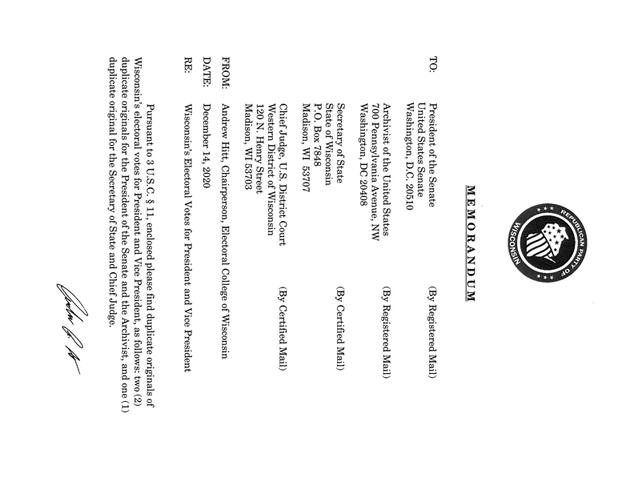
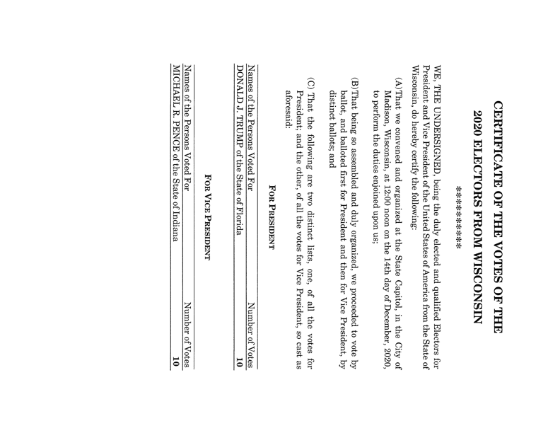
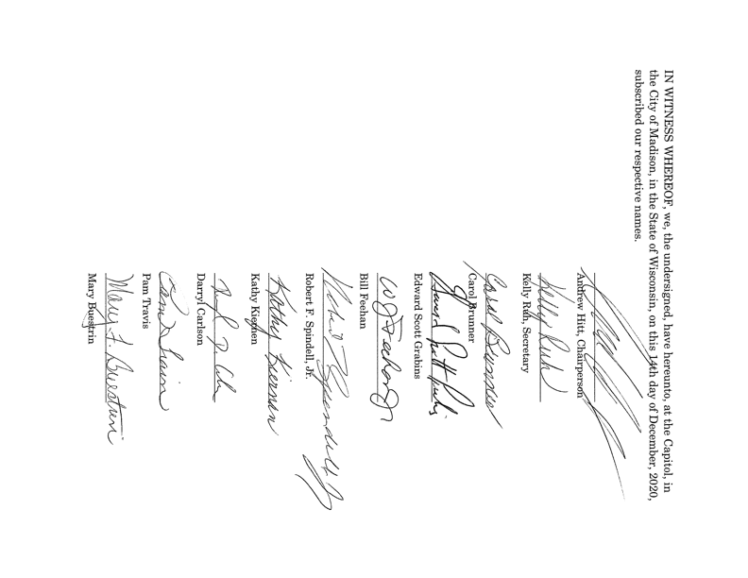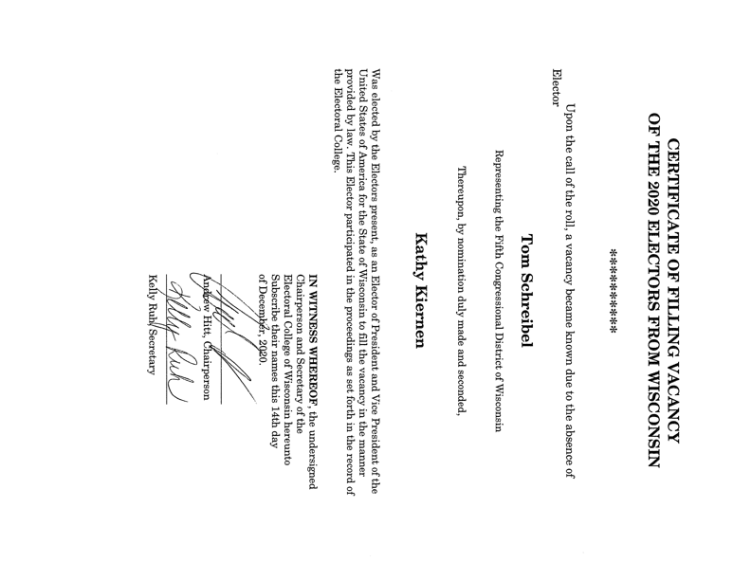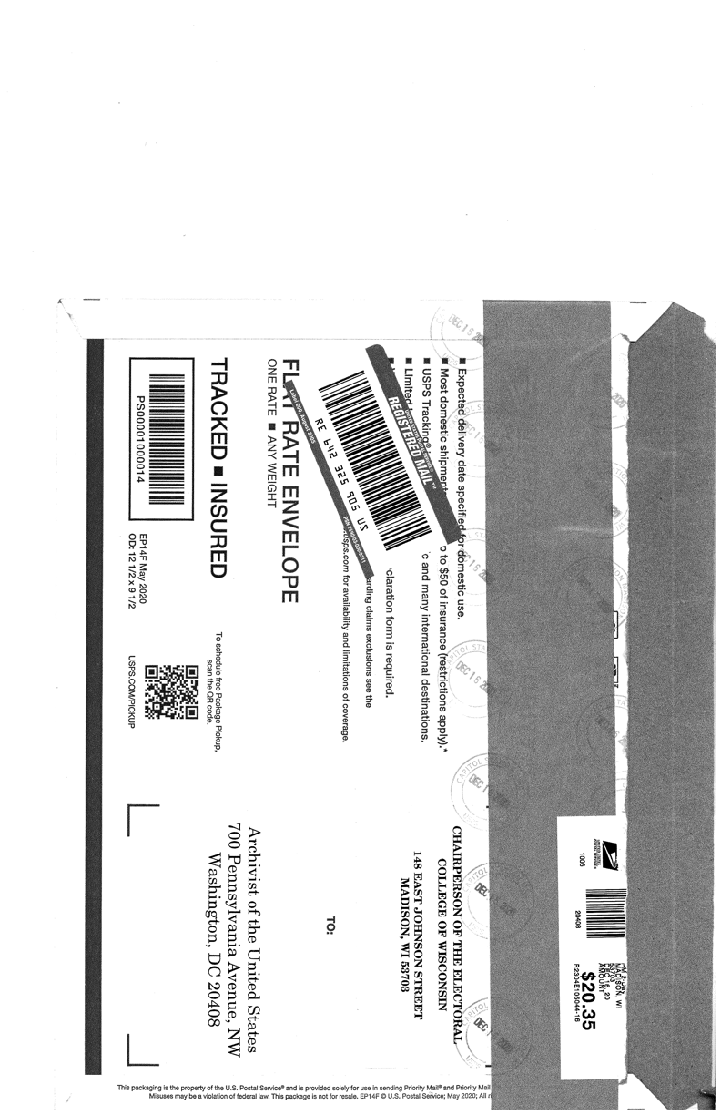
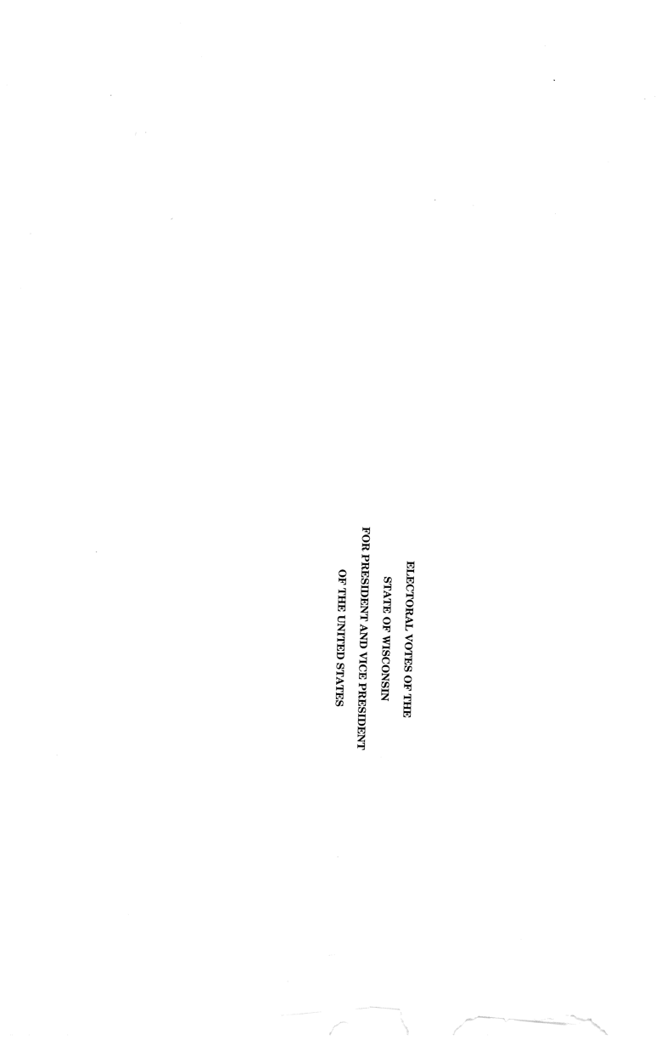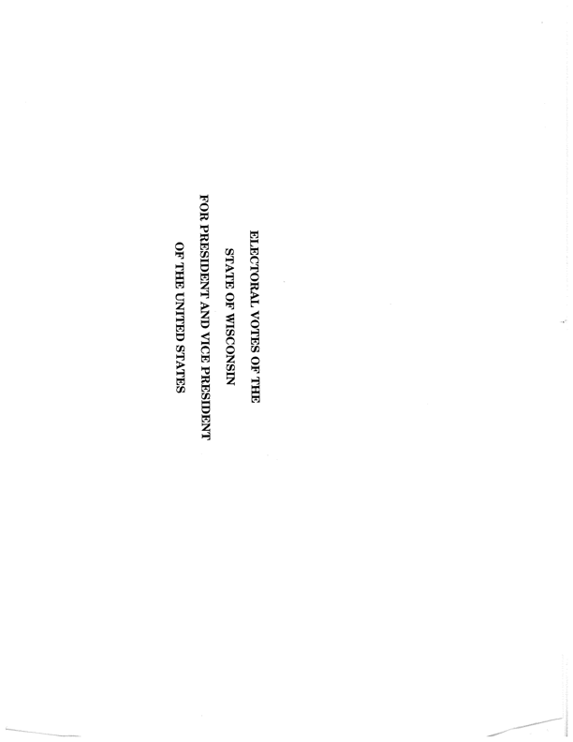

See infra Part III.A.
See infra Part III.A. for more on the bad-faith nature of Feehan v. Wisconsin Elections Commission, also known as the “kraken” suit. A district court dismissed the case on December 10, at which point the plaintiffs filed an appeal with the 7th Circuit. The 7th Circuit dismissed the case as moot on February 1, 2021. Feehan's lawyers filed a petition with SCOTUS on December 15 (the day after the meeting of the electors), which the court denied on March 1, 2021.

