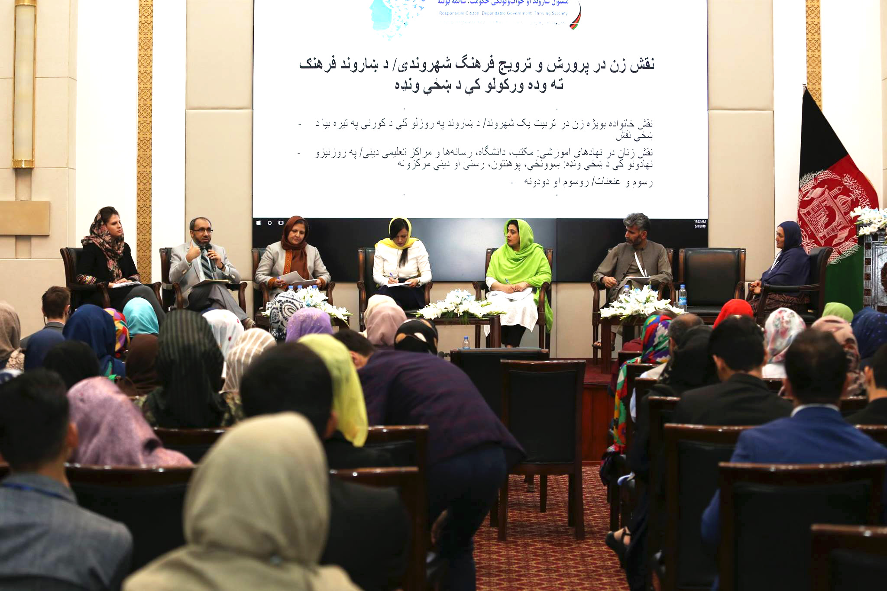  Handmade Jewellery by Zardozi Women |  | Zardozi  Markets for Afghan Artisans  - September 2017
 | . | IN THIS ISSUE

Nisfe Jahan’s volunteer members’ engagement in civic activities
Kubra in 5th Afghan women international symposium panel discussion
As the international community aid decreases in Afghanistan, the establishment of the Nisfe Jahan Association becomes a leading example of self-sustainability and self-reliance for other local organizations operating across Afghanistan. This institution manages and receives income through member association payments and service fees that help represent the presence of female entrepreneurs and small businesses. This includes providing business services, capacity building, and economic growth for businesswomen. The members of Nisfe Jahan are women who work as volunteers to build their communities and support the women in need. President Asharaf Ghani recognized these goals and offered up encouragement during the NGOs national conference.

In 2015, Nisfe Jahan’s income (average of all regions) from member fees was on target, representing 10% of the association’s expenditure and putting it on track for becoming increasingly cost effective in its operations. This percentage is not enough to support the bigger goals of the organization, creating a reliance on foreign aid. However, the member fees are enough to prevent Zardozi and Nisfe Jahan from closing its doors if the international funding ceased.

Today, Zardozi and Nisfe Jahan women provide business services through community business centers as well as actively engage in civic activities and empower more women to speak up about the problems in their districts.

Zardozi Kadars are responsible citizens that make a difference in society, helping to identify problems with members of the community, focusing particularly on women. These problems are mainly raised by women who are concerned about their society. They face challenges like lack of knowledge and direction on how to solve problems and which government entities to refer to, what processes to follow once they go to the relevant office. Kadars are the main voice of many women in villages, who without external support and guidance would not have been able to engage in their communities as men would.

Saleema Yaqoubi is one of the volunteer members of Nisfe Jahan. She says that, “The majority of the women in the villages are uneducated and less confident. These women do not have the courage to come out and fix the problems in society; we stand by them and guide them about how to be responsible citizens and what steps to take.”

When we asked the volunteer members about the process of problem solving in village, Ms. Kubra explained, “First of all, we identify the problems in the society in coordination with the villagers. Second, we talk with the community leaders including the Islamic scholars who have a bigger influence to support our cause. When the community leaders confirm, a complaint letter is written and taken to the relevant office on a district level where our problem will be heard. Sometimes our complaint is not taken seriously in the lower level and we have to refer to higher authorities where the job is done faster especially when they realize women have raised their voice. The positive discrimination is most of the times in our advantage.”
Women make up half of the population and are the strong ‘rock’ foundation of a nation. This is why if the foundation is weak and paralyzed half of the nation is paralyzed. This is where their involvement in civic activities is substantial to the growth of a country.
The following achievements have been accomplished with the responsible citizens of Kabul. The Kadars worked together with the villagers for these incredible milestones.
- Provided urban transportation for the Quran Zyart area in the 13th District of Kabul.
- Collection of waste from Chahar Qala e Wazir Abad, Kabul.
- Asphalt of road along with canal construction in Qadir Abad, Herat.
- School construction for boys and girls who used to study under tents in Sai Palak area of Herat.
- Provided drinking water for the people of Noabad region of Mola Abdullah area who did not have water for 5 months.
- Provided literacy classes for women in the Aliabad area of Mazar-e-Sharif.
- Coordinated with the Department of Public Health for the construction of Clinic in Faqir Abad, Mazar-e-Sharif.
- Facilitated litigation training for the majority of areas in Nangarhar as well as collection of waste from areas of Afghan Mena and Dronta.

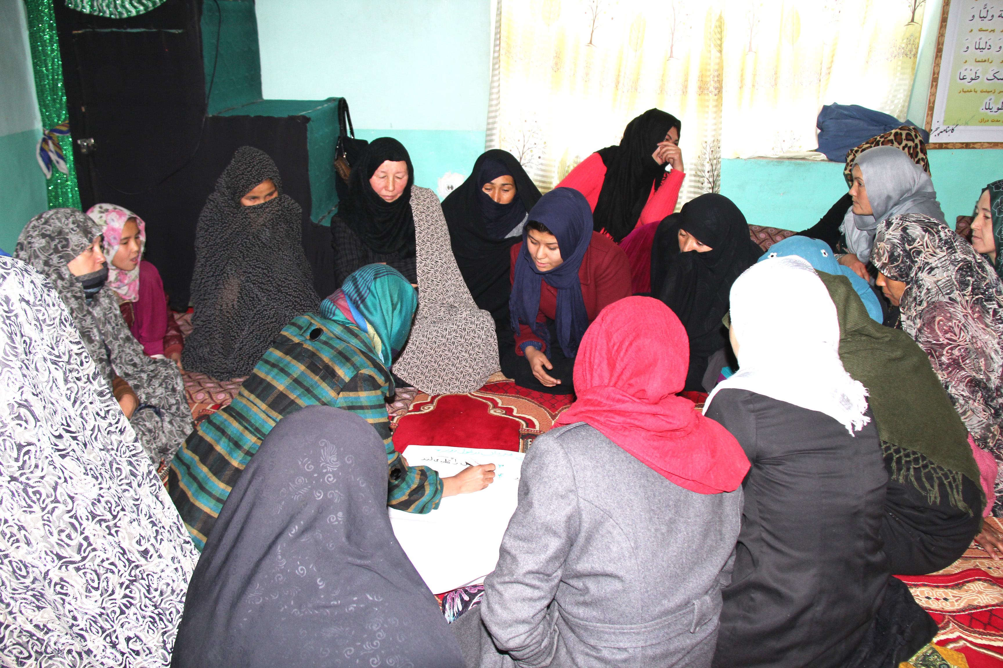
Zardozi Kadar solving the problems that the community women face
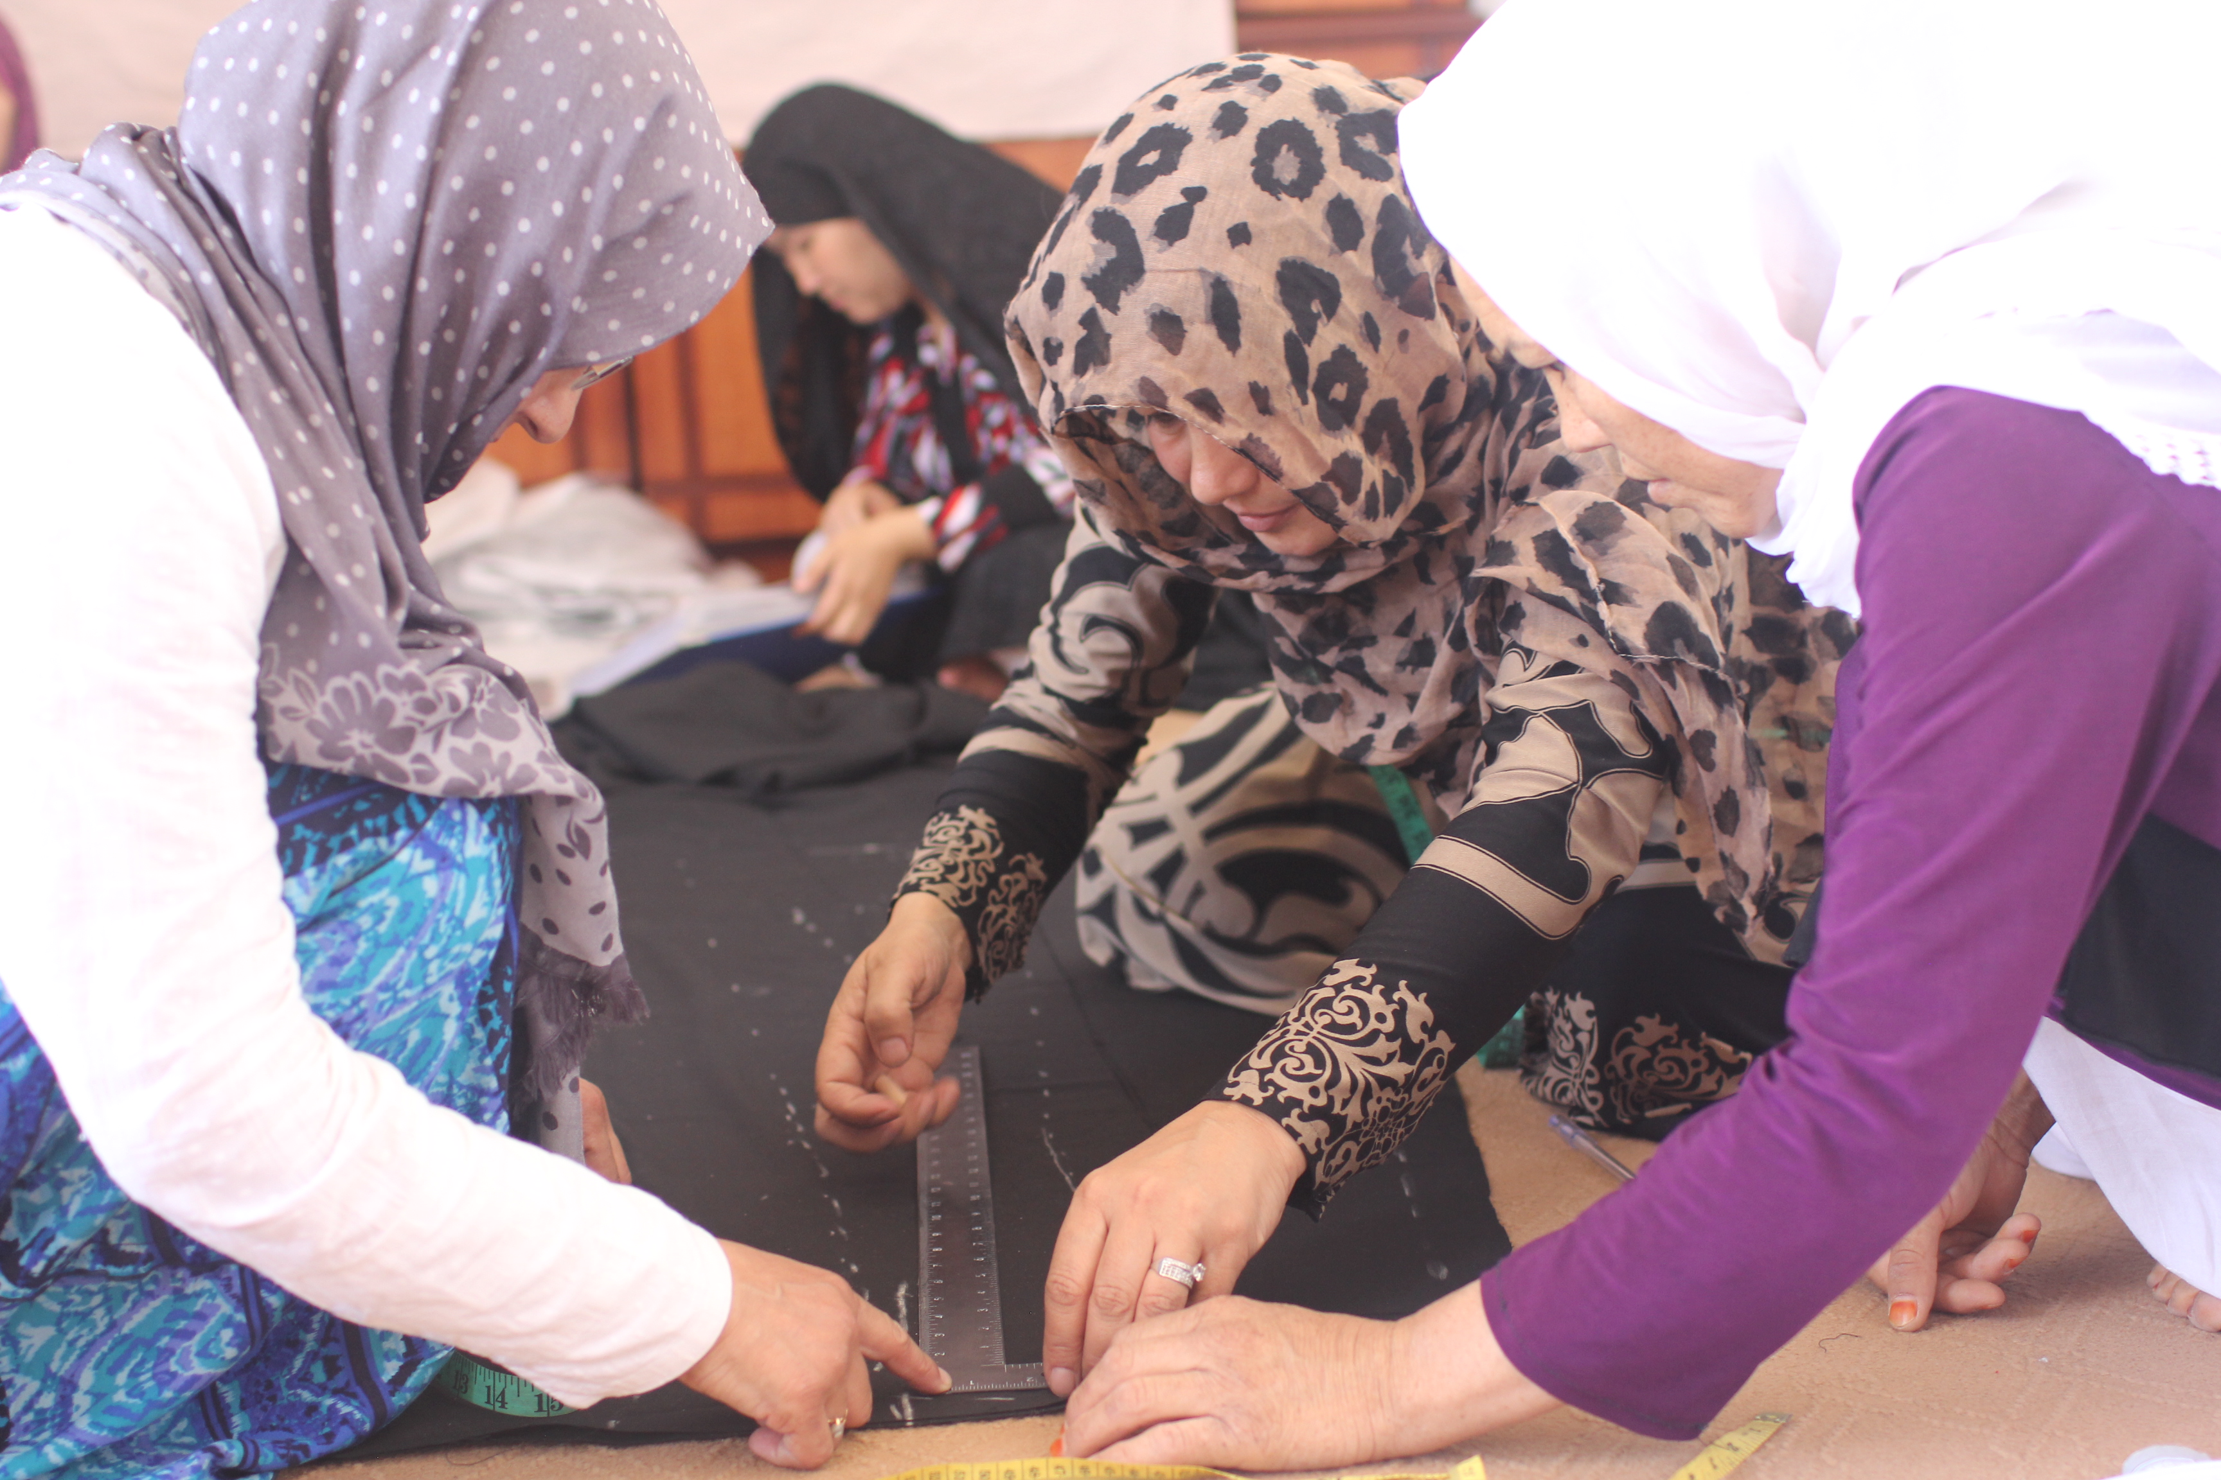
Meet the first group start up
A team work that led the five women toward success and big achievements

Ommulbanin, Zarguna, Bibi Mah, Fatima and Masuma are the first five women who were suggested to start a business as a group. This idea of group start-ups was discussed in the Annual Strategic Workshop at Zardozi’s main office. The organization observed that some women were unable to smoothly run their businesses, due to many home responsibilities and family problems. For women like Zarguna, Fatima and Masooma, running a business by themselves meant leaning toward failure and waste of resources and time. The five women partnered to begin their startup under the guidance and advisory of Zardozi Kadars, ECMS and trainers. They decided to work in as a team and make kitchen decoration handcraft sets for customers. By dividing tasks and covering for each other when one person was not available, the group was able to reach completion of goals as a team.
Bibi Mah says that the need for a group start-up was a great idea. Shopkeepers were not happy about the quality and quantity of her products due to her inability to focus solely on production. She says that the root cause is the large number of responsibilities and problems at home that did not allow her to dedicate much time to her business. Because of this, some of the shopkeepers canceled contracts with her. “Thereof, Zardozi advised me to join with a group of four more women who had similar problem. This is effective, because I didn’t have to begin from the scratch and reinvest,” added Bibi Mah.
The group began by signing an agreement letter that allowed them 1,000 AFS seed money to start their new business. At the beginning, the group received intense training about good team work, leadership, accounting and management. Soon they presented their first sample of handcraft for kitchen decoration to one of Mazar Sharif’s prominent market.
With this added training, the women became very marketable. The group was successful and took several orders from other shopkeepers and continued to run their business efficiently. The group found more customers and consumers when they attended Zardozi exhibitions and put their products into display.
Ommulbanin says that, “During this period of time we signed big contracts of 100-300 pairs of kitchen sets which I could have never managed and handled on my own. The group work is having fruitful results; we earn more than what we expect,” exclaimed Ommulbanin.

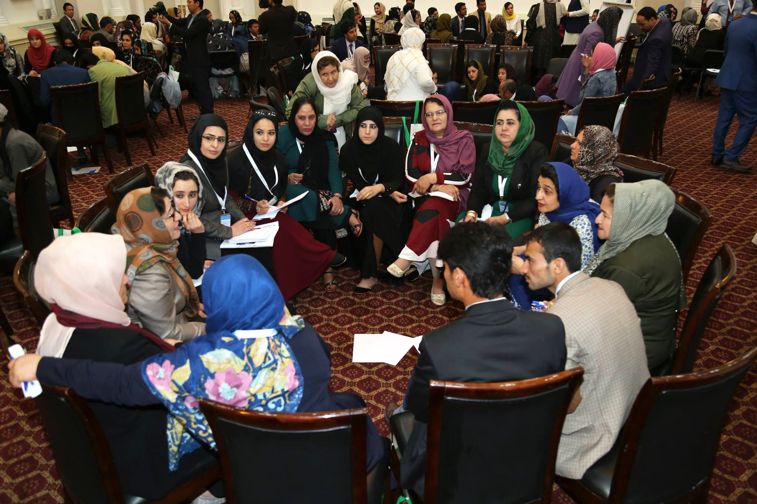
The Afghan Women international symposium under the title of "Women as responsible citizens," with the slogan of "Responsible Citizen, Dependable Government, and Thriving society" was held on 7-9th May. Among the guests were President Ashraf Ghani, First Lady Rula Ghani, State authorities along with 350 women from Kabul and provinces and international community members in the Presidential Palace. Afghan women symposiums, which were previously held in Washington DC, Oslo and Norway, are now organized inside Afghanistan where the voices of hundreds of women marginalized by war and oppression are heard.
Zardozi Kadars were also given the opportunity to be part of the conference and to join the panel discussions to discuss the importance of women’s role in building societies and to speak about the achievements they have gained as responsible citizens of their communities. The Kadars were acknowledged and warmly appreciated by the First Lady. She recognized the impact being made by these women coming together as a community, regardless of status or education level. A significant difference has been made by these women by cleaning the city, building schools, clinics and roads and providing drinking water to the people.
Kadars participated in the 5th Afghan Women International Symposium

Group discussions at the 5th Afghan women international symposium

For More Information
For more information, please contact:
info@zardozi.org
Zardozi – Markets for Afghan Artisans
Qala-e-Musa Square, Kabul, Afghanistan
www.zardozi.org

Zardozi’s program of Economic and Social Empowerment for Afghan Women is undertaken with the financial support of the Government of Canada provided through Global Affairs Canada

ZARDOZI ZARDOZI is a local non‐government and non-profit organization aiming to provide economic and social services to around 6,000 Afghan women in four provinces such as Herat, Mazar-e-Sharif, Jalalabad and Kapisa with its main office in Kabul, Afghanistan.
Zardozi’s objective is to support and empower Afghan women living in the urban and rural areas through its business skills development programs to engage them in the market economy. To achieve this goal, Zardozi has established Nisfe Jahan as an independent membership-based civil society organization which also runs local Community Business Center where women gather to receive business startup loans; and technical, advisory, business and marketing skills trainings.

About Zardozi

