Broth with noodles

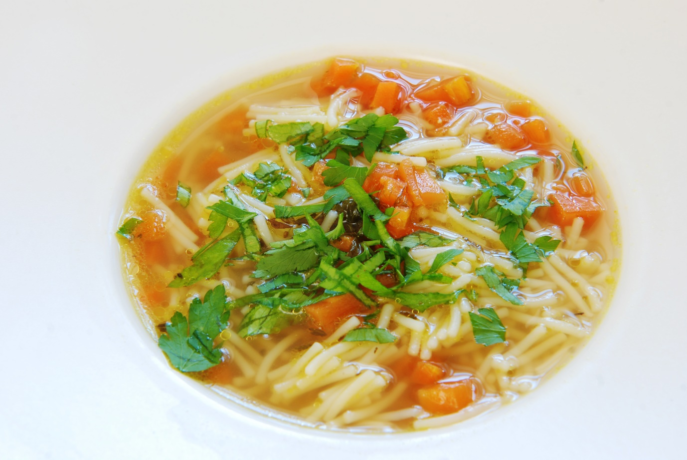
Ingredients: Preparation time: 3h
- ½ kg lamb on bone
- ½ kg turkey (or beef)
- 2 bay leaves
- ½ tsp ground cumin seeds
- ½ tsp coriander seeds
- ½ tsp ground ginger
- 10 whole black peppers
- Pinch red chilli or cayenne pepper
- Salt to taste
- ½ tsp turmeric
- Fresh vegetables:
3 carrots, 1 parsley root, 1 leek, 1 onion, 5 gloves of garlic,1 x fennel bulb, bunch of green parsley

Preparation:
On 4-5 litter of boiling water add: lamb, cumin seeds, coriander seeds, ginger, black pepper, chilli, turkey and salt. Cook on the very low heat for about 1.5h. Then, add green parley, turmeric, carrots, parsley root, leek, onion, garlic and fennel. Cook on very low heat for another 1h. In the meantime, check the meat and if it is ready - take it out. Do the same with vegetables. Stock should be cooked for about 3h in total.
Serve with egg noodles. Garnish with fresh green parsley.

