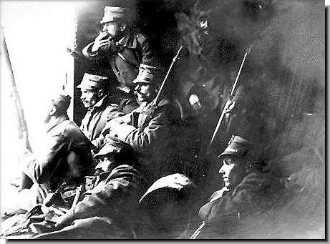
The Balkan Wars
1912/13
Experience, Perception, Remembrance
International Conference on the Occasion of the 100th Anniversary

ABSTRACTS
11-13 OCTOBER 2012
ISTANBUL

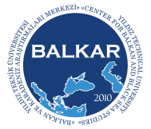


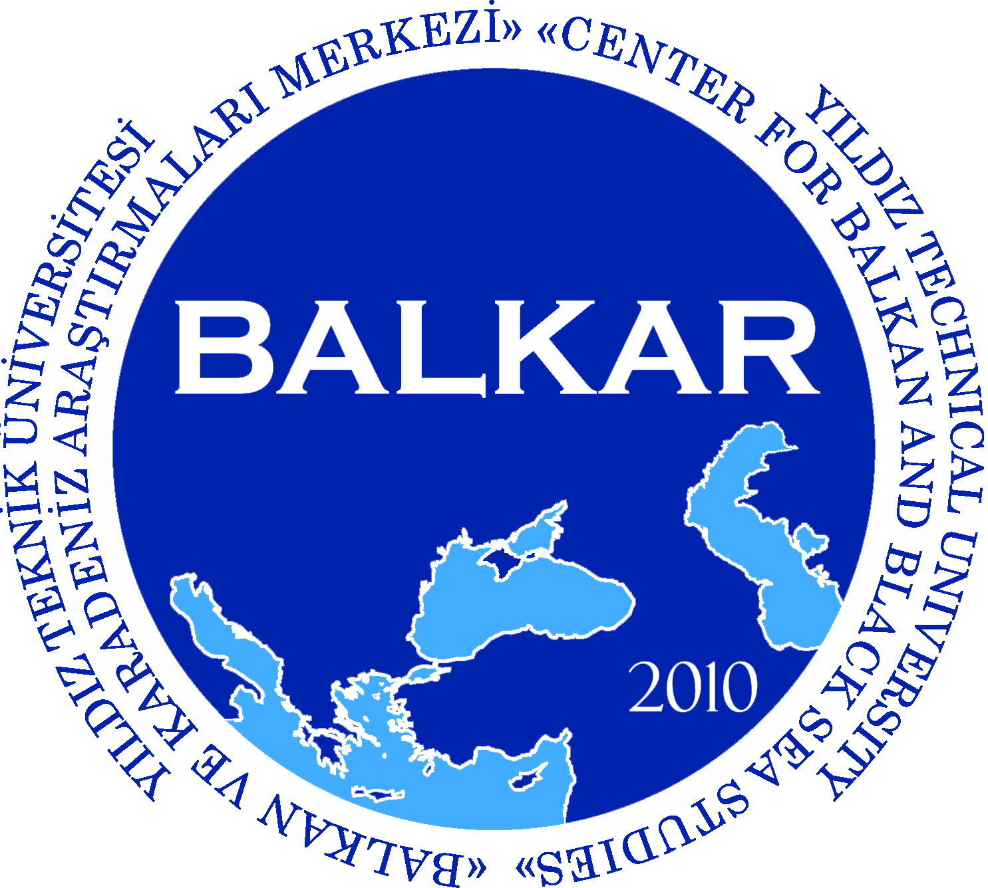


CONTENTS
CONTENTS 1
PROGRAM 7
PARTICIPANTS 11
GRUßWORT - EMILIA MÜLLER 15
KEYNOTES 17
Fikret ADANIR: Ethnonationalism, Irredentism, and Empire: Notes on the Last “Turkish War” in Europe" 17
PANEL 1: Diplomacy 19
Bruno KOREA GAJSKI: European Diplomacy and the Balkan Wars 19
Gül TOKAY: Balkan Wars and Great Powers through the Eyes of the Ottoman Diplomats: An Interpretation 21
M. Hakan YAVUZ: The Connection between War-Making and Nationalism in the Balkans 22
Konrad CLEWING: The War that Did Not End in 1912/13: Violence and Ethnic Politics in Southwestern Macedonia and Southern Albania 24
Michael H. CLEMMESEN: The Distant Storm and the Final Preparations for the Great War in Northern Europe 25
PANEL 2: Demographic / Social Engineering 27
Katrin BOECKH: Hopes and Illusions of Pan-Slavism: Pan-Slavic Actors and their mobilizing Efforts during the Balkan Wars 27
Mehmet HACISALIHOĞLU: Negotiations and Agreements for Population Transfers in the Balkans (from the Beginning of the 19th Century until 1912) 28
Edvin PEZO: Violence and Population Movements in the Balkan Wars and After. Dynamics and Entanglements of States and Societies in Periods of Crisis 29
Vera GOSEVA, Natasha KOTLAR-TRAYKOVA: The Position of the Muslim Population in Salonica and its Environment during the Balkan Wars (1912-1913) 30
PANEL 3: Soldiers 33
Richard C. HALL: The Thrakian Theater of War 1912 33
Mehmet BEŞİKÇİ: Perceiving the Defeat: The Failure of Ottoman Manpower Mobilization in the Balkan Wars and its Reform 34
Claudiu-Lucian TOPOR: Forgotten Lessons of the Balkan War: the Romanian Army between the Bulgarian Campaign (1913) and the Desaster of Turtucaia (1916) 35
Spyridon TSOUTSOUMPIS: Culture, Combat and the Barbarisation of Warfare among Greek Soldiers 37
PANEL 4: Civilians, Wounded, Invalids 39
Oya DAĞLAR MACAR: The British Red Cross Assistance in the Balkan Wars 39
Mile BJELAJAC: Treatment of Civilians, Wounded and Captured Enemies by the Serbian Army 1912/1913 42
Iakovos D. MICHAILIDIS: ‘Collateral Damages’: The Fate of Civilians in Macedonia 44
Eyal GINIO: Charity and Nationalism in the Home Front: Jewish Philanthropy during the Balkan Wars 45
PANEL 5: Memories of Victory and Defeat 47
Stefan ROHDEWALD: Figures of National Religious Memory and Their (Ab)Uses in the Balkan Wars as a History of Entanglements 47
Alexey TIMOFEEV: Serbian Chetniks in the Balkan Wars: Cultural, Social and Political Tradition of Irregular Warfare in Serbia 50
Dubravka STOJANOVIĆ: The Mould of War Remembrance. The Balkan Wars in Serbian History Textbooks 1932-2011 51
Eva Anne FRANTZ: Local Albanian and Serbian Experiences and Perceptions of the First Balkan War 1912/13 in Kosovo 52
PANEL 6/1: Perceptions from Within and from Outside 55
Nicolas PITSOS: Marianne Staring at the Balkans on Fire: French Views and Perceptions of the 1912/13 Conflicts 55
Stjepan MATKOVIĆ: The Croatian Perception of the Balkan Wars and the Idea of Yugoslav Integralism 57
Günther SANDNER: Deviant Perceptions. Leon Trotsky and Otto Neurath on the Balkan Wars (1912/13) 59
Sabine RUTAR: At the Doorstep to the Balkans: Increased Warship Building and Fear of War in Trieste after the Bosnian Crisis (1908-1913/14) 61
PANEL 6/2: Perceptions from Within and from Outside 63
Amir DURANOVIĆ: “An Outlaw and Robber Nation”. The Image of the Albanians in the Serb Press in Bosnia and Herzegovina During the Balkan Wars 63
Florian KEISINGER: Uncivilised Wars in Civilised Europe? The Perception of the Balkan Wars 1912/13 in English, German, and Irish Newspapers and Journals 65
Svetlozar ELDAROV, Bisser PETROV: Bulgarian Historiography on the Balkan Wars: Stages and Trends 67
Eugene MICHAIL: The Shifting Memory of the Balkan Wars in Western Historiography: 1912-1999 68

PROGRAM
11 October 2012 Thursday
9:00-11:00 | WELCOME ADDRESSES
İsmail YÜKSEK | President of Yıldız Technical University
Mehmet HACISALİHOĞLU | Director of BALKAR
Katrin BOECKH | Institute for East and Southeast European Studies (IOS)
 | KEYNOTES
Fikret ADANIR | Ethnonationalism, Irredentism, and Empire: Notes on the Last "Turkish War" in Europe
Wolfgang HÖPKEN | At the Brink of "Modernity"? The Balkan Wars in 20th Century European Warfare
11:30-13:15 | PANEL 1: DIPLOMACY
 | (Chair: Aydın Babuna)
Bruno Korea GAJSKI | European Diplomacy and the Balkan Wars
Gül TOKAY | Balkan Wars and Great Powers through the Eyes of the Ottoman Diplomats: An Interpretation
M. Hakan YAVUZ | The Connection between War-Making and Nationalism in the Balkans
Konrad CLEWING | The War that Did Not End in 1912/13: Violence and Ethnic Politics in Southwestern Macedonia and Southern Albania
Michael HESSELHOLT CLEMMESEN | The Distant Storm and the Final Preparations for the Great War in Northern Europe
15:30-17:15 | PANEL 2: DEMOGRAPHIC/SOCIAL ENGINEERING
 | (Chair: Ömer Çaha)
Katrin BOECKH | Hopes and Illusions of Pan-Slavism: Pan-Slavic Actors and their Mobilizing Efforts during the Balkan Wars
Mehmet HACISALİHOĞLU | Negotiations and Agreements for Population Transfers in the Balkans (from the Beginning of the 19th Century until 1912)
Edvin PEZO | Violence and Population Movements in the Balkan Wars and after. Dynamics and Entanglements of States and Societies in Periods of Crisis
Vera GOSEVA | The Position of the Muslim Population in Salonica and its Environment during the Balkan Wars 1912-1913
Natasha KOTLAR-TRAYKOVA
12 October 2012 Friday
9:00-10:45 | PANEL 3: SOLDIERS
 | (Chair: Taha Akyol)
Richard HALL | The Thrakian Theater of War
Mehmet BEŞİKÇİ | Perceiving the Defeat: The Failure of Ottoman Manpower Mobilization in the Balkan Wars and its Reform
Claudiu-Lucian TOPOR | Forgotten Lessons of the Balkan War: the Romanian Army between the Bulgarian Campaign (1913) and the Disaster of Turtucaia (1916)
Spyridon TSOUTSOUMPIS | Culture, Combat and the Barbarisation of Warfare among Greek Soldiers
11:15-13:00 | PANEL 4: CIVILIANS, WOUNDED, INVALIDS
 | (Chair: Heike Karge)
Oya DAĞLAR MACAR | The British Red Cross Assistance in the Balkan Wars
Mile BJELAJAĆ | Treatment of Civilians, Wounded and Captured Enemies by the Serbian Army 1912 – 1913
Iakovos D. MICHAILIDIS | “Collateral Damages”: The Fate of Civilians in Macedonia
Eyal GINIO | Charity and Nationalism in the Home Front: Jewish Philanthropy during the Balkan Wars
14:30-16:15 | PANEL 5: MEMORIES OF VICTORY AND DEFEAT
 | (Chair: Gencer Özcan)
Stefan ROHDEWALD | Figures of National Religious Memory and Their (Ab)Uses in and after the Balkan Wars as a History of Entanglements
Alexey TIMOFEEV | Serbian Chetniks in the Balkan Wars: Cultural, Social and Political Tradition of Irregular Warfare in Serbia
Dubravka STOJANOVIĆ | The Mould of War Remembrance. The Balkan Wars in Serbian History Textbooks 1932-2011
Eva FRANTZ | Local Albanian and Serbian Experiences and Perceptions of the First Balkan War 1912/13 in Kosovo
16:45-18:30 | PANEL 6/1: PERCEPTIONS
 | (Chair: Elçin Macar)
Nicolas PITSOS | Marianne Staring at the Balkans on Fire: French Views and Perceptions of the 1912-13 Conflicts
Stjepan MATKOVIĆ | The Croatian Perception of the Balkan Wars and the Idea of Yugoslav Integralism
Günther SANDNER | Deviant Perceptions: Leon Trotsky and Otto Neurath on the Balkan Wars (1912-13)
Sabine RUTAR | At the Doorstep to the Balkans: Increased Warship Building and Fear of War in Trieste
13 October 2012 Saturday
9:00-10:45 | PANEL 6/2: PERCEPTIONS
 | (Chair: Sabine Rutar)
Amir DURANOVIĆ | “An Outlaw and Robber Nation”. The Image of the Albanians in the Serb Press in Bosnia and Herzegovina during the Balkan Wars
Florian KEISINGER | Uncivilised Wars in Civilised Europe? The Perception of the Balkan Wars 1912/13 in English, German, and Irish Newspapers and Journals
Svetlozar ELDAROV | Bulgarian Historiography on the Balkan Wars: Stages and Trends
Biser PETROV
Eugene MICHAIL | The Shifting Memory of the Balkan Wars in Western Historiography: 1912-1999
11:15-11:45 | CLOSING SPEECH
Heike KARGE | The Wars that Knew No Post-War: Placing the Balkan Wars in the History of Wars of the 20th Century
 | FINAL DISCUSSION

PARTICIPANTS
Adanır, Fikret, Prof. Dr., Faculty of Arts and Social Sciences, Sabanci University, Istanbul; fikretad@gmail.com
Akyol, Taha, Journalist / Hürriyet, İstanbul; takyol@hurriyet.com.tr
Babuna, Aydın, Prof. Dr., Atatürk Institute for Modern Turkish Studies, Bosphorus University, Istanbul; babuna@boun.edu.tr
Beşikçi, Mehmet, Dr., Institute of Modern Turkish History, Yildiz Technical University, Istanbul; mebesikci@yildiz.edu.te
Bjelajac, Mile, PhD, Institute for Recent History of Serbia, Belgrade; mile.bjelajac@gmail.com
Boeckh, Katrin, Prof. Dr., Institute for East and Southeast European Studies, Regensburg; University of Munich; boeckh@ios-regensburg.de
Çaha, Ömer, Prof. Dr., Department of Political Science and International Relations, Yıldız Technical University; ocaha@yildiz.edu.tr
Clewing, Konrad, Dr., Institute for East and Southeast European Studies, Regensburg; clewing@ios-regensburg.de
Dağlar Macar, Oya, Assoc. Prof. Dr., ITICU, Department of International Relations, Üsküdar, Istanbul; oyadag@yahoo.com
Duranović, Amir, Research Assistant, Faculty of Philosophy, Institute for History, University of Sarajevo; aduranovic@yahoo.com
Eldarov, Svetlozar, Prof. Dr., Institute for Balkan Studies, Sofia; sveldarov@abv.bg
Frantz, Eva Anne, M.A., Commission South East Europe - Turkey - Black Sea Region, Austrian Academy of Sciences, Vienna, Eva.Frantz@oeaw.ac.at
Gajski, Bruno Korea, Mag. pol., Faculty of Political Science, University of Zagreb; brgajski@gmail.com
Ginio, Eyal, Dr., Department of Islamic and Middle Eastern Studies, The Hebrew University of Jerusalem; eginio@pluto.mscc.huji.ac.il
Goseva, Vera, Prof. Dr., Institute of National History, Skopje; veragsv@yahoo.com
Hacısalihoğlu, Mehmet, Assoc. Prof. Dr., Dept. Pol. Science and Int. Rel.; Center for Balkan and Black Sea Studies, Yıldız Technical University, Istanbul; mehmethacisalihoglu@gmail.com
Hall, Richard, Prof. Dr., Georgia Southwestern State University; Richard.Hall@gsw.edu
Hesselholt Clemmesen, Michael, Brigadier General (DA, ret.), M.A. (hist.), Centre for Military History, Royal Danish Defence College; ‎mhclemmesen@gmail.com
Höpken, Wolfgang, Prof. Dr., Chair of East and Southeast European History, University of Leipzig; hoepken@rz.uni-leipzig.de
Karge, Heike, Dr., Chair of Southeast and East European History, University of Regensburg; heike.karge@geschichte.uni-regensburg.de
Keisinger, Florian, Dr., German Parliament, Berlin; florian.keisinger@yahoo.de
Kotlar-Traykova, Natasha, Ass. Prof., Institute of National History, Skopje; kotlarn@yahoo.com
Macar, Elçin, Assoc. Prof. Dr., Department of Political Science and International Relations, Yıldız Technical University; elcinmacar@yahoo.com
Matković, Stjepan, Dr., Croatian Institute of History, Zagreb; matkovic@isp.hr
Michail, Eugene, Dr., Bader International Study Centre, Queen's University, Toronto; e.michail@sussex.ac.uk
Michailidis, Iakovos D., Ass. Prof., Department of History and Archaeology, Aristotle University of Thessaloniki; iakovos@hist.auth.gr
Özcan, Gencer, Prof. Dr., Department of International Relations, Istanbul Bilgi University; gencer.ozcan@bilgi.edu.tr
Petrov, Bisser, PhD, Institute for Balkan Studies, Sofia; bisser_p@hotmail.com
Pezo, Edvin, Dr., Institute for East and Southeast European Studies, Regensburg; pezo@ios-regensburg.de
Pitsos, Nicolas, M.A., Institute for Oriental Languages and Cultures, INALCO, Paris; nikolaospitsos@hotmail.com
Rohdewald, Stefan, Dr., Department of Modern and Contemporary History of Eastern Europe and its Cultures, University of Passau; stefan.rohdewald@uni-passau.de
Rutar, Sabine, Dr., Imre-Kertész-Kolleg, Jena / Institute for East and Southeast European Studies, Regensburg; rutar@ios-regensburg.de
Sandner, Günther, Dr., Institute Vienna Circle, University of Vienna; guenther.sandner@univie.ac.at
Stojanović, Dubravka, Assoc. Prof. Dr., Faculty of Philosophy, Belgrade University; dust@eunet.rs
Timofeev, Alexey, Dr., Institute for Recent History of Serbia, Belgrade; al.timofev@gmail.com
Tokay, Gül, PhD, London / Istanbul; gultokay@btinternet.com
Topor, Claudiu-Lucian, PhD, Faculty of History, Department of Modern History, University of Iasi; claudiulucian@yahoo.com
Tsoutsoumpis, Spyridon, PhD, Department of History, University of Manchester; spyros_tsoutsoumpis@yahoo.com
Yavuz, M. Hakan, Prof. Dr., Department of Political Science, University of Utah; hakan.yavuz@poli-sci.utah.edu

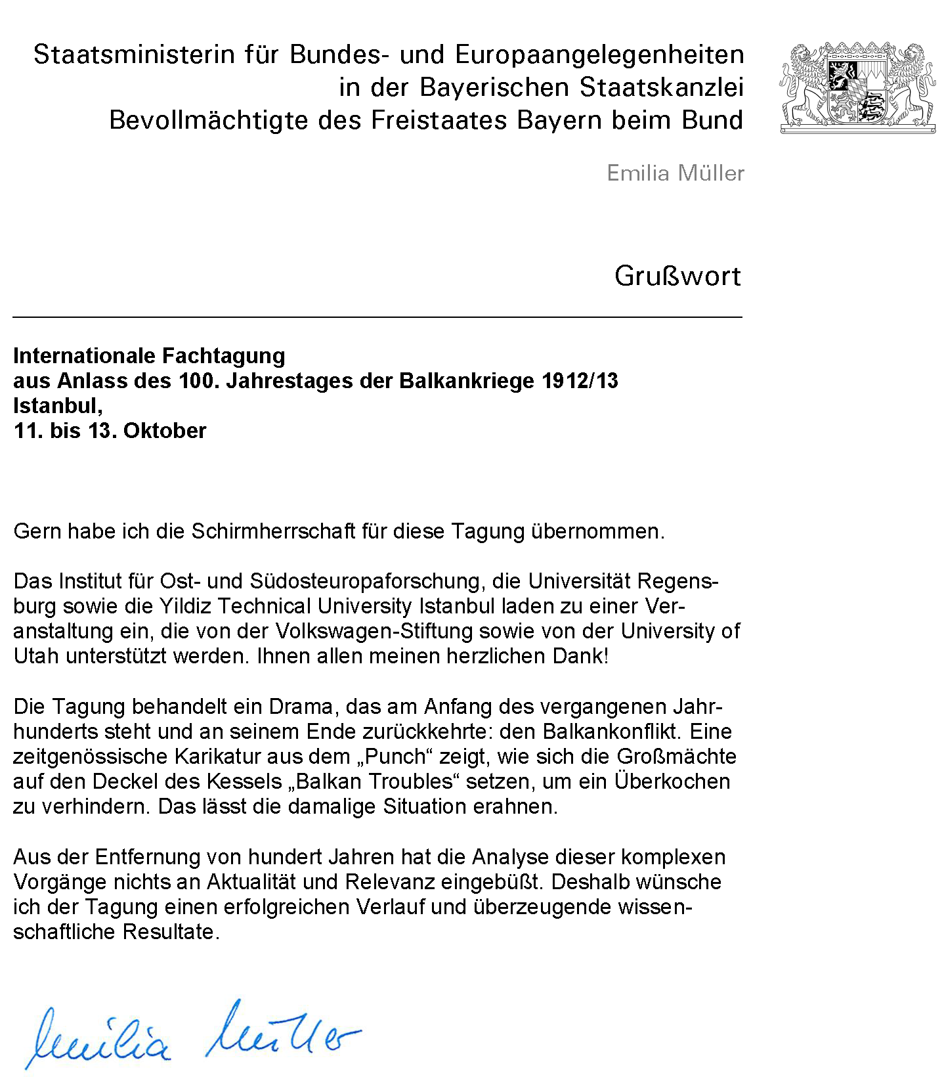

GRUßWORT - EMILIA MÜLLER

KEYNOTES

Fikret ADANIR: Ethnonationalism, Irredentism, and Empire: Notes on the Last “Turkish War” in Europe"
Popular uprisings in the Balkans against Ottoman rule almost always ended with military intervention by European powers. The restoration of peace usually entailed substantial changes in the political map and led, in the course of the nineteenth century, to the establishment of several nation-states. Especially after the Berlin Treaty of 1878, the incipient nations viewed it as their historical mission to emancipate their "brothers and sisters" still under Ottoman domination. The resulting irredentist discourse stressed the righteousness of wars of liberation. At the same time it served to justify a territorial expansionism that soon triggered a fierce rivalry over the Ottoman legacy. This process culminated in the Balkan Wars of 1912/13. One salient trait of the New Military History has been the focus on the question of how the image of the enemy is created and perpetuated both ideologically and psychologically. In this connection, it is striking that the methods of othering employed in the Balkan Wars evoke the stereotypes of the anti-Islamic propaganda rampant during the Turkish wars of the late medieval and early modern period. The Enlightenment's verdict that Ottoman rule was an Asiatic despotism is taken up as an additional argument, just as Gladstone's famous dictum of 1876 that the barbarian Turks should finally be expelled from Europe is echoed in a similarly draconic demand. Thus the onslaught of 1912 against the Ottoman empire was officially proclaimed by the Balkan allies as a war of "the Cross against the Crescent" (the Bulgarian text), a battle against a "medieval system of feudal exploitation" (the Serbian text), and a "crusade of progress, civilization and liberty against Asian conquerors" (the Greek text). The Ottoman statesmen of the period were primarily concerned with the preservation of their polyethnic and multireligious empire. The constitution recently reinvigorated through the Young Turk "revolution" rearticulated the pledge of the reform era Tanzimat (1839-76) to implement the novel concept of Ottoman citizenship based on civic rights and legal equality for all subjects irrespective of religious or ethnic affiliation. It is not surprising, therefore, that there was no reference to a Jihad in the sultan's proclamation of war in 1912, not least because non-Muslim recruits were expected to make up a high percentage of the army in the field. The Ottoman military debacle that soon followed brought with it not only the loss of "European Turkey", but also it prepared the ground for a CUP (Committee of Union and Progress) coup in early 1913. The Unionist opposition to peace proposals and the recovery of Adrianople during the Inter-Allied War seemed to corroborate the legitimacy of a single-party rule under the tutelage of the military that was to last until the end of World War I. Faced with a huge wave of Muslim refugees arriving in Anatolia, the CUP virtually abandoned its Ottomanist egalitarian attitude and began to instrumentalize Muslim grievances in the interest of a vindictive nationalism that aspired to a new mobilization of society along Turkish-Islamic lines. Already in early 1914, large numbers of Ottoman Greeks were expelled from Eastern Thrace and Aegean Anatolia. With the outbreak of the Great War, religiously fuelled nationalism in the service of an elite bent on ethnic engineering began to victimize non-Muslim populations on a much larger scale. Thus the consolidation of the Kemalist republic in the interwar period signified also the completion of the cleansing of Asia Minor of practically all its Christian inhabitants. The Balkan Wars of 1912/13 mark a watershed in this development; their history deserves a new attention from the perspective of our globalized world that continues to be polarized along religious divides.

PANEL 1: Diplomacy

Bruno KOREA GAJSKI: European Diplomacy and the Balkan Wars
The paper aims to identify the key effects of the Balkan Wars on both European politics and diplomacy. The paper is primarily based on three essential diplomatic problems: the infusion of Russian politics on the European scene; the last efficient diplomatic co-operation of the Central Powers; and the dismantling of the politics that maintained Europe’s balance of power. The first diplomatic problem dealt with the reactivation of Russian politics after a brief period of inactivity. The relationship that had existed at the time was valid only as long as Russia was weakened by defeat in the Russian-Japanese war. As soon as Russia had recovered to a degree, the situation became substantially more complicated. Russia was a key provocateur in encouraging an aggressive form of nationalism within small Balkan states and the main sponsor of the Balkan Association. Such policies among the Russians were a sign of the state’s frustration for not being allowed to participate in European politics at the time and a response to previous Austrian-German initiatives. The other problem derived from the last efficient diplomatic co-operation of the members of Central Powers. Austro-Hungarian policies toward the Balkans were oriented primarily to prevent the enhancement of Serbia and its rising influence over the southern Slavs within the Dual Monarchy. When it seemed realistic in the First Balkan War that Serbia would gain an access point to the sea, Austrian and Italian interests became endangered. More imperative, Germany realized both the seriousness of the situation in the Balkans and the imminent threats to the survival of the Austro-Hungarian Empire after the Second Balkan War. From this point forward, German and Austro-Hungarian politics formed an even closer working cooperation. Further, this was the last time that Italy maintained its solidarity with its allies. The Balkan Wars solidified the alliance between the two opposing camps much more than previous pre-war crises and, subsequently, led to the creation of an absolute balance of powers. From the vantage point of diplomacy, this was of crucial importance and, as such, the third major problem emanating from the Balkan Wars – the fracturing of Europe’s balance of power. After the Balkan Wars, it was obvious that Great Britain could thwart France and Russia; however, it could not remain idol if the continental balance was upended by the rise of Germany. The Balkans had been an ideal location for the outbreak of crisis and for the activation of the chain of inter-ally commitments. The members of the Entente and the Central Powers realized that the new balance of power negated the possibility of retreat, which meant that they each lacked a motive for starting the war.

Gül TOKAY: Balkan Wars and Great Powers through the Eyes of the Ottoman Diplomats: An Interpretation
This paper tries to reinterpret the period between the outbreaks of the Balkan wars until the London Treaty of 30 May 1912. It was not only the Young Turk regime but more the differences between the conservative and the liberal powers that made any cooperation over the affairs of the Peninsula impossible. When the triangular relationship between Europeans, Ottomans and the Balkan states reached a deadlock regarding any improvement in the Peninsula by late September, though hoping for a limited and localized conflict war was seen as the only alternative. But, at the same time, the powers declared on the maintenance of the status quo and no territorial changes. However, at the early stages of the war, declarations of the maintenance of the status quo were dropped by the collapse of the Turkish military power. Likewise, tension escalated between the Austrians and Russians that made the British under Sir Edward Grey to intervene and series peace talks commenced in London.
Within this framework, the purpose of this paper is twofold. Firstly, it discusses how the Balkan wars have so far been accounted in Turkish historical writing. Secondly, it reassesses the period between September 1912 and May 1913, by studying the dispatches of the Ottoman envoys abroad and establishes a more fulfilling picture on the Ottoman initiatives prior and during the First Balkan War despite the developments in the capital. No doubt, there are many valuable studies on the Balkan wars, but the present paper with the assistance of Ottoman Foreign Ministerial archives brings some new reasoning and raises some questions for further explorations in the future.

M. Hakan YAVUZ: The Connection between War-Making and Nationalism in the Balkans
The purpose of this essay is to examine the construction of a new political discourse under the catastrophic defeats of the Balkans Wars. The major challenge confronting leaders and thinkers of the period (1908-1918) was over how to transform a multi-ethnic empire into a modern centralized, yet not necessarily national, state all the while enhancing the ideological and cultural legitimacy of state institutions. While European powers were doing their best to dismantle the Ottoman state and partition its territories, the Young Turks still believed that they could save the state and maintain its territorial integrity through legal reforms, a constitution, and the creation of an Ottoman nation not based upon a specific ethnicity or religion. After the Balkan Wars, the Ottoman state was finally compelled to cast off its multi-cultural character and to begin a slide to “Islamic Ottomanism” and then to ethno-nationalism. With defeat, the Ottoman state stepped onto a stage of history, which had already been ushered in with Greek independence, and which became seemingly the only legitimate way for organizing state and society in the international system at the time; that is to say, nationalism based in and on ethno-religious homogenization. The Ottoman elite initially reacted to this new modern form of nationalism with a more ecumenical Ottoman patriotism (1839-1913). The conditions of the Balkan defeat forced the Young Turks to stop giving credence to the resilience of a multi-religious state. Their will to continue the fight to preserve the Ottoman state as it was had been finally exhausted, yet a new willingness to apply force in order to transform Anatolia into a Turkish homeland on the same pattern of the Balkan nation-state was born. This essay seeks to retrace the metamorphosis that transformed the multi-ethnic and cosmopolitan Young Turks imbued with the ideal of constitutional nationalism into vindictive ethnic nationalists determined to create a Turkish homeland.

Konrad CLEWING: The War that Did Not End in 1912/13: Violence and Ethnic Politics in Southwestern Macedonia and Southern Albania
The First Balkan War of 1912/13 was ostensibly led by the Balkan states to achieve a "Balkan of the Balkan peoples". Yet the way the war and post-war operations were led by them in Albanian and Macedonian regions clearly indicates that what they tried to obtain was in fact a "Balkan for the already existing Balkan states". Based mainly on archival material from the Austro-Hungarian and British general consulates in Monastir (Bitola) from 1912 to 1914, the paper focuses on Serbian and Greek policies directed against Albanians and diverse Muslims, but right from the start also against those parts of the population ethnopolitically associated with Bulgaria. Using methods of ethnopolitical exclusion and suppression earlier developed within the struggles of the "Macedonian Question", the newly dominant Balkan states targeted all unwanted groups in the former Ottoman territories wherever they had gained control. A second focus of their actions was directed against the political presence and diplomatic interference of the European Powers on the spot. The Powers and their diplomats tried to regain a decisive saying in what was to become Albania and in the wider region, but with quite limited success. The gain of international autonomy of the Balkan states caused that the region gradually slipped out of the pre-1914 European state system, which can be seen as one of the contributing factors to the eventual outbreak of World War One in that very region.

Michael H. CLEMMESEN: The Distant Storm and the Final Preparations for the Great War in Northern Europe
Winston Churchill had good personal reasons for ignoring the effect of the First Balkan War in his influential “The World Crisis, 1911-1918”. The crisis came before he gained decisive influence over the Admiralty, and he felt humiliated by the independent actions of his staff officers. In his title, Richard Hall called the Balkan Wars a prelude to the Great War. However, new research into preparations for war in Germany and Britain and neutrality defence preparations in Sweden and Denmark 1910-1913 makes clear that the First Balkan War was not only a prelude, it had an important and direct influence on what happened 21 months later. In all four countries the First Balkans War directly triggered war/defence preparations of a fundamentally new character, both directly by increasing combat readiness as a response to the crisis, but more importantly by focusing and accelerating the post-crisis national professional military and naval planning preparations as well as international preparations for war. A great power war was no longer just a possibility, the then policy-making professionals of the armed forces considered it inevitable and fast approaching – and acted accordingly. These reactions were not a response to the start of the general Balkan conflict in mid-October. It was only expected to bring a humanitarian crisis as Turkey pacified the region after the victory. The trigger was Turkey’s unexpected total operational defeat that brought the risks in early November of a Bulgarian capture of Constantinople. The destruction of expectations and the balance of power immediately led to crisis reactions in all four states far more comprehensive than the previous year’s Agadir Crisis. A couple of weeks later the reality of Serbian control of part of the Albanian coast the development was close to bring the great war, and the effect of this intensified and broke down bureaucratic and political barriers for effective war or defence preparations.
My paper outlines chronologically the reactions in all four countries from November 1912 to May 1913.

PANEL 2: Demographic / Social Engineering

Katrin BOECKH: Hopes and Illusions of Pan-Slavism: Pan-Slavic Actors and their mobilizing Efforts during the Balkan Wars
The wars conducted by Christian and Slavic peoples in the Balkans against the Ottomans – the first Balkan War was nothing less than the last “Türkenkrieg” – aroused a lot of sympathy among the Slavic public outside the Balkans, especially in the Russian Empire. In the wake of the Balkan Wars and during the wars in 1912/13, numerous demonstrations in Russian cities in favour of the Serbian and Bulgarian “brothers” were organized and practical and active help for them was instigated. The presentation focuses on these public Pan-Slavic appearances and scrutinizes their aims, political demands, and reactions when the Serbian-Bulgarian alliance broke off in the Second Balkan War. Furthermore, the question of the Pan-Slavic impact on Russian foreign policy will be highlighted. A prominent role during the Balkan Wars played the Russian ambassador in Belgrade, Nikolaus Hartwig (1857-1914), characterized as the “champion of Pan-Slavism”. His acting between Pan-Slavic illusions and political realism and his intention to avoid the outbreak of a war between Russia and Austria-Hungary will be discussed at length.

Mehmet HACISALIHOĞLU: Negotiations and Agreements for Population Transfers in the Balkans (from the Beginning of the 19th Century until 1912)
The history of population transfers on the basis of decisions by ruling authorities dates back to ancient times. In moderns times, however, the establishment of nation-states played a decisive role in forcible population transfers in the Balkans. Balkan historiographies tend to date back bilaterally agreed population transfers and population exchanges to the Balkan Wars in 1912/13. However, the process of establishing autonomous and independent states in the Ottoman Balkans saw multiple cases of forcible population transfer based on agreements and treaties. Some of them are well known cases, for example, the forcible emigration of Muslims from the newly independent Greek state in 1830, the forcible emigration of Muslims from Serbian principality in 1862 and several cases of negotiations on the emigration of Muslims from different regions, such as Crete or newly established Bulgaria. This paper deals with these processes in the Balkans beginning already as early as in the 19th century. Until the Balkan Wars, the population groups forcibly transferred were mainly Muslims in the newly autonomous Balkan states or principalities. With the Balkan Wars, however, also the transfer of non-Muslim population groups in the Balkans according to bilateral agreements or treaties started. After the discussion of negotiations on population transfers and their execution in the 19th century, I will also try to discuss possible reasons for neglecting these population transfers and attempted population transfers in Balkan historiographies.

Edvin PEZO: Violence and Population Movements in the Balkan Wars and After. Dynamics and Entanglements of States and Societies in Periods of Crisis
The Balkan Wars, generally and often primarily, are associated with violence and population movements. A synonym for two different military conflicts and for the forcible retreat of the Ottoman Empire out of the Balkans, these wars less often are considered in the context of their far-reaching violent entanglements in the region itself, and with regard to the impact they had on the states and societies of the region. Reinhart Koselleck‘s categories of a “space of experience” and a “horizon of expectation” can help us to better understand the dimensions and the interplay of violence, population movements, states and societies. I will discuss, on the one hand, the occurrence and experience of mass violence and population movements during and after the Balkan Wars, and, on the other hand, the expectations, hopes, and disappointments, which were connected to these experiences, often generating new conflicts. This affected not only the immediate consequences of mass violence and population movements – of “ethnic cleansing” – but also the young statehoods in the region and their ways of state and nation-building.

Vera GOSEVA, Natasha KOTLAR-TRAYKOVA: The Position of the Muslim Population in Salonica and its Environment during the Balkan Wars (1912-1913)
The main aim of this paper is to discuss the position of the Muslim population in Salonica and its environment during the Balkan Wars based on British and Austrian archival sources. The many assassination actions that were undertaken in this area in the eve of the First Balkan War (the end of 1911) implied large changes in the whole life of the population, including the Muslim one. The beginning of the First Balkan War was accompanied by brutal actions of the allied Bulgarian and Greek military units towards the civil Muslim population. There were numerous examples of crimes as killing, raping, robbing, and ignition on the homes, forced population removal and so on. With the occupation of Salonica (9 November 1912) by the allied armies the condition of the Muslim population got worse. The anarchy in the city resulting from the absence of an organized local government, as well as the large influx of refugees, caused inter alias, worryingly sanitary and health conditions (a large number of infected by measles). In an effort to close up this difficult situation the Muslim population several times asked an international factor to investigate the situation and to intervene. Also the British government was asked to protect the Muslim civilians from the devastating activities of the allied military units. With the end of the war and the signing of the Bucharest peace agreement, а new political situation was established in the region. This caused a huge wave of refugees and devastations of homes and property. 80 years after these human sufferings and disasters, the Balkans are confronted with the same historical unlearned lessons. The Yugoslav wars of the 1990s saw the same crimes (ethnic cleansing, killing, raping, destroying homes) as well as the Balkan Wars of 1912-1913.

PANEL 3: Soldiers

Richard C. HALL: The Thrakian Theater of War 1912
The Balkan Wars of 1912-1913 were the first important European conflict of the 20th Century. They initiated fighting that would become general throughout Europe two years later. In the First Balkan War, a loose coalition of Balkan states, Bulgaria, Greece, Montenegro and Serbia, confronted the Ottoman Empire. The most important theatre in this complex clash between Orthodox Christian nationalism and Ottoman authority was in Thrace, the Ottoman province (vilayet) located in the most south-eastern part of the European continent. Geography was a major reason for the importance of this region in the First Balkan War. Its relatively open topography lacked natural features to impede the movement of armies. Also Thrace was proximate to the Ottoman capital in Constantinople. These issues made it the chief arena for the clash of the Bulgarian and Ottoman armies. A Bulgarian success in Thrace would bring the war to the door of the ancient imperial city. An Ottoman victory in Thrace would open the way for an invasion of the Bulgarian heartland. This paper uses Bulgarian primary sources, Ottoman secondary sources and the contemporary observations of European journalists to analyze the initial Bulgarian successes at Lozengrad (Kırkkilise/Kırklareli) and Lüleburgaz-Pinarhisar and the Ottoman recovery at Chataldzha (Çatalca). The result of the largest European land battles in the period between the Franco-German War and the First World War was heavy losses on both sides and military stalemate.

Mehmet BEŞİKÇİ: Perceiving the Defeat: The Failure of Ottoman Manpower Mobilization in the Balkan Wars and its Reform
In this study I will focus on the Ottoman experience of manpower mobilization in the Balkan Wars of 1912-13. The failure of the mobilization mechanism was one of the major reasons of the Ottoman army’s poor performance on the battlefield. This study will be composed of three interrelated layers. First, I will examine the basic setbacks of Ottoman manpower mobilization during the war. Second, I will look at how Ottoman authorities analyzed the failure and what sorts of solutions they formulated after the defeat. This process of assessment and self-criticism resulted in a major overhaul in the Ottoman conscription system. Thirdly, and more importantly, I will scrutinize in what ways this major overhaul affected the Ottoman manpower mobilization performance at the beginning of the First World War. I will argue that, though the Balkan defeat was a humiliating one for the Ottomans, the self-criticism and the reforms that it gave rise to in the military field constituted the main reason why the Ottoman armed forces, the power of which had been underestimated before, were able to stand on their feet throughout the First World War. Ottoman archival documents, periodicals, and memoirs of statesmen and soldiers of the period will be the main documentary basis of this study.

Claudiu-Lucian TOPOR: Forgotten Lessons of the Balkan War: the Romanian Army between the Bulgarian Campaign (1913) and the Desaster of Turtucaia (1916)
The Second Balkan War (1913) has produced lasting consequences for all the parties involved in it. The memory of the conflict and the meanings of the Bucharest Peace have remained deeply engraved in the consciousness of the Balkan peoples. Not everywhere the experience of the war was perceived in a realistic manner. Romania, one of the victors, lived for a long time with the deceptive image of a complete success. This was a bravado enthusiasm, severely penalized by the subsequent evolution of the political realities in the Balkans. The military campaign in Bulgaria was not a moment of valor for the Romanian soldiers. On the contrary, it highlighted the numerous shortcomings in the organization of the army services. Military clash was nearly absent, and thus the event taking place in summer 1913 could not be considered a dress rehearsal for the World War that would come in the following years. Thus, only three years after the moment of a victory without glory, the Romanian army tasted fully the humiliation of defeat. In the summer of 1916, Romania exited neutrality, in order to wage its own national war. The new configuration of alliances in the Balkans, the improved relations between Bulgaria and Turkey on the one hand and the Central Powers on the other hand, forced Romania to divide its forces in a decisive confrontation waged on two fronts. Shortly after the start of the offensive in Transylvania, the Romanian army succumbed in Dobrudja to a much stronger and better organized enemy. The battle at Tutrakan (Turtucaia) was the conclusion of a historical evolution. Apart from relatively few German troops, the main combatants were Bulgarian soldiers. Motivated by the rhetoric of the historical revenge, they truly believed they were performing an act of national justice. Their victory was complete. The Third Bulgarian Army forced the Romanian forces to retreat in disarray from Dobrudja. A weak resistance was put up in Muntenia (Greater Walachia) ensued, but the enemy, now also pouring out from the Carpathian mountain passes, could no longer be stopped. The capital (Bucharest) surrendered without fight to the German Field Marshal Mackensen, in a last attempt to avoid the destruction of constructions that had been built with great sacrifices over a long period of time. Over three quarters of the country's territory was occupied by the enemy. The defeat at Tutrakan had proven that the Romanian Army had remained in too little a league for such a big war. Its effect was felt primary on the morale. Fear was struck into the troops' hearts. The commanders no longer acted lucidly. At the same time, gaps became apparent in the army's training and equipment. The ammunition was short, the training was deficient, the operations plan was incoherent. After such a disaster, it would have been natural to find out who was responsible for it. But after the war the responsibilities become diluted in the general wave of enthusiasm generated by the victory obtained by the Allies. After the war, all the national history writings were drawing on the heroic potential of the summer campaign of 1917, while glossing over the defeat of 1916. Tutrakan remained a sad episode, isolated in an epic of national rebirth. The lessons of the 1913 campaign went unheeded, because the campaign's immediate result – the rectification of the Dobruja frontier – remained unaltered until the end of the Great War.

Spyridon TSOUTSOUMPIS: Culture, Combat and the Barbarisation of Warfare among Greek Soldiers
Greek scholars of the Balkan wars have focused on politics, strategy and tactics, the paper will shift the focus to the common soldier, looking at how ideas of gender and masculinity influenced the conduct of war. Military historians have stressed the influence of societal culture in the waging of war. Omer Bartov has argued that anti-Semitism and anti-Slavic prejudices accounted for the ruthlessness of war in the eastern front; racialist ideology strengthen the resolve of men in the face of overwhelming odds while also leading to a barbaric conduct towards civilians. Craig Cameron similarly noted that long-standing anti-Asian prejudices led to an escalation of barbarism among American troops in the Pacific front. However, in contrast with the above soldiers, who came from literate, urbanized societies, the average Greek soldier was more often than not illiterate and of peasant origins. Nevertheless, societal culture had a deep impact in the way he saw and understood war. Contemporary Greek society had a high rate of interpersonal violence. Honour and masculinity were seen as dependent from the ability of men to exercise violence and protect their kith and kin. Such concepts were used by the Greek military to facilitate morale and motivate men in becoming better killers. Fighting for the nation was presented as an extension of the effort of men to protect kith and kin; thus violence and killing were repositioned into a cultural context that was meaningful and appealing to soldiers. This led to a strong identification between masculinity and soldiering. At the same time, it led to an escalation of barbarism and gendered violence against civilians, such as genital mutilations, rapes and ‘shearings’, that were used to assert masculine domination and underline the ‘other’s’ lack of honour and consequently of humanity.

PANEL 4: Civilians, Wounded, Invalids

Oya DAĞLAR MACAR: The British Red Cross Assistance in the Balkan Wars
During the Balkan Wars, the Ottoman Empire received aid from many foreign Red Cross and Red Crescent organizations, based on the Geneva Convention. Great Britain was one of the many countries sending medical aid. Many doctors, surgeons, nurses and other medical professionals came to the Ottoman Empire as part of the British Red Cross and the British Red Crescent, which had been established by Indian Muslims in London. The British Red Cross and Red Crescent corps assisted the wounded and sick soldiers by establishing hospitals in various places, in Istanbul and on the front. Apart from these organizations, many British medical professionals also individually came to Istanbul as volunteers. Regardless of where they came from, in addition to the humanitarian motivation for the help they provided, volunteers came with various expectations - such as personal interest in the Orient, acquiring professional experience in various medical fields, finding opportunities to apply the newest medical innovations of the day, and especially gaining new knowledge in war surgery. This article will investigate the medical aspect of the Balkan Wars from the viewpoint of the doctors, surgeons, nurses and other medical staff who assisted the Ottomans either under the umbrella of the British Red Cross or as individual volunteers. This group of people primarily consisted of well-educated British citizens of the middle and upper classes who worked in various ranks in the medical professions. Therefore, they represented a small group of people who witnessed the war. Because they were of the well-educated middle and upper class, many of them wrote in magazines and newspapers about their experiences after their return. A small number also published their memoirs in the form of books. These texts give us the opportunity to examine this period from a different perspective, approaching it from the viewpoint of a history of experience (Erfahrungsgeschichte). Their writings and assessments carry great importance in that they tell from a medical standpoint about the health problems they encountered during the war, the treatments they applied, the Ottoman soldiers’ reactions to these treatments, and how all of the above influenced the outcome of the war. The texts also shed a historical light on how this group, which until now has not received much of a voice, perceived the war. We can also say that important know-how was gained in terms of the organization of medicine, its administration and operation by the British Red Cross and Red Crescent during the Balkan Wars. There is no doubt about the great significance of the experience in how to administer a medical corps effectively, how to use medical supplies, and how to organize logistics correctly under the exceptional conditions of war. Having understood where their shortcomings lay, the British Red Cross and Red Crescent could improve and perfect their operations.
While the British doctors, surgeons and medical staff treated Ottoman soldiers, they also found an opportunity to become better acquainted with them. Criticizing the generalizations that the journalists who had come to the Ottoman Empire as war correspondents published in their articles, British medical professionals tried to paint realities in a more objective light. Yet, the work of the British Red Cross also drew heavy criticism from Ensari, one of the foremost names within the Indian Red Crescent; he claimed that the British Red Cross did not do their job properly and that they undertook missionary activities among the Muslims. Even though these claims could never be proven, these criticisms left both the British Red Cross and the British government in a difficult position.
This study should be seen as a first step towards a more comprehensive investigation of the topic at hand. Without a doubt, an investigation based on different sources will give the discussion greater depth. Once scholarly studies on the experience of the medical team not only in the Ottoman Empire, but also in other countries involved in the Balkan Wars have been completed, it will become possible to draw interesting comparisons. In this way, a different dimension of the Balkan Wars may come to light, thanks to the observations and assessments of the medical staff. Clearly, this type of studies will fill a significant gap in the scholarship on the Balkan Wars.

Mile BJELAJAC: Treatment of Civilians, Wounded and Captured Enemies by the Serbian Army 1912/1913
The image of the Balkans came into the focus of the very interest once more in the last century since the Yugoslav crisis has started in 1991. On one hand the scenes of the war have plagued world media, on the other, many rushed to respond expressing a sudden interest with analysis or books. While digging for the deeper roots some of them revealed almost forgotten memories concerning the Balkan Wars. Many suggested that there are links between distant and current history and that the Balkan is (was) a unique corner of Europe “provoking our boys die in conflict”. All that type of reassessments, especially after a 1993 published reprint of ‘A 1913 Carnegie Endowment Inquire with reflections on the Present Conflict has instigated us to address our research attention to the issue. Maria Todorova (Imagining the Balkans) and others responded promptly putting emphasis on the cultural–anthropological dimension. Our approach was based on digging into the archives in attempting to verify or cast other lights on the very same episodes listed in the ‘Report’. In addition we want to establish a broader scope on the issue (the highest intentions, plans and attitudes, practices on different levels and official records, media coverage, personal experience in letters and diaries, involving also comparative studies, that is to say practices immediately before the Balkan Wars and later on during First World War). Alan Kramer’s Dynamic of Destruction, Culture and Mass Killing in the First World War (Oxford UP, 2007) or Jonathan E. Gumz’s The Resurrection and Collapse of Empire in Habsburg Serbia, 1914-1918 (Cambridge UP, 2009) are in the line of our interest. Some of the results of our ongoing research is laid out in Thessalonica Front and Outcome of the First World War, Institute for the Balkan Studies, Thessaloniki 2005 (article: Other Side of the War: Treating Wounded and Captured Enemies by Serbian Army).

Iakovos D. MICHAILIDIS: ‘Collateral Damages’: The Fate of Civilians in Macedonia
It is already well known that the military operations during the Balkan Wars were completed in less than a year (October 1912 – August 1913). During that period, the rival armies of the Balkan nation states changed in the battlefields the territorial status quo, especially in the region of the geographical Macedonia.
This paper tries to remove from the diplomatic negotiations and military operations. It is an attempt to highlight the tragic fate of the civilians in Macedonia. Until the Balkan Wars geographical Macedonia was simply a province of the Ottoman Empire where people from different ethnic, linguistic and religious group used to live, side by side, for centuries. But the war changed their lives irreversibly. During the military conflicts, most of them were forced to emigrate from their homelands and take refuge in one of the neighboring states. These ‘collateral damages’ was the most awful result of the nationalism which spread across the Balkans at the beginning of the 20th century. State archives and private collections were used by the author in an effort to calculate the numbers of people who moved from one place to the other.

Eyal GINIO: Charity and Nationalism in the Home Front: Jewish Philanthropy during the Balkan Wars
The aim of this paper is to examine Jewish philanthropy during the Balkan Wars as against the current academic literature on philanthropy and the shaping of modern identities and states. Studies of philanthropy and communal identities indicate that they relate to one another in numerous and complex ways. In a likewise manner philanthropy plays a pivotal role during wartime. Beneficence during war time takes many forms and is affected by various agents, individuals, communities, institutions, and the state itself – all operating as benefactors towards those who are deemed deserving of assistance. The concept of need is also understood and articulated in different ways. Therefore, philanthropy can never be removed from political, cultural, social, or economic contexts. These observances are pertinent to this paper's discussion on Jewish philanthropy during the Balkan Wars. Generally speaking, I will argue that it is possible to discern two different arenas in which Jewish philanthropy was active during these prolonged conflicts: the first was the local Jewish arena – offering assistance to Jewish victims of the war – among them were Jewish refugees, who arrived from Eastern Thrace to Istanbul, Jewish Prisoners of War, both Ottoman soldiers and Jewish soldiers serving in the armies of the Balkan states, and Jewish families of recruited soldiers. While Jewish philanthropy towards their suffering co-religionists utilized new discourses regarding civic obligations and patriotism, it followed old traditions of communal charity. The second arena was the general Ottoman one: offering donations to military and civilian targets defined by the state and its agencies, participating as volunteers in Ottoman semi-voluntary associations, like the Ottoman Red Crescent society or the different local branches of the committees for National Defense, and opening Jewish relief institutions, like Jewish hospitals, to accommodate non-Jews as well. These two different arenas of philanthropy – the local Jewish one and the general Ottoman one –were perceived by Jewish benevolent donors as completing each other and not as contradictory.

PANEL 5: Memories of Victory and Defeat

Stefan ROHDEWALD: Figures of National Religious Memory and Their (Ab)Uses in the Balkan Wars as a History of Entanglements
Analyzing figures of national religious memory of the orthodox Southern Slavs up to 1944, I focus on the changes concerning the temporal horizon, and the contents, carried and brought to mind by the figures, and the forms of collective identity that were produced or reinforced by them in specific social, ‘national’, or military situations: In the context of the Balkan Wars and the following First World War, the veneration of figures as Kliment Ohridski, Sveti Sava, Cyril and Methodius and the Kosovo Myth changed. Within the framework of national movements, they had become important crystallization points for national identities or visions of national modernity during the 19th century, although initially their traditional veneration was – in the cases of Cyril and Methodius – to a great degree Slavonic, or transnational. One can distinguish more or less clearly a secularization of the saints in the 19th century, within the context of historicism and nationalism; while during the 1930s they served the sacralisation of nationalism. In the context of the Balkan Wars, these discourses became militarized and a means for the mobilization of masses: They were used to legitimize territorial claims and military action against neighbors with religious fervor and nationalized historic narratives. In the Serbian discourse, the victorious battle of Kumanovo in October 1912 became pivotal for the imagination of the successful revenge of 1389 in the framework of a sacral drama of national history. The rhetoric and performative combination of the remembrance of these two battles have been popularized since then as central elements of Serbian and Yugoslavian national identity leading up to the Second World War. On the other hand, when Serbian held Vardar-Macedonia was occupied by Bulgaria in World War I, especially Kliment Ohridski was made a central figure of Bulgarian national history and memory. Serb domination in Macedonia since 1912 was compared to imagined Ottoman slavery. After the loss of the area to the Kingdom of Serbs, Croats and Slovenes in 1918, the Macedonian emigration in Sofia successfully influenced Bulgarian discourses in making the lost territory and Kliment to be core elements of the very essence of the imagined Bulgarian nation, calling for the renewed conquest of the area, which occurred in 1941 when Bulgaria was an ally of Hitler-Germany. The experience of war and emigration, one could argue, led to new horizons of expectations and, eventually, to their realization, although under new circumstances.
The paper aims at further differentiating actors (historians, bishops, politicians etc.), and media, as well as discourses and their roles in making the Balkan Wars, World War I and their functions during the following interwar period. Of special interest is the entanglement of the simultaneous usage of figures as Cyril and Methodius, and to some degree Kliment, in Bulgarian as well as in Serbian contexts: The regional situation of national competition between ‘small power imperialisms’ (Seton-Watson) in the (post-) Ottoman setting was pivotal for the development and culmination of the usage of figures of national religious memory respectively. On a further note, the reprise and further radicalization of these procedures and contents in a quite similar situation during the 1930s and World War II must be elaborated upon. The combination of martial, national and religious discourses, then, should be contextualized in the European framework as central elements of modern collective identities in the 20th century, and not as a regional phenomenon limited to South Eastern Europe.

Alexey TIMOFEEV: Serbian Chetniks in the Balkan Wars: Cultural, Social and Political Tradition of Irregular Warfare in Serbia
The author compares the origins of guerrilla warfare waged by the Serbian irregulars (Chetniks) during the Balkan Wars: traditions of rebellion "hajduchija", traditions of military tactics and new influences in war technology. Organization and preparation of guerrilla warfare in terrorist like methods is also precisely reconstructed. Chetnik units were under the command of officers and non-commissioned officers of the Serbian army. The stuff of these groups was recruited on a voluntary basis from Serbia, Macedonia and Bosnia and Herzegovina. In the Balkan Wars in 1912/13 Serbs (as well as Bulgarians and Greeks) actively used guerrilla squads. Chetniks had several vectors of activity: precursor to the upcoming Army, saboteur behind the enemy lines of communication, gendarmerie unit and rudimentary administration in the newly liberated areas. Chetnik units were used against Bulgaria in the second Balkan War. After the Balkan wars "Chetnik units" were used for the pacification of the liberated areas (against Bulgarians and Albanian rebels). Their Gendarmerie-like role sometimes included acts of terror against the civilian population. The Balkan wars' experience with Chetniks was very useful for the Serbian army during the World Wars and had a significant impact on the evolution of the idea to use paramilitary formations to carry out some "dirty work" in order not to involve the army in it.

Dubravka STOJANOVIĆ: The Mould of War Remembrance. The Balkan Wars in Serbian History Textbooks 1932-2011
The Balkan Wars were considered to be the climax of Serbian war history, its most successful event. They were treated as the fulfillment of the medieval oath given to the Prince Lazar after his death in the Kosovo battle 1389 since Kosovo was regained for Serbia after 1912. For all those military, political, historical and mythical reasons the Balkan wars had a very important place in Serbian politics of memory. They were treated both as a proof of invincibility of the Serbian army and as the cradle of national pride. They were considered to be the start of the “liberation and unification” of Serbian people. Later they were perceived as the beginning of the creation of Yugoslavia, which put them in the center of the Yugoslav myth. During the 1990s they became the new source of national pride and inspiration of Milosevic’s war policy, especially in Kosovo. In history textbooks they always had their special place. The aim of this paper is to compare narratives on the Balkan wars from the first history textbooks in which they were interpreted (1930s) to the latest ones. The main thesis is that the mythical matrix had never changed despite different political systems and states in which Serbia had spent the 20th century and that the interpretation of the Balkan wars in Serbia became a mould for remembering all wars including the First World War, the Second World War and the war of the 1990s.

Eva Anne FRANTZ: Local Albanian and Serbian Experiences and Perceptions of the First Balkan War 1912/13 in Kosovo
In my paper, I aim to illustrate the diverging experiences, perceptions and memories of local Serbs and Albanians in Kosovo during the First Balkan War and the following year of Serb and Montenegrin rule. The narratives of local Serbs show that the arrival of the Serbian army and the subsequent reign was perceived as liberation from Ottoman rule. By contrast, memories of Albanians were often just the opposite, experiencing the advance of the Serb and Montenegrin armies as a military conquest and the following rule as an occupation. Both Serbian and Albanian memories draw an exclusive picture in seeing oneself as the victim and the other as the culprit alongside categories of perception that are based on ethnical, religious and social markers. By comparing memories of local Albanians and Serbs with other sources such as travelogues and consular as well as military accounts it becomes evident how subjectively experiences are constructed. While Serbian soldiers also describe violence against Albanians, this aspect of the First Balkan War, is virtually non-existent in the memories of local Serbs that were at my disposal. On the other hand, Albanian narratives focus only on the violence of Serbs and Montenegrins against Albanians. Evidence shows that Albanians who had been forcibly converted to Orthodoxy under the pressure of Serb and Montenegrin military were also the victims of Albanian violence. Also violence of Montenegrin soldiers against local Serbs - such as plundering - in Western Kosovo didn’t find a way into subjective or collective memory. Another aspect not existent in memories of local Serbs was the fact that after a first phase of enthusiasm about the arrival of the Serb and Montenegrin armies and the beginning of their rule in Kosovo, many local Serbs were unsatisfied with the conditions of everyday life.
The First Balkan War in Kosovo is a decisive break in the living together of Serbs and Albanians, but has to be seen in the context of the upset of social interaction between Serbs and Albanians at the end of the 19th and the beginning of the 20th centuries. As the Carnegie Enquiry Commission put it in 1914, it unleashed the accumulated hatreds, the inherited revenges of centuries. It made the oppressed Christians for several months the masters and judges of their Moslem overlords. It gave the opportunity of vengeance to every peasant who cherished a grudge against a harsh landlord or a brutal neighbor.

PANEL 6/1: Perceptions from Within and from Outside

Nicolas PITSOS: Marianne Staring at the Balkans on Fire: French Views and Perceptions of the 1912/13 Conflicts
The 19th and 20th century is an era of Nation States’ building in the Balkan Peninsula. The Balkan Wars represent a culminating point in this nationalist process as shown in Justin McCarthy’s and Benjamin Lieberman’s works on ethnic cleansing practices. These wars had also been largely followed by ‘imagined communities’ outside the battlefields. Exploring textual and iconographic sources such as newspapers articles and photos, this paper studies how these conflicts had been viewed and perceived by French society, focusing more particularly on the debates aroused among different political cultures. First of all, as far as the causes of 1912-3 Balkan wars are concerned, there had been a ‘culturalist-racist’ approach, developed mainly by nationalist anti-Republican writers and thinkers. It echoes the Balkan Allies’ rhetoric which justified the first Balkan War campaigns in terms of religious deliverance of oppressed populations, recycling the myth of liberation behind their expansionist plans. These pro-war observers had been fiercely opposed by a socialist and pacifist lecture of these conflicts which pointed out their mercantile and irredentist motivations. These distant views referred also to different past experiences and future expectations. According to the nationalist right-wing authors, these wars perceived as a Franco-German confrontation, represented a dress rehearsal for their Alsace-Lorraine revenge plans. They also experienced these conflicts as being comparable to the Italian and German unification movements. On the contrary, French socialists perceived these wars as a failure of the commitment to a peaceful settlement of international disputes. They tended to compare these conflicts both to previous colonialist campaigns and to the Polish breaking up dating back to 18th century.
Besides pro or anti-war attitudes, crusade-like or imperialist campaign-like interpretations, there had also been different approaches towards Balkan Wars’ savagery. On the one hand, essentialist comments considered this phenomenon, in what Maria Todorova would have called a ‘balkanist’ point of view, as inherent to Balkan/Oriental brutality, and completely strange to the Occidental civilized way of making war. On the other hand, there had been voices comparing the cruelty of these conflicts to the repression policies practiced by European colonial powers and/or the violence experienced during the French Revolution or Paris Commune. At the same time, various testimonies, mainly from war reporters, informed French society about the disastrous effects of military campaigns and occupations. Despite their competing narratives, they shed light on differentiated ‘media’ coverage of war events, mainly mistreatment of civilians, wounded soldiers or prisoners of war. Their opposing stigmatizations, inform us about the propaganda mechanisms developed by actors and commentators of these events, in order to manipulate French public opinion and to shape a representation of the ‘Other’ influenced by contrasted ideological orientations, stereotypical considerations or geopolitical interests.

Stjepan MATKOVIĆ: The Croatian Perception of the Balkan Wars and the Idea of Yugoslav Integralism
The most important role in shaping public opinion in the early 20th century was performed by newspapers that mirrored political attitudes and commercial interests of different groups. From that time press publishers engaged correspondents in the field, who shed new light on war phenomena. Beginning with the annexation of Bosnia and Herzegovina, through the Balkan Wars and World War I it is possible to follow new reflection patterns on international politics and the national question in Croatian lands belonging to the Habsburg Monarchy. In general, until the First Balkan War the political elite saw the solution to national issues in a federalization or a trialistic reform of the Empire. According to these views the creation of one fully autonomous unit would satisfy the demand of the Croats and other South-Slavic peoples under the Habsburg Crown. The introduction of the commissioner's office in Croatia opened the door for extreme changes on the public scene. Some actors took a wider environment into account, approaching swiftly the idea of South Slav integralism upon the ruins of the Habsburg Monarchy, as well as the Ottoman Empire. The Balkan Wars were a milestone in a pro-Yugoslav mood that spilled over, particularly among the members of youth movements. Thereafter, the concept of Yugoslav integralism was operated through the opinion that a victorious Serbia must be the Piemont of the whole South Slav region. In this way, during the Second Balkan War, the general public openly supported the Serbian side and strongly condemned the Bulgarians as breakers of Slavic solidarity. This evolution was also reflected in the movement of young Croatian nationalists, who encouraged the memory of uprisings (the martyrdom of Eugen Kvaternik, for example) and some of them took part in attempted assassinations of government officials. In some ways the Balkan Wars brought a new interpretation of traditional ideology through which even the exclusive Croatian statehood ideology could be incorporated into Yugoslavism.

Günther SANDNER: Deviant Perceptions. Leon Trotsky and Otto Neurath on the Balkan Wars (1912/13)
During the decade prior to World War I, future Vienna Circle philosopher Otto Neurath became a controversial economist who travelled in the Balkan region in the years 1912-13 on a Carnegie endowment. In numerous journalistic reports, he investigated culture, politics and, above all, the economies of different states and regions in the Balkans. His analyses, however, definitely did not conform to the anti-Serbian mood then widespread in the Austro-Hungarian Empire. His detailed analyses of the economies of the countries involved in the Balkan Wars were definitely the beginnings of what came to be known as war economy, a scholarly sub discipline of political economy that became relatively important during World War I and influenced the socialisation debates especially in Germany and Austria from 1918 onwards. Leon Trotsky set off on his trips into the Balkan region—as Neurath did—from Vienna, where he lived as a political émigré between 1907 and 1914. As special correspondent for the Russian newspaper Kievskaya Mysl, he travelled to Serbia, Bulgaria and Rumania during and after the Balkan Wars. In his numerous reports and essays, he not only opposed the widespread pro-Slavic alignment in Russia but also made some striking observations on the subject of nationalism and its future political relevance. Both Neurath and Trotsky deviated considerably from the mainstream discourse of their respective homelands, both of which—the Austro-Hungarian Empire and the Tsarist regime in Russia—were involved to a greater or lesser extent in the Balkan Wars. This paper compares the authors’ approaches to the conflicts and focuses on their unique individual features, e.g. their sometimes controversial assessments of the combatants, their reflections on economy and politics, on peace and war, on multinational states, nationalities and national cultural autonomy. Finally, it addresses the role that these experiences of war played in both Neurath’s and Trotsky’s later intellectual and political life.

Sabine RUTAR: At the Doorstep to the Balkans: Increased Warship Building and Fear of War in Trieste after the Bosnian Crisis (1908-1913/14)
Trieste's dockyards, as was the case with the other Austro-Hungarian port cities, witnessed an intense warship building in the years leading up to Austria's declaration of war to Serbia in July 1914. The workers who built these ships had, through their very work, a first-hand experience of war preparations, which meant that they perceived the increasing war mongering atmosphere in an immediate way. The paper is based on source materials reflecting this war-saturated atmosphere before and during the Balkan Wars in Trieste's social democratic milieu, to which many of the dockyard workers adhered. Not least, the documents mirror hopes that peace could be maintained and visions for a peaceful future. In multiethnic Trieste, characterized by a fierce Italian-Slovene national conflict, the socialists clearly blamed nationalism for what was perceived as a massive threat of war in Europe. With the war breaking out in Trieste's "backyard", the Balkans, these fears received proof of being legitimate (in several ways, Trieste's position at that time was echoed during the Yugoslav wars of the 1990s). For a considerable number of Trieste's socialists the outbreak of the First World War meant a personal crisis. Several of them experienced the end of Austria-Hungary as a biographic rupture - they left the city; they lost their identity and/or political affiliation; they radicalized. Some reacted with illness or even with committing suicide to the outbreak of war. The paper sheds light both on such individual life stories and the larger context of fear of war in the face of the culminating crises in south-eastern Europe and beyond.

PANEL 6/2: Perceptions from Within and from Outside

Amir DURANOVIĆ: “An Outlaw and Robber Nation”. The Image of the Albanians in the Serb Press in Bosnia and Herzegovina During the Balkan Wars
The beginning of the Balkan Wars (1912/13) coincided with the beginning of the so called military course in Bosnia and Herzegovina (1912-1914). The military course had a few important characteristics amongst which two especially stood out because of their importance. This was, first of all, the time when the Serb political elite expressed a greater self-consciousness and strengthening of nationalism as well as an aggressive political discourse. Daily press of that time which also was an official herald of political parties, including Serb political parties whose representatives gained seats in the Bosnian Parliament, regularly reported on the subject of the Balkan Wars. At the same time, the Serb population received news of military successes of the Serb army in a triumphant mode and they considered its defeats as their own. During the First Balkan War, the independent state of Albania was recognized in November, 1912. Public discourse of the Serb press in Bosnia and Herzegovina strongly opposed any political action which collided with the interests of Serbia and Montenegro. Among others, media strongly opposed Albanian independence.
The aim of this paper is to elaborate and discuss articles from the two most influential Serb daily newspapers, Srpska riječ (Serb voice) and Otadžbina (Homeland). During the Balkan Wars these two daily papers created openly negative attitude towards the Albanians which were often called “uncultured Arnauts’’, ‘’an outlaw and robber nation’’, a nation which is ‘’unable for independent sovereign life’’ or a nation ‘’ which by culture is very much similar to black tribes of Central Africa”. Firstly, my aim is to briefly describe the political and social context in Bosnia and Herzegovina during the Balkan Wars. Secondly, I will list and discuss articles referring to Albania and Albanians in the Serb press in Bosnia. Finally, I shall discuss possible consequences and impacts of these articles to the image of the Albanians.

Florian KEISINGER: Uncivilised Wars in Civilised Europe? The Perception of the Balkan Wars 1912/13 in English, German, and Irish Newspapers and Journals
“There has been a state of almost ceaseless warfare”, the Daily Telegraph wrote in summer 1913 at the end of the Second Balkan War, referring to almost 40 years of Balkan history. War and warfare in the Balkans during the course of the 19th century, observers of all political convictions could agree, differed widely from that of the western part of the continent. To find an appropriate comparison, as was frequently stated, it seemed necessary to draw upon the savage times of the Thirty Years War. But what was it that made warfare in the south-eastern corner of Europe such an outstanding event that the unionist Irish Times, among others, characterized the Balkan Wars 1912/13 as “the most horrible wars of modern times”? One answer certainly lies in the way the wars were conducted by all participating parties. “Not only armies”, but “whole nations are marching forth to battle”, the Times stated at the eve of the First Balkan War in October 1912, “leaving behind them only the women and children and the old men.” Unlike the “Near Western Question [the Irish Question]”, the “Near Eastern Question” was a European problem, which involved the active interests of all the Powers of Europe. Concepts towards the solution of this problem, and therefore towards the future status of the Balkan States, varied not just from country to country, but were also a matter of complex discourse within the national societies. Those concepts, however, had a significant influence on how the Balkan Wars were perceived and interpreted by western newspapers and journals, which were an important platform for those often highly politicised controversies. Moreover, lack of information due to strict measures of censorship as well as the often inaccessible nature of the seat of warfare opened up for editorial commentators the opportunity to interpret events in different ways. One such example is the well-known topic of 'Balkan atrocities'.

Svetlozar ELDAROV, Bisser PETROV: Bulgarian Historiography on the Balkan Wars: Stages and Trends
As the title suggests, the authors of the paper differentiate and outline the main phases in the development of Bulgarian historiography on the Balkan Wars within a period of almost 100 years. Generally speaking, they are predetermined by various factors; among the most important are those closely connected to the very development of the Bulgarian state. In this broader context, four main stages could be recognized. All of them, one way or another, are inevitably affected by the political situation at that time. Of course, this does not mean that the publications that come forth within these stages are devoid of purely scholarly value. Although studies of the subject do not go in a progressive line, both in quantitative and qualitative terms, in the long run, the interest in the Balkan Wars remained and remains alive during all these years.
The authors in brief reveal chronologically the main distinctive achievements and disadvantages of every stage, and draw conclusions based on a variety of empirical and bibliographical material. In their critical reading and evaluation they make an attempt not only to qualify studies of the Balkan Wars as such, but to display their institutional settings as well. This applies primarily to the establishment and activities of the Military Historical Commission at the General Staff of the Army. In conclusion, it can be said that classifying and evaluating writings in historical perspective is an uneasy task, but it is worth the effort in order to provide a better historiographical review, both in informative and analytical terms.

Eugene MICHAIL: The Shifting Memory of the Balkan Wars in Western Historiography: 1912-1999
Contemporary historiography on the Balkans works on the axiom that the Balkan Wars of 1912-1913 have always been viewed as the blackest page of local history. The common view is that the atrocities of the wars brought to the surface the negative streaks of the Balkanist discourse, which have remained `frozeń ever since then. The proposed paper challenges these assumptions. After offering an overview of the many different perspectives through which the Balkan Wars have been viewed since 1912, it will focus on a closer analysis of the negative image, which has been indeed the most dominant one. But instead of a linear reading of an unchanging memory of the wars it will propose a much more varied history, one in which the memory of the conflicts is closely interlinked with two other main narrative sources: the experience and then the memory of all the ensuing global conflicts that marred European history in the 20th century; and the changing standards on which commentators have been judging in that same time the causes of warfare, the modes of violence, and the historical meaning of the European history. In doing so the paper will follow the representations of the Balkan Wars in key European and North American historical studies, starting from the Carnegie report of 1913, moving through key texts from both sides of the two World Wars and the Cold War, and finishing with the Yugoslav Wars, which brought back to negative prominence the Balkan region and its history. The paper will thus link the memory of the Balkan Wars with the wider cultural history of war memory in the 20th century.

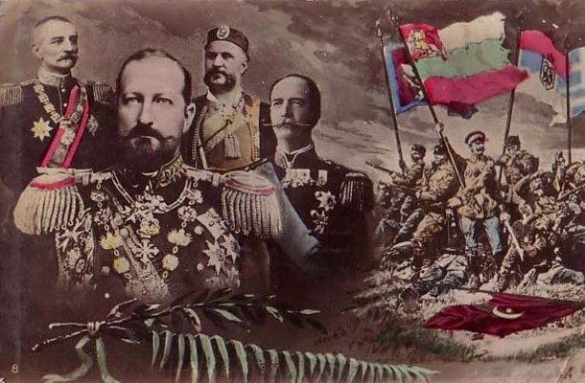
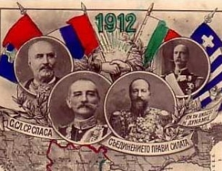
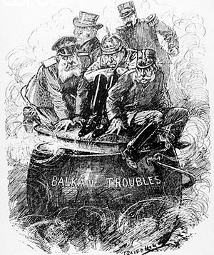
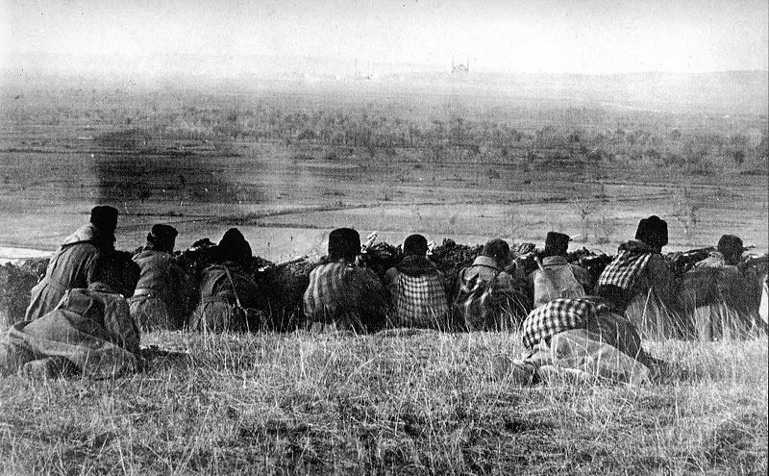

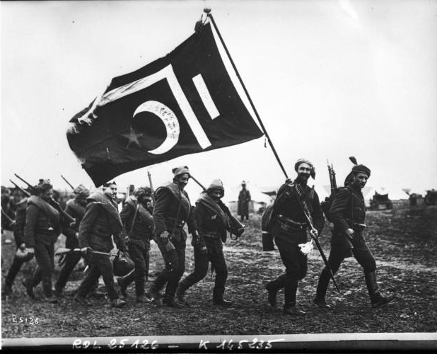
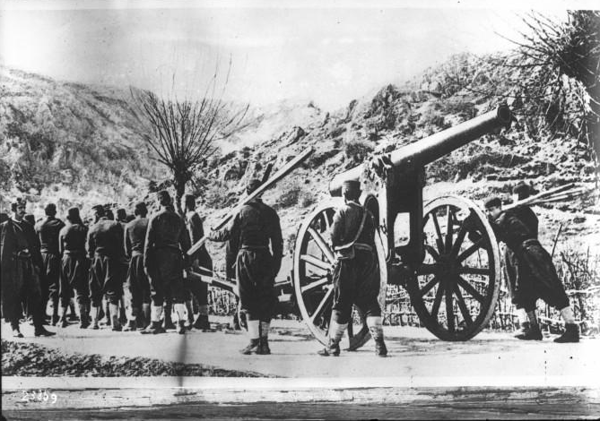
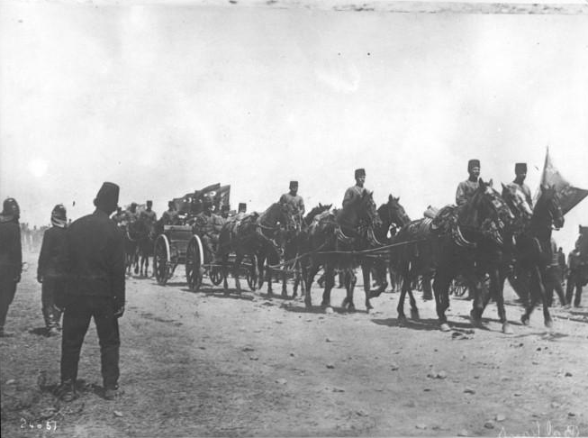
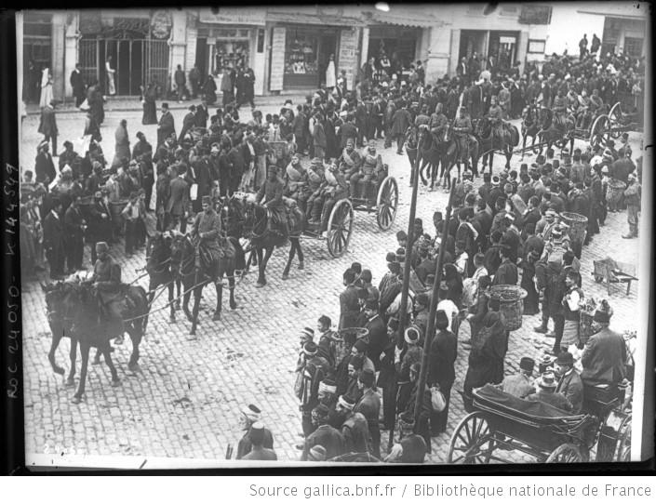
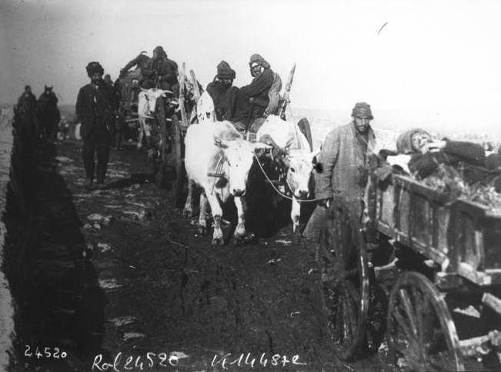
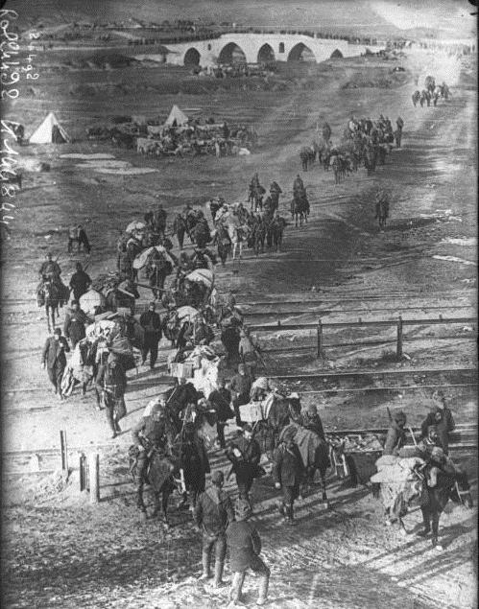
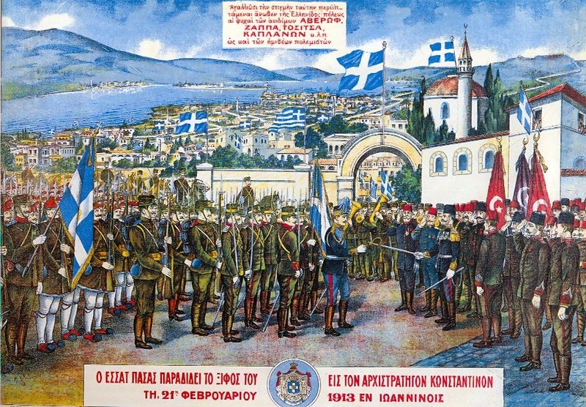
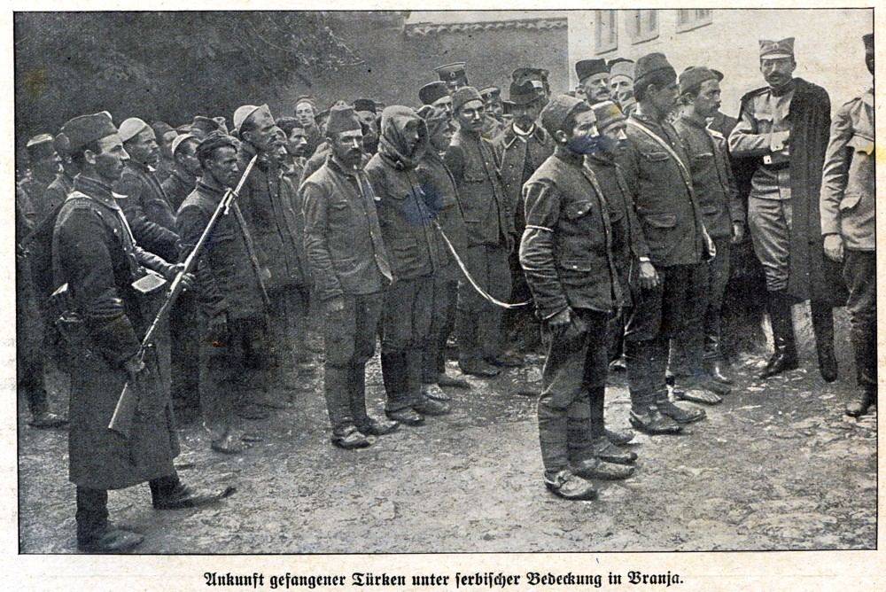
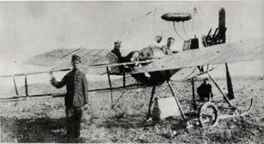
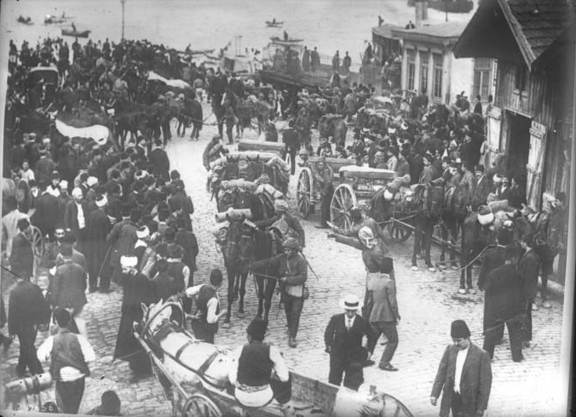
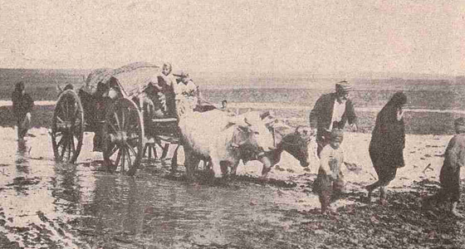
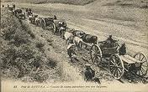
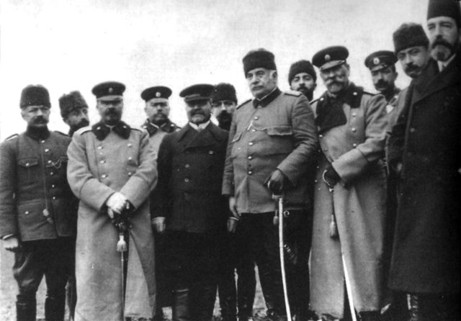

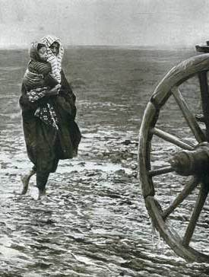

---------------------------------------------------------------------------------
---------------------------------------------------------------------------------
---------------------------------------------------------------------------------
---------------------------------------------------------------------------------
---------------------------------------------------------------------------------
---------------------------------------------------------------------------------
---------------------------------------------------------------------------------
---------------------------------------------------------------------------------
---------------------------------------------------------------------------------
---------------------------------------------------------------------------------
---------------------------------------------------------------------------------
---------------------------------------------------------------------------------
---------------------------------------------------------------------------------
---------------------------------------------------------------------------------
---------------------------------------------------------------------------------
---------------------------------------------------------------------------------
---------------------------------------------------------------------------------
---------------------------------------------------------------------------------
Organizers:

Center for Balkan and Black Sea Studies/Yildiz Technical University, Istanbul
Department of History, University of Regensburg
Institute for East and Southeast European Studies (IOS), Regensburg

Coordinators:

Katrin Boeckh
Mehmet Hacısalihoğlu
Heike Karge
Sabine Rutar

Emilia Müller, Bavarian State Minister of Federal and European Affairs,
acts as the patroness of the conference.

Sponsors




The organizers thank the students of Yıldız Technical University Department of Political Science and International Relations who helped the organizers during the conference and the Assistant of BALKAR Emin Uzun who prepared this abstract book.

