Excite Boost Which is an amazing sign that you could come to be a devoted sweetheart almost immediately without monstrous inconveniences withinside the interaction. With this top notch give, you could be guaranteed which you are turning into the adrenaline improve that your edge wants to complete at your decent withinside the room.
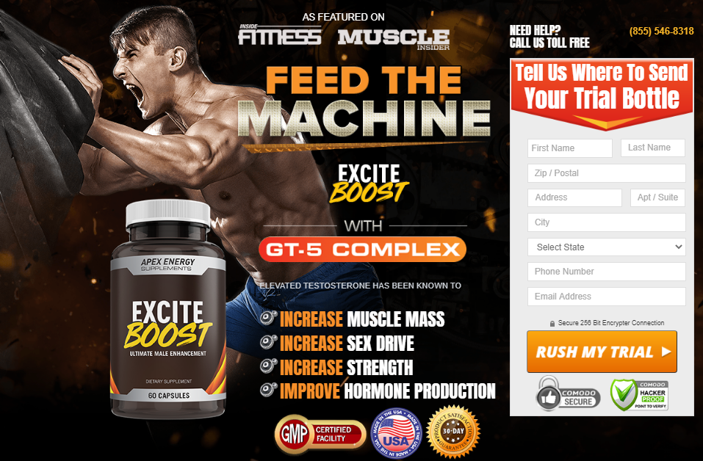
►►Click Here to Order Excite Boost◄◄
In any case, when you have any inquiries or concerns, try to talk together alongside your wellbeing expert sooner than the utilization of the detailing. Else, you could tap on any photo or catch in this website page to look on the off chance that you could proclaim a FREE TRIAL OFFER of the number 1 cases.
Yet, the more you stand by, the substantially more likely that this top notch gives should terminate, or assets should advance out. Thus, click on any photo or catch in this site page to get admission to your FREE BOTTLE sooner than it's past the point of no return!
►►Click Here to Order Excite Boost◄◄
What Is The Excite Boost Price?
You can pronounce the last Excite Boost Cost with the guide of utilizing clicking any photo or catch on this site page to take a gander at how the male upgrade stock think about! Our hyperlinks will dispatch you to the number 1 male upgrade combo with the goal that you can find the pleasant arrangements.
On the off chance that you rush, you could even proclaim a FREE TRIAL OFFER of the zenith advancing plan! With this top notch bargain, you could get your first commendation at the simple Excite Boost Cost of transport and taking care of!
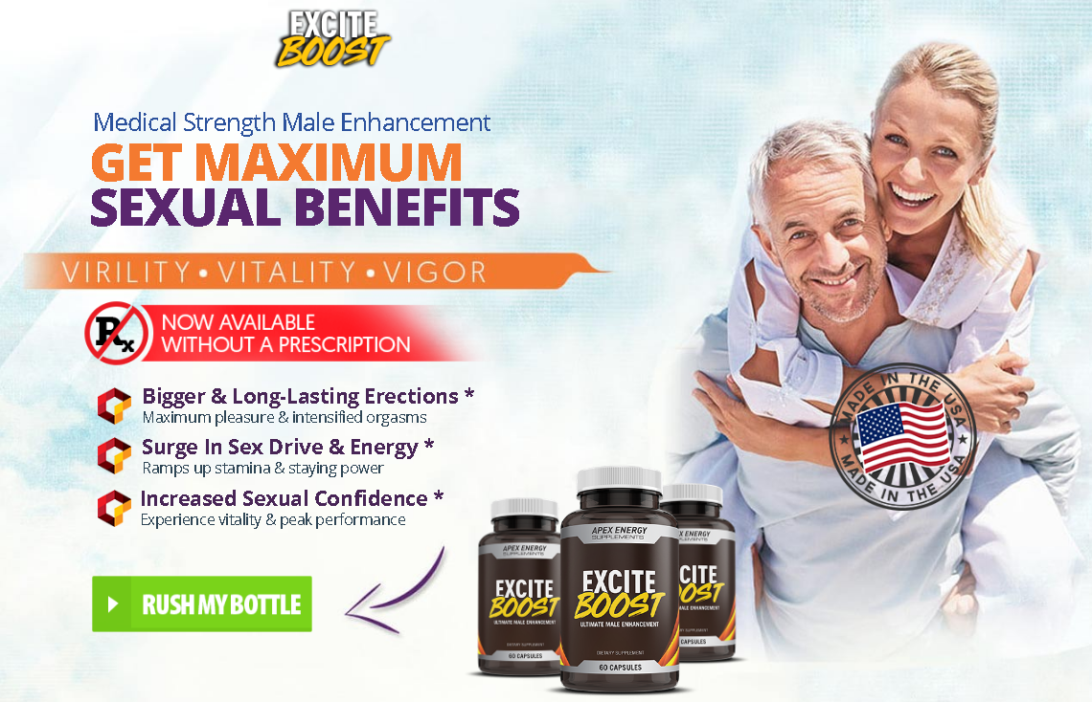
►►Click Here to Order Excite Boost◄◄
That way, you could endeavor out the definition for as long as about fourteen days to take a gander at what you trust you concentrated sooner than focusing on the combo completely. In any case, the more you stand by, Excite Boost considerably more likely that this top notch gives should lapse, or assets should advance out sooner than you will endeavor it. Thus, click on any photo or catch in this website page to say the last Excite Boost Cost sooner than assets are no more!
https://sites.google.com/view/excite-boost-pill/home
https://sites.google.com/view/excite-boost-pills/home
https://fetchbinarydog.com/excite-boost/

