Please complete the questions below using your knowledge recall, only referring to revision material to check your answer, or support you if you are stuck. You can either type your response into this sheet or write on paper – in this instance please take a photograph of your work using your phone and send to your teacher on the One Drive ‘Hand in’ folder. Your teacher will respond with feedback as quickly as possible.

1. What type of news programme is The Archers?
2. Which radio station broadcasts The Archers?
3. Identify 3 ways people can listen to The Archers.
4. The BBC is a public service broadcaster. What is their public remit?
5. How is the BBC funded? Identify 2 ways.
6. Identify one target audience for The Archers.
7. Explain two aspects of The Archers website that will appeal to this audience.
8. Explain why audiences would have enjoyed the Helen and Rob storyline we listened to in class. Refer to Uses and Gratifications in your response.
9. Which company regulates broadcasting in the UK?
10. In what ways has technological convergence made it easier for fans to engage with The Archers (this is an extended response carrying 8 marks)?
11. What marketing strategies has the BBC used to reach audiences, including new audiences, which may encourage them to listen to The Archers? (you may need to carry out some research into this)
12. What type of game is Pokemon Go?
13. Identify 5 technologies that PG needs in order to run.
14. Which company owns the Pokemon brand?
15. What is a freemium app?
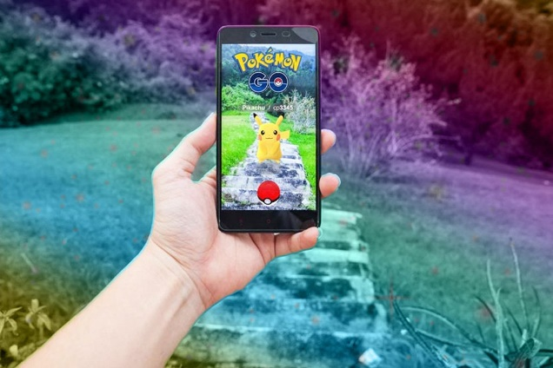
16. Identify and explain two ways that Pokemon Go makes money.
17. Explain how PG has used tie-in deals to generate profit.
18. Identify 2 audiences for PG.
19. For each audience you have identified, explain two aspects of gameplay that appeals to that audience.
20. How does Pokemon Go create opportunities for social interaction? Give 3 examples and a brief explanation.
21. In what ways are PG players ‘active’? Provide 5 ways.
22. Which company regulates the gaming industry in the UK?
23. What are some of the criticisms of PG in terms of health and safety.

CHALLENGE:
1. Why do audiences listen to The Archers? Refer to Uses and Gratifications in your response. (10)
2. Why do audiences play Pokemon Go? (10)

