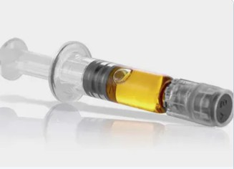
BUY SOUR SOOIE USA – GET IT NOW

Buy Sour Sooie USA. However, at present, there appears to be minimal possibility of full authorization in the United States. As a matter of first importance, the Republicans control the Senate until January 2021, at any rate. Until they lose their mind. For More Information Please Visit Our Website:
leafouts.com

