south africa music download

Customary African diversion utilizes a wide assortment of instruments, all made out of materials found in nature. These instruments incorporate drums, gongs, chimes, harps, woodwinds and xylophones. In African culture music, move and tune go inseparably and to isolate them into particular classifications is practically unimaginable. Music, move and tune is additionally a characteristic piece of each culture and is far beyond a unimportant type of amusement, it is a piece of their soul and is natural for their lifestyle. Today, despite the fact that numerous Africans not, at this point carry on with a conventional life yet have completely received western societies and western impacts, they despite everything hold an inborn love for music, move and melody.
south africa music download

Some conventional African moves that are as yet well known right up 'til the present time include:
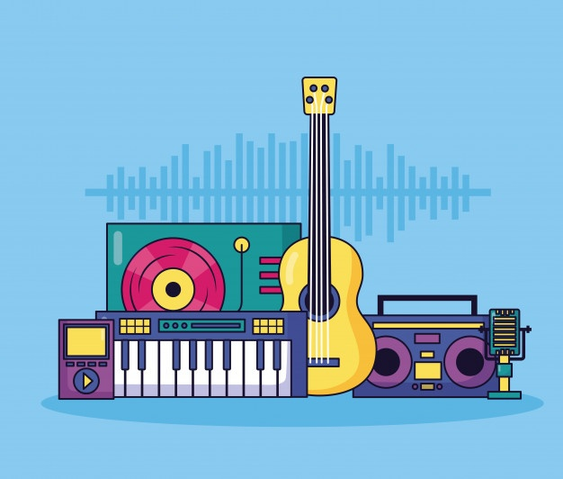
Agbaei, which is a coquettish, social move of the Krobo of Ghana. As indicated by the oral history of the Krobo, the older folks began the move when they understood that the young in a difficult situation with the entire romance procedure. They made the move with the goal that the youngsters and ladies of the town would need to take part in the move and consequently get familiar with certain tips that would help them, all things considered, circumstances.

Bamaaya signifies, "The stream (or valley) is wet" and is the most well known move of the Dagbamba individuals in Northern Ghana. Nowadays it fills in as a move for an assortment of social events, for example, celebrations, national day festivities and even burial services. It started, in any case, as a strict melodic presentation. The move requires a lot of wellness and adaptability as there is a great deal of midriff development and curving. At the point when it initially began it was a move that no one but men could partake in, the ladies did the singing, acclaim yelling and energized the artists. Presently both genders can participate in the move.

Yeve is a Stone or Thunder God that tumbles from the sky during or after a rainstorm. The individuals who accept this have a place with one of the most cryptic and amazing factions in the South Eastern Ewe regions in West Africa. Yeve music has a one of a kind structure that recognizes it as isolated from other Ewe music. Yeve music has a set-up of seven to nine move structures or developments and every development is identified with a particular period of love.

Kete is a move structure that is found in the illustrious courts of Akan people group. It is possibly performed if the main's status is with the end goal that he is qualified for be conveyed in a cart. The music is performed on state events and celebrations. There are three sections to each exhibition: 1) drum music 2) pipe breaks 3) vocal partner of the channel tunes. There are eight pieces to every exhibition. The pieces are distinguished by the name for the kind of drumming and moving done, by the dedicatory name of the occasion or by a name that is demonstrative of the members.

The most mainstream and surely understand customary instrument is the djembe drum. The drum originates from West Africa where it has an indispensable influence in the zones melodic conventions and culture. The drum is challis molded and secured with creature skin and is intended to be played with your exposed hands. The Bamana individuals in Mali state that the name djembe originates from the idiom "Anke dje, anke, be" which means "everybody assemble" and in this manner perfectly characterizes the drum's motivation.

The blend of the drum's cup shape, skin covering and thickness imply that it is equipped for creating a wide scope of tones, from a high sharp solid delivered from a slap to the round full bass tone. So as to accomplish the correct sound it is essential to center or scatter your hand's vitality by situating it in the right spot. Hitting the drum with your fingers and palm towards the focal point of the drum will create the bass note, while striking the drum close to the edge with the meaty piece of your palm will deliver the tone and the slap.

