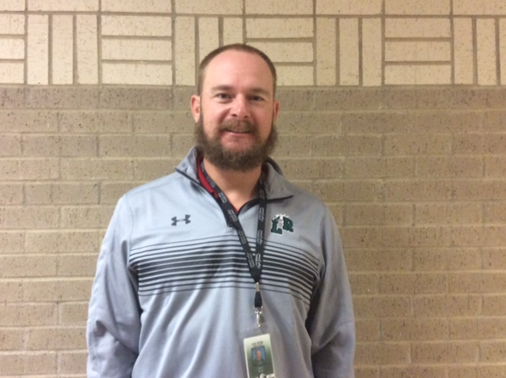
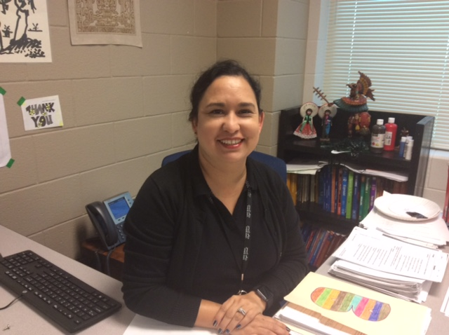
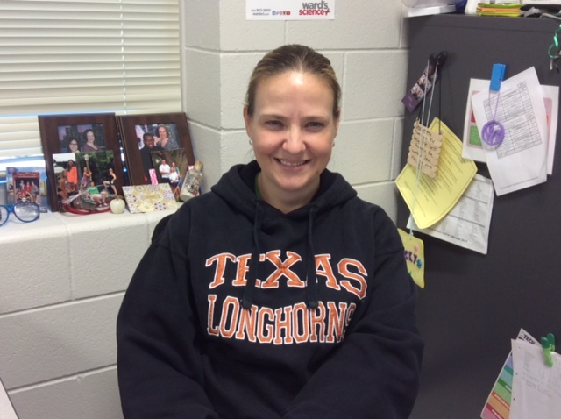






Teachers get Christmas gifts too?!
Favorite Christmas Gifts Ever! Learn about touching gifts your fellow teacher’s received.
I heard elves love to sing when they work on children’s toys. They are very good wrappers.
Joke of The Week
LRHS_ENN
LRHSENN

@LRHS_ENN
Eagle Nation News

Stay in The Loop!
Want to be heard? Got a story idea? Contact Mr. Sohel in room E-139
- Read about Lake Ridge Breaking the Toys for Tots Record!

- Get the latest news on exemptions.

- Learn some of your classmate’s holiday traditions.

